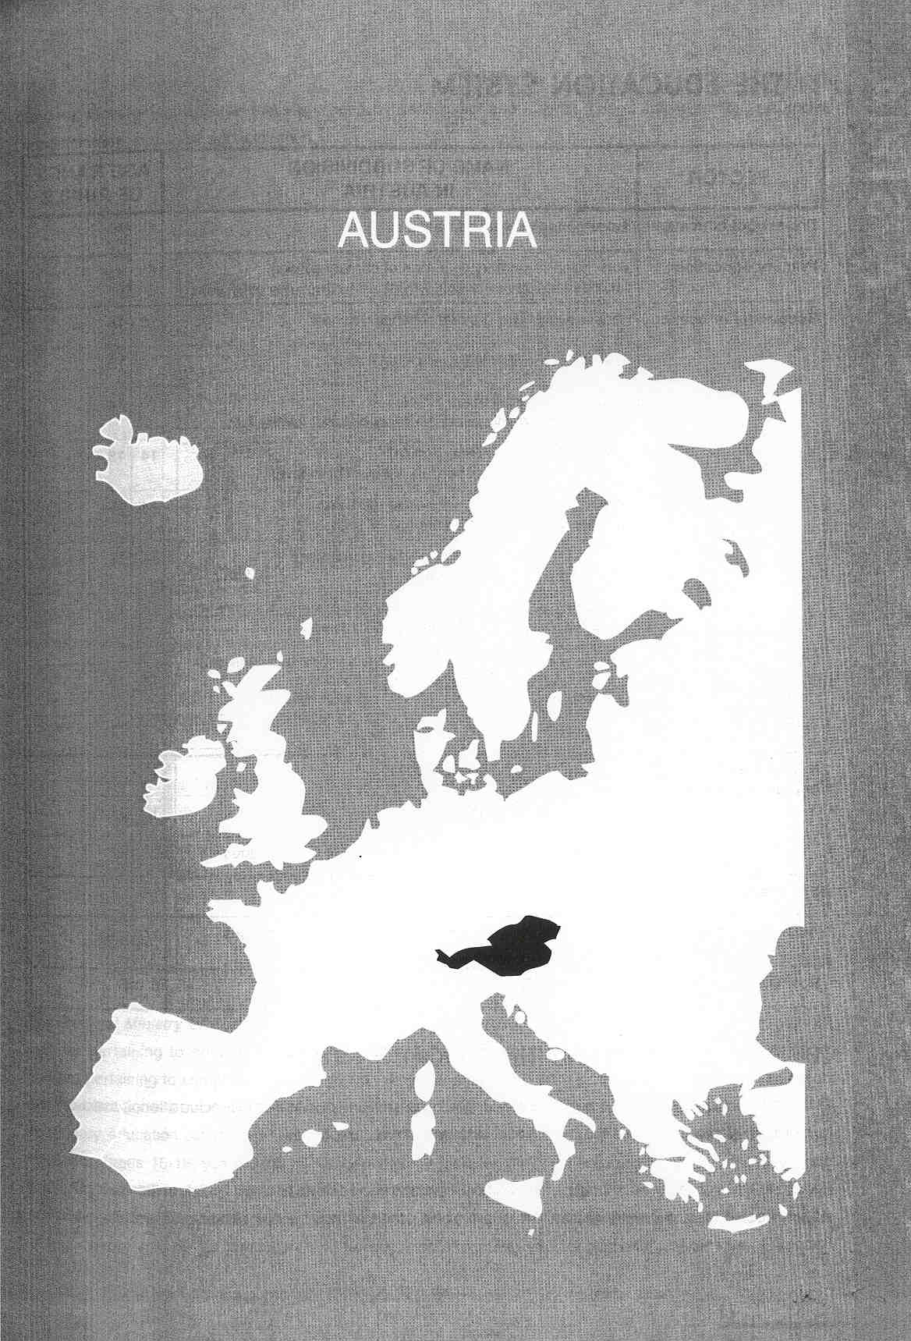

Νίκος Ηλιάδης, Πολ/κός Μηχ/κός Ε.Μ.Π., M.Sc.,
Ph.D. Industrial Education, Organization and Management,
Σύμβουλος του Παιδαγωγικού Ινστιτούτου

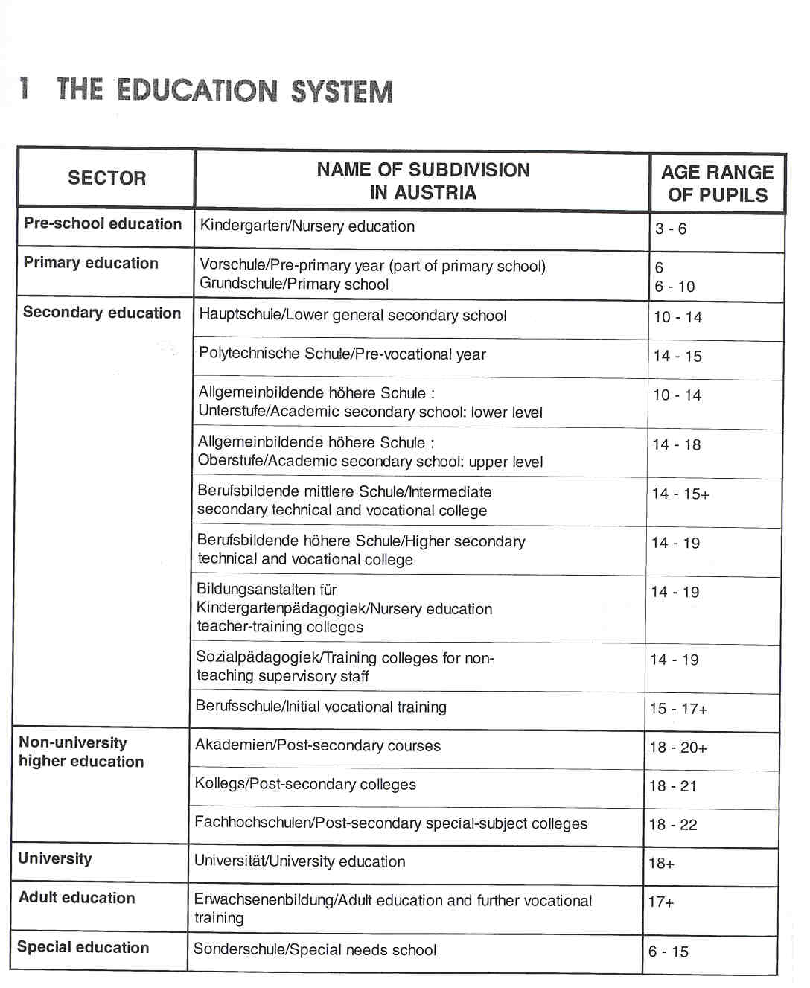

THE ADMINISTRATION OF THE EDUCATION SYSTEM

Constitutional legislation has assigned a complex system of responsibilities to education, based on the general division of responsibilities within the Austrian administration.

The Federal Minister of Education is the political head of the Federal Ministry of Education and Cultural f" Affairs. Secretaries of State Qunior Ministers) are not in post, but may be appointed on the decision of the Federal Government.

General Government administration is divided between direct and indirect federal administration, provincial administration and local administration.

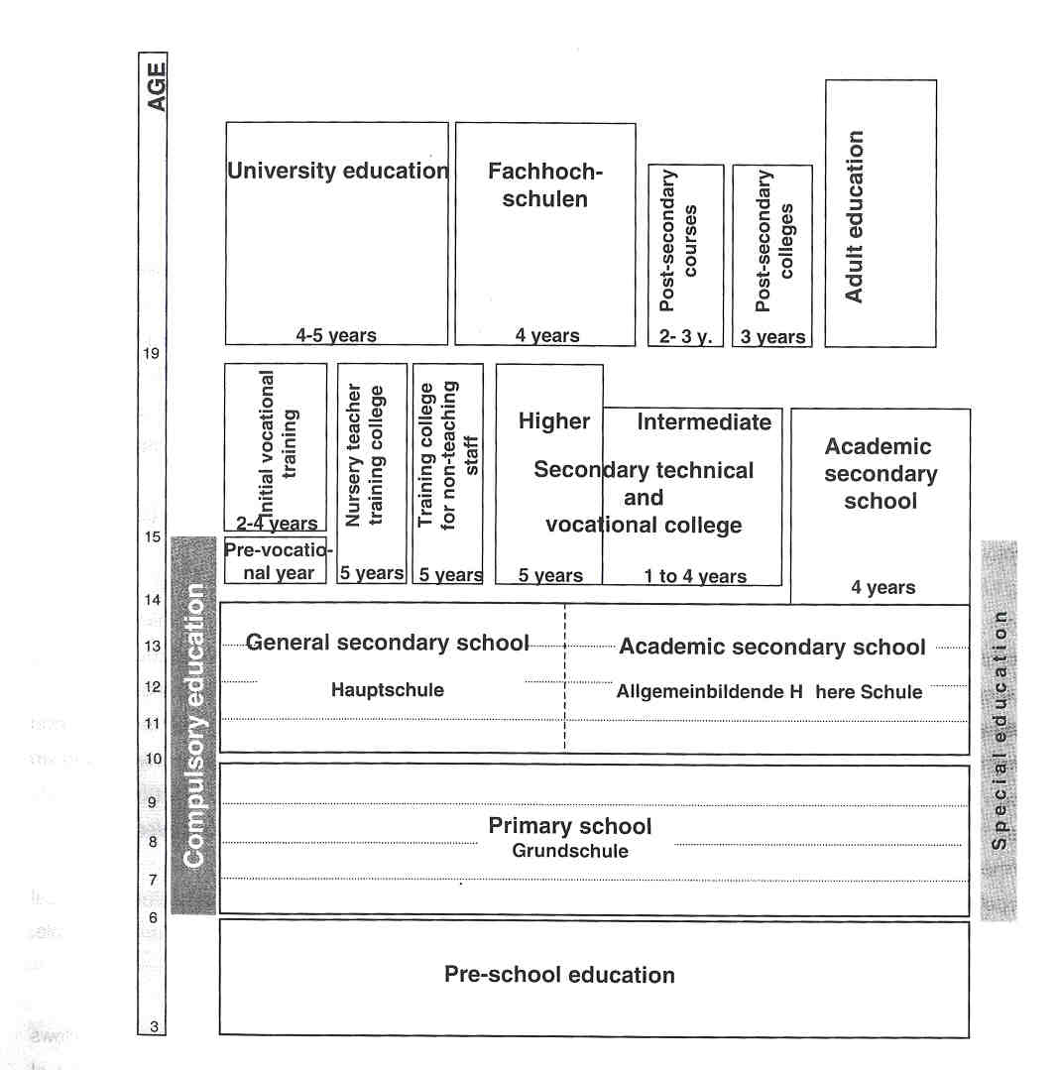

ThQ Federal Ministry of Education and Cultural Affairs in Vienna is the supreme executive authority in all matters pertaining to education. The Federal Ministry is responsible for legislation and the conduct of all matters pertaining to compulsory education, including teaching and curricula, private schools, the organisation O@@the educational authorities and the school Inspectorate, and the entire system of higher level general ~ndary education (ages 10-18, years 5-12) and of intermediate and higher level technical and vocational
ation (ages 15-19; years 9-13). This responsibility includes matters pertaining to the Service Code and $t@ft Representation for teachers at the above-mentioned institutions. It also includes initial teacher training and in-service training establishments, the "Fachhochschulen" and universities. Excluded are the maintenance 0-higher-level schools for agriculture and forestry, and all staffing matters at these schools.

Several bodies with consultative status are affiliated to the Ministry, such as the School Reform Commission, the Centre for School Development, with departments in Vienna, Graz and Klagenfurt, the Commission for Minority Education, the Commission for Minority Schooling and the Advisory Commission for Technical and Vocational Education and Training.

The core issues of legislation are laid down in federal law, while the contents are specified in detail in provincial acts. The federal and provincial levels, therefore, act as complementary legislators. Wherever the constitution accords the responsibility for enacting school legislation to the federation, these responsibilities are taken up at provincial level by the "LandesschuirAte" (provincial school boards). All of Austria's nine provinces have established a "Landessehuirat", which is known as the "Stadtschuirat" in Vienna. At the head of the "Landessehuirat" is the provincial governor, who acts as president; he presides over a collegiate board and an Office. In most cases, the president comes from the party with the majority in the diet (or Provincial Parliament). The president decides on all matters which have not been assigned to the board by law. The "Landessehuirat" is the most influential decision-making body within the provincial authority. It is made up of voting and consultative members. The latter include representatives of the churches and religious communities, of the "social partn,ers", the "Landessehulinspektoren", the Office Director and, occasionally, students' representatives.

The Office of the "Landessehuirat" is responsible for day-to-day operations. It is headed by the Office Director, who is the highest-ranking civil servant.

School administration at local level is the responsibility of the districts and the local communities. Every province is divided into political districts. Each political district has its own "Bezirksschuirat". In the province of Vienna, which currently holds the status of a municipality, the "Stadtschuirat" also acts as a "Bezirkssehuirat". The Federal Government fulfils its executive responsibilities in education at the local level through these "Bezirksschuir@ite". The "Bezirkssehuirat" consists of a director, a collegiate board, and an Office. The head of the "Bezirkssehuirat" is the district governor. The "Bezirkssehuirat' has direct responsibility for all "Aligemeinbildende Pfiichtschulenl" within the district territory. It has no authority over secondary intermediate and higher-level schools and "Berufssehulen".

The political districts are subdivided into local communities. In the Austrian administrative system, the local community is the lowest level of government and closest to the citizen. The local community is responsible, in particular, for general compulsory schools.

The concept of school autonomy, introduced by the 15th Amendment to the School Organisation Act, allows schools to devise their own curriculum within a given framework. This framework is to facilitate ease of progression in education. The "Landessehuirdte" are charged with ensuring that schools keep within this general framework. If schools fail to do this, they lose the freedom to devise their own curriculum. There are no national or regional examinations in Austria.

Under State law, anyone has the right to set up a private school. Private schools exist at all levels of education, in primary and secondary education, and in general and vocational education. The most significant

"Aligemeinbildende Pfiichtschulen" are general compulsory schools, comprising primary schools, general secondary schools ("Hauptschulen"), special schools and the pre-vocational year.
providers of private schools are the churches, notably the Catholic church, ahead of the "social partners", who are strongly involved in technical and vocational education.

The Private School Act distinguishes between two groups of private schools, i.e.:
- private schools which have a statutory counterpart in the public sector;
- private schools which do not have a statutory counterpart in the public sector.

Private schools which do not have a public-sector counterpart are called schools with an organisational charter. Within the charter, the schools set out their curriculum, their internal rules and the required level of training for teaching staff. The charter is subject to official approval. These schools differ considerably from existing public-sector institutions.

Private schools with a statutory counterpart in the public sector follow the curriculum of public-sector schools. A private "Voiksschule", for example, adopts the curriculum of a public "Volkssehule", or a private academic secondary school that of its public-sector counterpart. Deviations from the statutory framework for the curriculum or the prescribed number of teaching hours are inadmissible. Private schools, however, enjoy the same latitude as their public-sector counterparts in matters relating to curriculum design.

COMPULSORY EDUCATION

Compulsory education for children in Austria begins on 1 September following their sixth birthday and lasts for nine years. It ends, therefore, at the age of 15.

Parents are obliged to register their children at the appropriate school and to ensure that they attend on a regular basis. There is no certificate marking the end of compulsory education. Compulsory schooling starts with a four- or five-year period of attendance at a primary school. Years 5 to 8 may be completed at a senior primary school, a lower secondary school, the lower level of a secondary academic school or a senior special needs school. The ninth year may, in turn, be completed by pursuing a pre-vocational year or attending a secondary academic school or a technical and vocational school or college.

Compulsory vocational training is a part-time obligation. Pupils do not attend the "Berufssehule" on a daily basis, but for a few weeks in the year, or for one day a week. For the rest of the time, pupils (or apprentices) work in the firm which trains them. This system of training is called the dual system.

EDUCATIONAL SECTORS AND SUBDIVISIONS

Pre-school Education

Pre-school education includes all measures to promote the development of the total personality of a child from birth to the start of school.

There are several institutions for preschool education: infant and baby cr6ches, nursery schools ("Kindergarten"), and children's play-groups, often organized by private initiative as an alternative form of Pre-school education.

Cribehes cater for children under the age of 3.

For children between the ages of 3 and 6, nursery schools exist, both to complement education within the family and to help ensure a good start in formal education. Nursery schooling depends on parental choice and is voluntary. It is available either on a full- or half-day basis. It focuses on developing the child's personality as a whole and is not primarily concerned with preparing children for school. First and foremost, a child at nursery school should have the opportunity of acquiring experiences through appropriate play activities without the pressure of time or achievement. Nursery education is organized in groups, either in the form of age-related groups or "family groups".
A considerable number of nursery schools integrate mentally and physically handicapped children within mainstream groups.

School inspectors are not responsible for preschool education in Austria.

Primary Education

Primary education lasts five years (the pre-primary year and years 1-4), and is provided in the "Grundschule". The "Volkssehule" (years 0-8) extends beyond the primary level, but has been almost entirely replaced by the "Grundschule" (years 0-4), since the upper cycle of primary education (years 5-8) is available in only a few places today. The children in years 1-4 are taught by a single classteacher.

The first three years of primary education constitute a complete unit. The pre-primary year (the "Vorschule") is now part of the primary school. It is designed to foster the development of children of compulsory school age who have not yet achieved sufficient maturity. Such children may complete their first full year of compulsory schooling in the pre-primary class. They then have to spend a total of five years at primary school. The pre- primary year offers children aged 6 the opportunity to acquire sufficient knowledge to be able to follow lessons in year 1 of the primary school. Pre-primary pupils may attend a discrete pre-primary class or be taught alongside first-year pupils.

The curriculum of the pre-primary year includes compulsory instruction for all the children. This compulsory instruction comprises religious instruction, pre-reading and writing, oral work, environmental education, early mathematics, music and singing, art, physical education and traffic education, in addition to play.

There is no assessment of the children's performance at this stage. They are not graded at the end of the year. Their annual report states only that they took part in the learning.

All children may proceed to the second year on completing year 1, irrespective of their assessment in the annual report.

The primary school curriculum is designed to provide all pupils with the same elementary education. The curriculum provides only a framework to be filled in by the teachers' own work in the classroom. While this constitutes a national curriculum even for the primary school, limited modifications to content, use of local materials and additional subject matter arising from the local community are possible. Thus, the number of weekly periods assigned to common-core subjects may be determined, within the limits set by the total distribution of class periods, by the provincial school board based on local circumstances.

Special attention is paid to the social integration of children with special needs. There is no differentiation by class (streaming) in primary education. Different teaching approaches and differentiated tasks accommodate the pupils' different stages of development. Age-related groups may be constantly re-grouped as a part of internal differentiation. Children are placed into groups according to their interests, self-assessrnents, varying educational backgrounds, friendships, pace of learning, etc. Internal differentiation is facilitated by adequately resourcing schools or classrooms with teaching aids, audio-visual media, etc.

Secondary Educadon

Secondary education may be divided into a lower secondary level and an upper secondary level.

Lower Secondary Level

- General secondary school ("Hauptschule")
On completing year 4 of primary education, pupils may transfer to a "Hauptschule", which covers four years of secondary education (years 5-8) for pupils aged 10-14. It provides a basic general education and prepares pupils, according to their interests, talents and skills, for employment andlor transfer to an intermediate-level and higher-level school.
If pupils are successful at the "Hauptschule", they may be transferred directly to an "Aligemeinbildende hbhere Schule". Similarly, because of the identical curricula in the two types of school, pupils may also be transferred from the lower level of the "Aligemeinbildende h6here Schule" to the "Hauptschule".

- Academic secondary school: lower level ("Alinemeinbildende h6here Schule: Unterstu
The "Aligemeinbildende h6here Schule" consists of a four-year lower level (for pupils aged 10-14) and a four-year upper level (for pupils aged 14-18). Thus, "Aligemeinbildende h6here Schulen" normally cover @eight years, an exception being the special upper-stage form of the "Oberstufenrealgymnasium", which covers only the four upper years. Both levels of the "Aligemeinbildende hbhere Schule" are usually located in the same building. Since they cater for twice as many years as the "Hauptschule", the number of classes and pupils enrolled is considerably higher. The "Aligerneinbildende hbhere Schule" is organised in coeducational classes according to age. Classes are unstreamed.
The first two years of the lower level are uniformly organised, follow a common curriculum and serve as a period of observation and orientation. In the third year, pupils progress into three different types of course: the "Gymnasium" (which includes Latin), the "Realgymnasium" (with an emphasis on geometry, mathematics and craft) and the "Wirtschaftskundliches Realgymnasium" (with an emphasis on chemistry and craft ).

Upper Secondary Level

To respond to the increasingly distinctive and pronounced abilities and talents of the pupils and to the different require)rnents of society in terms of qualifications, the upper level of secondary education is characterised by increasing differentiation. In years 9-12 (and sometimes in year 13), the general branches of study are supplemented by technical and vocational courses. The following types of school exist in the upper level of secondary education:

- Academic secondary school: upper level ("Aligemeinbildende h6here Schule: Oberstufn)
It is the task of the upper level of the "Aligemeinbildende h6here Schule" to provide pupils with a comprehensive and in-depth general education and to prepare them for university studies. The upper level comprises four years, is for 14- to 18-year olds and is composed of the same three types of course as years 3 and 4 of the lower level (i.e the "Gymnasium", "Realgymnasium" and "Wirtschaftskundliches Realgyrnnasium").

As has already been said, there is also a separate upper-level type of academic secondary school, the "Oberstufenrealgymnasium". This form of school is open to all pupils who have successfully completed year 8 (the fourth year) of an "Aligemeinbildende h6here Schule", as well as for pupils transferring from a "Hauptschule", if they have attained a suitable level.

- Intermediate secondary technical and vocational colleges ("Berufsbildende mittlere Schulen")
These schools provide, not only a thorough general education, but also practical vocational training for specific occupations. Pupils are accepted on successful completion of year 8 and on passing an aptitude test. The "Serufsbildende mittlere Schulen" cover one to four years and provide pupils with a skilled worker or mediurn-level employee status. Longer training courses predominate in "Berufsbildende mittlere Schulen", and, moreover, they are tending to offer higher-level, in preference to medium-level, courses. The most important categories of "Berufsbildende mittlere Schulen" are: "Technische, gewerbliche Fachschulen" (industry and craft), "Handeisschuten" (commerce and trade), "Fachschulen far wirtschaftliche Berufe" (domestic science and commerce ), "Fachsehulen fOr Tourismus" (tourism), "Fachsehulen fOr Sozialberufe" (social services), "land- und forstwirtschaftliche Fachsehulen" (agriculture and forestry) and nursing schools.

- Higher secondary technical and vocational colleges ("Berufsbildende h6here Schulen")
The higher secondary technical and vocational colleges lead both to employment and to university. Education is full-time and lasts five years. The curriculum is divided into three equal parts: general education, vocational theory and practice. Pupils must take part in work experience in business and industry during the summer holidays. After three years of professional experience in their chosen area, pupils have access to the corresponding trade. The most important areas covered by the various "Berufsbildende h6here Schulen" are: engineering, arts and craft, business administration, the service industries and agriculture and forestry. All these areas are offered in colleges specialising in them.

- Traininci Collecies for Non-teaching Supervisory Staff ("SozialpAdaciogik")
The Training College for Non-Teaching Supervisory Staff trains supervisory staff for day-care centres and boarding establishments for children and adolescents. Admission is conditional on the successful completion of year 8 and passing an aptitude test. The courses last five years and end with the matriculation examination and a professional qualification. A two-year course is offered to upper secondary school leavers. All these features are also true for the "Kindergarten" Teacher-Training College (See later).

- Initial vocational training ("Berufssehule")
A considerable amount of initial training is provided by apprenticeship training schemes. This type of training has always been characterised by the dual system, which combines training in business and industry with a theoretical course at a compulsory vocational school. In order to be admitted to apprenticeship training, young people must have completed nine years of compulsory education; apprentices are, therefore, at least 15 years of age.

Regardless of their age, all apprentices are obliged to attend a "Berufsschule". Attendance at the "Berufssehule" is for the entire apprenticeship period. The "Berufssehule" offers complementary instruction in the theoretical and practical sides of the chosen profession and in general education. There are currently more than 200 different apprenticeship branches.

Within two to four years, pupils reach the level of skilled worker in a trade that is regulated by statute. Their remuneration as apprentices is regulated by a collective tariff agreement and approximates to 25- 40% of the initial salary of a skilled worker. Training in the workplace is regulated by the Vocational Training Act.

Higher Education

In higher education, a distinction is drawn between universities, fine-arts colleges, "Fachhochschulen" and study programmes at the post-secondary level.

University educatioln

There are twelve universities in Austria, all of which are State-run. Their principal task in the field of teaching is to prepare students for their future professional careers in the form of diploma and doctorate courses. Diploma lead to the academic title of "Magistee' or "Diplom-ingenieue'. The majority of courses are identical or similar in structure. Diploma courses are the most important form of higher education, both in terms of student numbers and in terms of the programmes they offer. Most courses last from four to five academic years. Courses leading to the degree of "Magistee', which serve primarily as preparation for a professional scientific career, generally comprise two cycles'of study. Each cycle ends with a diploma examination covering a number of subjects. Admission to the final examination is dependent on the presentation of a research paper. Some courses specialise during the second cycle in a variety of fields of study. In 1997, Austrian universities offered 119 diploma courses.
A post-graduate doctorate course, which may be pursued subsequently, is designed, first and foremost, to provide further scientific training. It takes at least one more year.

Fine-arts colleges

The principal courses at fine-arts colleges include teacher-training courses, in which secondary-school teachers of art or music receive their professional training. There are six fine-arts colleges in Austria, all of which are State-run.

"Fachhochschulen"
"Fachhochschulen" offer university-level courses providing a scientifically-based vocational education. The principal aims of such courses are: to ensure practical training at a high level; to convey the skills required to solve the tasks of a given occupation or profession in accordance with current standards of practice; to enhance the general appeal of higher education and promote the professional flexibility of its graduates.

The courses differ considerably from those offered by universities, especially as far as organisation is concerned. The minimum duration of courses at a "Fachhochschule", including the time needed to write a research paper, is three years, plus possible additional time for practical training programmes. Usually courses last four years, including periods of work experience. Courses end with a diploma examination, consisting of a research paper and an oral examination before a board of examiners. The academic title conferred ("Magiste@' or "Diplom-ingenieu@') entitles its holder to pursue a doctorate course at university, which is extended by two semesters for "Fachhochsehule" graduates, compared to similar courses for university graduates.

Post-secondary courses and colleges

Programmes of study at post-secondary level are provided in post-secondary courses and post-secondary colleges.

Post-secondary courses run for four semesters (two years); they provide students with the practical and theoretical education of a secondary technical and vocational college and end with a diploma examination. Courses are offered in engineering, business and the social services sector. They are designed to provide pupils leaving secondary academic schools, not wishing to pursue university studies, with the opportunity to acquire initial vocational qualifications within a relatively short time.

Post-secondary colleges lead to qualifications somewhere between those acquired in secondary colleges and the "MagisteC' level at university. There are post-secondary colleges for the following fields of study: social work, teacher. training and training for paramedical staff.

Teacher Training

In the context of initial teacher training, a distinction has to be drawn between training for preschool education, "Aligemeinbildende Pflichtschulen", "Berufsschulen", medium and higher-level secondary schools and higher education.

Teachers for preschool education are trained at preschool teacher-training colleges ("Bildungsanstalten fOr Kindergartenpddagogik"). Higher-level secondary schools provide training courses for nursery school teachers, starting at the end of year 8 and lasting five years (years 9-13). Their aim is to impart the professional attitude, knowledge and skills required to fulfil the tasks of "Kindergarten education", and, at the same time, to lead to university-entrance qualifications.

"Pddagogische Akademien" are teacher-training institutes, which build on the training provided at higher- level secondary schools in courses lasting six semesters. They are the direct responsibility of the Federal

Ministry of Education and Cultural Affairs. Teacher-training institutes train teachers for primary, general secondary and special schools and the pre-vocational year, to enable them to fulfil the tasks of the teaching profession with the required professional attitude, knowledge and skills. Prospective primary school teachers will acquire the full range of skills necessary for teaching all the subjects in the primary curriculum.

Teacher-training institutes may also conduct educational research. The Conditions of Service are not specific about the requirement for in-service training, which is largely at the discretion of the teachers. Participation in in-service training is not compulsory. One third of in-service training is provided during the holiday period, two thirds during the school year.

Teachers for academic secondary schools ("Aligemeinbildende h6here Schulen") and for general subjects at technical and vocational schools and colleges ("Berufsbildende mittlere Schulen" and "Berufsbildende h6here Schulen") are trained at universities and fine-arts colleges.

In Austria, there is no specific initial training for university lecturers. It is acquired on the job. In order to be appointed a university lecturer, candidates need a relevant university degree and the teaching qualification of an associate professor, or an equivalent national or overseas qualification in science; they need also to have proven teaching ability.

Adult Education

Adult education takes various forms. Alongside school and university education, it is, traditionally, the third pillar of the Austrian educational system. A special feature of adult education is the absence of any constitutional law regulating it; the only federal law concerning adult education is the 1973 law promoting it (the "Fbrderungsgesetz"). Adult education includes neither school-based instruction nor initial vocational training, but comprises all the openings provided by the second educational track, which are regulated in the School Organization Act; it includes all the necessary opportunities for further vocational training, all the programmes of the Public Employment Services (the "Arbeitsmarktservice") and specially-tailored programmes for those encountering problems in the labour market. Opportunities include:

• Regulated and career-related further education and training;
• Schools and colleges for people in employment - the second educational track;
• Non-career-related further education and training.

There are a number of State and private providers of adult education, with a variety of different programmes. Adult education and further vocational training aim to..
• improve the qualifications and skills of adults.,
• retrain employees, in order to give them a chance of promotion in their present occupation;
• raise the general level of education, especially that of adults with low-level basic training.

The adult education programmes provided in Austria are accessible to everyone. For some courses or training programmes, a specialist background is required; some are designed for specific targgt groups, such as migrants, the unemployed, unskilled young people, women, etc.

To be admitted to a school for adults in employment, applicants must have successfully completed year 8 at school, be over 17 years of age, and have completed their initial vocational trainingleducation or have already entered employment. Most adult education institutions are run as evening classes, to allow participants to combine work and school.

Special Education

Special education (the "Sonderschule"), in its various forms, embraces primary and secondary education (years 1-8 or g). It is charged with educating physically- or mentally-handicapped children in a manner consistent with their particular disability, and, where possible, in a form corresponding to provision in primary and general secondary schools and the pre-vocational year. "Sonderschulen" aim to prepare pupils for working life or further studies. Austrian special schools (for pupils aged 6-15) comprise nine discrete categories, corresponding to the different types of mental or physical disabilities listed in international literature on the subject. Pupils receive a basic education from specially trained teachers who use methods tailored to meet the children's individual requirements.

At the request of the parents and provided the special needs of the children can be met, disadvantaged children may also attend mainstream primary school. The decision on the feasibility of integrating special- needs children rests with the District Education Board. At present, there are a number of pilot projects on extending the integration of special-needs pupils to lower secondary and academic secondary schools.

2 THE ORGANISATION OFTHE INSPECTORATE

In Austria, principals have the main responsibility for monitoring and supervising teachers in their school. They are the line managers of all the teaching staff, and they are charged with advising them on their work. They must regularly evaluate the teaching and the standards of the pupils. In Austria, however, the education system is also characterised by a long tradition of external school inspections.

The authorities responsible for the inspection of schools are, for the most part, the district and provincial school boards and the Federal Ministry of Education and Cultural Affairs. As explained before, district and provincial school boards are separate educational authorities. The district school boards are the first tier of management for compulsory general schools. Provincial school boards are the first tier of management within a province for compulsory vocational schools, medium and higher-level secondary schools, academic secondary schools and training institutes for higher social occupations, as well as being the second tier of management for compulsory general schools. The Federal Ministry of Education is the second tier of management (See also above).

The, school Inspectorate was established by the Federal School Inspection Act. Its work is carried out by school inspectors and by teachers upon whom inspection duties have been conferred. The Inspectorate is made up of:

- "Landesschulinspektoren' (LSI): Provincial school inspectors (S1) are responsible for inspecting one or several types of schools within a province (Austria is divided into nine provinces);
- "Bezirksschulinspektoren" (BSI): District school inspectors (S2) are members of the school Inspectorate and carry out inspections in compulsory general schools within a political district;
- "Fachinspektoren' (Fl): Subject inspectors are teachers entrusted with inspecting certain individual or groups of subjects. Subject inspectors are responsible for only a small number of subjects, such as music, physical education, handicraft, art and religion. Subject inspectors for religious instruction are appointed by the church. These inspectors are part of the federal school authorities in the provinces (the "LandessehuirAte").

The school Inspectorate works primarily at the level of the adnninistrative districts and the provinces. There is no central, permanently established school Inspectorate operated by the Federal Ministry of Education and Cultural Affairs. In theory, the Minister could, under the provisions of the Federal Constitution Act, which allows school inspections in specific instances, inspect the quality of education in schools by appointing Ministerial agents.

At the level of the "H6here land- und forstwirtschaftliche Lehranstalten" and at Vienna's four higher technical and industrial schools, inspection, in the first instance, is the responsibility of the Federal Ministry of Education and Cultural Affairs.

The Federal Minister of Science and Transport oversees the universities and colleges of fine art. He must repeal any decisions taken by the different university bodies that are contrary to the principles of economy, efficiency and effectiveness. The universities and colleges of fine art may appeal to the supreme courts against such regulatory measures taken by the Federal Ministry. The universities and colleges of fine art are also subject to retrospective audits of their financial management. These audits are conducted by the Federal Court of Audit and by the Ministry itself.

Procedures for conducting school inspections are laid down in the "General Directive on the Conduct of School Inspections". The principles enumerated apply both to public and to private schools.

The Government has complete responsibility for funding the Inspectorate.

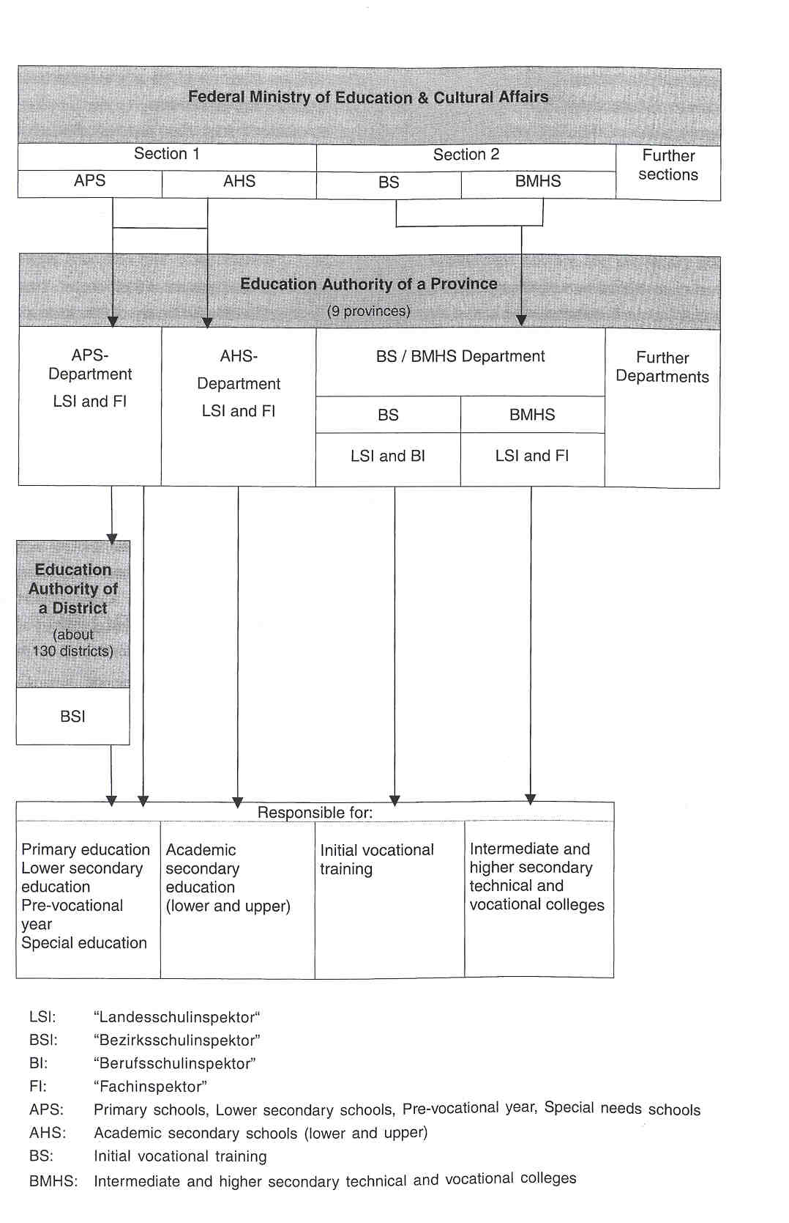

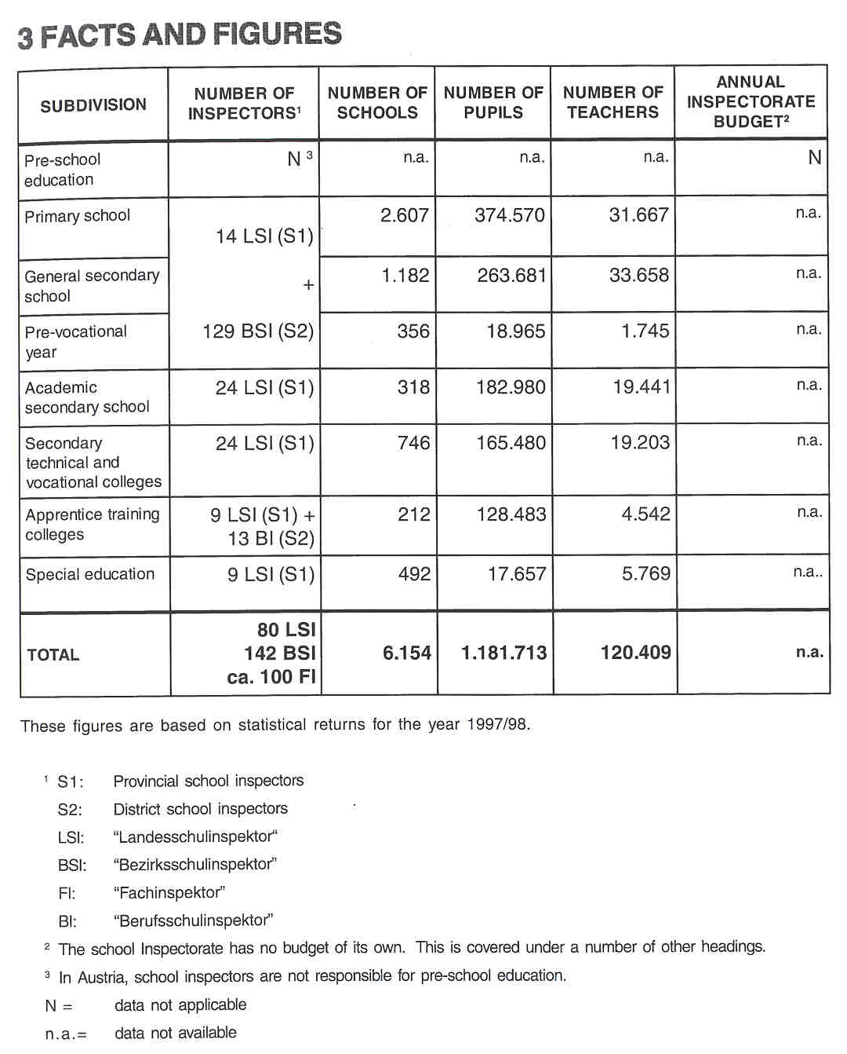

4 THE RECRUITMENT OFTHE INSPECTORATE

Applicants for the Inspectorate must be trained teachers. Additional certificates enabling the holder to teach in different types of school are desirable. Applicants must also have been assessed as excellent teachers in the appropriate type of school over a period of several years (The exact period of time is not specified).

Experience as a teacher trainer in pre- andlor in-service institutions andlor as an author of relevant papers is also desirable. Experience of school management is recommended, but no further details are specified.
There is no recruitment test. Information concerning the applicants is gathered in Assessment Centres in some provinces of Austria by means of a structured interview. Sometimes the Inspectorate's observations on a lesson taught by an applicant are taken into consideration.

These conditions for recruitment apply to all three types of inspector: the "Landesschulinspekto@', the "Bezirkssehulinspektor" and the "Fachinspektoe'.

5 THE WORKING CONDITIONS OFTHE INSPECTORATE

Inspectors are employed on a full-time basis. By law, they are permanently employed. Applicants must be in guaranteed permanent employment.

6 AREAS OF INSPECTORATE RESPONSIBILITY

6.1 EVALUATING

In general, the Inspectorate is responsible for the evaluation of school management and the quality of teaching. A system of full inspection, in which the whole school is evaluated, has not yet been developed in Austria.

The Quality ofteaching

Evaluating the quality of teaching is an important aspect of an inspector's work. Much time is spent on evaluating individual teachers, in order to assess them (with consequences for their career prospects) and in order to provide advice. The inspection of individual teachers is at the request of the school principal or on the inspector's own initiative during the early years of a teacher's career. The formal appraisal of teachers, however, is the responsibility of a special committee, and does not fall to the inspector.

The Inspectorate is the "safeguard" that the quality of teaching is at least satisfactory. It ascertains whether a teacher's work accords with the prescribed programmes of study Inspectors do not infringe the autonomy of teachers in terms of teaching approaches and classroom practice.

School Management and AdministrativeTasks

The organisation of the school and the pedagogical leadership of the principal are also evaluated. The inspection places a strong emphasis on school management and administrative tasks, such as the supervision of final examinations.

The Inspectorate also evaluates matters relating to financial management, such as the procedures for employing teachers, and administrative matters, such as teacher transfer and the supervision of teachers' overtime and expense accounts.

The School's Compliance with Statutory Regulations

In Austria, there is a strong emphasis placed on evaluating the school's compliance with statutory regulations, such as those concerning the curriculum, the school day and management by the principal, etc.

The Inspectorate must control developments in private schools, in terms of their acquisition and retention of recognised status in public law. The recognised status is provisionally granted for one year. If schools have completed their curriculum development, they may receive permanent recognition.

School's Procedures for Self-evaluation

Inspectors have to safeguard and improve standards in education. They do this by supporting the school's own procedures for self-evaluation and by providing an external evaluation of the match between the school's curriculum and the centralised framework. Self-evaluation by schools is to be made compulsory by an amendment to the statutory regulations for schools. At present, schools are engaged in self-evaluation on a voluntary basis as part of a pilot exercise. The final role of the Inspectorate has still to be clarified.

The Educational System as a Whole

The evaluation of the educational system as a whole is the responsibility of one particular department of the Ministry of Education, the Centre for School Development (the "Zentrum for Schulentwicklung"), which publishes its findings on a regular basis.

Aspects of provision

Occasionally, inspectors evaluate specific topics, but not an a large scale. Interest, however, is increasing in a focused evaluation of specific live issues in education. It is anticipated that such an approach could improve efficiency in a number of educational areas.

6.2 ADVISING

One important task of the Inspectorate is the provision of advice to the various participants in education, such as parents, pupils, principals, teams of teachers, etc. Inspectors advise teachers, for example, on new programmes of study and on new teaching methods; they also advise on matters relating to accommodation, such as renovations and new buildings.

In general, inspectors are required to support and advise schools in their growing autonomy, resulting from the continuing process of decentralisation and deregulation.

Generalizations of experiences derived from inspections contribute to the provision of advice to politicians, officials of the Ministry of Education, etc. Inspectors advise on the curriculum by offering informed opinions on newly-developed programmes of study before they are amended. Inspectors do not, however, participate in curriculum development.
Occasionally, inspectors take part in working groups set up by the Ministry of Education.

6.3 MONITORING

Inspectors are involved in co-ordinating decisions made by various departments of the school authority and in co-ordinating the work of the schools in their area.

Inspectors monitor and supervise the work of one or several teachers, the principal or the entire school. Apart from the Inspectorate, it is the principal's responsibility to guide teachers in their teaching and educational activities and to monitor, on a regular basis, the progress of classroom instruction and the pupils'achievements. Principals are, after all, responsible for the total functioning of their school and must be able to justify it to the Inspectorate.

The Inspectorate's involvement in monitoring the school's procedures for self-evaluation is to be increased; it will become increasingly important.

On a voluntary basis and for their own use, inspectors can be involved in the construction and management of a data bank about schools, containing, for example, pupils' results, inspection outcomes, etc.

The Inspectorate liaises with the Office of the "Landesschuirat", whose duties are performed by provincial inspectors and subject inspectors ("Fachinspektoren"). The Office is, for instance, responsible for assigning teachers to various schools.

Members of the district Inspectorate (the "Bezirksschulinspektoren") are attached to the district school board (the "Bezirksschuirat"), which is the first tier of management for the compulsory general schools ("Aligemeinbildende Pfiichtschulen") within its ambit. The district inspector is responsible for monitoring work in compulsory general schools.

It is the responsibility of the Inspectorate to maintain good relationships among the various bodies throughout the educational system, and to ensure that unbridgeable gaps do not develop between the different levels of education in their day-to-day work.

In addition to the guidance provided by the Inspectorate, the work in Austria's schools is scientifically monitored by the Centre for School Development, with its departments in Vienna, Graz and Klagenfurt.

6.4 REPOFMNG

Reporting is a less important task of the Inspectorate:
• Inspectors compile assessment reports on private schools with an officially regulated designation. These schools must prove that their standards are as high as those of a comparable school in the public sector, in order to be granted recognised status in public law.
• Inspectors also compile occasional reports on teachers, especially those on probation, who are assessed before becoming permanent members of staff. Such reports describe the teachers' ability in the classroom, the extent of their co-operation with the principal, other staff and parents and organizational skills.

7 THE ROLE OF THE INSPECTORATE IN EDUCATIONAL POLICY

The main duty of the Inspectorate is to promote the implementation of educational policy This duty is more important than evaluating the effectiveness of policy. Inspectors must ensure that policy is implemented effectively.

When educational policy is being planned and formulated, the Inspectorate is involved in providing advice, making recommendations and consulting with others.

8 WHO IS IN CHARGE?

The Federal School Inspection Act of 1962 is the legislative framework which governs the duties of the Inspectorate. These duties are specified in detail in the implementing laws issued by the provinces, and in the General Instruction on the Implementation of School Inspection, decreed by the Federal Ministry of Education and Cultural Affairs.

The emphasis in the evaluative work is decided by the Ministry of Education, the provincial school authority and the individual inspector.

The inspectors'work schedule can be decided upon by the responsible department of the Ministry of Education, the Regional Board of Education and the president of the provincial school authority This occurs, however, very rarely. In practice, individual inspectors decide upon most of their work schedule.

In Austria, there is no Inspectorate senior management, but some experienced inspectors do advise younger ones on an informal basis. In some provinces, there is a head of department.

9 THE POSITION OFTHE INSPECTORATE

In their role as civil servants, inspectors form part of the administration.

The Inspectorate is especially charged with advising the provincial school authorities and the Ministry, on statutory requirements and the procedures for their implementation. When, for example, reporting to civil servants of the provincial government, inspectors refer to provincial school regulations, and, when reporting to those of the Ministry, they refer to national school regulations for the different levels of education. They are further charged with implementing administrative decisions.

The Inspectorate has only indirect contact with the Minister and his cabinet via particular senior civil servants of the Ministry.

The Inspectorate provides advice and informed views to the Centre for School Development.

In Austria, there are no institutions for assessment or accreditation at national or provincial level.
10 THE INSPECTION PROCESS

There are no formalized procedures for inspections. \

As a general rule, the school principal and staff are given prior notice of a proposed inspection, provided this does not undermine the purpose of the inspection. For this reason, a decision on whether to give notice of an inspection visit or not is taken on a case-by-case basis.

For the most part, inspectors visit a school on their own initiative, often following complaints from parents. They may also be invited by the principal andlor staff to discuss and decide upon specified topics in a meeting with all the staff, a group of teachers or only the principal.
If the general aim of an inspection is to observe a lesson taught by an individual teacher, the inspector asks whether the teacher wishes to receive feedback on certain aspects of his/her teaching. The feedback is given as soon after the lesson observation as possible.

The inspection ends with a meeting of the inspector and the teachers inspected. The principal may attend this meeting, which is mainly advisory by nature. Not only are any observed deficiencies indicated, but also positive features of the teacher's work. If there is a written report, it is forwarded to the principal.

11 INSTRUMENTS AND METHODS

THE COLLECTION OF INFORMATION

a. Questionnaires

Questionnaires are used only for special purposes, not on a regular basis. In these special circumstances, inspectors administer questionnaires to school principals, pupils and parents. The questionnaires are developed by the Inspectorate for a specific purpose or by statisticians.

b. Interviews

Inspectors collect information by interviewing school principals on topics, such as the management of the school, school development, innovations, etc; they interview teachers on, for example, the quality of the teaching, innovations, etc. Inspectors do not normally interview parents, pupils or other members of the school community.

c. Observations

inspectors also observe the quality of the teaching and the pupiis'standards in class. They gather information from observing lessons and other school activities. They scrutinise the results of final examinations, but do not test or examine the pupils themselves.

d. The Collection of Documents

The various documents collected by inspectors include: a school timetable, the school's own programmes of study, lesson plans by staff, examination papers devised by staff, pupil and teacher timetables, overtime worked by staff, plans for school visits (to firms, workshops, factories, etc.), files with pupil data, etc. Additional information is gathered by consulting school statistics.

APPROACHES

A general directive, dating from 1983, describes the inspection process outlined above. A new directive is under discussion, but no common inspection instrument has been developed so far. There are a few general statutory criteria for assessing teachers; in addition, there may be criteria developed by the local authority or individual inspectors for their own use, when observing lessons or reviewing provision with the principal. Parliament has a responsibility for constructing such criteria.

During inspections, inspectors normally work singly.

12 JUDGEMENT AND ITS CONSEOUENCES

The assessments made as a result of the inspection are conveyed to the staff concerned (principal andlor teachers). Where levels of achievement are very poor, the inspector instructs the staff concerned to modify their approaches.
When an inspector discovers serious weaknesses in a teacher's work, suggestions are made for improvement, and formal follow-up visits are organised. Before a teacher is made a permanent member of staff of a school, the Inspectorate assesses his capabilities. in this way, the appointment depends upon the inspector's judgement. The scale of assessment comprises "excellent", "satisfactory" and "unsatisfactory".

There are no data available on how many judgements have been made and what their outcomes were.

The inspection of a school has no financial implications, but is the basis for advice to the principal and staff.

Private schools with an officially regulated designation must demonstrate that their educational standards are as high as those of a comparable school in the public sector, in order to gain recognition in public law. Recognised status is granted provisionally for one year. If a school has completed its curriculum development, permanent recognition may be granted. It may be withdrawn subsequently, if the criteria for recognition are no longer met, and if the shortcomings detected are not rectified, despite an official reprimand.

13 OUTCOMES

The main outcome of an inspection is the provision of advice for teachers and the principal. When offering advice, inspectors not only identify shortcomings, but, above ail, attempt to encourage and motivate teachers and to foster an exchange of experiences. In this process, positive features of classroom practice are highlighted. Instructions for future practice may also be given. If serious shortcomings were detected, or if a teacher were found to be unsatisfactory, a verbatim report is drafted, if necessary, of the advice given. There are normally no written reports on the inspection of individual teachers. Written reports, when submitted, include comment on teaching ability, educational standards, co-operation with teachers, the principal and parents and organizational ability.

Private schools are inspected by the Inspectorate, in order for them to gain and retain recognised status in public law; a report is compiled on such inspections (See above).

THE DESTINATION OF REPORTS

No formal reports are addressed to the Ministry, to individual teachers or to the wider public. Occasionally, reports are addressed to individual schools and to the president of the provincial school authority.

In order to draw attention to a specific school-based development, such as a modification to the curriculum, a special project report may be sent to other schools or to the Ministry.

The Inspectorate submits reports about the recognised status of private schools to the relevant Ministry.

14 FOLLOW-UP PROCEDURES

Inspectors visit schools regularly and monitor the consequences of their advice.
The number of visits to a particular school in one year depends on the inspector concerned and on the number of schools within his/her ambit.

Follow-up inspections are arranged at the inspector's discretion or at the request of the school.

15 INSPECTORS AS ARBITRATORS

Pupils and parents may approach'inspectors with complaints, although pupils rarely avail of this opportunity by themselves. Inspectors devote a considerable amount of their time to advising parents. Parents have ready access to inspectors.

Teachers also have the opportunity to approach inspectors with complaints about principals or governing bodies. This opportunity is, however, rarely taken. On average, some five such complaints a year are received.

Generally, insp ectors act as arbitrators to resolve disputes between, for example, parents and teachers, pupils and teachers, parents and principals, and principals and staff.

16 THE INSPECTORATE AS A PARTICIPANT IN PUBLIC DEBATE

If inspectors have the permission of the president of their provincial school authority, they may give interviews in the media. They may themselves decide to write articles for pedagogical journals or to publish books. A public talk to parents is the most frequently used method of inspectors to provide information.

17 THE EVALUATION OF THE INSPECTORATE

There is no formal evaluation of the work of the Inspectorate.

By law, there are set procedures for appraising civil servants and, therefore, members of the Inspectorate. Once a year, all the members of the Inspectorate have to attend an appraisal interview with their line manager. For example, the Director of the Office of the "Landessehuirat" interviews the "Landesschul- inspektoren", while the Office Director of the "Bezirkssehuirat" interviews the "Bezirkssehulinspektoren". The interview includes a review of the previous year's aims and objectives, to ascertain whether these were achieved; next year's aims and objectives are then considered.

Furthermore, the inspectors responsible for a province (the "Landessehulinspektoren") informally evaluate the work of colleagues responsible for districts (the "Bezirkssehulinspektoren").

Because of the lack of formal, systematic and scientific data from the above-mentioned appraisal exercise, the Inspectorate's tasks and duties are modified only to a minor extent as a result of appraisal. Methods, tasks and duties are adapted, however, by individual inspectors as a result of developments in educational policy.
In 1996, an extensive evaluation study of the Inspectorate was undertaken by Professor Michael Schratz of the University of Innsbruck, on behalf of the Ministry of Education. The findings of this study have contributed to discussions an new roles for the Inspectorate.

18 THE INSPECTORATE'S INITIAL TRAINING AND IN - SERVICE TRAINING

INSPECMRATE'S INITIALTRAINING

Recently, a training course, designed for new inspectors responsible for a district (BSI), was offered to all inspectors in their first five years. About 25 inspectors attended this course, and were to complete it in Septernber 1999. 360 training sessions were distributed in blocks of two to five days over a period of two years.
It is planned to develop a similar training course for inspectors responsible for a province and to implement it next year.

THE INSPECTORATE'S IN-SERVICETRAINING

Occasionally in-service training is organised for the Inspectorate. The Ministry of Education and the in-service institutes for teachers in the provinces organise in-service training, partly in response to needs articulated by the Inspectorate and partly in response to amendments to regulations. Professional development can also occur on the initiative of the individual inspector.

1 9 RECENT CF FUTURE ISSUES AND DEVELOPMENTS

RECENT

At present, the Inspectorate is considering whether its duties are still appropriate to the developing challenges in school and society and to the growing autonomy of schools. As a first measure, new forms of quality assurance, which will influence the work of the Inspectorate, are being drawn up. Several issues are being debated:
• individual inspections versus team inspections;
• inspections of individual teachers versus whole-school inspections;
• the tremendous increase in educational problems;
• the demands of the "client";
•changes in the national curriculum; •quality standards.

The intention of those involved in review and change is to combine two professional challenges for the Inspectorate in Austria: firstly, to be the teacher's critical friend and advisor and, secondly, to monitor and evaluate provision.

FUTURE

Some of the challenges facing the Austrian Inspectorate are:
•how to combine the conflicting concepts of advice and control within the management duties of the Inspectorate;
•how to differentiate between control and evaluation in the daily work of the Inspectorate;
•the development of new methods of quality assurance;
•the need for a systematic evaluation of the schools' procedures for self-evaluation; •involvement and interest in focused evaluations of live issues in education.

Some developments and future intentions are described in "Das Aufgabenprofil der Schulaufsicht" of October 1997:

• The inspection of entire schools will become more important, to the detriment of evaluating individual teachers.
• The former development implies that individual inspections will become less frequent, and that team inspections will become more significant.
• Educational quality can only be achieved through a combination of self-evaluation by schools and external audits by the Inspectorate.
• More emphasis will be put on professional development.

Austria is carefully following the international debate on re-defining the role of school inspectors, and will adapt its outcomes into decision-rnaking processes.

20 LITERATURE

BMUK, Grunddaten des dsterreichischen Schulwesens, Schuohr 1995196. Wien, 1996.

BMUK, Kenndaten des 6sterreichischen Schulwesens. Ausgabe 1997, Wien, 1997.

BMUK, Education at a Glance, Academic year 1997198. Wien, 1998.

BMUK, Education and Vocational Training. An Overview of the Austrian System. Wien, 1998.

EURYDICE, The Education System in Austtia. Eurydice Eurybase, 1999, http:llwwweurydice.org/Eurybaselfiles/

SCHMIDINGER, Elfriede, Beraterinnen im Wettstreit, in: B. Ender ua.(Hrsg.), Beratung macht Schule, Studien Veriag 1996. Linz, 1996.

SCHMIDINGER, Elfriede, Wie sichert die Schulaufsicht Lehrplanqualitdt? in: Erziehung und Unterricht 4197. Linz, 1996.

SCHRATZ, M., Die Rolle der Schulaufsicht in der autonomen Schulentwicklung. Wien, 1997.

21 CONTACT PERSONS

Name: Elfriede Schmidinger
Function: Landesschulinspektorin (Primary School, General Secondary
School and Special Education)
Address: Landessehuirat f@r Ober6sterreich
SonnensteinstraBe 23
A - 4040 Linz
Tel.: +43 7327071-1161
Fax: +43 7327071-1190
E-mail: elfriede.schmidinger@isr-ooe.gvat

Name: Gustav Breyer
Function: Landesschulinspektor (Secondary Education - Academic
Secondary School)
Address: Stadtschuirat fOr Wien Dr. Kari Renner Ring 1 A - 1010 Wien
Tel.: +43 1152525177231
Fax: +43 115252519977207
E-mail: gustavbreyer@ssrmagwien.gvat

Name: Waiter Grafinger
Function: Head of Division of the Technical and Vocational Schools and
Colleges Regional School Inspector
Address: H@itteldorfer Stra[3e 7 - 17 A - 1150 Wien
Tel.: +43 11525 25177301
Fax: +43 11525 2519977301
E-mail: waltergrafinger@ssrmagwien.gvat

Name: Hubert Pdgi
Function: Regional School Inspector (Vocational Schools for Apprentices) Address: HOtteldorfer Stra[3e 7 - 17 A - 1150 Wien
Tel.: +43 11525 25177323
Fax: +43 011525 2599177323
E-mail: hubert.prigi@ssr.magwien.gvat

