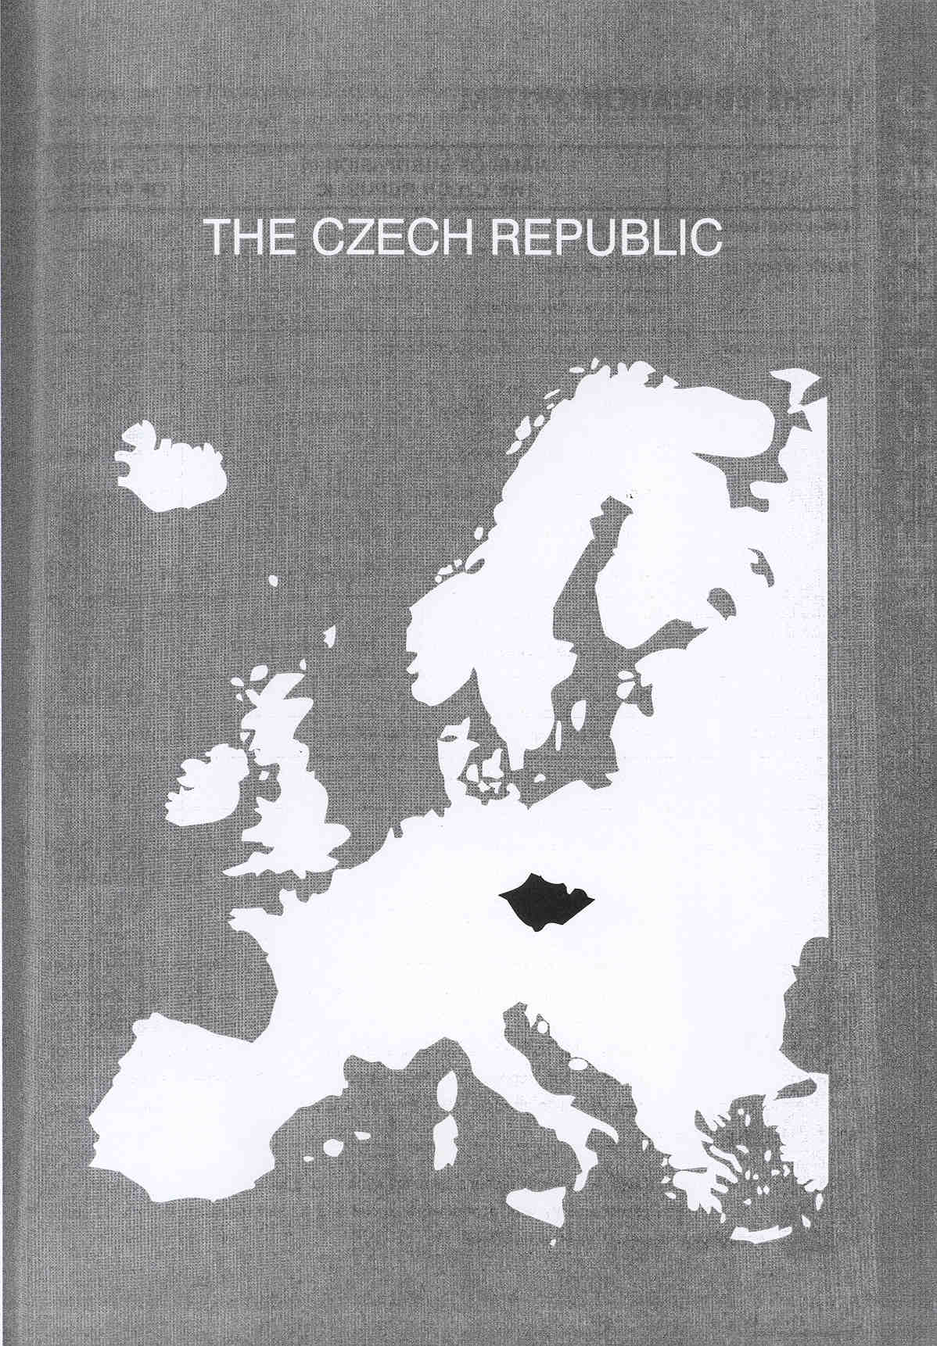

Νίκος Ηλιάδης, Πολ/κός Μηχ/κός Ε.Μ.Π., M.Sc.,
Ph.D. Industrial Education, Organization and Management,
Σύμβουλος του Παιδαγωγικού Ινστιτούτου

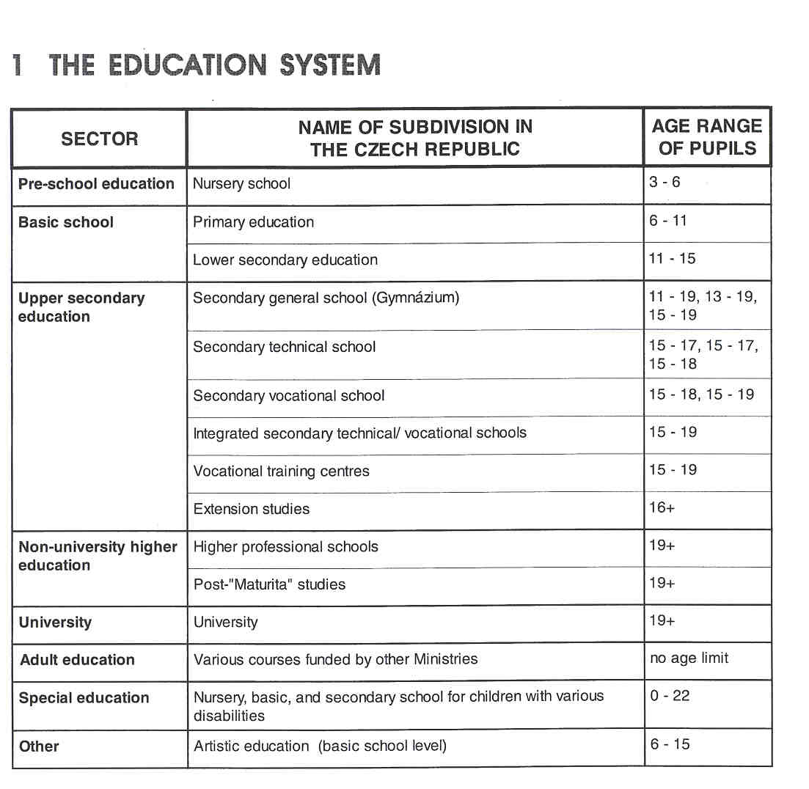

THE ADMINISTRATION OFTHE EDUCATION SYSTEM

In the Czech Republic education is administered both centrally and locally. The Ministry of Education, Youth and Sport is in charge of most educational activities administered by the State and sets out the conditions for its development. The Ministry of Education deals with overall strategy and educational policy and the preparation of appropriate statutory frameworks and executive and operational procedures. It establishes upper secondary and special schools and appoints their headteachers. It distributes the financial resources from the State budget. In higher education, the role of the Ministry is limited to the area of university funding and registration procedures.

Local Education Authorities (LEAS) are directly responsible to the Ministry of Education and are not autonomous units. They are entrusted predominantly with economic, financial and administrative tasks and, to some extent, with pedagogical issues at basic school level.

At regional level, the District School Council is responsible for safeguarding the interests of the community, staff and pupils. It has the right to discuss certain matters with the LEAs and to express an opinion on other matters. However, it does not have any decision-making powers.

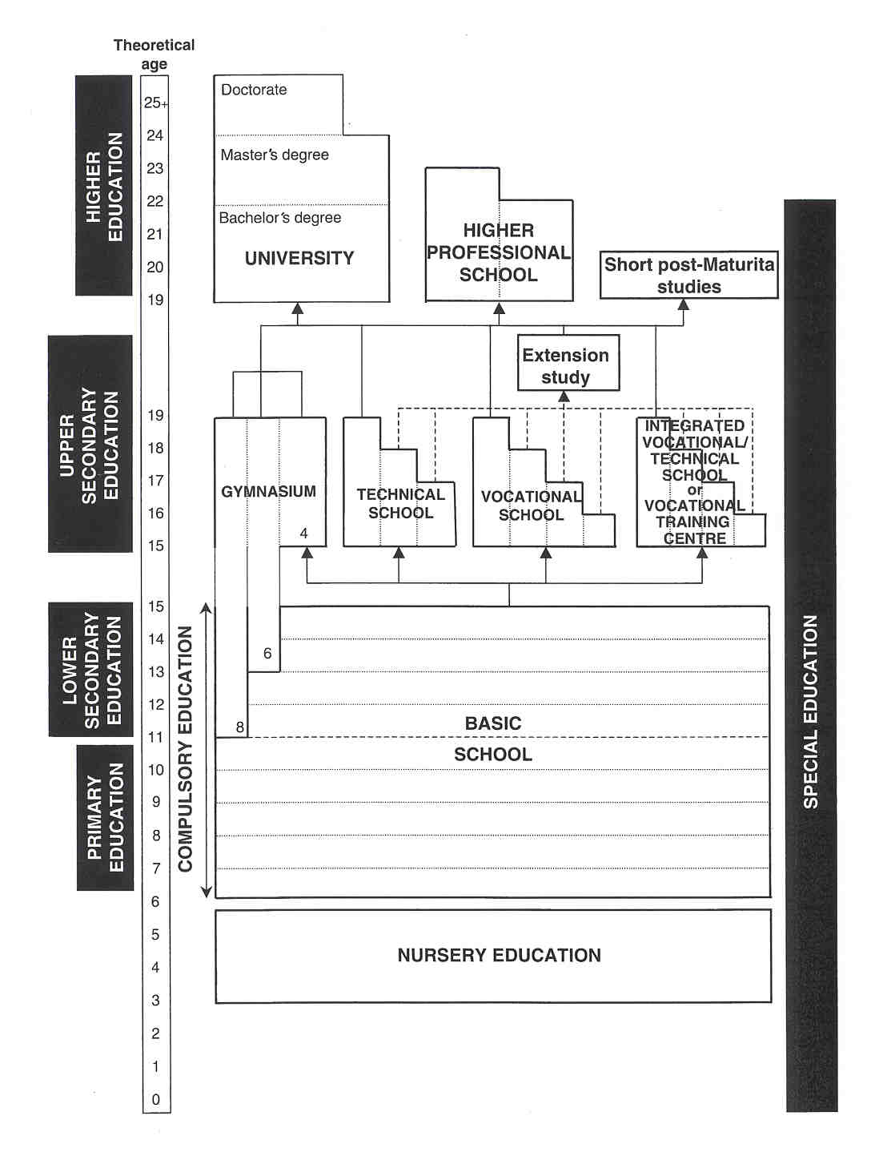

Schools have been given a large degree of autonomy, implying considerable freedom in economic matters, issues relating to personnel and administration and, to a certain degree, also in pedagogical questions. School headteachers were given full responsibility, not only for the quality and efficiency of the educational process, but also, over time, for the financial management of the school, for appointing and dismissing teachers and for relations with the community and the public.
Non-state schools (private and denominational) are a new phenomenon in the Czech education system, although they have a long pre-war tradition. The role of non-state schools is to offer a range of educational options, corresponding to the interests of the pupils and the needs of the labour market, and to create a competitive environment throughout the education system. Private schools contributed particularly to the elimination of discrepancies between supply and demand for places. Private schools can be run by either an individual or a corporate body. Private schools receive a State contribution towards salaries and costs which is based on the number of pupils, just as it is for State schools. Investment costs and rent for the school premises are covered by school fees and other private sources. There is no separation of Church and State and denominational schools are given the same support as State schools; they therefore charge no fees. Non-state schools emerged predominantly in the nursery, special and upper secondary school sectors.

Until now, the Czech education system has no national examinations in primary or secondary schools. The final examinations in the secondary school (the "Maturita") are not State examinations, but school based examinations. The content being in the headteacher's hands, they vary from school to school. At this moment, however, the Ministry is running a project to develop State comparative "Maturita" examinations.

COMPULSORY EDUCATION

Compulsory schooling begins at the age of six and lasts for nine years, i.e. until the age of 15. In other words, the basic school, consisting of two stages, is compulsory. Completion of the ninth year is a pre- condition for applying to study within any type of upper secondary school.

EDUCATIONAL SECTORS AND SUBDIVISIONS

Pre-school Education

Children normally attend nursery school aged three to six. In exceptional circumstances, it is possible to accept younger children. Currently there are also older children in nursery schools whose attendance at basic school has been deferred. Attendance at nursery school is not compulsory.

Nursery schools are usually open ten to eleven hours a day, and parents can use them according to their needs. A recent development in nursery schools is the practice of having different age groups within a single class, instead of organising classes according to age. Furthermore, the integration of children with disabilities into mainstream schools is at a more advanced level here than in the rest of the education system.

The programme depends almost entirely on the individual nursery school. Parents can significantly influence the direction of the programmes, and can participate in their implementation.

Most nursery schools are administered by municipalities, which also guarantee their funding (except for salaries and teaching equipment). According to the 1 993 regulations, nursery schools can charge parents up to 30% of the cost of caring for their child. Some authorities, however, are not making this charge.

Nursery schools, however, may also be administered by the Ministry of Education, Youth and Sport, by private initiative and by the Church. In general, these 3 types of trustees and the municipalities are responsible for the organisation of schools at all levels of education.

The Basic School

Since the 1950s, basic schools have incorporated primary and lower secondary education. Their task is to provide pupils with a general basic education, which should provide the minimum standard necessary for those going on to further studies of a general or vocational nature. The classes are coeducational. Since 1990, basic schools have been the responsibility of the municipalities. Some schools are administered by Education Authorities in the districts.

The basic school comprises the first level (years 1 to 5) and the second level (years 6 to g). in the first level, teaching in all subjects is usually provided by a single class teacher, whilst in the second level subjects are taught by teachers specialising in two subjects or, exceptionally, in one.

There is a new national curriculum, which came into effect in 1991 and which retains the current division of basic schools into first and second levels. The philosophy and programme of the first level reflect the attempt to bring education closer to the child's knowledge and experience of the world. In the second level curriculum, only the total number of teaching hours is specified for a selected group of subjects, and the school is able to make a choice, based on its aims and circumstances. An important element in the curriculum is the inclusion of optional subjects.

The pupils' knowledge is assessed continuously using written and oral work and homework. Pupils receive reports at the end of the first and the second semester. They progress from one year to the next on the basis of their results. The headteacher decides whether pupils have to repeat a year, if their work is unsatisfactory. There is no final examination at the end of basic school.

A major change in the makeup of the second stage of basic schools was the foundation in 1 990 of "Gymndzia" covering more than four years. This came about in order to offer pupils with higher intellectual abilities a more demanding education which began before the end of compulsory schooling. Thus, apart from the traditional four-year "Gymndzia", to which pupils transfer after basic school, there are multi-year "Gymndzia", some with eight-year courses (after five years at basic school) and others with six-year courses (after seven years at basic school). The courses are intended to be academic, the aim being for pupils to pass the final "Maturita" examination, the necessary qualification for progression to higher education.

Upper Secondary Education

Secondary schools

Upper secondary education is a multi-structured but internally co-ordinated system. It guarantees education and practical vocational training for almost the entire population of young people on completion of compulsory schooling and before taking up employment or continuing in higher education.

Education at secondary schools is provided either through full-time courses, part-time courses for employed people (such as evening classes and correspondence courses) or combined courses. There is no fixed system of standards in education as there is no national curriculum. Teaching is based on the textbooks.

A pre-requisite for acceptance at an upper secondary school is successful completion of the basic school programme. The pupils undergo written and oral entrance examinations at the school to which they hope to transfer. The results of these tests determine whether pupils are accepted into the school of their choice.

Secondary schools are divided into the following types, between which there is some overlap.
• The Secondary General School ("Gymndzium") is named after the Central European tradition. Study at the "Gymniizium" is completed with the final examination ("Maturita"), success in which means the pupil has completed a full course of secondary education. Attendance at the Secondary General School is for eight, six or four years. (See multi-year "Gymncizia".) The majority of students continue their studies at university or other post-secondary institutions.
In addition to general courses, "Gymncotzia" offer courses with a language/humanities or mathematics/ natural science bias. Besides these three basic types of "Gymndzium", there are also eight-year "classical Gymndzia" with Latin and "GymnAzia" with some or all subjects taught in a foreign language. "Sporting Gyrnniizia" exist for young people with a talent for sport.

• The Secondary Technical Schools are directed towards developing the ability to apply acquired technical knowledge and skills to a practical situation. Secondary Technical Schools offer professional courses which are traditionally four years long and end with the "Maturita' examination. In 1 990 short two- to three-year courses were introduced, which do not end with the "Maturita" as final examination and do not confer the right to continue studies at higher education institutions.
Secondary Technical Schools offer a theoretical and practical education. The prerequisite for acceptance is the successful completion of the compulsory schooling and succes in the entrance procedure.
Distinctions are drawn between:

- Secondary Technical Schools, having a very narrow institutional specialisation;
- Secondary Industrial Schools, specialising in mechanical and electrical engineering, construction, chemistry, transport, textiles, food studies, etc.;
- Secondary Agricultural Schools;
- Secondary Health Service schools, for training nurses; E Commercial Academies;

- Social Law Academies;
- Secondary Schools for Librarianship;
- Secondary Schools of Education, training teachers for nursery schools and for other professions in the field of education not requiring the completion of a higher education diploma (See Teacher Training.);
- Secondary Art Schools, divided into schools for applied arts, graphics, glass, sculpture, etc;
- Schools for the Performing Arts (music, drama, dance), which, unlike the others, provide six- to eight- year courses and transcend the secondary level.

- The Secondary Vocational School offers mainly "vocational courses" -apprenticeship training- for skilled manual occupations and ends with a final apprenticeship examination which does provide admission to post-secondary education. After the three-year courses, successful pupils receive an apprenticeship certificate in the trade which they have studied.
In addition, schools of this type offer some of their pupils professional, tour-year courses, ending with the "Maturita" examination (regarded in law as equal to a "Maturita" qualification from a "Gyrnndzium"). Pupils may also obtain the "Maturita" by taking a two-year extension course on completing a vocational course lasting one to three years. The majority of pupils, however, apply for jobs once they have
completed their studies. In vocational courses there are further numerous divisions into narrow, specialised occupations. There are Secondary Vocational Schools, which offer only theoretical instruction, and, conversely, independently organised practical training centres and practical training workplaces, which are usually located within firms.

- The Integrated Secondary VocationallTechnical Schools represent a new institutional element in the education system. They can provide the courses offered both in the Secondary Technical Schools and the Secondary Vocational Schools. Usually they are established by the latter, and they are geared predominantly towards vocational areas. The dual orientation provides greater educational choice and allows pupils to transfer easily between vocational and technical courses. At the same time, it provides a non-traditional education programme, i.e. a programme which allows choices to be made throughout the course.

- Vocational Training Centres are an important institutional innovation. Established on the basis of both the Secondary Technical and Secondary Vocational Schools, they offer re-training courses for Employment Offices, for business people and the general public. They are modern, well-equipped institutions, offering both a preparation for upper secondary education and a route to further education for people in employment.

Extension studies

Pupils in Secondary Technical Schools, Secondary Vocational Schools, Integrated Secondary Vocational/ Technical Schools or Vocational Training Centres who cannot be entered for the "Maturita", because they are following a technicallvocational course lasting one to three years, can opt for a one- to three-year extension course leading to the "Maturita".

Non-university Higher Education

HIgher Proftmional Schools

Higher Professional Schools were introduced in the Czech Republic in 1992. Applications to these schools exceed the number of available places by 150%. The schools are authorised to charge fees.
Higher Professional Schools are open to secondary-school pupils with the "Maturita". On completion of the course, students are awarded the "Absolutorium". These schools provide courses leading to qualifications for middle management and technical staff. The courses last three to four years and have a practical bias. A substantial component of this type of course is practical training in business, which may take up to one year and during which students work on a degree-year paper or on a project jointly assigned by their school and the respective business.

Post-"'Maturita"Studies

Some Secondary Technical Schools have established one- to three-year post-"Maturita" courses for pupils transferring f,r.o,m the "Gymnazia" and seeking a full secondary technical education and the chance of greater success in the labour market. These courses also cater for pupils transferring from technicallvocational schools and aiming to re-quality in a different area, to secure even more specialized training, or to update the existing qualification.

Universities

There are 23 universities in the Czech Republic whith a total of 110 autonomous faculties. University education is free of charge, but there is currently a lively debate about the introduction and level of tuition fees. The faculties themselves decide on the number of students to be accepted. The admission procedures differ depending on the university and the faculty. In general, an applicant is expected to have passed the "Maturita" examination. The universities decide independently whether they will hold entrance examinations or not.
A university course can last three to six years depending on the level: the first degree course lasting three years, the course leading to a master's degree (Mgr, lng.) lasting three to four years and finally the course leading to a postgraduate doctorate (Dr.)
On completing their studies, the students are questioned on their dissertation and sit State examinations. In some subjects, the length of study is six years, as in medicine, veterinary medicine, and architecture. Graduates receive the title of bachelor, master or engineer; graduates of the medical and the veterinary faculties are given the title of doctor. The engineering or masters' course is followed by a post-graduate doctorate course lasting three years, involving independent scientific work.
In some universities and faculties, a modular structure and various credit systems have been introduced, increasing the range of options and incorporating active teaching methods.

Teacher Training

In the main, teacher training is entrusted to the universities. Teacher-training courses always include practical experience, a thesis for a diploma and the final examinations, on the basis of which students obtain a certificate and an academic title.

A minimum requirement for nursery teachers is the completion of a Secondary Technical School course. Nursery school teachers obtain a full qualification from a four-year course with a final upper secondary leaving examination in Secondary Schools of Education. They may also take a three-year bachelors' course at a university faculty of education.

Basic and secondary school teachers obtain their qualifications on completion of a masters' course.
- Teachers at the first (or primary) level of the basic school gain their masters' qualifications after a four-year course, usually at a university faculty of education.
- Second-level (lower secondary) teachers and teachers of general subjects in upper secondary schools (usually a combination of two subjects) obtain their qualifications after a four- or five-year masters' course, available in university faculties of education, philosophy, natural sciences, mathematics/physics, physical education and sport. Second-level teachers tend to take a four-year masters' course, while teachers of general subjects in upper secondary schools tend to study at a faculty other than a faculty of education. Courses may focus on teacher training, or such training may be offered in parallel with a variety of subjects.
- Teachers of technical subjects in Secondary Technical and in Secondary Vocational Schools take a masters' course at specialised higher education institutions, such as technical universities, agricultural colleges, faculties of medicine, theology and fine arts, etc.

It is also possible to gain a teaching qualification by pursuing a,university course in education (usually lasting two years).

In recent years, some faculties have introduced single-subject courses, usually of three years' duration, culminating in a final examination and the title of bachelor. The introduction of this type of course was necessitated mainly by the situation in language teaching. When Russian was eliminated as a compulsory subject, it became necessary to (re)train a large number of foreign language teachers.

Adult Education

in the Czech Republic there are various courses for adults, many of which are developed by Secondary (Technical or Vocational) Schools. However, adult education courses are not funded by the Ministry of Education, Youth and Sport. Most of them are funded by the Ministry of Labour and Social Welfare and some are private initiatives.

Special Education

Special schools are intended for mentally andlor physically handicapped children from 0 to 22 years of age. They are divided into nursery, basic and secondary schools. The programme offered by special schools is determined by the type of disability, as in schools for blind children and schools for deaf children. At the present time, a new law is being formulated to promote the integration of the majority of handicapped pupils into mainstream primary and secondary schools.

Artistic Education

The Czech Republic provides artistic education at primary and secondary level. All children in basic school who are interested can pursue part-time artistic education voluntarily after compulsory school hours in a Basic School of Arts. When they reach the upper secondary level, pupils have to pass an entrance examination to gain entry into a Secondary Art School or a Performance Arts School. (See Secondary Technical Education.) So, only the really talented children can continue their studies during school hours. Pupils who fail the entrance examination can develop their hobby in specific courses after school hours. (See adult education courses.)

2 THE ORGANISATION OF THE INSPECTORATE

The Czech School Inspectorate (CSI) is the direct responsibility of the Ministry of Education, Youth and Sport. Being a Government body, it is fully financed by the State budget.

There are, at present, 303 school inspectors, working in 14 regions, with a total of 13 724 primary, secondary schools, Higher Professional Schools and special schools. The Inspectorate does not deal with universities or adult education. Inspectors responsible for artistic education inspect the specific (basic and secondary) schools of art and also the artistic subjects in other schools, such as music in primary schools.

The Inspectorate is organised in three levels: senior management in the headquarters of CSI, middle management under Area Chief Inspectors, who are responsible for a region, and the third level comprising the school inspectors.
The Central School Inspector is assisted by two Deputies. The first Deputy Central School Inspector (DCSI) supports the work of the Inspectorate, being responsible for the Economic and Service Department, consisting of three sub-units, for the External Relations Unit and the Complaints Unit. The other Deputy is responsible for the Methodological Department (and its sub-units) and the Organizational and Executive Department. The School Inspectors collectively belong to this last department within various sub-units. In their day-to-day work, the various departments and units work very closely together.

The Senior Management Group of the Inspectorate consists of the Central School Inspector, the two Deputies and the directors of the three departments.
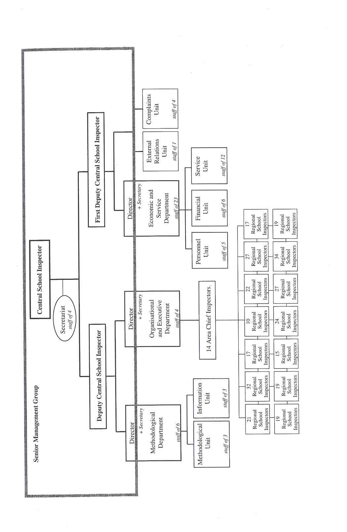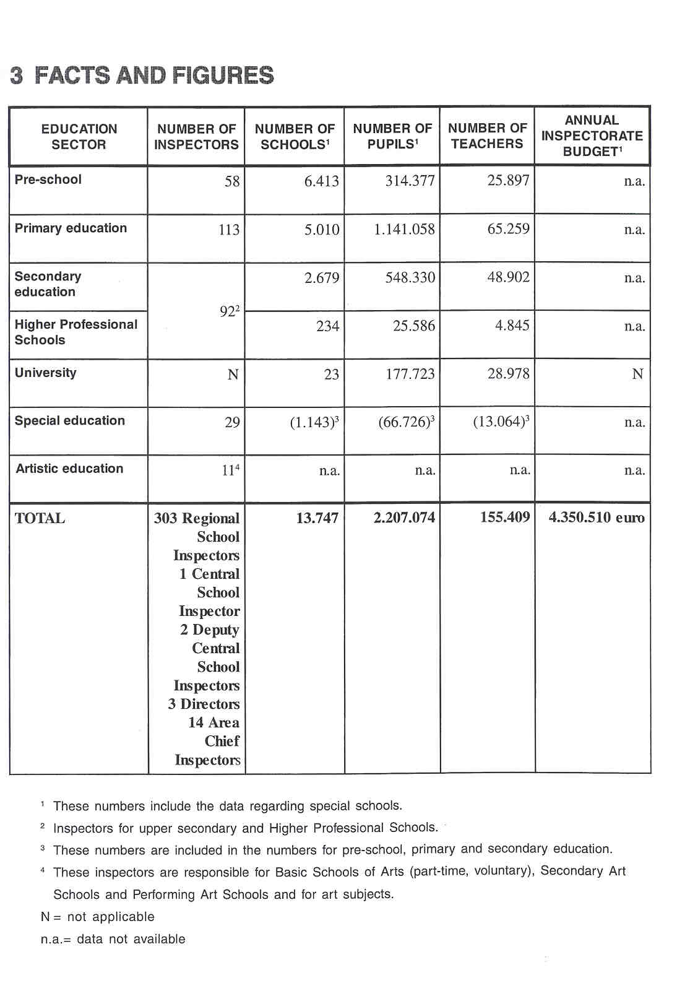

4 THE RECRUITMENT OF THE INSPECTORATE

inspectors must have completed university education and have had at least seven years'teaching experience. The CSI prefers headteachers, deputies of different school types and teachers with special qualifications in, for example, natural sciences, modern languages, etc. -Fhose employed in the various departments at the headquarters of the CSI must have pursued specific university courses, such as sociology or psychology.
Future inspectors must also fulfil other conditions of recruitment: they must have a sound reputation and no punishment records.

The recruitment for a vacant post takes the form of a detailed interview, which aims to bring out and to evaluate the knowledge and qualities of the applicant. The interview is conducted by the Recruitment Commission with Government representatives and specialists.

Succesful candidates are proposed by the Central School Inspector, but are appointed by the Ministry. On being appointed by the Ministry of Education, inspectors are entitled to inspect any school of any type in the Czech Republic.

5 THE WORKING CONDITIONS OFTHE INSPECTORATE

Inspectors are appointed by the Ministry and are full-time civil servants. According to civil law, inspectors may have part-time employment, combining Inspectorate work with other areas, such as literature, journalism, the arts, pedagogy or owning property Inspectors, however, are not often employed on a part-time basis.

Inspectors are employed by the State in a permanent capacity The Central School Inspector may sometimes employ a specialist for inspecting specialised areas primarily in Secondary Technical Schools.

All inspectors are nominated by the Minister as inspectors of the Czech Republic without reference to a specific area or type of school. It is clear, however, that inspectors are more suited to types of schools and subject areas which accord with their experience.

6 AREAS OF INSPECTORATE RESPONSIBILITY"

The main responsibilities of the Czech School Inspectorate are evaluating, advising, monitoring and reporting.

6.1 EVALUATING

The Czech School Inspectorate does not focus on the evaluation of the educational system as a whole. It deals with individual schools and, through different forms of inspection, evaluates particular aspects of provision, such as educational outcomes, the quality of professional and pedagogical management, staffing conditions, teaching materials and equipment, the efficient use of funds and the implementation of statutory regulations.

a. Complex lnspections

Schools as a whole are evaluated in so called 'complex inspections', which are carried out in selected schools. For the most part, complex inspections are reserved for schools with problems, schools with new management and schools suspected of being unsatisfactory by the Ministry or the Inspectorate. The Czech Inspectorate plans to expand this form of inspection.

A complex inspection is a complete audit of both school management and the educational process. Under the law, complex inspections aim to cover the following areas:

- The process and outcomes of education

The quality of teaching is evaluated by observing lessons and in follow-up interviews with the teachers. The findings of these lesson observations are communicated to the staff concerned and the headteacher. In the Czech Republic, an inspector is not authorised to make decisions about a teacher's career. Such decisions are made by the headteacher, who is the teacher's line manager.
Not only is the educational process evaluated, but also its outcomes, such as pupil attainment, together with school career data, such as the incidence of truancy, the number of pupils repeating a year, etc.
The inspection team focuses on the evaluation of individual subjects within the school. Normally, each team member makes a thorough evaluation of two subject areas, depending on his/her specialism. if necessary, inspectors may make a quick scan of the teaching in areas outside their specialism: for example, a mathematics inspector may evaluate the teaching in music, when the team is without an arts inspector and there are indications that there are some problems with music. The CSI does not undertake the complex evaluation of branches of study. Such evaluation at national level is the responsibility of other institutions, such as the Research Institute of Technical and Vocational Education.

- Staffing and physical resources

The quality of school management is always evaluated in a complex inspection. The Inspectorate cheeks whether a school is managed according to current principles of management. The indicatorslevaluation criteria for school management focus on planning and vision, the educational programme, the management of staff and the pedagogical management, quality assurance, information system, etc ... The CSI considers management to be the key factor in school provision and development. As a consequence
the headteacher and deputy are the most important partners of the inspectors during an inspection. The inspection team also cheeks the quality and safety of school accommodation, the equipment in
class and teaching material.

- Financial management and the statutory curriculum

State funding is used largely on staff salaries, the remainder being allocated to books, resources and staff development. By law, the CSI evaluates only the school's effectiveness in managing its budget, as in the provision and quality of school resources, the equipment in class, etc. In most financial aspects, however, schools are responsible to the Local Education Authority (LEA) and the municipal authorities. As a consequence, some administrative tasks, such as budget approval, do not feature in inspections.

- Compliance with statutory regulations, Ministry orders and methodological instructions

A very important task of the CSI, originating in law, is its emphasis on inspecting a schools' compliance with statutory regulations concerning the curriculum, school management, etc. Schools are obliged to make an annual school report, containing mainly statistical information about the school. By requiring this annual report, the Government is trying to promote self-evaluation in schools. The CSI cheeks whether the data in this report are correct, and uses some of the information in the inspection report.

\The Inspectorate normally observes procedures for entrance examinations at secondary schools and final examinations at selected secondary and Higher Professional Schools. Sometimes the Ministry of Education, Youth and Sport instructs the Inspectorate to check a school's compliance with statutory regulations concerning entrance examinations and final examinations, such as the "Maturita" and the "Absolutorium".

h. Orientation Inspections

The most common type of inspection nowadays is the so-called 'orientation inspection', when one or two inspectors visit a school for one or two days, in order to evaluate one or two aspects of provision, such as the teaching in mathematics, the school ethos, school management, etc. This type of inspection focuses on one or two elements of the complex inspection. While in a complex inspection all the various aspects of a school's provision are evaluated, only a small segment of this provision is evaluated in an orientation inspection. Area Chief Inspectors and their Inspectorate colleagues know the strengths and weaknesses of the schools in their area and decide which specific aspect(s) will be evaluated during an orientation inspection of a particular school.

c.Topical Inspections

The so-called 'topical or thematic inspection' is aimed at rapidly forming an overall picture of a particular issue in the country. It is a response to the current questions in the educational system. The choice of topics is co-ordinated by the Ministry of Education and the CSI. The staff department of CSI is highly involved in thematic inspections, in terms of phrasing the questions, communicating and analysing the answers. This type of inspection can include the evaluation of a subject area or a topic, such as racism and intolerance in schools.

All the inspectors contribute to the topical inspections by paying brief visits to two schools on a particular day, in order to answer a specific question. They are required to set aside 15 days a year in their diary for this purpose.

6.2 ADVISING

The CSI has an advisory role vis-A-vis the Minister. AS the Central School Inspector is a member of the Ministe@s cabinet, he can provide advice and information for the Minister, based on the findings of inspections. Inspection reports and their conclusions serve as a source for preparing educational policy. The findings of topical inspections are the basis for decision-rnaking by the Ministry.

The CSI has a close relationship with the LEAS. While the Inspectorate analyses the situation and suggests measures for improvement in schools, the LEAs are responsible for rectifying the weaknesses detected and for implementing the Inspectorate's recommendations.

The CS] establishes links with external bodies, such as the Institute for Information on Education, which provides data and information, such as statistics, analysis and documentation to the Ministry of Education as well as to the CSI.

The CSI plays an important role in the development of a national examination system. The Inspectorate co- operates closely with two national institutes responsible for the development of various tests and examinations: the Research Institute for TechnicalNocational Education and the Educational Research Institute. The former is a co-ordinating, consultative, specialist research body, investigating questions related to secondary and technical education. The latter focuses on general and special educational needs, including pre-school education.

The Ministry is currently running a project to develop State-wide standardised "Maturita" examinations, during which the Inspectorate will provide the control. The CSI also participates in the preparation of such examinations.

The CSI has contacts with international organisations, such as the lnspectorates in various European countries/ regions.

School inspectors do not have a formal advisory role, although many would like such a role, as most were teachers in the recent past., In principle, inspectors should diagnose, rather than advise and cure. Inspectors are not permitted to carry out advisory work, which is the province of the LEAS.

6.3 MONITORING

The Inspectorate is creating its own database in order, for example, to monitor the outcomes of inspections in qualitative and quantitative terms. The database facilitates the current work of self-evaluation and improvement following an inspection. In this way, it helps to enhance the outcomes of inspections. The findings of inspections are entered on to the data base. The information provided permits the monitoring and evaluation of a wide range of features in various types of schools. The database also enables the Inspectorate to respond promptly to Ministerial questions about the standards in several types of schools as, for example in topical inspections, in a very short time. The Inspectorate's database is not only a source of statistics, but also provides information on standards in schools, school management, physical conditions and quality of teaching, etc. All the outcomes of inspections are accessed immediately.
6.4 REPORTING

The Czech School Inspectorate reports on the quality of schools as a whole in complex inspections, and on the quality of certain aspects of a school's provision in orientation inspections.
At the request of the Ministry of Education, Youth and Sport the CSI undertakes topical inspections and reports on the results.

The systematic nation-wide evaluation of the entire education system is not a part of the Inspectorate's work. As a consequence, the CSI does not focus on the evaluation of the entire system. It deals with individual schools and evaluates specific aspects of provision based on complex or orientation inspections. At the request of the Ministry of Education, the Inspectorate undertakes nation-wide topical inspections. Collectively, the data from these inspections form the basis for the Annual Report of the Inspectorate, which contains the outcomes of inspections. This annual report is the basis for the report on the state of the educational system, written by the Ministry of Education, and addressed to Parliament and the public.

7 THE ROLE OF THE INSPECTORATE IN EDUCATIONAL POLICY

On the basis of its inspections, the Inspectorate provides the Ministry and other partners in education with the necessary data for initiating educational policy. In this sense, the Inspectorate has a role in preparing and promoting the implementation of policy.

The Central School Inspector is a member of the Minister's'cabinet. In this position, he can participate in decision making in all important matters concerning education. The CSI has no other opportunity to participate in decision-making in educational policy

The effectiveness of those policy aims and objectives, which have been adopted and implemented, is evaluated at the level of individual schools. The Ministry is kept informed through the reports of different types of inspections. The findings of inspections are published in the Annual Report of the Inspectorate. In this way, there is a strong emphasis on evaluating the effectiveness of the policy.

8 WHO 15 IN CHARGE?

The nature of the Inspectorate's responsibilities is decided upon by law. The Ministry determines the emphases and main trends of educational policy for the period exceeding one year. These aims and objectives form the basis for the CSI's work schedule. On the whole, the Inspectorate has a substantial degree of autonomy in the organisation of its work.

The Central School Inspector and the administrative branch determine the annual plan and the final specification of tasks in accordance with the interests of the Ministry The Central School Inspector and the Inspectorate Senior Management determine the yearly work schedule and incorporate long-term aims within this. The work schedule is then submitted to the administrative branch. In the course of the year, however, the Inspectorate must still respond to emerging needs.

Area Chief Inspectors determine the programme of inspectors in their area for a period of one to two months in accordance with the aims of Senior Management.

Inspectors work in schools and other educational institutions as team leader or member in complex or orientation inspections. They take part in topical inspections and investigate complaints, if requested to do so. Inspectors compile a monthly plan, but must respond immediately to an emerging problem. They are expected- to be independent and to be aware of the wide range of issues in education.

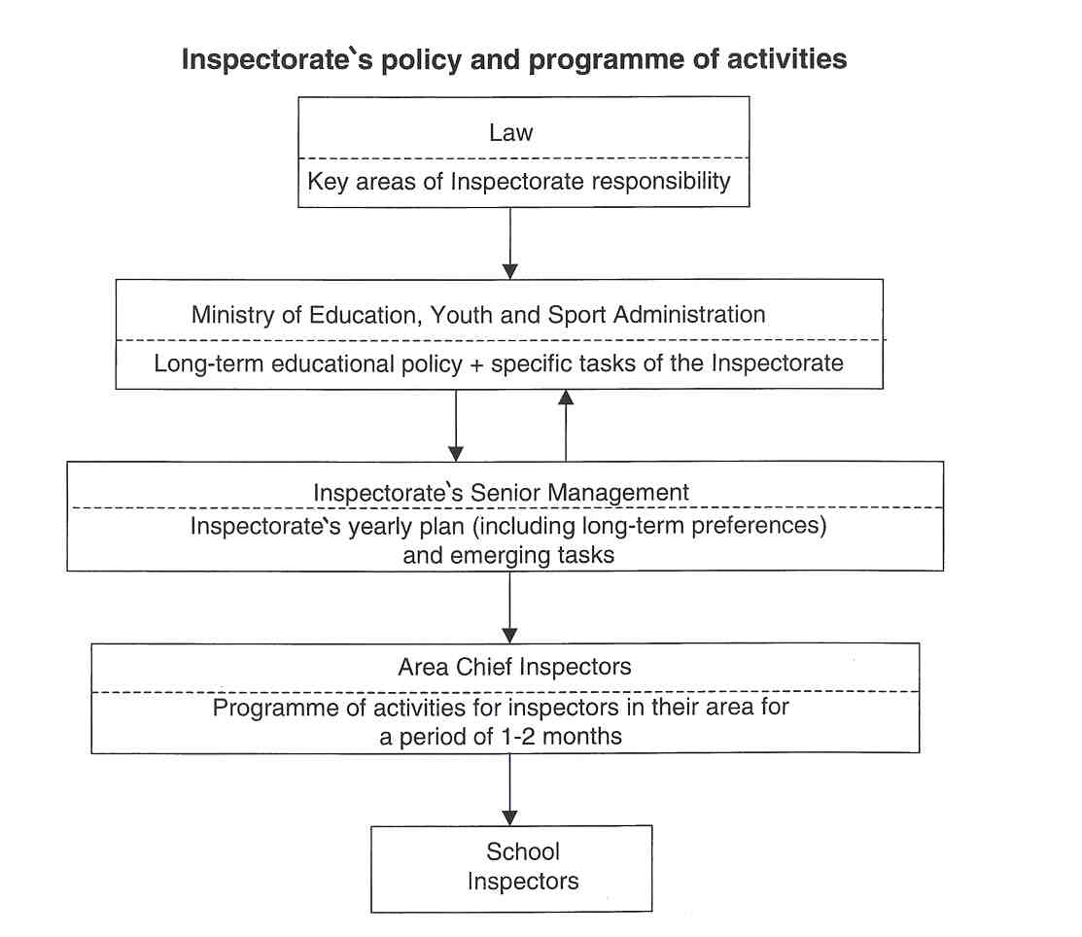

9 THE POSITION OFTHE INSPECTORATE

The Czech School Inspectorate is an independent organisation established by Law. It is the direct responsibility of the Ministry of Education, Youth and Sport although separate from it. The CSI is an autonomous body with its own budget, work schedule, staffing policy and strategy. It inforrns, advises and supports the Minister, who acts as line manager for the CSi and sets tasks for the Inspectorate. The Inspectorate evaluates and monitors the work of schools, and the outcomes of inspections inform the Minister's decision-making.

The Central School Inspectorate represents the Minister and has a strong involvement in implementing educational policy. The Central School Inspector is appointed by the Minister and is a member of his cabinet. He is equal in rank to the Deputy Minister, because he is a member of the senior management of the Ministry of Education, Youth and Sport.

Once a year, the Ministry submits to Parliament a report on the state of the educational system in the Czech Republic. One of the sources for this report is the Annual Report of the Czech School Inspectorate. The Czech School Inspectorate has no other link with Parliament.

The Local EducationalAuthorities are close partners of the Inspectorate. In reality, the Czech School Inspectorate is an organisation without decision-making powers. Decisions are made by the Ministry of Education (in the case of secondary and special schools) and LEAs (for nursery schools and primary schools). The Ministry, the Czech School Inspectorate and LEAs are the sole representatives of the State in education.

The Inspectorate and institutions for curriculum development are partners in education, although the Inspectorate takes no part in curriculum development.

The Inspectorate uses information from other national organisations, such as the Institute for Information on Education, the Research Institute of Technical and Vocational Education, the Pedagogical Research Institute and other organisations run directly by the Ministry.

The Czech Inspectorate also has close contacts and links with international organisations, such as lnspectorates of other European countries/regions.

10 THE INSPECTION PROCESS

The inspection process is subject to a uniform methodology and a programme, which are regularly updated.

PREPARAIION PHASE

The headteacher is informed well in advance of a complex inspection. The CSI's instructions stipulate that schools must be informed about an inspection "in time". Normally, inspectors inform the school by letter five to six weeks before an inspection. From the school year 1999-2000, the Inspectorate will try to inform all schools about planned inspections at the beginning of the school year.

Schools are informed two to three days before an orientation inspection.

Before the start of an orientation or complex inspection, the headteacher is requested to provide the inspector(s) with the necessary information, such as the annual school report, syllabi and timetables.

In the case of topical inspections, the nature of the topic determines whether the inspection visit is announced to schools beforehand. Some topics require an unanounced visit by the inspector.

SCHOOLPHASE

For complex inspections, the team remains in the school for one week or sometimes longer, depending on the size of the school.
For orientation inspections, one or two inspectors visit the school for one or two days.
Inspectors pay only a brief visit to two schools, in order to respond to the question(s) of a topical inspection.

REPORTING PHASE

After a complex or orientation inspection, the team leader or a colleague informs the headteacher about the findings and preliminary conclusions. The written report is sent to the headteacher as soon as possible, so he may comment on it. These comments become part of the report.

FOLLOW-UP PHASE

If an infringement of the law is discovered during a complex or orientation inspection, the inspector provides a report, and the headteacher and governors are obliged to rectify matters. The agreed measures are noted and become the basis for the follow-up inspection.

11 INSTRUMENTS AND METHODS

THE COLLECTION OF INFORMATION

a. Ouestionnaires

At present, inspectors issue a questionnaire to parents during a complex inspection, in order to ascertain their views of the school, whether they are satisfied with the quality of education etc.

The Inspectorate is also preparing a questionnaire for teachers and pupils, to obtain their views on the school ethos. This questionnaire will be used in complex and orientation inspections, if the school ethos is the objective of the orientation inspection.
At topical inspections, special questionnaires for various professional groups are devised.

b. Interviews

The most frequently used inspection strategy is the interview with the headteacher and his deputies concerning school management, school policy, the maintenance of compulsory records, etc.

Group and individual interviews with teachers, pupils and parents are also common. The type and nature of the interview are determined by the form of inspection and, especially, by the school context. The questions are either standardised or drawn up for the occasion.

c. Observation

The most important means of collecting information in complex and orientation inspections is the observation of teachers in class. The work of teachers is monitored in class, and the pupils are observed, to evaluate their standards, activities, skills, behaviour, etc. The same features are evaluated in practical lessons. An assessment is made of the teachers' competence in the interview following the observation of lessons. Teachers are also observed at departmental meetings, staff meetings, etc.

d. Tests/examinations

At present, there are no standardised central examinations for the whole republic.

The Inspectorate has itself devised achievement tests for the last year of basic school (for pupils aged 15) in seven subjects: Czech language, mathematics, physics, geography, history, biology and chemistry. These tests are used as an evaluative tool in complex and orientation inspections.

e. The Collection of Documents

Before the beginning of a complex inspection, the team leader (or the inspector responsible for an orientation inspection) asks the headteacher to prepare some statistical data unavailable on CSI's database or no longer up-to-date, such as staff qualifications, pupil numbers, timetables etc.

During the interview with the headteacher, the inspector asks for all required documentation, which reflects and determines the work and activities of the school.

The Inspectorate is also interested in the results of the pupils in the entrance examinations for secondary schools or in their results in final examinations, such as the "Maturita". The perusal of the school documentation by the Inspectorate is the basic source of information about the school.

f. The Use of National Data

Inspectors use national statistical data on the educational system, such as data on pupils, teachers, schools, salaries, equipment, etc. The data are gathered from the Institute for Information on Education (which possesses a register of school networks, basic data obtained at the start of the school year, etc.) and from basic departmental analyses, annual reports on the schools' self-evaluation and other documents on school policy. Every three months the inspectorate analyses the information on its own database, containing the outcomes of inspections.

APPROACHES

- Instruments

All the inspectors of the CSI use a common approach to complex and orientation inspections, described in "The Handbook of a School inspector', developed by the CSI and in use since 1995. The handbook was last updated in September 1997. The approaches advocated harmonise the methods and work of inspectors throughout the Czech Republic. It determines both the content and the form of inspection reports. It facilitates the standardisation, revision and updating of methods.
The handbook contains a framework for inspection, with indicators and evaluation criteria and guidelines. The same handbook is used for inspecting nursery, primary, secondary, higher and special schools. However, it contains specific guidelines for inspecting different kinds of schools.

In order to arrive at valid judgements, inspectors use evaluative criteria or indicators to ascertain the strengths and weaknesses of a particular school. Each indicator consists of a number of performance criteria. The performance criteria are descriptions of a particular aspect of school provision, indicating whether such provision is good (through the use of positive performance criteria) or poor (through the use of negative criteria). Inspectors use these indicators in the evaluation of related aspects of provision. The same set of indicators is used for evaluating schools in the various education sectors.

Performance criteria related to the vision and planning of the school management are appended as examples:

- Positive performance criteria (when these circumstances are observed a favourable assessment is given):
- The school has clearly-stated, long-term aims; the strategy for the school is written down or clearly articulated;
- E the principles of the school policy are clear and accepted by parents, teaching staff and governors; E the planned tasks are implemented and evaluated, the management has evaluation tools, and the feedback is effective;
- the number of pedagogical meetings is appropriate in terms of frequency, effectiveness and content.

- Negative performance criteria (leading to unfavourable assessment):

- Long-term objectives are not clearly determined;
- the school policy is not implemented;
- planned tasks are not monitored or assessed, there are no evaluation tools and no feedback;
- the pedagogical meetings are without a clear agenda, they focus mainly on current matters;
- principal pedagogical problems are unsolved.

b. Teamwork and Individual Work

Complex inspections can only be carried out by a team of at least two inspectors. Orientation inspections are largely the work of individual inspectors, although in some complicated cases inspectors also work in teams. In topical inspections, individual inspectors monitor aspects of provision, and aim to obtain up-to-date information as quickly as possible.

The number of inspections carried out by individual inspectors is greater than the number of team inspections to a ratio of 5:1.

Since 1995, there has been a preference for teamwork, but it is less economical in terms of Inspectorate resources.

12 JUDGEMENT AND ITS CONSEQUENCES

COMPLEX INSPECTIONS

Each school undergoing a complex inspection is evaluated according to standardised criteria and using an evaluation scale. The school is assessed on a seven-point scale, but the results of this assessment are entered only on the Inspectorate's database and do not form part of the school report. Recommendations for future action are set out in the conclusion to the report, in accordance with the findings of the inspection.

The findings of the complex inspections carried out in 1997 show that 60% of the schools received a favourable assessment, 10% received an unfavourable assessment, and the remaining 30% were deemed to be average schools. On the whole, multi-year "Gymnc@zia" and basic schools received better assessments than Secondary Vocational Schools.

If the evaluation is completely negative, the Inspectorate recommends an immediate solution: for example, the headteacher may be dismissed or the school may be removed from the State-maintained network. If the latter occurs, the school ceases to receive State funding, and may no longer issue official end-of-courses certificates. In the school year 1996-1997, the Inspectorate recommended that 17 schools (all private) be removed from the network; all these recommendations were accepted by the Ministry. This number represents 1.5% of the total number of private schools in the Czech Republic. The inspection determines the amount of State funding allocated to private schools. The decision to increase or decrease State-allocated funding is taken by the Ministry, not the Inspectorate.

ORIENTATION INSPECTIONS

When an infringement of statutory regulations is discovered, it is reported to the LEA (in the case of a primary school) or to the Minister (in the case of a secondary school). When the aspect of provision inspected receives an unfavourable assessernent from the inspector(s), the school is obliged to take immediate action to correct or improve the aspect of provision by following the recommendations.

13 OUTCOMES

REPORTS ON SCHOOLS

There are different kinds of school reports depending on the type of inspection:

Complex Inspection Reports

All schools undergoing a complex inspection receive the same type of report, although the content differs according to the education sector. The form of the inspection reports is fixed. The content is set down in the 'Handbook of a School Inspector'. Reports are required to respond to the questions and tasks contained in the framework of the inspection.

All complex inspection reports contain information about the quality of the educational process, the quality and efficiency of the professional and pedagogical management, staffing conditions, teaching materials and equipment, financial management and the school's compliance with statutory regulations. The central part of a complex inspection report is the evaluation of school management.

Another important part concerns the process and outcomes of educational provision. Evaluations of individual teachers do not appear in inspection reports. The teachers and headteachers are informed orally about such evacuations. The work of the teaching force as a whole is assessed, and the standard of the education provided is evaluated through the subject areas. In this way, the evaluation of subject areas forms part of the inspection report.

The inspection team also reports on the management of State-allocated funding. It examines and reports on, for example, the management of funding earmarked for staff development.

Another section of this paper covers the schools' compliance with statutory regulations. When regulations are infringed, inspectors make a detailed report and require immediate action to remedy the situation.

Each report contains a statement with recommendations for improving deficiences. This statement always forms part of the report, even when the school does not receive an unfavourable assessment. In the statement, the CSI can, for example, recommend the removal of the school from the network or the dismissal of the headteacher.

All complex inspection reports on schools and other educational institutions established by the Ministry of Education, Youth and Sport are addressed to the Ministry By law, the report is sent to the school trustees, the school, the LEA and the Board of Governors (if one exists), but not to the individual teacher. By law, inspection reports on schools are open to the public and obtainable on request at the office of the regional Inspectorate for a period of ten years.

The report is, therefore, in the public domain. The statement, however, remains confidential. This statement is sent to the headteacher, the LEA and the Ministry, but not to the school council.

Orientation lnspection Reports

The orientation inspection evaluates one or two aspects of provision covered in the complex inspection. The report is relatively short (two to three pages) and contains recommendations for the school. When the assessment of the inspectors) is unfavourable, the report is sent to the LEA (for primary schools) or to the Minister (for secondary schools).

ASPECT EVALUATION REPORTS (TOPICAL INSPECTION REPORTS)

The topical inspection focusses on one key issue, such as racism in schools, handicapped children in primary schools. The inspection is carried out across the entire education system using specific approaches. Reports on topical inspections contain recommendations for the Minister and the senior management of the Ministry of Education, Youth and Sport.
Reports on topical inspections (or selected information from each) are published after being approved by the Minister's cabinet. In most cases, the schools participating in topical inspections are also informed about the outcomes of the inspection. Topical inspection reports are stored in the archives at the headquarters of the csi.

THE ANNUAL REPORT OF THE INSPECTORATE

The Annual Report of the Inspectorate has a fixed format. The purpose of this report is to answer questions, such as: "How good are our schools?". The annual report contains information about the monitoring, supervision and evaluation of schools. This part of the report is based on findings of complex and orientation inspections of basic schools, upper secondary schools, special schools, nursery schools, Higher Professional Schools and Basic Arts Schools. It also contains the findings of various topical inspections and the outcomes of investigating complaints. It describes the outcomes of other work carried out by the CSI, such as international contacts, the professional development of inspectors and co-operation with LEAs and school trustees. The report is divided into a statistical section and an evaluative section. The end of the report contains the main trends and issues in education and recommendations to the Ministry of Education are formulated.

The CSI's annual report on the previous school year is published in the press and is obtainable free of charge on request.

The annual report is the basis for the report on the state of the educational system, written by the Ministry of Education and addressed to Parliament and the general public.

14 FOLLOW-UP PROCEDURES

Complex and orientation inspections with an unfavourable assessment or with serious recommendations for the beadteacher, the LEA or the Ministry must be followed by a follow-up inspection. As mentioned above (See 12.), the Inspectorate notes its recommendations, and an evaluation of the implementation of the agreed course of action becomes the focus of the follow-up inspection. There is no fixed time for initiating follow-up procedures, but follow-up inspections are normally held at the beginning of a new school year. Follow-up inspections are generally performed by one inspector; in each region one inspector is responsible for all the follow-up inspections.

The follow-up inspection investigates the progress made by the school since the complex or orientation inspection, the school's response to the recommendations and any action by the LEA or the Ministry. The findings are described in a new inspection report.

There can be severe recommendations, if the school has made no progress. In extreme, unresolved cases, the Inspectorate can fine the headteacher up to 28.25 euro, and this fine may be repeated. A final consequence may be the closure of the school, although this happens very rarely.

- INSPECTORS AS ARBITRATORS

By law, students and parents may approach inspectors with complaints about teachers or schools. In the school year 1996-97, parents and pupils lodged 356 complaints, which constitutes more than 51% of complaints received.

Teachers may also approach inspectors with complaints about headteachers or governing bodies. In the school year 1996-97, 78 such complaints were received, representing some 13% of complaints received.

The Czech School Inspectorate represents the Government in the educational system, and, as such, is obliged to investigate all complaints about teachers, headteachers, governing bodies and schools. The investigation procedures are determined by decree, and the Inspectorate must comply with these. Investigating complaints is part of the job description of each inspector. The Complaints Unit of the CSI monitors whether the complaint is resolved or not.

Schools, headteachers and teachers may make complaints about the Inspectorate or individual inspectors; they may, for example, make complaints about an inspector's conduct or about the content of a report. The Senior Management of CSI has to investigate such a complaint, and, if it is justified, resolve it.

16 THE INSPECTORATE AN ACTOR IN PUBLIC DEBATE

The Inspectorate responds to approaches from the mass media. When asked, CSI expresses an opinion on an educational issue and presents its findings. The Central School Inspectorate is often quoted and questioned in the educational press.

When an inspector speaks in public and writes in newspapers, etc, he does so as a civil servant, and not as a private individual.

17 THE EVALUATION OF THE INSPECTORATE

The internal evaluation of the Inspectorate is carried out at several levels. The inspection system is characterised by a rnuiti-level approach to internal evaluation.

- Firstly, a basic evaluation of the quantity and quality of inspection work is carried out in the regions by selected experienced inspectors, who use a common approach to evaluation. Their findings constitute a database, permitting an evaluation of the quality and quantity of the work of the entire Czech School Inspectorate.
- Secondly, an evaluation is carried out by the Area Chief Inspectors, who meet inspectors on a day-to- day basis.
- Thirdly, the Methodological Department at CSI headquarters carries out a regular analysis and evaluation at national level, using computer data processing.

Once a year, the Minister's cabinet performs an external evaluation of the Czech School Inspectorate.

Roles, tasks and methods are adapted as a result of evaluation. The feedback is assessed continuously, and, at the beginning of the school year, adaptations are made, not only in approach towards the schools to be inspected, but also within the Inspectorate itself.

The Inspectorate cannot ignore social developments, and must respond to changes in educational policy. While the system as a whole is constant, there are changes in emphases. As a consequence, roles, tasks and methods are also adapted as a result of developments in educational policy.

18 THE INSPECTORATE'S INITIAL TRAINING AND IN- SERVICE TRAINING

TRAINING NEW INSPECTORS

At present, there is no formal training programme for new inspectors. All the experiences provided for them are devised and organised by other inspectors. Some of these experiences include, for example, introductory information on the inspection system and its approaches, school legislation, computer skills etc. Each new inspector is helped by an experienced colleague, who shares these experiences.

The management of the Inspectorate does not consider the existing arrangements for training sufficient, but it is limited by the economic resources available.

PROFESSIONAL DEVELOPMENT

The Inspectorate enables its members to attend, largely external, professional study courses, and organises various educational activities for them.

The regular and systematic training of inspectors has not yet been established; it is being developed, but is limited by economic and human resources.

19 RECENT OR FUTURE ISSUES AND DEVELOPMENTS

RECENT

- In 1990-91, the Czech School Inspectorate was established as a new organisation in new social conditions. All former inspectors were dismissed and new ones were appointed.
- In 1991 -94, CSI began to develop working arrangements and policies.
- In 1994, the principal change in the organisation occurred: the district structure was dissolved, and regional lnspectorates were established under the direction of CSI headquarters.
- In 1995, the "Handbook of the School Inspector' was issued, incorporating new approaches, structures and content into inspections; the complex inspection was introduced, with an emphasis on teamwork.
- In 1997, the second version of the handbook was issued; the central information system was set up, with its focus on monitoring, using databases and periodic analyses.

FUTURE

- The serious challenge for education in the future will be the possible Czech membership of the European Union. The Czech education system is quite different from the systems in most other European countries. At present, there is no unified system of standards across all types of schools, and there is no national curriculum (the national curriculum mainly consists of a list of the compulsory subjects, the recommended optional subjects and the minimum teaching hours). All learning in Czech schools is based on subject syllabuses and on textbooks. The textbook remains the 'Bible' for many teachers. Moreover, there are no national examinations in primary or secondary education. These deficiencies are the result of 40 years of uniform education. By becoming a member of the EU, the Czech Republic will be confronted with these differences.
In all these areas, a very important role for CSI can be seen: on the one hand, to ensure compliance with statutory regulations and to supervise State examinations and, on the other hand, to protect a State- wide curriculum and standards in education.
- At present, the Ministry is running a project to develop State-wide standardised "Maturita" examinations; the Inspectorate is helping to draw up standards for these examinations.
- Another future challenge lies in the reduction in the number of schools due to the declining population.

20 LITERATURE

CESKA SKOLNI INSPEKCE, lnformace o skolnich inspektoritech v CR. Praha, Ceska skolni Inspekce, 1999, http://ms.anet.cz/ -wwwcsi

INSTITUTE FOR INFORMATION ON EDUCATION, The Education system of the Czech Republic. Praha, Institute for Information on Education, 1998, 44 pp.

INSTITUTE FOR INFORMATION ON EDUCATION, Basic figures on Education in the Czech Republic 1,9971,98. Praha, Institute for Information on Education, 1998, 19 pp.

21 CCNTACT PERSONS

Name: Miroslav Hanzeika

Function: Central School Inspector
Address: Ceskc@ @koinf lnspekce
Frani staimka 37
150 21 Praha 5
Czech Republic

Phone: + 420 2 51 02 31 00
Fax: + 420 2 51 02 36 50
E-mail: hanzeika@ms.anet.cz

Name: Petr Drabek
Function: Ist Deputy Central School Inspector
Address: Ceska skolni lnspekce
Frani stamka 37
150 21 Praha 5
Czech Republic

Phone: + 420 2 51 02 31 04
Fax: + 420 2 51 02 36 51
E-mail: drabek@ms.anet.cz

Name: Milan Pohi

Function: Deputy Central School Inspector
Address: Ceska skolni lnspekce
Frani stamka 37
150 21 Praha 5
Czech Republic

Phone: + 420 2 51 02 32 44
Fax: + 420 2 51 02 36 53
E-mail: m.pohl @ ms.anet.cz

