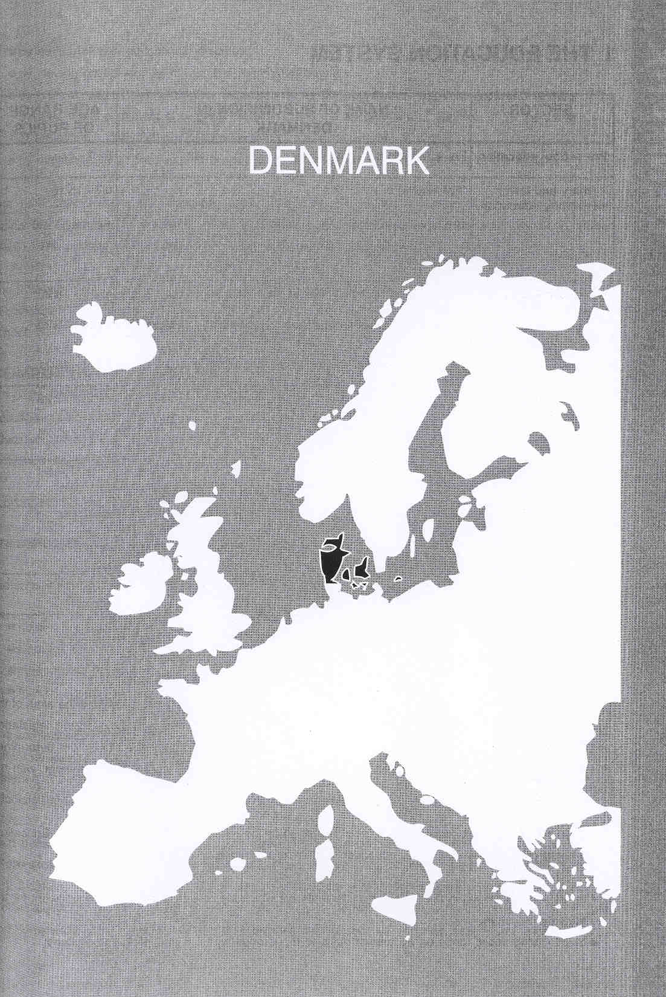

Νίκος Ηλιάδης, Πολ/κός Μηχ/κός Ε.Μ.Π., M.Sc.,
Ph.D. Industrial Education, Organization and Management,
Σύμβουλος του Παιδαγωγικού Ινστιτούτου

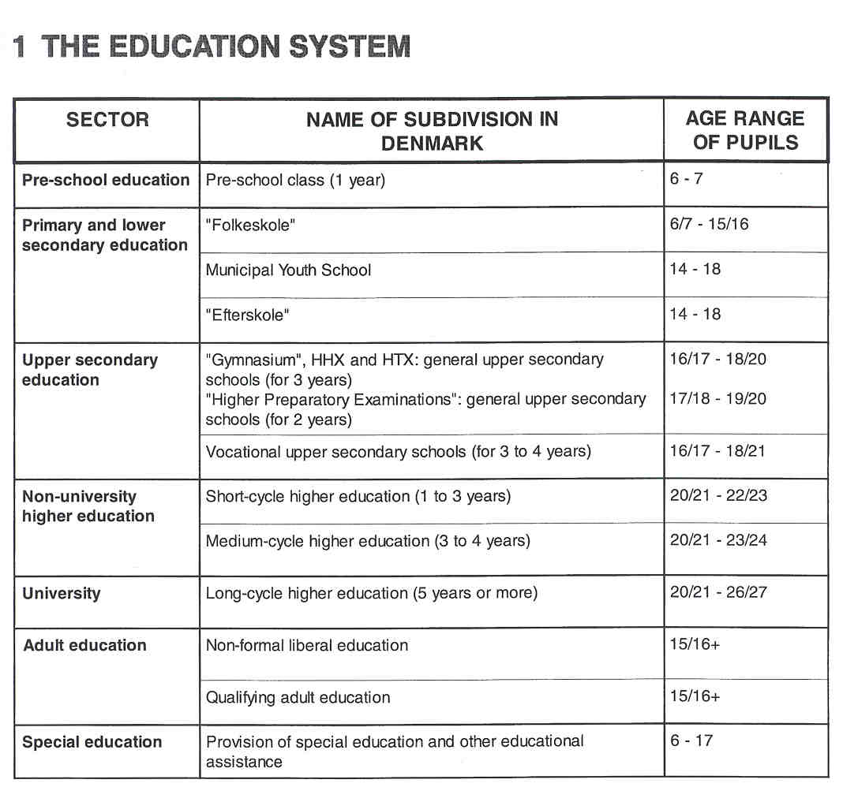

THE ADMINISTRATION Of THE EDUCATION SYSTEM

The more important fields of education are regulated by law. Generally, Parliament formulates the aims of the various types of education, but there is a considerable variation in the degree to which the legislation regulates the individual types of education. Through the annual Appropriation Act, Parliament determines how State funds are to be distributed between the various types of education. Finally, Parliament, with the assistance of the Office of the Auditor General, exercises control of the use of the funds.

Within the framework of the legislation, the main responsibility for education lies with the Ministry of Education. The Ministry controls and directs the education system in a number of ways:
- by issuing regulations in the form of ministerial orders which lay down the targets and framework for the education system;
- by allocating public funds on an annual basis to the various types of educational institutions;

- by setting certain educational disputes;
- by issuing guidelines, directives, and recommendations;
- by general supervision and other means, such as the approval of curricula in certain sectors of the system, the appointment of external examiners, and the appointment or approval of the permanent staff at educational institutions in certain sectors of the system, and
- by initiating quality development projects in certain subjects or certain sectors of the system.

The 14 county councils are financially responsible for all educational activities of the county institutions: mainly the Gymnasia, the Higher Preparatory Examination (HF) institutions and the adult education centres (VUC). The pedagogical supervision rests with the Ministry.

The 275 municipal councils are responsible for administering, monitoring and financing the municipal schools ("Folkeskolen"). The supervision of the schools is the responsibility of the school boards established at each school.

COMPULSORY EDUCATION

Education is compulsory for children between 7 and 16 years of age, i.e. 9 years of comprehensive basic education, which may be supplemented with an optional I-year preschool class and an optional 10th form. In 1994, 98% of an age group were enrolled in preschool classes, and 61% continued in the 10th form.

EDUCATIONAL SECTORS AND SUBDIVISIONS

Pre-school Education

Pre-school education is primarily offered in the following types of institutions:

- nurseries for children between 6 months and 3 years of age;
- kindergartens for children between 3 and 617 years of age;
- integrated institutions for groups with a wider age-group distribution than the 2 other types;
- municipal child-care facilities established by private individuals taking in a few children.

The administration comes under the Ministry of Social Affairs. All municipalities are required to establish pre- school education. In principle, preschool teachers are free to choose contents, working methods, didactical material, ... but the municipalities may draw up an "educational plan" and the school boards may define the principles for the activities of the institutions.

Also belonging to the preschool sector is the optional preschool class, established at basic schools ("Folkeskolen") and catering for children from the age of 516. The administration comes under the Ministry of Education, the municipal councils are responsible for the establisment of preschool classes within the "Folkeskolen". These classes aim at preparing children for normal school routine, encouraging them to play and co-operate with other children and thus become familiarised with the daily routines of school life.

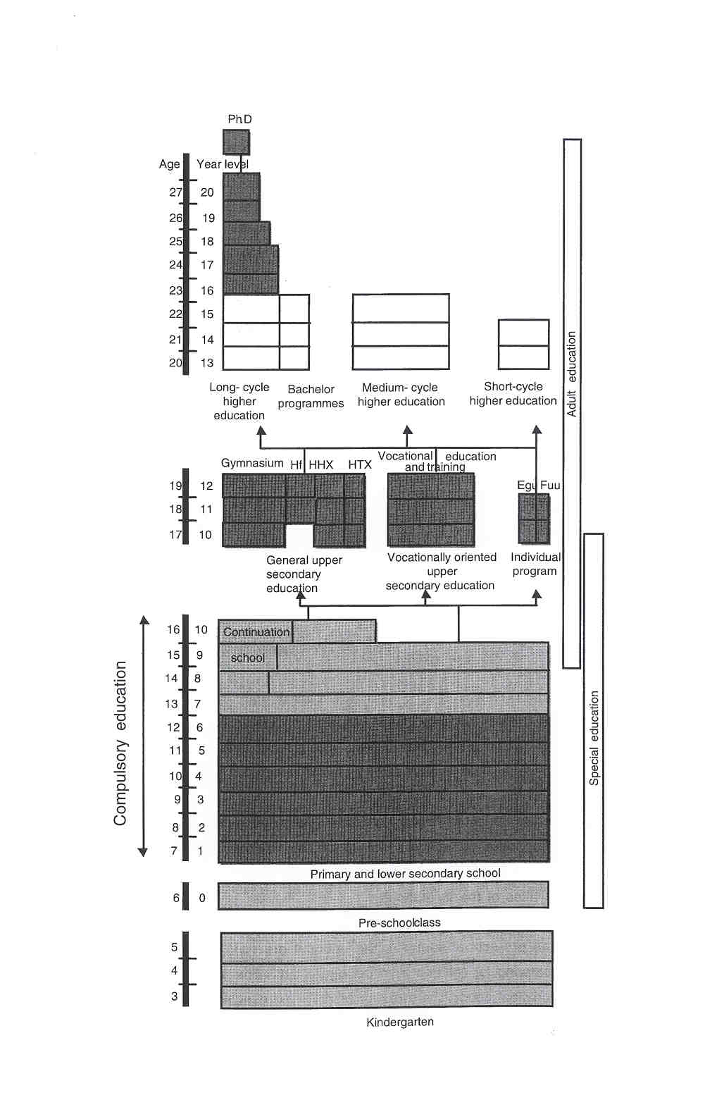

Primary and Lower Secondary Education

Primary and lower secondary education for children from 617 to 15116 years old (children begin Grade 1 in the year of their seventh birthday) is organised in the comprehensive "Folkeskolen'. These schools must comprise a one-year preschool class, a nine-year basic school (after which compulsory education ends) and an optional one-year 10th form. The 10th form is an offer to pupils wanting to spend one more year in the "Folkeskole".

In principle, the teachers are trained to teach all form levels of the "Folkeskole", and a class will therefore normally have the same teacher in the same subject for several years, sometimes all the way through. A feature particular to the "Folkeskole" is the class teacher who teaches the class for a great number of lessons per week, normally in Danish. The class teacher has the continuous contact with the pupils' homes and is the link between the headteacher and the class.

The Minister of Education's influence on the teaching of the "Folkeskole" is largely based on the principle of target and framework management. The Minister issues regulations pertaining to the aims of the teaching in the subjects and obligatory topics indicating central knowledge and proficiency areas as well as curriculum guidelines. In order to safeguard a uniform national standard in the outcome of the teaching in the country's about 1700 municipal schools, the Minister lays down regulations concerning the examination requirements in each of the subjects, conducting examinations, pupil assessment and marking and issuing the leaving certificates.

The municipal council has the overall responsibility for the "Folkeskole". This means, amongst others: grants to the school system and the financial framework of the schools, appoinment and dismissal of headteachers and teachers on the recommendation of the school board, the school structure, including the number of schools and the size and activities of each school in terms of form levels, special education, leisure-time education and the leisure-time scheme for children, the framework for setting up classes, the number of lessons of the pupils, special education, general guidelines for the activities of the schools as cultural centres for the local community, the approval of the curricula of the schools on proposal by the individual school boards. The municipal council may, wholly or partly, delegate its power to the school boards, with the exception of the powers following from its competence as grant-awarding authority and employer.

There is a core curriculum of subjects, which all pupils must be taught, and a number of optional subjects, which pupils may choose. The Minister of Education has issued guidelines for the weekly distribution of lessons based on a minimum number of lessons per subject. The 1994 Act on the "Fokeskolen" results in some pedagogical innovations. E.g. the teaching of individual subjects shall interact with the teaching of interdisciplinary topics and problems. A new subject, "Science" based on geography, biology and physics/ chemistry, is introduced in the lst-6th form.

As part of the teaching, there must be a regular assessment of the pupils' benefit from the teaching. No marks are given in the lst to 7th years, but schools are required to inform pupils and parents of the pupils' progress. In the 8th to 10th forms, the assessment of the level of attainment in Danish, mathematics,

English, German (or French) and physics/chemistry must be expressed in marks at least twice a year. In the gth and 10th forms, the pupils must draw up an obligatory project assignment, for which the assessment must be given in the form of a written statement and a mark, if the pupils so wish.

In each of the subjects mentioned above, pupils may sit for the written and oral leaving examination of the "Folkeskole" on the completion of the gth form. On completion of the 10th form, pupils may sit for either the advanced leaving examination or the leaving examination in the same subjects. The school issues a leaving certificate, which contains information about the educational activities in which the pupil has participated as well as the most recent proficiency marks. It furthermore includes the marks obtained at the leaving or the advanced leaving examination.

There are some alternatives for the municipal "Folkeskole". About 12 % of the pupils are enrolled in private schools. About 20.000 pupils spend 1 or 2 years in a continuation school or "Efterskole'. These schools, for the 14-18 age group, mostly emphasising special education and practical work, represent a second chance for late developed and non-intellectually gifted pupils who have suffered defeat in the ordinary school system. The Municipal Youth School, also for the 14-18 age group, has rnanifold objectives and clientele. Most of them follow ordinary education and late in the afternoon or evening they follow subjects at the youth school, which they are not able to take in their main educational institution. Some prefer to attend the youth school instead of the "Folkeskole" because of the more free concept of the youth school. The continuation school and the youth school represent "security valves" for the 14-18-year-olds who do not fit in the mainstream education system.

Upper Secondary Education ("Youth Education")

After the end of the gth or 10th form of the "Folkeskole", 95% of all pupils continue in some type of youth education. About 40% go to one of the many vocational education and training programmes offered by the vocational colleges, while about 60% choose a general upper secondary education programme, either the programme of the "Gymnasium" or the programmes leading to the Higher Preparatory Examination, the Higher Commercial Examination or the Higher Technical Examination.

Vocational Education and Training

Admission to a vocational course is open to all persons who have completed compulsory education, and students are not required to have passed the leaving examinations at the "Folkeskole". As far as the Technical College is concerned, the students may begin their vocational education and training in three different ways. Most students choose the so-called "school route", which is identical to the l st school period which lasts about 20 weeks. Some students follow the so-called "practical training route"; they begin their education as a trainee in a business enterprise. After about 20 weeks of practical training, the student attends the 2nd school period at a technical college. Finally, students may begin their vocational education by attending the 2nd school period directly. After the 2nd period, students, who do not already have a training agreement with a business enterprise, must enter into such an agreement. The basic structure of the training programmes is based on the alternance training principle and lasts generally no longer than four years. The programme is completed with an examination, which is carried out in connection with the final school period. The Business Colleges also offer the propaedeutical lst period and school and practical, training routes. Other types of vocational education and training are agricultural education and training, basic social and health training, home economics education, maritime education and programmes for assistants in the postal services and the State railways.

The division into programmes and specialisations, the targets and general framework of the individual programmes are laid down in Ministerial orders based on input from the trade committees. The Ministerial orders specify the basic subjects (113 of the lessons, basic practical and theoretical instruction), area subjects (113, practical and theoretical subjects relevant to a broad field of trades) and special subjects (116, the highest professional level, trade-specific and theoretical instruction) of the programmes and include the aims which the students must meet in the various subjects as well as to how assessment should be made. The last 116 of the lessons are reserved for optional subjects.

The Minister of Education issues Ministerial orders concerning admission, the required teacher qualifications, course contents, curricula and other matters relating to the teaching of individual programmes. In this connection, the Council for Vocational Education acts as an advisory body to the Minister. The Council's 20 members represent the relevant employers'and employees'organisations, the Association of County Councils, the Association of Local Authorities and the association of headteachers and teachers of the vocational colleges.

General Upper Secondary Education

General upper secondary education is offered in different forms and in different types of institutions. There are the more academically oriented programmes offered by the Gymnasia and the higherpreparatory examination (HF) institutions, and there are the vocationally oriented programmes offered by the business colleges and the technical colleges leading to the higher commercial examination (HHX) and the higher technical examination (HTX). Many of the subjects taught in more than one type of upper secondary education can be taken at low, intermediate or advanced level. And students who have already passed the examination in a subject with the mark 6 or more may be awarded credit for this subject, when they change to another type of upper secondary education.

Parliament lays down the overall targets and framework for the general upper secondary level. The Ministry issues curriculum and examination regulations, it produces the questions for the written examinations, decides on the subjects in which oral examinations are to be held and appoints the external examiners. As far as HHX and HTX are concerned, guidelines are issued by the two advisory bodies established by the Council for Vocational Education, and similar councils will be established in the year 2000 for the Gymnasia and the HF's.

The Gymnasium aims at providing general education and preparing students for further studies. Most are county schools, 17 are State-subsidised private schools. Students can choose either the mathematics line or the languages line. Applicants must have completed 9 or 10 years of basic education. The previous school of the applicant most declare him or her qualified for the Gymnasium (this will be changed in the year 2001), and the applicant must have passed the leaving examination of the "Folkeskole" with satisfactory results in Danish and mathematics, and for the language line in English, German or French, or in science for the mathematics line. The teaching comprises obligatory subjects, common to all students of the line chosen and optional subjects. The content of the teaching in the individual subjects is laid down in a Ministerial order, but the actual planning and organisation of the subjects are - as far as possible - carried out jointly by the teacher and the pupils. A total of ten examinations and a major written assignment are required in order to pass the "Studentereksamen' (the leaving examination), of which up to three may be passed after the ist and 2nd years. After the 3rd year, all students must sit for a written examination in Danish and in the subjects chosen at advanced level. The number of oral examinations is 6 or 7 and varies for the individual student according to the number of subjects chosen at advanced level. Written examinations are based on questions drawn up at central level by an examination committee set up for each subject by the Ministry's Department of Upper Secondary Education.

The "Studentereksamen" can also be taken in the Alternative 2-year programme. Here, the pupils are older and often active in the labour market. The teaching is given in a more concentrated form.

The Higher Preparatory Examination Programme (HF) is an alternative route to higher education. It is mostly offered at Gymnasia and colleges of education, at a few independent HF-institutions and at 60 adult education centres. Applicants must have finished compulsory education at least one year before admission to the HF- programme and must be accepted as qualified by the HF-institution. Applicants coming directly from the "Folkeskole" must have completed the 10th form and must be considered qualified by their previous school. The examination can be taken as a complete examination after a 2-year programme. It may also, as the alternative 2-year programme for the "Studentereksamen", be taken following single-subject instruction and pieced together into a complete HF-examination.

The Higher Commercial Examination Programme (HHX) offers a range of commercial and general subjects, it has the status of a university entrance examination and is offered by all 57 business colleges. Students who have completed compulsory education can be admitted to the HHX, if their previous school declares they are able to follow the instruction and complete the programme within the stipulated period of time.

The Higher Technical Examination Programme (HTX) prepares for access to higher education in the technical area. As far as entrance to higher education is concerned, it is placed on an equal footing with the "Studentereksamen" and the HF- and HHX-examinations. It is offered at 40 technical schools and lasts three years.

Alternative and Untraditional Youth Education and Training Programmes are initiatives for people who finished compulsory education, but could not begin a vocational training programme or dropped out from the Ist year, because they could not get a training agreement. They lack vocational skills and working life experience and risk unemployment. The Production Schools offer combined education and production courses. The students can attend the school for up to a year. Vocational Basic Training (EGU) is meant to be a coherent but flexible transition to the labour market for less academically minded students and represents a framework, which makes it possible to organise courses according to the wishes and abilities of the students, and it makes it possible for students to get credits, if they want to continue in the formal parts of the education system. An F:GU-course takes 2 years. The Individually Organised Youth Fducation (FUU) is for young people, who have not chosen or completed one of the formal types of youth education.

Higher Education

Higher education is divided into three levels:

- short-cycle higher education at non-university level (1 to 3 years);
- rnediurn-cycle higher education at non-university level (3 or 4 years);
- long-cycle higher education: the 3-year Bachelor-programmes at university level and long-cycle higher education at university level (mainly 5 years, i.e. 3-year bachelor programme + 2 further years).

The higher education institutions at university level and the universities are characterised by the fact that their teaching is based on the research carried out at the institution. Examples of medium-cycle higher education institutions are: colleges of education, educator training colleges, schools for social work, colleges of engineering, schools for nurses, physiotherapists, ... At short-cycle level, there are technical colleges (e.g. for construction, production planning, ...) and business colleges (e.g. for market economics, computer specialists, tourism, logistics, ...).

As a main rule, a completed youth education course is required in order to gain access to higher education. This means, for the medium- and long-cycle programmes, a "Studentereksamen", a HF, HHX or HTX. In addition, many courses also have specific admission requirements which may be a requirement of subjects taken at a certain level in the qualifying examination andlor a minimum average of the grades achieved at the examinations. Admission to the short-cycle programmes is open to students, who have completed a relevant vocational education and training programme.

At the universities, the programmes normally consist of a 3-year Bachelor's degree programme, followed by a 2-year programme leading to the Candidatus degree (Master's level) which includes 6 months' work on a thesis. The universities may also confer the doctoral degree based upon extensive and original research work. Many of the medium-cycle courses comprise one or more periods of practical training, as in the different types of teacher training.

Teacher Training

The teachers in pre-school education have received their training in specialised educator training colleges. Teachers for the "Folkeskole' must hold a diploma from one of the colleges of education. Students must have past the examination at general upper secondary level to be admitted to a college of education. The study programme is of 4 years' duration and is situated in medium-cycle higher education. The profile of the teachers at a vocational college comprises:

- teachers who have completed vocational education and training and who have at least 5 years (technical colleges) or 2 years (business colleges) employment in the trade;
- teachers having completed vocational education and training, followed by further theoretical education;
- teachers with a theoretical background, such as graduates from colleges of education or universities.

Teachers with no training in teaching methodology must, within the first 2 years of employment, complete a postgraduate teacher training course, ending with a final qualifying examination.
Teachers at general upper secondary level have a Master's degree. In order to be permanently employed, teachers in the Gymnasium and HF must go through a course in theoretical and practical pedagogy for the diploma in education ("Paedagogikum"). The theoretical part is given in classes established at regional level. The practical part takes place at a Gymnasium or a HF-institution. For the teachers in the HHX- and HTX- programmes the theoretical part is organised by the Danish Institute for the Educational Training of Vocational Teachers. The practical part is carried out at a vocational college.

Aduft Education

Adult education can be divided into popular enlightment or liberal education which is free from any kind of examination and qualifying adult education. Each of them offers a broad variety of educational opportunities.

Special Education

At pre-school education level, the integration of children with physical or mental handicaps in the mainstream education system is a central principle. It is the aim to give handicapped children or children with special social difficulties as "normal" a childhood as possible. The children are taken care of more intensely, frequently by attaching additional staff to the institution. Sometimes handicapped children are together in a separate group. The number of educators attached to such a group is particularly high, and the staff also has the possibility of consulting specialists.

The municipal councils' obligation to run the "Folkeskolen" also includes the provision of special education and other special educational assistance for children and young people under 18 years of age, whose parents wish them to be enrolled in the "Folkeskole". Here as well, it is a goal to avoid segregation of handicapped children. This means that they -if at all possible- are taught in ordinary classes, often with special aids. 12- 13 % of the pupils in "Folkeskolen" are referred to special education for shorter or longer periods of the school year. The special education provision varies from supplementary support inside the physical framework of the ordinary class to special education lessons, to special classes in bigger schools and to special schools in the biggest municipalities.

2 THE ORGANISATION OF OUALITY DEVELOPMENT AND QUALITY ASSURANCE

[Jniike the other countries and regions in this book, Denmark, since 1963, does not have an inspectorate of education. There is, however, a complex system of quality development and quality assurance, which has been given shape since the early 1960s and was developed more strongly in the 1980s and 1990s. The intention of this case study of Denmark is to try and describe those elements of Danish quality development and assurance which can in some way be compared with the tasks and responsibilities of inspectorates in Europe. The focus, therefore, will be the role of the national advisers in Denmark.

As wiii become more clear in the following pages, very few elements can be found which can be categorised as'external inspection imposed on schools and teachers'. Quality assurance in Denmark as it is conceptualized during the last decades, is to a large extent based on self-evaluation, voluntariness, decentralisation, local social control, a mixture of formal and informal elements and parental influence. External and imposed control, therefore, has been given a very low profile.

Summarizing, quality development and assurance are formed by the following elements:

- A high degree of decentralisation to the municipalities and counties and institutional self-regulation combined with 'framework management'by the Ministry of Education. Minimum requirements, sometimes more specific or directive than in other cases, are laid down amongst others and in this context most important of all, relating to curricula and examinations. Generally, within this framework management, the central level is to ensure adequate targets and frameworks for the activities of the institutions, to monitor the development (in other words to control the quality) and intervene in areas where a need for quality improvement has been found and to carry out continuous assessment of how the quality level in general can be improved.
- Different quality development projects issued by the Ministry of Education. These projects are e.g. aimed at the vertical evaluation of subjects throughout the levels of education, at analysing each level of education, at evaluating individual institutions (since 1989).
- The counties finance the Gymnasia and the HF-courses, but there is no quality control or evaluation of the teaching by these counties. That is the responsibility of the Ministry and of the schools themselves. The municipalities finance the “Folkeskole" and do not issue any orders regarding evaluation. But many municipalities establish targets and action plans which are followed up and assessed, i.e. evaluation at overall level. The Ministry issues guidelines and organises the final examinations.
- A strong tradition of self-evaluation and quality development by the schools themselves, resulting in tools and material published by the Ministry of Education in order to find common frameworks and to support other schools.
- Different types of "advisers" who on the one hand, monitor the quality of education and on the other give professional advice to colleagues.
- An examination system which is to a large extent centrally and externally organised and which is run by centrally appointed examiners and national advisers. This system is a.o. regarded as a controlling mechanism for the quality of education.

This case study deals with the role of national advisers in the "Folkeskole" and in upper secondary education. A brief description of quality control in higher education is included as well.

THE ORGANISATION OFTHE ADVISERS

Folkeskolen

At central level

At central level there are 17 subject and 7 other advisers. The latter category of advisers covers specific areas such as guidance in choice of education and job, or reading disabilities.... All advisers work part-time at the Ministry in the Department of Primary and Lower Secondary Education.

At local level

At local level there are a number of advisers (district advisers) depending on the size of the municipality The smallest municipalities, about 6.000-8.000 people, may have no advisory service at all, whereas the bigger ones, i.e. more than 50.000 people normally have a number of advisers. Although there is no formal link between the central and local advisers, they co-operate with each other.

Lipper Secondary Education

The management of the advisory services is organised centrally from the Advisers' Section in the Department of General Upper Secondary Education in the Ministry of Education. There is a Director for the Department, and the Department covers

- Gymnasia and HF-courses for which 1 Deputy Director and 1 0 senior advisers (4 of whom are part-time and spend the remainder of their working time as teachers in schools) are responsible. Each of the senior advisers has a different field of responsibility, such as in-service training, pilot projects, international relations, examinations, the Faroe Islands, Greenland, school visists, Quality Development Project,…,
- HHX and HTX for which 1 Deputy Director and 3 senior advisers are responsible.

The national subject advisers report to the Deputy Director. It is a subject-based organisation, but the advisers also report on selected general issues. For the Gymnasia and HF, there are 29 national subject advisers, and similary 25 national subject advisers for the HHX and HTX. All these advisers work part-time at the Ministry. (See 5.)

As for vocational education and training, the management for the advisory service is organised by the Department of Vocational Education and Training. There are a Director and 2 Deputy Directors (one for the 11 ordinary" education and one for the alternative and untraditional education) and 39 advisers. The Ministry's control confines itself to laying down general regulations regarding the courses (in co-operation with the Council for Vocational Education) and to laying down framework regulations for the individual courses according to decisions taken by the central trade committees.

The situation of private schools (a minority in Denmark) is quite different. Each private "Folkeskole" (established by private initiative, mostly based on a religious denomination) has attached to it an inspector chosen by the parents or appointed by the municipality. The role of this inspector depends on the school board. These private schools do not have to meet the same requirements as "regula@' schools (e.g. they do not have to participate in the national examinations). There are no inspectors in private upper secondary education and private schools at this level do have to meet the same requirements as other schools. The only difference is that they are established by private initiative and that 15% of their finances comes from parents (85% from the Ministry).

Quality Development in Higher Education

In 1992, the Centre for Quality Assurance and Evaluation of Higher Education was established under the auspicies of the Ministry of Education. The centre monitors the quality of higher education for the Ministry, and it serves the needs of institutions who engage in self-evaluation projects. The centre is responsible for the evaluation of higher education and must guarantee the use of valid and reliable evaluation methods as well as provide support and advice in all questions relating to quality development.

The centre has the following tasks:

- to initiate evaluation processes in higher education;
- to develop adequate methods of assessing programmes;
- to inspire and guide the higher education institutions in aspects concerning evaluation and quality;
- to compile national and international experience on evaluation of education systems and quality development.

A substantial part of the centre's work consists of regular and systematic evaluations of programmes on a rotating basis in which all programmes will be evaluated within a period of 5 to 7 years. In addition, it evaluates new programmes after their trial period and programmes for which the Ministry, an advisory body or an institution find that there is need for an evaluation of the quality. Generally, an evaluation will comprise 5 phases spanning over a period of 9-12 months: planning, self-evaluation, user surveys with enquiries among students, graduates and employers, peer review with a panel of independent experts and reporting.

As will be mentioned more concretely in item 19 (recent and future issues or developments), a similar system for primary and secondary education was decided upon in May 1999.

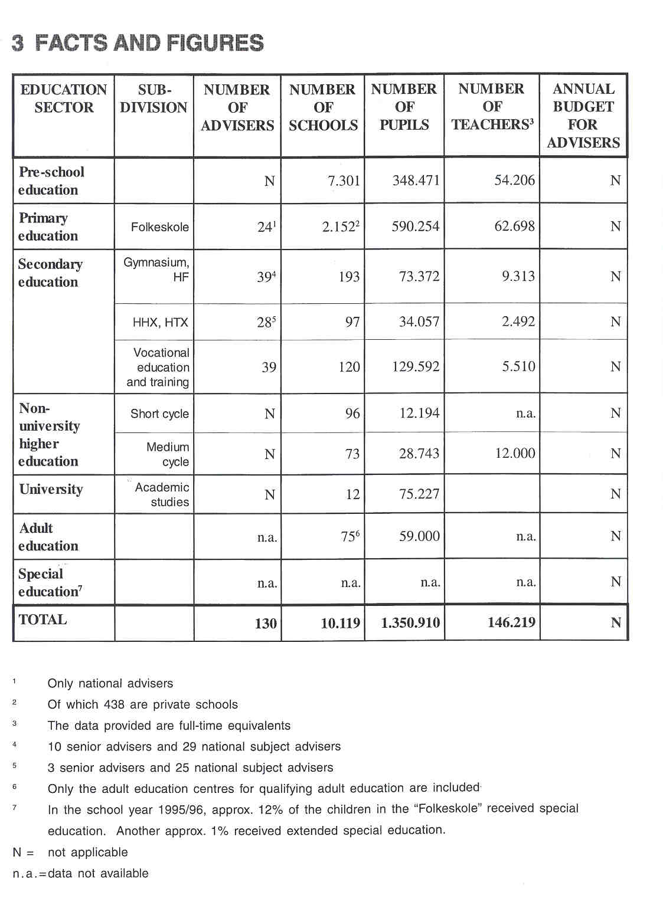

4 THE RECRUITMENT OF THE ADVISERS

National advisers are trained and work as teachers. Candidates have to apply to the Ministry of Education. They have to prove a high quality of competence in the subject they apply for. District advisers for the "Folkeskolen" are selected by the municipality council, also based on their subject competence.

5 THE WORKING CONDITIONS OF THE ADVISERS

National advisers are teachers who are seconded to the Ministry of Education for 3 years at a time, retaining 113 of their teaching duties at their original school. Thus national advisers have solid first-hand experience of day-to-day teaching. The 2 deputy directors and 4 out of the 10 senior advisors of Gymnasia and HF- programmes are employed on a full-time basis.

6 THE ADVISERS'AREAS OF RESPONSIBILITY

The term "adviser” is used to express the collegiality between teachers, headteachers and advisers which is aspired. Although advisers are no external assessors with the power of taking measures against schools or teachers, they do have a certain influence on the actual routine at schools.

In general terms, it is the task of the national adviser to participate in the development of the curriculum, to formulate syllabus goals and content for their subjects, to monitor and advise schools and teachers, and to communicate their observations and advice both "up" and "down" in the education system. The advisers' responsibilities comprise the following elements.

A. UPPER SECONDARY EDUCATION

6.1 Evaluating

Evaluation of Teachers

After being appointed, no formal assessment of individual teachers or headteachers takes place.

There is, however, an indirect evaluation. As will be described under the heading "Monitoring examinations", each year, subject advisers control the syllabuses of individual teachers. If these syllabuses are not in accordance with the regulations, shortcomings should be corrected before the examinations take place.

Furthermore, if a headteacher gets the impression that the quality of the teacher's work is lacking behind he or she may call upon the subject adviser who will attend a number of the teacher's lessons and advise him or her how to improve the quality of teaching. Afterwards, the adviser pays one or two visits to give further support and to see whether the situation has improved. If not, the teacher may be dismissed by the County council on the recommendation of the headteacher. After this procedure, the teacher can still be employed in another school.

6.2 Advising

The national advisers provide guidance on the best way of attaining the goals set for the various schoo subjects and give advice about the regulations which apply in a given area. Subject related matters are generally taken care of by subject advisers. The full-time advisers deal with more general school aspects.

Advising Headteachers

Questions about subject content, such as the correct interpretation of examination requirements often come from headteachers, who seek advice before making their own decisions.

Headteachers may also take the advice of the national advisers on the appointment of staff, on questions of formal teaching qualifications, on finding substitute teachers, and on the question of the competence of an individual teacher.

To an increasing extent, national advisers are asked to advise on matters of school development and the improvement of educational quality. This is a natural consequence of decentralisation. More responsibility has been devolved to heads of individual schools for the organisation of the teaching in their schools.

Advising Teachers

Teachers use the national advisers as consultants. Advice and guidance cover all professional issues from the choice of teaching materials to the setting and marking of written assignments, and from educational theory and practice to discussions of principle concerning the aims of the subject concerned. A large part of the advice is on the development of new teaching methods and materials.

The national advisers are responsible for the preparation of newly-appointed teachers for a diploma of education.

Advising Teachers and School Teams by Means of School Visits

Advisers frequently visit schools on a individual basis (each of the advisers has to cover six schools a year).
They usually sit in on classes and discuss current professional issues with their colleagues. The discussions are often based an the lessons observed and may be attended by the headteacher. Advice ranges from interpretations of the rules to suggestions and advice in terms of content and teaching methods. As part of the visit agenda the national adviser may engage in a general pedagogical debate with the whole staff. Discussion topics are decided upon in collaboration between the national advisers and the schools and are often related to issues of staff development.

At least once every year, each school receives a visit by a national adviser or other member of staff from the Department of Upper Secondary Education. larger schools tend to be visited by an adviser more often. These school visits may contribute to school development or clarify questions of local school policy. These visits are not requested by the schools. They are compulsory. If a school wishes to initiate major development work, it often happens that national advisers and other staff from the Department of Upper Secondary Education are sent for in order to discuss and evaluate the school's plans.

Advising Schools by Means of School Analysis

Until i998, the national advisers also participated in the Ministry's school evaluation project. Six to eight national advisers and other staff from the Department of Upper Secondary Education visited two schools each year to evaluate the teaching and extra curricular activity, the leadership and general school ethos etc. Schools applied to participate.

The purpose of the visit was in part to give the school an opportunity to reflect collectively on its routines and improve the quality of its teaching, and in part, by issuing a report, to inspire school development in general, a.o. by disseminating ideas of good practice gleaned from the visit. There was no intention of comparing schools on an evaluative scale.

Advising Further and Higher Education Institutions

National advisers offer advice to institutions of further and higher education whose degrees are relevant to future teachers in the Gymnasia and higher preparatory courses. The national advisers try to ensure that the content of courses corresponds to the requirements that must be met in the individual subjects.

In order to help bridge the gap between upper secondary and further and higher education, the national advisers keep institutions of further and higher education informed of any changes in the content of individual subjects at the Gymnasia and higher preparatory level.

Advising the Minister

The national advisers prepare draft recommendations for the officials of the Department of Upper Secondary Education, who then use them as background when advising the Minister. Cases may be matters of complaints from individual or groups of citizens about the content or organisation of teaching, questions from private individuals or politicians, drafts of speeches, contributions to the public debate, interviews etc.

6.3 Monitoring

The advisers play an important role in quality assurance by monitoring 3 important aspects of the education system: subjects, curricula and examinations.

Monitoring Subjects

As part of the Danish project on content and quality development in education, launched in 1988, committees consisting of specialists from all levels of the education system together with experts from outside the school world, have been set up for each subject making a report intended to serve as a basis for possible changes and improvements. National advisers serve as secretaries to the working committees. The committees describe and evaluate the subjects at all levels of the school system. Next to subjects, the project also comprises transverse themes such as the use of spoken language, language awareness, examinations and levels of attainment and accreditation, …,

This committee work has stopped because this type of evaluation wil be a part of the new Danish evaluation institution. (See 19.)

Curriculum Development and the Formulation of Content and Goals

The national adviser serves the Minister in the wording of executive orders and instructions concerning the teaching at the Gymnasia and the courses leading to the higher preparatory examination. National advisers help to ensure that the intentions of the Danish "Folketing" (Parliament) and the Minister are carried out, in order to reach agreement between the goals set at the political level and the teaching at the various institutions. The national goals for the teaching at the Gymnasia and higher preparatory courses are found in executive orders with appendices providing a more detailed framework (syllabus) for each subject.

These syllabuses are prepared by a number of subject committtees. The national advisers, with their subject expertise and teaching experience, serve on these committees as specialists. When the rules for Gymnasium or higher preparatory course teaching are changed, the subject advisers ensure, on a systematic basis, that headteachers and teachers are informed about the changes.

Monitoring Examinations

The subject advisers devote a considerable part of their efforts to the administration of examinations.

Their tasks are:

- selection of written examination papers in collaboration with examination committees;
- controlling how schools (individual teachers) have filled in the syllabus framework;
- selection of external examiners (people from other institutions or from vocational practice);
- review of examination questions set by teachers and external examiners for oral examinations;
- dealing with examination complaints;
- comments on the year's examinations and students' achievement on the basis of reports from external examiners.

In March, every teacher teaching a final year course must submit information to the Ministry about the material studied and the options selected for examination. By inspecting the syllabuses submitted, the subject advisers help to ensure that teaching is being carried out in accordance with the regulations. Shortcomings and deviations can be pointed out and be corrected before the examination is held.

The material (hundreds of forms) gives the subject advisers the opportunity to follow developments in the subject with regard to teaching materials used, typical tasks, use of computers, experimental work, out-of- school activities related to the instruction etc.

After the examination period, the subject advisers select, at random, a number of regions from which the questions set for the oral examination are to be submitted to the Ministry. In this way, the subject advisers gain a broad knowledge of the wording of examination questions, any supplementary material used etc. General problems concerning the oral examination are commented on in the journals published by each professional association, which are valuable means of communication for national advisers at courses and meetings with teachers in a region. This helps to ensure a consistent quality of examination questions and provides guidance for external examiners.

Following the written examinations, all teachers are informed about the examination in their subjects and the national advisers point out areas where there is room for improvement.

To ensure a uniform evaluation of the written examinations, the national advisers prepare guidance for the external examiners including a number of carefully selected examples of graded and annotated examination answers at different levels on the marking scale.

Examination results are reported by the schools to the Ministry and are controlled by the national subject advisers, who use these results and the reports from the teachers of their work for improvement and guidance at national level. This is important, since the examinations are closely aligned to the curriculum and the teaching.

6. 4 Reporting

The national advisers prepare annual accounts of their subject fields to be included in the report of the Department of Upper Secondary Education presented at the annual meetings of headteachers at Gymnasia and higher preparatory courses. The report is circulated to all schools, in order to keep the level of information among teachers about the various subjects up to date. In addition to subjects, topics of more general nature are also reported on.

The Ministry has recently set up committees of national advisers from all school sectors as well as representatives from higher education. These committees provide a forum for the informal sharing of information and they regularly submit publicly available 'vertical' reports to the Minister with special emphasis on developments within the particular school subject across the sectors, for example, issues of overlapping or gaps when students proceed from basic school into secondary education, or from secondary education into further and higher education.

National results on examinations are published as a total for the system and are broken down by subjects, but they are not published for individual schools.

As for the reports on the school analyses: only 1 or 2 schools were analysed each year. Therefore, the report is a combination of the findings of the team members. These reports were published with the intention of drawing attention to the expectations of good practice.

6.5 Other Responsibilities

Sustaining a Professional Network

In general, the national advisers play an important role in helping to sustain a professional network. They see it as their job to create and maintain a high level of professional consensus among the teachers of the subject, and to help ensuring that subject content and teaching practice are constantly developed and adjusted.

The national advisers can advise the Ministry that such initiatives be included in the executive order governing subject teaching. Through articles in professional journals and guidelines and information published by the Department of Upper Secondary Education, the national advisers can call attention to those areas where adjustments are needed.

Furthermore, the national advisers are responsible for investigating aspects of teaching practice, for example the use of teaching materials, the use of computers, the teaching of writing across the curriculum. On the basis of such investigations, the national advisers may institute courses for teachers.

An important task for the national adviser is to disseminate information about the current state of the various school subjects and of recent developments to the Ministry, teachers, schools and other interested parties. This information forms a basis for decisions to be made by the Minister.

Throughout every school year, the national advisers continuously feed back their observations and reflections to the Department of Upper Secondary Education. The feed-back may take the form of a formal written report or be an informal sharing of impressions that have general interest, covering everything from minor problems to major questions of principle. This fairly informal exchange between national advisers and the Ministry is a very important element in the way central educational supervision works in Denmark.

B. THE "FOLKESKOLEN"

The responsibilities of the advisers are very similar to those in upper secondary education. Nevertheless, the following aspects are typical for the "Folkeskolen".

Evaluation of Schools

There is no system of external assessment or evaluation at the level of the schools. According to the 1994 Education Act on the "Folkeskolen" the schools themselves are responsible for the quality of teaching in accordance with the aims laid down for the "Folkeskolen". The schools are supported by district advisers who do not have assessing or evaluating functions, although occasionally a larger municipality might mount an evaluation study.

Generally, the activities vary according to the characteristics of a particular district. For example, a large municipality such as Kopenhagen, has more facilities in terms of staff and other resources to carry out its own system-wide surveys (at district level) than a smaller community.

National advisers, operating nationally, do not intervene in the schools, because the "Folkeskolen" are controlled by the municipality and not by the central Ministry. In 1991, however, the "Folkeskole" Department did carry out a pilot project aimed at developing methods and procedures for the external evaluation of schools. The evaluation covered all activities of the school and is now seen as a basis for school development.

In their work, the central advisers co-operate with all the other adviser groups in the Ministry across all levels of education and with the district or local advisers.

Summarised, there is no national or local inspectorate of schools and central advisers are not involved in the external assessment or evaluation of the "Folkeskolen". However, due to the local nature of the organisation of the "Folkeskole" there are other influences which partially replace the need for external, inspectorial intervention, such as the School Board. These Boards have a number of responsibilities amongst which the most important ones are to lay down the principles for the activities of the school, approve the budget of the school, submit recommendations to the municipal council regarding the appointment of headteachers and teachers and draw up a proposal for the curricula of the school for submission to the municipal council. Given these responsibilities, each school board takes part in different ways in assessing the school as an institution. Over and above this system of parental influence (about 7 out of the 12 members of the school board are parents), there is also an informal communication between the parents and the teachers, co- ordinated by class teachers.

Advising Teachers

Unlike the advisers of upper secondary education, the advisers of the "Folkeskolen" are not responsible for the preparation of newly-appointed teachers.

Organising in-service training is not a responsibility of the "Folkeskolen" advisers either.

7 THE ROLE OF THE ADVISERS IN EDUCATIONAL POLICY

National advisers contribute in preparing the policy by reporting and recommending, formally and informally, on all kinds of educational matters to the officials of the Ministry of Education, who use this material when advising the Minister. The advisers themselves don't make policy decisions on national education. They may, however, influence and advise decision-makers. The advisers stimulate the implementation of the policy and evaluate its effectiveness, as in monitoring the quality of subject teaching and disseminating "good practice".

8 WHO IS IN CHARGE?

The tasks of the advisers are not laid down in legislation. The priorities for the advisers' work are decided upon by the director and his deputies. If the Minister asks for information or wants something to be done, the director and his deputy directors decide - in co-operation with the advisers - how to proceed. Furthermore, the heads of division are members of the Minister's advisory committee. Both the Minister and the heads of division can require special themes to be studied. Examples of such themes are IT in teaching and examinations, written language and process writing, health education, interdisciplinary ecology.

The advisers themselves decide to a certain extent on their own working plan. This is for instance very clear as far as their responsibility for the national written examination papers is concerned.

9 THE POSITION OF THE ADVISERS

The formal hierarchical line is: Minister - Permanent Deputy - Head of Division - Director - Deputy Director - Senior Adviser - Subject Adviser. At the lower level(s) in this hierarchy the differences are nearly invisible. In questions about a specific subject it is usually the subject adviser who solely decides - unless his/her decision contradicts general policy. In most working groups at the Ministry, the Deputy Director, the senior advisers and the subject advisers are working on equal terms.

There is a very fruitful and constructive co-operation between the Association of Local authorities, the associations of headteachers and teachers and the subject advisers. For each subject in the upper secondary school, there is a very active association of teachers and the cooperation between the Ministry (i.e. the national advisers) and these associations is essential for the whole education system. There are other forms of co-operation, such as with the Danish Institute for Educational Research. For instance: the National Committee for TIMSS in Denmark consisted of the national advisers in mathematics, physics and chemistry plus some staff members from the Institute.

10 THE ADVISORY PROCESS

ADVISING BY MEANS OF SCHOOL VISITS IN UPPER SECONDARY EDUCATION

The advisers visit, on average, six schools a year. The Department of General Upper Secondary Education allocates the advisers to the schools. The list is sent to the schools and the adviser contacts the headteacher. A date is fixed and the adviser informs the school about the themes she or he wants to discuss. The headteacher sends, in advance, a list of questions on educational matters the school staff wishes to be discussed. If the visitor is a subject adviser, the teachers of that subject must also send an agenda of their special wishes. A visit lasts 1 day and includes class observations, after which the teaching is discussed with the subject teachers. In the meeting with the subject group the adviser does not comment on the teaching of the teachers whose classes have been observed, but will refer indirectly to this through examples and questions. In very special cases - but normally not - they report orally or in written form to the Department of Upper Secondary Schools. These reports are internal.

SCHOOL ANALYSIS IN UPPER SECONDARY EDUCATION

First of all, it should be emphasised that in this project schools were invited to be analysed on a voluntary basis and on a selferitical attitude of the staff. One or two schools a year were visited.

Prior to the visits, each institution carries out a self-study, including an interview survey in which pupils and possibly other groups participate. Extensive written material about the school is submitted to the Ministry. A working plan is drawn up, comprising dates for the visit, date for the final report, plan for the visit (i.e. work distribution for the advisers), ... and the visit takes place about 6 months after the start of the preparation.

Senior advisers and subject advisers work together in the project - normally 2 to 3 senior advisers and 4 to 5 subject advisers per team. The team visits the school for 4 days attending classes, talking with technical and administrative staff and teachers, members of the management of the school, pupils, parents and people from the local community.

The team examines:

- teaching (teacher performance, methods, performance and active participation of the students, the content and its correspondence with the curriculum);
- nanagement (strategies, administrative methods, delegating ability, ability to develop and initiate, support to staff and students, co-operation ability, planning);
- administration (effectiveness, service to students, teachers and other interested parties, communication and ways of information);
- students (active participation in school life, attitude towards the school, future plans);
- ways of co-operation (school board, staff council, committee work, subject committees, co-operation between colleagues, extra-curricular activities, interplay between the school and its partners-the role of the school in the local community- and buildings and equipment).

All these elements are analysed and evaluated and subsequently written down in a draft report, which is sent to the school. The comments from the school are discussed and some of them incorporated in the final report.

In a subsequent report, attention is drawn to the school's strengths and weaknesses, and recommendations for future action are given.
The reports, containing descriptions and evaluations of local conditions written by a group of broadly experienced specialists, have a general character which makes them relevant to persons other than those directly involved.

As mentioned earlier, this system has recently been called off.

11 INSTRUMENTS AND METHODS

THE COLLECTION OF INFORMATION

a. Questionnaires

In the Departmental Order, it is decided that the Ministry has the right to collect any form of information from the schools. This is done first of all for statistical reasons. A report from each experimental class is asked for as well - even if the experiment is relatively small. Furthermore, information about IT (the number of pc's and the use of the pc's), about international activities, about environmental activities, about the schools' view on the way the Ministry works, etc. is asked for. Based on the collected information, books are published with examples of - what is considered in the Ministry as - "good practice" in the hope that other schools will learn from it.

b. Interviews

In the context of school analyses, interviews are used at 2 different moments in the procedure. First of all, a part of the school's self study preparing the analysis, are interviews with pupils and other groups. Secondly, during the visits, advisers interview a broad range of school participants. Amongst others, they interview pupils in order to obtain information about their attitude towards school life.

c. Observations

Both during school visits and school analyses, observation, by means of attending classes, is an important method applied by the advisers.

d. The Collection of Documents

Before a school analysis, extensive written material is submitted to the Ministry. This comprises all kinds of data - except information on students' achievements. By law, it is forbidden to publish examination results from schools or group's of schools - only results on national basis are allowed.

APPROACHES

a. Instruments

The booklet "Good practice. Signs of Quality in Upper Secondary Schools" (See also item 13. 'Outcomes'.) describes the criteria developed and used in the school analyses. The booklet carefully avoids the words ,criterion' or 'indicator', but it is now being used more and more as a list of 'performance indicators'. However, the term used in the booklet is 'sign of quality'. These 'signs' describe the shared but mainly tacit understanding of what constitutes effective teaching and learning at this level in Denmark. They are not meant to be exhaustive. Each set of 'signs' is introduced by a brief, descriptive section. The 'signs of quality' are formulated for 12 aspects: a good school (comprising the school's atmosphere and development), a school's pedagogical climate, a good faculty, a good teacher, in-service training, a good class, a good student, a good lesson, assessment and differentiation, coherence and co-ordination, leadership and co- operation (comprising the school's pedagogical leadership, administrative leadership, councils and assemblies, departments, education and careers counselling), the physical setting.
In order to give an impression, the 'signs of quality' listed under the heading 'a good school' are presented below. The 'signs of quality' by which a good school should be identified are divided into 2 groups: the school's atmosphere and the school's development. The text regarding the latter reads as follows:

'A feature of the school is that teachers and administration discuss how general education and education for further study are best dealt with in practice.
The school has a clear policy on the subjects offered, experimental instruction and extra-curricular activities, that reflects the overall goals.
The school has discussed and decided what changes in its usual way of doing things will be made as a result of the greater degree of self-management in the following areas:

- distribution of resources for teaching materials, teachers' in-service training and study trips;
- the use of money allocated through collective bargaining agreements.

At various levels (in departments, in the administration, in the teachers' council, //among students, ...) a time and place are provided for reflecting on how the school functions. Topics of general pedagogic interest are discussed.
The school has a sense of loyalty among colleagues that makes it natural for teachers to discuss one another's teaching. Teachers may sit in on one another's lessons, where this is agreed upon.
The school has attempted to shed light on how the students, the staff andlor parents or others outside the school assess the quality of the instruction, e.g. in the form of a questionnaire.'

b. Individual and Teamwork

Depending on the type of work, advisers either function individually or in teams. School visits are carried out by individual advisers. School analyses are performed by teams of 6 to 8 people, headed by the Deputy Director. During the visit, intermediate meetings are held and draft reports are written. Shortly after the visit, each member of the group compiles a report about what has been observed. A draft final report is written at a meeting 3 to 4 days later, and the final report after another meeting 3 days afterwards.

c. Self-evaluation

Prior to the school analyses by the advisers, schools carry out a self-evaluation. Prior to the visit, the advisory group has a meeting with the school. At this meeting, the school is asked to carry out the self- evaluation. It is up to the school how to do it, but they are told that - besides all kinds of statistics (except the students' performances, grades etc). - information about all aspects of school life is needed. The school is requested to use questionnaires for all teachers, all students, parents, committees in the school, the student council, etc.

12 JUDGEMENT AND ITS CONSEOUENCES

As the work of advisers is meant to be developmental, they don't make jugdements, but recommendations aimed at helping teachers and schools to improve their practice. Teachers are not obliged by the Ministry to follow these recommendations, but they could be obliged to do so by the headteacher. It is considered extremely important that the visit is perceived as a tool for school-evaluation and not as a school-inspection.

13 OUTCOMES

Depending on the type of work, advisers make different kinds of reports and publications.

The reports on school analyses are published and circulated to all schools, educators and other interested parties. The intention is to inspire other schools to start projects of self-evaluation or to arrange pedagogical seminars with the help of experts from outside. As the reports are public they are also available to parents. The schools themselves are responsible for the further development and implementation of the recommendations. For the general public, the outcome of this exercise is that every year 2 reports are issued. These are some 100 pages long, but are also available in a concise summary of around 10 pages, intended for the wider public. Next to the 'benchmarking' function described in item 6, these reports, therefore, also play an increasingly significant role in local discussions.
In the annual accounts of their subject fields the national advisers describe trends and recent developments based on the knowledge they have accumulated throughout the year. Their insight is based on syllabus forms, school visits, either as individuals or as members of an evaluation team, on conversations with teachers, on examinations, statistics etc. An evaluation is made of the effects of any major changes in subject regulations, and the attention is drawn generally to issues of concern. The position of the individual subjects in the curriculum as a whole may also be brought up. The reports are presented at the annual meeting of the headteachers and are sent to all institutions and other interested parties.

Advisers, as educational developers, also publish all kinds of materials to support schools. E.g. in 1993, the advisers of upper secondary education compiled a booklet entitled 'Good practice; signs of quality in Upper Secondary Schools'. This booklet is intented to inform the public about the criteria developed and used in the school analyses and to make a discussion on the subject possible. It corresponds to the process that schools must go through, at a time when more and more decisions are decentralised and put in the hands of the school management. Another example is 'School Development' (1996) which presents a proposal for how upper-secondary schools can begin a systematic process of development and in this connection report to the public on the work and activities of the school. The booklet takes its starting point in a model using target management concepts and is based on experience that has already been gained at many schools.

14 FOLLOW-UP PROCEDURES

On the basis of the report on a school analysis, the school draws up an action plan, and, approximately a year later, the ministerial group will return for a second, one-day visit, during which the school will report on the results achieved. The team listens to the school's presentation on the use of the report and on the amount of change and improvement achieved. The Ministry has no instrument to instruct the school to follow the recommendations.

Follow-up visits to teachers, requested by the headteacher to support his or her advice for a possible dismissal to the County council are also carried out by advisers. Such visits are the result of a complaint about the teacher from the students or the parents - or in special cases an initiave taken by the Ministry. Or, if there are problems with a teacher's accordance with the syllabus several times, a visit by the national adviser (who in such cases is inspecting more than advising) can be the result.

15 ADVISERS AS ARBITRATORS

Complaints are always addressed to the educational institution in question and problems are often solved at local level. A written complaint about a teacher from students or parents is in most cases sent to the Ministry by the headteacher or directly by the complainant.

The national advisers play an important role in cases of complaints about teachers. They observe the teacher in class, help clarify the issue and make recommendations about further action to the Ministry. The Ministry can recommend the County Council to dismiss the teacher from that school. It is thereafter possible for the teacher to get a new job at another school within or without the County.

In each examination period, there is a relatively small number of complaints about examination results and procedures. The complaints mainly come from individual students or their parents and sometimes from teachers and external examiners. Against the background of statements by those involved, the subject advisers make recommendations concerning any re-marking of written papers or oral re-examination.

16 ADVISERS AS ACTORS IN PUBLIC DEBATE

Advisers prepare the Minister's part in public debate. They also appear in public debate themselves. The Danish newspapers, for example, often address a national adviser on questions about subjects. Advisers often make contributions in professional journals as well.

17 THE EVALUATION OF ADVISERS

Advisers are evaluated rather informally by their superior. This is done by means of a yearly evaluative conversation.

18 THE ADVISERS'INITIAL TRAINING AND IN-SERVICE TRAINING

During the first year of his/her work, a new adviser is guided by a mentor. Also in the first year, advisers follow a 1-day introductory course plus 3 half-day courses. During these courses, they are introduced to the work in the Ministry (for instance, they receive information on how a law or a departernental order is created, on the routines in the department, on the way a civil servant has to conduct, etc.). Furthermore, there are monthly discussion meetings with all advisers.

19 RECENT OR FUTURE ISSUES AND DEVELOPMENTS

In the future, the following problems, issues and developments will occur. The Danish decentralised system is rooted in the country's conception of organising the relation between authorities and citizens and between citizens themselves and is, therefore, a sociological reality which exceeds the field of education. When comparing this system with others, certainly as far as educational outcomes are concerned, decentralisation might lead to an organisational inability to collect national information about standards and about quality in education in general. This is, however, in this decentralised system, not the main focus of educational quality and it doesn't exclude other forms of quality assurance. In the OECD review of 1995 on the sector of youth education in Denmark, the following critical perceptions were made on this subject (OECD, 104):

'...the Danish education service is peculiarly unreflective about its own performance. That is manifested by the tendency to seek quality assurance by 'front-loading' the system through detailing what should be taught and examined, by ensuring high quality accomodation, equipment and materials, and a generous supply of highly qualified teachers, while rarely asking about comparative performance within the system. Yet, if education is to be increasingly steered by frameworks and targets (see description of framework management in item 2 'The organisation of quality development and quality assurance', note from the author), it is the awareness of comparative performance that is the key to raising standards.' And further on: 'Overall, more money, time and thought need to be devoted to evaluating and comparing results and performance, outcome variables, as distinct from input and process variables. Relatively speaking, little time and money are devoted to institutional reviews. In consequence, very few take place. That lack of resources also contributes, in part, to the sparsity and scantiness of follow-up visits. The main challenges are to define standards, get them accepted by all the interested parties, and ensure that they are comparable across all the component parts of youth education. The outcomes and evidence from that increased evaluation effort should establish a baseline picture against, and within which, individual reviews and teachers' own evaluations can be viewed and judged. In short, the Danish education service needs to systematically build-up a solid, understood culture of evaluation by all involved. Only then could the overall effectiveness and efficiency of the system be gauged, its particular strengths and weaknesses be identified, and the good practice on which improvement depends be broadcast more widely through the system.' (OECD, 105-106)

This criticism resulted in discussion and reflection on the Danish quality assurance system and its place within international developments. These evolutions, combined with growing pressure from international comparative evaluation studies, make a shift towards more central intervention in assessment a possible future option. An important sign of this shift is the recently approved law (May 6,1999) to establish a Danish evaluation institution which should be operational in the autumn of 1999.

It concerns an independent public institution under the general direction of the Minister of Education. The general aim is to monitor the quality and development of education and training in Denmark. The institution can also co-operate with other ministers and institutions which are concerned about the quality and evaluation of their courses. As a consequence, the institute's responsibilities will not be limited to a systematic and compulsory audit (vertically and horizontally) of education. It will also gather national and international information concerning evaluation and quality development of education.

The institute will be managed by a board which directly reports to the Minister of Education. All sectors of education and training will be represented in this board. The chairman of the board (to be appointed by the Minister) is responsible for the daily management and must inform the Danish people about the institution's activities.

The board constitutes a team for each planned evaluation with specialists in the subject or theme concerned. The evaluations will be performed with no interference with the Ministry. This means the national advisers will not take part in the evaluations. Institutions depending on the Ministry of Education will be obliged to be evaluated. Private institutions are only obliged in case they are subsidized by the Ministry. Whether an institution is in some way linked to the Ministry or not, it has to provide information to the evaluation team. In case of refusal, measures can be taken. The evaluation team can audit an institution on several items, depending on the tasks of the institution involved.

After the evaluation, a report is drawn up and handed over to the board of the evaluation institute and the Minister involved and published 2 weeks later. The report cannot be amended by the Minister or the board but comments - also by the evaluated institute - can be added. The report may not contain any quantitative data which could lead to a qualitative classification of schools.

Afterwards, the Minister of Education can oblige the schools helshe is responsible for, to follow-up the evaluation. Helshe can't force other institutions, but measures can be taken (e.g. decreasing finances, or decreasing the number of pupils permitted or the number of courses allowed).

The evaluation institute will begin with the evaluation of the "Folkeskolen". This evaluation will last until the end of the year 2000.

20 LITERATURE

DANISH MINISTRY OF EDUCATION, National Advisers in Danish Upper Secondary Education. Copenhagen, 1993, 16 pp.

DANISH MINISTRY OF EDUCATION, School Development. With a report on the work and activities of a school. Copenhagen, Department of General Upper-Secondary Education, 1996, 35 pp.

EURYDICE, The Education System in Denmark (1997). Euridyee Eurybase 1998, http:llwww.eurydice.org/ Eurybase/Files/DKEN

HOPES, C., Assessing, evaluating and assuring quality in schools in the European Union. Frankfurt am Main, Geselischaft zur Fdrderung Pddagogischer Forschung/Deutsches lnstitut for lnternationale Pddagogische Forschung, 1997, 211 pp.

MINISTERIE VAN ONDERWIJS, CULTUUR EN WETENSCHAPPEN, Onderwijsorganisatie, curriculum en inspectie in zes Europese landen. Zoeterrneer, Directie Voorlichting en Bibliotheek, 1996, 28 pp.

MINISTRY OF EDUCATION, Education in Denmark. Principles and Issues in Education, Copenhagen, 1997, 32 pp.

MINISTRY OF EDUCATION, Education in Denmark. The Education system. Copenhagen, 1998, 89 pp.

MINISTRY OF EDUCATION, Good Practice. Signs of quality in Upper-Secondary Schools. Copenhagen, Department of General Upper-Secondary Education, 1993, 42 pp.

STEVENS BRODERSEN, R., Het onderwijs in Denemarken. Onderwijs in de Europese Unie: eenheid in verscheidenheid. Leuven/Apeldoorn, Garant, 1995, 80 pp.

ORGANISATION FOR ECONOMIC CO-OPERATION AND DEVELOPMENT, Reviews of national policies for education. Denmark. Educating Youth. Paris, OECD, 1995, 126 pp.

UNDERVISNINGSMINISTERIET, Forstag til Lov om Danmarks Evalueringsinstitut, Dep. j. nr. 1998-202-18, 18 pp.

VAN BRUGGEN, J., The position of the inspectorates in the various countries. Breda, SIGI-internal document, 1998, 25-49
