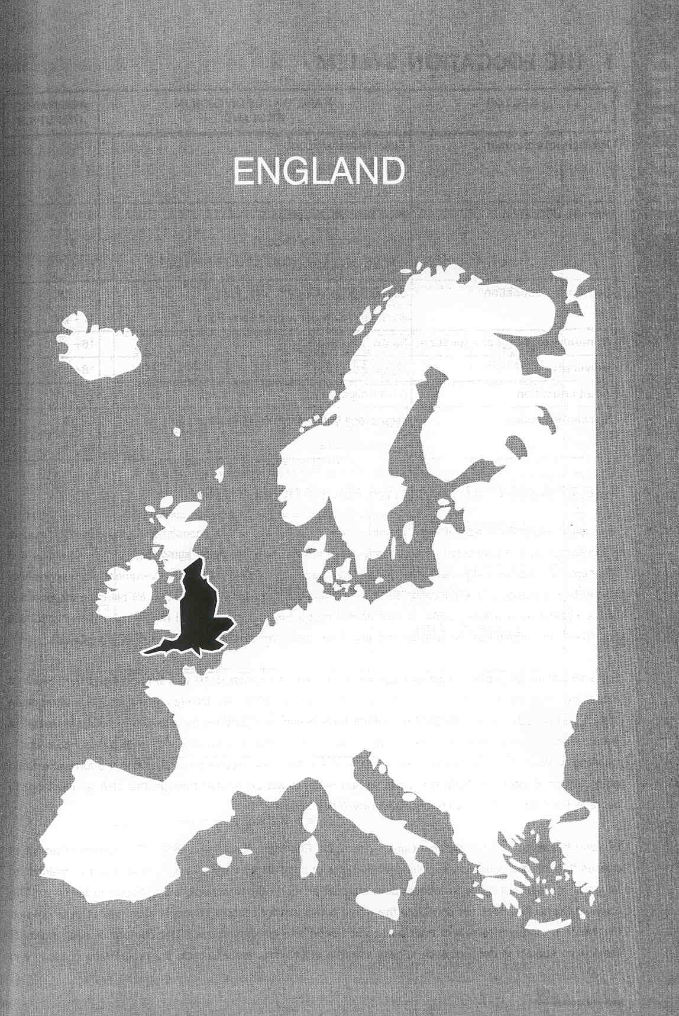

Νίκος Ηλιάδης, Πολ/κός Μηχ/κός Ε.Μ.Π., M.Sc.,
Ph.D. Industrial Education, Organization and Management,
Σύμβουλος του Παιδαγωγικού Ινστιτούτου

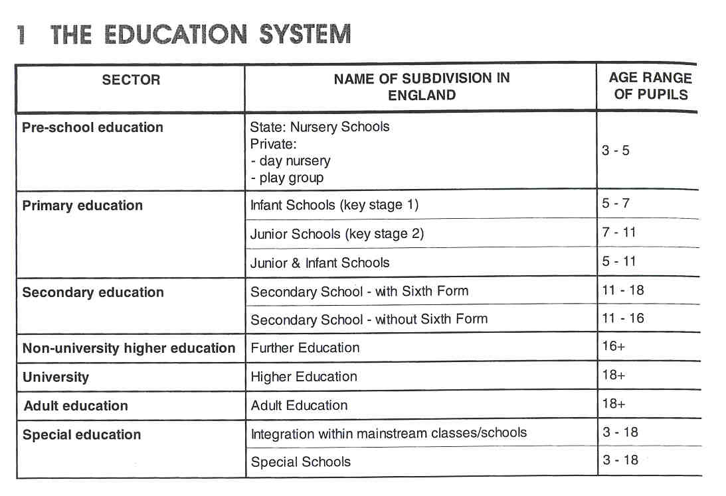

THE ADMINISTRATION OF THE EDUCATION SYSTEM

In England education is administered at both national and local level Responsibility for the education system is decentralised and distributed among central government, local education authorities (LEAs), churches and other voluntary bodies, individual institutions and the teaching profession. Central government has responsibility for the total provision of the education service, for determining national policies and for planning the direction of the system as a whole. LEAS, school governing bodies, and further and higher education institutions implement and administer the policies and also have their own statutory powers and responsibilities.

State education for pupils of statutory age for compulsory education (5-16 years) is provided by 2 types of maintained schools: LEA-rnaintained and grant-maintained. LEAs are locally elected county, metropolitan district or borough councils in England, which have a statutory duty for the provision and organisation of public education services in their area. Grant-maintained schools are primary and secondary schools which, following a ballot of parents, have opted to leave LEA control and receive their funding in the form of a State grant. From September 1999 grant-rnaintained schools will be funded through the LEA and will opt to become Foundation, Community and Voluntary-Aided schools.

England has established a National Curriculum by the Education Reform Act 1988. The National Curriculum defines the national educational entitlement of pupils of compulsory age. It applies to all pupils in maintained schools. It does not apply in independent schools although those schools may choose to follow it. The National Curriculum does not constitute the whole curriculum for schools. Schools have discretion to develop the whole curriculum to reflect their particular needs and circumstances. The content of each National Curriculum subject is defined; each subject consists of common requirements, the programme of study and 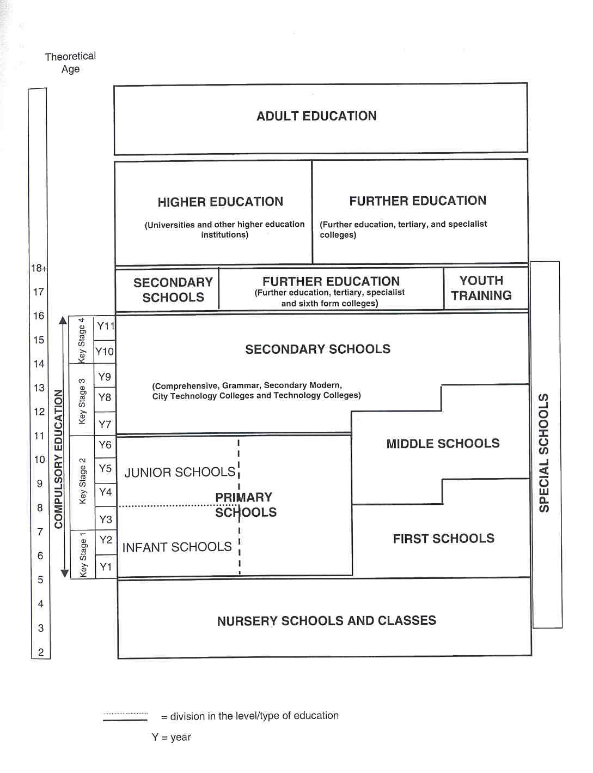

the attainment targets. The common requirements relate access to the curriculum for all pupils, pupils' use of language and pupils' access to information technology. The programme of study sets out the minimum knowledge, understanding and skills for each subject at each key stage, while attainment targets define the expected standards of pupil performance in terms of level descriptions or end of key stage descriptions.
In England pupils are statutorily assessed, using the national tests, at the end of the 4 key stages (normally at the age of 7, 11, 14 and 16).
The Qualifications and Curriculum Authority (OCA), a non-departmental government body under the Department for Education and Employment, is responsible for monitoring, disseminating and reviewing the National Curriculum and its core and foundation subjects. OCA also develops the National Curriculum statutory tests and tasks for the end of each key stage and manages the external marking of the tests of Key Stages 2 and 3. OCA is also responsible for the development and implementation of a coherent and flexible national framework of qualifications.

COMPULSORY EDUCATION

The statutory school age in England is from 5 years to 16 years. By law, all children of statutory school age must receive efficient full-time education suitable to their age, ability, aptitude and to any special educational needs which they may have, either by regular attendance at school or otherwise. If a child does not attend school, then any alternative provision that is made is subject to the approval of the appropriate Local Education Authority (LEA).

EDUCATIONAL SECTORS AND SUBDIVISIONS

Pre-school Education

In 1995 in England, 57% of children aged 3 and 4 attended state schools. In addition to state provision, a large percentage of children attend private institutions such as day nurseries, play groups and other forms of child day care. If all forms of day care provision are taken into account, over 90% of children receive some provision before reaching the age of 5. Most pre-schoolers do not attend a full-time preschool education; they only participate before or after midday. Currently, part-time nursery education is free of charge for all four year olds.
There are no specific legal regulations for the curriculum, teaching methods or assessment. All providers that are funded for 4 year olds are required to promote desirable learning outcomes. Children in nursery schools may be grouped according to age, depending on the size of the classes. Children in day nurseries are in mixed age groups. A minimum of 2 members of staff for every 20 children -one qualified teacher and one qualified nursery assistant- is recommended.

Priimary Education

All primary schools in England are state schools or, for a charge to parents, independent schools. They cater for pupils aged 5 to 11 years. In some areas there are separate primary schools for infant (5 to 7 years) and junior (7 to 1 1) pupils.

In England, the primary school normally has seven classes and comprises 2 key stages. Key stage 1 includes

pupils who are in Year 1 and Year 2; it also includes those pupils in the reception class who have reached compulsory school age (some pupils are admitted to the reception class before they have reached compulsory school age). Pupils in key stage 2 are in Year 3, 4, 5, or 6.
Generally, children aged 5 to 1 1 are taught by year groups in mixed-ability classes with one teacher in charge of teaching all subject to one class. Increasingly primary schools are setting pupils by ability in English, mathematics and science, particularly in Years 5 and 6. Some schools, particularly smaller schools, may operate mixed age classes. All pupils in primary schools, except for some independent schools, follow the National Curriculum. The objectives of the National Curriculum are evaluated at the end of every key stage by means of national tests. There are no certificates at the end of primary education.
In some areas of England, schools are organised in 3 phases: first (5 to 8 or 9 years), middle (8 to 12 years or 9 to 13 years) and secondary (12 or 13 to 16+ years). Legally, middle schools are classified as primary or secondary schools according to whether the majority of pupils are under or over 1 1 years of age.

Secondary Education

lnstitutions

The first five years of secondary education, from 11 to 16 years, fall within the period of compulsory education. Secondary schools normally cater for pupils aged 11 to 16 or 18 years.
Most secondary state schools in England are non-selective and accept pupils regardless of ability. These schools are known as comprehensive schools and they provide a wide range of secondary education. In some areas there are also schools which select all their pupils by ability. Schools that are designated selective schools are commonly known as grammar schools. There are currently 158 grammar schools in England. They provide a mainly academic education.
Modern schools provide a general education for pupils who have failed or have not taken the examination up to the minimum school leaving age of 16; their pupils may stay on beyond that age.
Technology colleges have a particular expertise in teaching a specialist area of the curriculum. The 'Specialist Schools Programme' allows state secondary schools to specialise in a particular area of the curriculum such as modern foreign languages, arts, sports or sciences and technology, while still delivering the full National Curriculum. There are currently 151 Technology Colleges, 42 Language Colleges, 6 Sports Colleges and 3 Arts Colleges involved in the programme.

Pupils are organised into year groups. Teachers usually teach one or more specialist subjects. Depending on the policy of the school pupils may be divided, within the year group, into classes or tutor groups with a designated teacher who has organisational and pastoral care responsibilities. Pupils may be grouped by general ability (a practice known as 'streaming'), taught in mixed ability groups, or more commonly, grouped according to ability in each particular subject (a practice known as 'setting'). Most schools use setting for some subjects only, such as mathematics and foreign languages, and teach other subjects in mixed ability groups. Pupils are placed in a class according to their age and, at the end of each school year, they progress to the next class, unless, in exceptional circumstances, the parents and the school decide that a child would benefit educationally from an extra year in a particular class.

Certificates

After key stage 3 (age 1 1 to 14) there are national tests in English, mathematics and science. Key stage 4 ends with the General Certificate of Secondary Education (GCSE). Students are free to choose for which subjects they want to take an examination. The GCSE consists of a range of examinations in single subjects and there are no regulations governing the minimum or maximum number of subjects to be taken by a pupil at any time. A certificate is issued listing the grade that a candidate has achieved in each subject attempted. The results are reported on an eight-point scale: A*, A, B, G, D, E, F, and G. Candidates who fail to reach the minimum standard for grade G are recorded as 'U' for 'unclassified' and do not receive a certificate.
The Part One General National Vocational Qualification (GNVO) which is currently being piloted is a two-year course designed for 14 to 16-year-olds. Pupils may study Part Ones at either Foundation Level (equivalent to two GCSEs at grade D - G) or Intermediate Level (equivalent to two GCSEs at grades A*- C). The areas currently being piloted are: art and design, business, health and social care, information technology, leisure and tourism, manufacturing, and engineering. Schools are able to offer the Part One GNVO since September 1 998.
Finally, there are a number of qualifications approved which are aimed at pupils who are not yet ready for GCSEs or GNVOS, in literacy, numeracy and information technology. These have been available for use since September 1996.

Post compulsory/Fuirther Education

lnstitutions

Post-compulsory education for young people aged 16 to 18 is provided in the sixth form of many secondary schools, in sixth form colleges and in further education institutions. Where it is provided in schools it is considered to be secondary education and is subject to Schools Regulations. In England the education of young people between the ages of 16-19, where it is not provided in schools, is covered by the legislation relating to further education. This legislation also embraces the education of adults. About half of 16-19 year olds are in school sixth forms. The other half is in sixth form colleges or colleges of further education. There is no National Curriculum.
The sixth form comprises the final 2 years of secondary education for pupils aged 16 to 18. These post- compulsory educational establishments offer largely full-time academic courses but they may also offer vocational courses. The sixth form is mainly for preparing students for higher education.
Whereas schools offer post-compulsory education on a full-time basis, institutions of further education offer full-time and part-time courses. They also offer day-release courses or block-release courses for students in employment. There are no specific branches of study in further education. Students may take a combination of general andlor vocational courses. However, traditionally further education colleges offered vocational education and training while sixth-form colleges provided largely general education. Further education colleges now tend to offer a combination of academic and vocational courses, but some remain specialised, offering specific vocational education, as in colleges of agriculture and horticulture, technical colleges, colleges of art and of commerce.
Tertiary colleges are educational establishments for the 16-19 age group, which combine the functions of a further education college and a sixth-form college, and which offer further education through a full range of courses, both vocational and academic.

The management of the main initial vocational training programme, Youth Training, has been transferred from the Employment Department to the Training and Enterprise Councils (TECs). Youth Training offers a guarantee of vocational training to school-leavers under 18 years old that are neither in employment nor receiving full- time education. Young people between the ages of 18 and 25 may also be eligible for Youth Training even if they are employed. Youth training provides broad-based vocational training, both on-the-job and off-the-job, and planned work experience. It enables trainees to work towards a wide range of qualifications.

Certificates

Further education institutions offer courses that lead to a range of nationally recognised qualifications awarded by a number of different bodies. These qualifications may be academic, general vocational or job specific. For instance a General Certificate of Education Advanced Level is achieved by a single subject examination normally taken at age 18, after following 2 years of study after the General Certificate of Secondary Education (GCSE). Students normally attempt three subjects, but there are no formal requirements for a minimum or rnaximum number.

Higher Education

The main providers of higher education are the universities and other higher education institutions, including specialist institutions such as teacher training, agricultural, art and theological colleges. Some higher education is provided by colleges of further education. The Open University provides higher education courses through distance learning. All higher education institutions are autonomous.

Each higher education institution has its own admissions policy. In general, applicants are required to have at least 3 passes in General Certificate of Secondary Education (GCSE) examinations at grade C or above and 2 passes, in different subjects, at General Certificate of Education Advanced Level. In practice, due to the competition for places, most institutions require levels of qualifications considerably above the minimum.

Universities

Each university determines which degrees and other qualifications it will offer and the conditions that apply. Nevertheless, all universities are organised along similar lines and all offer research opportunities. Universities offer first degrees, post-graduate degrees and some professional qualifications at post-graduate level. They also offer diplomas, professional qualifications and certain qualifications below degree level which nevertheless are defined as higher education.
First degree courses lead to the title of Bachelor (most common are Bachelor of Arts and Bachelor of Science). Courses usually last 3 years, although some take longer. Higher degrees are available to those who already hold a first degree. A higher degree may be a taught or a research degree, or a combination of these. The 3 higher degrees are: Masters' Degrees, Doctorates and Higher Doctorates. Masters' degrees usually require a minimum of one year's full-time study (more commonly two years), or the part-time equivalent. Doctorates are postgraduate qualifications, normally obtained after 3 years' full-time individual research, or the part-time equivalent. They are awarded for an extended essay, known as a thesis.

Other Higher Education Institutions

Non-university higher education institutions also provide degree courses, various non-degree courses and postgraduate qualifications. Some may offer higher degrees. External bodies such as a local university or the Open University validate degrees and other qualifications offered by most non-university higher education institutions. Institutions can apply for university status but must satisfy a number of criteria, including the power to award its own first degrees and higher degrees.

Teacher Training

School teachers employed in maintained schools at all phases (nursery, primary, including reception classes, and secondary) are required to have Qualified Teacher,Status (QTS). There are currently various models of training which lead to QTS. The 2 traditional routes are the concurrent model and the consecutive model.

The concurrent training model usually involves four years of full-time teacher training leading to an education degree, normally the Bachelor of Education (BEd). This training is offered by university-level higher education. The consecutive training model involves 3 or 4 years of study in (a) specialist subject(s) leading to a first degree, followed by 1 year of professional training leading to the Postgraduate Certificate in Education (PGCE). The PGCE focuses on education theory and practical teaching skills. All PGCE students training to be primary teachers must spend at least 18 weeks gaining practical experience in schools. New regulations require students preparing to become secondary school teachers to spend at least 32 weeks in schools.

Adult Education

Adult education centres may also be known as adult education institutes or community colleges. They offer part-time education and training, as well as leisure courses, to students over compulsory school age. These institutions are largely funded by Local Education Authorities (LEAS) and they may apply to the Further Education Funding Councils (FEFCS) for funding through an FEFC sector institution sponsoring body although they are not part of the FEFC sector. Adult education centres may not apply directly to the Funding Councils. The Further Education Council is responsible for allocating the funds put at its disposal by Parliament to those colleges which comprise the further education sector and to LEAs and others for those further education courses run by them under schedule 2 to the Further and Higher Education Act (1992).

Special Education

In England, the Education Act 1996 places emphasis on educating children with special educational needs (SEN) alongside their peers in ordinary schools, where possible. Local Education Authorities are required to take into account the wishes of pupils and their parents in the choice of a particular school, whether mainstream or special. A small minority (about 2 per cent) of children need more help than an ordinary school can provide without additional staff or equipment or adaptation to school buildings. Provision for these children may take various forms, depending on the nature of the ability and the policy of the school and the LEA:
- integration within an ordinary class, receiving extra help within this setting;
- attendance at special units or classes within mainstream primary or secondary schools;
- attendance at a special school (or in a hospital) on a part-time, daily or residential basis;
- attendance at free-standing units;
- home tuition (usually part-time).

Special schools provide education for children with 'special educational needs' who cannot be taught satisfactorily in an ordinary school. Special schools cater for a variety of special needs and they include schools for blind pupils, for pupils with speech and language impairment, for pupils with moderate, severe or specific learning difficulties, for pupils with.hearing impairment, and for pupils with emotional and behavioural Difficulties. Special schools are generally much smaller than mainstream schools and have a lower pupil/ leacher ratio.

The Education Act of 1996 requires all maintained schools including special schools to follow the National Curriculum. However, the Act allows modification of the National Curriculum, and related assessment arrangements, or exemption from the National Curriculum for an individual child who has a statement of special needs.

2 THE ORGANISATION OF THE INSPECTORATE

The Office for Standards in Education (OFSTEID), officially the Office of Her Majesty's Chief Inspector of Schools in England, was set up on 1 September 1992. The School Inspections Act 1996 lays down the duties of Her Majesty's Chief Inspector (HMCI). It is a non-ministerial government department, separated from the Department for Education and Employment (1DfEE). OFSTED is financed by the government.

Over the past 5 years, OFSTED has been responsible for inspecting over 20 000 primary, secondary and special schools. England has separate quality control organisations for further and higher education. OFSTED's remit includes pre-compulsory and compulsory education, post-compulsory education in school sixth forms, teacher education and training, Youth and Adult Education funded by LEA and LEA itself. OFSTED inspects and advises the Secretary of State on quality and standards in independent schools. OFSTED's remit does not include sixth form colleges, further education colleges and higher education other than teacher training.

OFSTED comprises a professional arm and an administrative arm. The professional arm is Her Majesty's Inspectorate (HMI), comprising 205 Her Majesty's Inspectors (including the 2 Directors of Inspection), who are responsible for quality assurance of the education system and for interpreting and reporting on inspection findings. The administrative arm is responsible for developing the range of regulatory and financial functions within OFSTED.

OFSTED is headed by Her Majesty's Chief Inspector (HMCI). HMCI is supported by the Directorate and a secretariat. The Directorate includes the 2 Directors of Inspection, who report directly to HMCI and are responsible for the smooth running of OFSTED and all policy matters. Seventeen divisions, to whom particular responsibilities are delegated, report to the Directorate. Each division is headed by a divisional team manager. Besides the Inspectorate's headquarters in London there is a network of 12 regional offices spread across England. Regional offices provide support for the HMI who work throughout England, as well as undertaking tasks required centrally.
Inspection teams in England include the following three categories of independent school inspectors:
- Registered Inspectors (Rgis) are team leaders who are trained to use the "Framework for Inspection" and contracted by OFSTED to conduct school inspections on behalf of Her Majesty's Inspectors (HM1s). The work of Registered Inspectors is monitored by Her Majesty's Inspectors (HMI). Rgis are responsible for the inspection team and for the report. The Registered Nursery Inspector (RGNI) conducts the inspection of funded nursery provision (without the assistance of a team) and is responsible for the report.
- Professional Team Members (TMs) are trained inspectors who wish to take part in the inspection system without assuming the responsibilities of a Registered Inspector. They would normally have experience of teaching or inspection. TMs inspect particular aspects of a school's work (such as National Curriculum subjects) and contribute their findings to the report.
- Each inspection team must include at least one inspector without personal experience in the management or the provision of education in any school. These are known as Lay Inspectors (Lis), and may be drawn from industry and commerce or from the wider community. Lay Inspectors are expected to contribute a comrnon-sense view of a school. On every school inspection team there must be at least one Lay Inspector.

The organisation of the Inspectorate implies that HMis of the Office for Standards in Education (OFSTED) only participate to a minor extent in the school inspections. HMI's role has changed from direct inspection of schools to providing the professional advice necessary to regulate and monitor the new system.

Distinctions exist between the work of HMI and that of the Registered Inspectors and their teams. HMI are on the staff of OFSTED. Registered Inspectors are not members of OFSTED, but they inspect schools under contract to OFSTED. These
contractors are paid by OFSTED from a central budget. 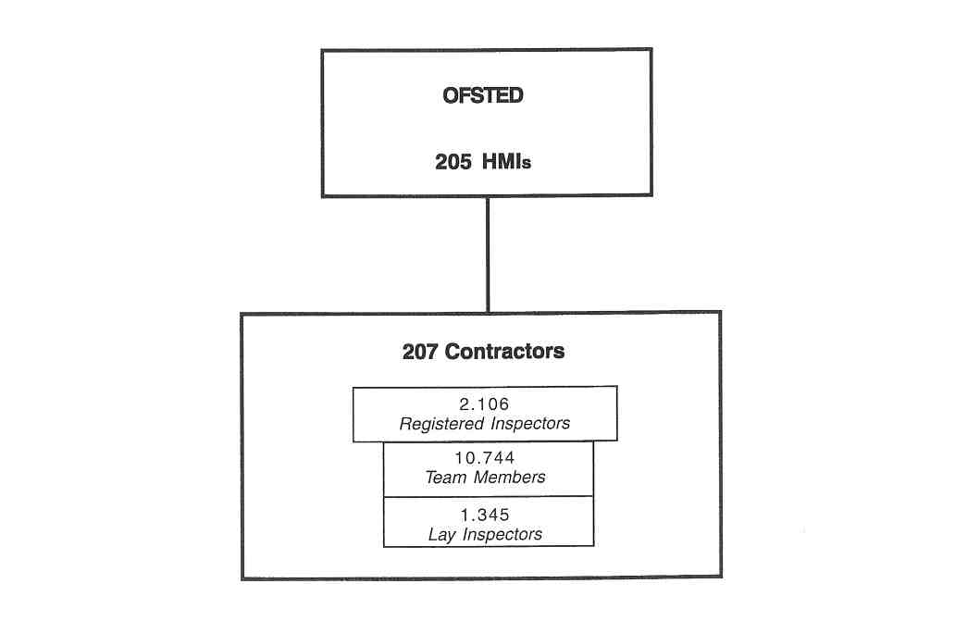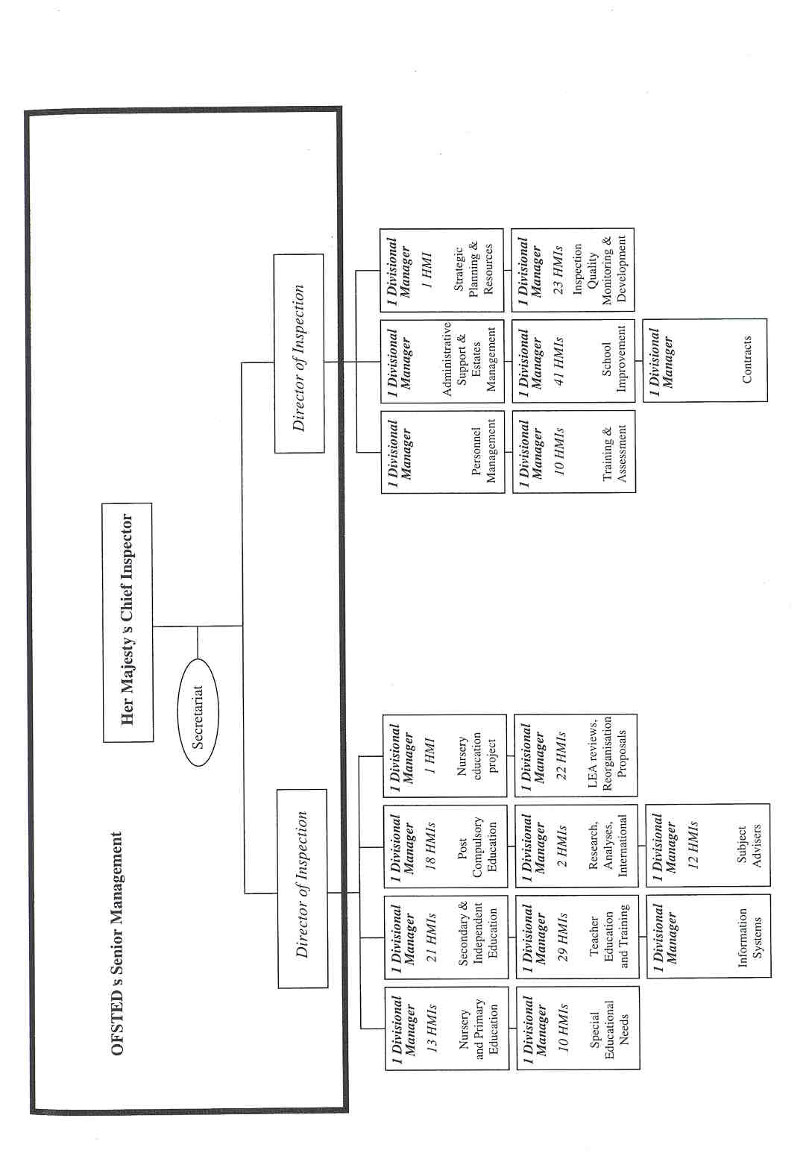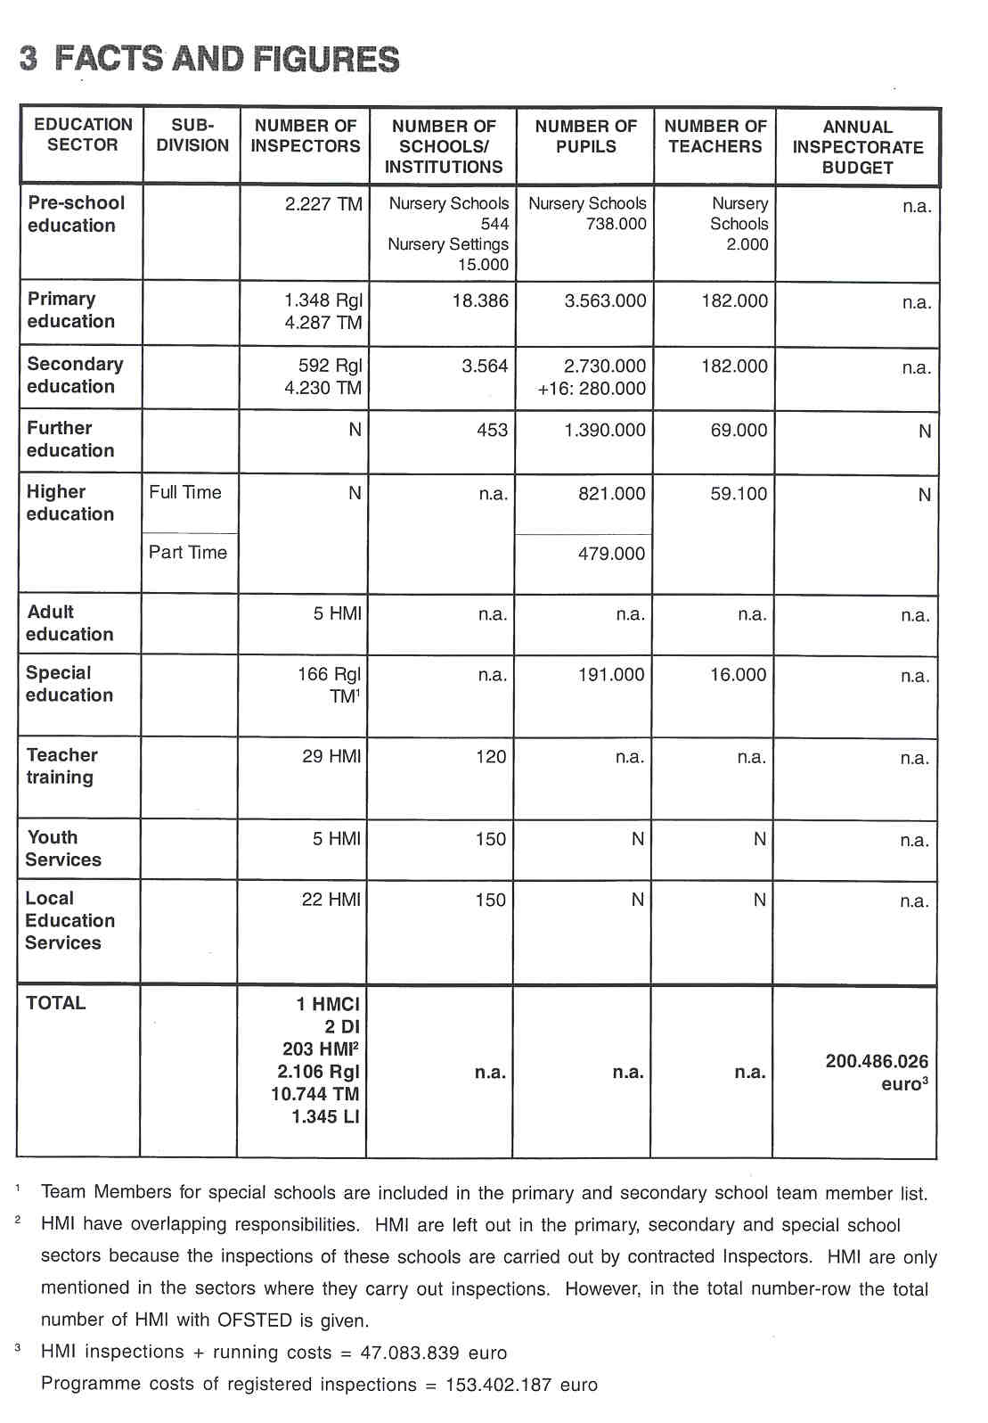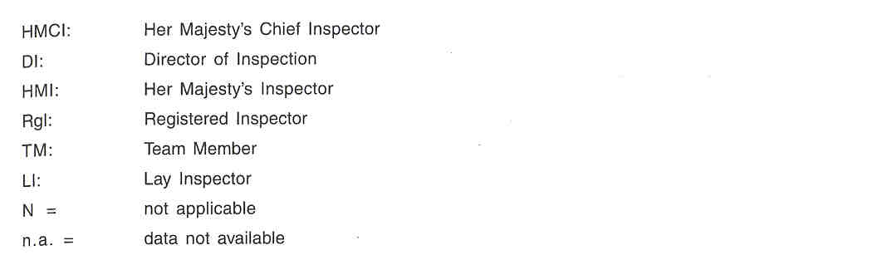

4 THE RECRUITMENT OF THE INSPECTORATE

To become a member of Her Majesty's Inspectorate subject expertise for the relevant post and good ten years of experience are required. In general, senior management expertise in educational institutions or organisations that lasted 3 years is also required. There is no recruitment test but a minimum of one interview with 3 senior members of OFSTED. HMI are recruited through fair and open competition on merit, in accordance with Civil Service recruitment procedures. Recent competitions resulted in more than 400 applications for approximately 10 posts.

- For contracted Inspectors the following recruitment conditions concerning the educational background and required years of experience are standing:
- For Team Members: teaching qualification in a specific subject and a compulsory 5 day training followed by 1 day of assessment on 5 specific competencies.
- For Registered Inspectors: teaching qualification in a subject and meeting requirements for Team Members plus an extra training.
- For Lay Inspectors: no specific qualification but a 5-day training programme including assessment.

The focus of the training course is to see whether the candidates are capable of applying the requirements of the Handbook for the Inspection of Schools. The further week training of Registered Inspectors involves working alongside Her Majesty's Inspectors during a real school inspection.

5 THE WORKING CONDITIONS OF THE INSPECTORATE

The job of HMI is a full time function. In the vast majority of cases Her Majesty's Inspectors are permanently appointed. Permanency is the traditional method of appointment to the Civil Service. Recently however fixed-terrn contracts have been used to increase flexibility.

Registered Inspectors are re-registered every five years depending on the track record of the inspector. The activity of individual inspectors varies greatly. A market system operates so that employment of inspectors depends on the state of the market.

6 AREAS OF INSPECTORATE RESPONSIBILITY

The 1992 Education (Schools) Act introduced a statutory system of independent school inspection and

changed the role of the national Inspectorate. Afterwards Parliament has passed a series of Acts, which shape OFSTED's work. The purpose of OFSTED is to improve standards of achievement and quality of education through regular independent inspection, public reporting and informed advice.

OFSTED's principal task is the management of the independent system of school inspection (regular inspection of ail schools in England that are wholly or mainly state-funded). The different areas of Inspectorate responsibility towards the mentioned educational levels are further illuminated in what follows. The responsibilities of the contracted Inspectors are mentioned as well.

6.1 EVALUATING

Full Inspections by Contracted Inspectors

Full inspections of primary, secondary and special schools are carried out by Registered Inspectors. Under section 5 of the Nursery Education Act of 1996, OFSTED is also responsible for regulating a system for inspecting publicly funded nursery education. These inspections are conducted by Registered Nursery Education Inspectors (RgN]s) and are regulated in a similar way to school inspections.

Evaluation of entire schools forms the focus of the full inspection. Full inspection requires Inspectors to evaluate and report on 4 key elements:

- the quality of the education provided by the school;
- the educational standards achieved in the school;
- whether financial resources made available to the school are managed efficiently; and
- the spiritual, moral, social and cultural developments of pupils at the school.

OFSTED has developed a uniform Framework for the Inspection of Schools and various Handbooks for the Inspection of Schools to evaluate virtually every major aspect of the work and life of the school in a reliable, valid and consistent way. In order to reach a judgement on the 4 key elements full inspections by contracted Inspectors include the evaluation of the following aspects:

a. Apects of the School

Educational Standards Achieved by Pupils at the School
- Attainment and progress focuses on the first priority of inspection: to determine what pupils know, understand and can do, and how this compares with national standards or expectations; and to evaluate their progress.
- Attitudes, behaviour and personal development constitutes pupils' response to what the school offers through its teaching and other provision.
- Pupils' attendance

Quality of the Education Provided
- Teaching is the major factor contributing to pupils'attainment, progress and response. Thorough evaluation of its quality and its impact on the educational standards achieved by pupils is, therefore, central to the inspection. Inspectors evaluate and report on the quality of teaching rather than on individual teachers.

This is graded on a 7-point scale. These grades are fed back to individual teachers and to the Head Teacher in confidence. More generally, Inspectors evaluate and report on the quality of teaching in the school, and its contribution to pupils' attainment and progress.
- The curriculum and assessment involves evaluation of how the school provides and assesses a full range of learning experiences in order to promote the attainment, progress and personal development of all pupils. Inspectors must evaluate and report on the planning and content of the curriculum and its contribution to the educational standards achieved by all pupils, taking account of age, attainment, gender, ethnic background and special educational needs. This includes references to personal and social education, covers education and guidance, extra curricular activities including sports and procedures for using pupils' attainment.
- The spiritual, moral, social and cultural development of pupils is concerned with four aspects of personal development in which schools have an important role to play.
- Support, guidance and pupils' welfare focuses on the provision the school makes to enable all pupils to take full advantage of the educational opportunities offered, to feel secure and to have high but realistic expectations of themselves.
- Partnership with parents and the community explores the links which can strengthen the support and guidance of pupils, enrich curricular opportunities and help pupils to progress.

The Management and Efficiency of the School

- Leadership and management is concerned with how well the governors, head teachers and staff with management responsibilities contribute to the quality of education and the educational standards achieved by pupils. The Framework of Inspection requires Inspectors also to evaluate the extent to which the school meets the statutory requirements to teach the subjects of the National Curriculum, religious and sex education, where these apply. They also evaluate and report on the extent to which the statutory requirements are met by the governing body in areas such as information to parents in school brochures, admissions policy, and health & safety matters.
Inspectors must evaluate and report on how well the school monitors and evaluates its work and development. However this is not a strong component of inspection. Self-evaluation is not used as part of the inspection process.
- Staffing, accommodation and learning resources is concerned with the adequacy of the school's resources and their impact on standards and quality.
- Τhe efficiency of the school calls for an evaluation of the efficiency and effectiveness with which the school manages its resources including the use made of specific grants and the use made of funds to pupils with special educational needs and the extent to which the school provides value for money In that sense the budget-financial management is evaluated. This evaluation of the efficiency of financial control and school administration is however not an important focus of inspections.

b. Curriculum Areas end Subjects

Inspectors are not only required to evaluate and report on the different aspects of the school but also on each of the National Curriculum subjects and religious education. There is a strong emphasis on this evaluation. Some schools are inspected under specific contracts which stipulate particular subjects or courses that will be evaluated and reported on.

For nursery education this inspection includes pupils' attainment and progress in relation to the following areas of learning: linguistic & literary, mathematical, scientific & technological, creative & aesthetic, physical, human & social, moral & spiritual areas of learning.

In prirnary education the organisation of the curriculum varies from school to school. Often, subjects are irnbedded within themes or topics. It is important, however, to evaluate the subjects of the National Curriculum. With the exception of English, mathematics and science Registered Inspectors are free to group subjects for reporting purposes.

In secondary schools a separate report must be written on each subject. In cases where subjects are grouped, a clear evaluation of each subject must be included.

Inspections by HMI

OFSTED's HMI are responsible for the inspection of initial teacher training, Local Education Authorities, independent schools and LEA provided adult education and youth work. HMI also carry out inspections using Frameworks. But these frameworks are very different from the Framework used in contracted inspections.

- Based on the Teacher Training and Higher Education Act 1998 the Teacher Education and Training Team of OFSTED inspects initial Teacher Training.
- HMI & OFSTED inspect Independent Schools for the purpose of registration.
- Under Section 39 of the Education Act of 1997, OFSTED is responsible for inspecting on LEAs support for raising standards. The aim of these inspections is to review the way LEAs perform their functions and in particular, to determine the contributions which LEA support, including support to individual pupils, makes to school improvement. A Framework for the Inspection of LEAs has been published. These inspections are carried out by HMI with the assistance of the Audit Commission. The Audit Commission was established in 1983 and is responsible for appointing auditors to local authorities such as health and education.
- OFSTED's Post-Compulsory Education Team inspects on LEA provided further education (adult education and youth work), education in prisons and Young Offender Institutions.

Aspect Evaluations

OFSTED also has other evaluation tasks such as aspect evaluations. These inspections use some information from contracted inspections but they mainly rely on HMI inspection visits (often 1 day visits). HMI inspect schools for survey purposes such as to evaluate the National literacy Strategy. This is usually done by analysing the information of a large amount of schools that is available from the database of OFSTED. That way a selection can be made of some very good and some defective schools for instance with regard to aspects of mathematics. Such a sample of schools is used by the Inspectors of OFSTED to make specific evaluations.

The Post-Compulsory team in OFSTED has recently inspected the GCE A-Level examining system and continues to inspect the GNVQ assessment system. This inspection was carried out by a specifically designed inspection by HMI.
6.2 MONITORING (BY OFSTED)

Monftoring Contracted Inspectors

The principal duty of OFSTED is to establish and maintain the system for the regular inspection by independent inspectors of all state-funded schools in England. To do this the HM Inspectors have the following responsibilities with regard to the members of school inspection teams:

- Approving the training of Registered Inspectors, professional Team Members and Lay Inspectors.
- Establishing and maintaining a register of 'fit and proper persons' who may conduct inspections under the School Inspections Act 1996, HMCI can impose general or specific conditions on an inspector's registration. The monitoring activities of the HMis are written down and sent in confidence to the Registered Inspectors. The letter indicates strengths as well as areas for improvement concerning:
- planning of the inspection;
- management of the inspection;
- professional knowledge and judgement;
- oral and written communication.

- Giving guidance to Registered Inspectors on inspection and reporting; this guidance focuses on the use of the Framework for Inspection, but also gives advice on a very wide range of technical and qualitative issues arising from inspection.
- Keeping under review the standards of inspections and of reports made and the extent to which statutory requirer-nents are being met by the Registered Inspectors.

Construction of the Database

The Research & Analysis team in OFSTED constructs a database using data from contracted inspections, together with data provided by the DFEE. The data are used to provide a national position of standards and quality and to produce Pre-inspection Context and School Indicator reports (PICSI reports) for inspectors and more recently Performance & Assessment Reports (PANDA reports) for schools and for LEAS. Contracted inspections use evidence from national examinations to form judgements on standards. OFSTED's powerful database is also used to analyse text and data from inspections, in particular for HMCI's annual report.

Disseminating Good Practice

OFSTED does not develop educational materials. It does, however, aim to promote the improvement of educational standards and quality by disseminating good practice e.g. by means of publications. OFSTED has produced, for example, "Arts and Young People Initiative: Good Practice", "Good Practice in Planning and Assessment - Case Studies", and "Videos and Guidance on Literacy and Numeracy Lessons".

6.3 ADVISING

Contracted Inspectors

Contracted inspections provide evaluation rather than advice. A closer look at the everyday practice of the work of education inspectors demonstrates however that during the school inspection and certainly in the discussion on the draft report with the school management, advisory work is 'dealt with quite naturally'. During the oral discussions informal advice might be given to teachers. In the written report one could interpret the "key issues for action" as a kind of advice too.

OFSTED

OFSTED gives advice and works together with a number of bodies, organisations and groups to help to raise educational standards:

- HMOI has the duty to provide advice on a range of specific matters based on inspection evidence. The Secretary of State sets out the areas on which he wishes to receive advice (e.g. standards in youth work, travellers and inter-cultural education, standards of literacy,
- OFSTED also advises the Secretary of State on the quality of initial and subsequent teacher education and training. It also offers inspection-based advice to the Teacher Training Agency (TTA) on primary and secondary initial teacher training provided by specific teacher training institutions and providers.
- OFSTED retains close links with DFEE and the Qualifications and Curriculum Authority (e.g. by advising on the input of policy and quality of students). OFSTED also works closely with the Further and Higher Education Funding Councils in England.
- OFSTED also advises on statutory proposals for school reorganisation and significant changes of character, on independent schools for registration purposes and also independent and special schools for registration and approval purposes.
- OFSTED advises on the development of national examinations, for example, based on inspection exercises and evaluations carried out on the examination process and the standards being set.
- OFSTED also provides advice on the Service Children's Education Agency on the quality of education provided in an agreed sample of their schools. OFSTED also continues to give advice on European Community schools.

OFSTED works in conjunction with a wide range of bodies, organisations, and groups that have a stake in education in a number of ways.

- OFSTED works in co-operation with those who represent the various interest groups in the sphere of education such as teachers, governors, parents, head teachers and others to improve the inspection system. Representative groups are directly involved in the process of consultation. For example, OFSTED has been working together with the Committee of Vice Chancellors and Principals (CVCP) to clarify working arrangements for the inspection of teacher training institutions.
- OFSTED works together with a number of other Government Departments and with other public bodies on inspections of institutions where education is provided to ensure a co-ordinated approach. For example, OFSTED's inspections of LEAs are conducted with the assistance of the Audit Commission: the latter's audit expertise complementing OFSTED's professional knowledge of education. OFSTED also works together with the Home Office when inspecting educational provision in prisons and with the Social Services Inspectorate when inspecting secure units.
- OFSTED has close links with OHMCI (Wales) and with OFSTED's counterparts in Scotland and Northern Ireland. Furthermore, OFSTED has contact with lnspectorates in other countries.

6.4 REPORTING

Reports on Inspections of Schools/institutions/organisations

Contracted Inspectors as well as HMI report on the results of their inspection work in (independent) schools and institutions providing primary education, secondary education, special education, initial teacher training, publicly funded nursery education, and LEA provided further education (youth work and adult education) and in LEAS.

Statistical Reports on Schools and LEAs

OFSTED provides schools and LEAs with relevant statistical analysis drawn from inspection and other data, complementary to inspection. Every primary and secondary school has been provided with a Performance and Assessment Report (PANDA) which provides each school with its assessmentlexamination and inspection judgement data. These data are compared with national norms and with the data relating to schools with similar pupil intakes. Every LEA has also been issued with a statistical profile which performs a similar function for LEAs as PANDAs do for schools.

Reports on Aspect Evaluations

OFSTED issues a range of publications as a result of research (aspect evaluations) on issues of educational importance which inform the national debate on education matters (e.g. reports requested by the Secretary of State).

Annual Report on the State of Education

Because evaluation of the entire system is considered to be very important, HMCI has the statutory responsibility to produce an Annual Report before Parliament, the government and the public on the state of education. In addition to contracted inspections this Annual Report draws on HMI-led inspections and on research reviews commissioned by OFSTED. The compelling nature of the data influences governments through the public and political debate, for instance with the investment of large sums of money in improving literacy and numeracy teaching.

7 THE ROLE OF THE INSPECTORATE IN EDUCATIONAL POLICY

Her Majesty's Chief Inspector is one of the bodies advising the Secretary of State on preparing the policy. The Secretary of State is appointed by the Prime Minister and is accountable to Parliament for controlling and giving direction to the public education system. He is a member of the Cabinet of the Prime Minister and is assisted by a Minister of State and Parliamentary Under-Secretaries. The Secretary of State is also assisted by the professional and administrative staff of the DFEE and the staff of the
non-ministerial and non-departmental public bodies such as OFSTED and the Qualifications and Curriculum Authority (OCA). The advising function of HMCI is performed through published and commissioned reports and through specific requests.

The educational policy is formulated by the Secretary of State and the DFEE. OFSTED is not directly involved in policy formation 'and decision-making but it does provide advice.

The DFEE also commissions aspect evaluations by HM Inspectors with OFSTED, for example to evaluate the impact of the National Literacy Strategy. These inspections evaluate the policy by providing evidence of standards and quality in schools.

Furthermore the regular contracted inspection of schools provides a strong stimulus to policy implementation.

8 WHO IS IN CHARGE?

OFSTED's work is shaped by legislation. The Parliament has passed a series of Acts that shape its work.

It is the OFSTED directorate who determines the aims and objectives. These are presented in the Corporate Plan together with Criteria for Success. The Department for Education and Employment (DFEE) comments upon OFSTED's aims and objectives but it does not dictate the programme of work or comment upon the advice given to the Secretary of State. OFSTED's aims, objectives and Development Plan have to be agreed with the Treasury before funding is allocated to OFSTED to carry out its aims. The Treasury is committed to a concerted approach to public expenditure.

Team Managers within OFSTED subsequently determine for their division programmes of activities needed to meet the objectives identified with the resources available.

The individual HM Inspectors plan the detail of the inspection projects needed to meet objectives identified and they manage specific projects.
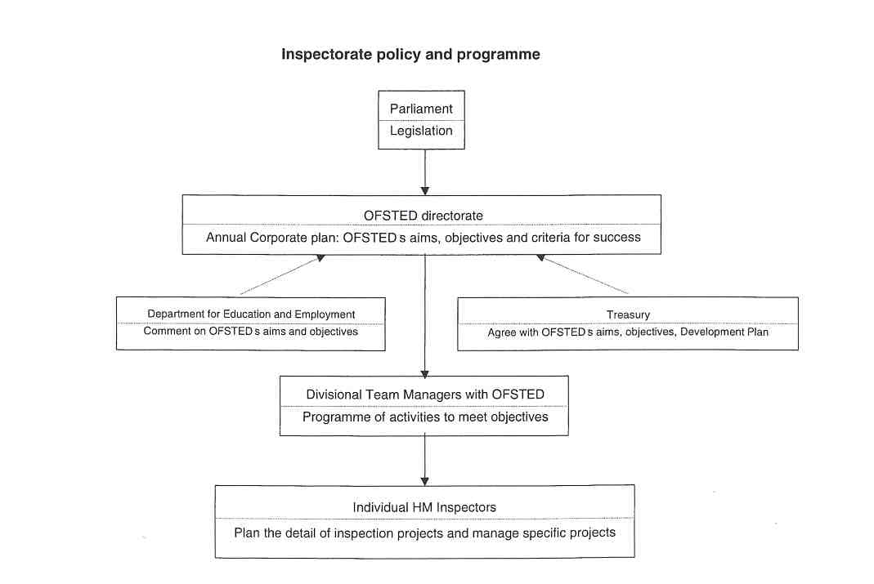
9 THE POSITION OFTHE INSPECTORATE

OFSTED is a non-ministerial government department. It advises the Secretary of State but is not directly accountable to it. If OFSTED needs to be represented in Parliament, this is done by the Secretary of State. HMCI can be called to appear before the Parliamentary Select Committee on Education. OFSTED also provides advice to the Department for Education and Employment (DFEE) that sometimes commissions work from OFSTED. The Inspectorate provides information about the performance and needs of the education system as a whole and about specific deficiencies in the system.

Furthermore, OFSTED provides advice based on the inspections to various organisations, e.g.:

- The Qualifications and Curriculum Authority (OCA);
- Awarding bodies for GCE A-Level and for General National Vocational Qualification (GNVQ);
- Teacher Training Agency on teacher training;
- Home Office on Education in prisons and secure units;
- Social Services on children in care;
- Audit Commission on joint work and Local Education Authorities.

HMI has close links with a wide range of bodies, organisations and groups that have a stake in education, e.g. representatives of teachers, governors, parents, with LEAS, with other (national and international) lnspectorates.

10 THE INSPECTION PROCESS

The first step in the process of full inspection by independent Inspectors consists of OFSTED selecting the schools to be inspected in a particular term.

Because of the market economy there are automatically as many inspectors as needed. OFSTED is able to choose between different inspection contractors on the basis of competition. Thus, for all institutional inspections carried out by Registered Inspectors, OFSTED operates a system of open competition. Once the list of schools to be inspected in a particular term has been decided, contractors are invited to tender for the inspections. Bids are assessed strictly on value for money, taking into account the quality of the proposed team, fitness for purpose, and price.

When the contract has been rewarded OFSTEI) notifies the school and the Registered Inspector contacts the school to arrange a date. At this point the actual inspection process starts.

Teams do differ in their approach, and so the description of the process will not apply exactly in all cases; it does however give a good impression of the methods normally used. The team is led by a Registered Inspector and is usually divided into core members and (ordinary) team members. The core members attend meetings arranged by the Registered Inspector before, during and after the inspection. For each size and type of school the minimum number of inspection-days and guidelines for the composition are prescribed.

PREPARATION PHASE

Schools are informed about one term before the inspection. Recently, the period between the announcement of the school inspection and the inspection itself is out back considerably, to approximately 12 weeks. Prior

to each inspection, OFSTED will provide the Registered Inspector with copies of a Pre-Inspection Context and School Indicator report (PICSI report). This report contains information about the school, pupils, community, curriculum, financial recourses, etc. The Registered Inspector must provide the appropriate authority and the head teacher of the school with a list of the information and documents that are needed.
In addition the Registered Inspector will need to visit the school and prepare for the inspection (called initial visit). All the persons involved are informed about the inspection process, including lesson observation procedures and other aspects of methodology. Some pre-inspection evidence is gathered for the School Profile through discussion with the head teacher, other staff and representatives of the appropriate authority if available.
The Registered Inspectors should also invite the appropriate authority to distribute the parent's questionnaire in order to return it to the Inspector before the meeting with the parents. This meeting, with parents of pupils who wish to attend, is meant to brief them about the inspection and to listen to their views about the school.

On the basis of the information gathered from the school documents, the questionnaire to parents and the first discussions with the school board and teachers the Registered Inspector completes the pre-inspection section of the School Profile. The School Profile contains all questions to be answered during the inspection. The final preparatory activity is the informing of the inspection team by the Registered Inspector. Besides the discussion of all the information available, a planning of the responsibilities and tasks is involved.

SCHOOL PHASE

The inspection usually takes 1 week's (3 to 10 days) presence in the school by 3 to 8 Inspectors. In addition to inspecting lessons, interviews are arranged with key staff to discuss matters that cannot be assessed by observation, or in order to seek further evidence. The validity of the inspection findings requires that a sufficient and representative sample of the work of the school should form a major part of the evidence base.
The instruments and methods used are discussed below (see 11).
As the week progresses, a consensus view starts to emerge regarding the strengths and weaknesses of the school, and regarding the tone that the report should take. Points requiring further investigation and evidence are identified.
The Registered Inspector should ensure that the overall judgements about the school command the agreement of the inspection team. These corporate judgements can most easily be reached through discussion involving all team members towards the end of the inspection. If necessary the Registered Inspector has the final word an judgements to be included in his or her report. During the discussions the Registered Inspector and the team should also determine whether a school requires special measures.
Towards the end of the week oral feedback is provided to those with significant responsibilities.

REPORTING PHASE

At the end of the inspection, meetings are held between the Registered Inspector and the head teacher and any other staff of the school whom the head wishes to invite, normally the school's senior management team. At this meeting an oral report of the main findings is given to the responsible authority (normally the governing body). This provides an opportunity for the school to correct any factual errors and to query the emphasis and interpretations in the draft report. The Registered Inspector then has maximum five weeks to write the final version and a summary of the report.

FOLLOW-UP PHASE

OFSTED carries out a follow up visit in schools with serious weaknesses between 6 and 8 months after the full inspection. Schools requiring special measures have to prepare an Action plan. When the Action Plan is agreed upon HM Inspectorate visits the school within 6 months and, if necessary, until they judge that the school is providing pupils an acceptable standard of education.

11 INSTRUMENTS AND METHODS

THE COLLECTION OF INFORMATION

The evidence base gathered by the Inspectors will need to include a range of methods in order to collect the necessary information. Included are questionnaires, interviews, observations, the collection of documents and the use of data.

a. Ouestionnaires

- A standard form (the Head teacher's Form and Statement) is completed by the Head Teacher to provide information for Inspectors. It contains a minimum core of quantitative data about the school together with the head teacher's commentary on the school which should include a brief description of the characteristics of the school, its pupils, and those features of the area it serves which influence its work.
- A questionnaire is sent to all parents to collect their views of the quality of education provided by the school.

b. Interviews

- Inspectors meet with parents before the inspection and invite parents to give their views on the quality of education provided by the school.
- During the inspection, Inspectors interview the Head Teacher, senior managers and teachers about standards and quality.
- Inspectors also interview pupils to judge standards of achievement and the impact of provision.

c. Observations

- In contracted inspections lessons are inspected. Judgements are made of the quality of teaching, pupils' response, attainment and progress. The Inspectors are obliged to spend 60% of their available time in the classroom.
- A sample of the pupiis'work is also inspected. Pupils are observed in class and around the school. For instance information is gathered concerning their participation in extra-curricular activities, concerning the interaction between pupils and staff. This provides key observation information for the evaluation of pupils' attainment.

d. Tests/lexaminations

Inspectors use data in public lists of examinations to inform the judgement of attainment and progress. And they also use results from any standardised tests, for example of reading, which the school provides.
Pupils are interviewed by Inspectors and their written work is analysed, but no tests are set.

c. The Collection of Documents

Inspectors draw on a wide range of evidence including test and examination results, school development plans, timetables, records on behaviour and sanctions, school policies and schemes of work. Inspectors should also read the annual report to parents. Inspectors also use results from any standardised tests, for example of reading, which the school provides.
OFSTED has deliberately limited the amount of documents that Inspectors should ask for in order to reduce the pressure that inspection causes.

f. Use of National Data

For contracted inspections OFSTED provides a Pre-inspection Context and School Indicator (PICSI) report which contains key performance data about the school from earlier years to enable trends to be identified. It also includes information about the social and economic characteristics of the school area and comparative data to help Inspectors set the school data in a national context.
Public lists of examinations are also used to inform the judgernent with a national comparative perspective.

APPROACHES

a. Instruments

Instruments for Contracted Inspectors

OFSTED has designed a Frarnework for the Inspection of Schools to provide a consistent approach to inspection and to assure the standard of inspection visits. The purpose of the Framework is to secure consistency, comparability and a high standard of school inspections. It is designed to meet the specific needs of the inspection exercise and sets out the obligations of independent Inspectors. OFSTED wants to keep the framework straightforward otherwise it will be unmanageable for both the Inspectors and the schools. The Framework defines the standards inspections have to meet, outlines the procedures to be used, and prescribes the inspection schedule. This schedule sets out the matters to be inspected, indicates the sources of evidence to be taken into account, provides criteria by which evidence is to be evaluated, and lays down the format and content of the report. The same Framework is used for inspections by independent Inspectors in nursery, primary, secondary and special education.

But there is more detailed and separate guidance for the different education sectors on all aspects of inspection in the various OFSTED Handbooks for the Inspection of Schools. Each Handbook contains the Framework and guidance on the use of the Framework. The Handbooks also deal with guidance on the organisation of the inspection, the arrangements for reporting and the returns which have to be made to OFSTED. Moreover, the guidance supports Inspectors in arriving at their judgements of quality. It sets out amplification of the criteria which should be used to distinguish between good and poor quality across the full range of inspection matters, indicates the issues to be considered when reviewing the evidence, lists the factors to be considered in reaching a judgement, and notes particular features of the interpretation of the Framework in different contexts. This guidance covers basic information about the evaluation of:
- schools;
- teachers and pupils;
- standards of achievement and quality of learning; • efficiency of the school;
- pupils' personal development and behaviour;
- subjects of the curriculum and other curricular provision;
- and a series of other factors contributing to these findings.

During the inspection process inspectors reach an evaluation based on gathered evidence. In order to reach professional judgements and evaluations they are helped by criteria. Criteria are quite similar to indicators, but in England the term 'indicator' is normally used to refer to quantitative evidence such as attendance or test results. The criteria amount to standards for good practice. They provide Inspectors with a basis for accurate and consistent evaluation and they underline the weaknesses and strengths of a school. In the different Handbooks guidance is provided for the Inspectors to use the criteria as a source of reference to evaluate and report on virtually every major aspect of the work and life of the school. As an example we describe some criteria of the quality of teaching. Teaching quality is to be judged by the extent to which:
- teachers have clear objectives for their lessons;
- pupils are aware of the objectives;
- teachers have a secure command of the subject;
- lessons have suitable content;
- activities are well chosen to promote learning of that content;
- teaching methods engage, motivate and challenge all pupils, enabling them to progress at a suitable pace, and to be aware of their achievements and progress.

The Framework is publicly available, as are the Handbooks of Inspection.

Instruments for inspections by HMI

Inspections by HMI are also carried out by using frameworks (e.g. Framework for the Inspection of Independent

Schools, Framework for the Inspection of LEAS), but these are very different from the Framework used in contracted inspections.

There are also separate guidance for inspecting independent schools, youth work, adult education, initial teacher training and Local Education Authorities.

b. Team Work

- Contracted Inspectors always work in teams, depending on size and plan of school; approximately 3-6 for primary schools and 5-14 for secondary. However, during the inspections of Nursery education the Registered Inspector works individually
- In Initial Teacher Training inspections the HM Inspector works in a team of 3 or 4 for primary providers and 2-1 1 for secondary.
- Local education Authorities are inspected by a team of Her Majesty's Inspectors.

12 JUDGEMENT AND ITS CONSEOUENCES

JUDGEMENTS

Inspectors grade aspects of standards and quality on a 7-point scale; 1 represents excellent, 7 represents very poor. However, the Inspectors do not provide an overall grade for the school. About 10% of schools are judged to have serious weaknesses and about 2% have been made subject to special measures (they are failing schools).

CONSEQUENCES OF THE POSSIBLE JUDGEMENTS

Schools which receive very favourable reports may be named in HMCI's Annual Report. They are considered for 'Beacon School' status and can then receive extra funding to disseminate good practice.
Schools which receive poor evaluations can be declared to have 'serious weaknesses'. They would merit follow up visits by HM Inspectors.
Failing schools are declared as needing 'special measures'. Formal action then follows which can result in closure if no improvement follows.

13 OUTCOMES

Different kinds of reports are published by the Inspectorate. More specifically the Inspectorate publishes reports on individual schools, on other educational institutions and on the education system.

REPORTS ON INDIVIDUAL SCHC)C)LSANSTITUTIC)NS

Reports of Full Inspections by Contracted Inspectors

All Inspectors report on compliance with statutory regulations and on the quality of teaching. The proportion of lessons judged to be excellent or very good, and the proportion judged to be satisfactory or better is stated in the report. Grades for individual teachers are repeated in confidence to the Head Teacher and to the teacher concerned.
All contracted secondary reports contain a section on each subject of the national curriculum and sections on the particular branches of study identified in the framework. In addition some contain sections specifically commissioned for that inspection.
Inspections evaluate and report on how well the teaching and curriculum are monitored, evaluated and supported and how well the school identifies relevant targets and monitors and evaluates its progress towards them.
The idea is that parents and others involved in the school will use the report as a basis to put pressure on the school management to introduce improvements; or else children will be removed from the school and no more students will be enrolled.
The elements described in the report can be made more explicit by illuminating the general structure of the report:

- Introduction (e.g. basic information about the school); • Main findings and key issues for action;
- Standards and quality (e.g. standards of achievement, quality of learning); • Efficiency of the school (e.g. use of resources);
- Pupils' personal development and behaviour (e.g. pupils' spiritual, moral, social and cultural development behaviour and discipline);
- Subjects of the curriculum and other curricular provision (e.g. English, Mathematics, Science, Music, etc.);
- Factors contributing to these findings (e.g. quality of teaching; assessment, quality and range of the curriculum, equality of opportunity, provision for pupils with special educational needs, management and administration, etc.).

All contracted inspection reports are addressed to the appropriate authority This is normally the Governing Body of the school. The Registered Inspector also produces a summary of the report. This is sent to the appropriate authority and the school. It is their responsibility to communicate this to the parents of every pupil. Individual teachers have access to the Inspector's full report and the summary report. Inspectors provide oral feedback to individual teachers and inform them of their grades which are also given in confidence to the Head Teacher. These grades are not published.
Published OFSTED reports are available through Her Majesty's Stationary Offices. Inspection reports are public documents and the Governing Body of the school must make arrangements for the dissemination of the summary and of the full report to designated individuals and bodies. The school should send full copies of the report to the local media and to local libraries. A full copy of the report must be available in the school and photocopies of the full report must be supplied on request and on payment of a small fee. The wider public has access to contracted inspections through the lnternet (www.ofsted.govuk).

Reports on HMI-led Inspections

HMI report on the results of their inspection work in of teacher education, independent schools, and LEA- provided further education (youth work and adult education). For example, OFSTED produces reports for the Teacher Training Agency and for each of the training institutions inspected. Reports on Primary and Secondary teacher training courses are available on OFSTED's website.

Statistical PANDA Reports on Schools

OFSTED provides schools and LEAs with relevant statistical analysis drawn from inspection and other data, complementary to inspection. Every primary and secondary school has been provided with a Performance and Assessment Report (PANDA) which provides each school with its assessmentlexamination and inspection judgement data. These data are compared with national norms and with the data relating to schools with similar pupil intakes. Schools find these PANDAs useful as a starting point for self-evaluation. Each LEA has been provided with the PANDAs for all of its maintained primary and secondary schools.

REPORTS ON ASPECT EVALUATIONS

HMis in OFSTED carry out a range of surveys on issues of educational importance and OFSTED publishes reports on the outcomes of this research (e.g. "Using subject specialists to promote high standards in Primary Schools"; "Setting in Primary Schools") to inform the national debate on education matters. OFSTED issues a range of publications as a result of research (aspect evaluations) on issues of educational importance which inform the national debate on education matters.

REPORTS ON C)RGANISA7IC)NS

Reports on HMI-led lnspections of LEAs

After the inspection of Local Education Authorities HMI produces reports, which evaluate the effectiveness of the advisory service provided by each LEA to schools, and the effectiveness of their support for school improvement. These reports identify the strengths and weaknesses of the LEA and provide recommendations for how the LEA's work can be improved. Reports on LEAs inspected are sent to the Secretary of State and to the LEA concerned. OFSTED intends to publish LEA inspection reports an the website in the future.

Statistical Reports on LEAs

Every LEA has also been issued with a statistical profile which performs a similar function for LEAs as PANDAs do for schools.

REPORTS ON THE EDUCATION SYSTEM

HMCI's Annual Report presents a national overview of standards and quality in education. This report briefly outlines the good and bad developments on the basis of the large amounts of data (including statistical data). It contains a commentary on some of the issues of importance and a more detailed section on the evidence from the year's inspections across the range of matters which fall within the remit of HMCI. The annual report draws on three sources of evidence: inspections carried out by Registered Inspectors, inspections carried out by HMI and research commissioned by OFSTED (e.g. homework in schools). It also lists the best schools and provides examples of 'good practice'.

HMCI's Annual Report is laid before Parliament and available to the public through Her Majesty's Stationary Offices. In 1998 the report was sent to all state primary and secondary schools. Other reports commissioned by the Department for Education and Employment are also published.

14 FOLLOW-UP PROCEDURES

All contracted inspection reports contain a set of Key Issues for Action. It is the responsibility of the appropriate authority for the school to submit an Action Plan or to ensure that this is implemented.

If schools are identified as having serious weaknesses, the Registered inspector notifies OFSTED who will carry out a follow up visit between 6 and 8 months after the inspection.
When a school is identified as requiring special measures the Registered Inspector also notifies OFSTED. The judgement of the Registered Inspector has to be confirmed by HM Inspectorate. The appropriate authority - usually the school governing body- must prepare an Action Plan within 40 working days of receipt of the inspection report. The Action Plan must set out what the authority proposes to do in the light of the report's findings, together with the time-scale and the person responsible for monitoring such action. The Action Plan must be sent, within 5 days of its completion, to parents, to OFSTED and to DFEE.
When the Action Plan has been agreed upon the school implements it. HM inspectorate will visit the school within 6 months and, if necessary, termly until they judge that it is providing pupils with an accomplished education.

15 INSPECTORS AS ARBITRATORS

In contracted inspections, Inspectors hold a meeting to which parents are invited. Parents are also sent a questionnaire to complete. They are asked to express their level of satisfaction with various aspects of provision but they are specifically asked not to comment on individual teachers.

in all contracted inspections, Inspectors interview pupils individually and in groups. They are invited to comment on quality of provision in the school, but are equally specifically asked not to comment on individual teachers.

Inspectors do not function as arbitrators. There is no formal complaint procedure for teachers concerning the head teacher or governing bodies. Teachers can however raise any matters of concern with Registered Inspectors, who will interpret them in the light of other Inspectors' evaluations. Complaints about Head Teachers and governing bodies are uncommon, probably in only one in ten inspections.

If an individual has complaints about schools, they lodge these with the responsible authority, the LEA or the DFEE.

There is however a formal complaint procedure concerning the inspection itself. OFSTED considers complaints from schools, LEA'S, parents and other interested parties about the quality of inspections and inspection reports.

16 THE INSPECTORATE AS AN ACTOR IN PUBLIC DEBATE

OFSTED has a high public profile. OFSTED's aims are published in the Corporate Plan. One of the aims of the Inspectorate is to promote the improvement in educational standards and quality by disseminating good practice, by publishing reports based on inspection findings and by stimulating and contributing to public debate. This includes lectures, articles in newspapers and media interviews given by HMC]. The Chief Inspector gives radio and television interviews on matters relating to the inspection work. Individual HM Inspectors and contracted Inspectors are allowed to act in public debate on education and education policy. HMI frequently give talks and contribute to conferences. That is part of OFSTED's objectives.

17 THE EVALUATION OF THE INSPECTORATE

EXTERNAL EVALUATION OF THE WORK OF CONTRACTED INSPECTORS BY OFSTED

The inspector "Quality Monitoring and Development Team" in OFSTED monitors and evaluates the performance Of Registered Inspectors. They do this by visiting inspections, attending team meetings, interviewing Head Teachers and other teachers and finally by reading the reports.
OFSTED also sends questionnaires to all schools following an inspection to find out if they were satisfied with the inspection and the report. The questionnaire is returned to a special department of OFSTED. Analyses of this material showed that 94% of the schools generally agree with the outcomes of the inspection and that 97% of inspected schools state that the inspection report was successful in revealing the weak and strong points of that particular school.
OFSTED has also carried out an evaluation of the validity of lnspectors'judgements.

EXTERNAL EVALUATION OF THE WORK OF OFSTED

The work of OFSTED is scrutinised by the House of Commons Select Committee on Education. HMCI is appraised by the Permanent Secretary of the Department for Education and Employment against the objectives that OFSTED has set.

INTERNAL EVALUATION

OFSTED has an internal appraisal system which follows the line-management in the organisation chart e.g. the Directors of Inspection are appraised by HMCI, and HMI are appraised by team managers.

ADAPTATIONS AS A RESULT OF EVALUATION

The OFSTED staff department pays a great deal of attention to the continuous improvement of the quality of the inspections. The Framework and guidelines are adjusted in light of the evaluations. OFSTED also issues regular updates to Inspectors to provide further guidance in methodology.

ADAPTATIONS AS A RESULT OF DEVELOPMENTS IN EDUCATIONAL POLICY

Contracted inspections have been adapted to accommodate new policy developments, e.g. changes to the National Curriculum and the implementation of the national literacy and numeracy strategy.

18 THE INSPECTORATE'S TRAINING AND IN-SERVICE TRAINING

TRAINING OF NEW INSPECTORATE MEMBERS

Contracted lnspectors

Contracted Inspectors are trained by accredited trainers. Her Majesty's Inspector in OFSTED's "Training and Assessment of Independent Inspectors Teams" monitors and evaluates the effectiveness of the training of new members. OFSTED has produced a Quality Assurance Standard for Contractors which sets out the standards expected from Inspectors.

Formerly, the initial training course was the same for both Registered and Team Inspectors, namely a five day residential course either primary or secondary. It covered the essential elements of activities before, during and after an inspection. After completion of the first course there was a second stage for training Registered Inspectors which involved taking part in a HMI-led inspection as part of the team.

Since Septernber 1995 there has been a new style of training for independent Inspectors. The intention is to embody the core principles and major content of the five day HMI course into a more flexible and extended programme. Completion of the course is separate from the OFSTED assessment. The new course is structured in a way that allows for alternative delivery modes and training styles. The emphasis is on distance learning and for those in education who have no inspectionladvisory experience. The total course commitment is approximately 90 hours. The course is run mainly by accredited higher education institutions. Assessment is the responsibility of OFSTED and leads to accreditation as a team member. This separate assessment process lasts for one day at regional centres.

For Lay Inspectors there is a five-day non-residential course. Its overall purpose is to provide the lay person with sufficient guidance to enable them to make efficient use of their time on inspections and to contribute effectively to the tearn. Her Majesty's Inspectors monitor and accredit the trainers who use a detailed training manual to ensure consistency across courses.

HMI

Within their first week at work new HMI receive centrally provided Induction courses which last two days. The aims of these courses are to provide an overview of the work of OFSTED, where the new entrant's work fits in to the corporate objectives, and to explain conditions of employment. Additionally, the divisions that are related to their work will train new HMI.

PROFESSIONAL DEVELOPMENT OF INSPECTORATE MEMBERS

Contracted Inspectors

For contracted Inspectors, contractors have an obligation under the Quality Assurance Standard to keep Registered and Team Inspectors up to date with changes in the system. HMI with OFSTED's "Inspector Quality, Monitors and Development Team" inspect the work of Contractors and the fulfilment of this obligation. Registered Inspectors are required by law to undergo up to 5 days additional training each year.

HMI

Existing HMI use an appraisal system which assess their training needs for the year. The training needs are identified from objectives which are set at the start of the year. Training can take the form of courses, seminars and induction.

19 RECENT OR FUTURE ISSUES AND DEVELOPMENTS

RECENT

The most recent developments have been the inspection of Local Education Authorities, of all providers of Secondary Initial Teacher Training and of government funded nursery education.

FUTURE

The English Inspectors state an inspection eventually boils down to a judgement on a particular school in five 'key factors' which an Inspector should be able to mark yes or no. Obviously, in this judgement all kinds of data will be classified under a much larger number of indicators. The five key factors or key questions are:

- Is the quality of the input sufficient, is the education offered by the school of sufficient quality (including curriculum, the material, the teaching-learning process, the testing)?
- Is the quality of the output sufficient?
- Is the management of the school sufficient with regard to the organisation, finances, efficiency and purposes?
- Does the school create a sufficiently good learning climate?
- Is the school in 'good health', is it continuing to improve, has the development come to a standstill, or is it declining.

The inspection of secondary schools began in September 1993 and of primary and special schools in September 1994. All secondary schools had been inspected by July 1997 and all primary and special schools by July 1998. Since the first cycle of inspections is completed and contracted Inspectors have begun to inspect schools for a second time; OFSTED is consulting on possible changes to the inspection system for good schools. OFSTED is presently considering whether the same inspection is needed for all schools or whether the inspection should be adjusted according to the performance of schools as measured by the previous Inspector's report and a small set of Performance Indicators. OFSTED is considering the idea that for a number of schools a short inspection by a group of Inspectors may be sufficient. An integral school evaluation, as intensive as in the first round, would only be required if the quick scan reveals one or more (serious) weaknesses. This approach provides a link between the problems of the long cycle of,inspecting all schools and those of an elaborate and fairly detailed evaluation framework, creating a practicable compromise. At present OFSTED has produced some proposals regarding this matter and is consulting on them.

20 LITERATURE

CARPENTER, B. & STONEHAM, C., Inspection effectiveness: an analysis of an OFSTED inspection. British Journal of Special Education, 1994 (21), n" 2, 70-72.

DEPARTMENT FOR EDUCATION AND EMPLOYMENT (DfEE), The DFEE web site. London, DFEE Strategy and Communications Directorate, 1996, http:llwww.dfee.gov.uk/

EURYDICE & CEDEFOP, Structures of the education and initial training systems in the European Union. Luxembourg, Office for Official Publications of the European Communities, 1995, 458 pp.

EURYDICE, The education system in the United Kingdom (England, Wales & Northern Ireland-1998). Eurydice Eurybase, 1999, http:llwww.eurydice.org/Eurybase/Files/UKVOIUKVO.htrn

HOPES, C., Assessing, evaluating and assuring quality in schools in the European Union. Frankfurt am Main, Geselischaft zur Fbrderung P;@dagogischer Forschung (GFPF), Deutsches institut for lnternationale P,@dagogische Forschung (DIPF), 1997, XVII + 211 pp.

OFFICE FOR STANDARDS IN EDUCATION (OFSTED), Corporate Plan 1998. 1 ondon, OFSTED, 1998,30 pp.

OFFICE FOR STANDARDS IN EDUCATION (OFSTED), Framework for the inspection of schools. London, HMSO, 1995, 27 pp.

OFFICE FOR STANDARDS IN EDUCATION (OFSTED), Handbook for the inspection of schools. London, Her Majesty's Stationary Office (HMSO),1993, loose-leaf - not numbered consecutively.

OFFICE FOR STANDARDS IN EDUCATION (OFSTED), The Annual Report of Her Majestyk Chief Inspector of Schools. Standards and Quality in Education 1997198. London, The Stationary Office, 1999, 92 pp.

OFFICE FOR STANDARDS IN EDUCATION (OFSTED), Ofsted web site. London, OFSTED, s.d., http:ll www.ofsted.gov.uk/

OFFICE FOR STANDARDS IN EDUCATION (OFSTED), The Ofsted Handbook, Guidance on the Inspection of nursery and primary schools. London, The Stationary Office, 1 995, 129 pp.

OFFICE FOR STANDARDS IN EDUCATION (OFSTED), The Ofsted Handbook, Guidance on the Inspection of secondary schools. London, Her Majesty's Stationary Office (HMSO), 1995, 138 pp.

OFFICE FOR STANDARDS IN EDUCATION (OFSTED), The Ofsted Handbook, Guidance on the Inspection of special schools. London, Her Majesty's Stationary Office (HMSO), 1995, 136 pp.

QUALIFICATIONS AND CURRICULUM AUTHORITY (QCA), Qualifications and Curriculum Authority. London, OCA, s.d., http:llwww.qea.arg.uk/

ROTH-VAN DER WERF, G.J.M. & STANDAERT, R., Het onderwijs in Engeland en Wales. (Onderwijs in de Europese Unie: eenheid in verscheidenheid.) Leuven-Apeldoorn, Garant, 1997, 88 pp.

STANDAERT, R., Onderwijsinnovatie en -beleid in Engeland en Wales. Leuven, Katholieke Universiteit Leuven, Onderzoekscentrum voor Comparatieve Pedagogiek, 1989, 440 pp.

THOMAS, G., The New Schools' Inspection System; Some problems and possible Solutions. Educational Management & Administration, 1996 (24), n' 4, 355-369.

VAN HOYWEGHEN, Dorothea, lnspectie nieuwe stiji in Engeland en Wales. lmpuls, 1997 (28), nll 1, 9-17.
