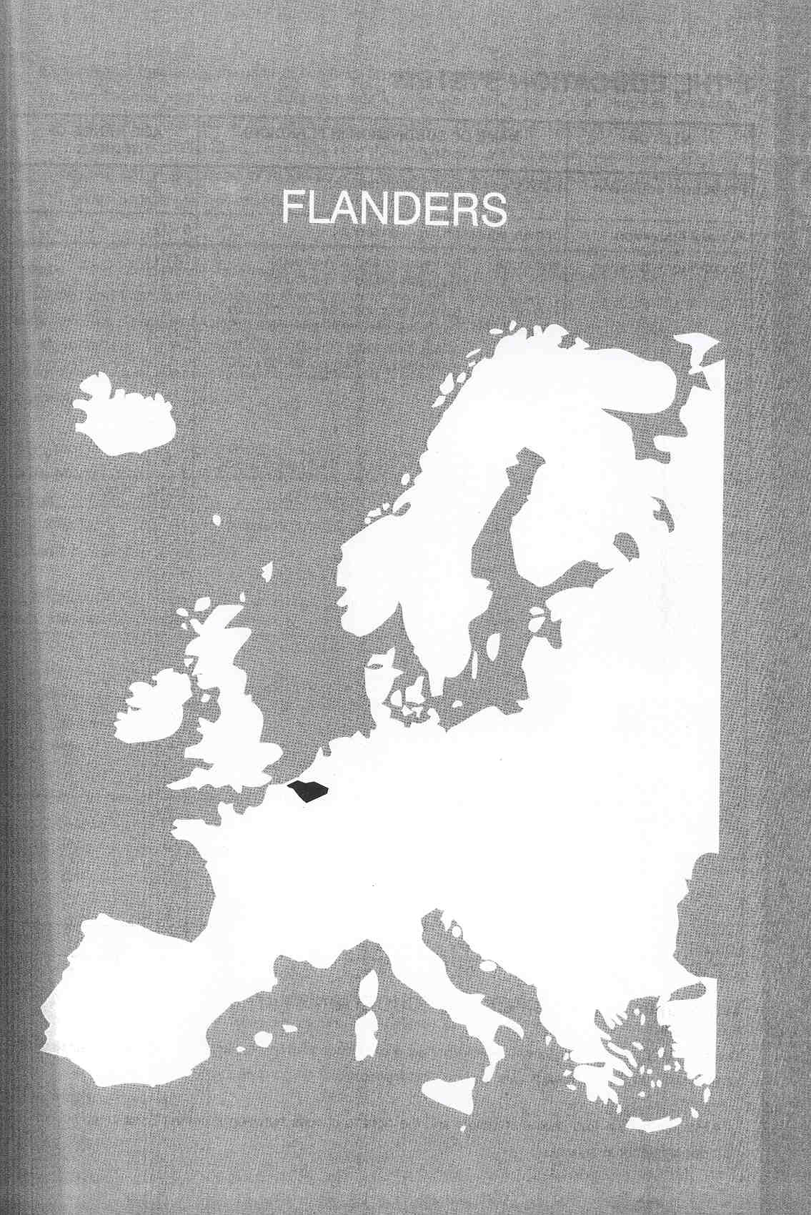

Νίκος Ηλιάδης, Πολ/κός Μηχ/κός Ε.Μ.Π., M.Sc.,
Ph.D. Industrial Education, Organization and Management,
Σύμβουλος του Παιδαγωγικού Ινστιτούτου

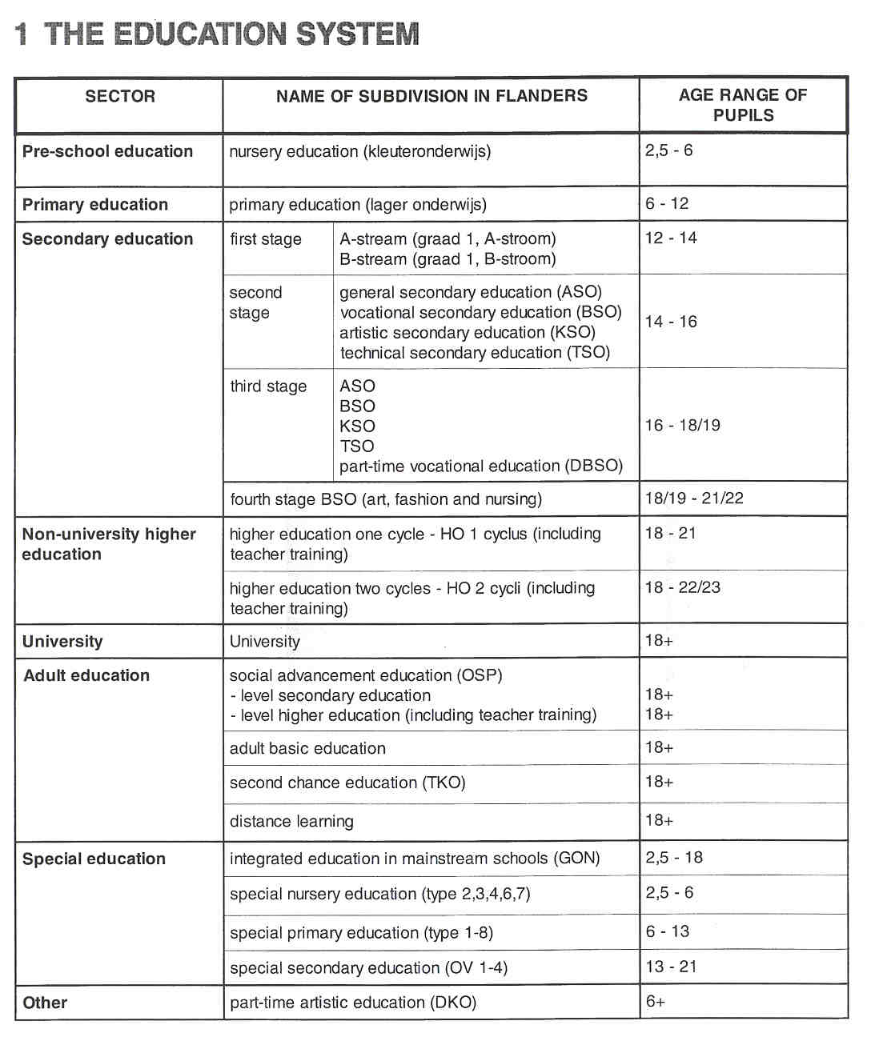

THE ADMINISTRATION OF THE EDUCATION SYSTEM

The Belgian Constitution guarantees the principle of "freedom of education". This principle consists of 2 pillars: "free choice of school" and "educational freedom".
- Parents have a free choice of school and the right to choose between a neutral community school or a denominational school.

- Educational freedom is the right to establish schools autonomously. In Belgium, any natural or legal person has the right to provide education and to establish institutions for that purpose. Freedom of education as a constitutional right renders the organisation of educational networks possible. Traditionally, 3 networks are distinguished: community education (organised by the Flemish Community), grant-aided official education (organised by Provinces and Municipalities) and grant-aided free education (organised by private individuals, free associations, or non-profit organisations).

Since 1970, the unitary Belgian State has been channelled towards a federal state through 4 stages of revision of the Constitution. As a result of this process, there are 3 Communities (the Flemish, the French- speaking, and the German-speaking Community) in Belgium. In the third stage (in 1988-89) almost all responsibilities related to education have been transferred from the federal government to the governments of the Communities. At the federal level, only 3 responsibilities remain: fixing the beginning and end of the compulsory school attendance period, establishing the minimum conditions for granting diplomas, and maintaining the pension system.

The general framework of educational administration consists of 3 major levels: the Department of Education of the Ministry of the Flemish Community, the educational networks and the local schools and their organising bodies. The organising body of a school is the authority, the individual or collective person(s) who have full responsibility with respect to that school. Schools, which may be owned by different organising bodies, are grouped in educational networks.

- The Department of Education of the Ministry of the Flemish Community is responsible for all aspects of education from nursery to university education. The Department finances community education and subsidises the other schools if they meet certain conditions and respect the legislation concerning education. Recently, the Department has been pursuing a policy of deregulation and decentralisation, which implies that less externally imposed rules should result in a greater degree of autonomy and accountability for every school.
- While respecting the legal and statutory provisions, each organising body may determine its own programmes, curricula, pedagogical methods (including the assessment of pupils) and its organisation.
- The educational networks have a strong co-ordinating influence on their organising bodies. For example, they draw up central curricula for their schools based on the compulsory core curricula laid down by the Flemish Parliament. Although an organising body is in principle free to develop its own curricula, most of them choose for the central curricula of their network.

The monitoring of the education system involves an interplay among the different levels of educational administration. Over the last few years attempts have been made to concentrate all internal consultation within one organisation as much as possible. Therefore, the Flemish Education Council is composed of representatives of the organising bodies, unions, parents, university experts, civil servants from the Department of Education, of the social and economic sectors, and recently of pupils as well. The Minister of Education has to seek the opinion of this Council on all preliminary draft decrees (laws of the Flemish Parliament) on educational matters (with the exception of the education budget) and on policy reports and papers addressed to the Flemish Parliament.

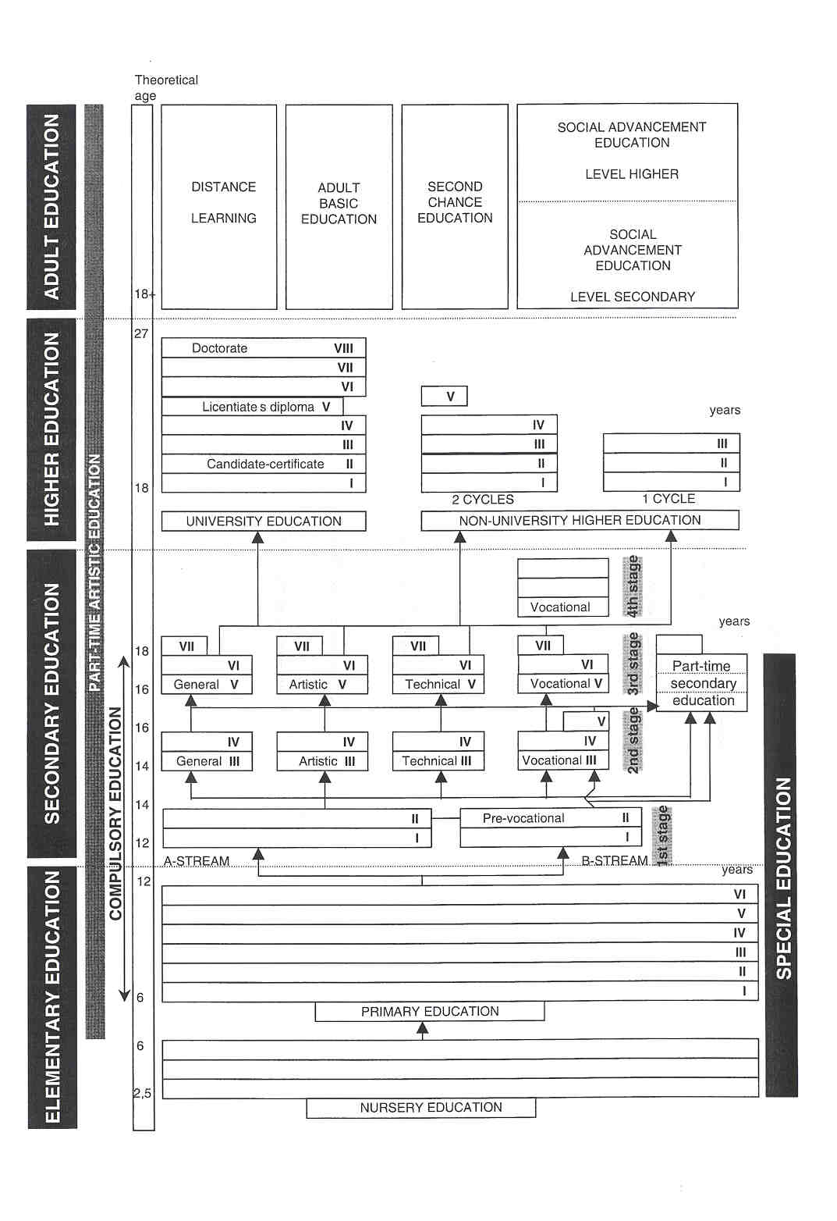

In order to get value for money, the Flemish Community sets certain standards as to the quality of the education provided. Therefore, the concept of "final objectives" was introduced on the level of curricula. Final objectives are minimum aims that must be striven for and reached by the majority of pupils. Subject- specific as well as cross-curricular final objectives exist. The final objectives for primary education and for the first stage of secondary education are already ratified 1by Parliament as requested by law.
As far as nursery school, special education and the B-group of the first stage of secondary education are concerned, the term "developmental objectives" is used: aims a school must strive for as much as possible but need not really achieve.
The final and developmental objectives are formulated by the Department for Educational Development (DVO) and approved by the Flemish Parliament, upon recommendation of the Flemish Education Council (V1. 0. R.).
Final or developmental objectives must be incorporated into the curricula.

There are no state examinations in Flanders. All formative and summative exams and tests are organised by the teacher(s). The class teacher in primary education - often in consultation with the headteacher and sometimes other team members - or the class council in secondary education (the principal and all the teachers of a certain group of pupils) decides whether a pupil has successfully completed a school year. The Government of Flanders recognises the competence of schools to grant certificates.

COMPULSORY EDUCATION

In Flanders school attendance is compulsory for a period of 12 years, starting in the school year during which the child reaches the age of 6 and ending at the end of the school year during which the youngster reaches the age of 18.
Compulsory school attendance is full-time up to the age of 15 or 16, depending on the individual case. However, if pupils leave full-time education when they are 15116 years old, they are obliged to follow part- time education until the end of the school year in which they have their eighteenth birthday.

EDUCATIONAL SECTORS AND SUBDIVISIONS

Elementary Education

Elementary education includes nursery and primary school. Although they are independent from one another as far as structure is concerned, an attempt is made to obtain a smooth transition between both. Nursery school is provided for children aged 2,5 to 6. This education is not compulsory and free of charge. Nearly all children attend nursery school in Flanders.
The core curriculum in nursery as well as in primary education consists of 5 learning fields: physical education, expressive arts, language, environmental studies, and mathematics; in primary education final objectives are also formulated for 2 cross-curricular themes: learning-to-learn and social skills. Normally, there is one teacher for all courses. Sometimes, a special teacher will be appointed for music, physical andlor religious education.
Primary education is meant for children aged 6 to 12. When they finish this cycle successfully, children are granted a certificate of elementary education.

Secondary Education

Secondary education is meant for youngsters aged 12 to 18 and consists of 3 stages of 2 years each.
The first stage can be divided into a mainstream with 85% of the pupils (the A-stream) and a B-stream for the remaining 15%. An elementary education certificate is necessary to enter into the first year A of the A- stream. Pupils who didn't obtain this certificate and pupils who don't seem to have the prerequisites for following the first year A, are admitted into the first year B of the B-stream. They receive education aiming at reintegration into the mainstream (first year) or they are directed towards a vocation-oriented choice of studies (second year).
From the second stage onwards 4 types of education are distinguished: general (ASO), technical (TSO), vocational (BSO) and artistic (KSO) secondary education.
- general secondary education (ASO) offers a broad theoretical training and is intended to facilitate transition to higher education.
- technical secondary education (TSO) provides general and technical-theoretical subjects, concentrating on the practical application of theoretical knowledge. It prepares for an occupation as well as for higher education.
- artistic secondary education (KSO) offers general and broad education linked up with active art practice, providing an artistic and technical-technological basis. It prepares for employment and for higher education.
- vocational secondary education (BSO) provides practical education, combining the training of specific technical and practical skills with general education. It mainly prepares for employment.

Each type of education contains several courses of study. Within each course of study, the training programme contains a common part (determined by the type of education) and a specific part which characterises the course of study. Final (A-stream) and developmental objectives (B-strearn) are formulated for all courses within the core curriculum and for 5 cross-curricular themes: learning-to-learn, social skills, education for citizenship, health education and environmental education. In secondary education, different teachers teach different disciplines.
Normally, each stage consists of 2 years, but in some cases the training in the second and the third stage may be completed by a third year.

At the end of the first and of the second stage, successful pupils are granted a certificate. At the end of the second year of the third stage ASO, KSO, TSO or at the end of the third year of the third stage BSO, successful pupils obtain a secondary education diploma (pupils in BSO have to complete an extra year to obtain the diploma; they receive a certificate at the end of the second year of the third stage).

Some schools also offer a fourth stage in vocational education with 3 lines of study: the arts, fashion and nursing.

Next to full-time secondary education, part-time vocational secondary education (DBSO) is provided. This type of education is situated on the level of the third stage. In this type of education, pupils attend classes during 15 periods a week. For the remainder, they gain professional experience by entering in a part-time labour or apprenticeship contract or by working in the family business. Next to DBSO, other kinds of training are recognised within the framework of part-time compulsory school attendance, e.g. forms of apprenticeship, training courses for the self-employed in small or medium-sized enterprises (VIZO).

Higher Education

Higher education includes education provided by higher education institutes and university education. In order to gain access to higher education, a student must hold a secondary education diploma (one out of two Flemish youngsters chooses for higher education). "Numerus clausus" requirements are non-existent at the moment in the higher education institutes or the universities. However, for some lines of study (e.g. the arts, civil engineer, medicine and dentistry) candidates have to pass an entrance exam.

Higher non-university education institutes offer a broad spectrum of education possibilities, divided into 1 1 lines of study. There are basic training programmes of 1 cycle (3 years) or 2 cycles (4-5 years). The aim of 1 cycle higher education is providing youngsters with practical vocational skills, based on scientifically founded knowledge, so they are able to hold an occupation after their studies. Two cycle higher education is academic level education, based on scientific knowledge. The 29 higher education institutes can also provide continuing or postgraduate training programmes.

In University education there is a close link between research and education. The academic education of the universities is based on scientific research and prepares students for being a scientist or for applying scientific knowledge. The 8 universities offer 18 lines of study, representing 80 disciplines. A full course takes 4, 5 or 7 years, depending on the line of study. University education has three stages or cycles. The candidate's degree is obtained after a basic university education of 2 to 3 years. In order to obtain the licentiate's degree, one must study another 2 to 3 years (in some lines of study even longer). Usually, this degree gives one the authority to hold a certain profession. The third degree, the doctor's degree, can only be obtained by defending a dissertation. The doctor's title is required for being appointed as a member of the university staff. The universities also organise complementary or specialised academic training programmes.

Teacher Training

Teachers are trained at 3 levels. Each of these levels prepares for teaching in a certain educational sector:
- teacher training provided by higher education institutes (1 cycle) prepares teachers for nursery school, for primary school, and for the lst and 2nd stage of secondary education and for all the stages of vocational secondary education;
- pedagogic higher education for social advancement (OSP) prepares for teaching certain vocational and technical subjects in secondary education;
- academic teacher training in the universities or in some higher education institutions (2 cycles) prepares for teaching specific subjects in the second, third and fourth stage of secondary education and for teaching in 1 -cycle higher education. University professors need a doctor's degree.

Adult Education

Part-time adult education consists of social advancement education, distance learning, basic education and second chance education.

Social Advancement Education (OSP) offers vocational and technical secondary education courses and higher educatio n courses. However, the civil effect of the OSP-diplomas is in most cases not identical to those of full-time education. The disciplines within OSP cover a wide range of general courses (mainly language courses: over 50%), technical courses, and practical vocational courses in many fields, including advanced speciaiisations.

Furthermore, 29 basic education centres provide several education and training programmes for low-skilled adults: basic language and arithmetic skills, social skills, social training and preparation for work or continued studies. The centres are also responsible for Dutch-language classes for foreigners.

Second Chance Education (TKO) is accessible for anyone above the age of 18 with at least basic primary education knowledge. It offers a second chance at obtaining the secondary education diploma or the certificates of secondary education. TKO consists of 3 stages and has a civil effect identical to full-time education.

Distance learning courses on a wide spectrum of subjects are provided, such as languages, mathematics, computer and information technology, trade, science and technique. Next to the traditional "correspondence courses", language cassettes and exercise discs for computer applications are also available. In the future, distance learning will be developed into a multi-media education form.

Special Education

Special education is adapted to training and educating handicapped pupils, who, temporarily or permanently, need special aid. About 4% of the overall school population attends special education. The following distinction is made:

- special nursery education for children aged 2.5 to 6;
- special primary education for children aged 6 to 13;
- special secondary education for pupils aged 13 to 21.

Elementary and secondary special education is structured in different types, adapted to the pupi'is' needs.

On the special secondary education level (BuSO), 4 training levels called 'Iraining forms" are also organised. Here, pupils from different education types can be gathered. Each training form meets well-determined needs:

- training form 1: offering social training with the aim of integration into a protected environment;
- training form 2: offering general and social training with the aim of integration into a protected environment and work situation;
- training form 3: offering social and vocational training with the aim of integration into a regular environment and work situation;
- training form 4: offering preparation for study in higher education (for physically impaired pupils).

Integrated education (GON), meaning guiding and helping handicapped children or youngsters in a regular school with the aid of specialists from special education, is also possible in Flanders.

Some children entitled to special education are not able to attend school - temporarily or continuously - due to the nature or seriousness of the handicap. They can be given education at home on a permanent basis.

This means that a special education teacher comes at home to teach for a number of periods a week.

Part-time Artistic Education (DKO)

Part-time artistic education responds to one's artistic interests, gives the possibilities to develop one's artistic skills, or may provide professional training with possibilities in professional life. DKO focuses on the 4 traditional expression forms: image (visual arts), dance, music and the spoken word (theatre, recitation, eloquence). All courses are grouped into 4 levels: a lower degree (complementary to elementary education), a middle degree, a higher degree and a specialisation degree (together complementary to secondary education). Part-time artistic education is not compulsory.

2 THE ORGANISATION OF THE INSPECTORATE

The Inspectorate in Flanders has to be equally represented, half of the members of the Inspectorate have to be recruited from the official schools and half of them from the grant-aided free schools. The government is completely responsible for funding the Inspectorate.

The Inspectorate is divided into divisions: the Inspectorate for elementary education, the Inspectorate for secondary education, the Inspectorate for adult education and the Inspectorate for part-time artistic education. Furthermore, there is an Inspectorate for the guidance centres (CLBs). However, due to its specific nature, the OLB-Inspectorate is not elaborated on any further in this document.

The Inspectorate has full responsibility for inspecting all the subjects taught at schools with the exception of moral or religious courses. The legal representative bodies of each recognised moral or religious community organise the inspection and support of courses of religion or non-denominational moral education. These bodies have appointed inspector-advisors. They report to the representative bodies and to the Co-ordinating Inspector-General. Due to its special status, the Inspectorate of moral or religious courses is not discussed any further in this document.

The Co-ordinating Inspector-General is responsible for generally co-ordinating the activities of the entire Inspectorate. He also directly co-ordinates and organises the work of the adult education, part-time artistic education and guidance centres lnspectorates. Furthermore, he is also administratively responsible for the inspector-advisors of moral and religious courses.

The Inspector-General for Elementary Education heads the division of the Inspectorate responsible for inspecting nursery and primary education (including special education). This Inspectorate is further divided into 6 subgroups: 1 subgroup for special education and 5 subgroups responsible for the 5 Fiernish Provinces. A Co- ordinating Inspector heads each subgroup. The Elementary Education inspectors are responsible for inspecting all learning fields.

The Inspector-General for Secondary Education heads the secondary education Inspectorate. He is assisted by 2 Co-ordinating Inspectors, who are charged with the co-ordination of the work of the inspectors. Secondary education inspectors are responsible for inspecting some subjects or branches of study. They are divided into
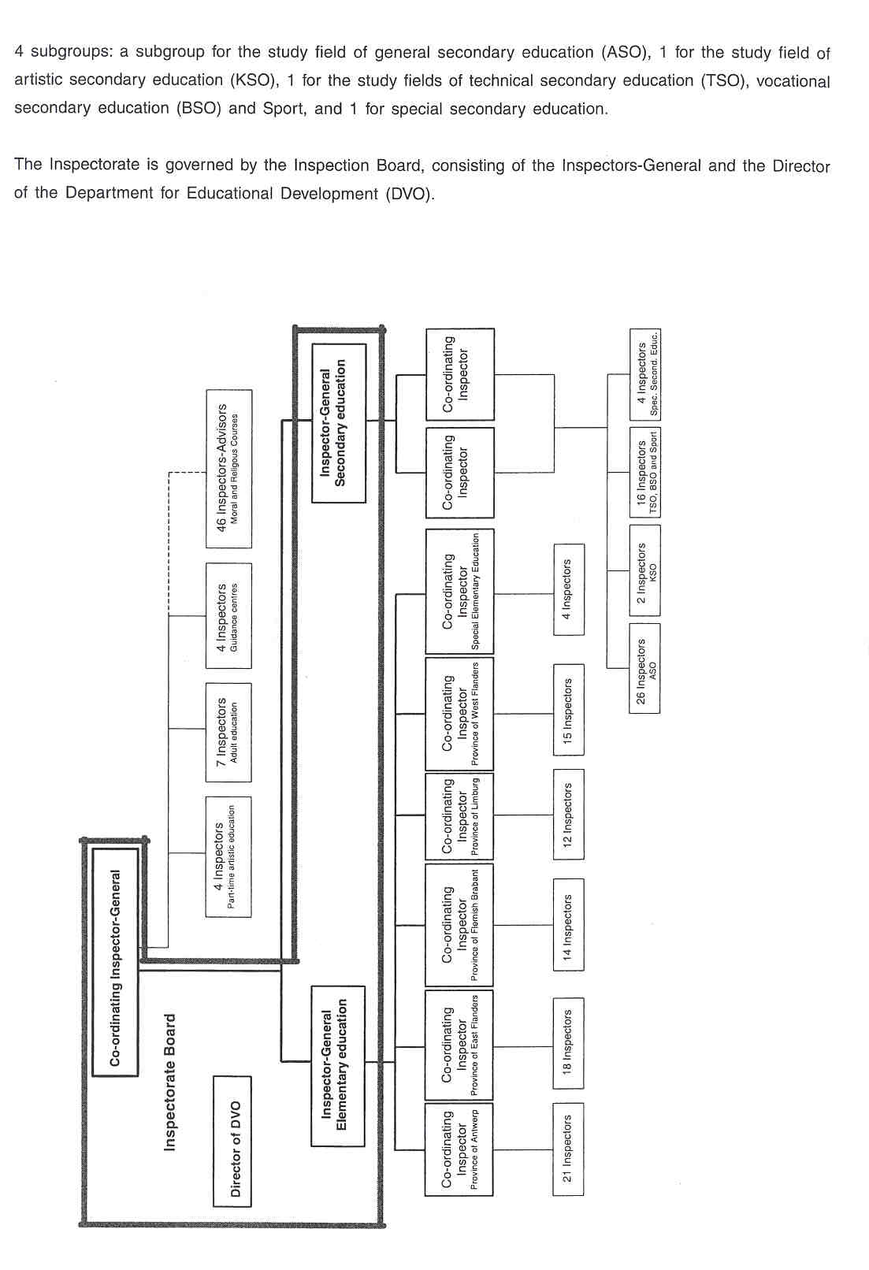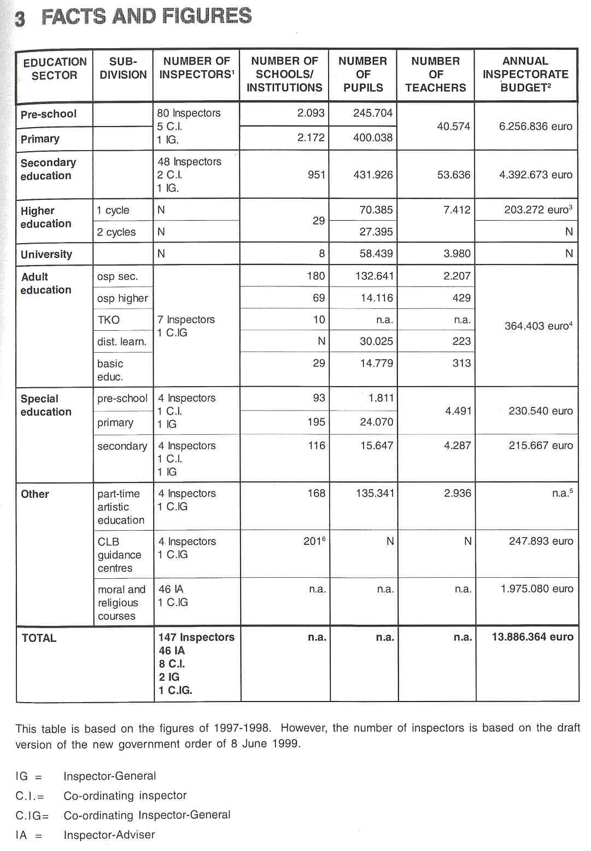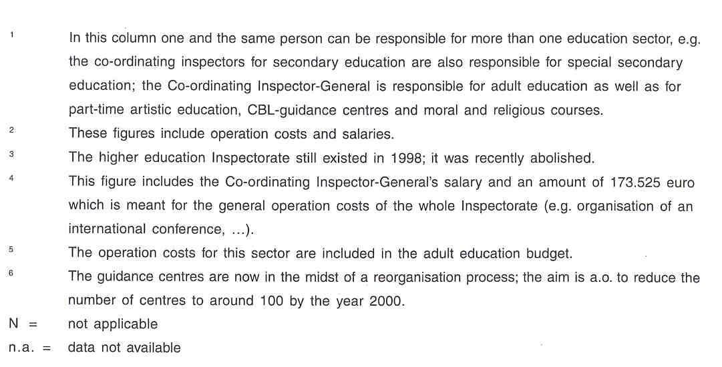

4 THE RECRUITMENT OF THE INSPECTORATE

Candidates for the function of inspector must have at least 10 years of service seniority and be permanently appointed in education (as management or teaching staff, paramedic, social or psychological staff) or in pedagogic counselling services. Persons applying for a job as inspector of special education must have worked in special education for at least 3 years. The Inspectorate Board determines some specific requirements for each vacant position. The Government of Flanders may also lay down specific diploma conditions for certain Inspectorate functions.
All candidates have to submit a curriculum vitae featuring all elements concerning their educational insights, applied social skills and subject-instructional specialisation.

Vacant positions are published in "het Beigisch Staatsbiad" (the official State bulletin). A committee, presided by an Inspector-General and consisting of inspectors, civil servants from the Administration, and university professors, examines all the candidates. Candidates must pass a written and oral test. The written test deals with an educational subject determined by the examination board. The oral part consists of:

- an interview that must reveal whether the candidate has the necessary attitudes, capacities and professional knowledge for the position of inspector. Moreover, this interview must reveal that he is well acquainted with contemporary educational problems;
- discussing the solution of an administrative problem based on applying legislation and rules-,
- reporting on analysing a school or a guidance centre (CBL) through a simulation;
- assessing a simulated educational or counselling problem.

The committee ends up with a list of applicants in order of preference, which is submitted to the Minister, who takes the final decision.

Based on his performances and his report on his activities, the inspector is assessed at the end of the probationary period by the Inspector-General and by his mentor. If the inspector is positively assessed, he gets a permanent position from the Government of Flanders.

5 THE WORKING CONDITIONS OF THE INSPECTORATE

Inspectors hold a full-time position. Each political mandate or mandate with an organising body or each assignment in an educational institution or pupil counselling centre, is incompatible with the function of inspector. This way, conflicting interests are avoided as much as possible.

By holding a permanent position, inspectors get the opportunity to acquire a lot of expertise. A lifelong position also guarantees some continuity.of the inspection work.

The members of the Inspectorate staff (the inspectors-general and the co-ordinating inspectors) have a mandate for 4 years, which is only extended in case of a positive evaluation.

For full inspection of schools providing secondary education, adult education or part-time artistic education, the Inspectorate may appeal to external specialists. These specialists - who do not hold the title of inspector - are paid only for the inspection activities they contributed to.

6 AREAS OF INSPECTORATE RESPONSIBILITY

Inspectorate tasks and responsibilities are laid down in the Parliament of Flanders Act concerning the Inspectorate and Counselling Services (July 17, 1991). In this Act, the key functions of the Inspectorate are described: evaluating, advising, monitoring, reporting, and all other tasks that are/will be assigned under the laws and decrees.

6.1 EVALUATING

Full lnspection

Evaluation of the quality of education provided by each school is a main aim of the Inspectorate. Inspectors must examine whether the school offers sufficient guarantees for the certificates delivered and whether the official funds granted are used in a justified and efficient way. The Inspectorate opts for a system approach, in which the quality of education is examined in each school. This means that the inspectorate cheeks whether the school meets the expectations of the authorities regarding high-quality education by means of an external audit, in which many actors and aspects of the school are involved. As a matter of fact, the Inspectorate concentrates on the different aspects of the functioning of the school when conducting full inspections. The quality of pupils' attainment (output) is evaluated by means of meta-evaluation of school tests and evacuations (the Inspectorate does not have central test data as no central exams are held in Flanders). The quality of a school's work (process) is also examined. When evaluating the output and process of the school the specific features of the school visited are taken into account. In fact, the school context and the school's means and possibilities (input) are taken into account.

During the full inspection the Inspectorate (except in adult education and part-time artistic education) uses an instrument with indicators. Specific points of attention are data on the quality of pupils' attainment (output indicators,,) and the quality of the educational policy and the organisation policy of the school, including the efficiency of school management (process indicators).

During the audit, the Inspectorate also cheeks whether the school meets the requirements of some Acts and regulations, in particular whether the school

- realises the curricula approved by the government;
- realises the pupils achieving the subject final objectives as much as possible;
- makes the efforts required to strive for the pupils achieving subject-specific developmental objectives, cross-curricular objectives and attitude objectives;
- correctly applies holiday rules and rules concerning the use of school time;
- respects language laws;
- meets the standards for hygiene, safety and habitability of the school accommodation;
- has high-quality instructional material and a good school equipment.

On the occasion of the audit, the school as an organisation is linked up with supervision of different learning fields/subject fields (excluding moral and religious courses). Here, the Inspectorate cheeks whether - among other things - subject-specific and learning field-specific final objectives are reached and whether the developmental objectives, attitudes in final objectives and cross-curricular final objectives are striven for.

- In elementary education, all learning fields (and cross-learning field activities) are checked to get an idea about the quality of the school's educational work.
- In secondary education, the inspection team mainly reports on the quality of the subjects (and cross- curricular activities) for which the inspection team members are responsible. Each inspector for secondary education is responsible for a restricted number of subjects.
- In principle, special elementary education inspectors don't say anything about the quality of learning fields or development fields itself. Special schools offer an individualised curriculum, made to measure the pupil. During the full inspection, the Inspectorate cheeks whether the school team adequately selects the developmental aims for each pupil by means of the action planning process and whether the school makes sufficient efforts to realise the selected aims.
- In special secondary education, the inspection team evaluates the quality of the general and social education on the one hand and the quality of vocational training on the other hand.

The Flemish Community consciously opted for a very restricted role of the Inspectorate at classroom level. Legally, the Inspectorate cannot judge individual teachers or educational methods used. The Inspectorate must restrict itself to the possible declaration that education process deficiencies were observed. Only the school board (in most cases represented by the principal) is responsible for the evaluation of teachers. The principal and possibly the educational counselling service advise teachers and see to it that their performance improves.

As each school is free to spend its budget, the budget-financial management of a school is examined by the Inspectorate only in function of possible repercussions thereof in the instructional field.

Based on the full inspection, the Inspectorate analyses the whole school in detail as far as strong and weak points are concerned. This way, it provides the school with insight into its own functioning. At present, external assessment by the Inspectorate does not (yet) focus on checking the quality of internal evaluation by the school. However, schools must fill out a questionnaire preceding the audit. In many cases, this leads to indirect self-evaluation. Moreover, by means of the report, the Inspectorate tries to stimulate the school to assess its own functioning.

Evaluation of Branches of Study In Secondary Education

The secondary education Inspectorate recently started evaluating branches of study (e.g. Mechanics, or Nursing). A number of branches of study must be inspected in all schools or in a sample of the schools that offer the branch of study involved. These evaluations can be considered to bring the strong and weak points of a certain branch of study in Flanders to the fore, but not of the schools that provide these branches of study. That is why such an evaluation cannot lead to sanctions for the school. However, it does result in recommendations to the authorities and to all schools that provide the branch of study involved.

Aspect Evaluation

Yearly, a range of specific topics is evaluated in the various education sectors. The government can commission the Inspectorate to execute particular checks concerning the compliance with statutory regulations (e.g. supervision regarding compulsory education) and the implementation of government policy (e.g. the use of the extra grants for special needs provision, the implementation of the education priority policy, the problem of repeating). The specific themes for aspect evaluations are selected as they are very topical or as they are crucial to the quality of education or policy preparation. The topics that will be examined in a certain school year in one or all education sectors are determined by the Inspection Board, an Inspector-General or the Minister. The evaluation of these specific topics is included as much as possible in the full inspection activities.

Evaluation of Boarding Schools

According to the Act, the Inspectorate is also responsible for the external quality control in the boarding schools. However, in reality this task is executed by officials from the administration.

Evaluation of Guidance Centres (CLBs)

The inspectors for guidance centres are a.o. responsible for monitoring the implementation of

- a rules to be observed by the centres;
- a hygiene, habitability and quality of the accommodation and equipment of the centres.

6.2 ADVISING

The Act stipulates that the Inspectorate has to advise the Minister regarding accreditation and subsidisation/ funding of the inspected schools.

The Inspectorate must advise the Minister on the curricula, drafted by the curriculum committees in the educational networks or by separate organising bodies (often in co-operation with the 3 networks) on the basis of the final and developmental objectives. Here, the Inspectorate uses certain criteria (e.g. whether the final and developmental objectives are incorporated in the curricula in a recognisable form).
Another task established by Law, is that the Inspectorate must give advice on education policy matters, for example:

- by providing the Minister with advice upon request, as in retaining branches of study or not,
- by having a seat in all kinds of advisory bodies, as in the Flemish Educational Council,
- by replying to parliamentary questions.

The Inspectorate for guidance centres must give policy advice regarding the operation of these centres.
Moreover, the Inspectorate is responsible for advising the administration on the accreditation of newly established schools or new lines of study in a school by checking whether a new school or line of study meets a number of legally determined conditions to be qualified for subsidisation/funding by the authorities.

However, the Inspectorate cannot advise any teachers; this is the responsibility of the school and the educational counselling service.

6.3 MONITORING

By providing curriculum advice, the Inspectorate preventively monitors the contents of learning fields (elementary education) and subjects (secondary education). However, the inspectors themselves do not develop final and developmental objectives or curricula.

The Department of Education has a database containing purely administrative data on institutions, staff and pupils. Through the Budget and Data Management Division of the administration, the Inspectorate may retrieve data from this database. As the Inspectorate does not yet have a computerised database of its own about school careers, pupils' results, data and results of full inspections, the Inspectorate's monitoring task is still being developed.

The inspection reports and written school data, requested in elementary and secondary education for full inspections, are collected only in archives. However, developing a computerised database is being considered.

6.4 REPORTING

Each full inspection of a school leads to a written report about the quality of the school as a whole. This report is meant for the Minister and the school involved. The Act about the public nature of administration stipulates that this report must also be sent to anyone who requests it from the Inspectorate.

When a guidance centre is inspected, a report on the quality of the centre is written for the Minister and the centre involved.

Yearly a public report is written on the state of affairs of the entire education system. This annual report consists of 3 sections, one about elementary education, one about secondary education and one about adult education, part-time artistic education and the guidance centres. In each education sector, the audit findings of the different inspection teams are combined and summarized into a report on the state of affairs in that education sector in Flanders. The findings of the inspections in schools/guidance centres inspected in a certain school year are extrapolated to make some general conclusions on the system level.

In most cases, the annual report also contains the results of the aspect evaluations performed in that school year. Sometimes, separate reports on these aspect evaluations are also provided for the one who ordered them (e.g. the Minister).

Recently, the Inspectorate started evaluating and reporting on the quality of some branches of study in secondary education in Flanders. A general report on these evaluation activities, which is part of the annual report, contains recommendations for the authorities and for the schools that provide these branches of study.

7 THE ROLE OF THE INSPECTORATE IN EDUCATIONAL POLICY

The Inspectorate has an advisory function regarding educational policy to the Permanent Secretary of the administration, to the Minister or to the Parliament through reports and on special requests. Information about the effects of the policy on the school level and as regards education in general are crucial for the preparation and the further development of educational policy. One of the ways in which this is provided are the annual reports of the Inspectorate on the state of affairs of the education system.

The Inspectorate is not directly involved in policy-making. Decisions regarding educational policy are made by the Minister of Education and the Parliament of Flanders.

By means of inspections, the Inspectorate indirectly stimulates the implementation of the government policy. After all, in full inspections the Inspectorate uses a uniform evaluation instrument consisting of a framework with indicators. During the inspection process, the inspectors draw particular attention to these indicators. In constructing the framework, indicators were selected based on the educational policy.

Furthermore, the Minister of Education can commission the Inspectorate to evaluate the effect of particular policy measures (aspect evaluations). The indicators and other points of special interest of the Inspectorate, reflecting policy, stimulate the implementation of the educational policy.

During full inspections, inspectors pay attention to the quality of the educational process as well as to the results achieved by the pupils of a school. In addition, inspectors can be commissioned to evaluate the effects of a particular policy measure, such as measures regarding the provision of pupils. In that way, the Inspectorate can check whether schools implement the guidelines of the policy in the prescribed way and whether this is done efficiently and effectively. To what extent the implementation of the policy goes wrong or runs smoothly in the inspected schools, is an indication of the effectiveness of the policy. In a way, the Inspectorate evaluates the effectiveness of the government policy.

8 WHO IS IN CHARGE?

The areas of Inspectorate responsibility are laid down in an Act, ratified by Parliament. The Act outlines the work field of the Inspectorate and lays down some rules of the game. However, the scope of the Act provides sufficient room for different individuals/bodies to lay specific emphases regarding the inspectors' tasks and methods.

Within the Ministry of Flanders, the Department of Education is responsible for nearly all aspects of educational policy, from nursery school to university education (including the Inspectorate). The Minister of Education decides only on the general approach of the Inspectorate. However, he can commission the Inspectorate to carry out specific tasks, such as performing an aspect evaluation.
The Directors-General of the administration (and in some exceptional cases also the Permanent Secretary of the Department of Education) may turn to the Inspection Board or to an Inspector-General for specific assignments (e.g. representation in all kinds of committees).

The Inspection Board is entrusted with generally steering and leading the Inspectorate. This board is composed of the Inspectors-General and the Director of the Department for Educational Development (DVO). The Co- ordinating Inspector-General is the chairman. This board has 2 key functions: firstly seeing to the effective operation of the Inspectorate and secondly steering the quality-improving tasks the Inspectorate executes on behalf of the government in the schools and guidance centres.

Each Inspector-General may additionally put specific emphases for his own group and assign tasks to his full staff (e.g. for aspect evaluations), certain subgroups of inspectors (e.g. the reporting task force) or individual inspectors (e.g. to represent the Inspectorate on a committee).

The Co-ordinating Inspectors co-ordinate the inspectors'activities (e.g. composing inspection teams, appointing the reporting inspector).

The individual inspectors still have a relatively large amount of freedom for planning their activities:

- Except for audits, the inspectors mainly work at home, where they can plan their activities and work on their own (within certain boundaries).
- During a full inspection, inspectors may plan their own activities to a relatively high extent though this is done in consultation with the reporting inspector and the other members of the inspection team.

9 THE POSITION OF THE INSPECTORATE

The Inspectorate operates as a relatively independent service of the Flemish Department of Education. The Inspectorate, as an organisation, is formally accountable to the Government. It is responsible for the inspection of education on the authority of the Flemish Minister of Education. The Inspectorate reports to the Minister according to the items mentioned in the 1991 Act. (See 6.) Every year, the Co-ordinating Inspector-General, with the help of the other Inspectors-General, writes an annual report on the state of affairs of the education system for the Parliament of Flanders.

The Inspectorate, operating as a relatively independent division, is not directly connected with the administration. it is only indirectly accountable to the Permanent Secretary. As the members of the Inspectorate are no civil servants in the strictest sense of the word, there is no hierarchical line between the Inspectorate and the Permanent Secretary or the administration, only a communication line. Indirectly, the different "education sector groups" of the Inspectorate can co-operate with the corresponding levels of the administration (e.g. for retrieving data from the administration's database or an administration official may come along during a full inspection).

The Inspectorate has a specific relationship with the institute responsible for developing the final and developmental objectives, namely the Department for Educational Development (DVO). In the past (according to the 1991 Act), DVO was a study department of the Inspectorate. In those days, DVO a.o. had the tasks of formulating proposals for in-service training of the Inspectorate and of developing instruments for full inspections. Recently, DVO was given an new status. It is now an educational study department of the Minister and the Department of Education and it works together with or alongside the Inspectorate. As a result, the task concerning the in-service training no longer exists. However, DVO does continue to work together with the Inspectorate through the Inspection Board and through the development of instruments for the Inspectorate.

Inspectors are not allowed to evaluate teaching methods or school development plans, nor to give general pedagogical and methodological advice to teachers and schools. These are tasks of the "educational counselling services". Each educational network has its own counselling service, consisting of advisers who deal with advising schools and their staff. The Inspectorate has an evaluating function regarding the schools, whereas the educational counselling services have a supporting function.
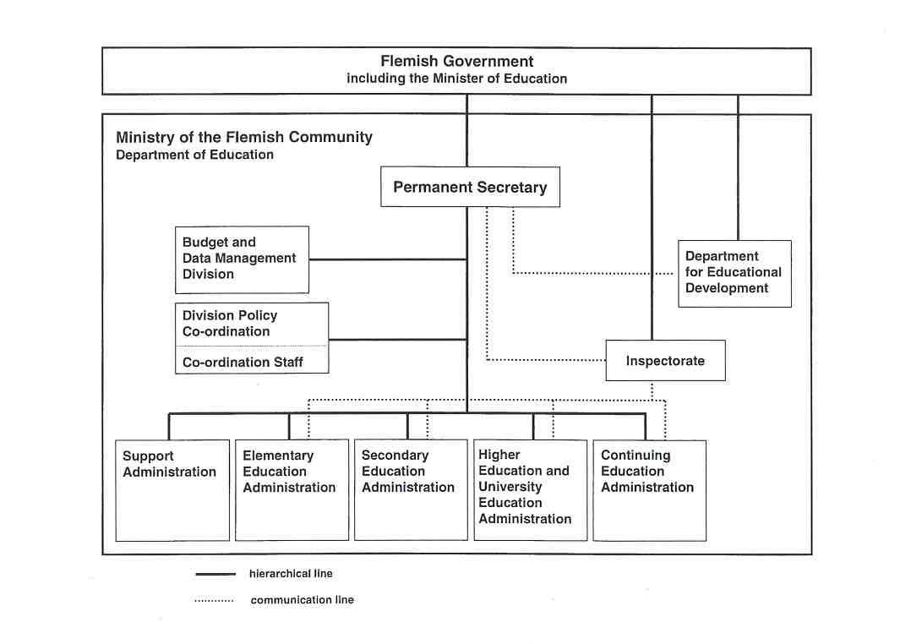

10 THE INSPECTION PROCESS

For each education sector, the Inspectorate management (consisting of the Inspector-General and the Co- ordinating Inspectors) selects the schools to be inspected in a certain school year. Here, the inspection teams are composed and in each team a reporting inspector is appointed. The reporting inspector heads the inspection team. He is responsible for the organisation of the full inspection, the contacts with the school, and the co- ordination of the report.

FULL INSPECTION OVER A LIMITED PERIOD OF TIME IN ELEMENTARY AND SECONDARY EDUCATION

Preparation Phase

At least 30 calendar days before the beginning of the inspection, the Inspector-General announces the full inspection to the principal and the organising body of the school in writing. This letter also mentions which information must be sent to the Inspectorate before the audit begins and which information the school must make available during the inspection. The school also receives one or more questionnaires that must be filled out and sent to the inspection team. The organising body must prepare the school to the full inspection: e.g. by informing staff and pupils. The reporting inspector visits the school in order to make arrangements with the school regarding the organisation of the audit.

School phase

This is the period in which the inspection team visits the school in order to collect the necessary information through interviews and observations and in order to study the documents. This way, they intend to arrive at assessing the quality of the school's work and at developing a detailed analysis of the school's strengths and weaknesses. This phase takes about 3 to 5 days.

Reporting Phase

After deliberations the inspection tearn formulates - in consensus - an advice for the Minister regarding the accreditation andlor financing/subsidisation of the school. The findings as well as the advice are written down in an extensive report.

- The whole inspection team is responsible for the final report. Each team member makes a contribution to the report. The reporting inspector integrates these findings into a first draft report, which is ther submitted to the different team members for annotation and amending. All tearn members later approVE a common version which subsequently becomes the draft report.
- This draft report is presented to the Inspector-General, who reads and finalises it.
- Not later than 60 calendar days after the audit, the inspection tearn/the reporting inspector has discussion with the principal and the organising body and provides its findings.
- Not later than 30 calendar days after this discussion, the Inspector-General sends the report to th, principal and the chairman of the organising body.
- The organising body initials the report and sends it back to the Inspector-General within 30 calende days. On this occasion, the organising body may voice its remarks an the report. These remarks ar attached to the report.
- The Inspector-General sends the school report to the Minister through the Director-General of the administration involved.

Follow-up Phase

The follow-up procedure depends on the nature of the advice of the inspection team. In case of a negative advice, a new full inspection is conducted as soon as possible by another inspection tearn. When the advice is positive or conditionally negative, follow-up inspections are made.

PHASE-MODE FULL INSPECTION IN ADULT EDUCATION AND PART-TIME ARTISTIC EDUCATION

Preparation Phase

This phase is quite similar to the preparation phase of full inspections in elementary and secondary education.

School Phase

The audit on the spot consists of 4 to 7 inspection visits, each lasting 1 or 2 days and held by part of the inspection team. On each of these occasions, a certain aspect or some aspects of the institution are screened. Visits are announced about 1 week in advance.
Not all visits are paid by the same inspectors as different aspects are examined each time. The frequency of the visits and the number of team members (per visit) depend on the size and structure of the institution. The inspection team members autonomously plan and set up the inspection visits. The sole restriction is that the full inspection of an institution must be finished within 2 years.

Reporting Phase

- After each inspection visit (except for the last one), an informative report is sent to the institution. It indicates the strong and weak points of the aspects examined during that particular visit. These intermediate reports (which have no official value whatsoever) are written by the inspectors who examined the aspects and are only meant for the institution. Based on these reports the institution can start with rectifying the deficiencies. These improvements may be noticed during the next inspection visit. In fact, the school and reporting phases overlap as the audit is done over a period of time.
- After the last visit, the reporting inspector drafts the final report and the whole team discusses it. The final advice also takes the improvements into account that were made by the institution during the audit itself.
- This draft report is presented to the Inspector-General, who reads and finalises it. The rest of the reporting phase is the same as in a full inspection of elementary/secondary education.
- (See reporting phase.)

Follow-up Phase

Partial follow-up and some adjustments already take place in the school phase itself by means of the intermediate reports.

As in elementary 'and secondary education inspections, follow-up procedures are provided depending on the nature of the advice.

EVALUATION OF BRANCHES OF STUDY IN SECONDARY EDUCATION

The branches of study to be evaluated are selected and the inspection teams are composed. As a rule, a tears consists of 2 or 3 people (1 inspector and 1 or 2 external specialists). The inspector heads the team and is responsible for the report. Moreover, the same inspector is the chairman of all teams evaluating the same branch of study in the different schools. The external specialists are familiar with the occupation as well as with the basic training, enabling them to assess the contents and level of the education activities in relation to the expectations of the professional world.

Preparation Phase

The Inspector-General notifies the schools about the evaluation in writing. On that occasion, the principal also receives the information file he is supposed to fill out.

School Phase

The inspection team visit takes 1 to 11/2 day. The reporting inspector assesses the educational aspects such as evaluation, students' counselling, whereas the external specialists mainly focus on aspects concerning the contents, such as apprenticeships, infrastructure and curriculum.

Reporting Phase

After collecting the required data through analysis of the information file and the inspection activities during the school visit, an analysis of strengths and weaknesses of the branch of study in a certain school is made. Based on the written findings of each team member, the reporting inspector writes a synthesis report, which is submitted to the team members for completion and differentiation. This rather informal report is meant as a service to the schools concerned in exchange for their co-operation.

As soon as one branch of study is evaluated in the various schools, an overall report is written on the quality of that particular branch of study in Flanders. This report is meant for Parliament and the Minister and contains a summary of the main data, findings and recommendations (without mentioning the names of the schools visited).

11 INSTRUMENTS AND METHODS

THE COLLECTION OF INFORMATION

Inspectors use a range of methods to collect the necessary information. There are some similarities as regards methods between the Inspectorate divisions of the different education sectors, but there are also quite some differences.

a. Questionnaires

- In a full inspection the principal has to fill out a written questionnaire about the school, which must be sent back before the school phase starts. However, the content and focus of this questionnaire is not the same for the different education sectors.

- In elementary education, the questionnaire only examines the actual context and input data. The context data relate to the main demographic, structural, financial, juridical, administrative, instructional and material aspects of the school that may affect the functioning of the school. Concerning input data, information about the human resources of the school (pupils and school staff) is requested.
- In secondary education, the questionnaire asks for information not only concerning context and input, but also concerning a number of process and output indicators. Regarding context, the school is asked to give information on geographical, administrative and juridical aspects. The input questions deal with the human resources, structural means (structure and educational provision of the school) and material means (instructional materials and infrastructure). The process section in the information file is rather restricted and forms a brief examination of the process indicators. (See below.) The output questions relate to the pupils' attainment, school career data and outcomes. Moreover, a questionnaire concerning the safety system of the school must be completed.
- In special elementary and secondary education, the questionnaire requests information about the school, the school tearn and the pupils.
- In adult education and part-time artistic education, the principal has to fill out a questionnaire with a.o. questions about the evolution of the number of pupils.

- Sometimes, one or more questionnaires are used by the Inspectorate to perform aspect evaluations.
- In order to evaluate branches of study in secondary education, the principal must fill out a questionnaire, dealing with some features of pupils and staff and requesting for data on the organisation of a specific branch of study Moreover, specific surveys are developed for the teaching staff, the pupils and sometimes also the apprenticeship leaders and mentors.

b. Interviews

- Interviewing is an important method in full inspections to get a picture of the school's quality.

- In elementary education, the inspection team members talk with the principal and the teaching staff. They are questioned about the functioning of the school: joint purposiveness (i.e. whether the school staff jointly works towards the same aims), communication, relations with the surroundings of the school, capacities of the teaching staff, the tasks and role of the principal). The principal is also requested to describe the position of the school and to provide information on deliberation procedures, co-operation with external experts, special care, infrastructure and instructional equipment. Teachers are sounded out about their opinions and activities concerning class practice.
- In special elementary education, the principal, the teaching staff and the paramedics are questioned regarding the action planning process and the functioning of the school organisation.
- In secondary education, the inspectors themselves determine whom they will talk to, what will be discussed and which form these discussions will have (in a group or not, structured or not). In principle, most inspectors converse with some or all teachers of the subject they are inspecting. This is often done individually and some inspectors also set up group discussions with all the teachers of a certain subject or line of study. Other teachers, the middle management, and a number of pupils and parents can also be interviewed. The reporting inspector always talks to the principal and mostly also to the representatives of the organising body, of the participation structures, of the guidance centre.
- In special secondary education, the principal, the middle management, all teachers and paramedics and a selection of pupils are interviewed. Occasionally and when necessary, there are also interviews with representatives of the organising body, parents, staff of the MP] (i.e. medical instructional institute), guidance centre and external aid providers working for the school.
- In adult education and part-time artistic education inspectors interview the organising body, school board, teachers, and students.

- In aspect evaluations inspectors sometimes collect information through interviews.
- In order to evaluate branches of study in secondary education discussions are sometimes held with a.o. the principal and the (co-ordinating) technical advisor.

c. Observations

- In full inspections the members of the inspection team make observations.

- In elementary and secondary education (including special education) the inspection team tries to get a picture of (1) the quality of the school's educational functioning, (2) the effectiveness of the school organisation and (3) the results reached by the pupils. Moreover, the inspectors check, amongst others, the available instructional material, the safety and hygiene of buildings through observations. At the school level, relatively much time is spent on systematically observing the infrastructure, instructional equipment, safety and hygiene. It is also checked -through observations - to which extent the school functions adequately as an organisation, e.g. by attending class councils.
- By attending teaching activities, inspectors may observe which efforts the school team makes to realise the educational objectives. During these activities, the inspectors also observe the pupils to examine to what extent these aims have actually been realised.
- In adult education and part-time artistic education, short class visits and observations are made to examine the quality of the infrastructure.

- Some aspect evaluations require observations.
- In evaluating branches of study in secondary education, some lessons are attended by members of the inspection tearn. Moreover, work assignments in progress are checked. Finally, rooms are visited (e.g. classrooms, media library, workshops) in order to check infrastructure, equipment, safety and hygiene.

d. Tests/lexaminations

Pupils are not tested by the Inspectorate nor are there any national examinations in Flanders.

e. The Collection of Documents

- In full inspections a number of documents have to be sent to the inspection team in the preparation phase and a number of documents have to be available for the inspection team during the school phase.

- The elementary education inspectors analyse planning documents and reports (e.g. class register, year plan, minutes of meetings, school development plan) at school and class level. They also check documents containing data on the children's development (e.g. report cards, tests, work of children). At school level, information brochures and documents for outsiders are also studied (e.g. information leaflets for parents, school regulations, appeals to the community for taking part in a project.)
- In special elementary education audits attention is paid to documents illustrating the action planning process of the school (e.g. action plans, activity plans, evaluation documents, books and work of pupils, class agendas). At school level, documents demonstrating the functioning of the school organisation (e.g. educational project, school development plan, minutes of class councils, reports of meetings) are analysed.
- In secondary education, a whole series of documents is requested at school level as well as at subject and class level. The school must prepare documents proving that national regulations and rules are respected (e.g. curricula, safety file, reports and documents about the class councils, documents about the use of school time, documents about examination schedules and apprenticeships, and documents showing that the school makes the required efforts to realise the cross-curricular and attitudinal final and developmental objectives). The school must provide the inspection team with an inventory of instruction means. Moreover, documents about the education and organisation policy have to be provided. For each subject, the teacher documents (e.g. year plans), the pupil documents (e.g. agendas, notes, tasks) and the assessment documents (work, tests, exams), showing inat ine subject final objectives and curricula have been realised by the pupils, are requested.
- When auditing special secondary education schools, a number of documents concerning the school staff members, pupils, planning, and some reports are requested by the inspection tearn. Concerning staff, the school must provide an outline of the establishment, job descriptions of all staff members and arrangements for replacement and supervision. Regarding the pupils, a number of documents are also examined (e.g. a list of pupils by unit, pupil files). Moreover, planning documents at class and school level (e.g. all forms for action planning, apprenticeship planning, teachers' course preparations and planning) are analysed. Documents with data on the development of pupils (e.g. tests, books, works, report cards, qualification committee documents) are also requested. Some reports e.g. fire brigade report, reports of participation structures, reports of class council decisions are studied.

- Some documents are requested and analysed by the inspection team in order to evaluate institutions providing adult education and part-time artistic education.
- For certain aspect evaluations it is necessary to collect and analyse documents.
- A number of documents are analysed (e.g. exams, textbooks, documents about apprenticeships) in order to evaluate certain branches of study in secondary education.
f. Use of National Data

The Inspectorate sometimes uses the available data in the data bank of the Administration of the Department of Education to collect the required facts and figures about the schools in the context of (full) inspections or aspect evaluations. However, until now this is still very limited. For the moment most of the data have to be delivered by the school to the Inspectorate.

APPROACHES

a. Different Forms of Inspection and Evaluation

There are 3 different types of inspection in Flanders:

- full inspection of a school by a team of inspectors over a limited period of time (the whole team visits the school for one week) according to the CIPO-model. (See below.) This type of inspection is used in elementary education, secondary education, and special education.
- phase-mode full inspection (consecutive method) in which a school is evaluated over a period of 2 years. During this time the institution for adult education or part-tirne artistic education receives 4 to 7 inspection visits (each of them lasting 1 or 2 days) by 1 or 2 inspectors. Each time a different aspect is evaluated.
- evaluation of a branch of study in secondary education, in which various or all schools that provide a certain branch of study are visited over a certain period by a team for a day or a day and a half.

Aspect evaluations may also be done in different ways.

- Sometimes, a certain topic is given specific attention during each full inspection performed in a certain school year. The information collected in these inspections is then combined in order to judge the overall situation in Flanders.
- All inspectors are assigned to go to some additional schools - not in the context of a full inspection - in order to examine a certain aspect, in which the data provided by all inspectors are then combined.

b. Instruments

The Department for Educational Development (DVO) in co-operation with members of the Inspectorate develops the uniform evaluation instruments for full inspections. Some instruments are ready, others will be finished in the near future. There will be 4 evaluation instruments: one for inspecting elementary schools, one for inspecting special elementary schools, one for inspecting secondary schools and one for inspecting special secondary schools.

These evaluation instruments are based upon the CIPO-model (context-input-process-output model). This conceptual model is a systemic framework, that is also used by the OECD to define international education indicators. In this framework any understanding of the effects of education (of a school) must be informed by the educational and organisational processes employed and by resources (human, structural and material input) deployed, against the background of contextual factors in the environment of the school or of the educational system (e.g. juridical, administrative, demographic factors). This implies that the Inspectorate 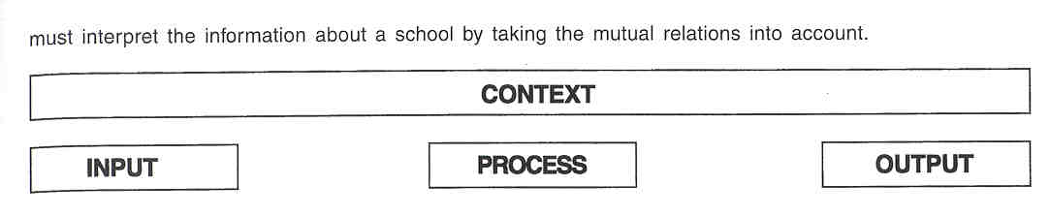

As the CIPO-model is an empty framework, it must be fieshed out in a well-considered way with carefully selected indicators and facts. The selection of indicators is a.o. based on the major outlines of the Fiernish educational policy This is one of the reasons why the specific indicators differ from one education sector to another.
- The evaluation instrument of the elementary education Inspectorate was brought into use in September 1995. The instrument was last updated in September 1997.
In elementary education the process as the "whole of educational and school-organisational features and activities indicating which efforts the school makes in order to attain the targets laid down by the authorities" is the focus of the full inspection. The educational features and objectives are summarised in 3 overall aims, which are operationalised in 9 indicators and 65 illustrative descriptions:

- Airn 1: basic education as a coherent whole must be guaranteed for each child
- Aim 2: stimulate overall personality development in each child
- Aim 3: the best possible special care should be realised in order to provide all children with the best possible development opportunities.

The school-organisational features and activities are summarised in 4 features, operationalised in 15 indicators and 64 descriptions, referring to the ability of the school to conduct an own local policy:

- Feature 1: having common aims
- Feature 2: having internal leadership in order to conduct an own policy
- Feature 3: having communication and deliberation abilities
- Feature 4: availability of space for professional development.

For the moment the output-indicators are still in development, these indicators will focus on the pupil qualifications relating to the final objectives.
The instrument also describes context and input data, which are essential as possible sources of explaining andlor shading the output. The input is the whole of personal data of anyone directly involved in the educational process (pupils, teachers, principal).
The context includes the demographic, structural, financial, juridical, administrative and educational/ instructional data that (may) affect a school's input, process and output.
- For inspecting special elementary schools the instrument of elementary education was adapted to the characteristic features and the specific educational approach in special education. The instrument was put into use in September 1997.
The special elementary education Inspectorate also focuses on the quality of the educational and organisational functioning of the school. With regard to the effectiveness of the school organisation the points of interest (features and indicators) of the special education inspectors are the same as in regular elementary education. However, with respect to the educational process the emphasis of the Inspectorate is quite different and adapted to the specificity of special education. In special elementary inspections the evaluation of the quality of the school's process to construct, implement and evaluate individual action plans for each pupil is highlighted.
- The instrument for secondary education has been tried out since September 1998. The definitive version will be used from the school year 1999-2000 on.
In secondary education the output-indicators are the starting point of the audit. Output is the education effect that the school has on pupils' learning and attainment. The main output-indicators are learning performances (final objectives), school career data, outcomes (e.g. transition towards higher education or employment) and effectiveness (added value). These are operationalised in variables.
Through the process, the Inspectorate checks how the school uses the available means to realise quality. There is one general process-indicator, "Process Indicator 1: Joint Purposiveness", which is operationalised in 3 variables and 38 descriptions. The rest of the process-indicators are divided into indicators with regard to the educational policy and indicators concerning the education-supporting policy. The 4 educational policy process-indicators deal with the learning process. They are operationalised in 13 variables and 133 descriptions:

- Process indicator 2: Curriculum
- Process indicator 3: Coherence
- Process indicator 4: Pupil counselling
- Process indicator 5: Assessment.

The education-supporting policy indicators indicate to which extent the school's organisation, logistics and professionalisation policy support the realisation of the education targets. The education-supporting policy is defined in 3 indicators, 7 variables and 79 descriptions:

- Process indicator 6: Organisational policy
- Process indicator 7: Personnel policy
- Process indicator 8: Logistic policy

Data on input and context are also included because they may explain or back up the output, just like the process indicators do. The input data refer to the means the school contributes to realise quality. There are input data about the human potential (pupils and school staff), structural and material means. The context data contains school identification data, data on school location, administrative and juridical data.

- In special secondary education (instrument in the making - try-out until 2000) the context data will refer to school identification data, data on school location, structural and material data, financial data, administrative data and juridical data. The input data contain information about the human potential, structural and material means. There will be 5 process-indicators:

- Process indicator 1: Optimal and harmonious personality development and integration
- Process indicator 2: Joint purposiveness
- Process indicator 3: Internal leadership
- Process indicator 4: Communication and deliberation
- Process indicator 5: Professional development

The output refers to the pupils' learning and attainment, school career data, outcomes, and after-care.

For certain aspect evaluations, the inspectors mostly use a "manual"; this sees to it that each inspector uses the same points of attention.

To evaluate branches of study in secondary education, a brief instrument was developed in order to provide external specialists with data about the purpose and course of the evaluation. This instrument includes a job description of the inspection team and a description of the methods. Up to now, no indicators or evaluation criteria have been designed for these evaluations.

c.Teamwork

Within the scope of a full inspection inspectors usually work in teams.

- In elementary education a team with an average of 3 inspectors (from 2 to 6 inspectors, depending on the school size) visits the school.
- in secondary education an average inspection team consists of 5 inspectors (±2 inspectors, depending on the school size). The inspection team is sometimes accompanied by an official from the Administration. He evaluates the pupil administration, the school administration and the accountancy of the school.
- In special elementary education 2 or 4 inspectors (depending on the school size) form a team.
- In special secondary education the inspection team always consists of all 4 inspectors, and is sometimes accompanied by an official from the Administration.
- In adult education 1 or 2 inspectors, sometimes assisted by external experts andlor accompanied by an official from the Administration, conduct the inspection procedure.
- One or 2 inspectors are responsible for inspecting institutions providing artistic education.
- A team consisting of 1 inspector and 1 or 2 outside specialists conducts evaluations of branches of study in secondary education. The inspector is the chairman of all teams evaluating a certain branch of study in the various schools.

In the near future, the Inspectorate will also be able to appeal to outside specialists to complete the inspection teams in secondary education and part-time artistic education.

Not all inspection tasks are conducted by a team, however. Sometimes the Inspector-General or the Co- ordinating Inspector can charge one inspector with a particular task (e.g. to give advice on a specific matter, to cheek curricula, to represent the Inspectorate on a committee).

12 JUDGEMENT AND ITS CONSEQUENCES

Based on the full inspection, the inspection team gives substantiated advice to the government about whether or not a school or a part of it still is entitled to be accredited andlor financed/subsidized in the future. This goes for the inspections in all the education sectors. The advice may be given in 3 ways:

- a positive advice: this means that the school further qualifies for accreditation and subsidisation/financing, According to the inspection team, the school fulfils its social assignment.
- a conditionally negative advice that may become positive under certain conditions when the deficiencies are sufficiently remedied by the school: in this case, the Inspectorate reports the deficiencies observed and lays down the deadline for remedying them. A follow-up inspection will be held to examine whether the deficiencies are remedied.
- a negative advice: this advice can lead to withdrawing the accreditation of a school or part of it. The Inspectorate provides substantiation for this advice. It is automatically followed by a new inspection by an equally represented board of inspectors. The advice of this board is sent to the Minister. If this advice is also negative, the government may suspend the accreditation of a school or part of it. The government may also suspend a school's funding or financing partly or completely.
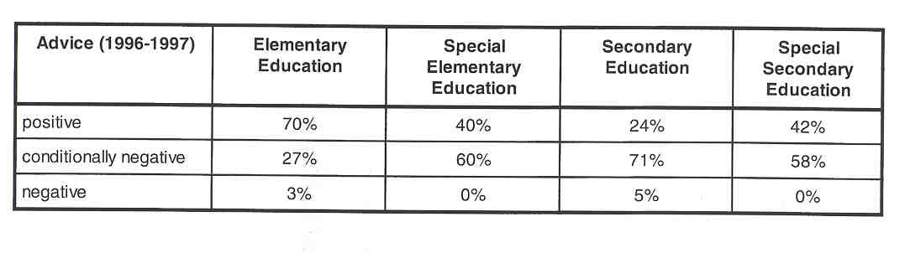

Regarding the evaluation of specific branches of study in secondary education, no advice is given about the accreditation andlor funding/subsidisation of a certain branch of study The strengths and weaknesses are described and non-binding recommendations for the school and the authorities are formulated, but no sanctions are imposed.

13 OUTCOMES

In Flanders, the Inspectorate draws up reports on schools/institutions, branches of study, aspect evaluations, and on the state of affairs of the entire education system. There are no separate reports on specific subjects (e.g. mathematics, geography). However, the evaluations of the quality of specific subjects may be integrated in a school report (e.g. in secondary education, each member of the inspection team reports on the subjects he inspected) or in the annual report.

REPORTS ON SCHOOLS/INSTITUTIONS

Any full inspection leads to a report on the quality of the education provided in the audited school. This report indicates to which extent the school meets the expectations of the governement regarding high-quality education. Each report includes a descriptive part, a conclusion part and an advice.
- The descriptive part includes the findings made when conducting the inspection.
- The conclusion part contains the conclusions, drawn from the positive and negative findings. This part must also mention to what extent the legal stipulations were met or not. The inspection team also formulates some recommendations here.

- Finally, the report contains an advice to the government, motivated by the findings in the descriptive part. To the extent to which this advice is favourable or not, it will lead to further financing/subsidising the school or not. The advice must also reveal to which structural part of the school it applies (e.g. only for some lines of study or subjects or for the whole school).

In its evaluations and recommendations, the Inspectorate explicitly takes the school's own unique features into account. With this report the Inspectorate also wants to support the school management, informing them about the strong and weak points detected, and to promote self-evaluation.

As a school report is anonymous in principle, the names of teachers may not be mentioned.

Each school report is meant for Parliament, the Minister and the school. The school is not allowed to use this report for commercial purposes or to compare schools or to construct league tables either. The organising body of the school has the liberty to send the report to the educational counselling service. The school must put the inspection report on the agenda (within 30 calendar days after receipt) of a staff meeting and it must be discussed in full with the teachers. A copy of the full report must be available at the school secretariat. The organising body must also submit the report to the participation council or the local school council, in which the parents are represented. Members of participation structures (e.g. participation council, special committees) may request a copy from the organising body. A school is not obliged to send the report to every individual parent, not even when helshe explicitly asks for it. However, the public nature of administration Act entitles any interested parties, including parents, to peruse the report and receive a copy thereof, provided they pay a fee, by making a request to the Inspector-General.

Though the structure of school reports is roughly the same for all education sectors, the different Inspectorate divisions add their own emphases.

REPORTS ON THE EVALUATION OF A BRANCH OF STUDY

As a result of the evaluation of specific branches of study, two kinds of reports will be written: an informal synthesis report on the quality of that branch of study in a certain school and an overall report on the quality of that branch of study in Flanders.

- The informal synthesis report describes the strengths and weaknesses of the branch of study in one school and is only meant for the school concerned.
- The overall report about the quality of a specific branch of study is directed to Parliament and the Minister. It contains data on influx, success rates, employment, motivation and study behaviour of the pupils. The administrative situation, assignments, additional training and professional well-being are treated as well in the overall report. In the part about organisation, management and leadership, educational-instructive organisation, external links, infrastructure and safety are described. It also contains some conclusions and recommendations to the schools and to the authorities.

REPORTS ON ASPECT EVALUATIONS

The results of aspect evaluations are written down in a report for the government or for the one who ordered the evaluation. In most cases, these specific evaluations are integrated in the annual report. However, separate reports on these topics are also written in some cases.

REPORTS ON THE EDUCATION SYSTEM

The annual report on the state of affairs of the entire education system consists of separate sections: each section is written by one of the different Inspectorate divisions (corresponding to the different education sectors). The annual report mostly contains a number of findings and conclusions drawn from the (full) inspection activities. It also deals with the aspect evaluations the Inspectorate conducted that year. Furthermore, in the annual report the Inspectorate reports on some aspects of its advisory function (e.g. its advice on approving the curricula and its participation in different councils and committees). However, the contents of this annual report may vary considerably from one section (education sector) and school year to another. As a matter of fact, each Inspectorate division adds its own emphases in this annual report (e.g. one division reports on curriculum advice and the other does not, one division reports on the quality of a certain subject and the other does not).
The annual report is written for the Parliament of Flanders and in a sense also for the Minister. He or she must be enabled to conduct a policy based on information relating to the genuine developments in the field of education itself. Furthermore, the annual report is published and sent to all schools and guidance centres (CLBS) and it is made known to the general public, e.g. through the press.
The annual report is also thoroughly discussed in the Flemish Education Council (VI.O.R.), as the Minister of Education must seek, prior to the discussion in the Parliament of Flanders, the opinion of the Council on all preliminary draft decrees on educational matters and an policy reports and papers addressed to the Parliament of Flanders.

14 FOLLOW-UP PROCEDURES

FOLLOW-UP OF FULL INSPECTIONS IN (SPECIAL) ELEMENTARY EDUCATION AND (SPECIAL) SECONDARY EDUCATION

In case of a negative advice, a new inspection is conducted as soon as possible (within 45 calendar days) by an equally represented inspection team (half of the inspectors come from official education and the other half come from free education) of at least 4 inspectors who did not belong to the original inspection team. The Minister determines the composition of this new team. Based on a new inspection, this team must provide a definitive advice, which can only be positive (maintaining acereditation/subsidisation/financing) or negative (suspending acereditation/subsidisation/financing). If the advice contains a proposal to abolish the accreditation of a school or part of it or to end subsidisation/financing, the organising body of the school may make a written appeal to the Minister. Eventually, the latter decides on the basis of this plea and the Inspectorate's advice.

In case of a conditionally negative advice that may become positive under certain conditions, a follow-up inspection is made to reveal to what extent the deficiencies have been remedied. This follow-up inspection may not take place earlier than 90 calendar days after the date on which the full inspection report was sent to the school. This follow-up may include one or more visits by one or more members of the original team and it only deals with the deficiencies observed. The follow-up inspection must lead to a positive or a negative advice. However, the inspector(s) may also decide to extend the period allowed to remedy the deficiencies (e.g. when large-scale infrastructure activities are required).

In case the first inspection results in a positive advice, follow-up inspections can also be conducted. In most cases the reporting inspector cheeks whether the school sufficiently reacted to recommendations of the inspection team that were mentioned in the inspection report.

FOLLOW-UP OF PHASE MODE FULL INSPECTIONS IN ADULT EDUCATION AND PART-TIME ARTISTIC EDUCATION

Partial follow-up and some adjustments already take place during the school phase of the full inspection, as the inspection is conducted in phases. For such a phase-mode inspection, an intermediate report is written after each visit and the school knows that the next inspection visit may be expected after about 3 months as long as the school phase of the inspection process is not completed. That is why most institutions try and make as much corrections as possible already during the school phase.

In case the school gets a (conditionally) negative advice or a positive advice at the end of the inspection process, follow-up is provided as in full inspections of elementary or secondary schools. (See above.)

15 INSPECTORS AS ARBITRATORS

In principle the Inspectorate does not deal with complaints (neither from parents, nor from pupils, nor from teachers). This responsibility has not been laid down in law. Normally, complaints must be dealt with by the organising body of the school. Sometimes, parents or teachers write to the Minister. In some cases, the latter assigns the Inspectorate with conducting research of the complaint.

In reality, no formal complaint procedure is available for parents or pupils. In (special) elementary education, the full inspection procedure does not present the opportunity to have the members of the inspection team talk with (representatives of) pupi-Is or parents. but in secondary education inspections and in phase mode inspections of adult education and part-time artistic education inspectors usually do have a discussion with representatives of the parents or the pupils. This implies that parents or pupils would be able to formulate complaints through these representatives. This happens rarely, however. More frequently, parents call the Inspector-General or the Co-ordinating Inspectors to file complaints (particularly after an assessment period, e.g. at the end of the school year).

The Inspectorate rarely receives complaints from teachers about their school or principal. If letters of complaint from teachers do arrive, they are in principle sent on to the responsible educational network with the request to examine the complaint and to let the Inspectorate know what was done about the complaint.

During the inspection process, the members of the inspection team talk with some or even all teachers. In principle, these discussions aim at collecting data, but teachers may use this occasion to file complaints about the principal or the governing bodies. When such complaints are filed during the inspection, the inspection team will always examine to which extent these complaints must be included in the school report. If a complaint turns out to be more general andlor directly affects the quality of education in that school, it will be included in the report and a conclusion can be linked up with it.

The Inspectorate never acts as a referee. On the other hand, dealing with a complaint and including it in a school report does indirectly imply some judging influence.

One may conclude that the Inspectorate can - to a limited extent - be addressed when one has a complaint, but that it is not qualified to deal with a complaint.

16 THE INSPECTORATE AS AN ACTOR IN PUBLIC DEBATE

Inspectors have the permission to explain the educational policy and publish articles in the specialised press. As each inspector was given a mandate by the authorities to execute his task, it goes without saying that he abides by the point of view of the government.

Only the Minister of Education or his Attach6 may discuss the educational policy in newspapers, on the radio, on television. As the case may be, the Minister can authorise an Inspector to give his (i.e. the Minister's) opinion on educational policy in the press.

17 THE EVALUATION OF THE INSPECTORATE

EVALUATION OF INSPECTORS

An evaluation system for the inspectors has recently been introduced by the Decree of 14 July 1998. This decree stipulates that an evaluation must be conducted of every one who works for more than 3 months in one year with the Inspectorate. The evaluation is based on the job description consisting of tasks and objectives. The tasks contain 9 parts: the result areas, which are the tasks that have to be performed, and the competences, which are the skills and qualities that are required for these tasks. The annual objectives are agreed upon by the evaluators and the inspector.

- In principle, evaluations are conducted at least every 2 years by at least 2 trained evaluators (in the first 3 years of their career, inspectors have to be evaluated annually).
- Inspectors and Co-ordinating Inspectors are evaluated internally by superiors of different ranks. Every inspector is evaluated by his Co-ordinating Inspector and by his Inspector-General. The Co-ordinating Inspectors are evaluated by their Inspector-General and by the Co-ordinating Inspector-General.
- The Inspectors-General are evaluated internally by the Co-ordinating Inspector-General as well as externally by the Permanent Secretary of the administration.
- The Co-ordinating Inspector-General is evaluated externally by the Permanent Secretary of the administration and by the Minister of Education.

The evaluation procedure is as follows. First, the inspector must prepare a self-evaluation. Based on this self- evaluation, all aspects of performance are discussed with one or more evaluators in an evaluation discussion. Subsequently, the evaluators write a substantiated evaluation report that does not include a final conclusion, except in case of the "insufficient" judgement. The evaluated inspector is allowed to add his remarks. The evaluation report, including the remarks, is kept in a personal file of the inspector. An inspector who does not agree with the "insufficient" judgement can appeal.

A permanently appointed inspector can be dismissed due to professional incompetence if he has received an evaluation judgement "insufficient" for 2 consecutive times or 3 times in his career at the Inspectorate.

The members of the Inspectorate management (the inspectors-general and the co-ordinating inspectors) have a temporary mandate, which is only extended in case of a positive evaluation.

ADAPTATIONS AS A RESULT OF EVALUATION

Sometimes inspection methods are adapted as a result of an evaluation by the Inspectorate. For example, inspection instruments (e.g. questionnaires) or procedures have been developed or changed.

ADAPTATIONS AS A RESULT OF DEVELOPMENTS IN EDUCATIONAL POLICY

Methods, tasks, functions are adapted as a result of developments in educational policy. This can be illustrated by the introduction of final objectives. By introducing final and developmental objectives, not only the task of the Inspectorate, but also the inspection method is affected and changed.

18 THE INSPECTORATE'S INITIAL TRAINING AND IN- SERVICE TRAINING

THE TRAINING OF NEW INSPECTORS

New Inspectors are admitted to the probationary period by the Government of Flanders. This period must include a full year of real work under the supervision of a mentor (an experienced inspector). At the end of the probationary period, the new inspectors have to submit a report on their activities, which is evaluated by the mentor and the Inspector-General of the education sector involved. Fleshing out the initia 1 training is laid down by the Inspector-General of the education sector involved.

PROFESSIONAL DEVELOPMENT

DVO used to be responsible for making propositions for in-service training of the Inspectorate. However, a new Act has abolished this DVO-task. The emphasis in the contribution of DVO was mainly on executing and supporting in-service training with regard to the evaluation instruments for full inspections.

Each Inspector-General lays down the content, concrete form and frequency of in-service training for all inspectors in his own division.

19 RECENT OR FUTURE ISSUES AND DEVELOPMENTS

RECENT

- the Decree of 17 July 1991 concerning the Inspectorate and the educational counselling services modified the task of the Inspectorate: from supervising individual teachers to full inspection of schools.
- the introduction of finalldevelopmental objectives: the government lays down the minimum aims and the Inspectorate must see to it that they are included in the curriculum and check whether they are genuinely realised and striven for in the schools.
- the development of uniform evaluation instruments for full inspection of schools providing elementary, secondary or special education led to a modification of the way these lnspectorates operate.
- the new organisation of the Inspectorate, the installation of an Inspection Board, and the new system for evaluating inspectors.
- the introduction of the evaluation of specific branches of study in secondary education.
- the abolishment of the Inspectorate for higher education.

FUTURE

- the modification of the job description for the DVO: it is no longer a staff department for the Inspectorate and the task concerning in-service and initial training of inspectors is abolished.
- recently, new approaches towards a performance measurement system for pupils in Flanders are taken under consideration. This may lead to a modification of the job description of the Inspectorate.
- as the uniform evaluation instruments are relatively new and the inspectors are still in the process of learning how to use the instruments, this method was not yet thoroughly assessed. This is going to happen in the future, however, and the results thereof may lead to modifications of the instruments and methods of the Inspectorate.
- the public nature of inspection reports: due to the public nature of the administration Act, anyone can request these reports from the Inspectorate. However, these reports are nowadays not written with the large public in mind. The form and content of the inspection reports are now being reconsidered.

20 LITERATURE

Besluit van de Vlaamse regering betreffende de wijze waarop sommige bevoegdheden van de onderwijsinspectie van de Vlaamse gemeenschap worden uitgevoerd. Brussel, Departement Onderwijs, 1998, 7 pp.

Besluit van de Vlaamse regering betraffende de werking en de organisatie van het paritair college van onderwijsinspectours belast met het advies betreffende de opheffing van de erkenning van een school of een vestigingsplaats ervan, een onderwijsinstelling of een onderdeel ervan. Brussel, Departernent Onderwijs, 1998, 4 pp.

Besluit van de Vlaamse regering tot vaststelling van de goedkeuringsoriteria en indieningsmodaliteiten van de leerplannen voor hot basisonderwijs (26 november 1996). Beigisch Staatsbiad, 24.01.1997, 36056-35057.

Besluit van de Vlaamse regering tot vaststelling van de goedkeuringscriteria en indieningsmodaliteiten van de leerplannen voor het secundair onderwils (26 november 1996). Beigisch Staatsbiad, 06.02.1997, 2280- 2282.

Decreet betreffende inspectie en pedagogische begeleidingsdiensten. 17 juli 1991 (en de latere wijzigingen).

DEPARTEMENT ONDERWIJS, Charter van de onderwijsinspectie van de Vlaamse Gemeenschap. Brussel, Ministerie van de Viaamse Gemeenschap, Departement Onderwijs, lnspectie, s.d. 6 pp.

DEPARTEMENT ONDERWIJS, Schooldoortichting Vademecum. Brussel, Ministerie van de Viaamse Gemeenschap, Departement Onderwijs, lnspectie Secundair Onderwijs (intern document), s.d., 17 pp. + bijiagen

DEPARTEMENT ONDERWIJS, lnspectie en begeleiding. Brussel, Ministerie van de Viaamse Gerneenschap, Departernent Onderwijs, Afdeling lnformatie en Documentatie, 1995, 32 pp.

DEPARTEMENT ONDERWIJS, Onderwijs in Vlaanderen en Nederiand. Brussel, Departement Onderwijs, Afdeling lnformatie en Documentatie, 1996, 107 pp.

DEPARTEMENT ONDERWIJS, Zicht op schooldoorlichting door de onderwijsinspectie in het basisonderwijs. Brussel, Ministerie van de Viaamse Gemeenschap, Departement Onderwijs, Afdeling lnforrnatie en Docurnentatie, 1996, 20 pp.

DEPARTEMENT ONDERWIJS, Education in Flanders. Brussel, Ministerie van de Viaamse Gerneenschap, Departement Onderwijs, Afdeling lnformatie en Documentatie, 1997, 16 pp.

DEPARTEMENTONDERWIJS, lnstrumentSchooldoorlichtingBasisonderwijs.Brussel, MinisterievandeV]aamse Gemeenschap, Departernent Onderwiis, Dienst voor Onderwijsontwikkeling, 1997, 139 pp. + bijiagen.

DEPARTEMENT ONDERWIJS, Instrument Schooldoorlichting Buitengewoon Basisonderwijs. Brussel, Ministerie van de Viaarnse Gemeenschap, Departernent Onderwijs, Dienst voor Onderwijsontwikkeling, 1997, 59 pp. + bijiagen

DEPARTEMENT ONDERWIJS, Niet op zand gebouwd. Verslag over de toestand van het onderwijs: lnspectie Basisonderwijs 1997. Brussel, Ministerie van de Viaamse Gemeenschap, Departement Onderwijs, lnspectie Basisonderwijs, 1997, 104 pp.

DEPARTEMENT ONDERWIJS, Versiag over de toestand van het onderwijs: lnspectie Secundair Onderwijs 1997. Brussel, Ministerie van de Viaamse Gemeenschap, Departement Onderwijs. lnspectie Secundair Onderwijs, 1997, 121 pp.

DEPARTEMENT ONDERWIJS, Versiag over de toestand van het onderwijs: Deeitijds Kunstonderwijs, Volwassenen onderwijs en Psycho-medisch-sociale centre 1997. Brussel, Ministerie van de Viaamse Gemeenschap, Departernent Onderwijs, Algemeen lnspectie-generaal, 1997, 82 pp.

DEPARTEMENT ONDERWIJS, Procesindicatoren en -variabelen ten behoeve van de schooldoorlichting in het secundair onderwijs. Brussel, Ministerie van de Viaamse Gerneenschap, Departement Onderwijs, lnspectie Secundair Onderwijs en Dienst voor Onderwijsontwikkeling (intern document), 1998, 59 pp.

DEPARTEMENT ONDERWIJS, Van handelingsplanning tot handelingsplan in het buitengewoon onderwijs. Brussel, Ministerie van de Viaamse Gemeenschap, Departernent Onderwijs, Administratie Basis- en Secundair Onderwijs, lnspectie Basis- en Secundair Onderwijs, Dienst voor Onderwijsontwikkeling, 1998, 27 pp.

DEPARTEMENT ONDERWIJS, Schooldoorlichting lnformatiedossier. Brussel, Ministerie van de Viaarnse Gerneenschap, Departement Onderwijs, lnspectie Secundair Onderwijs, 1998, losbiadig.

DEPARTEMENT ONDERWIJS, Schooldoorlichting BUSO Inforrnatiedossier. Brussel, Ministerie van de Viaamse Gemeenschap, Departement Onderwijs, lnspectie Buitengewoon Secundair Onderwijs, 1998, losbiadig.

DUNON, Rita, MOENS, G., OSAER, L., & VER EECKE, Els, De schooldoorlichting: een model-benadering. Van solo-optreden naar geregisseerd teamwerk. T.O.R.B., 1997-98, nr. 3-4, 201-214.

EURYDICE, The education system in Belgium - Fiernish Community (1998). Eurydice Eurybase, 1999, http:l lwww.eurydice.org/Eurybase/Files/BNEN/BNEN.htm

MAES, B., Bevorderen en bewaken van de kwaliteit van het onderwijs, de opleiding en de vorming. Een uitwerking van kritische succesfactor 1 uit het doeistellingenrapport "Lerend Viaanderen". - In: Departement Onderwijs, Een decennium Vlaamse onderwijsautonomie. Brussel, Ministerie van de Viaamse Gemeenschap, Departement Onderwijs, 1999, in press.

MUSSCHOOT, K. (Ed.), lntranet van het Departement Onderwijs. Brussel, Ministerie van de Vlaamse Gemeenschap, Departernent Onderwijs, 1999, http:llintranet.ond.viaanderen.be

MUSSCHOOT, K., (Ed.), lnternet Departement Onderwijs. Brussel, Ministerie van de Viaamse Gemeenschap, Departement Onderwijs, 1999, http:llwww.ond.viaanderen.bel

STANDAERT, R. Startintenties Dienst voor Onderwijsontwikkeling. Brussel, Ministerie van de Viaamse Gemeenschap, Departement Onderwijs, Dienst voor Onderwijsontwikkeling, 1993, 18 pp.

WIELEMANS, W., Het onderwijs in Beigid. (Onderwijs in de Europese Unie: eenheid in verscheidenheid.) Leuven/Apeldoorn, Garant, 1994, 94 pp.
