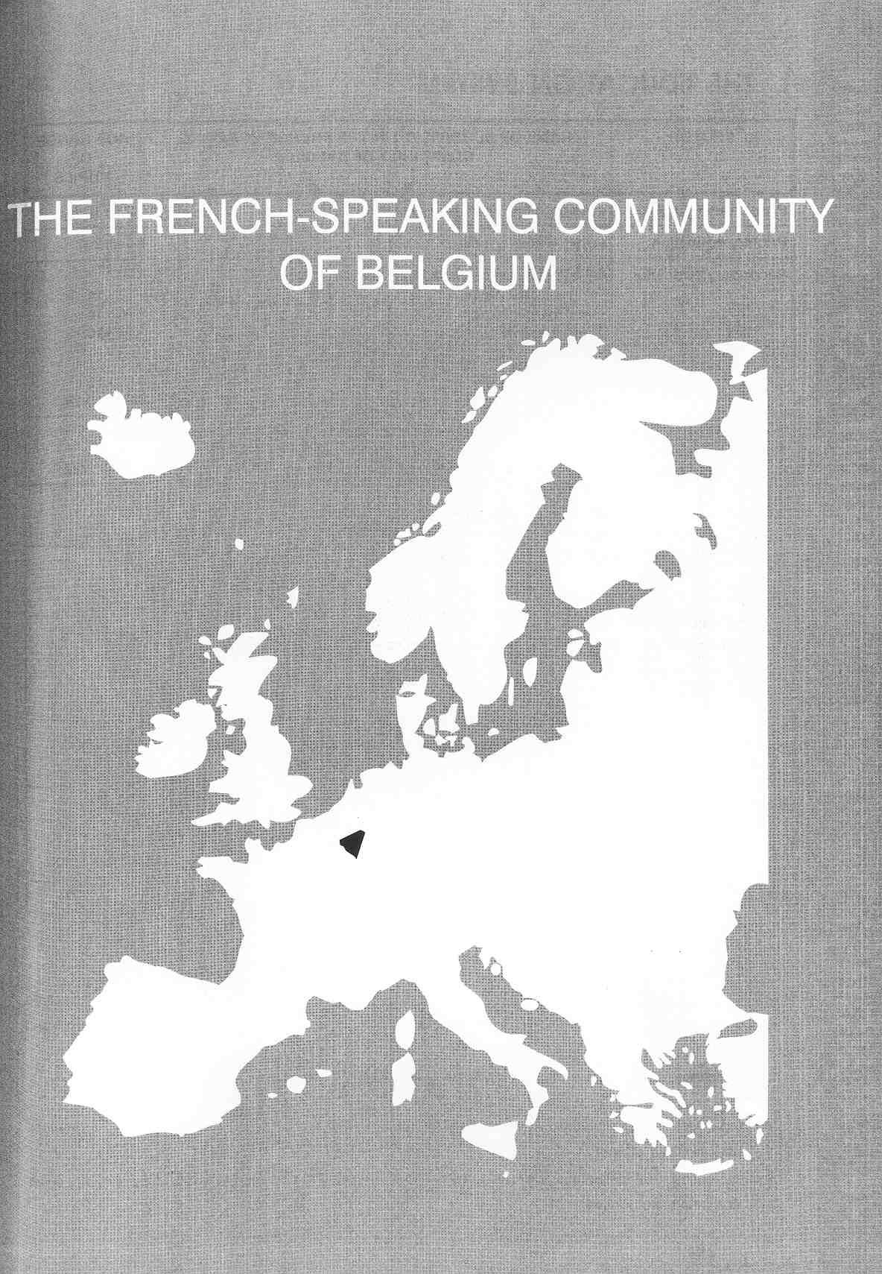

Νίκος Ηλιάδης, Πολ/κός Μηχ/κός Ε.Μ.Π., M.Sc.,
Ph.D. Industrial Education, Organization and Management,
Σύμβουλος του Παιδαγωγικού Ινστιτούτου

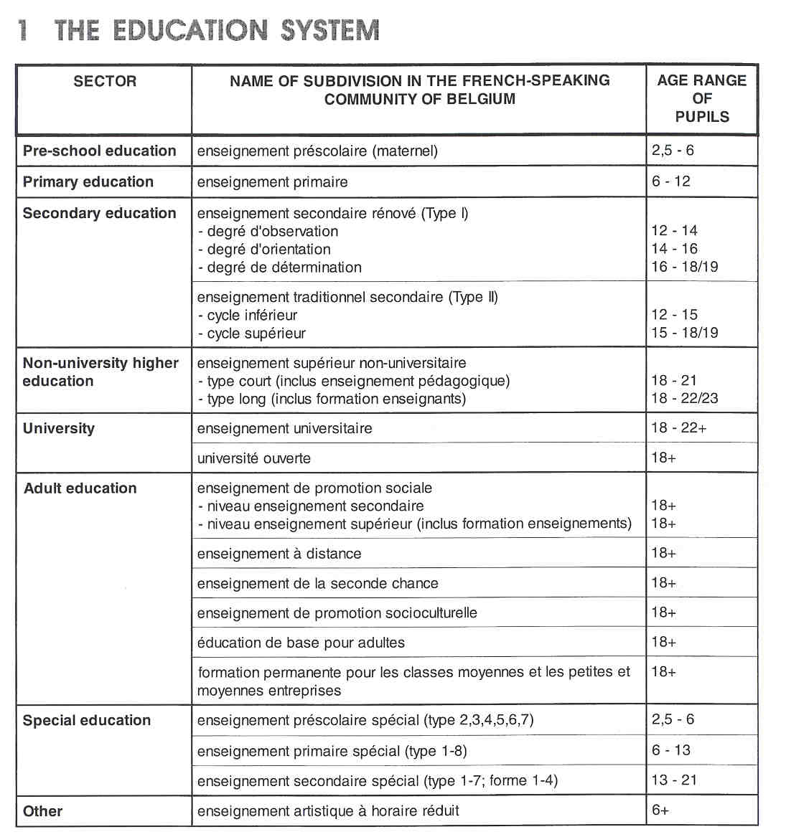

THE ADMINISTRATION OF THE EDUCATION SYSTEM

The Belgian Constitution requires the Communities to guarantee parents a free choice in respect of the type of education they wish their children to receive. This principle is built on two beliefs: "open enrolment" and "educational freedom".

In the French-speaking Community, there are three main types of educational institutions:

- public educational institutions, organised and managed by the French-speaking Community and financed in total from its budget;
- public educational institutions, subsidised by the French-speaking Community, but managed by provincial or communal authorities;
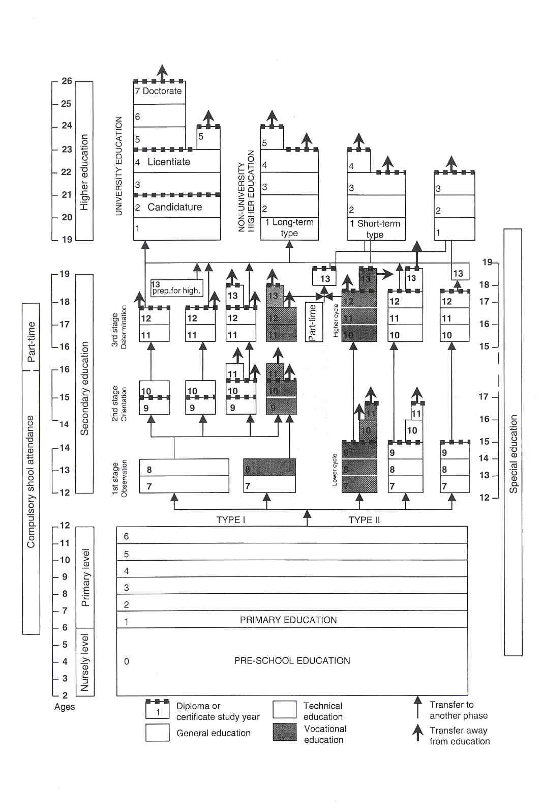

- independent educational institutions, denominational (predominantly Catholic) or non-denominational (neutral), subsidised by the French-speaking Community, if they meet certain conditions and respect educational legislation. Catholic schools are run by dioceses, congregations, parishes and Christian associations. The Community maintains Jewish, Islamic or Protestant denominational schools, mostly at primary level. The few non-denominational, private grant-aided schools include, for example, Decroly and Freinet schools. Public education is required to respect the philosophical and religious beliefs of all parents and to offer a choice between instruction in a recognised religion (Catholic, Protestant, Jewish or Islamic), ethics derived from these religions or instruction in nondenominational ethics.

Educational freedom is the right to establish independent schools. In Belgium anyone is entitled, by right or statute to provide education and to establish institutions for that purpose.

Since 1970, the unitary Belgian State has been moving towards a Federal State through four stages of revision of the Constitution. As a result of this process there are three cultural Communities in Belgium (the Flemish, the French-speaking, and the German-speaking Communities). In the third stage of this process (in 1988-89), almost all responsibilities related to education were transferred from the Federal Government to the governments of the Communities. At the federal level, only three responsibilities remain, i.e. deciding the beginning and end of compulsory schooling, attendance period, establishing the minimum conditions for granting diplomas and maintaining the pension system.

As a consequence of the recent reforms of the State, policy for education and higher education policy is the responsibility of the Council of the French-speaking Community and its Government, in which there are several Ministers in charge of preschool education, primary education, secondary education, higher education, special education and academic research. The Council of the French-speaking Community is composed of representatives of the organising bodies, unions, parents, university experts, civil servants from the Ministry of Education and representatives of the social and economic sectors. The Ministers of Education have to seek the opinion of this Council on all preliminary draft decrees (laws of the French-speaking Parliament) on educational matters (with the exception of the education budget) and on policy reports and papers addressed to the Parliament of the French-speaking community.

The general framework of educational administration consists of four major levels: the Department of Education of the Ministry of the French-speaking Community, the educational networks, the committees for co-operation and the zonal councils, and the local schools and their organising bodies.

The Department of Education of the Ministry of the French-speaking Community is responsible for all aspects of education from nursery to university education.The organising body of a school is the authority, individual or collective, who has full responsibility for the school. Schools, administered by different organising bodies, are grouped in educational networks. While respecting statutory requirements, organising bodies may determine their own programmes, curriculum content, teaching methods (including pupil assessment) and internal organisation; they may, for example, appoint staff. Most of them opt for the central curriculum of their network.

The organising body of Community schools is the Government of the French-speaking Community. It administers and manages establishments (at all levels) and the careers of administrative staff within its own educational network. The organising bodies of subsidised public schools, however, are the provinces and communes; the organising bodies of independent subsidised schools are the persons responsible by right or statute.

The educational networks have a strong co-ordinating effect on their organising bodies. By virtue of the constitutional and legislative framework for education, the networks are concerning the organization of education, the networks are empowered to define and develop their own educational projects. Their autonomy can generate a wide diversity of philosophical and pedagogical views, depending on the educational establishments. The networks, for example, draw up a central curriculum for their schools, based on the compulsory core curriculum established by the Parliament of the French-speaking Community. The bodies, however, grouping organising authorities into one and the same network propose adhering to common educational projects, subject to regular review. Traditionally, there are three such networks: Community education (administered by the French-speaking Community), grant-aided public education (administered by the provinces and municipalities) and grant-aided independent education (administered by private individuals, independent associations, or non profit-making organisations).

The committees for co-operation and zonal councils comprise representatives of the organising bodies, including the Minister, representing the organising body of Community education.

At the level of the school, the organising body may opt for particular co-operative association. Since 1990, participation councils have been set up within Community education, to make proposals and express opinions on, for example, pedagogical matters, such as the implementation of the school's aims and objectives, material resources and school management. Councils comprise, inter alia, the headteacher, representatives of the teaching and administrative staff, parents, pupils, unions and local policy-makers.

In order to obtain value for money, the French-speaking Community sets certain educational standards. For this reason, the concept of "final objectives" was introduced into the curriculum. Final objectives constitute the minimum standard to be striven for and attained by the majority of pupils. Final objectives are formulated by a committee comprising representatives of the three networks and adopted by Parliament. Final objectives must be integrated into the curriculum.

Within the limits of statutory requirements, organising bodies may indicate the type of assessment they whish to implement, together with the means of monitoring standards and reporting-back. There are no State examinations in the French-speaking Community of Belgium. All formative and summative examinations and tests are organised by the teaching staff. The class teacher in primary education, (often in consultation with the principal and, at times, other team members), and the class council in secondary phase, (comprising all the teachers of a particular class and the principal), decide whether a pupil has successfully,,completed a school year. The Government of the French-speaking Community of Belgium recognises the competence of schools to award certificates, which, in turn, are ratified by the Ratifying Commission of the French-speaking Community.

COMPULSORY EDUCATION

According to the Act of 29 June 1983, compulsory education lasts for 12 years, starting in the school year when the child reaches the age of six and finishing at the end of the school year during which helshe reaches the age of 1.8.

Children are required to attend school full-time until the age of 15, after completing primary education and at least the first two years of secondary education. Those who have not completed the first two years of secondary education are required to attend school full-time until the age of 16. Those who do not wish to continue full-time education may then follow compulsory part-time education until the age of 18. Part-time compulsory education is defined as studies in a recognised establishment, in the form of either part-time study or a recognized training course.

EDUCATIONAL SECTORS AND SUBDIVISIONS

Pre-school Education

Pre-school education is an integral part of the education system. It is optional, free and co-educational, and is provided for children aged from two-and-a-half to six years and, in exceptional cases, seven years.

The children are supervised mainly by nursery teachers. The organization of classes is very flexible, in order to adapt teaching to children's needs. Nursery education helps the children become more mature, so that they may cope succesfully with basic learning at the beginning of primary school. There are various activities to encourage the child's development, including activities to promote psychomotor, artistic, linguistic, logical and social skills, but no formal lessons as such. There is no formal assessment at this level and pupils progress automatically to the next class.

Most preschool establishments are attached to primary schools. As a result, the vast majority of nursery schools are governed by the same regulations concerning facilities facilities and hygiene, staff remuneration, teaching qualifications, staff-teacher ratios, the school calendar, etc.

Primary Education

Children are admitted to primary education after the summer holidays of the calendar year in which they become six. Primary education formerly comprised six classes (or years groups), subdivided into three cycles of two years each.
Normally, classes are organised by age, with one class teacher for all subjects, although a specialist teacher is employed for music, physical andlor religious education. Class teachers sometimes remain with their class for a few years.
The current trend is for more and more schools, regardless of size, to create vertically grouped classes for pedagogical reasons. It is hoped that vertical grouping (classes comprising different age groups) will encourage shared learning. Circulars recommend that teaching teams be set up to share teaching, to share the responsibility for children and to draw up a common scheme of work ("pedagogical project").
By law, compulsory courses include religion or ethics, reading, writing, arithmetic, geography, history, the rudiments of drawing, natural science and hygiene, singing, physical education, road safety, manual work and basic aesthetic appreciation. A second language must be taught in years 5 and 6. In some geographical areas specified by law, this subject is compulsory. In Brussels, for example, Dutch is compulsory from year 3 to year 6.
When they have successfully completed six years at primary school, pupils receive a certificate of primary education. They may also obtain this certificate by passing the cantonal examination (see later).

Secondary Education

Secondary education covers 6 years, and is intended for pupils aged 12 to 18. There are two forms of organisation for secondary education, called Type 1 and Type 11.

In the French-speaking Community, secondary education is also divided into two main straims.

- The main purpose of the transition stream is to prepare students for tertiary education whilst keeping open the option of entering employment. In this stream, the group of core options occupies 6-12 periods a week. Courses tend to be of a general nature.
- Conversely, the main purpose of the qualification stream is to prepare pupils for employment by obtaining a Qualification Certificate, while keeping open the option of continuing into tertiary education. In this stream, the group of core options occupies 17-24 periods a week.

Secondary Education Type I

Secondary Education Type 1 ("reformed" ("renove") education) comprises three stages each lasting two years.

The Observation Stage (usually for pupils aged 12 to 14)

The first stage can be divided into a main straim (the A-stream) with 90% of the pupils and a B-stream for the remaining 10%.

In year 1 (A stream) and year 2 (A and B streams), all pupils follow the same curriculum (32 periods a week). For pupils with difficulties at primary school (children who repeated a year, children with a long-term illness and special needs children), a year 1 (B stream), with a modified curriculum, is offered. In year 2, alongside the common curriculum, a year of vocational education is also offered, with a different curriculum. The pupils are introduced to a minimum of two vocational areas.

Pupils cannot fail after the end of year 1. Instead, they are allowed to reach the required level by the end of the first stage. A supplementary year may be added to the first stage for pupils who are not deemed able to complete the stage in two years.

The Orientation Stage (usually for pupils aged 14 to 16)

From the second stage, there are four discrete types of secondary education:

- general secondary education offers a broad academic education and is intended to facilitate progression to higher education.
- technical secondary education offers a range of general and technical subjects, with an emphasis on the practical application of theory. It prepares pupils for employment, as well as for higher education.
- artistic secondary education offers a broad general education, with an artistic, technical and technological bias and providing practical experience of art.
- vocational secondary education provides practical education, combines training in specific technical and practical skills with general courses. It prepares mainly for employment.

The four types of secondary education each contain several areas of study. The training programme within each course of study comprises a common element (depending on the type of education) and a discrete element which distinguishes one course from the rest. In all the four types of education, the number of subjects in the curriculum taken in common decreases each year, whereas the number of optional subjects increases.

In vocational secondary education, the optional subjects are grouped into nine areas. One such group constitutes 25 weekly periods. At the end of the second stage of vocational education, there may be a year of further education or specialization.

The Determination Stage (usually for pupils aged 16 to 10)

At this third stage, the pupils make a definitive choice from the range of subjects offered. The common core of the curriculum is further reduced, and the number of optional subjects further increased. For these two years, the pupils must adhere to the same course of study.

At the end of the third stage of technical and vocational education, one-year advanced andlor specialised courses may be offered. Certain schoolslinstitutions offer a preparatory year for higher education or university. Others offer a preparatory year for supplementary vocational education: a seventh year of vocational education, or a year of further education, or specialisation in a qualification stream.

In some schools, a fourth stage is organised in supplementary full-time vocational education for certain areas of vocational training, such as general and psychiatric nursing (mental health and psycho-analysis). This stage entails three years of study.

Secondary Education Type II

Secondary Education Type 11 ("traditional" education) comprises two stages each lasting three years. The four discrete types of secondary education provided in Type 1 are replicated in Type 11, i.e.: general, technical, vocational and artistic education (See above). Type 11 only comprises some 3% of the pupils attending secondary school.

Secondary schools are usually coeducational; they do not charge fees. Classes are generally organised by age and sometimes by subject. In some schools, classes,oan be organised by level of ability. Because, however, some pupils repeat a year, classes sometimes include pupils of various age-groups.

Secondary education includes common core subjects and a set of options, in which courses or activities can be grouped or imposed by the organising bodies. Teachers use formative assessment methods on a regular basis. The results of this continuous (periodic) assessment, together with the results of the one or two examinations which may be set, influence the decision taken at the end of each school year by the class council (in Type 1) or the teaching staff (in Type 11) to recomrnend that a pupil should progress to the next year group (with or without restriction) or repeat the current year. When set, examinations are written, oral or practical, depending on the subject.

In Type 1 and 11 of secondary education, certificates are awarded by the schools concerned. The upper secondary education certificate is ratified by the Ratifying Commission, which ensures that schools comply with regulations concerning the organisation of courses. An upper secondary education certificate is awarded to each pupil who has successfully completed year 6 of Type 1 or 11 in general, technical or artistic education. Pupils pursuing vocational education must complete an extra year to obtain this certificate.

Beyond full-time compulsory schooling, the training of young people below 18 years of age comes under three types, each conforming to requirements for part-time compulsory schooling up to the age of 18:

- part-time vocational secondary education;
- apprenticeship (including industrial and commercial apprenticeship);
- recognised training courses, such as those in centres for training in independent professions and non profit-making associations.

These courses form part of the third stage. The centres for part-time education provide courses combining general education (including personal and social education) and preparation for employment. The content of courses is limited and designed to continue full-time education.

Higher Education

Higher education includes the provision of higher education institutes and university education. In order to gain access to higher education, a student must hold a secondary education diploma. At present, there are no (quantity) restrictions (no numerus clausus) on entry to higher education institutes or universities. For some areas of study, however, for example arts and civil engineering, candidates must to pass an entrance exam.

Non-university Higher Education

Non-university higher education institutes offer a broad spectrum of educational possibilities, divided into eight areas of study: agriculture, arts, economics, education, paramedies, social studies, technical studies and translation and interpreting.

In five of the eight areas, (agriculture, arts, economics, social studies and technical studies), students may opt for a short or long course.

- The short cycle higher education course (3 years) gives students the necessary technical training to be qualified for employment in specific fields, requiring scientifically-based knowledge.
- The long cycle higher education course (4-5 years) is academic in content and with an emphasis on scientifically-based knowledge. A first stage (2 years) of general and scientific studies prepares the student for a second stage of specialised studies. At the end of the second stage, the undergraduates present and defend their thesis, project or end-of-course paper. In some areas of study, the second stage of the long cycle course lasts three years and not two.

In both cycles of non-university higher education, studies include lectures, application of theory, practical work, scientific experiments, written reports and work experience or teaching practice.
Higher education. institutes can also provide continuing or postgraduate training programmes.

University Education

University education is divided into discrete cycles of study. Each cycle leads to the award of a degree, which is required for entry to the next cycle. The first university degree is the candidature, obtained after two, or sometimes three years of study. It certifies that the student has the basic indispensable knowledge to enter the second cycle. The second cycle leads to the degree of licentiate, obtained after two or three years of study. It includes specialised study and the presentation of a thesis. In some disciplines, the second cycle lasts longer and leads directly to the qualified doctor, pharmacist and engineer status and thus lasts sometimes longer to engage in a profession. Second cycle degrees generally give the right to engage in a profession. University education may also include a third cycle in some specialisrns and lead to the award of a doctorate. The examination for a doctorate includes the presentation of an original dissertation, together with a thesis, defended in public. Graduates deemed able to carry out individual work and scientific research have the right to undertake a doctorate.

In addition, diplomas of complementary studies can be awarded after studies on completion of the first or second cycles. These studies complement or broaden basic studies in the same or a different area.

Three universities in the French-speaking Community consist of the five traditional faculties (philosophy and arts, law, sciences, medicine, applied sciences) and a varying number of departments, schools and institutes which organize courses in other disciplines (agricultural sciences, oriental studies, business and economics, education, science, etc.).

Open University

The Open University is a State-funded establishment of higher education offering distance-learning courses for people aged 18 and over. The main objective of the Open University is to make higher education accessible to adults who want a second chance.
Open University courses are organised in the form of discrete modules. Students may combine various courses to compile their own progra mme of study. It is also possible to complete a full higher education or university programme.

Teacher Training

All initial teacher-training courses for the various education sectors are part of higher education. Teachers are trained at three levels, each of which provides teacher training for a particular sector of education:

- teacher training provided by higher education institutes (short type) trains students for pre-school teaching, the primary school, the lower secondary level and the upper secondary level of the qualification stream, as well as for the working as ancillary staff.
- pedagogical higher education courses for social advancement train students of teaching certain vocational and technical subjects in secondary education.
- academic teacher training in the universities or in some higher education institutions (long type) trains students to teach specific subjects in the upper secondary level of the transition stream and in the fourth stage of secondary education,- for teaching Latin and Greek in the first stage and for teaching in higher education (short type). University professors need a doctorate.

A Ministerial decree instituted the creation and recognition of courses leading to a teaching certificate for the education of "abnormal children". Nevertheless, possession of this certificate is still not mandatory for teaching in special education. Teachers in the special education sector who possess this certificate receive a higher salary.

Adult Education

Part-time adult education consists of courses in social advancement, distance learning, basic education, courses in artistic sociocultural advancement, continuing training for independent professions and second- chance courses.

Social advancement education ("enseignement de promotion social") offers vocational and technical secondary education courses and higher education courses. In most cases, however, the diplomas awarded do not have quite the same currency as those obtained in full-time education. The disciplines taught constitute a wide range of general courses (over 50% of which are language courses), technical courses and practical vocational courses in many fields, including advanced specialisms.
There are three main groups of students:

1 . those who would like to obtain an additional qualification (a diploma at a higher level than the one they already hold); this is known as vertical advancement.
2. those who would like to receive additional training or to specialise (an additional diploma at the same level as the basic diploma); this is known as horizontal advancement.
3. those who aim at personal development or social emancipation.

Second chance education ("enseignement de la seconde chance") is accessible to anyone above the age of 18 with at least basic primary education with knowledge of at least basic primary education. It offers a second chance to obtain the secondary education diploma or the certificates of secondary education. It consists of three stages and has a currency similar to that of full-time education.

Distance learning ("enseignement a distance") is also known as "correspondence courses". Courses on a wide spectrum of subjects are provided, such as languages, mathematics, computer and information technology, trade, science and technique. Alongside the traditional "correspondence courses", language cassettes and exercise, discs for computer applications are also available. In the future, distance learning will be developed into a multi-media form of education.

Distance learning, adjusted to suit the level of the individual student, is mainly intended for adults who need to fill gaps left in their education, who are faced with the necessity of retraining or who are preparing for examinations set by the Boards of Examiners of the French-speaking Community, leading to a certificate of secondary education. Distance learning also prepares students for civil service recruitment and promotion competitions at various grades of the civil service.

Education for artistic sociocultural advancement ("enseignement de promotion socioculturelle") is divided into four disciplines: the plastic arts, music and lyrics, dance and technical broadcasting arts.

Basic education for adults ("education de base pour les adultes") is for adults who experience difficulties in reading and is provided by field organisations. Basic education centres provide several education and training programmes for low-skilled adults, such as courses in ba sic language and arithmetic skills, social skills, social training and preparation for work or further courses. These centres are financed by responsible for French- language classes for foreigners. Those centres are financed by the Continuing Education Department and by the Department for Social Affairs.

Training organised by the French-speaking Institute of Continuing Training for Independent Professions ("Institut francophone de Formation Permanente pour les Classes moyennes et les Petites et Moyennes Entreprises"), provides for the acquisition of the general and vocational knowledge, necessary for entry to a liberal profession represented on the Higher Council of the Independent Professions (i.e. small and medium-sized trade or crafts and some white-collar professions). The Institute has 13 sub-regional departments and co-ordinates the activities of 13 Continuing Training Centres for independent professions.

Basic training and apprenticeship enable one to acquire the skills required to exercise an independent profession.

Special Education

Special education provides training and education for handicapped pupils, who need special support temporarily or permanently. The main aim is to integrate the pupils into the world of education, on the one hand, and into society on the other hand. About 4% of the overall school population receives special education.

Special education is organised in six different forms in special pre-schools (for pupils aged 2.5 to 6), eight forms in special primary schools (for pupils aged 6 to 13) and seven forms in special secondary education (for pupils aged 13 to 21), each form adapted to the needs of the pupils. The forms of special school correspond to the various types of mental or physical disabilities.

Special secondary education is organised into four training levels called 'Iraining forms". Each training form meets well-determined needs:

- training form 1: Special secondary education for social adjustment endeavours to teach students to live as independently'as possible in a sheltered living environment. This form of education strives to encourage the students to integrade into society as far as they are able and to develop contacts with others.
- training form 2: Special secondary education for social and vocational adjustment endeavours to give students a general, social and vocational educatio h, to enable them to integrate and to work in a sheltered working environment. Priority is given to both vocational training related to general education and a differentiated programme, with a view to later working within a sheltered environment.
- training form 3. Special vocational secondary education endeavours to give students a general, social and vocational education, to enable them to integrate into a normal living and working environment.
- training form 4: This form of education is directed at students who, in spite of their disability, are capable, through studying, of attaining the same level as students in mainstream education. It prepares physically impaired students for higher education. Form 4 may include either general, technical, vocational or artistic education; either within the transition stream or the qualification stream.

In each of the above 'Iraining forms", teaching is largely to composite groups of students with various types of special educational need.

Part-time Artistic Education

The purpose of part-tirne artistic education ("enseignement artistique a horaire reduit") is twofold. On the one hand, it endeavours to offer students a preliminary introduction at the secondary level, to enable them to enter tertiary education in arts subjects and, on the other hand, to grant all those, who feel the need, the opportunity to acquire artistic skills. It responds to the students' artistic interests, enables them to develop their artistic skills, or may provide professional training with possible entry into professional life. It focuses on the four traditional forms of expression: the visual image, dance, music and the spoken work (acting, theatre, recitation and eloquence).
All courses are grouped into four levels: a lower level (the equivalent of primary education), a middle level, a higher level and a specialist level (all three the equivalent of stages in secondary education). Part-time artistic education is not compulsory.
Pupils are admitted from the age of 8. An initiation to musical theory or music and dance is offered for children aged 6 and above.

2 THE ORGANISATION OF THE INSPECTORATE

The French-speaking Community's Inspectorate performs the tasks entrusted to it by the Ministry. The Government of the French-speaking Community is completely responsible for funding the Inspectorate of the French-speaking Community of Belgium.

The Inspectorate is divided into several groups: there is an Inspectorate for primary education, for secondary education, for higher education, for special education, for guidance centres and for educational support. An Inspectorate has also been set up for social advancement education run by the French-speaking Community.

A Co-ordinating Inspector for primary education organised by the French-speaking Community heads the eight Inspectorate groups responsible for preschool and primary education. The primary inspectors are responsible for all areas of study.

An independent Inspectorate, appointed by the French-speaking Community, has been established for public grant-aided pre-schools and primary schools. According to the law, the level of instruction in grant-aided primary schools is subject to monitoring by principal inspectors and cantonal (or district) inspectors, a canton being an administrative sub-division. The Inspectorate of grant aided preschool and primary education is attached to the "Administration G6n6rale de I'Enseignement et de la Recherche Scientifique" (AGERS); it includes an Inspector-General, principal inspectors and several cantonal inspectors for pre-school and primary education. The principal inspector maintains close links with the cantonal inspectors within his jurisdiction. The jurisdiction of the Inspectorate for grant-aided pre-school and primary schools covers a territory approximately equivalent to one area (an area comprising approximately 75.000 inhabitants).

Two Inspectors-General head the Inspectorate for secondary education lead. One Inspector-General is responsible for general and philosophical courses. The other heads the Inspectorate responsible for technical, vocational and special courses. Both are charged with co-ordinating the work of the inspectors within their sector. Secondary education inspectors are responsible for only one or a few subjects.
Inspectors may be either inspectors of general courses (in lower and upper secondary schools or at non- university tertiary level) or inspectors of technical courses and vocational experience (in lower or upper secondary schools).

The Co-ordinating Inspector for special education heads the Inspectorate responsible for preschool, primary and secondary special education.

One group of inspectors is responsible for monitoring the Centres for Psychological, Medical and Social Services (or guidance centres). Two Co-ordinating Inspectors head this group. Due to its specific nature, however, this Inspectorate is not developed any further in this document.

Another group of inspectors is responsible for educational support, such as audiovisual resources, the new technologies and class councils.

A Co-ordinating Inspector for higher education heads the Inspectorate responsible for the short-type higher education courses. There is no Inspectorate for long-type higher education courses or university education.

Social advancement education is inspected by a Pedagogical Administrator and his staff of inspectors.

The Inspectorate of the French-speaking Community of Belgium has to be equally represented: half of its members must be recruited from publically-run schools and half from grant-aided independent schools. The number of inspectors is based on the various divisions and sub-divisions in the education system, the range of subjects and subject-combinations, the number of schools, the number of staff members to advise and the extent of the Inspectorate's jurisdiction.

Certain organising bodies of grant-aided schools have their own inspectors. Diocesan inspectors of Catholic grant-aided schools help, for instance, to devise a test for pupils completing primary education. Due to its special status, the Inspectorate of such organising bodies is not discussed in detail in this document.

As far as religious education is concerned, every educational authority has its own Inspectorate. The statutory bodies representing recognised moral or religious communities organise the inspection of and support for religious instruction or non-denominational moral education. There is a separate Inspectorate for the Catholic, Protestant, Jewish and Islamic, religions and an Inspectorate for non-denominational ethics. The inspectors liaise with the representative bodies and the Co-ordinating Inspectorlinspector-General and, once a year, with the Minister. The French-speaking Community does not subsidise this form of inspection. Due to its 1 special nature, the Inspectorate of moral or religious courses is not discussed any further in this document.

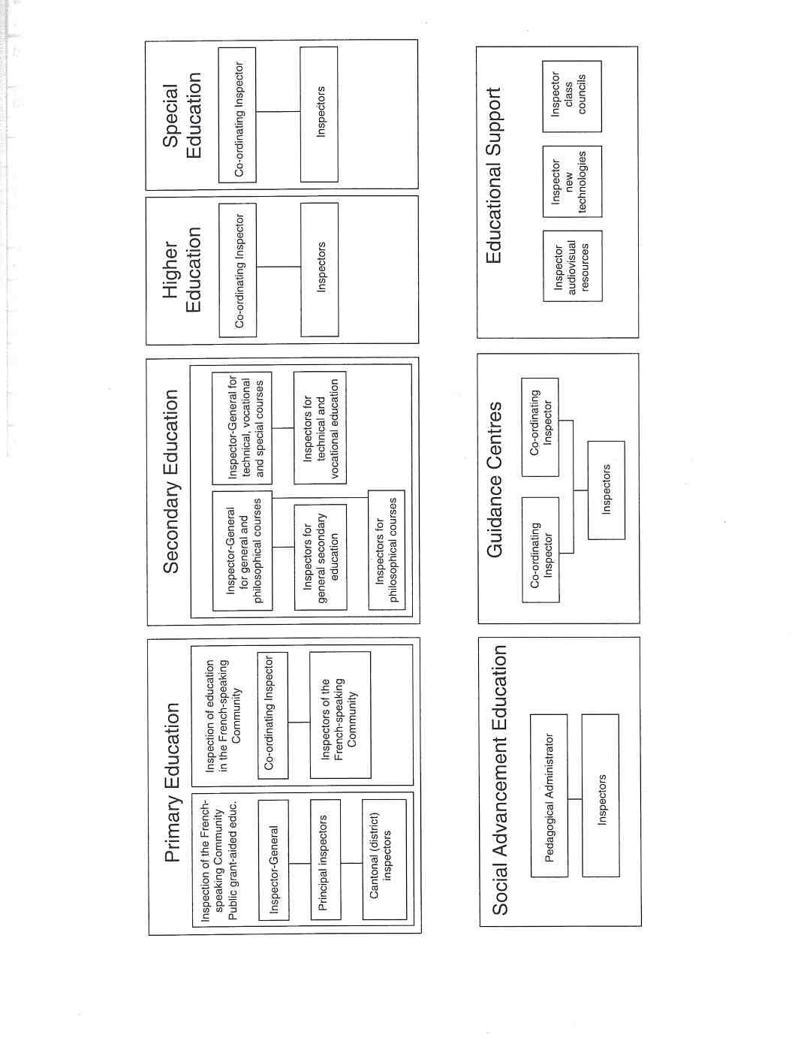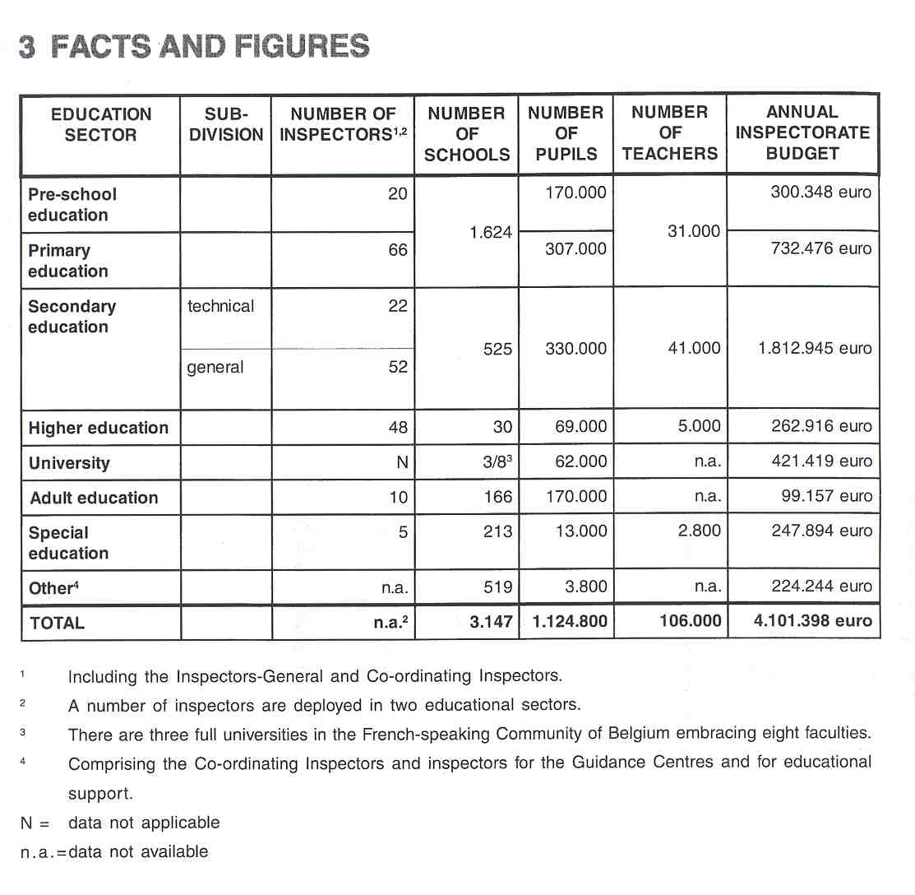

4 THE RECRUITMENT OF THE INSPECTORATE

To be eligible for the post of inspector, candidates have to fulfil certain requirements.

Candidates must have a teaching qualification and minimum ten years' teaching experience, with 6 of those years in the relevant sector. The minimum age for an inspector is 35 years.

Applicants must have received a "good" mark in the most recent report compiled by the school principal and the inspector.

Several selection tests are devised by the Inspectorate to assess applicants: firstly a written examination about school legislation and administration, secondly an oral examination about legislation, school management, the education system and pedagogy, and finally a written assessment of an actual lesson. The selection tests vary depending on the vacant position.

On passing these examinations, the candidates receive a certificate (the "brevet"); they may then apply for a vacant post. They are placed in rank order by a special commission, using a set of positive criteria. The Minister makes the final selection from among the highest ranked candidates.

5 THE WORKING CONDITIONS OF THE INSPECTORATE

The post of inspector is a full-tirne appointment. This arrangement supports the Inspectorate's independence from other interest groups. Inspectors are appointed in a permanent capacity to ensure continuity in their work.

6 AREAS OF INSPECTORATE RESPONSIBILITY

The role of education inspectors in the French-speaking Community is two-fold. In Community-run schools, their work covers the full extent of provision: they are, therefore responsible for the various programmes and syllabuses in use, teaching methods, school organization, equipment and infrastructure, etc. In practice, inspectors represent the authority of the Minister, to whom all these responsibilities devolve. Community inspectors also have the task of inspecting subsidised schools, which enjoy pedagogical autonomy. Since the Decree of 29 May 1959, subsidised education has been autonomous in this respect. As a consequence, the remit of the Community Inspectorate is severely ]imitated. The inspectors' authority is limited to monitoring the minimum number of courses, the minimum syllabus, the levels at which the pupils are working, the application of the laws pertaining to languages, health and safety, the quality of the accommodation, teaching resources and equipment. In other words, inspectors are not entitled to interfere in any way in the teaching approaches and methods used.

6.1 EVALUATING

In the French-speaking Community of Belgium, there is no system of full inspection developed.

The Quality of Education In Schools

Through their visits, inspectors must ensure that Community-run schools fulfil their educational purpose within the region suitably and comprehensively. The Inspectorate has to evaluate the educational quality of the school and its contribution to the pupils' attainment and progress.
For the various stages and study cycles of the first eight years of compulsory schooling, monitoring the quality of education also includes ensuring that:

- activities proposed to the pupils are consistent with the final objectives;
- 2. priorities set within the scope of the final objectives are respected;
- the level of the tests administered to the pupils is equivalent to that produced by the Inspectorate in its tests.

Therefore, inspectors must evaluate the planning for and content of the curriculum and its contribution to the educational standards achieved by all the pupils, taking account of age, attainment and special educational needs within the 'curriculum of Community-funded schools; they must ensure that the curriculum of funded schools is implemented appropriately. The inspector monitors whether the level of instruction by the teachers is sufficient to guarantee progress. 11

The Inspectorate is also required to verity that regulations concerning the curriculum are complied within all the subjects taught. It has full responsibility for all the subjects taught, with the exception of moral or religious courses. As far as religious education is concerned, every authority which organises its own education has its own Inspectorate at its disposal. The statutory representative bodies of each recognised moral or religious community organise the inspection of and support for courses of religious instruction or non-denominational moral education.

The Inspectorate for schools organised by the French-speaking Community, the cantonal inspectors and the headteachers are entitled to enter classes, in order to verify that the statutory requirements for organising a philosophy course are duly respected. Such monitoring, however, cannot in any way affect the content and methodology of philosophy courses.

In certain administrative subdivisions (known as cantons or districts), the cantonal inspector organises an examination at the end of the sixth year of primary education to evaluate educational standards. The tests are in mathematics and French (the mother tongue). The results of this external assessment can help to determine the award of the Primary Education Certificate (CEB).

A "Ratifying Commission" has the task of verifying whether secondary-level studies have been completed in keeping with the provisions of legislation and the regulations. The commission is also responsible for approving upper secondary school certificates.
The education authorities enforce procedures for the award of other qualifications, such as certificates of vocational qualifications, and also validate diplomas awarded in higher education. At university level, there is also a "Ratifying Commission".

The Quality of teaching

Inspectors evaluate the work of teachers for formal assessment purposes. They are authorised to observe lessons and to scrutinise written work. They evaluate the level of instruction. They may be expected to examine, if necessary, the files of staff. This assessment can be a decisive factor in recruiting, employing and promoting teachers.
Inspectors question pupils during lessons and assess their work in order to evaluate the quality of the teaching.

The Quality of School Management

Inspectors evaluate the quality of school management only when requested to do so in a special assignment. The focus on whole-school inspection is limited to subsidised schools; it occurs in publically-run schools only by special request.

Statutory Requirements

The Inspectorate has to evaluate the extent to which schools comply with statutory requirements imposed by the Minister and the Government, such as those concerning the teaching package, the timetable, school equipment, the number of teachers, classroom resources, teaching materials, health and safety regulations, etc.

In pre-school and primary education administered by the Community, the Community inspectors work on behalf of the administration. They must satisfy themselves that the general standards in schools are appropriate, that instructions are followed, that teaching aids are used effectively and that staff are suitably competent. The Inspectorate has no responsibility for deciding on budgetary allocations.
In grant-aided schools, the Inspector is required to review school applications for funding. The Inspectorate ensures that Community funding is being used correctly. It also inspects accounting procedures.

Evaluations of Aspects of Provision

A range of specific topics is inspected at the request of the Minister, the Government or the Ministry

6.2 ADVISING

Advising and informing principals of schools, governing bodies, the Ministry, etc. constitute an important part of the Inspectorate's work.
In preschool, primary and secondary education organised by the Community, the Community inspectors monitor the work of teachers and promote good teaching. They offer an opinion on the work of teachers, keep them informed and help them to improve. Some individual inspectors are charged with giving specific continuing support to teachers. The inspection service of the French-speaking Community, for example, also provides educational support by advising teachers in teaching methods and in the choice and use of textbooks. They help to plan lessons and prepare timetables. To this extent, the Inspectorate provides in-service training for teachers.
Advice to individual teachers is also offered, as appropriate, during the inspection.

Inspectors in (independent) grant-aided schools must refrain from giving any guidance on teaching methods, in accordance with the principle of autonomy in education.
Certain organising bodies of grant-aided schools have their own inspectors. They provide advice of a general nature to principals and teachers collectively during the annual teaching conferences held in schools.

Advisory work about administrative decisions is carried out on special request, but it is not an important part of the inspection.

Organizing bodies may also have educational advisers within their network.

6.3 MONITORING

At present, members of the Inspectorate are only occasionally involved in constructing and managing a data bank, but their contribution in this area is increasing. Assisting in the collection of data and in constructing and managing a data bank is carried out on a voluntary basis.

One aim of the Inspectorate in preschool and primary education is to monitor the conditions under which funds are allocated to schools, including the quality of teaching.

Inspectors also monitor the practical organisation of schools, the proper execution of statutory regulations, particularly those concerning compulsory- education, compliance with the provisions of the "Mission, Decree" and respect for neutrality, wherever it is required (in schools organised by the French-speaking Community).

In preschool, primary and secondary schools of the French-speaking Community, the Inspectorate monitors the implementation of the final objectives.

A number of primary education inspectors are members of the General Education Council, which makes proposals for the general direction of primary education and assesses the extent to which various strategies might achieve its objectives. It discusses proposals relevant to these objectives, transmitted by different task forces and forwards them to the Government.

One aim of the Inspectorate in secondary education and the short type of higher education courses is to provide a pedagogical link between educational administration, schools and teaching staff. The Inspectorate is in charge of monitoring the quality of teaching in secondary schools and short type higher education institutions, organised by the French-speaking Community and grant-aided authorities.

Representatives of the Inspectorate for social advancement education are members of the Consultation Commission on education for social advancement, which has the task of facilitating the introduction and setting up of social advancement courses for group 1 (see above) in schools. It is also in charge of reference material (specimen timetables and minimum course content, procedures for assessing the market value of qualifications, etc.) necessary for implementing a training programme. The commission is consulted before the creation of any section of short type supplementary education.

Inspectors are assigned to resolve disputes or conflicts between a school and its community.

The Inspectorate intervenes in the work of an employing authority only at the express request and on behalf of that authority.

6.4 REPORTING

- The Inspectorate compiles assessment reports on teachers for school principals and reports on the school to the Government. Teacher assessment can be a decisive factor in the recruitment, employment and promotion of teachers, such as candidates for permanent, temporary or short-term contract posts, candidates for posts in school management and candidates for the Inspectorate examination.

- The Inspectorate has to report on the quality of the school's educational provision and on its contribution to the pupils' attainment and progress. Inspectors must, therefore, report on the planning and content of the curriculum and its contribution to the educational standards achieved by all the pupils, taking account of age, attainment and special educational needs within the total curriculum of subsidised schools; they need to ensure that the curriculum, devised by the organising body of these subsidised schools, is implemented correctly.

Reports are also written about the practical organisation of schools or educational institutions, and the proper implementation of statutory regulations, particularly those concerning compulsory education, compliance with the provisions of the "Mission Decree" and respect for neutrality, wherever it is required.

- Inspectors also compile reports on special themes or aspects of provision, proposed by the Government, the Minister or the Ministry of Education.

6.5 OTHER RESPONSIBILITIES

Curriculum Development

In pre-school, primary and secondary education organised by the Community, Community inspectors participate in planning the content of the curriculum.

Inspectors are now involved in defining final objectives (in terms of competences and skills). This formal system of benchmarking, which sets out, in a structured way, which competences must be developed by the end of the first eight years of compulsory education, and which levels must be attained by the end of each stage: i.e. the second year of primary education, the sixth year of primary education and the second year of secondary education. These competences are deemed necessary for social integration or to resume further studies.

The Inspectorate has developed three different types of final objectives. There are general integrated subject competences and competences related to specialist subjects. Final objectives include inter-disciplinary or cross-curricular competences, which are gradually acquired by the pupils, ensuring their personal development and progress, as well as subject-related cornpetences taught in class. The final objectives are identical for all types of school.
The Inspectorate plans the curriculum in co-operation with subject teachers.

Since 1991, motivated pupils in special vocational secondary education (form 3), having obtained th qualification certificate at the end of the fifth year, can have access to a sixth year of advanced studies. This year includes several training courses, in order to bring the pupil into touch with social and vocational reality. Its attainment target is a predetermined vocational profile. The Inspectorate draws up this profile in co- operation with the relevant vocational bodies.

The Development of Educational Material

The inspection service of the French-speaking Communay contributes to the planning and development of teaching methods.

The Inspectorate develops educational materials with the co-operation of its In-Service Training Centre.

The Development of Tests

Every school year, the cantonal Inspectorate develops an examination at the end of the sixth year of primary education. The questions are set by an inspector or group of inspectors in the same canton. The inspectors and teachers on the board of examiners are also responsibe for marking. The subjects examined are mathematics and the mother tongue.

Language courses organised in years 5 and 6 of primary education are subject to external assessment organised under the auspices of the Inspectorate of the French-speaking Community, in co-operation with representatives of the different organising bodies of schools.

7 THE ROLE OF THE INSPECTORATE IN EDUCATIONAL POLICY

Educational policy is formulated by the Minister and the Goverment of the French-speaking Community The Inspectorate has no official role in drafting policy, but its evaluation reports on particular aspects of provision or topics contribute to the policy-making process. Sometimes, a member of the Inspectorate serves as assessor within study groups and, as such, can influence and advise policy makers in the Government and the Administration, but the influence is rather limited. The Inspectorate is, however, engaged in advising on and preparing draft legislation.

The Inspectorate is involved more frequently in promoting the implementation of policy. The results of its evaluations in individual institutions could serve to encourage further implementation.

The Inspectorate has no central role in evaluating the effectiveness of policy; it has to evaluate the way in which schools implement policy. The direct contact of inspectors with individual schools, management bodies, teachers, pupils and parents is frequently a source for delineating further lines of policy. Following an inspection, the Inspectorate must inform the Minister about the issues identified and the improvements needed. The evaluation reports of the Inspectorate are sometimes referred to in the debate about the effectiveness of policy.

8 WHO IS IN CHARGE?

The Minister of Education is responsible for the legislative and administrative aspects and the overall supervision and development of education.
The Inspectorate's role is set down in legislation. Inspectors, in fact, obey orders from the Minister, who decides, for the most part, on the Inspectorate's outline programme. The Inspectors-General and Co-ordinating Inspectors decide on the Inspectorate's work schedule within the Minister's guidelines.
Parliament may ask the Minister to ask the Inspectorate to evaluate a particular topic or aspect of school provision. Parliament itself, however, does not decide on the programme. If there is a national priority area, the Inspectorate, in any case, tries to include it in its work schedule.

The membership of the Inspectorate senior management is small, considering the variety of matters senior inspectors have to address, besides regulating the work of their staff. Individual inspectors enjoy a fair amount of freedom. They consult with the administration. The Inspectorate implements decisions made by the administration.
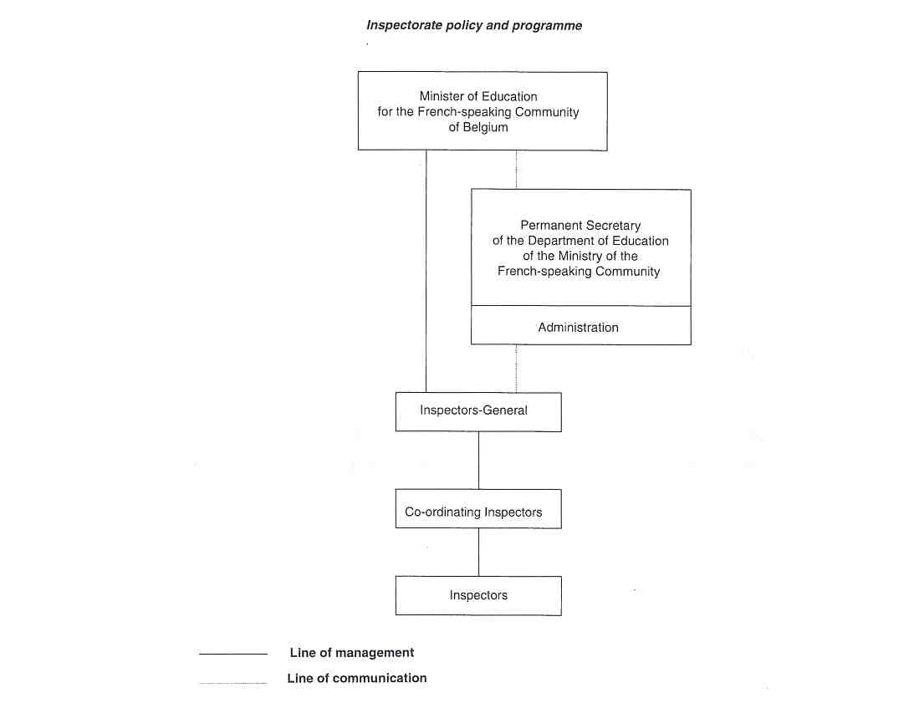

9 THE POSITION OF THE INSPECTORATE

The Inspectorate is indirectly responsible to the Minister of Education, who bears the final responsibility for the supervision of education.

Individual inspectors and, particularly, members of the Inspectorate senior management are regularly involved in meetings with the Minister and his/her Cabinet and with the Permanent Secretary of the Department of Education on policy matters in which professional advice is required.

The Inspectorate is, at one and the same time, a partner and an evaluator in terms of the administrative branch of the Ministry of Education, whose role is to aid, sustain and support the processes of planning, implementing and evaluating the education policy decided at Government level. Inspectors inform the administration about the performance of schools, the organisation of schools and the education system as a whole. They also implement administrative decisions, but, in principle, they are totally independent of the administration. Inspectors are not civil servants. Some inspectors have been seconded to the administration for short-term tasks.

In the French-speaking Community of Belgium, there is no network of specialist organisations and agencies, which support, maintain and enhance the education system. Institutions for curriculum development do not exist, apart from a pilot unit, whose role is limited to devising a few aptitude tests for pupils during compulsory education. The Inspectorate co-operates with this unit.

Institutions for national or regional assessment do not exist either. The Inspectorate sometimes co-operates with those responsible for particular projects.

10 THE INSPECTION PROCESS

Inspection in the French-speaking Community of Belgium cannot be described as a formalised process with well-defined procedures. An inspection can be initiated by the inspector, the school principal and, occasionally, on the orders of the Minister. In general, inspectors visit schools at regular intervals, but they must decide how to handle each particular assignment and how to deal with the school.

Schools are generally not informed beforehand about a planned inspection. Prior information about it depends on the good will of the inspector; if there is no need for secrecy, the plans may be revealed to the school. Inspectors generally need prior information to carry out an inspection.

At the end of the inspection, the school receives an oral report of the inspection's findings. Oral feedback is also given to teachers after their lessons have been observed. A detailed written report is compiled and sent to the school.

Cantonal inspectors liaise with the municipal authorities and visit all the schools in their canton at least twice a year. They ask the municipalities, school management and teachers for all the information they need to monitor compulsory school attendance and the practical organisation of teaching. They communicate the results of the inspection to the headteacher and staff concerned.

11 INSTRUMENTS AND METHODS

THE COLLECTION OF INFORMATION

a. Questionnaires

Questionnaires are rarely sent to schools. They are used mainly for the evaluation of specific subjects or topics, most of the time at the special request of, for example, the Minister, the Government andlor th Permanent Secretary of the Ministry of Education.

b. Interviews

Interviews occur in circumstances similar to those mentioned above. The main participants are generally teachers and principals of particular schools. The issues and the interviewees depend on the purpose of the evaluation.

c. Observations

Classroom visits and the observation of classroom activity are undertaken to establish the quality of the teaching process and of pupils' learning in primary and secondary schools. The direct observation of teachers during lessons and of the skills of the pupils in class is current practice.

d. Tests/examinations

In primary schools, inspectors measure the pupils' level of attainment, mainly to verify the teachers' own assessments. The Inspectorate is, for instance, involved in developing the annual cantonal examination and the external assessment of language courses (see "Development of tests" above).

In secondary schools, inspectors conduct similar exercises, but only in the limited manner mentioned above.

e. The Collection of Documents

The school development plan, schemes of work, the teachers' preparation, lesson plans, activity plans, schedules, pupils' examination papers, examination results, exercise books, homework books, homework assignments, etc. are all necessary documents for the inspection. The school is asked to make them available to the Inspectorate, and they set a framework and guidelines for its work.

APPROACHES

a. Evaluation Criteria

The Inspectorate has no uniform inspection instrument for all the members of a particular Inspectorate section. The approach adopted depends on the individual inspector.
The Inspectorate uses, although not systematically, a set of criteria for evaluating the schools' own quality assurance procedures; these include statistics, OECD recommendations, international testing, etc. Inspectors also use nationallregional data, such as population trends, pass/fail statistics, etc.

b. lndividual Work and Teamwork

When on inspections, inspectors work alone for the most part. In some cases the help of a colleague may be sought. More than one inspector must be involved, for example, when a teacher applies for a principal's post, etc. The percentage ratio of individual work to tearn work is 90 : 10.

12 JUDGEMENT AND ITS CONSEQUENCES

Teachers in primary and secondary schools are assessed on the following scale: exceptional, very good, good and insufficient.
This assessment can be a decisive factor in recruiting, employing and promoting teachers. A positive report, for example, provides teachers with the possibility of becoming a school principal, and of competing in the Inspectorate examination. The consequences for teachers of a negative assessment are, for example, lack of advancement for permanent teachers and failure to obtain a permanent post for temporary or short-term contract teachers (or a delay in obtaining such a post). Of course, other criteria are taken into account, such as the principal's assessment, years of service, etc.

As mentioned before, subsidised schools depend only partially on the judgement of the Inspectorate, never totally When a school appears not to comply with statutory regulations, it is obliged to take remedial action. In the case of a negative report, funds are suspended for a year in the area inspected.

13 OUTCOMES

When on an inspection, inspectors compose a lot of notes; they contain the most important findings, the agreed course of action and the recommendations. Within the Inspectorate, however, there are features and guidance for various aspects of a school's work, which help to ensure a common framework and shared values for the recording of Inspectorate judgements.

Official reports contain observations and descriptions of teaching activities in and sometimes outside the classroom; there are comments, assessment, evaluation, advice on teaching, an evaluation of the teacher's work and recommendations for future development. Reports about individual teachers are addressed to them, via the school principal. They sign them and indicate whether they agree with the findings or not.

The report on the inspection of the quality of a school's provision is intended for the Minister and the school principal.

The extent to which the reports on advisory work influence practice depends on the good will of those who read them. The reports on the evaluation of teachers andlor the assessment of lessons have greater influence, but only if the principal agrees with the findings. The school's compliance with statutory regulations may form part of the report, but has limited influence at advisory level.

In primary education, inspection services provide the Government with precise indications of the standards and progress noted in schools, and indicate the measures needed for achieving a "succesful school". They carry out an annual survey of the measures implemented.

Occasionally reports on the assessment of subject areas, of branches of study, and of certain themes and aspects of provision are compiled. The remarks on the evaluation of subject areas and branches of study have a possible effect on curriculum development. Discussion on the evaluation of aspects of provision at national or regional level is rather limited.

Inspectors also compile reports on their observations about the practical organisation of schools or institutions, the proper adherence to statutory regulations, particularly those concerning compulsory education, compliance with the provisions of the "Mission Decree" and respect for neutrality, wherever it is required (This applies to schools organised by the French-speaking Community).

The statutory representative bodies of each recognised moral or religious community organise the inspection of and support for courses of religious instruction or non-denominational moral education.
This Inspectorate reports to the representative bodies and to the relevant Co-ordinating Inspectorlinspector- General. Each year, in the month of October, all the religious leaders address a detailed report to the Minister, containing precise information on the way religious education is taught in their schools.

All reports are confidential and none are published.

14 FOLLOW-UP PROCEDURES

Follow-up Procedures depend on the type of visit undertaken by the individual inspector.

Inspectors revisit the school several months or a year after the initial assessment was made and the inspection report was forwarded to the school principal, to ascertain how the school has responded to the report's main issues for action.

In-service teacher-training sessions are arranged to help rectify weaknesses. Occasionally, a new inspection team is formed.

15 INSPECTORS AS ARBITRATORS

The Inspectorate is charged with settling disputes or conflicts within a school and its community.

Pupils or parents have the opportunity to make an indirect approach to inspectors with complaints about teachers or schools. They complain to the principal of the school or to the Minister, who passes the complaint on to the Inspectorate.
Sometimes, when the advice of inspectors is sought, for example, regarding examination papers prepared by teachers, they can act as arbitrators.

Teachers also have the opportunity to make an indirect approach to inspectors with complaints about headteachers or governing bodies.

Inspectors may also be asked to carry out an information-seeking exercise or a formal investigation.

16 THE INSPECTORATE AS AN ACTOR IN PUBLIC DEBATE

Occasionally inspectors are invited to contribute a perspective on a specific issue, but they are not totally independent in their judgements on, for example, the quality of work in schools. They have to defend the point of view of the Minister.
Their role as a participant in public debates includes contributing lectures and articles in newspapers, journals and educational magazines, although in a low key. Occasionally an Inspector-General or Co-ordinating Inspector is interviewed by 1 newspaper or TV station on specific matters related to the Inspectorate's work and the educational system. They carry out such duties discreetly and with the permission of the Minister or his Cabinet.

17 THE EVALUATION OF THE INSPECTORATE

The Inspector-General monitors the quality of inspectors' work. He is responsible for evaluating the whole Inspectorate.

The methods, tasks and duties of the Inspectorate are adapted as a result of developments in educational policy and sometimes as a result of internal evaluation.

18 THE INSPECTORATE'S INITIAL TRAINING AND IN- SERVICE TRAINING

New members of the Inspectorate do not receive any kind of initial training. There is no special provision for the professional development of members of the Inspectorate.

Individual inspectors may choose to attend seminars to further their own professional development.

19 RECENT OR FUTURE ISSUES AND DEVELOPMENTS

RECENT

The recent past has seen the introduction of final learning objectives (attainment targets) and the Inspectorate's involvement in defining them and ensuring their implementation. Inspectors have been involved in drawing up the curriculum in co-operation with subject teachers.

There has been a strict limit on the duties of the Inspectorate in higher education because of the introduction, in the academic year 1996-97, of a system for assessing the quality of provision in non-university higher education.

FUTURE

The phased involvement of schools in the Successful Schools Project will extend to all schools in preschool and primary education by the year 2005. The basic aim of this reform is to enable each child to progress through education in a continuous manner and at its own speed, from the start of nursery education to the end of year 6 in the primary school. It will enable the child, during that time, to achieve the fundamental learning objectives, in terms of the competences defined in conjunction with the organising authorities and incorporating the notion of levels of attainment. This action plan will affect the organisation of the work of the Inspectorate as it is responsible for promoting and monitoring the implementation of the new system.

20 LITERATURE

COMMUNAUTE FRANCAISE DE BELGIOUE, MINISTERE DE I'EDUCATION, DE LA RECHERCHE ET DE LA FORMATION, Compldments aux annuaires statistiques 1988-1989 et 1989-1990. Ventilation des effectifs par annde de naissance et par section. Service des statistiques, 1995, 284 pp.

COMMUNAUTE FRANCAISE DE BELGIQUE, MINISTERE DE I'EDUCATION, DE LA RECHERCHE ET DE LA FORMATION, Organisation de 1'enseignement secondaire a partir du lor septembre 1995. Direction generale de 1'enseignement secondaire, 1995, 154 pp.

COMMUNAUTE FRANCAISE DE BELGIOUE, Rapport Gdnerale Annde Scolaire 1996-1997. Inspection de la Cornmunautd pour 1'enseignement fundamental subventionnd, 1997, 35 pp.

COMMUNAUTE FRANCAISE DE BELGIGUE, MINISTERE DE I'EDUCATION, DE LA RECHERCHE ET DE LA FORMATION, Structures de 1'enseignement secondaire. Direction generale de 1'enseignernent secondaire, 1993, 8 pp.

COMMUNAUTE FRANCAISE DE BELGIOUE, MINISTERE DE CEDUCATION, DE LA RECHERCHE ET DE LA FORMATION, 1999, http:llwww.restode.cfwb.belcf/index.htm

EURYDICE, Dossiers dinfomation sur les systdmes d'dducation dans Tees dtats membres de ta communautd europdenne. Rapport des communautds francaises et germanophones de Beigique. Reseau d'information sur l' education dans la Communaute Europeenne, 1992, 123 pp.

EURYDICE/CEDEFOB, Structures of the Education and Initial Training Systems in the European Union: The French-speaking community Eurydice Cedefob, 1995, 19 pp.

EURYDICE, The education system in the French-speaking Community in Belgium. Eurydice Eurybase, 1999, http:llwww.eurydice.org/Eurybaselfiles/

WIELEMANS, W., Het onderwijs in Beigid. In: OPEN UNIVERSITEIT HEERLEN, Onderwijs in de Europese Unie. eenheid in verscheidenheid. Leuven-Apeldoorn, Garant, 112 pp.
