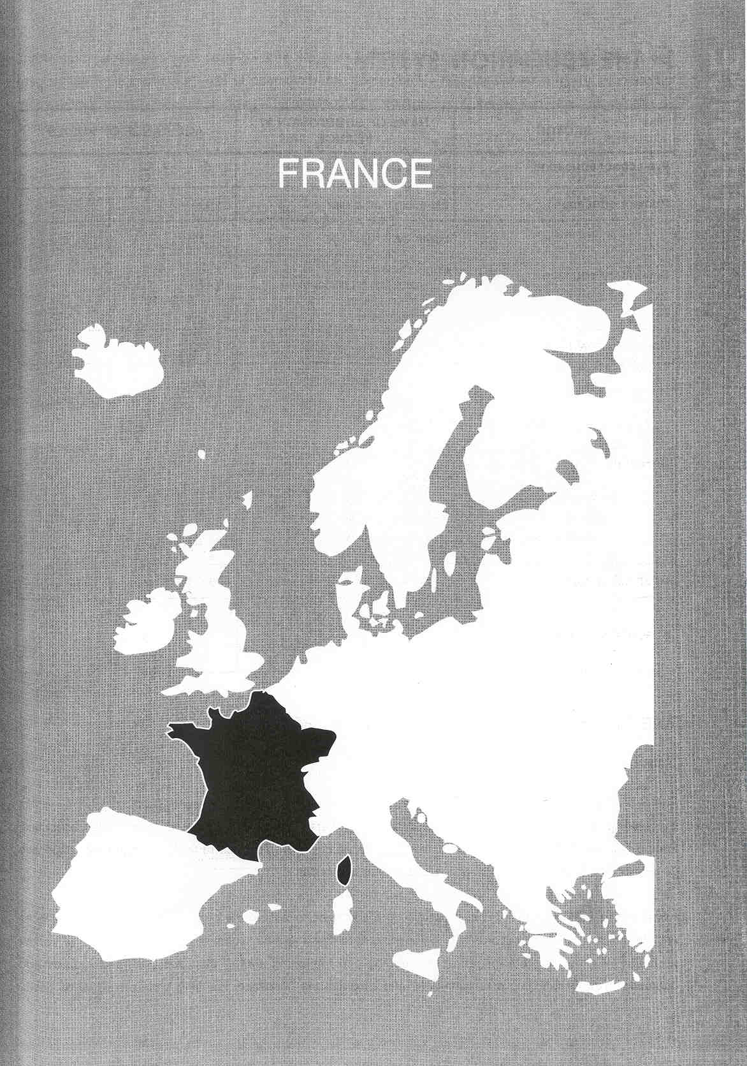

Νίκος Ηλιάδης, Πολ/κός Μηχ/κός Ε.Μ.Π., M.Sc.,
Ph.D. Industrial Education, Organization and Management,
Σύμβουλος του Παιδαγωγικού Ινστιτούτου

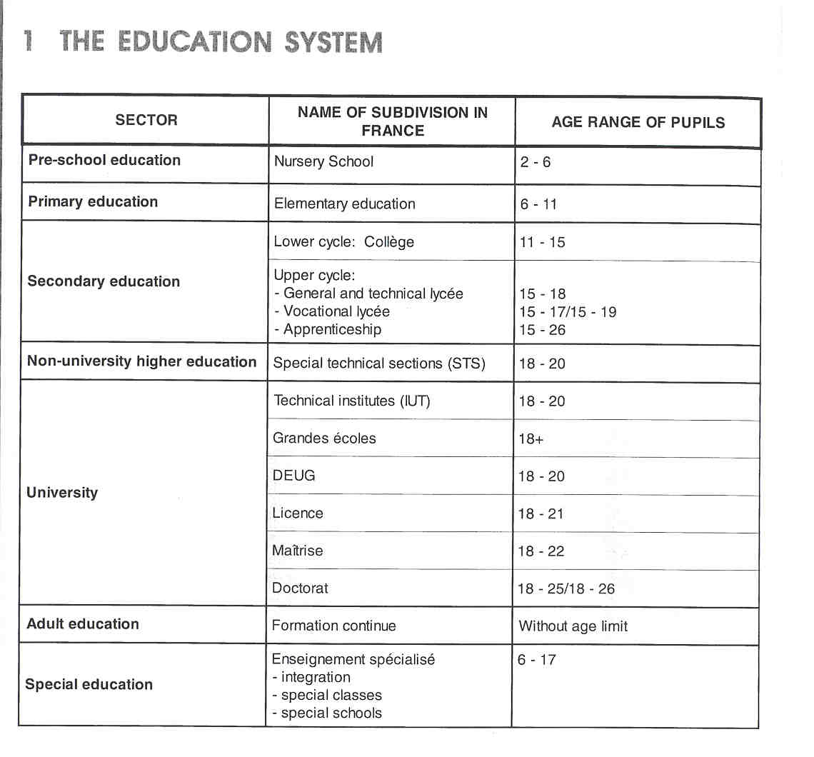

THE ADMINISTRATION OFTHE EDUCATION SYSTEM

General Administration

The French educational system has by historical tradition always been highly centralised.

By deciding to shift some powers and responsibilities hitherto held by the State over to territorial authorities, France has, since 1982, undertaken considerable decentralisation. This has radically changed the respective powers of the State departments and the territorial authorities.

However, the State still has a considerable role. It continues to ensure the proper running of public services and the coherence of education. Thus, it continues to define the educational choices and curricula, and, just as before, it is responsible for recruiting, training and managing staff. It also decides on the status and operating rules for teaching establishments, and allocates the necessary teaching and administrative posts.
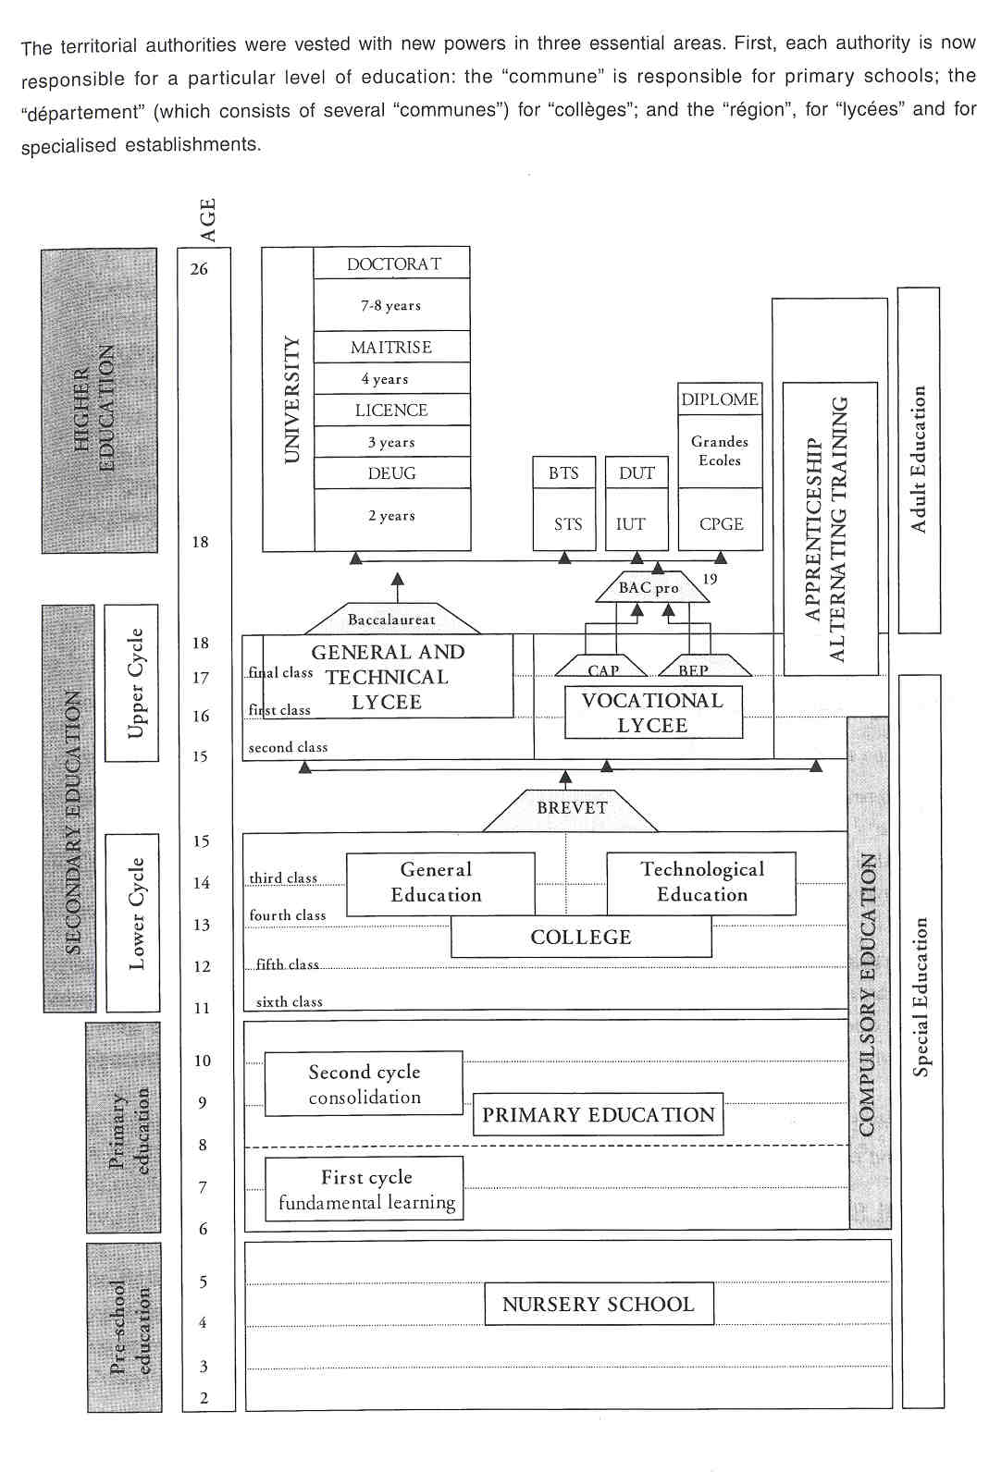

Secondly, school planning is now organised to include the territorial authorities in decisions about the levels for which they are responsible, drawing up projected training and investment programmes. In other words, every school building, rebuilding, or extension deemed advisable is also decided by the territorial authorities. Thirdly, local authorities were given a more active role in the daily running of schools.

In other words, the territorial authorities are, to a certain extent, involved in administrative and financial policy making. The "recteur" is responsible for purely educational matters. (See further.)

General Administration at Regional Level

Administration at regional level is the responsibility of the 30 "acaddmies' or "rectorate" An "acaddrnie" is an educational body, while the "r6gion", mentioned above is a purely administrative body.

The "acaddmie" is run by a "recteur', who is a senior civil servant chosen from among graduates having a State "doctorat". The "recteue' is appointed by the President of the Republic by a decree in the Council of Ministers. His powers cover every level of education, whether primary, secondary or higher. The "recteur" also supervises the "ddpartements" (subregions) within his "acaddmie". The "recteur" is assisted in his various tasks by a group of services called the "rectorat".

General Administration at Subregional Level

The subregional level corresponds to the "ddpartement" level. There are 96 metropolitan "ddpartements' and four overseas "ddpartements" (Guadeloupe, Martinique, Guyana and Rdunion).

General administration at "ddpartement" level is referred to as "d6parternent" administration or "inspection d'acaddmie'. It is headed by an "inspecteur d'acaddmie', appointed by decree of the President of the Republic after nomination by the Minister of Education. He has responsibilities in all levels of education except higher education.

The "inspecteur d'acaddrnie" is not an inspector. He is director of the educational services in the "ddpartement" and is subordinate to the "recteur", from whom he receives orders. His closest colleagues are the assistant "inspecteur d'acad6mie", who participates in ail decisions taken by his superior, and the head of administrative services, who directs all the departments of the "inspection d'acad6mie".

Furthermore, the "inspecteur d'acaddrnie" is assisted by various civil servants in a technical and advisory capacity and by a number of "inspecteurs de I'Education nationals" for primary schools.

COMPULSORY EDUCATION

Compulsory education, as defined in 1959, concerns all children aged between 6 and 16. This age-band includes both primary ("6cole 616mentaire") and lower secondary education ("colidge"). On average, pupils leaving the "coilbge" are 15 years old and therefore must still attend full-time school for at least one more year to satisfy the compulsory schooling requirement, either in a general or technological "lyc6e" or in a vocational "lyede".

EDUCATIONAL SECTORS AND SUBDIVISIONS

For each education sector there are public and private schools. The public sector is far more important in terms of number of schools and pupils. Public education is free of charge, except for higher education. Private schools require parents to make a financial contribution, but they are also subsidized by the State.

At all educational levels schools have to follow a national curriculum devised by the Ministry.

Pre-school Education

Institutions offering preschool education are known as "6coles maternelles" (nursery schools). They are the only type of institution offering schooling for all children from the age of two until compulsory school age. Pre-school education is optional. France has a long tradition of providing preschool education, and for this reason more than 99% of children aged three attend school. As a consequence, there is a particularly large number of these institutions. The new structures and organisation (since 1992) fully integrated preschool and primary education into one whole, emphasising the continuity between nursery and primary education.

Primary Education

The institutions offering primary education are called "primary" or "elementary" schools ("6coles dldmentaires"). They take care of all children from the age of six until their entry into lower secondary school at 11 years.

Primary education provides pupils with a solid preparation for further schooling at the "colidge". It comprises five classes divided into two cycles: the cycle of fundamental learning (years 1 and 2) and the consolidation cycle, which covers the last three years of primary school.

There is no examination at the end of primary school.

Secondary Education

Secondary education lasts seven years, from the sixth to the final class. There are two levels: lower secondary education (four years) and higher secondary education (three or four years).

Lower Secondary Educatiion

Lower secondary schools are known as "colidges'. The "coII6ge" is the single educational establishment for all pupils who have completed their primary schooling. Education in the "collibge" lasts four years. Even when preparing pupils for vocational education, the "coII6ges" provide secondary education of a general nature within the framework of compulsory education.

The decree of May 29 1996 laid down a new educational organisation in the "colidge" based on three cycles. According to this new organisation, the sixth class is the observation and adaptation cycle of secondary education; the fifth and fourth Classes become the consolidation cycle and the third class becomes the orientation cycle in which the pupils must choose between the general and technological divisions.

The third class concludes with the national diploma, the "brevet" created in 1987. This is awarded on the basis of marks obtained in a written examination and during continuous assessment in the fourth and third classes.

Upper Secondary Education

Upper secondary education is divided into two distinct branches: general and technological education on the one hand, and vocational education on the other.

General and Technological Education (“Lycees d’ enselgnement general et technologique”)

This type of education is provided in institutions called "lyc6es' for general and technological education (LEGT). General and technological education lasts three years and leads to the general and technological "baccalaur6at" which is a national school-leaving diploma leading to higher education. The "baccalaur6at" is the first step towards university. Students not obtaining the "baccalaur6at" may, in certain cases, obtain a secondary school-leaving certificate. The "brevet de technician' enables students to enter employment, but also provides the opportunity to continue studying for the "brevet de technician supdrieur'.

Continuous assessment of pupils in the "lyedes" is organised as in the "collbges". Furthermore, since 1992, national entry-assessment with formative aims has been organised at the start of the second class in three subjects: French, mathematics, and the first modern language (English, German or Spanish), to allow teachers to identify pupils' difficulties and skills, and to organise their teaching accordingly.

Vocational education

Vocational Lycees

The purpose of vocational "lyc6es" is to give young people training for professional qualifications. During the two years of study they prepare for examinations for which the following certificates are awarded:

- The vocational aptitude certificate ("certificat d'aptitude professionelle-CAP"). This is designed to provide a qualification to engage in an occupation. The preparation involves general education, technological and vocational education and varying periods of on-the-job learning.
- The vocational studies certificate ("brevet d'6tudes professionnelles-BEP"). The vocational studies certificate confers on the student the vocational qualification of skilled worker or employee. It requires more extensive training in a vocational field than the "CAP". The courses include general education, technical education and periods of on-the-job learning.
- The vocational "baccalaur6at". Pupils holding a "BEP" or a "CAP" can either enter working life or continue their studies in preparation for a vocational or technical "baccalaur6at" ("BAC pro"), which requires two further years of study. Unlike the other "baccalaur6ats", it leads directly to employment, although it also entitles holders to enter university studies. Besides on-the-job training, attention is given to general education and vocational, technological and scientific education.

Alternating troining

Alternating training, in schools and enterprises, enables students to study for a diploma while working at the same time. It is designed for students between 16 and 26 years of age and is based on two types of work contract: the qualification contract and the apprenticeship contract.

- In the qualification contract, training occupies at least one quarter of the period of the contract. It leads to a diploma, such as the "CAP", the "BTS" (higher technician certificate - See further.) and the engineering diploma.
- Apprenticeship combines the acquisition of know-how under the supervision of a firrn-based tutor with theoretical education in a "centre de formation des apprentis" (CFA). The apprenticeship contract is the most common and most suitable for the preparation for all types of diploma. The contract is concluded for a period ranging from one to three years, and students are between 16 and 25 years of age. This period may be extended in the event of failure, or reduced in the event of early success. Two or three apprenticeship contracts may be undertaken in succession, to prepare for qualifications or diplomas. The salary depends on age and the length of the contract.

Higher Education

Higher education is marked by a great diversity of institutions, the organisation and admission requirements varying according to the nature of the institution and the purpose of the courses offered. The different higher education institutions are attached to different ministerial departments.
After the "baccalaur6at", obtained usually at 18 years of age, students can choose one of the following main directions of higher education :

- The university course is fairly similar to those of other European countries. There are 78 universities in France. They offer scientific, cultural and vocational courses and are multi-disciplinary. Each university is composed of units for education and research (UFR) in each subject, with common objectives. Except for pharmacy and medical studies, there is no selection for entry into university. University education is made up of three cycles, leading to the following certificates:
- "DEUG - diplome d'etudes universitaires generales” he second-year university diploma of general studies is a national diploma awarded to students completing the first cycle of university studies ("baccalaur6at" + 2). The title of the diploma includes the main subject studied.
- The "licence” is the national university degree awarded after three years of university study or following the first year of the second cycle of university studies. The title of the "licence" includes the national reference to the main subject studied.
- The "maitrise” is the French national postgraduate degree awarded at the end of the fourth year of university studies or at the end of the second cycle. Most "mattrises" require students to write and present a dissertation. Some "maitrises" offer vocational training.
- The "doctorat” is a third-cycle university diploma awarded for three to four years of research work under the guidance of a research director.

- In addition, there are two large categories of short, two-or-t,hree-year, technical courses:

- Technical institutes ("IUT") are semi-autonomous structures within universities, leading to a university diploma in technology ("DUT") ;
- Special technical sections ("STS") are offered within certain high schools and lead to the equivalent of a degree, the higher technician certificate ("BTS"). This type of course covers many different vocational fields and is offered by a very large number of public and private schools.

These courses last two years after the "baccalaur6at". As they are short and technology-oriented, they lead directly to employment. The degrees obtained are valid nationally. The students may pursue another year of studies in some particular area to obtain the national specialized technology diploma ("DNTS").

- The programme offered by the "grandes dcoles' provides an engineering or business degree. Each year the best science students from secondary schools attempt to gain entry to the "grandes bcoles", which prepare students to become future "ingdnieurs". Access to the scientific "grandes dcoles" is mainly obtained by succeeding in the competitive entrance examinations prepared for in the scientific preparatory classes for the "grandes 6coles" ("CPGE"). The students admitted have passed their scientific "baccalaur6at" with distinction and also have an excellent secondary school record.

Teacher Training

Almost all teachers receive their initial training at a university institute of teacher training (an 'institut universitaire de formation des mattres" or "IUFM"). Students are admitted after obtaining a "licence" (three years of university study). At the "IUFM", students take general subjects and specialist subjects, depending on the level and type of education. At the end of the first year, students sit a recruitment examination or "concours" (a national examination which compares and ranks students and which many fail). If they succeed, they can enter the second year which is practically-oriented. Students receive the salary of a "professeur stagiaire" (student-teacher). At the end of the second year, teachers are evaluated and appointed. There are teachers for preschool and primary education ("professeur d'6coie") and for secondary education ("professeur certifi6"). The "professeur agr6g6" (teachers with the highest teaching degree) are qualified to teach in secondary education and in higher education. Students need to have obtained a "mattrise" in order to be trained in one of the four "bcoles normales supdrieures' or in other university teacher training institutes.

Adult Education

In general, adult education encompasses two major forms:

- It refers, first, to continuing education ("la formation continu6e"), given to different target groups (employed workers, unemployed workers and school leavers) in a weli-defined legal framework. Continuing education reaches from vocational to university education.
- Secondly, adult education refers to distance learning. In France, distance learning is traditionally carried out by the National Centre for Distance Learning ("CNED"), a State-owned institution, run by the Ministry of Education and Technology and Vocational Integration. Distance learning is generally aimed at adults and can take different forms:
- permanent education,
- second chance education and
- university education.

The distance-learning aids used include written media, audiotapes and videocassettes. On-line data processing media are also used to access data banks, to take tests and to communicate with instructors (for some courses). In many training schemes, it is difficult to differentiate between the vocational, personal development and recreational aspects of the training.

Special Education

Several types of schooling may be envisaged for each particular case and for the specific nature and degree of handicap(s):

- Full-time or part-time integration in a mainstream class with teaching, psychological, medical andlor paramedical support. This solution is pursued above all others.
- Schooling in special classes: certain primary schools and, exceptionally, nursery schools have classes of varying degrees of academic integration for pupils who have physical, sensory or mental handicaps and who can benefit, in a mainstream school environment, from schooling adapted to their age and capacities and to the nature and extent of their handicap. In State or private secondary schools, special and adapted education is organised by special education departments ("SES") and adapted general and vocational education departments ("SEGPA") or in workshop-classes ("GCA"). For pupils with a mental handicap, "educational integration units" ("UP]") have been set up.
- Full-time or part-time admission into a special institution.

2 THE ORGANISATION OF THE INSPECTORATE

Like all centralised, State-run administrations in France, the Ministry of Education has a general Inspectorate empowered to carry out administrative tasks. However, given the specific nature of aspects of education, there are also education-oriented inspection organisations. At this moment, about 3400 people can be called "inspector”, but they are divided into different categories. An organisational distinction is made between the national and the regional level of inspection.

NATIONAL LEVEL

The 'Inspection Generale de I'Education National” (IGEN) is the overarching body of inspectors working at the national level. Its tasks are laid down in the decree of 9 November 1989: the general evaluation of the work of the education system and its results.

Each inspecteur 96n6ral (also called IGEN) belongs to one of the 14 specialist-groups within the IGEN (e.g. biology, history arts, etc.). Besides these subject-specific distinctions within the IGEN, there is also a specific group for primary education and another for "educational establishments and school life" (etablissements et vie scolaire). The primary group deals especially with nursery and primary schools.

Each group has a separate "doyen" (dean), appointed by the Minister for two years. The "Doyen General" (the one in charge of the Inspectorate management) is appointed for five years. The IGEN is responsible for primary schools, "coII6ges", "iycees", "lycees professionneis" and for the professional staff training institutes. The National Inspectorate does not assess teaching in private schools as a rule, but may be asked to do so by the Minister. The assessment of teaching in private schools is normally carried out by the regional Inspectorate. In addition to the IGEN, there is the "Inspection Generale de I'Administration de I'Education Nationale'(IGAEN). The IGAEN is responsible for supervising and inspecting staff (headteachers, heads of department, administrative staff, not teaching staff), the central and local services institutions under the direct authority of the Ministry. It also supervises the administration of the educational system and the consistency and effectiveness of structures and methods.

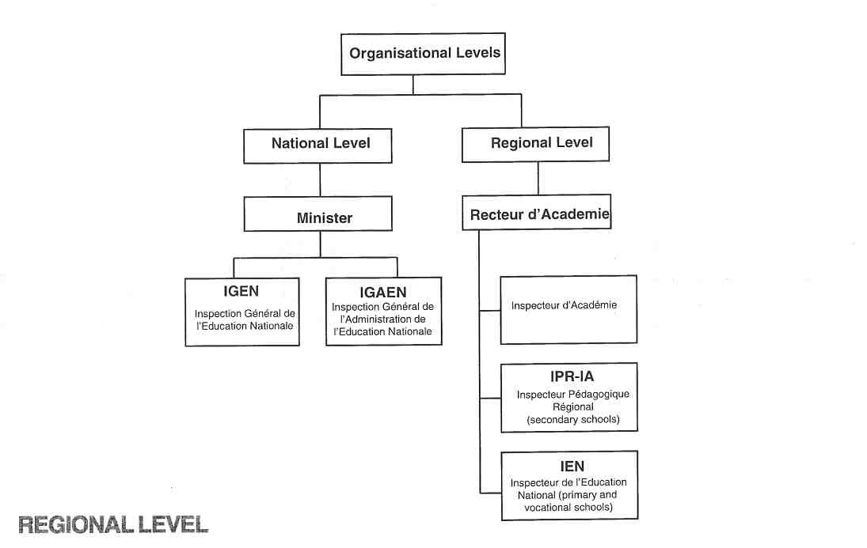

Inspection at regional level is the responsibility of regional inspectors. Within each of the "acaddrnies", their work is carried out under the authority of the "recteur". (France is divided into 30 "acaddrnies" that each form one educational region; there are two to five "d6partements" in one "acad6mie"). The "recteur" is the "regional minister of education". He works under the direct responsibility of the Minister and is in charge of organising, structuring, improving and assessing education in the "acad6mie". Each "acad6mie" has an action plan drawn up annually by the "recteue' and the correspondent of the General Inspectorate. Since 1990, the regional Inspectorate ("1'inspection p6dagogique acaddrnique", "IA") has comprised two organisations:

- lnspecteurs Pddagogiques Rdgionaux-lnspecteurs d'Acaddmie (IPR-IA);
- lnspecteurs de I'Education Nationale (IEN).

Both groups of inspectors are connected to a specific "acad6mie". The IPR-IA are responsible for ensuring the implementation of educational policy, as determined by the Minister, for a specific subject for the whole of the "acaddmie'. The IEN, on the other hand, work on evaluation and supervision in one "ddpartement" (in, for example, specific subject areas, professional development in vocational schools). The IPR-IA evaluates and supervises staff (under the IGEN) and school buildings (under the "recteur"). IPR-IA only concern themselves with the secondary sector and IEN with the primary sector. There is also a second group of IEN who are responsible for the vocational sector.

The "inspecteur d'acadernie" (one in each "departernent"), actually the director of the 'departernent', is the link beween the "recteur d'academie" and the "IEN" at the level of the "departement". He or she works under the "recteur”, supervises the "IEN" and is responsible for all schools in the "departernent".

To sum up: regional Inspectors are closely concerned with the assessment of teachers, while, at the same time, performing an advisory and developrnental role. The task of the national Inspectorate is to evaluate the quality of education in a more general sense and to publish a report on the state of education. (See 6.)

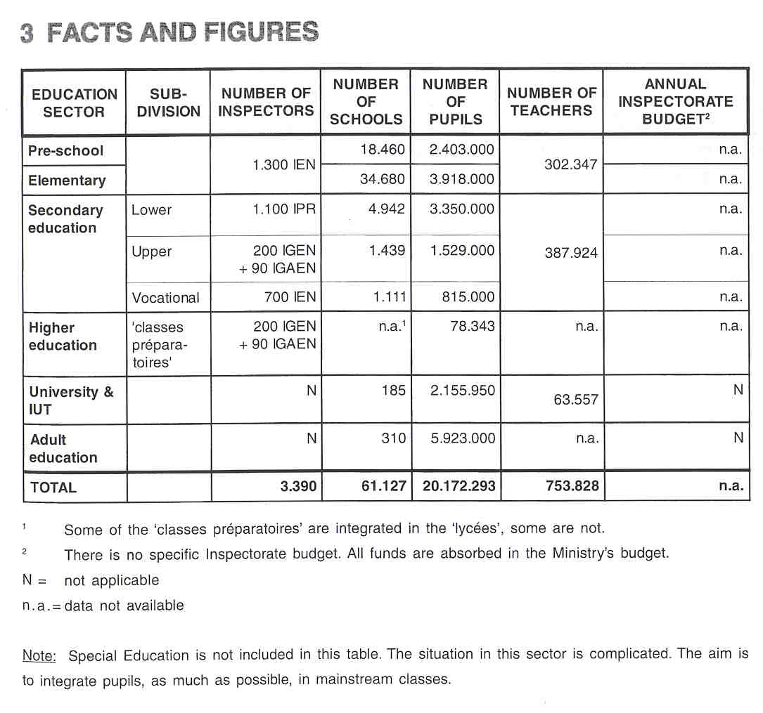

4 THE RECRUITMENT OF THE INSPECTORATE

The IGEN must hold a university degree and teaching qualification. Ten years' experience are required, including at least five years' teaching experience. All applicants must be class-A civil servants and must have reached the age of 45 years.

Vacant positions are published in the "Bulletin Officiel". A special committee of 21 members (seven inspectors, seven university lecturers and seven senior administrators from the Ministry) interviews all the candidates for a certain position in order to end up with a short-list of three applicants. The list is then, in order of preference, submitted to the Minister who takes the final decision.

IGENs are recruited by means of an open procedure. The basis on which information on the applicants is gathered is laid down in the decree. It determines the role of interviews, publications and essays in the recruitment procedure.

IPR-IA are recruited from qualified teachers who have passed the "agrdgation' (a qualification to teach in the upper secondary schools and in higher education) and from managerial staff, higher education teachers and IEN. At least five years' teaching experience is required.

The files of candidates are examined by a special consultative committee. The names of candidates selected are put on the list of qualified candidates. Appointments to IPR-IA positions are made by the Minister from among the candidates on the list after further examination of each by a consultative committee.

Those eligible for the entry competition for the post of IEN are full-time primary teachers with at least five years' service or teaching, educational or guidance personnel who have completed five years' service and hold a bachelor's degree. The selection competition is made up, of written and oral tests.

5 THE WORKING CONDITIONS OF THE INSPECTORATE

Inspectors are full-time appointments. Inspectors hold a permanent position and cannot return to their previous employment (teacher, headteacher). In other words, being an inspector is an appointment for life.
'My

6 AREAS OF INSPECTORATE RESPONSIBILITY

The different Inspectorate bodies have specific responsibilities. According to the decree of 9 November 1989, the IGEN has to evaluate and report on the state of the art in French education, stimulate the Minister's educational policy and supervise personnel.

The statute of 18 July 1990 stipulates the responsibilities of the "Inspecteurs Pedagogiques Regionaux- lnspecteurs d'Academie" (IPR-IA). The most important is ensuring the implementation of the educational policy of the 'academie' by pursuing the work programme of the IPR-IA determined by the IGEN and the “recteur" of the "academie".

The "Inspecteurs de I'Education Nationale" (IEN) are responsible in a "departement" for specific evaluative and supervisory tasks in primary education. A separate IEN-group works on vocational education. Their objective is, by carrying out a number of diverse tasks, to contribute to the development of this branch of education.

The following describes the Inspectorate's responsibilities, according to the format of this publication, and indicates the role played by each different branch.

6.1 EVALUATING

The IGEN

The main responsibility of the IGEN is to evaluate how his/her subject is being taught in one particular school Most of the IGEN are subject inspectors and, as such, assess and advise individual teachers in the classroom. (See 10 The Inspection Process.)

The IGEN evaluates the state of the art in French education by means of research conducted in co-operation with the IPR-IA and the IEN. This evaluation of the educational system as a whole concerns schools, types of training, content of teaching, curricula, teaching methods, school results, procedures and the finance used.

Within these broad permanent tasks, particular working themes are incorporated each year by the Minister in the "programme de travail".

Within the IGEN, the group responsible for "1'dtablissement et vie scolaire" is in charge of the evaluation and development of the school as a system. Its members focus on the implementation of educational policy in schools, the quality of school management, the role of headteachers, co-operation between teachers and on more general aspects of education, such as the pedagogical climate of a school and relations between the school and home. They carry out a kind of full inspection, excluding subjects and individual teachers. Their work resembles that of the IGAEN.

The IGAEN

The tasks of the IGAEN involve supervision and assessment. They concern administrative, financial, accounting and economic matters. They also concern the staff, central and regional departments, public institutions and all the bodies dependent on or assisted by the Ministry of Education, including higher education. In accordance with an annual plan ("programme de travail"), determined each year by the Minister, the IGAEN carries out assessments on priority national topics. It also prepares local and regional assessments.

The IPR-IA

The IPR-IA evaluate the work of teachers (singly and as a tearn) in secondary schools. They also contribute to the evaluation of education in different branches of study and at school level by classroom observation. Furthermore they evaluate whether schools adhere to statutory targets and the national curriculum. This includes subject inspection.

The IPR-IA also supervise specific aspects such as examinations, teaching materials, the orientation of pupils towards further education, etc.

The IEN

The IEN evaluates the work of primary school teachers and teachers in vocational education and suggests grades (marks) for their teaching. In addition, they ensure that schools are respecting official directives regarding curricula and organisation.

6.2 ADVISING

The IGEN

Within the areas for which it is responsible, the IGEN offer opinions and proposals to the Minister for Education. In this way, they provide policy-related advice for the Minister.

During their evaluation work in schools, the IGEN also advise individual teachers.

The IGAEN

The IGAEN provide advice for the Ministry, the "recteur", schools and institutions on the topics for which they are responsible.

The ]PR-IA

The IPR-IA advise and assist the "recteur" in the area of their expertise. They also advise teachers.

The IEN

The IEN for vocational education advise and assist the "recteur' in the area of their expertise. The IEN for primary education, upon request, advise and assist the "inspectour d'acaddmie" All IEN also advise teachers, both singly and as a group, on their classroom practice.

6.3 MONITORING

The IGEN

The IGEN are responsible for the "inspection personnelle'in the "acaddmies'and for supervising all educational personnel in schools by conducting rneta-evaluations. The IGEN is senior to the IPR-IA and the IEN, but only with regard to their statutory evaluative tasks, since the IPR-IA and the IEN are under the direct authority of the "recteur". In each "acad6mie" an IGEN is appointed as "acad6mie correspondent", whose task is to determine with the "recteur" the programme of the inspectoral groups in the "acaddmie".

The IGEN participate in the management of inspection personnel and in co-ordinating the activities of all the inspection units. They take part in the recruitment, training and evaluation of the different inspection bodies.

The IGEN monitor national examinations by supervising the examinations devised by the regional inspectors. The IGEN have ultimate responsibility for examinations in their subject.

The IPR-IA

The IPRA-IA are responsible for devising examinations in co-operation with groups of experienced teachers.

The IEN

The IEN in primary education exercise control over manpower resources, provide replacements for absent teachers and propose school opening and closing dates.

The IEN in vocational education organise examinations and participate in teacher recruitment competitions.

6.4 REPORTING

The IGEN

The IGEN is responsible for reporting annually on the state of education. They also report on individual teachers, although this is normally the province of the IPR-IA.

The IGAEN

A yearly report is produced for the Minister on the topics for which the IGAEN is responsible.

The IPR-IA

The IRR-IA provide reports on the work of educational personnel, on subjects, on branches of study, on educational topics (e.g. the teaching of foreign languages) and an annual report for the "recteur”.

The IEN

The IEN report on the work of educational personnel, on subjects, as far as vocational education is concerned, and on educational topics according to the yearly programme determined by the "acaddrnie".

6.5 OTHER RESPONSIBILITIES

The IGEN

The IGEN promote the implementation of the educational policy proposed by the Minister by means of lectures, workshops and directives with regard to the IPR-IA and the IEN.

The IGEN are represented in the various committees in charge of the curriculum. However, they are not solely responsible for curriculum development, and they have no authority to make decisions. They are not encouraged to develop educational materials personally.

The IPR-IA

The IPR-IA participate in the studies of the IGEN on the topical areas for the year.
Furthermore, they participate in the pre-service and in-service training of teachers and other school staff and in marking examinations for professional qualifications and competitions for teacher recruitment. They also represent the "recteue' at meetings.

The IEN

The iEN participate in the initial and continuing training of primary teachers and ensure that there is follow- up to training.

The IEN in vocational education participate in training activities and in commissions dealing with technical education.

Summary

The main functions and tasks of the different Inspectorate bodies are summarised in the following table:
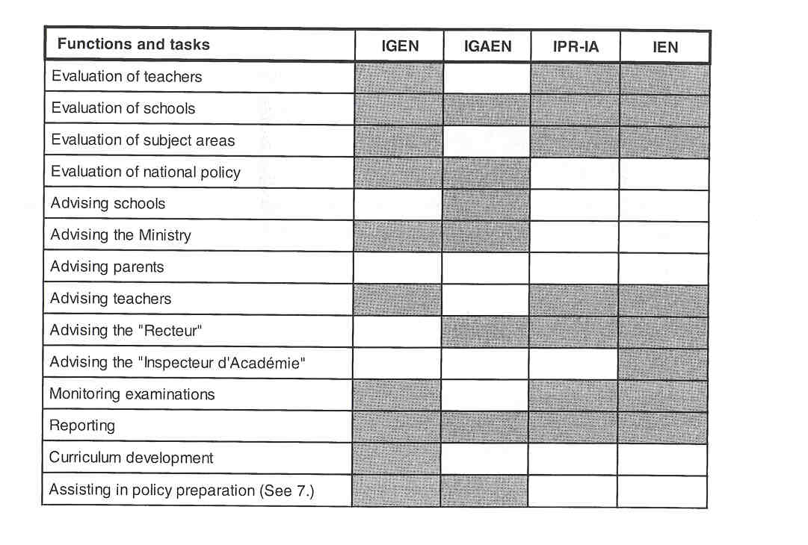

7 THE ROLE OF THE INSPECTORATE IN EDUCATIONAL POLICY

The Inspectorate at national level formulates advice and proposals on behalf of the various heads of department at the Ministry, who refer to these in preparing policies. Policy-related decisions are taken by the Minister and the various departments. Important tasks of the IGEN, carried out in conjunction with the regional inspectors, are promoting the implementation of policy and evaluating its effectiveness.

8 WHO IS IN CHARGE?

Inspection guidelines are issued by the Ministry and relayed to the Inspectorate through its senior management ("Le doyen de 1'inspection general"). There is one "doyen" for the IGEN and one for the IGAEN nominated by the Minister. It is the Minister who decides on the yearly programme, based on the proposals of each group's senior management. Finally, the individual inspector decides on the organisation of his different tasks and on his schedule. The following are examples of evaluations carried out by the IGEN in 1996-1997:
- the evaluation of pupils' progression by schools;
- the evaluation of the contribution of the curriculum to "education for citizenship".

The regional Inspectorate carries out tasks set by the "recteu@' in accordance with the Ministry's educational policy. The IPR-IA work locally in co-operation with the IGEN on the implementation of programmes, teaching methods and pedagogy. Within each subject group, the IGEN are responsible for a number of "acaddmies", thus establishing links with the local IPR-IA.

9 THE POSITION OF THE INSPECTORATE

The IGEN choose the subjects to be focused on during inspections, but the work programme has to be approved by the Ministry. Much emphasis is put on the independent advisory role of the IGEN concerning policy. The IGEN also has the opportunity to formulate its own evaluative research in collaboration with the "Direction de la programmation et du ddveloppement" (DPD) of the Ministry.
The Inspectorate at national level advises the administration and institutions for curriculum development and (national) assessment.

Both the IGEN and the IGAEN are under the direct authority of the Minister, who alone can give them special tasks. They are appointed by the Minister, but remain independent in the way they carry out evaluations and report. Indeed, their yearly reports might be very controversial. The regional Inspectorate is under the authority of the "recteur". As the head of an "acad6mie" the "recteur" can be considered as the "regional minister of education", in charge of organising, structuring and inspecting the education in his "acad6mie". The "recteu@' has to justify his actions to the national Minister of Education.

10 THE INSPECTION PROCESS

THE IGEN AND IPR-IA

The IGEN concentrates on subject areas, whereas the inspection of schools (excluding the inspection of teachers) is carried out by the IGAEN and the group "Etablissements et vie scolaire", who have their own procedures.
It is the individual inspector who determines his/her programme at the beginning of the academic year. This brings about a number of differences between the various inspection processes.

The school is informed about the planned inspection usually a week or ten days in advance. Pre-inspection information (e.g. teachers' timetable) may be sent to the inspector if requested. On the day of the inspection additional information may be requested.

The inspector makes a list of teachers to be inspected and contacts the headteacher, who inforrns the teachers of the time of the inspection. The inspection is followed by an interview with the teacher, who receives via the school a copy of the inspector's report. The mark or grade for his/her teaching, awarded by the inspector, is sent to the teacher by the Ministry or the "rectorat". The inspector awards the mark on behalf of the national or regional authority but on his own responsibility. Suggestions for follow-up can be made.

Subsequently, the inspector holds a meeting with all the teachers of the subject in the school to discuss methods, new curriculum, etc. The inspector writes a report on the teacher, which is first sent to the "acaddmie", then to the teacher. The teacher is requested to sign his/her copy of the inspector's report, if in agreement with it. If not, the report is sent back to the inspector, who has to provide additional information to justify his assessment. In rare cases of serious disagreement, a new inspection by another inspector is organised.

11 INSTRUMENTS AND METHODS

THE COLLECTION OF INFORMATION

The instruments and methods used for the collection of information at all Inspectorate levels are normally:

a. Questionnaires

Questionnaires to school heads, pupils, parents and teachers are devised only in the case of special reports that are part of the "programme annuel" determined by the Minister.

b. Interviews

The issues discussed at the various interviews depend very much on the themes that are set every year. All possible groups within the school may be asked to contribute. Interviews with parents' representatives are rare and never occur in individual inspections.

c. Observations

The quality of the teaching and mastery of the subject taught are observed during lessons, the skills of the pupils during class activities and the teamwork evinced by staff at meetings.

d. Tests/examinations

The testslexaminations sat by the pupils are devised by groups attended by inspectors. They occur at various stages in the pupils' time at school.

e. The Collection of Documents

Depending on the nature of the assessment and the task to be carried out, the Inspectorate uses "national data" and analyses.

APPROACHES

There are guidelines and criteria based on the yearly programme and which have to be followed. The IEN for the primary sector and the IEN for vocational education have their own guidelines for the inspection of individual teachers. However, there is no uniform instrument for all the members of a particular Inspectorate grouping. The published guidelines, which are similar but not necessarily the same for all Inspectorate groupings, are presented as a series of general statements on the nature of the teacher's role in secondary education. They describe the cornpetences required and are aimed at the various bodies in charge of teacher training, namely the IUFM ("Instituts Universitaires de Formation des Maitres"), the universities, the Inspectorate, school heads and future teachers. They describe the teacher as having precise responsibilities within the educational system, the school and the classroom.

Inspectors work both individually and in teams.

12 JUDGEMENT AND ITS CONSEQUENCES

The judgement on an individual teacher may be positive, in which case the teacher's mark is increased for promotion purposes. In this case, the teacher progresses more quickly to a higher pay scale. In the case of a negative evaluation, the mark is not changed, and the teacher is usually asked to attend in-service training before the next inspection.

13 OUTCOMES

The IGEN does not compile reports on individual schools, as there is no whole-school inspection at the IGEN or "acad6mie" level. However, whole-school inspections may be requested by the "recteu@'. For example, a sample of "coII6ges" may be inspected,.in order to propose changes in this sector. In this type of inspection, several Inspectorate groups are involved: the IGEN for subject areas and individual teachers and the IGAEN for school management.

If the inspection is carried out by the group "Vie scolaire" (See 6.), the report is only issued to the school. If the IGEN, possibly in co-operation with the IPR-IA, interviews pupils, assistant teachers or the headteacher of a specific school, a report is compiled and sent to the school. Reports on the evaluations of subject areas are sent to those who co-operated in the inspection. Some reports however are only for the Ministry or even for the Minister himself. As such, not all reports are published. Only those which are part of the "programme de travail annuel" (the yearly programme) are published. Some chapters are published as separate booklets.

The regional Inspectorate writes reports for the "recteur", e.g on branches of study.

14 FOLLOW-UP PROCEDURES

Follow-up procedures influence the promotion of teachers. It can be accelerated ("promotion au grand choix") or not ("promotion A 1'anciennete"). There are very few negative follow-up procedures. As the great majority of teachers are civil servants, they cannot be dismissed. In the case of severe problems, frequent follow-up inspections are carried out. (This is certainly the case for the IEN.)
15 INSPECTORS AS ARBITRATORS

Pupils, parents and teachers do not have the opportunity to approach inspectors with complaints. Occasionally, and only if specifically asked by the Minister or the "recteur”, inspectors act as arbitrators. The IGEN may be asked to act as arbitrators after an IPR-IA or IEN has concluded, after an inspection, that a teacher is incapable of carrying out his duties. An arbitration may also be carried out at the request of a headteacher who has received complaints. In this case, the various parties are interviewed by the inspector.

A decree of December 2nd 1998 establishes official mediators in education, separated from the Inspectorate. The decree came into effect only recently. The mediators have to deal with complaints about the way the education system functions in relation with its users and employees. The people selected for this job all have gone through a career within the education system. There is a mediator at national level as well as in each "academie".

16 THE INSPECTORATE AS AN ACT OR IN PUBLIC DEBATE

Inspectors may take part in public debate in accordance with the "devoir de reserve" (a code of conduct for civil servants). The report on education by the IGEN is presented at a press conference, which is the only time the IGEN enters the public arena.

17 THE EVALUATION OF THE INSPECTORATE

The national Inspectorate (the IGEN and IGAEN) is not evaluated. The tasks of the Inspectorate are, however, modified, as they are set by the Minister within the areas of development of his educational policy.

Only the IPR-IA and the IEN are evaluated by the national Inspectorate and by the "recteur”. This evaluation is based on the number of teachers inspected, the quality of their reports and their personal involvement in the various tasks set by the "recteur” and the IGEN.

18 THE INSPECTORATE'S INITIAL TRAINING AND IN-SERVICE TRAINING

THE TRAINING OF NEW INSPECTORS

At present, there is no training for new IGEN or IGAEN, the majority of these inspectors having previously had supervisory teaching experience that prepared them for assessment and reporting. In future, new appointees will receive supplementary training lasting several weeks because inspection work demands precise technical knowledge.

After recruitment, the ]PR-IA and JEN are given a year's training, followed by a year's work in the field. At the end of the two years, they become qualified inspectors.

PROFESSIONAL DEVELOPMENT

There is no systematic professional development for the national Inspectorate. A number of days are assigned for the professional development of the ]PR-]A and IEN usually under the guidance of the various groups of the national Inspectorate. Similarly, seminars may be held by the "recteur" of the "acad6mie".

19 RECENT OR FUTURE ISSUES AND DEVELOPMENTS

The main developments occurred in 1989, with a shift from assessing individual teachers to evaluating the educational system and its policy and with a move towards more regional autonomy.

20 LITERATURE

EURYDICE, The Education System in France (1997), Euridyee Eurybase 1998, http:llwww.eurydice.org/ Eurybase/Files/dossier.htm

HOPES, C., School lnspectorates in the Member States of the European Community. France. Deutsches lnstitut fOr lnternationale PAdagogische Forschung, Frankfurt am Main, 1991, 75 pp.

JOURNAL OFFICIEL DE LA REPUBLIQUE FRAN@,'AISE, Ddcret n'89833 du 9 novembre 1989 retatif au statut des inspecteurs gdndraux de 1'dducation nationals, 1 0-1 1

MINISTERE DE I'EDUCATION NATIONALE, DE LA RECHERCHE ET DE LATECHNOLOGIE, Education in France. 30 indicators on the education system. Direction de la programmation et du developpement, Paris, 1998, 46 pp-

ROGGHE, Anne, Het onderwijs in Frankrijk. Onderwijs in de Europese Unie: eenheid in verscheidenheid. Leuven/Apeldoorn, Garant, 1995, 72 pp.

STANDAERT, R., Onderwijs-innovatie en -beleid in Frankrijk. Leuven, K.U., Onderzoekscentrum voor Comparatieve Pedagogiek, 1989, 321 pp.

VAN BRUGGEN, J.C., De inspectie van het onderwijs in Frankrijk. lnspectie van het onderwijs, Secretariaat lnternationaal, Breda, 1998, 15 pp.
