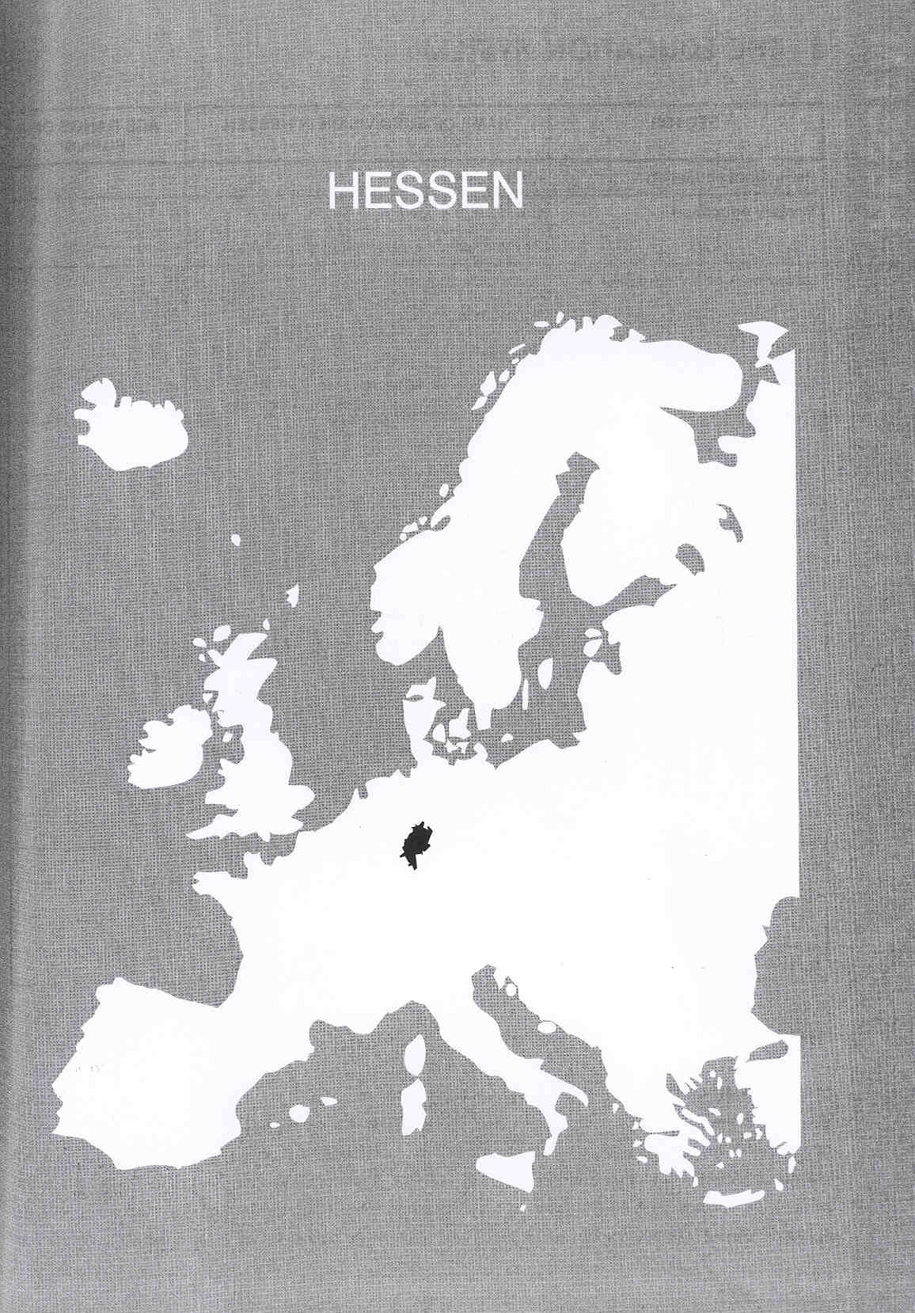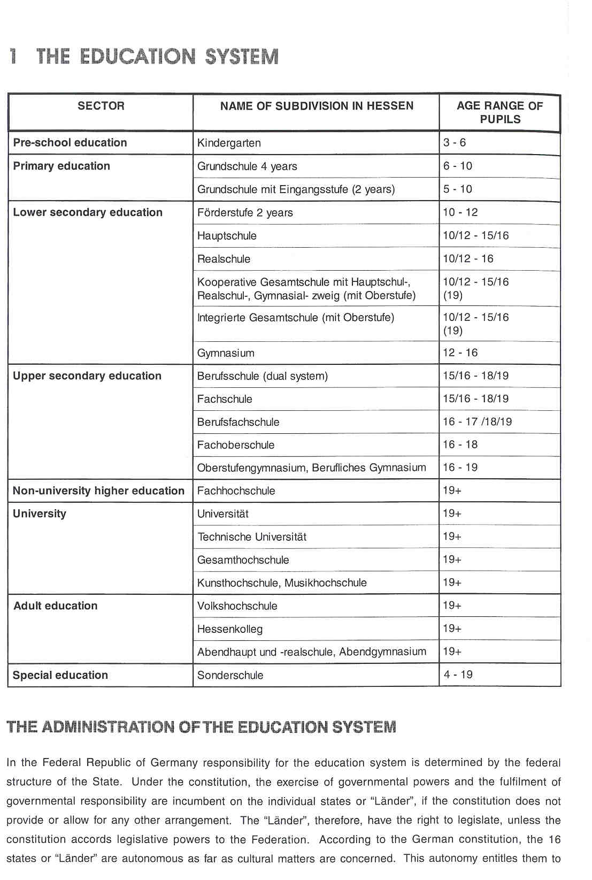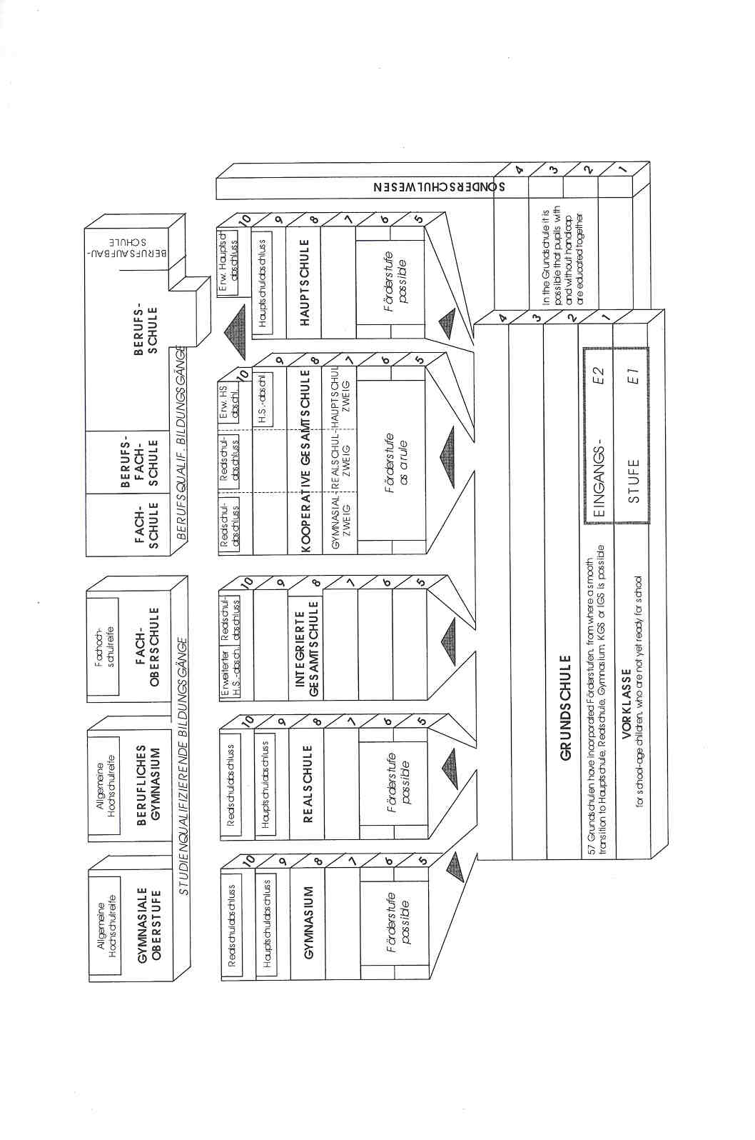
Νίκος Ηλιάδης, Πολ/κός Μηχ/κός Ε.Μ.Π., M.Sc.,
Ph.D. Industrial Education, Organization and Management,
Σύμβουλος του Παιδαγωγικού Ινστιτούτου

establish their own education system. Educational legislation and the administration of the education system, therefore, are primarily the responsibility of the "Lander”. Nevertheless, the structures are generally very similar because of the "Kultusministerkonferenz", the "conference" at which the ministers of education of the "Lainder” make decisions in common about the major issues affecting German education.

The organisation of primary education is the same for the whole of Hessen. The organisation of secondary education differs from county to county. The previous table and following text provide a general description of the Hessian educational system.

COMPULSORY EDUCATION

The period of compulsory schooling begins for all children at age six. It usually lasts twelve years, consisting of nine years of full-time schooling and three years of part-time schooling.

EDUCATIONAL SECTORS AND SUBDIVISIONS

A common feature at all school levels is the compulsory curriculum framework which schools have to follow. This curriculum occupies 60 % of the total amount of time available to a school. The remaining 40 % of time is determined by the school.

Pre-school Education

Pre-school education refers to all institutions of the non-public and public youth welfare services which cater for children from the time they reach the age of three until they begin school. It is not a part of the statutory school system. In Germany, attendance at preschool institutions is entirely voluntary.

The "Kindergarten" is the traditional form of institutionalised preschool education for children between the ages of three and six. For children aged five, who are not yet of school age and whose parents wish to provide them with special assistance and preparation for primary school (the "Grundschule"), preparatory classes ("Vorklassen" or "Vorschulklassen") are provided.

Primary Education

Primary education is provided at primary schools ("Grundschulen") and lasts for four years. Children are enrolled in the first year at the age of six and usually transfer to a secondary school after the fourth year. In about 50 schools, children start at the age of five. This stage is called the "Eingangsstufe". This first year here is meant to be a transition between the "Kindergarten" and the "Grundschule". Their is no free choice of schools in primary education.

The "Grundschule" is meant to bring children forward from learning through play at the preschool level to more systematic forms of learning as they approach secondary education.
Teaching provision in schools is usually based on classes organised according to age. Teaching takes place in the mornings for five days a week from Monday to Friday.

Before moving up to the next year, a pupil must fulfil certain minimum requirements in all relevant subjects. Primary schools teach "Sachunterricht" (at an elementary level: history, geography, learning about society, biology, physics and chemistry), German, mathematics, "musisch-kulturelle Bildung", religion, sports and a foreign language from the third year onwards.

On successfully completing the "Grundschule" programme, pupils are recommended by their school to transfer to one of the different types of lower secondary school, where they remain at least until the end of their full- time compulsory education (aged 15). The parents make the final decision regarding which type of school their children will attend.

Secondary Education

Lower Secondary Education

In the fifth and sixth years, pupils can follow a programme of support, observation and orientation (called the "F6rderstufe"), which prepares them for a later educational route, incorporating subject specialisations. The "Fdrderstufe" may be offered in the "Hauptschule", the "Realschule" or the "Gesamtschule" or it may be appended to the "Grundschule" programme. From the seventh year on, the different types of school and educational routes are increasingly diverse. The following paragraphs describe the different types of school which offer one or more than one educational route.

The "Hauptschule" provides pupils with a basic general education. It generally covers the fifth to the ninth year (or, following the "Forderstufe", from the seventh year to the ninth year). On completing the programme, the pupils obtain the "Hauptschulabschiuss". In Hessen, pupils have the option of completing a voluntary tenth year at the "Hauptschule" (called the "extended Hauptschulabschiuss") in order to acquire a further qualification.

The "Realschule” offers pupils an extended general education. The term "extended" means that pupils can choose a second foreign language. The curriculum for the "Hauptschule" is more practical and job-orientated, while that of the "Realschule" is more academic. The "Realschule" covers the fifth to tenth year (or, following the "Fdrderstufe", from the seventh to the tenth year).

The "Realschule" leaving certificate (the "RealschulabschiuB") permits progression either to a training course leading to a vocational qualification or to a type of school providing a higher education entrance qualification.

"Gymnasien” offer pupils an intensified general secondary education. They normally cover the fifth to the thirteenth year (or the seventh to the thirteenth year). At the end of the tenth year of the "Gymnasium", pupils who have achieved pass marks in all their subjects are promoted to the upper level of the "Gymnasium" (the "Gymnasiale Oberstufe").

At the end of years 9 and 10, all lower secondary leaving certificates may be obtained at the "Gesamtschule”. There are 2 types:

- The "Kooperative Gesamtschule' combines the programmes followed at the "Hauptschule", "Realschule" and "Gymnasium" in one organizational and educational unit. Pupils are streamed according to their intended final qualification.
- The "Integrierte Gesamtschule” constitutes an educational and organisational entity. In some subjects, setting is gradually phased in, and pupils are taught courses at a minimum of two different levels.

Upper Secondary Education

The education available for 16- to 19-year-olds at upper secondary level includes general education, courses of vocational education and training and mixed general and vocational courses.

The “Gymnasiale Oberstufe” covers years 11 -1 3. After a transitional period in year 11, pupils enter the "qualification phase", where they are grouped according to their courses and are no longer taught in whole- class units. Although the pupils are still obliged to study certain subjects or subject groups, they now have considerable opportunity to decide on which topics to concentrate due to the extended range of courses. Cognate school subjects are grouped together into three main areas: language, literature and the arts; social sciences; mathematics, natural sciences and technology.

The upper level of the "Gymnasium" ends with the "Abitur" examination. This examination is organised by each individual school under the supervision of the "Staatliches Schularnt" as far as standards and quality are concerned. (See below.) Candidates who are successful in the "Abitur" after 13 years at school are awarded a general higher education entrance qualification (the "aligemeine Hochschuireife"), which is necessary for admission to university education and which provides admission to all forms of higher education.

Vocational Training at Full-time Vocational Schools

The "Berufsfachschule” (Full-time vocational school)

"Berufsfachschulen" are full-time schools which prepare pupils for employment or provide them with vocational education while continuing their general education. They offer a very wide range of courses. There are, for instance, "Berufsfachschulen" for careers in business, foreign languages, the craft industries, home economics, social work, the arts, the health sector, etc. Depending on the type of employment, the period of training varies from one year to three years.

The"Fachoberschule"(Technical secondary school)

The "Fachoberschule" covers the years 11 and 12 and requires a "Realschule" leaving certificate. It equips its pupils with general and specialised theoretical and practical knowledge and skills. It leads to the "Fachhochschuireife", which provides access to "Fachhochschulen". There are "Fachoberschulen" for technology, business and administration, nutrition and domestic science, agriculture, social work, design and nautical science, etc. Practical training in the specialist subject takes place in year 11, i.e. in year 1 of this type of school, on four days a week for the whole year. In addition, pupils are expected to spend at least eight teaching periods per week in class.

The"Berufliches Gymnasium" (Upper level of the "Gymnasium" with a technical emphasis)

Unlike the "Gymnasium", which, as a rule, provides continuous education from the years 5 to 13, the "berufliches Gymnasium" offers no lower or intermediate level. Requiring a "Realschule" leaving certificate at a level entitling attendance at the "gyrnnasiale Oberstufe", the "berufliches Gymnasium" usually leads to a qualification granting access to higher education (the "aligemeine Hochschuireife"). "Berufliche Gymnasien" offer career-oriented subjects and specialist subjects, such as business and engineering (e.g. electrical, metal and construction engineering).

The "Fachschule"

"Fachschulen" are technical schools providing advanced vocational training after a period of working experience. Those who successfully complete courses at a "Fachsehule" operate at a level between a graduate employee and staff trained in the dual system of vocational training.
"Fachschulen" offer one, two and three-year courses. Two-year courses are offered in about 90 different specialist subjects from the fields of technology, business, design, domestic science and geriatric nursing.. They all lead to a final examination recognised by the State.

The Dual System of Vocational Education and Training

At the end of full-time compulsory education, the majority of young people in Hessen go on to gain vocational qualifications through the dual system. The system is described as "dual", because training is carried out in two places of learning, i.e. at the workplace and in the "Berufsschule". The aim of the dual system is to provide a broadly-based basic vocational education and the necessary skills and knowledge required to engage in an occupation in a properly structured course of training.

In the context of the dual system of vocational education and training, the "Berufsschule" is an autonomous place of learning. "Berufsschulen" provide their pupils with a basic and specialised vocational training, while permitting them to continue their -, general education. About a third of the total teaching time at the "Berufsschule" is taken up with general education subjects, namely Gerrnan, social studies, economics, religion and sport.

Pupils attend the "Berufssehule" on a part-time basis and usually attend at least 12 lessons per week. In some cases, instruction takes the form of continuous blocks of time. On leaving the "Berufssehule", pupils receive a leaving certificate. Together with the certificate proving that they have successfully completed the requisite vocational training in the workplace and have appropriate professional experience, the leaving certificate issued by "Berufsschulen" entitles those who hold it to admission to advanced vocational training at a "Fachschule".

It is also possible to receive basic vocational training in a separate first stage, either in the form of a year's full-time schooling or through a dual system arrangement. This is known as the basic vocational training year (the "Berufsgrundbildungsjahe'). Its purpose is to provide general knowledge and skills not limited to one specific career area. Successful completion of the "Berufsgrundbildungsjahe' is counted as the first year of vocational training in the specific recognised occupation associated with the pupil's chosen career area.

Higher Education

There are two types of higher education: non-university higher education in the "Fachhochsehulen" and university education.

"Fachhochschulen" serve a specific purpose of their own in the context of the task, common to all higher education institutions, of providing an academic education. The bulk of their courses of study are in the engineering sciences, economics and business studies, agricultural science, the social sciences, librarianship, documentation and information management, and design. The courses of study themselves and the organisation of teaching and study are of a practical nature and geared to the demands of professional practice.
Courses at "Fachhochsehulen" lead to an examination for a diploma ("Diplomprefung").

The universities and equivalent higher education institutions ("Technische Universitaten"/"Hochschulen", "Universitdten-Gesamthochschulen" and institutions with some university departments) are responsible for undertaking research, teaching and studies, as well as for producing highly qualified young scientists and acadernics. Universities and equivalent higher education institutions are entitled to award doctorates ("Promotionsrecht") and to certify additional academic achievements in research and the teaching of a specific discipline ("Habilitationsrecht").

The "Universitaten-Gesamthochschulen' bring together under one roof research, teaching and study normally carried out by universities, "Fachhochschulen" and sometimes by "Kunsthochschulen" and "Musikhochschulen" (colleges of art and music). They offer integrated study programmes combining the educational objectives of university courses and the degree programmes of "Fachhochschulen". The "UniversitAten-Gesamthochschulen" run study programmes of varying duration leading to different degrees.

"Kunsthochschulen' and "Musikhochschulen' (colleges of art and music) offer courses of study in the design, the visual and performing arts and in musical disciplines; some also offer courses in the related scientific disciplines (i.e. the science of art, history of art, musicology, history of music, music education). Art and music courses lead to a "Diplom" (first degree), nomination as a "MeistersehOlee' (master pupil), the "konstierische ReifeprOfung" (final arts examination) or the "Konzertexamen" ("concert" examination).

Studies at institutions of higher education are generally divided into a first stage, the "Grundstudium" (usually lasting four semesters at university) leading to an intermediate examination, and a second stage or "Hauptstudium" ending with the final degree examination. It is important to distinguish between State and Church examinations in the context of academic qualifications. Success in the final examination usually qualifies the candidate for a particular profession.

The academic examinations, on the basis of which academic degrees are conferred, include:

- the "Diplornprufung" ("first degree examination"), which leads to the "Diplomgrad", e.g. "Diplom-Ingenieuer” (awarded by a university), or "Diplom-ingenieur" (FH) (awarded by a "Fachhochsehule");
- the "Magisterprufung" (Master's examination), leading to a "Magistergrad" (Master's degree): e.g. "Magister Artium" (Master of Arts);
- the "Promotion" (doctoral thesis), leading to a "Doktorgrad" (doctorate), e.g. "Doctor philosophiae" (PhD).

Some courses, leading to professions in which there is a particular public interest, end with a "StaatsprOfung" (State examination). This is especially so for courses in medicine, dentistry, veterinary medicine, pharmacy, law, food chemistry and for teacher training courses.

Teacher Training

Those working in preschool education do not undertake a teacher training in the real sense of the word. They take part in vocational training in child care at the "Fachsehule" or in nursery school teaching at the “Fachhochsehule".

Teacher training for primary teachers and for those in the "Hauptschule", "Realschule", "Gesamtschule", ,,Gymnasien" and vocational schools is provided at university. An "Abitur" is required for admission. The first part of the training is called the "Studium" and lasts a minimum of three to four years. The "Studium" ends with a state examination or "Erste Staatspr@fung". The second part takes place in a "Seminar". It takes the theoretical preparation further on and provides practical training in a school. Students must pass the "Zweite StaatsprOfung" in order to obtain a permanent teaching post.

Aduft Education

Under the continuing education legislation of some "L@inder", it is the task of the 'Volkshochschulen', the local adult education centres, to provide general continuing education courses, in other words to provide a regular and comprehensive range of courses which meets the most diverse social requirements and individual needs.

In addition to the "Volkshochschulen", there are "Kollegs". These establishments form part of the so-called "Zweite Bildungsweg", where adults attend full-time classes to obtain the general higher education entrance qualification (the "Hochsehuireife"). "Kollegs" are full-time schools.

It is usually possible to acquire school-leaving qualifications later in life at evening classes. 'Abendhauptschulen' prepare adults during a one-year course (lasting two semesters) for the ."Hauptschulabschiu[3". "Abendrealschulen' prepare adults for the "RealschulabschiuB" in evening classes (lasting four semesters). "Abend_qymnasien' enable sufficiently capable adults to obtain a higher education entrance qualification (the "Hochschuireife") usually over a three-year period. Applicants must be at least 19 years old and usually have to complete a one-sernester preliminary course before entry to the main course.

Special Education

The aim of special education ("Sonderschulwesen") is to enable children and young people, who are either disabled or facing the threat of disablement, to exercise their right to a form of schooling and education that is tailored to their personal capabilities. Children and young people receive support in the form of personalised assistance, so that they can achieve the highest possible level of integration at school and at work, participate in society and, as far as possible, lead independent adult lives.

There are special schools for children with learning disabilities, schools for the blind and visually handicapped, schools for the deaf and hard of hearing, schools for children with speech handicaps, schools for the physically handicapped, schools for mentally handicapped children, schools for children with behavioural problems and schools for pupils with long term illness.

2 THE ORGANISATION OF THE INSPECTORATE

The Inspectorate of Hessen is involved in a major process of change. The former three levels of Inspectorate were, on 1 August 1997, changed to two levels (the level of the three regional councils being abolished):
1 . The "Kultusministerium" (the Ministry of Culture, responsible for all cultural affairs including education) is the upper level of the Inspectorate. The "Kultusrninisteriurn" decides on all matters of general importance for the educational system, according to the laws and decrees which are drafted in the Ministry.
2. The 15 (previously 24 before August 1997) "Staatliche Schuljmter' implement the decisions of the Ministry and Parliament. Their responsibilities and organisation are set out in an official document called "Geschdftsordnung". The "SchulAmtee' monitor teaching staff ("Dienstaufsicht") and academic standards ("Fachaufsicht"). They are sometimes responsible for the supervision of teacher training as well. The "Schuldrntee' also advise and support schools.

The areas of responsibility are divided differently in the 15 "Schuic"imte@'. The most common pattern is for one inspector to be responsible for primary education, lower secondary education (ages 10-16) and special education, another for upper secondary education (ages 10-16 and 16-19) and a third for vocational schools.

Each "Schulamt" has a head of staff. The personnel in the "Schulamter" comprise inspectors or "Aufsichtsbeamte", psychologists, lawyers and other staff.
The government is wholly responsible for funding the Inspectorate. 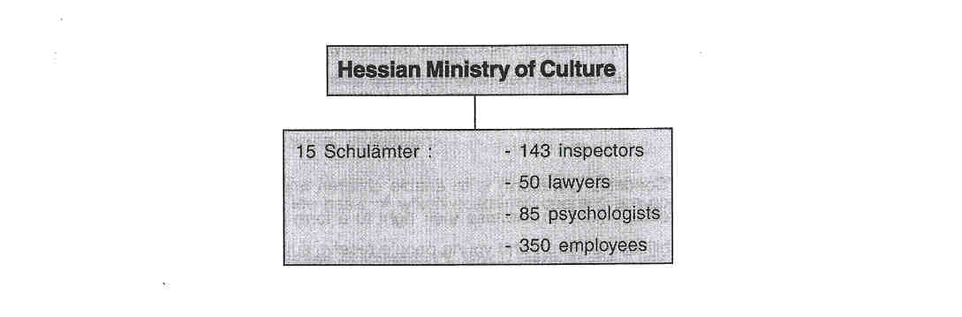
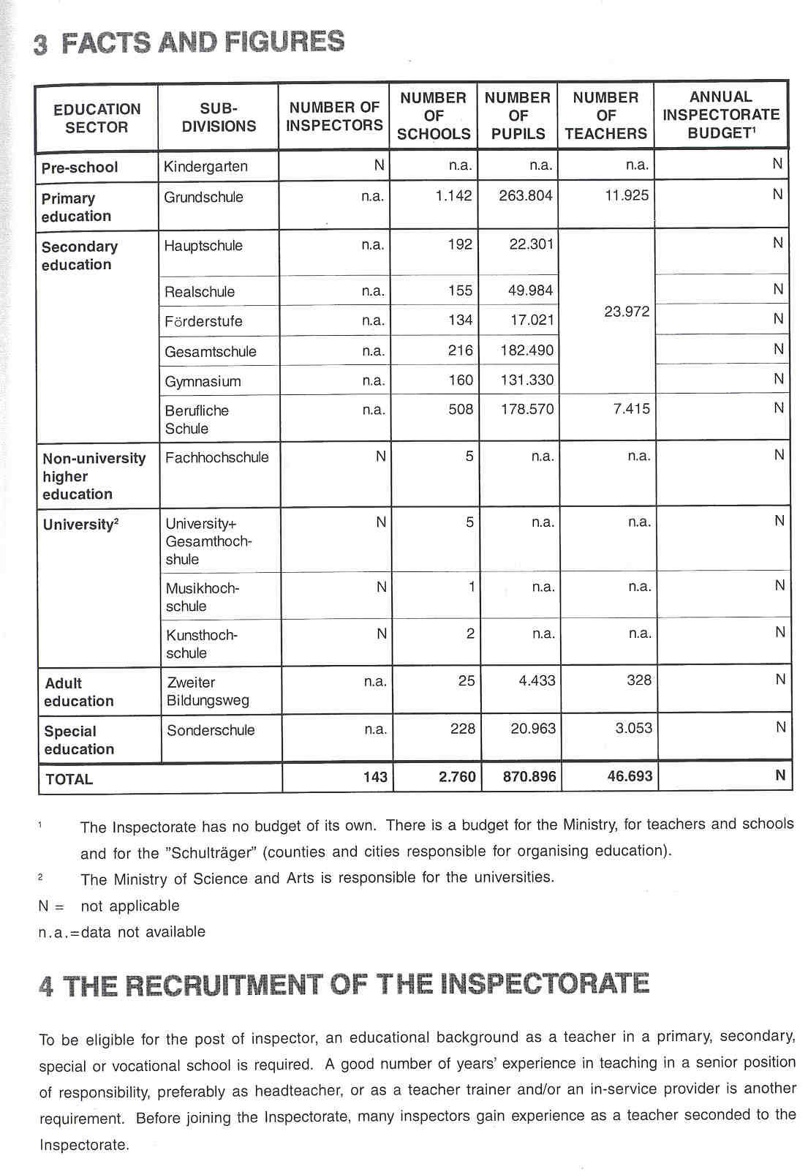

The above-mentioned experience and the quality of the work carried out are documented in a report which is partly the basis for recruitment. Other necessary recruitment information is obtained from an interview carried out by the Ministry of Culture. Credit is given to candidates who have continued their professional development and who possess the necessary personal, social and emotional qualities of leadership.
5 THE WORKING CONDITIONS OF THE INSPECTORATE

The post of inspector is a full-time, permanent position. They are civil servants like the majority of teachers in Hessen. The question of temporary appointment for senior posts in the civil service is under discussion but no changes have occurred so far.

Seconded teachers carry out different supporting tasks for the Inspectorate, such as taking down minutes, interviewing staff, talking with headteachers, teachers, parents and pupils, answering the telephone when an inspector is absent and assisting an inspector in drafting a speech, etc. They usually work half-time in their school and half-time at the "Staatliches Schulamt" or at the Ministry of Culture. This secondment is considered to be valuable in-service training.

6 AREAS OF INSPECTORATE RESPONSIBILITY

In Germany, the Inspectorate's responsibilities are part of the Government's constitutional tasks concerning the supervision of schools. These tasks are:

- Supervision of staff ("Dienstaufsicht"), i.e. teachers and headteachers, in order to ensure they are carrying out their duties. Civil service guidelines stipulate the need for the appraisal of teachers on specific occasions (end of probationary period, promotion, transfer) and, in some cases, at periodic intervals.
- Academic supervision ("Fachaufsicht") concerns the education offered by schools. The school inspectors support and foster the work of the school, ensure that curricula and other legal provisions are adhered to and that teaching and learning are pursued professionally using appropriate methods and are improved wherever possible.
- The organisation, improvement and maintainance of the school system.
- The promotion of good teaching.
- Ensuring that those responsible for the organisation and management of the school and its staff carry out their duties.
- Enhancing the schools' own sense of responsibility.

Within this constitutional framework, the Inspectorate in Hessen has the following responsibilities:

6.1 EVALUATING

- In the Hessian Inspectorate there is a strong emphasis on the evaluation of schools' compliance with statutory regulations concerning the curriculum, management, finances, the timetable and number of pupils in classes. It should be noted that inspectors have no involvement with the school's budget, which is the concern only of the schools and the "SchultrdgeC'. Inspectors do, however, select schools for financial support for all kinds of projects, such as the pilot project in school development planning; they also suggest how much money should be awarded by the Ministry. Inspectors make these proposals based on their knowledge of the school's provision.

- The Inspectorate has an important responsibility for evaluating the work of individual teachers. The performance of individual teachers is evaluated in order to recruit, employ, appoint and promote teaching staff. The Inspectorate is formally responsible for:
- the second State examination ("Zweite StaatsprOfung") of teachers after training (the first State examination being for a university degree).
- the assessment of teachers after their probationary period before they become permanent civil servants.
- the appointment of staff, which is the exclusive responsibility of the Inspectorate. The Inspectorate assesses teachers when they apply for a post in school management, initial teacher training or in- service training.
- all problems or disputes between teachers and pupils, parents, colleagues and headteachers.

- At present, there is no evaluation of entire schools in Hessen. Only severe problems, such as parental complaints which lead to questions in Parliament, can cause such a very rare kind of evaluation. Full inspections, however, including an evaluation of the school development plan and the schools' procedures for self-evaluation, are planned. Schools will not be obliged to present a development plan before the school year 199912000. As a consequence, there is little experience so far of such an evaluation. Self- evaluation remains a challenging task for schools. Some pilot schools have developed methods for self- evaluation, but no general approach has yet been decided upon and the responsibility of inspectors in this field has still to be clarified.
- In the context of school planning, self-assessrnent and evaluation, the evaluation of subject areas is increasing in importance.
- There is little emphasis on the evaluation of branches of study or specific topics.

6.2 ADVISING

- The Inspectorate advises on all disputes within schools which are referred to the Ministry or the "Schulamt".
- The Inspectorate also advises on all matters concerning educational and developmental work in schools.
This advise may be requested or may be given on the initiative of the inspector. For example, for the last two years the Inspectorate has advised and supported schools in their work of school development planning by:
- organising a pilot project with 151 schools. The results of the pilot exercise were described in booklets offering advice to all schools not involved with the project;
- organising conferences and workshops at the level of the "Schulamt" for headteachers and teachers as a joint venture of the Inspectorate, the in-service training institutes and the teacher-training "Seminaren";
- organising conferences and workshops within the inspection area of.the individual inspector;
- a organising conferences and workshops within the school.

- The Inspectorate advises on the professional performance of teachers and headteachers.
- Inspectors advise schools whithin their phase and geographical area on all changes in school policy
- The Inspectorate advises the Ministry on the results of anticipated changes, pilot projects, etc.
6.3 MONITORING

- Inspectors have a general responsibility for monitoring of quality of school management. They do this by:
- appointing staff to positions of responsibility for school management
- training staff involved in management;
- appointing teachers to all schools.

- The Inspectorate has financial responsibility for the supply of schoolbooks to all pupils. Schoolbooks are provided free to all pupils. Schools/teachers may choose from a variety of books which must be recommended/approved by the Ministry. Books are recommended by teachers chosen for their professional qualities. They review the books in a report to the Ministry. Final approval is given by a committee within the Ministry.
- The Inspectorate has responsibility for two regional examinations: the second State examination for teachers (See above) and the final school examinations (the "Hauptschul- und RealschulabschiuB", and the "Abitur"). The Inspectorate has to ensure comparability between examinations. For example, an inspector, as head of an examination commission, ensures fair and correct judgement based on the examination regulations.
- Data banks are constructed by the Inspectorate on schools, for the purpose of supplying schools with the required number of suitably qualified teachers, and on teachers for administrative purposes. Only a small number of inspectors are involved in the construction and management of this data bank.

6.4 REPORTING

Reporting is an important Inspectorate task. The following types of reports are the most common:

- Reports on candidates for positions of responsibility in school management and on candidates for the Inspectorate;
- Reports on the suitability of probationary teachers to become permanent civil servants. Part of this assessment is now being carried out by headteachers;
- Reports on special programmes launched by the Ministry, such as "Gemeinsamer Unterricht" (integrated teaching for mainstream and disabled children), "Grundschulen rnit festen Offnungszeiten" (primary school with fixed opening hours) and "Europaschulen" (schools with a European bias).

6.5 OTHER RESPONSIBILITIES

Curriculum Development

The Ministry is responsible for curriculum development. Members of the Inspectorate are invited to serve on curriculum committees, together with members of the Central Hessian Institute of Education ("Hessisches 1 andesinstitut fur Padagogik" or "HeLP")1 . The implementation of the curriculum is promoted by the Inspectorate, the Central Institute of Education and the teacher- training "Seminaren".
Whether Children Should Attend Special Schools

Inspectors decide whether a child should attend a special school. Standardized intelligence tests are administered to help them make this decision.

7 THE ROLE OF THE INSPECTORATE IN EDUCATIONAL POLICY

Only members of the Inspectorate attached to the Ministry of Culture participate in preparing and decision- making with regard to the educational policy.

The inspectors in the 15 "Staatliche Schuldmter" (the second tier of Inspectorate) are responsible for implementing the policy. This is generally achieved by organising conferences or workshops. Furthermore, inspectors evaluate the effectiveness of policy, in general or specific terms, if problems arise.

8 WHO IS IN CHARGE?

The Inspectorate's work schedule for a given period is decided by the legislature (the State parliament) and the Minister. Parliament is responsible for formulating laws, such as the "Hessisches Schulgesetz" of 1992.

The focus of the evaluative work is decided by the three bodies involved: the Ministry of Culture, the "Staatliche Schularnt" and the individual inspector. The senior management of the Inspectorate provides guidelines and advice and takes responsibility for the implementation of laws and decrees. The individual inspector takes part, with the senior management, in the decision-making process and carries out the agreed tasks.

The Inspectorate's work is not done according to a strict hierarchical process. All "SchulAmter" are quite free to decide how they carry out their duties. Senior inspectors, i.e. the heads of the 15 "Schui,;imte@', do not impose procedures on their Inspectorate colleagues, but involve all of them in developing a system of working. Most "Schuldmte@' are in the process of drawing up a development plan, comparable to.the one required of schools, for, according to the "Gesch,@iftsordnung" for the "Schuldmter", each "Schularnt" has to set out its goals and priority areas in a "Schulamtsprogramrn". They must do this in co-operation with the schools, with the "Hessisches Landesinstitut fOr Pddagogiek" and with the "Studienseminaren" (teacher-training institutions). They must also agree on procedures for evaluating the implementation of these goals.

9 THE POSITION OF THE INSPECTORATE

The Inspectorate must implement laws and decrees formulated by the Minister who is its superior. The Inspectorate is itself part of the administration, and, as a consequence, inspectors and legal experts work together in the "Staatliche Schulamtee' and share responsibility

The Ministry and the first tier of the Inspectorate is responsible for curriculum development. The institutions charged with in-service training and school development make a substantial contribution to curriculum development.
10 THE INSPECTION PROCESS

Inspection in Hessen is not a strictly formalized process with uniform procedures. While there are procedures for the appointment of staff, inspectors decide for themselves how to deal with schools. Depending on the subject, they may ask schools for written information. They may talk with the principal or visit a particular school. In the past, these visits occurred most frequently when, at regular intervals, the competence of individual teachers had to be assessed. Part of this assessment is now carried out by the principal, which gives the inspector more opportunity to visit schools for other purposes, such as advising the whole school as an educational system. As yet, inspectors have a limited experience in this field. Visits can either be initiated by the school or the inspector. As a rule, schools are informed in advance. The inspector decides whether information is needed prior to the visit. Feedback is provided in the form of an oral report.

11 INSTRTUMENTS AND METHODS

THE COLLECTION OF INFORMATION

a. Questionnaires

Questionnaires are rarely used to collect information, although they are gaining in importance. The content of the questionnaire is, in most cases, decided by the individual inspector or by the inspectors attached to a particular region or type of school.

b. Interviews

Interviews are frequently used, but they are not at all regulated. (There is no prescribed procedure or "model interview".)
Formal meetings with the principal or staff of a particular school are a further means of collecting information.

c. Observations

Observation is common practice, certainly as far as the quality of teaching in class is concerned.

d. Tests/examinations

Inspectors rarely test or examine pupils. Standardized intelligence tests, however, may be administered by a specialist before the Inspectorate decides to place a child in a special school.

e. The Collection of Documents

[)ocuments may be requested of schools by individual inspectors.
Considerable emphasis will be placed on school development plans in the future.

f. The use of National Data

National data are available, but are primarily of use for political purposes and less for the day-to-day work of the Inspectorate.

APPROACHES

- No uniform instrument or criteria common to all inspectors can be cited.
- Working in teams is so far an exception. However, when the competence of teachers applying for the post of principal or inspector has to be assessed, this task is now normally undertaken by more that one inspector.

12 JUDGEMENT AND ITS CONSEQUENCES

An inspector may pass judgement on the weaknesses or strengths of a particular school The inspector may indicate what a school needs to do to improve. There are no consequences for the school's budget.

Teachers with a positive evaluation may be promoted; they may, for example, become principal. Those who receive a negative evaluation may, for example, be transferred to another school or take a drop in salary. Teachers are civil servants and may be sanctioned by the administration. Teaching methodology is, to a large extent, the responsibility of the individual teacher. In practice, it is difficult to distinguish between evaluation and advice when it comes to teaching methodology.

13 OUTCOMES

There are reports on the assessment of individual teachers. These reports remain confidential. Only the teacher involved and the headteacher receive a copy.

There are no reports on schools. Matters are resolved by the Inspectorate in direct contact with the school.

Occasionally, reports on the evaluation of certain subject areas are written. This may be at the request of Government or Parliament or on the initiative of the Inspectorate. This is also the case for reports on the evaluation of a branch of study, aspect-evaluations at national level and advisory work. Reports written on demand of Goverment or Parliament become public.

14 FOLLOW-UP PROCEDURES

Since inspection is not a formalized process, follow-up procedures depend on the type of intervention carried out by the inspector.

15 INSPECTORS AS ARBITRATORS

Pupils and parents frequently take the opportunity to approach inspectors with complaints about teachers or schools. For example, the "Staatliches Schulamt" of Darmstadt-Dieburg, one of the 15 in Hessen, receives approximately 150 complaints a year.

Teachers also have the opportunity to approach inspectors with complaints about headteachers or governing bodies. Moderate use is made of this facility. For example, the "Staatliches Schulamf' of Darmstadt-Dieburg receives approximately 30 to 40 complaints a year.

Inspectors can, therefore, act as arbitrators in, for example, disputes within a school's management team, between headteachers or teachers and parents or pupils, and between headteachers and teachers.

16 THE INSPECTORATE AS AN ACTOR IN PUBLIC DEBATE

Public relations work is the exclusive domain of the head of the "Schularnt". Inspectors can, however, take part in various public debates, as in lectures, reports, newspapers articles and interviews. To engage in this type of activity, inspectors need the approval of the head of the "Schulamt". Simply informing the head, however, is often sufficient. Serious matters are discussed beforehand or are handled by the head.

17 THE EVALUATION OF THE INSPECTORATE

The Inspectorate is evaluated:

- Externally by consultancy firms. The aim of this external evaluation was to give advice on the planned new structuring of the Hessian educational administration. All the activities within the administration of a "Staatliches Schulamt" were, therefore, closely observed. The advice was followed in part.
- Internally by methods developed within a "Staatliches Schulamt". Internal evaluation takes place within discrete groups of staff, such as inspectors, lawyers, officials in charge, or in mixed groups. Either there is mutual agreement about change as in the way telephone contacts are made, or the head of the "Schulamt" decides as in who is responsible for certain decisions.

As already mentioned above, according to the "Geschdftsordnung" for the "SchuldmteC', each "Schulamt" has to indicate its goals and priority areas in a "Schulamtsprogramm". This must be done in co-operation with the schools, with the "Hessisches lnstitut f@r P,@dagogiek" and with the "Studienseminaren". Agreement also has to be reached on procedures for evaluating the implementation of these goals.

18 THE INSPECTORATE'S INITIAL TRAINING AND IN- SERVICE TRAINING

There is no system of quality assurance or initial training for new members of the Inspectorate. They are trained and supported by senior colleagues.

in-service training for the Inspectorate is provided by the "Hessisches Landesinstitut fcjr P;Rdagogik". Attendance is not compulsory. Inspectors are asked to indicate their preferred topics for in-service training.

19 RECENT OR FUTURE ISSUES AND DEVELOPMENTS

The Hessian school system, the Inspectorate and the administration have been undergoing major changes, important elements of which are:

- the new Hessian school laws (dating from 17 June 1992), including increased autonomy for schools, increased participation of parents and increased responsibilities for the "SchultrAge@' (cities and counties);
- new curricula for all levels of education and all subjects (since 1995);
- a project for all Hessian schools (from 1997): to develop, implement and evaluate school programmes.

The Inspectorate has to promote the implementation of these various elements in schools. As a consequence, there is a considerable need to train inspectors to be able to carry out these tasks in the future.

Furthermore, as a result of these changes, there are informal plans to modify the Inspectorate's tasks, methods and instruments. There should be instruments for a school's self-evaluation and external evaluation within the next two years. Within the same period, the Inspectorate's role in external evaluation and in the process of establishing school development plans and procedures for self-evaluation, should have been specified.

20 LITERATURE

Bildungsserver Hessen, http:llwww.bildung.hessen.de/

EURYDICE & CEDEFOP, Structures of the education and initial training systems in the European Union. Luxembourg, Office for Official Publications of the European Communities, 1995, 458 pp.

EURYDICE, The Education System in Germany (1997), Eurydice Eurybase 1998, http:llwww.eurydice.org/ Eurybase/Files/DEENIDEEN.htrn

HESSISCHES KULTUSMINISTERIUM, Bildungswege in Hessen (Nr.1). Frankfurt/Main, Hessisches Kultusministerium, 1994, 51 pp.

HESSISCHES KULTUSMINISTERIUM, GeschAftsordnung fOr das Staatliche Schulamt, Wiesbaden, 1999, 10 pp.

HOPES, C., Assessing, evaluating and assuring quality in schools in the European Union. Frankfurt am Main, Geselischaft zur F6rderung P;@dagogischer Forschung/Deutsches lnstitut for lnternationale Pddagogische Forschung, 1997, 211 pp.

STANDAERT, R. & ROTH-VAN DER WERF, G., Het onderwijs in Duitsland. Onderwijs in de Europese Unie: eenheid in verscheidenheid. Leuven/Apeldoorn, Garant, 1996, 102 pp.

STANDAERT, R., Onderwijsinnovatie en -beleid in de Duitse Bondsrepubliek. Leuven, K.U., Onderzoekscentrum Cornparatieve Pedagogiek, 1989, 289 pp.

VAN BRUGGEN, J., The position of the lnspectorates in the various countries. Breda, SICI-internal document, 1998, 25-49

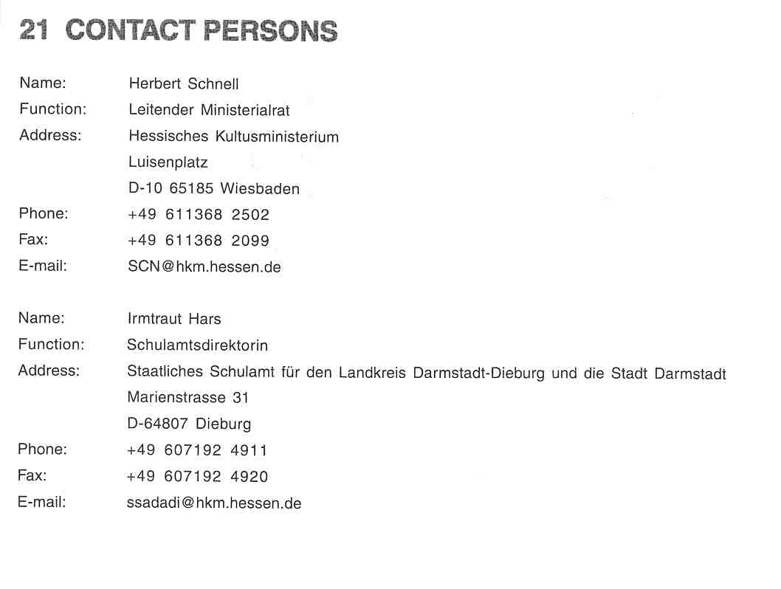

1 One central, six regional and 15 local pedagogical institutes are responsible tor regional school development, advising individual schools and in-service training.

