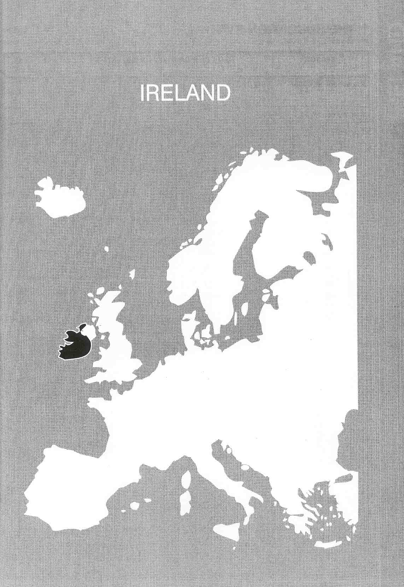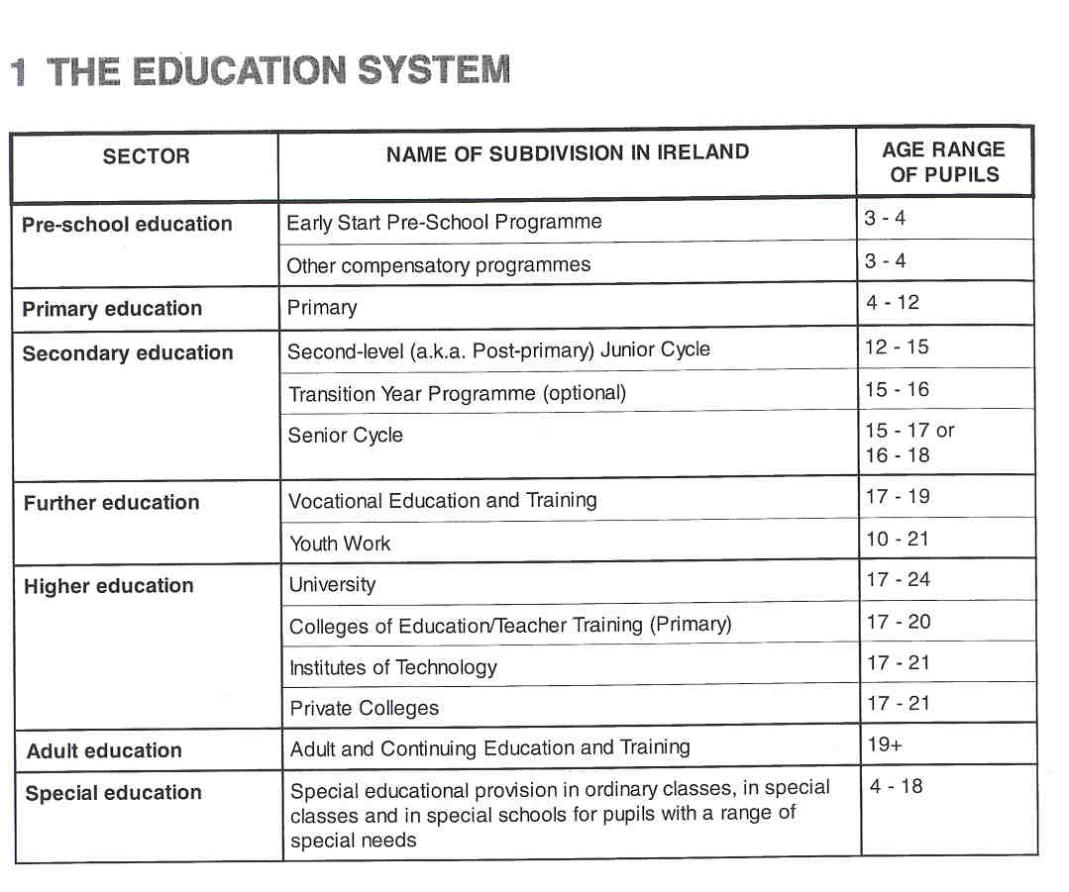

Νίκος Ηλιάδης, Πολ/κός Μηχ/κός Ε.Μ.Π., M.Sc.,
Ph.D. Industrial Education, Organization and Management,
Σύμβουλος του Παιδαγωγικού Ινστιτούτου

THE ADMINISTRATION OFTHE EDUCATION SYSTEM

The Irish education system is best described as one of partnership between the State and various private agencies. The education system relies on indirect subsidisation of local and often corporative initiative. There has been very little parliamentary legislation on education matters until the passing of the Education Act 1998. The education system is controlled by regulation rather than by statute. Many aspects of the administration of the Irish education system are centralised in the Department of Education and Science. This Department sets the general regulations for the inspection and recognition of schools, effectively controls the curriculum and the public examination system and establishes regulations for management, resourcing and staffing of schools, and negotiates teacher's salary scales. The Department also exercises a detailed control function particularly in budgetary matters within the vocational sector. The Department has an overview function in relation to certain third level institutions and is directly responsible for negotiating overall funding levels for designated institutions under the Higher Education Authority (HEA). The HEA is responsible for furthering the development of higher education and assisting in the co-ordination of State investment in higher education and preparing proposals for such investment.

Education is not organised on a regional basis in Ireland, therefore there is no comprehensive regional structure in Irish educational administration.

At local level county councils, county boroughs and urban district councils appoint Vocational Education Committees (VECs). The VECs are responsible for vocational education in their area, e.g. they provide and administer vocational schools, they manage and fund colleges in the technical and further education sector, they are responsible for most adult courses with an emphasis on practical or vocational subjects. Each of these committees consists of 14 members elected by the local authority of the administrative area.
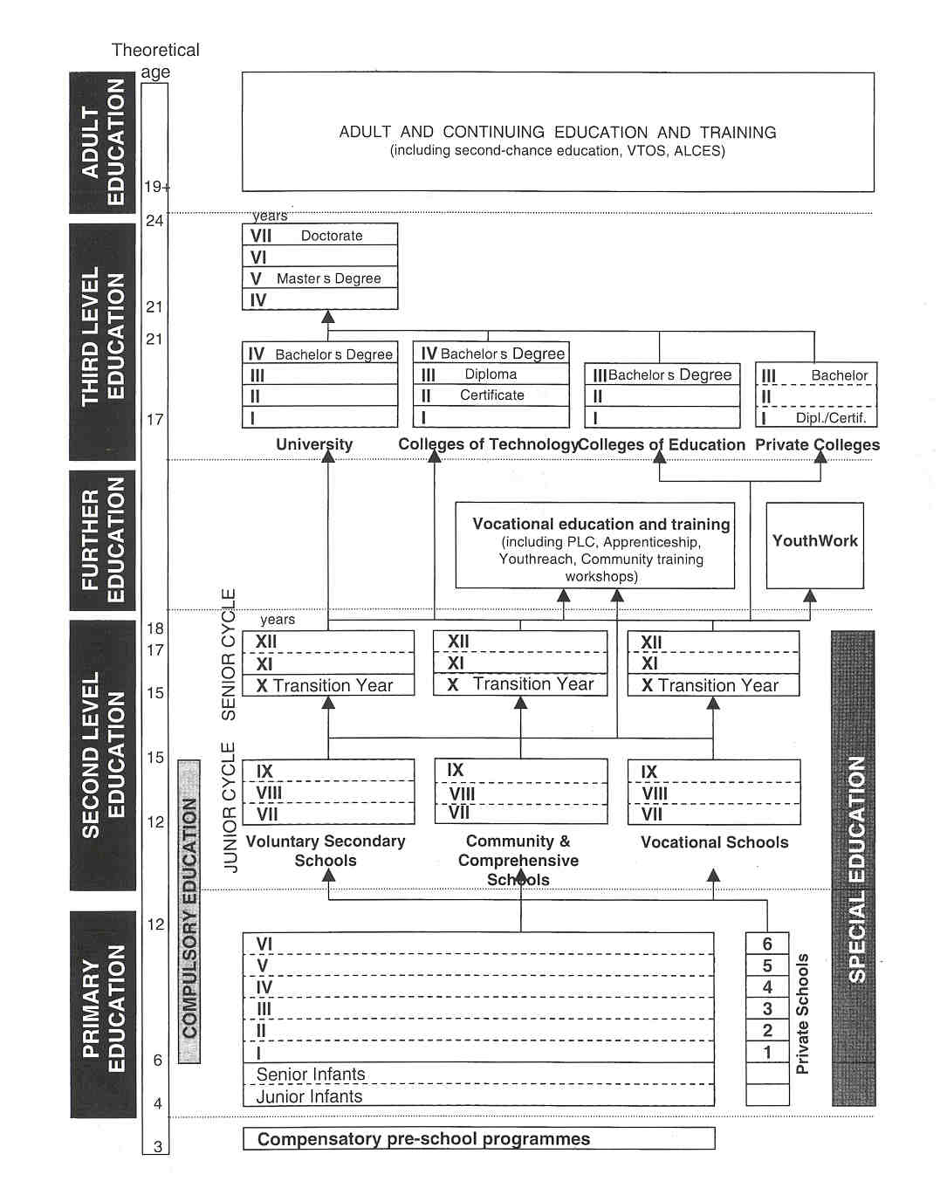

COMPULSORY EDUCATION

The period of compulsory schooling in Ireland is from 6 to 15 years of age. (Proposed new legislation on Educational Welfare will raise this to 16 years). This broadly covers primary education and junior cycle of second-level education. However, many pupils attend school full-time from age 4 to age 17118.

EDUCATIONAL SECTORS AND SUBDIVISIONS

Pre-school Education

There is no formal national preschool provision in Ireland. Where preschool services exist they are usually private and outside the formal education system (e.g. preschool playgroups). Children are not obliged to attend school until the age of 6, but more than half of 4-year olds and almost all 5-year olds are enrolled in the two infant grades of primary schools (Junior and Senior Infants). The curriculum in those 2 years is part of an integrated programme which extends for 8 years to the end of primary schooling. Therefore much of what is considered preschool education in other countries is included in the primary education system in Ireland.
There is, however, a limited number of compensatory programmes for 3- to 4- year olds. These include pre- school programmes for children of people with itinerant occupations, for children in an inner-city Dublin area, for children with special educational needs and a new programme, a pilot project called "Early Start", targeted on areas of social disadvantage. In the latter case, the preschool is an integral part of the primary school to which it is attached and operates within the general framework of the primary school system.

Primary Education

This first-level education sector covers pupils aged 4 to 12 years, 98% of whom are in state-aided primary schools (the vast majority are parish schools). In these schools education is provided for free. The rest are private schools which receive no state funding.
The typical primary school divides pupils by age in to 8 year-groups or standards ranging from Junior and Senior infants to Standard V]. More than 50% of the primary schools have 4 or fewer teachers.
The curriculum encompasses the content, structure and processes of teaching and learning, which the school provides in accordance with its educational objectives and values. The curriculum in schools is concerned, not only with the subjects taught, but also with how and why they are taught and with the outcomes of this activity for the learner. The Primary School Curriculum is child-centred rather than subject- centred. The various aspects of the current curriculum include religion, Irish, English, mathematics, social, environmental and scientific education, art & crafts, music and physical education. A major review of this curriculum by the National Council for Curriculum and Assessment (NCCA) has just been completed and a revised curriculum will be introduced to schools, beginning in 1999. Major developments will include the realignrnent of some curricular aspects under generic headings, the accommodation of new areas of learning and a greater focus on learning processes. There are different levels for the development and implementation of the curriculum. At national level, the curriculum is formulated by the Minister of Education and Science, on the advice of the National Council for Curriculum and Assessment (NCCA). The Department of Education and Science oversees its implementation through its Inspectorate. At school level, the particular character of the school makes a vital contribution. Adaptation of the curriculum to suit the individual school is achieved through the preparation and continuous updating of a school plan.
The NCCA gives advice to the Minister on all aspects of the curriculum, provides curricular objectives and guidelines, and advises on assessment methods and on transition arrangements from primary to second-level schools.
There is no formal examination and no formal certification at the end of primary education. Primary school teachers carry out their own assessment of pupils performance. A formal report card is completed by each teacher about each pupil at the end of primary education. These cards are sent to the pupil's secondary school. Parents receive annual reports from schools.

Secondary Education

Secondary education is provided within the Second-level (or post-primary) sector. Pupils transfer to second- level schools when they have completed the full primary course, usually at age 12. The Second-level sector comprises voluntary secondary schools, community or comprehensive schools, and vocational schools. These school types can be differentiated by ownership, management and vocational orientation.

- voluntary secondary schools, educating 60% of the second-level students, are privately owned and managed but part-financed by the Department of Education.
- community and comprehensive schools, educating 14% of the students, are state-operated and financed.
- vocational schools, educating 26% of the students, are administered by Vocational Education Committees and financed by the Department of Education.

Education is free of charge in all vocational, comprehensive and community schools and also in the majority of voluntary secondary schools. Approximately 5% of secondary schools charge fees.
All school types offer a broadly similar curriculum that combines academic and vocational subjects.

Second-level education consists of a 3-year Junior and a 2- or 3-year Senior Cycle, each of which has a final examination, provided by all schools.
- The Junior Cycle (12-15 years) offers a unified comprehensive programme (the Junior Certificate programme) leading to a common State examination, the Junior Certificate. This programme provides a broad set of subjects and levels suitable for a wide variety of abilities. The NCCA develops the syllabuses for the different subjects of the Junior Certificate programme. Recognised schools must confirm to State requirements in regard to educational standards and the general structure of the curriculum. Nonetheless, schools may exercise considerable curricular freedom by availing themselves of the scope for choice that exists within the range of subjects accepted for the Certificate Examinations. Pupils in secondary schools have to take a number of core subjects (Irish, English, mathematics, history, geography and civic, social and political education) and at least 2 other subjects from a list that includes languages, science, home economics, business studies, music, art, craft and design. The curricula offered in vocational, comprehensive and community schools tend to approximate those in secondary schools though with some differences in emphasis. Comprehensive and community schools provide comprehensive curricula combining academic and practical subjects. Vocational schools by tradition emphasise the practical subjects. There is a Junior Certificate School Programme to cater for a small number of students whose learning needs are not adequately met by the Junior Certificate: it emphasises the essential skills of numeracy and literacy as well as personal and social needs and generally involves up to 5 Junior Certificate subjects. As a rule pupils in Junior Cycle study from 8 to 10 subjects for the Junior Certificate Examination.
- In Senior Cycle there is an optional 1 -year Transition Year programme followed by a choice of 3 Leaving Certificate programmes (2 years). The Transition Year Programme provides a non-examination, interdisciplinary and student-centred learning environment. The curricular content of the transition year is a responsibility of the school, but educational activities undertaken should enable students to have a valid and worthwhile learning experience with emphasis given to developing study skills and self-directed learning. Another feature of this programme is work experience.

At the end of compulsory schooling pupils may follow one of the Leaving Certificate programmes leading to the final second-level certification examination, called the Leaving Certificate. Pupils following the established Leaving Certificate Programme must take at least five subjects (including Irish) from a wider list than in Junior Cycle. The list is divided into 5 groups (language, science, business studies, applied science, and social studies). The NCCA is responsible for developing and revising the curriculum (subject syllabuses) at senior cycle level.
The Leaving Certificate is used for a variety of purposes: e.g. as an entry qualification for a range of third-level institutions (including universities) and as a selection test for many kinds of employment.
The Department of Education and Science in collaboration with the NCCA has developed 2 alternative Leaving Certificates: the Leaving Certificate Vocational Programme (LCVP) and the Leaving Certificate Applied (LCA).

- The LCVP is the normal Leaving Certificate programme with a concentration on technical subjects. it has a high vocational content. In addition, pupils must take a linked modular programme involving preparation for work, work experience and enterprise. Study of a modern Continental European language is also compulsory.
- The LCA is a person-centred programme involving a cross-curricular approach consisting of a number of modules and an emphasis on work experience. It prepares for adult and working life. LCA differs from the other Leaving Certificate programmes because the certification is not a qualification for direct entry in third-level courses. However, students who successfully complete the programme will be able to proceed to most Post-Leaving Certificate courses.

Further Education

The further education sector makes provision for post-second-level students not participating in traditional third-level education and those who have not completed the full second-level cycle. It broadly covers a wide range of vocational education and training courses in preparation for employment and for other education and training opportunities, apprenticeship training schemes, education and work-experience programmes for young people leaving school with no formal qualifications, literacy/nurneracy tuition for those at risk due to poor educational attainment and for young people with an itinerant occupation caught in a cycle of illiteracy and social deprivation. This sector also includes support for some youth work programmes.

Vocational Education and Training

- Post-Leaving-Certificate courses are aimed at those who have completed senior cycle education. There is a variety of vocational, professional, technical courses of 1 or 2 year duration. The objective of these courses is to provide skills to meet the needs of the economy, to equip young people with the vocational and technological skills necessary for employment and progression to further education and training, and to foster innovation and adaptability in participants. Increasingly, these courses are including national forms of accreditation under. the National Council for Vocational Awards (NCVA). This council has to develop a comprehensive certificate system for the growing range of vocational education and training programmes.
- Apprenticeship operates primarily in a number of designated trades, e.g. engineering, construction, motor, electrical, printing, furniture and catering. Standards to be achieved in each trade are measured through on-the-job competence testing, together with modular assessment and formal examinations for off-the-job elements.
- Youthreach. The purpose of this programme is to provide up to 2 years of education, training and work experience or work placement for young people who leave school without any formal educational qualification. Youthreach programmes are certified by the NCVA. The programme has 7 phases, 4 consisting of on-the-job training and 3 relating to off-the-job training.
- The Community Training Workshops (CTW) programme is run for the training of young people in the 16- 25 year age group who are at risk due to poor educational attainment, literacy or numeracy difficulties and low self-esteem. These people cannot avail themselves of the more mainstream training and employment programmes. Training courses provided include basic training, work activation and vocational training. CTWs are part of the Youthreach structure.
- Travellers Training Workshops are located around the country and cater for the remedial education and training needs of young unemployed travelling persons.

Youth work

The Department of Education and Science supports a range of national youth organisations offering young people (within the age range 10-21) opportunities to develop their skills in a process of learning by doing. These organisations provide out-of-school programmes catering for the needs of young people who are disadvantaged (due to unemployment, social isolation, drug abuse, ...). An objective of youth work is to facilitate the return of these young people to the formal education or training systems.

Higher Education

The third-level education sector comprises Universities, Institutes of Technology offering certificate, diploma and degree courses and Colleges of Education. Also included in this sector are a number of independent private colleges, offering a range of mainly business-related courses conferring professional qualifications and, in some instances, recognised diplomas and degrees.

Universities

The main entry requirement is the Leaving Certificate. However, there tend to be more applicants than places for most courses. Places are allocated in order of merit on the basis of qualifications in the Leaving Certificate examination. The universities offer degree programmes in the humanities, in the scientific, technological and social sciences, and in the medical area. The duration of study for the first degree, the Bachelor's degree, is 3 to 6 years, depending on the course followed. The first post graduate degree, the Master's degree, requires another 1 to 3 years. A further 2 years at least are normally required for the degree of Doctor of Philosophy (Ph.D.), and 4 years for a higher Doctorate, such as Doctor of Science (D.Sc.) or Doctor of Literature (D.Litt.). A range of undergraduate and post graduate diplomas is also offered and all the universities have continuing and some distance education programmes.

Colleges of Technology

The Institutes of Technology offer education and training, both full-time and part-time, for trade and industry over a broad spectrum of occupations and levels, in the areas of business studies, engineering & technology and science & pararnedicine. A Leaving Certificate is an entry requirement. The National Council for Educational Awards (NCEA) has statutory award-giving authority for non-university higher education qualifications in almost all relevant institutions. It also sets and monitors standards in the colleges and, through it, a transfer network operates whereby students can move from Certificate (2-year programme) to Diploma (3-year programme) to Degree level (4-year programme) depending on examination performance. Qualifications awarded by NCEA are internationally recognised by academic, professional, trade and craft bodies.

Colleges of Education

These colleges provide general primary teacher training and specialist teaching training. (See further.)

Independent Business and Professional Training Colleges

Many of the programmes offered by these independent private training institutions are validated by the NCEA. Some of these colleges have liaisons with universities andlor professional associations through which the courses on offer are validated.

Teacher Training

The system of teacher training differs between primary and second-levei school teachers.

- Primary schoolteachers complete a 3 year programme, leading to a Bachelor of Education degree, at one of the Colleges of Education. Places in these teacher training colleges are allocated in order of merit on the basis of qualifications in the Leaving Certificate examination. There is, from time to time, a graduate- entry training programme of approximately 18 months duration. Among the entry criteria for primary school teacher training is a good proficiency in the Irish language.
- Second-level teachers complete a primary degree at university and then follow up with the Higher Diploma in education, again at university. The length of training can be from 3 to 5 years depending on course. The entrance qualifications for the Higher Diploma in education vary according to college and teacher qualification required (a quota system is in place).
- Some colleges or institutions engage in the education and training of teachers for the practical subject disciplines in second-level schools (art, craft & design, home economics, physical education, science, metal and engineering technology and wood and building technology, religious science). All of these institutes are associated with universities for their degree awards.
- One college offers a 1 -year Diploma in Special Education to a limited number of teachers. This diploma is recognised for teachers in special schools or classes.

Adult and Continuing Education and Training

Adult education is characterised by the voluntary nature of participation and the variety of opportunities available from a wide range of sources. Courses may be focused on leisure activities, on specific training areas as well as on compensatory education, languages, courses to enable adults to have access to the many forms of higher education in colleges and universities. Provision, at present, includes general adult and continuing education and training and initial and second-chance adult education and training programmes, including the Vocational Training Opportunities Scheme (VTOS) and the Adult Literacy Community Education Scheme (ALGES), in addition to those involving the Area Based Partnerships.

- VTOS is designed to provide education and training opportunities for the long-term unemployed. The courses provided under the scheme are full-time (30 hours/week). They have a predominantly vocational training content but also include appropriate related subjects such as mathematics and English.
- ALCES is focused on those whose basic literacy skills are inadequate, to enable them to function in their day to day lives.
- Area-Based Partnerships are organisations, each of which has an education sub-committee (including a representative of the Inspectorate) dedicated to carrying out Government policy on integrated local development of mainly designated disadvantaged areas. These partnerships operate a programme managed centrally by an EU-recognised company set up by the Government to disburse funds (partly European Social Funds, partly government funding) for the purposes of the programme.

Some postgraduate activities at third-level, including management degree programmes and distance education programmes (e.g. organised by the National Distance Education Centre), are also part of adult education provision. Many of the programmes under VTOS are certified by the NCVA at Foundation Level, National Vocational Certificate Level 1 or Level 2, as appropriate.

Speciai Education

Educational provision for pupils with special needs in the area of reading andlor mathematics is made in ordinary classes in primary or second-level schools. Remedial teachers serve the pupils in these classes. Visiting teachers help and advise parents and teachers of visually and hearing-impaired pupils and some children with Down's Syndrome as well as children from people with itinerant occupation who require special attention.
Pupils with varying types of disabilities and language disorders attend special classes in primary or second- level schools. There are also special classes in primary for children of people with an itinerant occupation. Additional teachers have been appointed to primary and second-level schools in areas of socioeconomic disadvantage to cater for pupils with physical, hearing or visual impairment. There are special primary schools catering for pupils from age 4 to age 18. At present some 0.9% of pupils of primary and second-level age receive their education in special schools. There are special schools for pupils with a mental handicap (mild, moderate, severe and profound), a physical impairment, a severe or profound hearing impairment, multiple disabilities, learning difficulties, emotional disturbance and deviant behaviour. There are also special schools catering for young offenders, children at risk, children from people with itinerant occupation.
A small scheme for home tuition provides education for pupils whose medical condition or disability prevents them from attending school (regularly).
The Department of Health provides substantial preschool services for children with disabilities before they reach the compulsory school-going age.

2 THE ORGANISATION OF THE INSPECTORATE

The inspectorate of the Department of Education and Science is a largely integrated service, consisting of inspectors working at primary and at second-levels in the education system and including the Psychological Service (incorporating inspection of Guidance Services). The majority of pre-schools and all private primary schools are not subject to inspection by the Department of Education.

The Inspectorate has 2 broad functions: inspection and advice. Inspection is focused solely on first and second-level provision. There is no formal inspection of any education sector outside the first and second levels. The Inspectorate acts, however, in an advisory capacity and contact capacity with providerslagencies/ projects/prograrnmes in the broad adultlfurther/continuing education area and in relation to some aspects of third-level education (e.g. teacher education).

While the 3 distinct groups of staff (Primary Education Inspection Service, Second-level Education Inspection Service and the Psychological Service) have specific responsibilities within their particular sectors, a signifi- cant and growing amount of integrated and interdisciplinary activity takes place, particularly at senior mana- gement level. In this latter case, the Primary and Second-level Services are each headed by a Deputy Chief Inspector who also has other system-wide and cross-sectoral duties. The Deputy Chief Inspector for second- level education is also responsible for the Psychological Service. The 2 Deputy Chief Inspectors are assisted by 10 Assistant Chief Inspectors. The Chief Inspector is the sole co-ordinating authority under the Secretary General of the Department and the Minister. The Assistant Chief Inspectors, the Deputy Chief Inspectors along with the Chief Inspector constitute the "Senior Management" of the Irish Inspectorate.

The Inspectorate is organised on a regional basis (8 regions), each region comprising staff from each of the 3 sectors of the Inspectorate and headed by an Assistant Chief Inspector who also has specific sectoral and cross-sectoral duties.

Nine Assistant Chief Inspectors organise delegation, monitoring and communication of the work of the inspectors throughout the country. These field based inspectors are at 2 grades, "recruitment grade" and "first promotion grade". Primary inspectors at recruitment grade are called District Inspectors, and become Divisional Inspectors when they achieve the first promotion grade. Second-level inspectors at recruitment grade are Inspectors, and become Senior Inspectors when they get their first promotion.

Inspectors in the recruitment grade (the local inspectors) and, on occasion, some in the first promotion grade (due, for example, to staff shortages) are assigned a number of schools. These local inspectors have a particular role regarding liaison with the school in relation to a range of matters such as advice on school management and operation, curriculum planning, teaching methods, placement of/provision for pupils with special needs, school accommodation, investigation of complaints, explaininglclarifying education policies and procedures etc.

One Assistant Chief Inspector has overall,responsibility for the work of psychologists in the Psychological Service which is also organised on a regional basis. There is also a difference between Psychologists (recruitment grade) and Senior Psychologists (first promotion grade). Some of these psychologists have a complementary role as Inspectors of Guidance Services. Each is assigned a number of schools. All second- level schools, but only primary schools in designated disadvantaged areas and in some selected geographical areas to date, have access to psychological services. The Government has recently (February 1999) agreed to the setting up of a National Educational Psychological Service as a separate self-managed agency of the Department of Education and Science which will ensure psychological services to all first and second level schools within 5 years. This service begins operations from 1 Septernber 1999 under the aegis of the National Educational Psychological Service Agency which will be a statutory funded agency of the Department of Education and Science with more than 200 psychologists and administrative staff, operating with a separate and distinct management and service delivery structure. A very small number of psychologists will continue to work within the Inspectorate.

The Departement of Education and Science is completely responsible for the funding of the Inspectorate and its services.
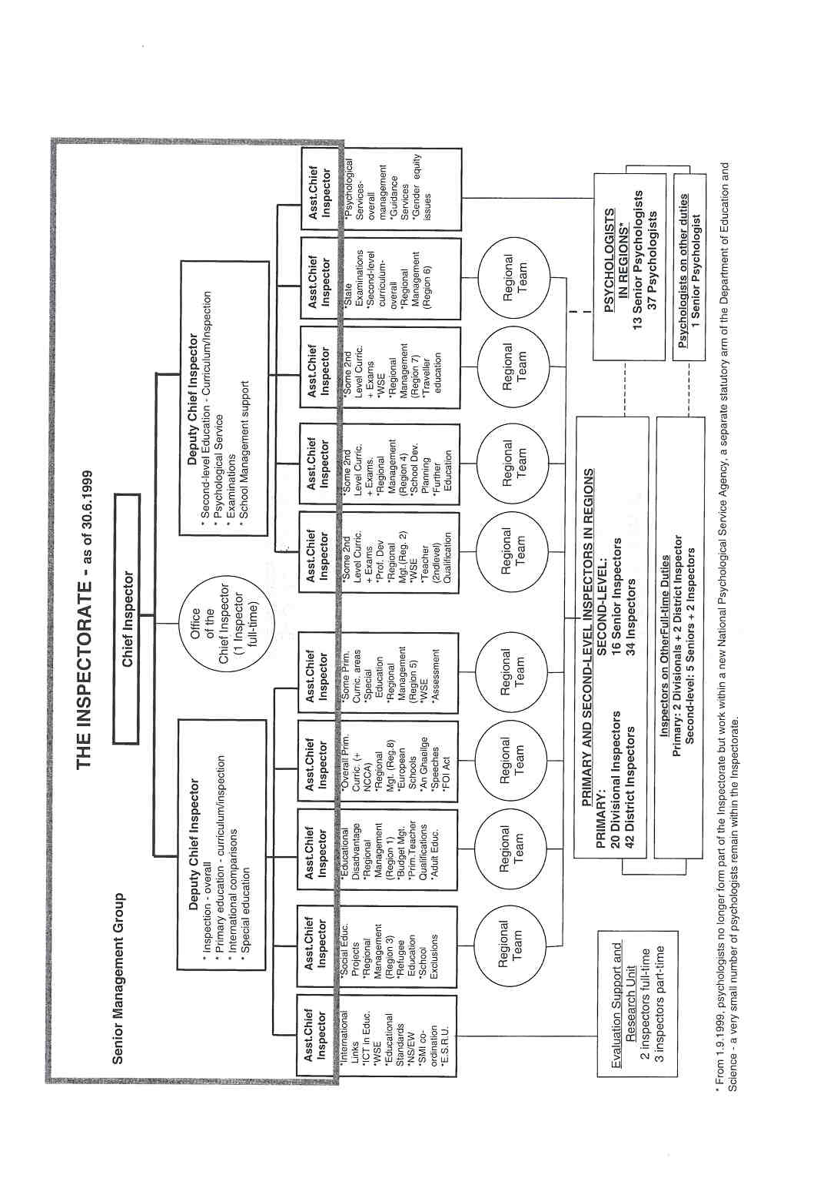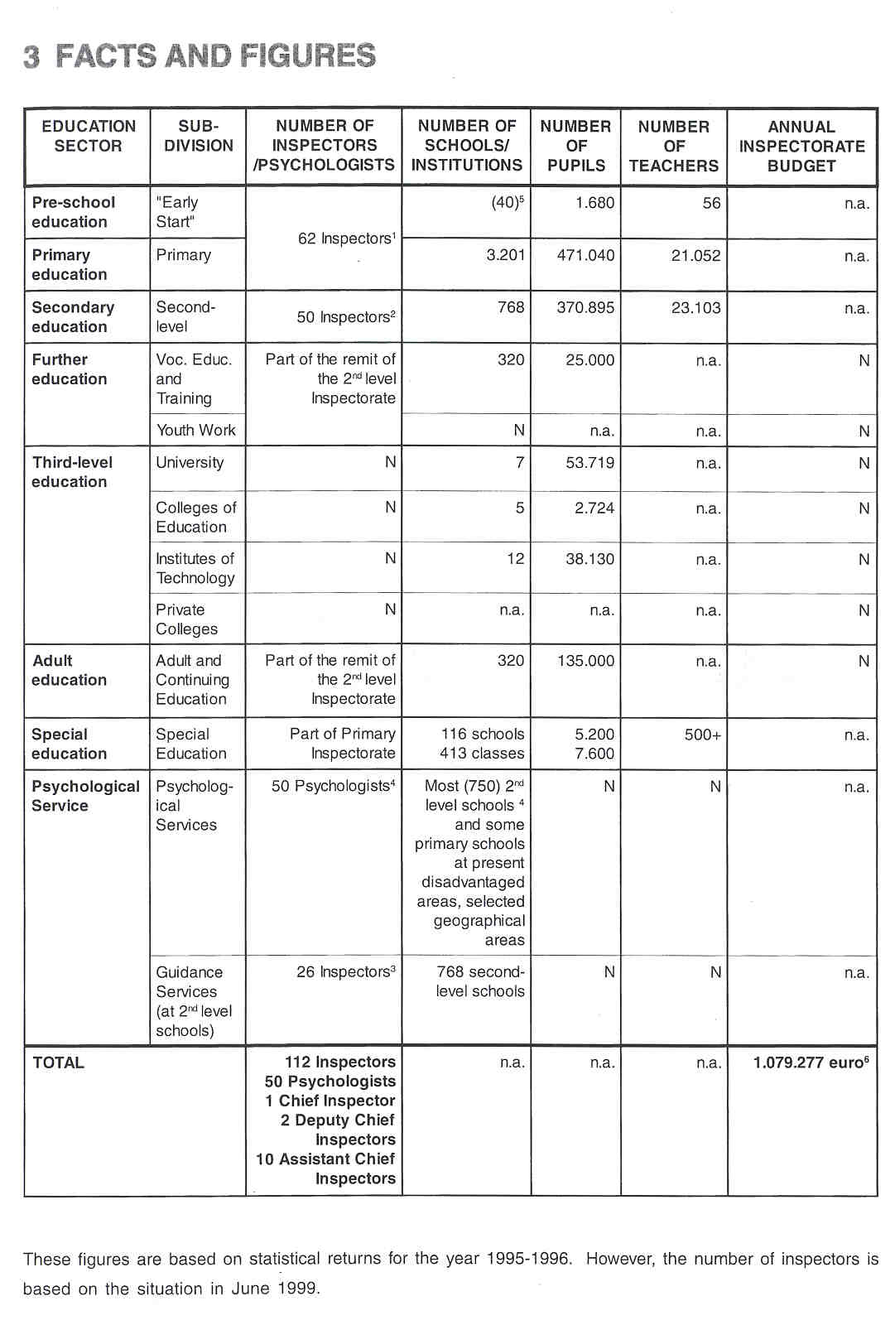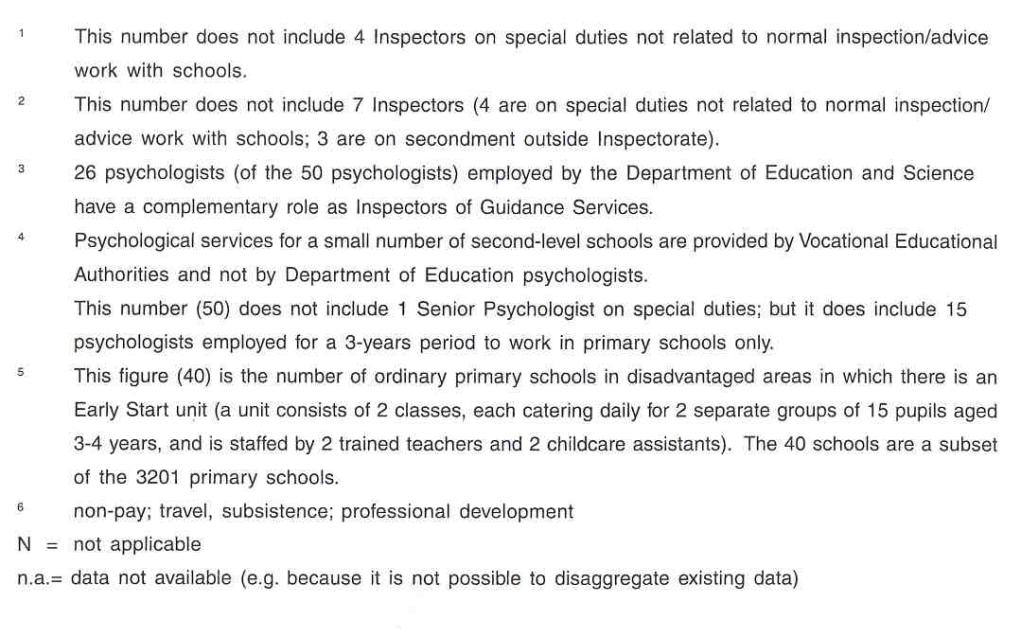

4 THE RECRUITMENT OF THE INSPECTORATE

All candidates need to have a first or second class honours primary degree and a recognised qualification as a teacher. To be eligible for the position of Second-level Inspector a primary degree in the relevant subject discipline is a necessity.

For Primary education Inspectors satisfactory teaching experience in primary education of at least 3 years is required. Second-level Inspectors need at least 3 years satisfactory teaching experience or relevant industrial or research experience.

Candidates for the post of Inspector in the Psychological Service need to hold qualifications as psychologists or need to have other expertise, including expertise in the education of students with special educational needs.

All candidates are required to have a level of competence in Irish and in English which is sufficient to conduct the work through the medium of both languages. Candidates are also required to have a comprehensive knowledge and understanding of the Irish education system together with leadership qualities, good communication and interpersonal skills.

From time to time, experience in specified aspects of education is identified as desirable e.g. Special Education, Early Childhood Education, Information Technology, Further Education etc.

Recruitment of new inspectors is based on one or more interviews held by the Civil Service Commission. Normally a Deputy Chief Inspector andlor Assistant Chief Inspectors are influential members of the selection interviewing board. Finally, Inspectors are appointed by the Minister.

5 THE WORKING CONDITIONS OF THE INSPECTORATE

At present, recruitment to the Inspectorate is on a full-tir-ne basis only. They are recruited as members of the Civil Service, and as such inspectors would be entitled to apply for certain part-time arrangements after a period in post e.g. job-sharing.

Being a member of the Inspectorate is a life-long career until retirement age, because inspectors hold permanent positions within the Civil Service. However, in the Department of Education and Science White Paper on Education "Charting our Education Future" (1995), the concept of secondment of teachers to the Inspectorate on short-term contracts for specific periods was first rnooted. Such secondment has been provided for in the Education Act, 1998. The Minister may, if the teacher and the board consent, second that teacher to the Inspectorate for a certain period, to carry out any or all of the functions conferred on an Inspector. However, this is not yet in practice. From time to time, the Department seconds a small number of specialist teachers on a full-tirne or part-time basis to assist the second-level inspectors in work solely related to State examinations (for example, in setting of papers where there is no inspector specialist in a particular subject due to a current vacancy).

6 AREAS OF INSPECTORATE RESPONSIBILITY

To support the key goals of the Department of Education and Science a set of specific objectives are outlined for each division of the Department, including the Inspectorate. According to the Strategy Statement of the Department (1998) the Inspectorate has the following specific objectives:

- to develop and implement systems for the evaluation of the quality and effectiveness of the education provided in primary and second-level schools;
- to promote the attainment of high standards of learning and teaching, commensurate with the broad range of abilities of all pupils, and of high standards in the management of schools in the primary and second-level sectors;
- to develop, as resources permit, a national educational psychological service;
- to promote high standards of validity and reliability in the conduct of State examinations;
- to provide advice on education policy, issues and needs;
- to monitor and advise on the implementation of special education policy and to evaluate the quality and effectiveness of provision for pupils with special educational needs in the primary and second-level sectors.

The Inspectorate is placed on a statutory footing for the first time under the provisions of the Education Act (1998). This document describes the key functions of the Inspectorate.

6.1 EVALUATING

The evaluation of the quality and effectiveness of the education provided in primary and second-level schools in Ireland is realised through different kinds of assessment, evaluation and inspection.

Full lnspections

According to the new Education Act the Inspectorate has to visit schools and centres for education in order to evaluate their organisation and operation, the quality and effectiveness of the education provided, and the education standards in these institutions.

Currently full inspections, called "School Inspections" are carried out in primary schools only. However, the Inspectorate is in the process of developing, through a pilot project, a new inspection system for schools as a whole called "Whole School Evaluation" (WSE) which will operate at primary and at second-level. The focus of WSE is the quality of planning and preparation, the quality of learning and teaching and the quality of school management. The pilot project is scheduled to be completed by the end of June 1999. Thirty five schools (18 primary and 17 second-level schools) will have been involved in the pilot project.
The final report on the WSE pilot project is almost ready to issue to all concerned parties, after which a new round of consultations with the "partners" (school management authorities, teacher unions, parents' representative organisations etc.) will begin. Mainstreaming of WSE will depend on the outcome of these negotiations and the effect of other initiatives such as support for School Development Planning and some initial promotion of a school self-evaluation culture, both of which are 'lied into" to the concept and strategy of school improvement.

The purpose of School Inspections and WSE is to evaluate the work of the school as a whole and to foster and promote the development of school activities as a whole. It is not intended that the full inspection process will substitute for any process concerned with disciplinary proceedings against a teacher, and the work of individual teachers will not be referred to in a full inspection report.

The evaluation of a school's own assessment of its activities (meta-evaluation) forms a key part of Whole School Evaluation/School Inspection, although formalised school self-evaluation is a relatively new in-school management process in Ireland. The evidence from school self-review, school-based testing and any procedures for quality assurance that operate within the school are significant components in the evaluation of the school's work.

During Whole School Evaiuations/School Inspections, the focus may be on broad curricular areas such as language teaching, the sciences, etc.

Full inspections have been a dominant feature of the work of primary inspectors for many years. Between 350 and 450 of these School Inspections are carried out annually, that is about 12-15% of all primary schools. At present, the planned cycle is that each primary school will be inspected every 6 years.
These School Inspections (at primary level) have the objective of focusing and improving, through advice to management, staff and individual teachers, the quality of school planning, the quality of learning and the quality of school management. This includes evaluating curricular provision at school level.

At second-level, there has been, to date, no extensive system of full school inspection other than visitation required to provide occasional reports on school organisation. Some secondary schools were the focus of organisational inspections up to the mid-80s but this practice had fallen into abeyance. As many aspects of full inspection are new to the education system at second-level, WSE is a very significant culture change for second-level schools and for the inspectors assigned to those schools.

There are many similarities between WSE and the existing full school inspection system for primary schools. The new system has greater formalisation and standardisation of evaluation criteria and a stricter time- scaling. In WSE written evaluation schedules and a report template are introduced, and there are some changes in the consultation with teachers before and after evaluation visits.
The Inspectorate has developed a framework for WSE consisting of 3 Units, divided in 10 "Key Areas", which are further divided in 33 "Evaluation Criteria" (performance criteria). Each "Evaluation Criterion" consists of a number of descriptors.

At primary level, all aspects of the school are reviewed and evaluated in WSE.
At second-level, the pilot exercise focuses on aspects of planning and management and an the quality of learning and teaching in a selected number of specific subjects. At least two subjects from among English, mathematics, home economics and physical education are chosen for each second-level school. In addition, areas such as civic, social and political education, business studies, classical studies, technological studies and German may be evaluated in schools depending on the specialisrns of the Department inspectors involved in the evaluation process. Other subjects will be included in a later phase of the WSE-pilot project.

Subject Evaluations in Second-level Schools

The second-level Inspectorate has no major tradition in full inspection of schools. Instead of evaluating second-level schools as a whole, inspection has concentrated on individual subjects. In subject inspections all the teachers of a particular subject are visited for the purpose of advising the school on the teaching of that subject. However, these inspections do not normally include formal inspections of individual teacher's work. In reports on subject inspections it is normal practice not to identify individual teachers.

Evaluation of lndividual Teachers

Evaluating the quality of teaching and the effectiveness of teachers is one of the key functions of the Irish Inspectorate. Individual teachers are evaluated in order to advise them and to assess them with consequences for their careers. Planning and preparation, teacher's knowledge and delivery of curriculum, learning environment and pupil attainment are particular foci of formal inspection of the work of individual teachers.

At primary level, the work of all probationary (Year 1) teachers is inspected. In addition, regulations provide for the inspection of teachers whose work fails below satisfactory standards or of those teachers who voluntarily request an inspection on their work or of teachers whose school authorities have requested inspection. Teachers who, during incidental visits to schools or during School Inspections (or Whole School Evaluations), are considered in need of advice are also evaluated. In the school-year 1995-1996 there were approximately 350 probationary inspection reports, 9 reports based on requests for inspection and 30 "stage" reports on teachers whose work was deemed unsatisfactory.
At second-level, opportunities for the inspection of individual teacher's work differ according to the type of school. The involvement of inspectors in the probation of teachers at second-level has fallen into abeyance because of other Work demands. There is no formal external inspection process for individual teachers in the secondary or community and comprehensive schools. In these schools probation of new qualified teachers is a matter for the school principal. Even where a complaint against a teacher requires to be investigated by the Inspectorate, visits to the school and meetings with the teacher are mostly concerned with the giving of advice.
Vocational schools, which are under the control of Vocational Education Committees (VECs), operate under the terms of a circular letter relating to the inspection of schools, colleges and courses conducted under VECs and to departmental procedures in connection with adverse reports on teachers employed by VECs which may result from inspections of schools or from investigation of complaints. In other words, in the case of vocational schools the inspections of individual teacher's work often relate to disciplinary issues (e.g. because their work merits an unsatisfactory rating) but may equally include visits to teachers whose work is very satisfactory. There are no data available on the number of "adverse" reports on teachers in VEG schools annually. A formal probationary inspection process for teachers in those schools has fallen in almost total disuse.
However, second-level teacher's work (in all school types) is inspected in the context of subject inspections and the new WSE system. In 1995-1996 the work of 279 teachers was inspected on foot of subject inspections. Individual reports on such teachers are not issued.

Evaluation of Schools'Compliance with Regulations or Rules

As there is very little educational legislation at present, compliance with statutory regulations is a very limited focus for inspection. However, Inspectors do have a function in relation to schools' compliance with non- statutory regulations and rules made by the Minister from time to time, covering areas such as curriculum, teacher competence, time at school. The Education Act states that the Inspectorate is responsible for assessing the implementation of regulations made by the Minister in the schools and centres for education. This type of assessment can be a focus of evaluation of school management policies and practices as a part of a full school inspection, but it mostly occurs as a part of, or as a result of general visitation of schools, or as a part of an investigation resulting from a complaint of some sort to the Department.

Aspect Evaluations

Aspects of the education system are evaluated from time to time:

- At primary level, information for the evaluation of certain provision, such as Remedial Education or trends in teaching of modern languages, is gathered in schools involved in School Inspections.
- Specific curricular programmes at second-level, such as the Transition Year programme (where schools have significant freedom in relation to content and methodology) are evaluated based on a nation-wide sample of schools offering such programmes. These reports have been published.
- As part of nationallinternational surveys of pupil attainment, areas such as English Reading, Mathematics, Science are evaluated.
- Summer schools for primary and second-level pupils who wish to add to their learning of the Irish language, are inspected annually.

.&ssessing the Needs of Individual Students

Inspectors may conduct assessments of the educational needs of students in recognised schools, while the in Psychological Service is responsible for the assessment of the psychological needs of students in these schools.

Evaluation of Special Education Provision

Inspectors of the Psychological Service have. key responsibility for the evaluation of the quality and effectiveness of provision for pupils with special educational needs in the primary and second-level sectors (including the inspection of Guidance Services).

6.2 ADVISING

The Inspectorate has a strong professional advisory relationship with the Minister and with the Department of Education and Science in its decision-making structures. The Chief Inspector is a member of the Top Management Group of the Department. The Inspectorate advises the Minister, the Government and the Department of Education and Science on any matter relating to educational policy and provision, including the curriculum taught in recognised schools, assessment and teaching methods. Moreover, the Inspectorate provides support in the formulation of policy by the Minister. Therefore, Inspectors may conduct research into education.
The Inspectorate also gives advice to the Department on educational issues and needs (e.g. accornodation needs of schools and pupils).
The Psychological Service of the Inspectorate advises the Minister on any matter relating to the provision of psychological services to schools and individual pupils, and on guidance issues at second-level.

The Inspectorate is responsible for advising schools and teachers in relation to educational provision. Inspectors advise and assist teachers, in-school management and management authorities of schools, in respect of the performance of their duties and responsibilities. In the course of general school visitation at both primary and second-level, support for school management is an integral part of the advisory function of inspectors (advice on the implementation of educational policy, on accommodation needs, provision forlplacement of pupils with special needs, curricular planning .... ). However, in relation to in-school management, the Inspectorate has no function in administrative decisions.
Teachers, individually and as staffs, are assisted by the Inspectorate in employing improved methods of teaching and conducting classes. Primary and second-level teachers are advised on foot of full inspections, whether during the existing primary School Inspections or the new Whole School Evaluation (pilot project) visits. Teachers in second-level schools also get advice in the context of subject inspections. While inspectors are visiting teachers in their classrooms and evaluating what is going on there in the context of a full inspection or a subject inspection agenda, issues may arise which might prompt some on the spot, confidential advice for the individual teacher from the inspector. Teachers are also advised during incidental school visits fror.n the local inspector.
Recognised schools with access to psychological services are advised by the Psychological Service on policies and strategies for the education of children with special educational needs. In collaboration with parents, the principal and teachers in recognised schools, the Psychological Service has to assist in the creation of a school environment which prevents or limits obstacles to learning which students may experience.

The Education Act also states that the Inspectorate has to advise parents and parents' associations on matters relating to the provision of education.
Inspectors and Psychologists of the Psychological Service give advice to individual students (in recognised schools), their parents and their schools on the educational and psychological development of these students, based on assessment of their educational needs.

The Inspectorate establishes links to external bodies (e.g. the National Council for Curriculum and Assessment (NCCA), the State Tourist Industry Training Authority (CERT), the National Council for Vocational Awards (NCVA), the National Council for Educational Awards (NCEA) in order to give advice to these partner bodies.

The Inspectorate plays an active role in national developments, such as curriculum developments. The Inspectorate is a partner in all curriculum development activity. The Inspectorate is represented on bodies charged with curriculum development (NCCA) and is liaising with other bodies having a curriculum development role (e.g. curriculum development units attached to Vocational Education Committees; education centres, third-level institutions).

Developing educational materials is not a planned function of the Inspectorate, except insofar as individual Inspectors may advise on such development as part of a broader function (e.g. advising on the development of school programmes on "Substance Misuse", "Relationships and Sexuality Education", working on education subcommittees of local development partnerships etc.).

6.3 MONITORING

One of the key functions of the second-level Inspectorate is the management of State examinations. The Inspectorate has a lead responsibility for major aspects of the State examination system. Inspectors are responsible for the preparation and marking of school examinations as well as for the monitoring and evaluation of the content and standards of these examinations. Promoting high standards of validity and reliability in the conduct of State examinations is one of the key functions of the Irish Inspectorate. This function includes paper-setting and -proofing, standards, selection and monitoring of all examiners, marking schemes, the results appeals process, quality control and reporting on the system and the results to the Minister.

The Inspectorate is also responsible for the management of special projects and special provision, e.g. special provision for children of people with an itinerant occupation, for schools in disadvantaged areas, for children with disabilities, for refugees, the development of new in-school management emphases. The Inspectorate also has to deal with school exclusion cases and is responsible for the placement of pupils with special needs.

The development of a national educationalpsychological service is one of the objectives of the Irish Inspectorate, an objective which is well on the way to fruition (see previous references to the imminent establishment of the National Educational Psychological Service). Until the September 1999 the Inspectorate included the Psychological Service of the Department of Education and Science. This Service, which incorporated the inspection of Guidance Services, was responsible for monitoring and evaluating special education provision, and for monitoring and advising on the implementation of some aspects of special education policy

The Inspectorate has a key involvement in the management of specific input in the area of Information and Communication Technologies in schools.

In-career development courses for teachers are monitored in accordance with set approval criteria.

The Inspectorate has only marginal input into the construction and management of databases on schools and examination results. This work is handled within the administrative wing of the Department.
The construction and management of databases related to school inspectionslevaluations will, in the near future, be a key responsibility and focus for the Inspectorate. For the moment the Inspectorate database is at a very early stage of development. It will, in time, be related to the development of Whole School Evaluation instruments.

Apart from responsibility for the management of its own delegated administrative budget, the Inspectorate does not have any significant budget-financial management function. From time to time, there may be a requirement to deal with, in co-operation with Department administration, financial matters related to specific projects with which it becomes involved e.g. teacher in-career development programmes for individual staffs, tuition schemes for individual pupils.

6.4 REPORTING

The Education Act states that the Inspectorate has to report to the Minister

- on matters relating to the Inspectorate's supportive and advisory activities in recognised schools or centres of education. This means that the Inspectorate has to report on

- the evaluation of the organisation and operation of these schools and centres and the evaluation of the quality and effectiveness of education provided in these schools or centres including the quality of teaching and the effectiveness of the individual teachers,
- the evaluation of education standards in these schools and centres,
- the assessment of the implementation of regulations made by the Minister;

- on any other matter relating to the activities of those schools and centres and the needs of students in those schools and centres;
- on the inspectorate activities concerning the State examination system;
- on the quality and effectiveness of the provision of education in the state, including comparisons with relevant international practice and standards. Until now, that reporting has been -and will continue to be- in different forms and of varying natures. Aspects of the education system are evaluated from time to time (see aspect evaluations) and aggregated state examination results provide indicators of system performance. But, there is, at present, no formal reporting (to the government or the public) on the entire system or of sectors within that system. In other words, existing system-related evaluation is generally programme-driven. However, once the WSE-system is mainstreamed, the Inspectorate will have an instrument that provides high quality data for the purposes of system evaluation (based on full inspection data). Under the Education Act a more public reporting on the system as a whole is newly envisaged. Soon governmental departments will be required to report publicly on their activities on an annual basis and the Inspectorate will have an input, as yet unspecified, into the Annual Report. This has not been done to date, except through the medium of internal annual reports from the Inspectorate to the Minister on the work of the Inspectorate in all its forms, including some commentary on aspects of the system as a whole.

This results in reports on individual teachers, reports on subject inspections in second-level schools, reports on schools (reports on School Inspections/Whole School Evaluations and reports on schools' compliance with regulations and rules), in reports on aspect-evaluations at national level, reports on the Inspectorate, reports on the State examination system, and finally in reports on other Inspectorate work.

6.5 OTHER RESPONSIBILITIES

The Inspectorate is involved in many other activities, such as:

- the verification and validation of teacher qualifications;
- European dimension activities, including inspection of European schools;
- interview boards for the appointment of teachers in communitylcomprehensive schools and in schools under Vocational Education Committees.

Note

In the past there was a significant difference in priorities and activities between the primary and the second- level inspectors. While primary inspectors put most of their time (almost 50%) in formal inspection (full School Inspections, inspections of probationary and unsatisfactory teachers) and other school visits, second- level inspectors spent less than 10% in these activities. Managing the State examinations was the task that took up a lot of the time of second-level inspectors (30-40%), while the time primary inspectors spent an this activity was negligible (about 0.5%).
However, second-level inspectors have been spending significantly more time on formal inspection work due to the advent of Whole School Evaluations in 1998-99.

7 THE ROLE OF THE INSPECTORATE IN EDUCATIONAL POLICY

The Inspectorate has a key function in preparing the policy by advising the Minister and the Department on all policy matters pertaining to education.

As the Chief Inspector is a member of the Top Management Group of the Department, he contributes fully to decision-making at that level.

Through its various field activities and its contact with a wide range of education providers and partner groups, the Inspectorate is in a key position to stimulate the implementation of national education policy.

The Inspectorate places strong emphasis on feeding back to decision-making levels the results of its professional assessment of the effectiveness of various policies.

8 WHO IS IN CHARGE?

The Minister for Education and Science, who is answerable to the national Parliament, has overall responsibility for educational matters. The Minister's administrative agency is the Department of Education and Science, which is headed by the Secretary General of the Department. The Department is divided into 6 main divisions, including the Inspectorate.
Activities such as advice to Minister and Department, State examination work, inspection of probationary teachers and unsatisfactory teachers, evaluation of schools are tasks set for the Inspectorate by the Minister through regulation (in the Education Act).

The Senior Management of the Inspectorate, consisting of the Chief Inspector, the 2 Deputy Chief Inspectors and the 10 Assistant Chief Inspectors, has significant autonomy in deciding on other inspection emphases, some of which will be in line with Governmental and Ministerial policies of the time.

Decisions on the Inspectorate's programme of activities for a certain period are made by the Inspectorate Senior Management taking due account of key policy decisions of the time, the Inspectorate's ongoing school inspection programme and its responsibilities vis-d-vis probationary teachers, the development of new and ongoing initiatives and certain administrative limitations (budget etc.).

The individual Inspector has significant autonomy in managing his work within the demands of the wider programme of activity decided upon and allocated by Senior Management.
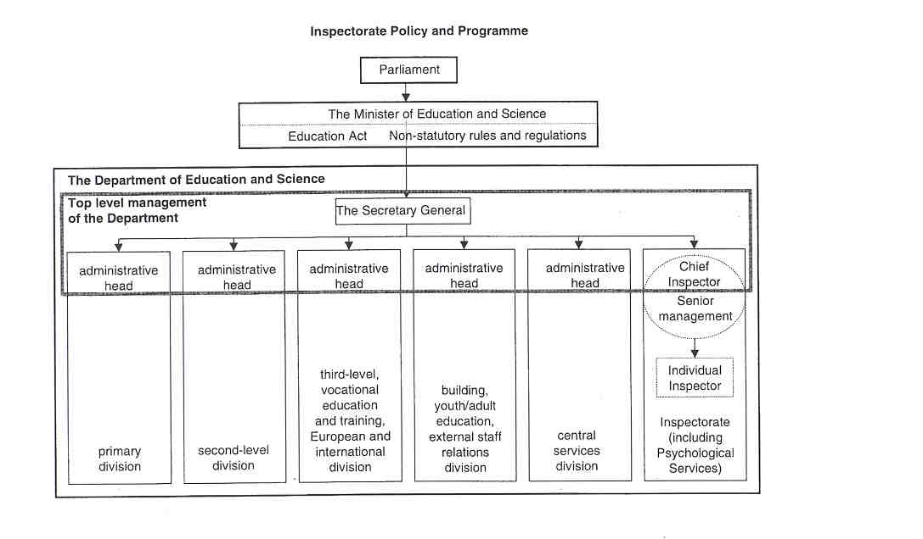

- THE POSITION OF THE INSPECTORATE

The Inspectorate acts as professional advisor to the Minister on all matters relating to educational policy and provision.

The Inspectorate provides professional advice to the various administrative sections of the Department of Education and Science. The Chief Inspector is, along with the administrative heads of the different divisions of the Department (primary, second-level, third-level, central services, external relations etc.), a member of the Top Management Group of the Department.

The Inspectorate represents the Department at various levels within the National Council for Curriculum and Assessment (NCCA), the body charged with curriculum development at first- and second-levels. This body has a statutory basis in the Education Act (1998). The Inspectorate evaluates all documentation emanating from the NCCA and advises the Minister accordingly.
The Inspectorate also represents the Department in dealings with institutions for national assessment and accreditation set up by the Government the NCCA, the National Council for Educational Awards (NCEA), and the National Council for Vocational Awards (NCVA).

In addition, the Inspectorate liaises continually with a variety of other organisations. For example, inspectors have liaisons with

- organisations responsible for issues of educational disadvantage;
- CERT (State Training Agency for Hotels, Catering and Tourism skills) to monitor and develop a national system of assessment and certification for the hotel, catering and tourism industries;
- FAS (the Training and Employment Authority), who has national responsibility for training apprentices (e.g. Youthreach programmes);
- Colleges of Education.

Local Inspectors have a special link with a number of schools in order to support and advise them.

10 THE INSPECTION PROCESS

WHOLE SCHOOL EVALUATIONS/SCHOOL INSPECTIONS

School Inspections and Whole School Evaluation (WSE), are initiated by the Inspectorate as part of an annual programme of inspection. Under the system currently operating at primary level (School Inspections), schools are inspected every 6 years. It is expected that this policy will continue under WSE.
The Inspectorate adopts the following inspection process (the protocol and processes described below are largely in use, with some modification, in the new Whole School Evaluation system):

Preparation Phase

This phase normally takes place within the month preceding the evaluation visits.
In Septernber schools are informed of the intention to carry out a school inspection within the current school- year.

One member of the inspection team is designated as the reporting inspector. The local inspector is always a member of the inspection team. Helshe works with the school on a regular basis as part of normal inspection, support and advice activity The inspection team normally requests updated information on the school in advance of the formal visits, and agrees an inspection time-table with the school (principal, senior staff, management). An initial meeting takes place between the school principal (and the Chief Executive of the Vocational Education Committee in case of a Vocational School) and the reporting inspector.
In addition in the case of primary schools a pre-inspection meeting is held with all staff members. In second- level schools, there will be a general meeting with the whole staff as well as meetings with teachers involved in the areas being evaluated. During these pre-inspection meetings the focus of the inspection is outlined. In the case of both primary and second-level schools a separate meeting will be held with representatives of the Board of Management (including parents' representatives) or with the Manager. Provision will be made also for a meeting between a representative of patrons, trustees, owners or governors and the reporting inspector. During these meetings the School Inspection/WSE-process is fully clarified. The aim is to set out clearly the purpose and procedures and to allay any anxieties, misgivings or fears that participants may have.

School Phase

The length of this phase is related solely to the size of the school, the number of inspectors involved andlor the range of aspects being evaluated - from 1 day to 2 weeks.
Inspectors who focus on aspects of planning and management arrange to discuss these aspects of school life with the relevant personnel. Documentation relating to school planning and management is examined and discussed.
The Inspector spends time in the school on formal classroom visits and meetings (average time spent with each teacher at primary level is 0.5 days and at second-level, time spent will depend on the size of departments etc.). During classroom visits the quality of learning as well as the quality of teaching is inspected, in a spirit of positive reinforcement. When the inspection visit is completed oral feedback and advice is given privately to each teacher in a supportive and constructive way.
In carrying out their work, Inspectors take all relevant school context factors into account.

Reporting Phase

The reporting phase normally is finished within the month after the evaluation visits but takes no longer than 6 weeks.
Every school inspection ends with post-inspection meetings. Shortly after the evaluation has been completed, these meetings are arranged between the reporting inspector (or the inspection team) and the principal (and the Chief Executive in case of a Vocational School), relevant staff members andlor with the whole school staff as appropriate. Provision is also made for a meeting between a representative of patrons, trustees, owners or governors and the reporting inspector or the inspection team.
During these post-inspection meetings the work of the school is discussed and the findings of the evaluation are outlined. Strengths and weaknesses are discussed and recommendations regarding further development are put forward. This provides an opportunity for staff to engage in discussion with the inspectors) on the inspection outcomes, leading to an agreed agenda for future action.
A separate meeting is held with representatives of the Board of Management (including the parents' representatives) at which the findings of the evaluation are outlined.

Within 6 weeks of the post-evaluation meeting, a report is sent to the school principal and the staff, to the chairperson of the management authority and to trustees of the school. All aspects of the report have been discussed previously at the post-evaluation meetings. The Department of Education and Science also receives a written report from the inspection tearn shortly after the end of the inspection. This report is not published.

The protocol and processes described above are largely in use, with some modification, in the new Whole School Evaluation system.

SUBJECT INSPECTIONS IN SECOND-LEVEL SCHOOLS

An individual Inspector specialising in a particular subject area will, on occasion, visit all teachers of that subject in a school, talk to classes, discuss matters with teachers, individually and in groups, but may not see teachers actually teach (it has, to date, been a trade union position in some types of schools that teachers do not agree to teach before an inspector and this stance is adopted in some schools of this type).
These inspections are usually initiated by the Inspector, but may result from a request by a school for such a visit. Due to the enormous pressures on second-level inspectors in relation to State examination work, these inspections are random (there are no specific procedures and timing for this kind of inspections).
Schools and teachers are informed about the planned inspection. Any pre-inspection information required is gathered informally beforehand. The outcomes of the inspection are discussed with relevant staff afterwards.

PROBATIONARY TEACHERS

The inspection system for probationary teachers requires Inspectors to pay a number of advisory visits to the teacher (some visits are announced, some are unannounced) over a period of 1 year from date of appointment (the probationary year).
The primary Inspector has to write 2 reports: the first of which (at half-year) informs the Department of the progress being made during the teacher's probation, and the second report (at the end of the probationary year) gives the Inspector's evaluation of the teacher's pedagogic skills and abilities. This latter report is provided to the teacher, to the school and to the Department. It is the basis on which probation is deemed to have been completed successfully or otherwise. In the case of failure, the probationary period is extended and further advice and inspection takes place. In exceptional individual cases of failure to achieve satisfactory status, a number of further opportunities may be allowed. Ultimately, failure results in withdrawal of recognition.

The system for VEC schools differs from the primary system outlined above in the fact that only 1 report is normally required (instead of 2).

OTHER INDIVIDUALTEACHERS

Not only probationary teachers are the object of inspection but also probated teachers whose work has fallen below a satisfactory standard, as established normally during incidental, unannounced visits over an extended period where such a fall in standard is indicated, or as a result of visits during full-school inspections. Furthermore, in some cases teachers voluntarily request inspection of their work (where they require up-to- date inspection reports for promotional purposes, for example) or the school authorities ask for an evaluation of certain teachers (where, for example, school management is unhappy with a teacher's performance or where there is a complaint from parents).
Depending on the regulatory procedure involved, teachers may, or may not, receive advance notice of the visits.
in the case of requests for inspection, the process involves one visit on a single day and only one report issues.
In the case of poorly performing teachers, because each visit is designed to allow the teacher to achieve a satisfactory rating, the length of this process will vary from case to case - the entire process could last up to 2 years. A number of interim reports may be prepared for the Department and a single report is provided for the teacher and the school at the end of the process - this may be a satisfactory or unsatisfactory report. In the case of an unsatisfactory report, an appeal system exists. The final outcome of an unsatisfactory rating may be withdrawal of recognition from the teacher.

INSPECTION OF SCHOOLS' COMPLIANCE WITH REGULATIONS AND RULES

Normally, inspectors monitor, rather than inspect, schools' compliance with regulations and rules informally during incidental visits and will bring any infraction to the attention of school management on the spot. Occasionally, as a result of a complaint to the Department, an inspector will be requested to formally investigate a breach of rules and will report in writing on the outcome, recommending appropriate action. This may or may not involve formal notification of a visit. This work invariably involves one inspector only. The nature and process of investigation depends on the specific infringement involved. Where action is recommended by the inspector, the Department communicates with school management on the matter and the inspector will monitor compliance with any directive.

- INSTRUMENTS AND METHODS

To assist them in their evaluation tasks a range of inspection methods and instruments are devised. The methods and approaches to collect and interpret the necessary information are different for the different kinds of inspection.

THE COLLECTION OF INFORMATION

Inspectors use a range of methods to collect the necessary information, which include questionnaires, interviews, observations, testslexaminations of pupils, the collection of documents and the use of national data.

a. Questionnaires

There is no standardised questionnaire in use for school inspection or teacher inspection purposes at present. Individual inspectors or inspection teams may devise their own such instruments as they see fit.
Questionnaires are used in evaluations of specific provision or projects, e.g. interventions focused upon schools catering for disadvantaged communities, alternative Senior Cycle programmes (such as the Leaving Certificate Applied), the implementation of the Relationships and Sexuality programme in schools. These questionnaires would be distributed to principals, staff, parents and management.

b. Interviews

During pre-evaluation and post-evaluation meetings in School Inspections/WSE a number of people are interviewed by the reporting inspector or the inspection tearn. The meetings held with Principal Teachers are about in-school management matters. Department heads and groups of subject teachers are interviewed about the curriculum, programmes, methods, and resources. The meetings with whole staffs deal with general findings and matters of whole-school policy and practice. And finally, in the interviews held with boards of management, trustees, or governors of schools information is gathered on broader management issues.
Pupils are not interviewed per se, but there is significant interaction between Inspector and pupils or students in the course of classroom visitation.
Parents are consulted only in their representative role as members of Boards of Management.

Where inspectors interact with individual teachers (whether as part of probationary visits, or during subject inspections, or during full inspections) they avail of the interaction period to discuss the work of the individual teacher as appropriate. Formal interviews are not used.

In inspecting schools' compliance with regulations, it is with the school principal andlor the Chairperson of the Board of Management that inspectors interact. The topics that are discussed would include time-tabling, enrolment policy, discipline policy, teacher discipline, expenditure of grant-aid, etc.

c. Observations

Observation of the teaching and learning situation is a key element of the evaluative function of the Inspectorate and takes place during classroom visits as part of full inspections, inspection of the work of probationary teachers, and during visits relating to complaints against teachers. However, in carrying out subject inspections in second-level schools, inspectors must operate within an environment which encompasses a teacher union policy that teachers may refuse to teach in front of an inspector. Observation is not a practice normally associated with the evaluation of schools' compliance with regulations.
In School Inspections/WSE management style and methodologies are observed and evaluated during discussions with management personnel. School ethos and philosophy is observed and evaluated in the overall activity of the inspection within the school over the period of the inspection. Formal observation of staff meetings, however, is not a feature of inspection.

d. Tests/examinations

Inspectors interact with and examine pupils or students in classrooms as a key element of their evaluative function as part of full inspections, in subject inspections, and in evaluating the work of individual teachers. It does not apply in relation to schools' compliance with regulations.
Inspectors may apply their own evaluative instruments (tests etc.) as they see fit. They also may engage with a class in a variety of ways including: asking questions, giving a short written assignment, listening to oral reports of work completed or checking a sample of copies.

The results of school-based formative and summative, norm-referenced and criterion-referenced pupil testing are important aspects of inspectionlevaluation evidence and information. However, the results of State examinations are not used as evidence in school inspections.

c. The Collection of Documents

Occasionally documentary evidence will form part of the evidence base in inspectors' evaluations. Progress records (pupil attainment, work covered), test results and examples of pupils' work/portfolios etc. are used as a basis for evaluative commentary. Teachers' individual planning notes, and documents concerning communications with parents, school management, and the Department of Education and Science are also analysed. Of particular and growing interest will be the school development plans (including school policy documents and documents about school self-review). Documentation relating to school planning and management is examined and discussed with the relevant personnel.
In the case of subject inspections, documentation might include teachers' lesson notes, textbooks chosen by the school, pupils' written work.
In the case of schools' compliance with regulations, documents might include policy statements, written communications with parents etc.
In evaluating the work of individual teachers, their preparation notes, progress/pupil records and pupils' written work would be the documentation examined.

f. The use of National Data

Nationally standardised tests (norm- and criterion-referenced) are used for comparability purposes in national surveys e.g. of reading or mathematical standards at primary level. The State examination system applies at second-level.

APPROACHES

a. Instruments and/or Evaluation Criteria

There is no uniform instrument for subject inspections, for the inspection of school's compliance with regulations, nor for the inspection of teachers. However, there are a number of evaluation criteria for the formal inspection of the work of teachers.

Instrument and evaluation criteria for full ftwwtions

The Inspectorate has developed an instrument for full inspections. This instrument is designed to ensure that evaluation is reliable and valid and reflects fairly the work of the school. It also has to enhance the inspection process and ensure a consistent approach throughout the system.
It is a new instrument, used in a pilot exercise. It is never before applied. However, the differences between this new system and the current primary School Inspections are minimal (the evaluation criteria of School Inspections are less formalised and standardised).

In the framework 3 aspects of schools have been identified and are referred to as Units of school quality: "teaching and learning", "school planning" and "in-school management". Each of these Units is further divided into a number of Key Areas. WSE (and School Inspections but in a less structured format) cover all these Units and Key Areas:
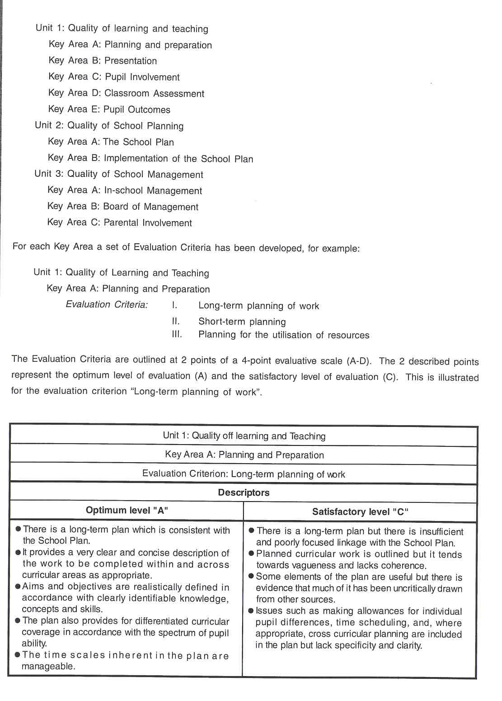

All Inspectors apply these criteria to their observations, they give a score to each criterion, and are required to make a summary evaluation per Unit, thus forming the basis for the final written report.

School context factors including for example, accommodation and facilities, socioeconomic circumstances and school enrolment policy, are an important consideration for those evaluating the school's work and are taken into account in WSE.

Evaluation criteria for Inspecting the work of lndividual teachers

During formal inspection of individual teachers' work, the focus of evaluation criteria is on preparation and planning, match between pupil's needs and teaching input, learning environment and classroom organisation, teacher's knowledge of curriculum, syllabus or programme, the overall quality of teaching and learning and pupil attainment.

b. Teamwork In Full Inspections

The size of an inspection team will depend on the size and complexity of the school being inspected. In primary schools, a team will invariably consist of the local inspector and his immediate superior - for very large schools, a third inspector, usually from the same division, will be used. Primary inspectors each inspect all aspects of the curriculum. The inspection of a school will involve the allocation of different classes to each inspector with post-inspection consultation to collate and standardise evaluations.
In second-level schools the team consists of a specialist for each of the subjects or subject areas being evaluated and a number of inspectors to evaluate planning and management issues specifically. A team normally consists of 6 inspectors. In the case of large schools, arrangements are made to ensure that the process is carried out with a minimum of disruption to the activities of the school.

c. Liaison between the School and the Local Inspector

In the case of primary schools the term "local inspector" refers to the District Inspector or the Divisional Inspector. In order to support and advise schools and teachers, the local inspector has a special liaison with a number of primary schools.
In second-level schools the term means the inspector who has been assigned a particular role regarding liaison with the school in relation to a range of matters such as Ministerial visits, school tours, etc.

The local inspector is responsible for the evaluation of the work of individual (probationary) teachers in the primary or second-level schools (this only applies to second-level schools conducted under Vocational Education Committees; the inspection of individual teachers does not apply in other second-level schools) assigned to him/her. In this case the inspector operates individually. The local inspector is also responsible for inspecting school's compliance with regulations and rules.

d. Random Sampling In Aspect Evaluations

For the purpose of participating in national or international surveys - e.g. the 1998 National Reading Survey (primary), the upcoming PISA survey in mathematics, science and English (second level) - the Inspectorate makes use of random samples of schools or classes.

12 JUDGEMENT AND ITS CONSEQUENCES

SCHOOL INSPECTIONMHOLE SCHOOL EVALUATION

The consequences of judgements of a School Inspection are reflected in a series of recommendations for future action by in-school management andlor by the school authorities in order to facilitate and encourage the school in its pursuit of quality. These recommendations are discussed and agreed with the relevant groups (staff, Board of Management) prior to the issuing of the report to the school.
Where a school is considered to have serious deficiencies, the responsibility for addressing such problems lies with the principal and his in-school management tearn. Support will be provided by the Inspectorate and clear lines of action are outlined to school management for the remediation of the deficiencies e.g. better planning, in-service education etc.

In the case of Whole School Evaluation, a set of recommendations is prepared as part of the final report for the school (Principal, management team, staff, school authorities). A single overall rating is not applied to the work of the school as a whole. Although the written report is based on scores to the evaluation criteria of the Key Areas and Units, these scores are not incorporated in the school report.
The result of a Whole School Evaluation is not related to the continuance or otherwise of Departmental support for a school. For the individual school the WSE Report has as its primary objective the maintenance and development of the quality of education in that school. The assurance of quality within the education system as a whole is a further goal of such inspection activity.

The results of WSE/School Inspections are not used to compare schools or to construct league tables.

SUBJECT INSPECTION IN SECOND-LEVEL SCHOOLS

As subject inspections are not formalised and are more developmental than evaluative in nature, any judgements made by inspectors would be related to the advice and assistance they may consider giving as a result of their observations during such visits. They are considered to be more effective and necessary in the case of subjects where there is no defined syllabus or examination e.g. physical education, but which schools are required to provide as part of the school curriculum.

INSPECTION OF THE WORK OF INDIVIDUAL TEACHERS

In the case of inspections of the work of individual teachers, possible judgements are "satisfactory" or "unsatisfactory". "Unsatisfactory" ratings are extremely rare.

In the case of individual teachers at primary level, a "satisfactory" rating allows a teacher to continue in service. An "unsatisfactory" rating requires, by regulation, that further periods of advice and support be allowed prior to re-inspection. Where it has not been possible for a teacher to improve performance within a specified period, recognition and salary is withdrawn by the Department of Education and Science, on behalf of the Minister, on the recommendation of the Inspectorate. As it is school management authorities which employ teachers recognised by the Department, a school authority would then be obliged to terminate a teac eployment in such an instance. A teacher may appeal an "unsatisfactory" report and specific teacher's em

regulations are set down for such an eventuality.

In the case of second-level teachers employed by Vocational Education Committees, a similar process of inspection, re-inspection and appeal exists, with the major difference that action in respect of a teacher failing to achieve a satisfactory rating is at the discretion of the Minister under the terms of the Vocational Education Acts.

11 INSPECTION OF SCHOOL’S COMPLIANCE WITH REGULATIONS AND RULES

There is no collation of data on the outcomes of inspector's interaction with schools in the area of compliance with regulations. Each case is handled on an ad hoe basis. The judgements would simply define whether or not there was compliance. While non-compliance is invariably overcome through agreement by the school authorities, in extreme cases (which are very rare) consequences of noncompliance could involve withdrawal of grants, withdrawal of salary (in the case of individual teachers), or fines.

13 OUTCOMES

As the Irish Inspectorate has a variety of tasks, set by the Education Act, different kinds of reports are written, reflecting the wide range of inspectorate responsibilities and activities.

REPORTS ON INDIVIDUAL TEACHERS

Inspectors write reports on their evaluation of the quality of teaching and the effectiveness of probationary teachers, of probated teachers whose work has fallen below a satisfactory standard, of teachers who voluntarily request inspection of their work and of teachers whose school authorities have requested inspection of their work.
Reports on findings and advice given in relation to inspection of individual teachers' work as part of the probationary process and where unsatisfactory teaching has been found to exist, have to be submitted to the Department of Education and Science. These confidential reports, which give the Inspector's evaluation of the teacher's pedagogic skills and abilities, are also provided to the evaluated teacher and his school.

REPORTS ON SUBJECT INSPECTIONS IN SECOND-LEVEL SCHOOLS

In the case of subject inspections there is no reporting system or structure.

REPORTS ON SCHOOLS

Reports on School lns~ioneJWhoie School Evaluations

Whole School Evaluation/School Inspection reports refer to the quality of learning and teaching, management and planning. The report doesn't contain any reference to specific ratings nor does it make comparisons between schools. The focus of the report is the work of the whole school and not the work of individuals. Identification of individual teachers in school reports is expressly forbidden. The report has to affirm positive elements of the school's work and has to suggest lines for further curricular, managerial and organisational development. These reports also contain commentary on subject areas and broad curricular areas evaluated. As all aspects of the report have been discussed previously at the post-evaluation meetings, the report may not contain any surprises.
Whole School Evaluation/School Inspection reports are lodged with the Department of Education and Science which then issues copies to the relevant school authority and to the principallstaff of the school. These reports are confidential. Moreover, data gathered during full inspections will not be used to compare schools locally or nationally or to construct any form of national league table.
Inspectors also pay general advisory visits to schools for which they are contact inspectors (local inspectors). These visits do not, at present, require reports to follow.

Reports on Schools'Compliance with Regulations and Rules

The Inspectorate reports confidentially to the relevant administrative sections of the Department on breaches of regulations and rules or on non-compliance with regulations and rules.

REPORTS ON ASPECT EVALUATIONS AT NATIONAL LEVEL

Inspectorate's reports on specific curricular programmes (e.g. reports on specific second-level programmes such as the Transition Year) have been published. These reports are dissiminated to schools and they are available to the wider public by request.
The Inspectorate contributes to, but does not publish independently, reports resulting from national and international surveys on pupil outcomes in certain areas of learning e.g. English reading, mathematics, science.

REPORTS ON THE INSPECTORATE

Soon governmental departments will be required to report publicly on their activities on an annual basis and the Inspectorate will have an input, as yet unspecified, into the Annual Report of the Department of Education and Science.

REPORTS ON THE STATE EXAMINATION SYSTEM

Inspectors, in their role as Chief Examiners, prepare reports on the operation of the state examination system for selected subject areas on a rota basis. These reports are addressed to the Minister, but are published, on a cyclical basis, to schools. These reports provide an indicator of the education system performance. The reports give a statistical analysis of answer patterns, for example, and point up aspects of answering techniques which might reflect teaching and learning styles and practices which require to be re-evaluated by schools - in that way, these reports are also useful in-service aids for teachers.

REPORTS ON OTHER INSPECTORATE WORK

The Inspectorate reports confidentially to sections of the administration of the Department of Education and Science on a number of matters e.g. on school accommodation, special education placement issues, school attendance problems etc.. These reports automatically include any advice given in the circumstances.

14 FOLLOW-UP PROCEDURES

HOOL INSPECTIONAYHOLE SCHOOL EVALUATION

In the course of incidental visits to schools for which they are contact inspectors, Inspectorate staff monitor progress on recommendations made during Whole School Evaluations/School Inspections and offer ongoing advice and support.
Follow-up inspections are not separate from the normal rota of school inspections. A school may expect to be re-inspected within a period of 6 or 7 years and this next inspection will focus on recommendations specified in previous inspection reports and the progress made in implementing those recommendations in @the interim.

INSPECTION OF SCHOOL:S COMPLIANCEWITH REGULATIONS AND RULES

The follow-up procedure of the inspection of school's compliance with regulations and rules would involve establishing, after a reasonable period allowed to the school or teacher for compliance, that compliance had actually taken place.

SUBJECT INSPECTIONS IN SECOND-LEVEL SCHOOLS

There is no formal structure for subject inspections which, on balance, are generally more developmental than evaluative in nature and in practice. The follow-up of subject inspections involves discussion with the school principal and the relevant staff team and future subject inspections, whenever undertaken.

INDIVIDUAL TEACHERS

In the case of individual teachers, those achieving satisfactory ratings are not normally inspected again except where their performance is deemed to be failing/have fallen below this rating or where they request an inspection of their work. Teachers rated unsatisfactory are re-inspected after a further period of advice and support.

15 INSPECTORS AS ARBITRATORS

Although parents have the opportunity to approach the Inspectorate with complaints about teachers or schools, they rarely make use of this possibility. Most complaints are made directly to teachers, principals or school authorities. The normal procedure, when approached with a complaint (written or oral) is to refer the complaint to the administration of the Department of Education and Science which will then follow a standard procedure for dealing with any complaints received directly. This procedure includes referral of the complaint to school authorities for internal investigation and comment, request to the Inspectorate to investigate and interview the complainant, where necessary, and formal judgement on the complaint. In most cases, the school authorities are able to bring a complaint to a successful conclusion without the involvement of the Inspectorate.

There is no formal structure for involving the Inspectorate, as a matter of course, in complaints by teachers against principals or school authorities. Complaints by teachers against superiors are handled through a complaints procedure agreed between teacher unions, management representative bodies and the Department. Inspectors may be requested by the Department to investigate and report on matters related to such cases.

While there is no formal mechanism or requirement for inspectors to act as arbitrators in disputes, individual inspectors do, occasionally, act in such a manner, largely in informal rather than formal settings.

16 THE INSPECTORATE AS AN ACTOR IN PUBLIC DEBATE

The Inspectorate is an actor in public debate on education and education policy, but not independently of the Department of Education and Science. Inspectors represent the Minister and the Department in delivering addresses to conferences, in media interviews, in any Inspectorate publications.

17 THE EVALUATION OF THE INSPECTORATE

EXTERNAL

There is no formal or regular external evaluation of the Inspectorate. However, the Department of Education and Science or other Departments have commissioned studies of the Inspectorate within broader strategic management functions. As with any other branch of the civil and public service, the organisation and management, efficiency and effectiveness of the Inspectorate is open to evaluation and review by appropriate government agencies.

INTERNAL

There is, of course, as part of normal management practice, regular internal review of policies, procedures and practice with a view to ensuring the efficiency and effectiveness of the Inspectorate in carrying out its remit and functions. The Deputy Chief Inspectors and the Assistant Chief Inspectors are responsible for the performance appraisal within the Inspectorate.

ADAPTATIONS ARISING FROM EVALUATION AND EDUCATIONAL POLICY

Methods and functions of the Inspectorate are adapted in response to both internal and external review. For example, an external review questioned the fragmented nature of Inspectorate management and services. As a result, significant progress has been made in integrating the Senior Management of the Inspectorate and the delivery of various services.

In response to developments in educational policy, adjustments are made to the Inspectorate's work. As an example, "the partnership ethos", upon which all relationships between the Minister, the Department and the relevant stakeholders in education are now based, has permeated the work of the Inspectorate in developing more effective and mutually acceptable methods of micro- and macro-evaluation of the education system.

18 THE INSPECTORATE'S INITIAL TRAINING AND IN- SERVICE TRAINING

TRAINING OF NEW INSPECTORATE MEMBERS

An Assistant Chief Inspector has specific responsibility, under the general direction of the Chief Inspector and Senior Management, for developing an introduction programme for newly-appointed inspectors. This programme involves familiarisation and orientation activity within the Inspectorate and within the broader administrative area of the Department and supervised work-shadowing and mentoring. The probationary period is 1 year, which includes the training period of up to 9 months.

PROFESSIONAL DEVELOPMENT OF ALL INSPECTORS

In-house and external facilitation is used in developing professional development for the Inspectorate. An Assistant Chief Inspector is responsible for managing on-going programmes of professional development. Areas addressed include a.o. IT familiarity, time management, interpersonal skills, stress management, change management, report-writing. Inspectors are supported by the Department in pursuing personal development initiatives related to their work.

19 RECENT OR FUTURE ISSUES AND DEVELOPMENTS

RECENT

- Development and piloting of the Whole School Evaluation model of school inspection (1998+).
- Improving the quality and transparency of the State examination system (e.g. candidates permitted to view corrected scripts) (1998+) and more frequent reports on examinations on a 3-year cyclical basis.
- The placing of the Inspectorate and its functions on a statutory footing as part of the Education Act, 1 998.
- Integration of Inspectorate services; restructuring of management through regionalisation (1 99711998).
- Professional development.
- Recruitment of 22 new colleagues (1 99811999).
- Co-operation with other lnspectorates on projects, exchanges etc. (on-going) - especially between the north and south of Ireland.
- IT development (hardware, software applications) for the Inspectorate.

FUTURE

- The advent of the Freedom of Information Act, 1997 which came into effect in April 1998, will have ramifications for the reporting function of the Inspectorate.
- In the context of relationships with Northern Ireland, further contacts and co-operative ventures between the Inspectorate and its counterparts in the Department for Education of Northern Ireland will be of great significance.
- The ability of the Inspectorate to report on system-wide issues and topics will be enhanced by the development of a formalised audit ethos supported by effective data-gathering and data-processing associated with its formal inspection instruments within the context of WSE.
- The restructuring of Psychological Services within an independent statutory body (the National Educational Psychological Agency) under the aegis of the Department of Education and Science. This will have significant implications for psychologists currently functioning within the Inspectorate. The Psychological Service will no longer be a part of the Inspectorate, although a small number of individual psychologists will be retained within the Inspectorate.

20 LITERATURE

DEPARTMENT OF EDUCATION, Statistical Report 1995196. Dublin, Department of Education, Statistics Section, 1997, XVI-124 pp.

DEPARTMENT OF EDUCATION, White Paper. Charting Our Education Future, Dublin, The Stationery Office, 1995, 235 pp

DEPARTMENT OF EDUCATION AND SCIENCE, Brief Description of the Irish Education System. Dublin, Communications Unit, Department of Education and Science, 1998, 40 pp.

DEPARTMENT OF EDUCATION AND SCIENCE, Strategy Statement. Implementation of the Public Service Management Act, 1997. Dublin, Department of Education and Science, 1998, 32 pp.

DEPARTMENT OF EDUCATION AND SCIENCE, Whole School Evaluation, Draft Evaluation Criteria. Dublin, The Irish Inspectorate, Department of Education and Science, 1998, 21 pp.

DEPARTMENT OF EDUCATION AND SCIENCE, Whole School Evaluation, Pilot Project Proposals. Dublin, The Irish Inspectorate, Department of Education and Science, s.d., 14 pp.

EURYDICE, The education system in Ireland (1998). Eurydice Eurybase, 1999, http:llwww.eurydice.org/ Eurybase/Files/IEVOI

GOVERNMENT OF IRELAND, Department of Education and Science. Dublin, Government of Ireland and the Department of Education and Science, s.d., http:llwww.irigov.ieledue

GOVERNMENT OF IRELAND, Education Act, 1998. Dublin, The Stationery Office, 1998, 46 pp.

HOPES, C., Assessing, evaluating and assuring quality in schools in the European Union. Frankfurt am Main, Geselischaft zur F6rderung PAdagogischer Forschung (GFPF), Deutsches lnstitut fOr lnternationale P5dagogische Forschung (DIPF), 1997, XVII + 211 pp.

MAC GLEANNAIN, S., & MAC IONRAIC, S., Ireland. - In: C. HOPES (Ed.), School inspectorates in the member states of the European Community. Frankfurt am Main, Deutsches lnstitut f@r lnternationale PAdagogisch Forschung, Abteilung Recht und Verwaltung, 1991, 92 pp.

OFFICE OF THE CHIEF INSPECTOR, Inspectorate. Dublin, Office of the Chief Inspector, 1998, 9 pp.
