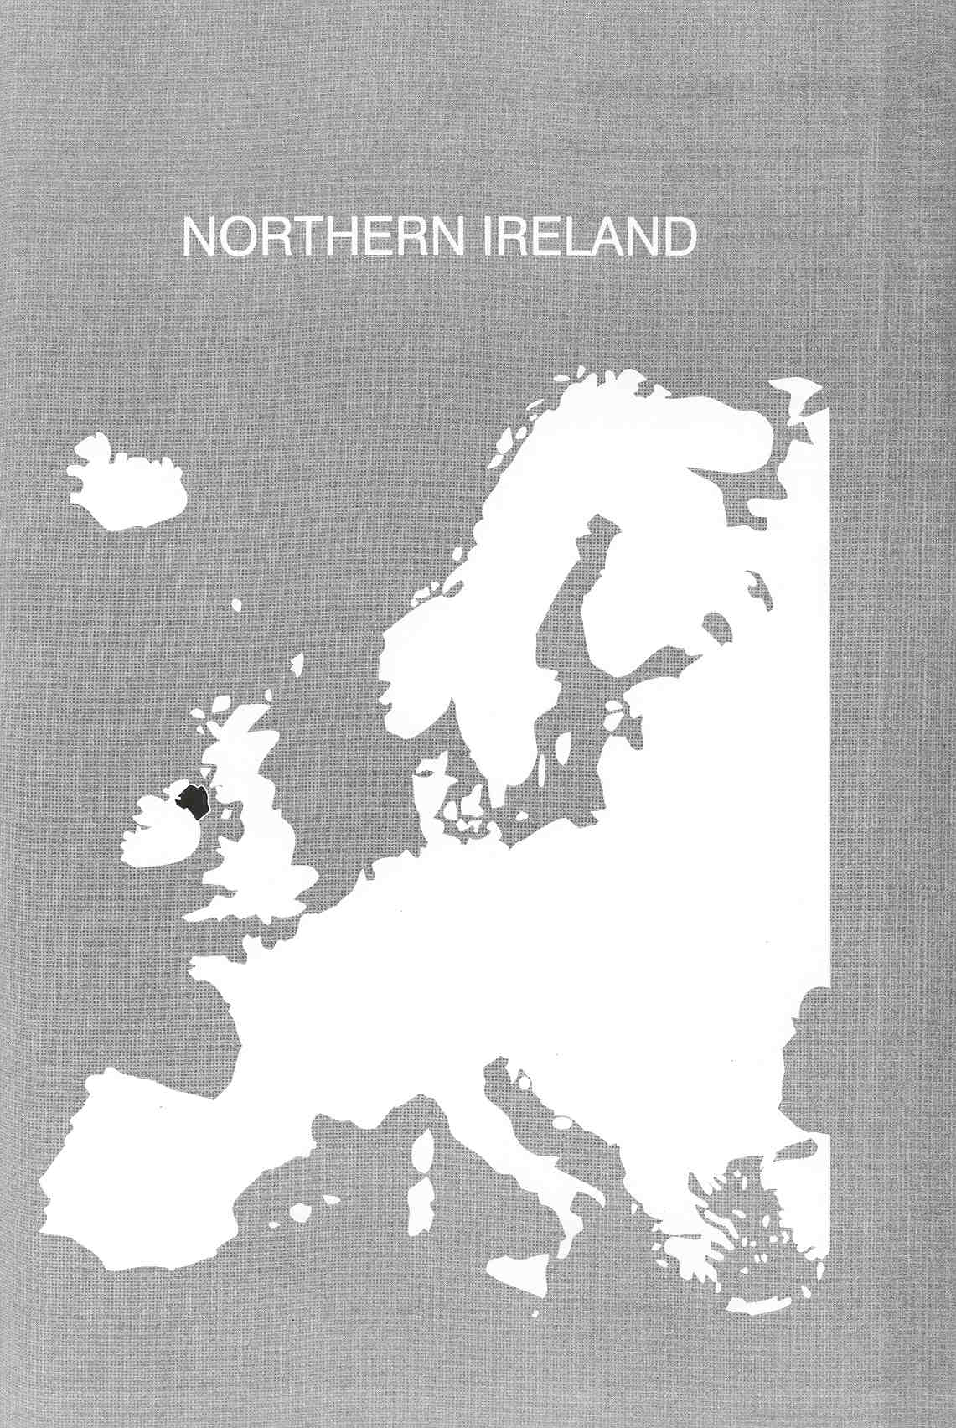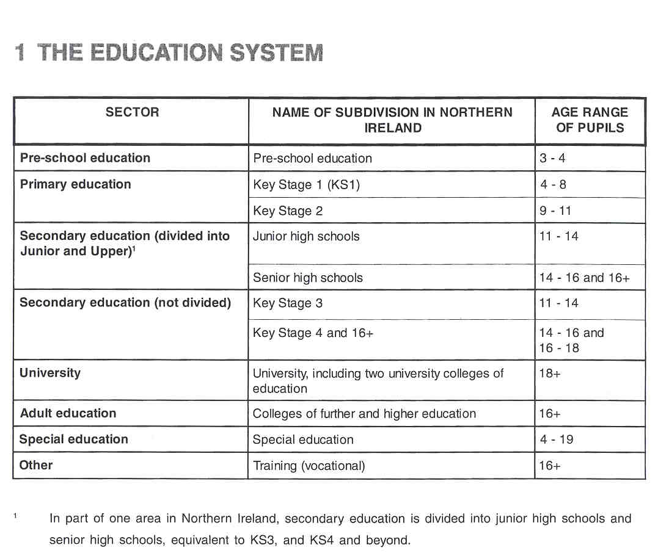
Νίκος Ηλιάδης, Πολ/κός Μηχ/κός Ε.Μ.Π., M.Sc.,
Ph.D. Industrial Education, Organization and Management,
Σύμβουλος του Παιδαγωγικού Ινστιτούτου

THE ADMINISTRATION OF THE EDUCATION SYSTEM

Educational legislation and educational structures in Northern Ireland are independent from those in England and Wales, although they are, to a certain extent, influenced by them. For example, in Northern Ireland, the fundamental reforms embodied in the Education Reform Order 1989, reflected many of the provisions of the Education Reform Act 1988 for England and Wales. They also included, however, some important measures which were particular to Northern Ireland, such as the importance of education in improving understanding and tolerance between the two main communities in Northern Ireland.

Public education in Northern Ireland, other than university education, is administered centrally by the Department of Education for Nothern Ireland (DENI) and locally by five Education and Library Boards (ELBs).

The central Department has a strategic role in developing and implementing education policies and it is concerned with the whole range of education, from nursery education through to further and higher education, as well as sport and recreation, youth services, the arts and culture and the development of community relations within and between schools.

Each ELB is the local education authority for its area. The role of the ELBs is to establish general systems, both practical and advisory, to support schools and colleges. Their duties, amongst others, include ensuring
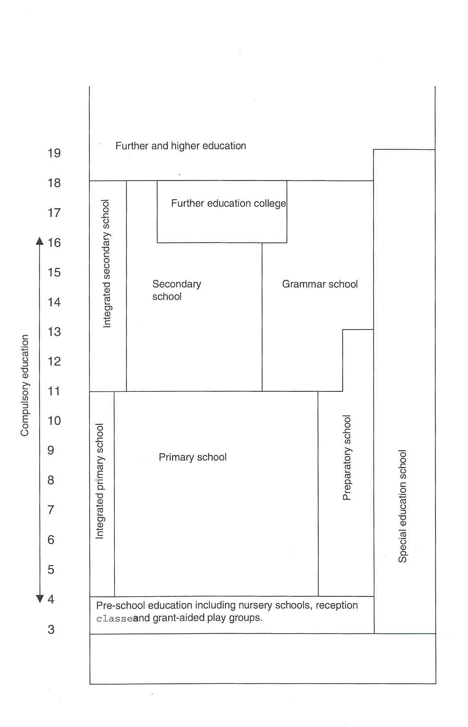

that there are sufficient schools of all kinds and colleges of further education to meet the educational needs of their areas, awarding university and other scholarships, identifying and making provison for children with special educational needs and providing a curriculum advisory and support service. The boards are wholly responsible for the schools and colleges under their management.

In Northern Ireland, as elsewhere in the United Kingdom, the law guarantees that every school is open to all pupils regardless of religious denomination. Some schools have both Protestant and Catholic pupils, but, although coeducation is part of Government policy, segregated housing has been an important determinant of patterns of school attendance in many areas.

There are five types of subsidised schools (96.5% of the pupils):

- controlled schools, established by an ELB and managed by a Board of Governors, receiving largely Protestant pupils;
- voluntary maintained schools, establised by private initiative and also managed by a Board of Governors, receiving largely Catholic pupils;
- voluntary grammar schools, also established by private initiative and managed by a Board of Governors; they provide education for the entire 11-18 age range and are permitted to select pupils on the basis of their ability;
- a new category of voluntary schools: legislation to create a new category of voluntary schools was introduced in November 1993. Existing voluntary maintained schools and voluntary grammar schools can opt for designation as a new category which is eligible for 100% capital grant, on the condition that no single interest group has a majority of norninees on the Board of Governors;
- grant maintained integrated schools: in recent years, a small number of integrated schools have been established at primary and secondary levels with the aim of providing education for Catholic and Protestant children together.

There are also 18 independent or private schools (1994) which cater for a very small proportion of the total school population (3.5%) and which receive no financial assistance from public funds.

The Education Reform Order 1989 introduced a common curriculum with the following areas of study: religion, English, mathematics, science and technology, the environment and society, creative and expressive studies and language studies (only in secondary schools). Each area of study has a number of contributory subjects of which some are compulsory. Also compulsory are the cross-curricular themes: cultural heritage, education for mutual understanding, health education and information technology. In secondary education, careers education and economic awareness are added to this list. Each subject is specified in terms of attainment targets, statements of attainment and programmes of study. Attainment targets describe the range of knowledge, skills and understanding which pupils are to master as they progress through school. The targets themselves offer general objectives, setting out areas within which pupils need to develop. The statements of attainment are much more precise and are normally grouped into eight levels of attainment. These eight levels cover the full range of attainment for the majority of pupils of different abilities during compulsory education. Each new level represents, on average, two years of progress. The statements of attainment provide the basis for the assessment arrangements. Programmes of study for each subject set out the essential content, skills and processes which need to be assimilated by the pupils. Most programmes of study are organised by key stages.

COMPULSORY EDUCATI0N

Compulsory education in Northern Ireland starts at the age of four (one year earlier than in England, Wales and Scotland) and ends at the age of 16. Education is free of charge until a pupil reaches the age of 18.

EDUCATI0NAL SECTORS AND SUBDIVISIONS

Pre-school Education

Pre-school education has traditionally been provided either in nursery schools or nursery classes in primary schools. In 1998, however, the Government introduced an expansion of preschool education. Some £27rn is being invested to provide additional preschool education places for all children in the year before compulsory education. All of the children will follow a preschool curriculum designed to foster their all-round development and secure a sound foundation for learning.

Primary Education

Primary education, for pupils from 4 to 11 years of age, is divided into two key stages. Key Stage 1 covers the 4 to 8-year-olds, Key Stage 2 the 9 to 11 -year-olds. In addition to primary schools, there are "preparatory departments", attached to a small number of grammar schools and attended by a small minority of pupils. The Education Reform Order 1989 introduced a common curriculum and formal assessment for both key stages (at ages 8 and 11). A centrally organised examination at the age of 11 and an evaluation report by the teachers, influence the choice of study in secondary education. However, secondary schools are not allowed to use the test results as admission criteria. Grammar schools use the results of DENI's so-called "transfer tests" in English, mathematics and science to select their pupils. Other than in grammar schools, there is a system of open enrolment both in primary and in secondary education. Only where schools are over- subscribed, must children be admitted on the basis of published admission criteria drawn up by the school.

Secondary Education

The first five years of secondary education are part of compulsory education. These five years are divided into two key stages: Key Stage 3, for pupils from 11 to 14 years of age, Key Stage 4 for pupils from 15 to 16 years of age. The system of secondary education is largely selective. Pupils are divided into two categories of post-primary schools. In the first category are the academically oriented grammar schools for 11 to 18 year-olds. The second category comprises the "secondary (non-selective) schools' for 11 to 16 year-olds and, in some cases, 11 to 18 year-olds. At the end of Key Stage 4 (the end of compulsory education), the majority of pupils take a centrally organised examination in order to obtain the "General Certificate of Secondary Education" (GCSE). The GCSE is organised by subject. Course work counts for 20-30% of the final mark.

After compulsory education, pupils may continue their studies in a school which offers courses post 16 or in an institution for further education. Schools offering "post-compulsory education" are full-time day schools ("grammae' and "secondary" schools). In addition to these, there are colleges of further and higher education.

Pupils preparing for higher or university education specialise in two to tour subjects in order to obtain the "Advanced Level of the General Certificate of Education" (A level). Another possibility is to take "Advanced Supplementary Examinations" (AS level), which are of the same academic standard as A level but with only half of the content. The curriculum can also consist of a combination of subjects at A level and AS level and include subjects which are not examined (e.g. physical education). Pupils are free to choose their own subject combination. Most of them take A or AS exams at the age of 18. Since 1992, some schools (and all colleges of further education) have offered courses leading to General National Vocational Qualifications (GNVOs). Details of these courses are given later.

Further Education

Colleges of further education provide a wide range of vocational and non-vocational courses. Prior to 1998, they were non-denominational "controlled" institutions adnninistered by the ELBS, open to students of all ages who met the appropriate entrance requirements. Since 1 st April 1998, they are incorporated, independent, non-denominational institutions funded directly by the Department of Education. On attaining the upper limit of compulsory school age, young people may elect to continue their academic studies (at GCSE and GCE A/ AS level) or take up work-related vocational courses. On the non-vocational side, colleges provide basic education courses for adults seeking a second chance to learn, community education programmes and a significant degree of leisure-type provision, which does not always lead directly to any specific qualification. The levels of course provision in colleges range from basic education in literacy and numeracy through to programmes of higher education.

National Vocational Qualifications (NVQs)

In 1986, a new four-level framework of NVOs was announced nationally with the formation of the National Council for Vocational Qualifications (NOVO). The framework, which has now been extended to include a fifth level, covers all occupational areas, with NVOs relating to competence in the workplace and based on standards set by industry. FE colleges have a leading role in the delivery of this system. In 1992, General National Vocational Qualifications (GNVOS) were introduced in selected schools and colleges in five occupational areas. A new form of qualification, it is aimed at the 16-19 age group and it intends - together with NVOs - to replace other vocational qualifications and become the mainstream national provision for education and training. GNVOs provide a foundation from which pupils can progress into either further or higher education, employment or further training, i.e. a genuine alternative to A levels. Many colleges and schools are offering GNVQs as part of the phased introduction of this inititative. GNVQs will, in due course, be offered alongside GCSES. At present, they are offered to complement GCE A level or separately.

The Jobskills Programme

The Jobskills programme is an integrated vocational training programme for all young people in the 16-17 age group. It provides a structured programme of directed and workplace training leading to vocational qualifications or credits towards them. The Jobskills programme is administered by the Training and Employment Agency and operates through a network of Recognised Training Organisations (RT0s) of which the Colleges of Further Education are a major part.

The New Deal Programme

The New Deal programme provides adults who have been long-term unemployed with the opportunity to return to employment, either through a subsidised employment place, a work opportunity in a voluntary or environmental programme or an opportunity to participate in full-time education and training. An important and fundamental principle underpinning the New Deal is the commitment to good quality training within all options. Employers offering subsidised employment under New Deal must allocate one day per week vocationally-relevant training, normally with appropriate units of an NVO. A similar commitment to training i's required within the voluntary and environmental options. The New Deal is administered by the Training and Employment Agency and operates through consortia of providers. Many Further Education Colleges are the lead partners in a consortium.

Higher Education

According to the Education Reform Order 1989, higher education offers courses of a higher level than those leading to an A-level or AS-level certificate. Universities and other institutions for higher education are all grouped within the category "higher education". In Northern Ireland, higher education is provided by the Queen's University of Belfast, the University of Ulster, the "Open University" and two "university colleges of education". All these institutions may provide students with first or Bachelor degrees after three years of study. All may also provide students with Masters and some with Doctorate degrees. The two university colleges of education are exclusively concerned with teacher training.

The universities have a two-fold role: they are an integral part of the United Kingdom's higher education, system and they provide the full range of higher education needs of the Northern Ireland community. Colleges of further education can transfer to the sector of higher education when more then 55% of their students are enrolled at the level of higher education.

Someone seeking enrolment in an institution of higher education is usually required to have grade E or better in at least two subjects at GCE A level or the equivalent. Additional requirements may be imposed.

Teacher Training

Initial teacher training (ITT) for primary education is a four-year training course, which leads to a Bachelor of Education (B Ed) degree. The same entry requirements as for higher education are in force; in addition, GCSE "passes" in English, mathematics and science are required (from 1998).
Those with a university degree who wish to teach in secondary education follow a one-year course leading to the Postgraduate Certificate of Education (PGCE). A "first degree" is an entry requirement with the same additional GCSE passes as for the B Ed degree course. The Open University offers a part-time PGCE.
The teacher training institutions are accredited by the Department of Education for Northern Ireland on the advice of the Inspectorate. Only an accredited ITT course can enable a teacher to acquire the "Qualified Teacher Status", necessary for a teaching post in a grant-aided school.

Special Education

Under the 1986 Education and Libraries Order, ELBs have responsibility to provide for children and young people with special educational needs (SEN) up to the age of 1 9. This provision may be made in primary or secondary schools, in special units or in day or residential special schools; if a child is unable to attend school, home tuition may be provided. It is possible for ELBs to arrange for special educational provision to be made elsewhere, should suitable facilities not exist in Northern Ireland. The curriculum and assessment provisions of the Education Reform Order apply to the special sector in the same way as to mainstream primary and secondary schools. However, in a minority of cases, these are modified or disapplied in the children's statements of special educational needs in order to cater for their particular needs and abilities.

2 THE ORGANISATION OF THE INSPECTORATE

The present Inspectorate is in direct and unbroken descent from the Inspectorate established in 1832 by the Commissioners of National Education in Ireland. A number of inspectors transferred to the Inspectorate of the Ministry of Education for Northern Ireland when it was established in 1922. In January 1989, the Inspectorate's work was extended to include the training service in Northern Ireland, and it became known as the Education and Training Inspectorate (ETI). The duties of the Inspectorate are to report on the quality of education and training.

The Inspectorate is headed by the Chief Inspector (Cl), who is the principal adviser on education and training matters to the Department of Education (DENI) and the Training and Employment Agency (T&EA), an executive agency within the Department of Economic Development (DED). In the next tier of management there are five Staff Inspectors who have individual responsibility for a major sector of the Inspectorate's work. There are, currently, 52 inspectors drawn from a variety of professional backgrounds and with wide experience and expertise in particular areas of the education and training services. Most inspectors work mainly in two phases of these services, for example, the primary and secondary sectors or further education and training; some have duties in three or four phases. All inspectors evaluate general aspects of education and training, as well as provision in their specialist area. Much of the work of an inspector consists of furnishing written reports to DENI and T&EA.

The Inspectorate is responsible for primary, secondary and further education, for vocational training, for teacher training, for the ELBs and for the Youth Service.

The 1986 Order gives the statutory basis for the involvement of lay inspectors in inspection teams to accompany and assist inspectors and to bring an additional, distinctive perspective to the inspection process. The lay person has no responsibility for evaluating the two key professional issues of teaching and learning. DENI has adopted a gradualist approach to the implementation of lay involvement, and lay persons are currently deployed only in general inspection teams in larger primary and secondary schools and in some special schools. (See item 6.)
The Government is responsible for funding the Inspectorate.
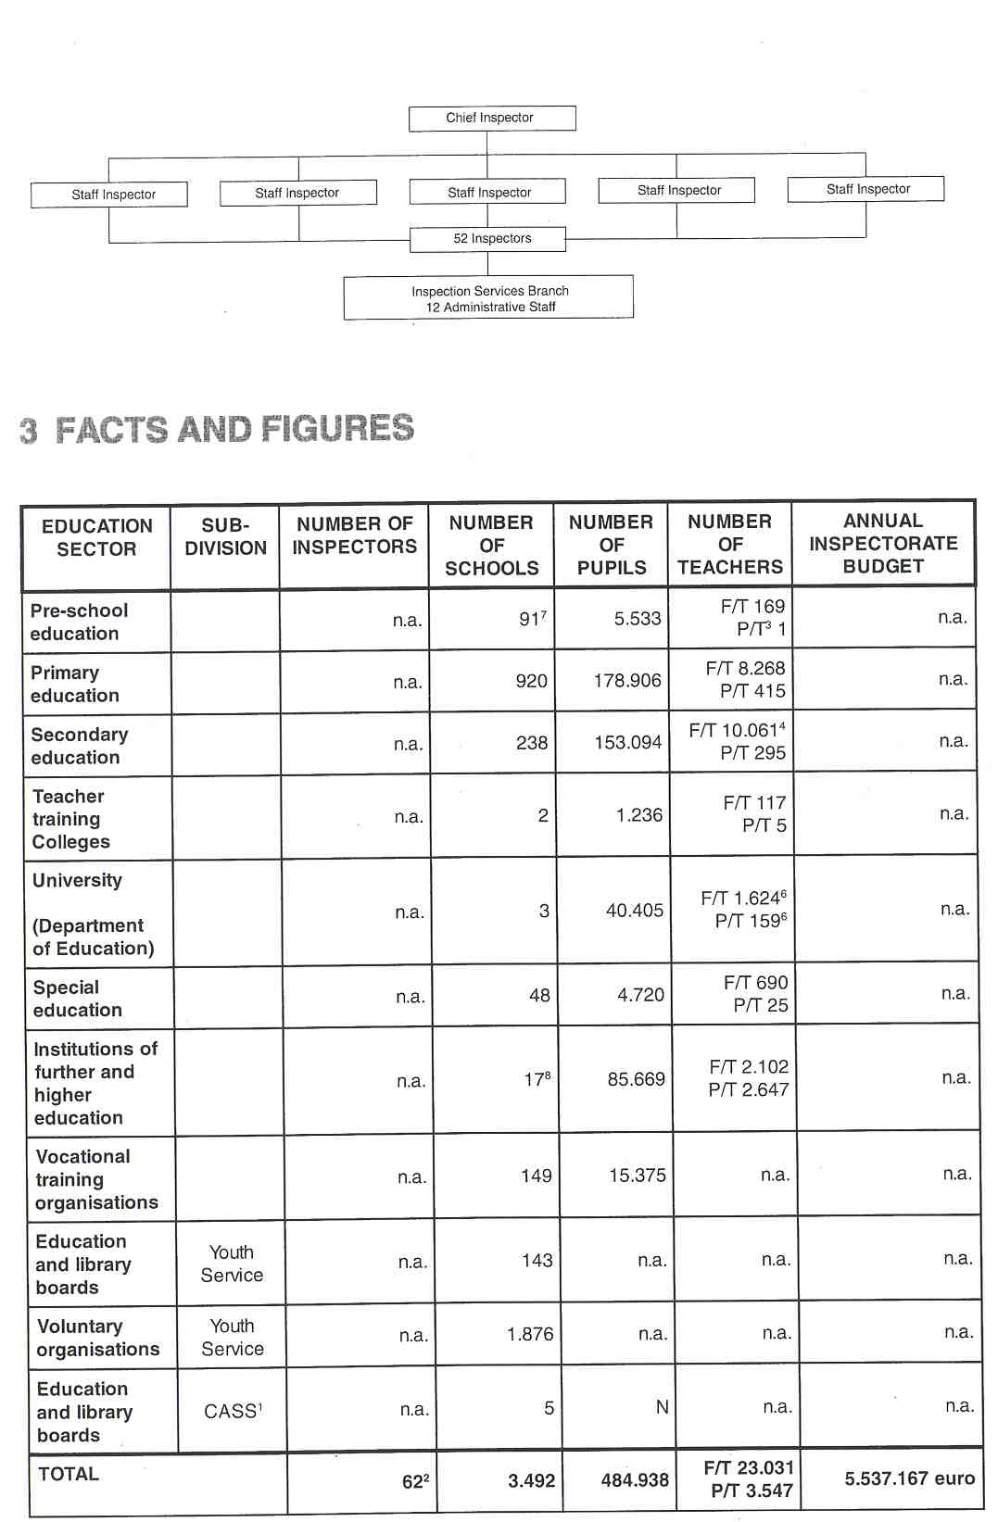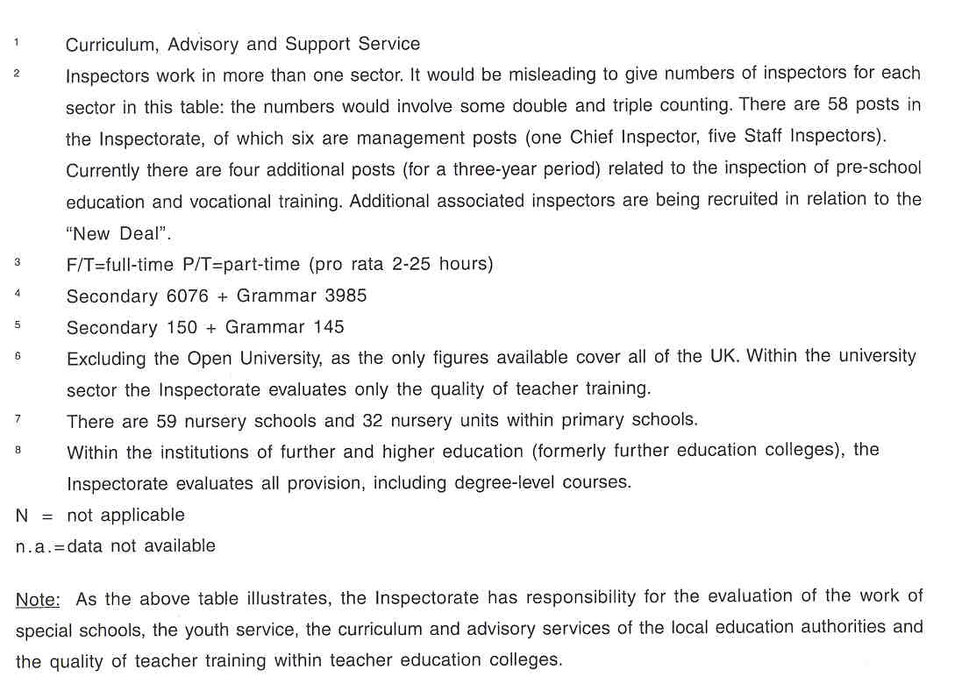

4 THE RECRUITMENT OF THE INSPECTORATE

To be eligible for the position of inspector candidates have to fulfil certain requirements. The required educational background varies depending on the post. Usually a good honours degree is required in the area in which expertise is sought and always a teaching qualification. The required years of experience also vary with the nature of the post. Not less than seven years' experience in teaching with three of those in a management post relevant to the post is required.
Appointments are made following an interview in an open recruitment process managed by the Recruitment Service, an agency within the Northern Ireland Civil Service. Appointments may be made in one of three modes:

- secondment (for a maximum of three years);
- fixed term contract (usually of three or five years);
- permanent contract.

5 THE WORKING CONDITIONS OF THE INSPECTORATE

Inspectors are normally appointed on a full-time basis, as the range and scope of the work require that degree of commitment. However, if an inspector were to seek to job-share, as happened on one occasion in the recent past, that request would be facilitated if the business needs of the Inspectorate could be fully met.
Most inspectors are permanent appointments. Some fixed-term contracts (three or five years) and, occasionally, secondments (three years) are used. The Northern Ireland (NI) Inspectorate has experience of both forms of appointment and is currently experimenting with the involvement of school principals in inspection teams. In the latter case, the principal is involved in a single inspection in the sector in which he or she is experienced.

6 AREAS OF INSPECTORATE RESPONSIBILITY

The most recent legislation on the Inspectorate's responsibilities is The Education Order 1996, article 33, section 5: "it shall be the duty of inspectors to promote the highest standards of education and of professional practice among teachers, in relevant establishments which provide education by:

- monitoring, inspecting and reporting on the standard of education being provided in those establishments and the standards of professional practice among teachers on the staff of such establishments;
- advising the Department on any aspect of the curriculum of any of those establishments which the Department may refer to them or on which they think advice is appropriate'

The "relevant establishments" referred to in this article are "a school, a college of education, a grant-aided institution or establishment; or an institution or establishment which is established, maintained or managed by a board or the activities of which are organised by a board".
Section 6 of the same article describes the Inspectorate's tasks regarding the Education and Library Boards: "it shall be the duty of inspectors to monitor, inspect and report on the nature, scope and effect of advisory and support services provided by boards under Article 29 of the 1989 Order in relation to curricula and staff of grant-aided schools".

According to this official description, the main responsibilities of the Inspectorate are evaluating, advising, monitoring and reporting.

6.1 EVALUATING

DIstrict and Specialist Visits

Although in recent years the inspection process in schools has undergone changes to meet the requirement for more frequent inspection of individual schools, there will continue to be opportunities for inspection visits by individual inspectors to schools for which they have a district responsibility and, more generally, to follow- up specialist interests in areas of the curriculum. District and specialist visits by inspectors, working individually or in pairs, may concentrate on a particular theme or aspect of the school's work. None of these visits lead to a published report on the individual school, but a brief spoken report is always given to an appropriate member of staff at the end of any visit.

Visits in the Context of an Inspectorate Survey (Aspect Evaluations)

If the school has been visited to gain evidence for an Inspectorate survey of an aspect of provision, the findings are published in a general report. While the schools which were selected for such surveys are listed in an appendix to the report, there are no published reports on the individual schools.

General lnspections

A general inspection is designed to provide an evaluation of a school across a broad spectrum of its activities. The starting point for such an evaluation is the statement by the school of its aims, policies and targets (often incorporated into the school development plan), so that inspectors can consider the extent to which these aims, policies and targets are reflected in practice. The main emphasis of the inspection is on the educational provision and outcomes, as seen in the quality of the pupils' learning and achievements and the teaching.

In a general inspection, the team of inspectors makes judgements about the nature, range and appropriateness of the curriculum and the experiences provided for the pupils, taking due account of the statutory requirements of the Education Reform Order 1989 and the context in which the school is working. The inspectors make judgements about whether the curriculum and experiences present appropriate challenges for the pupils, and whether the standards attained by the pupils reflect their ability

The broad scope of a general inspection means that in secondary education it is not always possible for each team to include specialists to cover all the subjects in the curriculum; a specialist from each area of study is, however, always involved. Following the receipt of notification of a general inspection, the Board of Governors of a school may decide to ask the Chief Inspector to arrange for the inspection to include religious education. Whilst the Chief Inspector endeavours to meet such a request, there are occasions when the inspection of religious education may need to take place outside the period of time scheduled for the general inspection.

The inspection team, in evaluating the quality of the pupils' education, examines the extent to which certain features of the school help or hinder this. Such features include the general ethos of the school, links with parents and other schools, the quality of the teaching and the appropriateness of the teaching approach for the activity being undertaken, the nature of the planning, preparation and assessment, the means of organising and managing the class and the curriculum, the deployment of staff and the nature and scope of their continuing professional development, the effectiveness of the leadership and management arrangements and the nature, range and appropriateness of material provision and its use, including accornodation, library provision, equipment and other learning resources. Only those factors which clearly influence the experiences and outcomes of the pupils - beneficially or adversely - receive mention in detail.

In keeping with the Citizen's Charter and the Inspectorate's own commitment to openness and continuous improvement in inspection procedures, a lay person may accompany and assist inspectors during inspections. The purpose of lay involvement is to allow for an additional, impartial perspective on the work of a school and the process of inspection. The lay person has no responsibility for evaluating the two key professional issues of the quality of learning and teaching. Such evaluation is the sole responsibility of the Inspectorate.

Focused Inspections

A focused inspection concentrates on particular aspects (or on one aspect) of the school's provision. The particular aspects being inspected are, whenever possible, viewed within the broader context of the school as a whole. Schools are always informed in advance about the aspect(s) on which the focused inspection will concentrate, and though these aspects may vary, the following are likely to be included:

- particular areas of study (which, in primary schools, generally include English andlor mathematics);
- an issue which was identified in a previous inspection and about which there remains. some concern;
- an issue which is recognised as having special interest and importance, such as careers education, provision for special needs education and post-16 programmes.

Quality Assurance lnspections

In "Evaluating Schools" (1998), the Inspectorate, using its observation of practice in schools, identified certain indicators of quality and features of practice which it associated with outcomes which were assessed as good or not good enough. These indicators are grouped under three headings : the ethos of the school, the quality of teaching and learning and the quality of management.
The main purpose of "Evaluating Schools" is to encourage and assist schools themselves to undertake an effective evaluation of their provision and, where necessary, to implement improvements in order to raise the standards of achievement of their pupils.
The quality assurance inspection, building on the. thinking behind "Evaluating Schools", is intended to help schools to further the process of self-evaluation and improvement. In the first instance, the school, as part of its normal work of self-evaluation, carries out an internal audit of a substantial part of its provision and produces a report, containing recommendations and priorities for action. The school may then invite the Inspectorate (by a request to the Chief Inspector) to assess the efficacy of its internal quality assurance procedures and to comment on the validity of the outcomes. A published report on the Inspectorate's findings is distributed to parents. The school undertakes to inform the Inspectorate, within three months of receiving the report, of any changes it will make in its quality assurance and quality improvement systems and on what aspects of provision it will focus in the near future with regard to quality assurance.
Quality assurance inspections have been piloted in a small number of secondary schools. The procedures involved and the format of reports are being developed, and the pilot exercise may be extended to include primary and special schools. At the moment, a small minority of secondary schools have developed a system of self-evaluation and quality assurance which functions reasonably well. Other schools are working towards improved self-evaluation. The Inspectorate uses the following criteria for internal quality assurance and quality improvement:

- The school should have a well-defined development plan and its internal quality assurance procedures, through their identification of priority areas, should be linked to this plan.
- Clear targets should be formulated for these priority areas in the school's strategy for internal quality improvement, including a list of desired "performance indicators".
- The school's evaluation procedures should be clear, comprehensible and appropriate, and capable of providing quantitative and qualitative data and judgements which can be verified by external experts.
- The data and judgements should come from teachers, pupils, parents and the school's Board of Governors; they should also be based on observations in classrooms throughout the school.
- The procedures should cause a minimum of disruption to the school's daily routine.
- The targets, performance indicators and evaluation procedures should be discussed fully by staff, and there should be a consensus on all three.

Other evaluations

- Public examination results are analysed according to the norms for schools of a given type and reported on in comparison with schools of the same type.
- The Inspectorate regularly inspects the quality and standards of the procedures used by the Examining Board chosen most by NI schools, i.e. The NI Council for Curriculum, Examinations and Assessment
- The Inspectorate, in parallel with OFSTED in England and OHM.CL in Wales, inspects new qualifications, such as the General National Vocational Qualifications.
- The Inspectorate inspects the nature, scope and effectiveness of the advisory and support services provided by the Education and Library Boards (ELBs). This evaluation is undertaken after consultation with the Boards.
- The Inspectorate evaluates the quality of teacher education, both in initial training, and early professional development. Work in the teacher training colleges and university schools of education is monitored through inspection visits to the Higher Education Institutes. Early professional development (including induction) is monitored through the inspections of the ELBs' advisory and support services, including the Regional Training Unit.
- Inspecting quality and standards in the Youth Service is also an Inspectorate responsibility
- The Inspectorate inspects and reports on quality and standards in the colleges for further and higher education.
- Inspectors always give a brief, oral evaluation of the work observed. They do not make reference to the teaching of individual teachers in inspection reports. Where serious weakness in teaching is observed, the Inspectorate is required to draw unsatisfactory practice to the attention of the teacher and the principal, and to prepare a separate written report for issue to the teacher, the principal, the school governors and the employing authority. There are, then, certain procedures to provide support to help the teacher to improve, coupled with further monitoring. The Inspectorate, technically, has no involvement after the first stage, except at the request of the employing authority to the Chief Inspector.
If the principal's work is found to be unsatisfactory, the written report will issue to the principal, the governors and the employing authority.

6.2 ADVISING

The Inspectorate's key role is evaluative; advice on the work observed is given at the point of inspection to teachers, headteachers, governing bodies and, subsequently, to the Department of Education and the Training and Employment Agency, for which the Inspectorate is the principal source of advice on all professional educational issues and on standards of educational provision. The ELBs' Curriculum and Advisory Support Services have an advisory and supportive role in schools.

6.3 MONITORING

- The Inspectorate monitors the use made by schools of the Computerised Local Administration System for Schools (CLASS), which provides information, for example, about pupil attendance, staffing, teachers' qualifications, examination results and subject choices.
- The Inspectorate has its own data bank of judgements made by inspectors, which is an increasingly powerful source on which to base advice to the Government, the Department of Education, schools and the general public. The Inspectorate also has access to the Department's statistical data which include details of results in public examinations, pupil attendance rates, school budgets, enroirnents etc.

6.4 REPORTING

The Inspectorate reports on the different types of inspections mentioned above.

The single-institution inspection arrangements, which are designed to allow feedback to be given to individual schools, also provide data which, when aggregated, can, with surveys and inspections of broad issues, inform the education system and the general public about matters of common interest, such as discipline, or staff development and deployment. Inspectorate reports are published on the quality of education in general and on aspects or levels of education, and the data mentioned here are used for these purposes.

6.5 OTHER RESPONSIBILITIES

- As far as curriculum development is concerned, the Inspectorate has representation on the NI Council for the Curriculum., Examinations and Assessment, which allows it to inform curriculum decisions. Although it may serve in a representative capacity on curriculum working groups, the Inspectorate has no executive role; it is, however, required to advise DENI policy makers on whether the Council's recommendations on the curriculum should be endorsed or modified. Ultimately, the curriculum is approved or not at Ministerial level.
- The Inspectorate has no formal role in developing educational materials. From time to time, inspectors may participate as observerslassessors in working groups, or comment on papers submitted to DENI from those seeking Government support for the development of materials. The main responsibility for developing educational materials rests with the Curriculum Advisory and Support Services.
- The Inspectorate may contribute to in-service training courses, when asked to do so by the Education and Library Boards' advisory and support services, and responds to requests for consultation from Boards and other agencies.

7 THE ROLE OF THE INSPECTORATE IN EDUCATIONAL POLICY

At the preparation stage, inspectors may contribute to policy making as assessors within working groups, and advise policy makers in the Department of Education and the Training and Employment Agency. The Inspectorate itself does not make policy decisions on education. It may, however, influence and advise decision-makers. The Inspectorate prornotes the implementation of policy and evaluates its effectiveness through inspection and through the dissemination of inspection findings.

8 WHO IS IN CHARGE?

The role of the Inspectorate is laid down in Government statute. Annually, the Chief Inspector, in consultation with his management team, determines the priorities for the Inspectorate's business plan in the light of DEN] (Ministerial) priorities. In short, the Inspectorate's business plan do vetails into that of the Department, which is subject to Ministerial approval. In this process, the Inspectorate takes its cue from Ministerial priorities, and itself, advises on which priorities are appropriate.

If there is a national priority area, such as literacy, the Inspectorate seeks to reflect this in its work programme. Parliament, through its select comr-nittees, may propose such an area for the attention of DENI and, indirectly, the Inspectorate. Under-achievement in secondary education, for example, was the focus of a Parliamentary Select Committee in 1996-97.
The Inspectorate may also respond to requests for inspection from Boards of Governors of schools, from local education authorities and from schools themselves.

Their draft annual business plan is submitted to all inspectors for comment and may be modified in the light of their suggestions.
The work programme for each inspector has a substantial element which is centrally programmed or scheduled. Helshe decides how and when to complete other non-centrally programmed tasks or responsibilities.

9 THE POSITION OF THE INSPECTORATE

The Minister is open to the views of the Inspectorate, and the Chief Inspector, as a member of the Top Management Group in the Department, has frequent meetings with him about policy issues. Staff Inspectors are regularly involved in meetings with the Minister and senior Departmental officials on policy matters in which professional advice is required. The Minister has spoken with the Inspectorate as a body and there is ongoing contact with him on a range of matters.

The relationship with DENI is increasingly reciprocal. Some inspectors have worked on attachment, for short- term tasks, to the administration. Generally the Chief Inspector and the Staff Inspectors have frequent working contacts with senior Departmental officials. Inspectors have regular contact with administrative colleagues in the Department on matters related to their area of specialist expertise.

The Inspectorate has assessor status on the Northern Ireland Council for Curriculum, Examinations and Assessment (NICCEA) both on the Council itself and on its sub-groups. It also represents the Department, as an assessor, on UK bodies, such as the British Educational Computing Technology Agency, the Council for Innovation in language Teaching and the Qualifications and Curriculum Authority.
The Inspectorate inspects the quality of CCEA's examination procedures, on a sampling basis, as part of a rolling programme. It is also asked to evaluate, in parallel with OFSTED (England), the quality in General National Vocational Qualifications and the standards of assessment in National Vocational Qualifications. From 1999, it is to be involved in the accreditation of teacher training.
The Education and Library Boards are required by the 1989 Order to provide advisory and support services for the schools and colleges in their area. Given the nature of the Inspectorate's work, it is particularly important that members of the Inspectorate and the Boards' services should know one another's views on key issues, and that schools, colleges and individual teachers should have coherent and consistent advice on such issues. It is thus vital that there should be professional exchange and sharing of ideas among inspectors and Board support staff, to ensure that schools, colleges and teachers have clear, unambiguous guidance about improving standards. The Inspectorate also evaluates the Boards' advisory and support services.
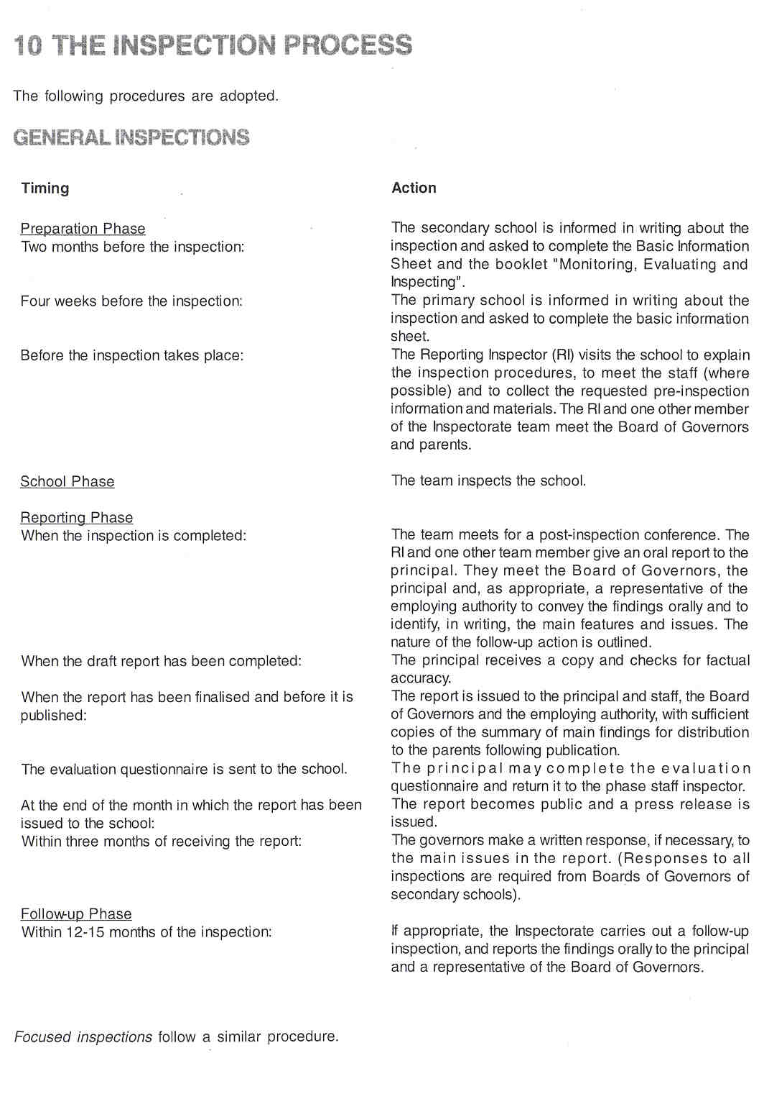

INSPECTIONS IN INSTITUTES OF FURTHER AND HIGHER EDUCATION

The Inspectorate has recently revised its inspection procedures in institutesicoiieges of further and higher education. The effectiveness of a college's own internal quality assurance now forms an important part of an inspection, and, at least two weeks before an inspection, a college is required to provide a self-evaluation report on the quality of its provision and the standards achieved by the students. The format of the self- evaluation is based on elements contained in the Inspectorate's document "Improving Quality: Raising Standards", which provides relevant quality indicators, performance indicators and sources of evidence. The Inspectorate, in evaluating the quality of provision, considers the good features and shortcomings in each programme and allocates a grade. In the future, the grades will be published, providing a clear statement on the quality of provision and an indication of how the sector is developing over time.

In line with developments in institutes of further and higher education, the Inspectorate is developing similar procedures for the inspection of training, which will be piloted during 1999-2000 and introduced from September 2000.

QUALITY ASSURANCE INSPECTIONS

Preparation Phase

- A school requests the Inspectorate to conduct an external quality assurance inspection, to assess the rigour and fitness for purpose of its evaluation procedures and to verify the findings of its internal evaluation. The remit and scope of the exercise are then discussed by the school and the Inspectorate. Agreement is reached on a provisional date for the inspection and on the statistical information to be provided, in addition to the school's internal evaluation reports.
- The report of the internal evaluation and associated documentation are made available for scrutiny prior to the inspection.
- The reporting inspector (RI) for the external quality assurance inspection visits the school to:

- recollect the written evidence in support of the school's procedures and findings, together with other information required for the external audit, including statistical information about whole-school provision;
- explain to the staff, if requested by, and in conjunction with, the principal and the school management tearn, the procedures for the inspection.

School Phase

- The external audit always includes an examination of a sample of the pupils' work and an inspection of classroom practice. The inspection is usually completed within one week and the normal procedures for inspecting and reporting back to staff and management apply.

Reporting Phase

- A written report is published commenting on the school's evaluation procedures and the validity of their outcomes. When the Inspectorate is unable to support the findings of the internal evaluation, reasons are given and aspects of the evaluation, which, in the view of the Inspectorate, need to be reviewed, are identified.

Follow-up Phase

- Within three months of receiving the report, the school provides a response to DENI, indicating the action it proposes to take on the issues raised in the report and in the exercise in general.

11 INSTRUMENTS AND METHODS

THE COLLECTION OF INFORMATION

a. Questionnaires

For each type of inspection and for each level of education (e.g. general inspections of further and higher education, general inspections of a recognised training organisation or youth service inspections) a questionnaire booklet of information requirements (the basic information sheet) is sent to schools in advance of the inspection. The questionnaire deals, for example, with aspects of organisation, pupil and staff data, the documents required before the inspection, the information to be available on the first day of the inspection and assessment outcomes. In addition, the reporting inspector (RI) visits the school or the institution to obtain more detailed information.

For general and focused inspections, the booklet "Monitoring, Evaluating and Inspecting in Secondary Schools 1997-1998" gives an extensive list of required information, together with the instruments needed to generate this information. Use of the CLASS System (See 6) is an integral part of this exercise. The booklets are not only useful to the Inspectorate, but can also be used by schools and others to facilitate the process of school improvement. The booklets assist schools in their monitoring and evaluation by collating, analysing and interpreting data.

There are also questionnaires for the inspection of specific topics, such as careers education and guidance.

b. Interviews

Interviews take place with all key players and with small groups of parents. The inspectors meet parents wishing to attend a meeting before a General Inspection, to hear their views and to answer questions.

c. Observations

Inspectors observe what happens during learning and teaching and draw conclusions from the evidence available to them. The judgements made by the Inspectorate are informed by the indicators of quality set out in "Evaluatin_q Schools' (See 6 e.) These indicators act as guidelines, but are not a template for inspectors' judgements. The Inspectorate's evaluation and reporting depend heavily on observation at first hand. In this context, "observation" involves not only an examination of practice, but also discussions with teachers and pupils, and, normally, a scrutiny of the pupils'written work. Inevitably, some evidence is drawn from information provided by the principal and other teachers. When such evidence is used in the inspection report, the source is identified as the school itself. This practice is not, in any sense, to devalue what has been said, but simply to highlight the fact that the inspectors did not make the observations themselves.
Other aspects of provision observed by the Inspectorate include: the quality of relationships throughout the school, the appropriateness of the aims of the school, the content of courses and conduct of lessons, the match between the activities seen and the abilities of the pupils, the attitude and motivation of the pupils and their oral expression, the effectiveness of the school's organisation and management, the nature, condition and appropriateness of the accomodation and recources and the scope and use made of library provision.

d. Tests/examinations

The inspection tearn does not itself measure the performance of the pupils in a quantitative way It draws, however, on information from the school's own monitoring of the pupils' achievement through the normal process of continuous assessment, the use of standardised tests in literacy and numeracy, the arrangements for assessment at the end of key stages (See 1) and, in the secondary sector, results in public examinations.

e. The Collection of Documents

An inspection is intended to give, as far as possible, a picture of the school as it is in normal everyday operation. The inspection team usually requests to see written statements of policy, schemes of work, school guidelines, or, where appropriate, summaries of examination results, i.e. material that is normally available and in everyday use. It is not intended that such material should be prepared solely for the inspection. Such preparation would represent an unnecessary burden for the school and could divert the attention of the staff from the main activities associated with learning and teaching.

Increasing use is being made of development plans, in which schools may summarise their policies, identify aims, set specific targets for themselves, set out a framework for evaluating how well or how far their policies, aims and objectives or targets are being implemented, and identify priorities for review and development. Since 1998, it is the Board of Governors' duty to prepare the school development plan.

The Inspectorate also examines samples of the pupils' work, including written material.

f. The use of (National) Data

The Inspectorate makes increasing use of the data held by schools on their Computerised Local Administration System for Schools (CLASS). (See 6.) Each school holds key data on a standard set of software modules, including, for example, data on administration, pupils, teachers, finance, the library and the curriculum.
Furthermore, regional data on examination performance are used and taken into account during inspections.

APPROACHES

a. Instruments
"Evaluating Schools" (See 6.), together with its indicators, is used as an instrument by all inspectors. Furthermore, there are handbooks to guide inspections in different phases, as well as an in-house record of inspection notes and grades. All such documents are checked annually and, if necessary, revised to ensure that they are still up-to-date.
Inspectors compose their own observation notes; they do not write to a template in class. There are, however, features and guidance (unpublished) for various aspects of a school's work, which help to ensure a common framework and shared values for the recording of Inspectorate judgements.

In making their evaluation of the quality of teaching and learning and of the achievements of the pupils, the members of an inspection team consider together the insights and evidence which have been gained during the inspection about aspects of the schools' work. They take into account matters such as:

- the context in which the school is working;
- the quality of the teaching and the extent to which it encourages interest, curiosity and motivation in the pupils;
- the standards achieved and the extent to which these are in keeping with the pupils' abilities;
- the extent of progression in the pupils' work;
- the adequacy of the opportunities for the pupils to learn in a self-reliant way and to work individually and co-operatively;
- the variety of activities which the pupils experience and the extent to which their experiences promote creative thinking and practical involvement;
- the degree to which the pupils see purpose in what they are learning.

In general and focused inspections, the team reaches an agreed view on factors such as leadership, management of resources, use of the library, planning and preparation, in-service training arrangements, the degree to which the school or department is implementing its aims and meeting its targets, the coherence of curricular policy and practice, the quality of pastoral support, the effectiveness of different teaching styles, the general ethos and the response of the pupils.

The inspection findings represent the team's collective evaluation of the school's achievement. This evaluation takes due account of all the circumstances in which the school is operating; it is not a measure against some ideal blueprint.

b. lndividual Work and Teamwork

Inspectors either work individually or in teams depending on the type of inspection. (See 6.)

As far as teamwork is concerned, inspections of individual schools are usually conducted by a team of at least two inspectors. The inspections are led by a reporting inspector (RI), who is responsible for drawing together the main findings of the team members. The RI is also responsible for drafting the report and for communicating the inspection findings to the school, the Board of Governors (or its Chairman) and a representative of the employing authoritity (at the invitation of the principal). The inspection team establishes a pattern of working that depends on the skill of the inspectors in knowing what to look at, what to ask about, and what to make of the evidence.

During quality assurance inspections, inspectors are assisted by an associate assessor, an experienced headteacher whom they invite to support them in their work.

c. Self-evaluation

Inspection teams take into account what the school itself has done through its own evaluation, and are sensitive to the planning and priorities that have been identified. To help schools in the process of self- evaluation, guidance has been given in the Inspectorate's document "Evaluating Schools'. (See 6.). As the school's process of self-evaluation becomes more firmly established, it could sit alongside the external inspection arrangements as a means of establishing an effective approach to quality assurance in schools, in line with the initial pilot exercise in quality assurance inspections. (See 6.). In this regard, the work of the Inspectorate is part of the process of monitoring, evaluating and improving educational standards. The programme of general and focused inspections should be seen as one element in a much broader process of quality assurance, in which the continuing programme of self-evaluation by schools is an equally important component.

12 JUDGEMENT AND ITS CONSEIGUENCES

The conclusion of a general inspection report indicates whether the school is:

- one which is doing a good job, is meeting the needs of its pupils and has many major strengths. If it has any weaknesses, these are minor and the school is well able to address them;
- one which has strengths in aspects of its work, but which also has some significant issues, which it needs to address if it is to meet consistently the needs of all its pupils;
- one which has major areas of weakness - in ethos, in teaching and learning or in management - and few (if any) strengths; what it provides for the pupils and what they achieve are not good enough.

For schools assessed as doing a good job, no formal response is required from the Board of Governors and no formal follow-up inspection is necessary.

For schools belonging to the second category, the reporting inspector (RI) provides a written outline of the issues and gives this to the Board of Governors when making the oral report of the inspection findings. The Board is required to make a written response to the inspection within three months of receiving the report. The response must include an action plan, indicating what is being done or planned to address the issues identified by the inspection. The Department considers the response and, if it is satisfied with the action plan, writes to the school supporting what has been proposed. If the Department is not satisfied, it writes to the Chairman of the Board, outlining what still needs to be addressed. The Department sends copies of correspondence to the relevant Education and Library Board (ELB) and, for Catholic maintained schools, to the Council for Catholic Maintained Schools (CCMS). There is a follow-up inspection within one year of the initial report, which evaluates what has been achieved through the action plan. The findings of the follow-up inspection are not published, but are discussed with the principal and the Chairman of the Board of Governors. A written report of the follow-up inspection is sent to the Board only if the school has not made the necessary improvements.

For a school assessed as having major weaknesses, the RI gives the Board of Governors a written outline of the matters to be addressed. In addition, for all schools in this third category, the Department writes forrnally to the Board, identifying where improvements have to be made, and indicating what must be included in the detailed action plan forming part of the Board's written response. This letter will be copied to the relevant ELB and to the CCMS for Catholic maintained schools. The school's response, which must be submitted within three months, must show the timescale for improvements and the means by which they will be achieved. The Department considers the action plan and, subject to any modifications it may require, indicates its agreement with what is to be done. There is a follow-up inspection within one year, which evaluates what has been achieved through the action plan. The report of the findings of the follow-up inspection is published. A further inspection (either another general inspection or one focused on a particular aspect of the school's provision) is undertaken, if the follow-up report shows that the school has not addressed the issues satisfactorily. The report of this further inspection is also published.

When an inspection report states that the school is not giving its pupils an acceptable standard of education and.

- this is due (in whole or in part) to the management of the school by the Board of Governors,
- and recommends that the powers of the Department should be exercised in relation to the school,

the Department has the powers to appoint as many additional voting members to the Board of Governors as it thinks fit. The Department may appoint one of these additional members to be Chairman of the Board. This situation has not yet arisen.

Schools may also be selected for intensive support within the Schools Support Programme - a Government initiative intended to raise standards in schools where the performance of pupils is weak. The work undertaken by these schools is given additional structured support by the ELBs'Curriculum Advisory and Support Services (CASS) and, in the case of Catholic maintained schools, by the Council for Catholic Maintained Schools (CCMS). The schools' progress is monitored, evaluated and reported on by the Inspectorate.

The intention of the programme is that schools should be self-sufficient in improvement within three to five years of this period of intensive support. Where this is not the case, however, and appears unlikely to be so, the situation cannot persist. Depending on the circumstances of the school concerned, amalgamation with another school or closure are legitimate options where a school is judged to have persistent serious weaknesses.

13 OUTCOMES

The Inspectorate publishes different kinds of reports, depending on the type of inspection. The reports of inspections are always public, unless commissioned by the Minster or Department for consideration at policy formulation stage or for other purposes internal to Government.

Firstly, there are reports on individual schools.

The report of a general inspection has two main parts. The first section of the report, the basic information sheet, contains factual inforrriation provided by the school. The second section is mainly evaluative and contains:

- a summary of the main findings;
- an evaluation of the ethos of the school, the quality of the pupils' learning, the appropriateness of the standards attained, the quality of teaching and of the experiences offered to pupils in all of the areas of study;
- an evaluation of management arrangements or of any other additional factors which affect the quality of teaching.

The report of a focused inspection has three main parts:

- factual details similar to those required for a general inspection;
- comment on the ethos of the school or department;
- detailed evaluation of the particular aspect(s) forming the focus of the inspection, including the quality of the pupils' learning, the appropriateness of the standards attained and the quality of the teaching and of the experiences offered to the pupils. Reference is made to any factors which have helped or hindered the achievement of outcomes of good quality.

Reports on individual schools may refer to their failure to comply with regulations, as, for example, on the rare occasion when the school day is shorter than the regulations require. In practice, however, this seldom happens.

The reports on individual schools are addressed to the schools and to the parents of the children who attend them; the parents receive a summary of the report. Reports may be accessed by any member of the public, and notice of their availability is given in press releases issued by the Department's Inspection Services Branch. In future, all reports will be published on the lnternet.

No reports are written/published on individual teachers, nor do the reports on schools comment on individual teachers. When, however, a teacher's work is judged by the Inspectorate to be unsatisfactory, the Department forwards a report to the teacher, the headteacher, the Chairman of the Board of Governors and the employing authority. All teachers receive copies of reports on their schools, and any teacher can request a copy of a report on any school in Northern Ireland. Oral feedback is given to teachers after lessons have been observed.

There are published reports on the evaluation of subject areas and branches of study. For example, in order to report on "The quality of teaching and learning in English, Mathematics and Science in a sample of primary schools in 1994-1995", the findings of 78 focused inspections in these three curriculum areas were collated and analysed'. This report:

- esumrnarizes the main findings;
- identifies some of the main trends, including particular strengths and weaknesses in teaching and learning in English, mathematics and science in primary schools;
- outlines some examples of good practice;
- identifies issues for consideration by schools and by the Curriculum and Advisory Support Service (CASS) and other support agencies.

There are also reports on aspect evaluations at regional level, such as assessment at a particular key stage, staff deployment, drug education and discipline in schools.

Furthermore, there are reports on the work of the Education and Library Boards' Curriculum Advisory and Support Service in assisting school improvement.

Finally, there are reports on the evaluation of significant Government initiatives in education, such as the education element of "Making Belfast Work", a major inter-Departmental policy initiative targeting an area of socioeconomic deprivation in Belfast, and reports on the vocational training provided by the Trainin_q and Employment Agency.

14 FOLLOW-UP PROCEDURES

Depending on the outcomes of the general or focused inspection, the Inspectorate may carry out a follow-up inspection to assess the progress made in addressing the main issues identified in the report. Follow-up inspections usually take place about a year after the inspection report has been published and are normally carried out by the District Inspector.

The nature and scope of the follow-up inspection are not the same for all schools, but reflect the findings of the previous inspection. Schools where major issues are identified which need attention have a more searching follow-up inspection than those where the concerns identified are less significant. A report of the follow-up inspection is made to the Department of Education. The findings of follow-up inspections are not normally published, but are always discussed with the principal and a representative of the Board of Governors. There may be circumstances, however, when a published written statement of the findings of a follow-up inspection is justified, as when, for example, the school has made significant improvements in response to a general inspection report, or conversely, when no effective action has been taken.

Should the follow-up inspection reveal that some issues have not been sufficiently or satisfactorily addressed, these will be highlighted during the discussion with the principal and representative of the governors, and could form the basis of a subsequent focused inspection with a published report.

- INSPECTORS AS ARBITRATORS

Pupils or parents may write to the Chief Inspector with complaints about teachers or schools, but they rarely do so. Parents may also raise concerns at the pre-inspection meeting prior to a general inspection. The Inspectorate would argue that any complaint about the work of a school should be made in the first instance to the principal and the school governors. About two to three complaints are received annually by the Chief Inspector.

Teachers are encouraged to raise concerns about an inspection with their headteacher and, in the event of continuing dissatisfaction, with the governing body. Beyond that, they may complain to the Inspectorate. When teachers approach inspectors with a complaint, they are advised to follow the procedures set out in a leaflet. In practice, they rarely need such advice, since the system is well established. They may, of course, complain via their trade union or professional association.

Inspectors 'do not act as arbitrators. When the governors of a school, however, have concerns about the work of the principal, a member of staff, a department or the school as a whole, the Chairman may write, on behalf of the governors, to the Chief Inspector, requesting an inspection. Such requests should be copied to the principal and, if appropriate, to the teacher concerned. They should be made only after the governors have tried, with limited success, to address the issues within the school. If the Chief Inspector agrees to such an inspection, the appropriate Staff Inspector makes the necessary arrangements for the inspection to take place.

16 THE INSPECTORATE AS AN ACTOR IN PUBLIC DEBATE

In public debate, the Inspectorate generally takes a low profile. The Inspectorate is often invited to contribute a perspective on a specific issue, but, although independent in its judgement of the quality of work in schools and the impact of DENI policies on provision, the Inspectorate is a branch of the Civil Service. As such, it evaluates policy, and does not argue for or against it in public.

17 THE EVALUATION OF THE INSPECTORATE

INTERNAL

The Staff Inspectors (senior managers within the Inspectorate) monitor the work of the inspectors within their reporting group by checking their work, working with them and discussing matters face to face.

EXTERNAL

Schools are requested to complete an evaluation after every inspection, which is returned to the phase Staff Inspector.

Research bodies often evaluate one or more aspects of the Inspectorate's work, and the NI Audit Office, which evaluates public sector organisations periodically, has undertaken an investigation into the work of the Inspectorate to see if it provides value for money The Queen's University of Belfast has conducted a pilot study into the schools' view of the work of the Inspectorate.

The Inspectorate has a complaints procedure. The Staff Inspectors also convene focus groups of principals, or visit them individually to seek their views on the quality of inspection procedures. In addition, there is an exchange programme with HMI in Scotland, which contributes to a form of benchrnarking of quality and standards in inspection.

ADAPTATIONS ARISING FROM EVALUATION AND EDUCATIONAL POLICY

Changes do occur as a result of evaluation. For example, the length of notice before an inspection was changed in the light of feedback from principals. In addition, as a result of feedback, it was felt by the Chief Inspector that the Inspectorate's communication/ interpersonal skills needed to be further enhanced, and a training course was organised to facilitate this process.

Generally, the Inspectorate refines its approaches to inspection when necessary to make inspections fit for purpose.

18 THE INSPECTORATE'S INITIALTRAINING AND IN- SERVICE TRAINING

There is a structured induction programme for new inspectors which, in the case of permanent appointees, takes place largely over the first three months.

There is an ongoing programme of professional development for the Inspectorate, consisting of five centrally programmed training days and other such time initiated by individual inspectors and tailored to their needs. This programme is part of the Strategy for Professional Development, which aims at increasing knowledge, improving skills and, if necessary, changing attitudes and behaviour, thereby enhancing the efficiency and effectiveness of the Inspectorate.

19 RECENT OR FUTURE ISSUES AND DEVELOPMENTS

Recently the following issues have affected the work of the Inspectorate:

- The continuing need to ensure consistency both of conduct and judgement;
- The pressure on the Inspectorate to manage competing priorities for its attention;
- The pressure on the Inspectorate to demonstrate value for money in its work and to impact on raising standards in educational achievements.

In the future, the following problems, issues and developments will impinge on the work of the Inspectorate:

- The continuing need to demonstrate effectiveness in contributing to school improvement;
- The pressure on the Inspectorate to focus more directly on different aspects and forms of education within the context of providing value for money;
- The relationship between self-evaluation and external evaluationlinspection;
- The tension between the quantitative and qualitative evaluation of education;
- The need to inform parents about quality and standards in education;
- The comparability of standards in schoolsleducation in Northern Ireland with those in other countries (especially countries regarded as economic competitors of Northern Ireland);
- The maintenance of effective evaluation in the face of diminishing human resources, while raising the profile of education in the country;
- The challenge of changing the Inspectorate for the better, increasing, in particular, its openness, strengthening its distinctiveness and its corporate image.

- LITERATURE

The Education and Libraries (Northern Ireland) Order 1986. Belfast, Her Majesty's Stationery Office, Statutory Instruments, 1986 No. 594 (N.I. 3) (reprinted 1994)

The Education Reform (Northern Ireland) Order 1989. Belfast, Her Majesty's Stationery Office, Statutory Instruments, 1989 No. 2406 (N.I. 20)

The Education (Northern Ireland) Order 1996. Belfast, Her Majesty's Stationery Office, Statutory Instruments, 1996 No. 274 (N.]. 1)

The Education (NI) Order 1998. Extract from part IV Performance and Management of Schools. Statutory Instruments, 1998 No 1759 (N.I. 13)

DEPARTMENT OF EDUCATION NORTHERN IRELAND, Circular No 1994/30. GeneralinspectionArrangernents for Schools and Colleges of Further Education.

DEPARTMENT OF EDUCATION NORTHERN IRELAND, Evaluating Schools. Bangor, Education and Training Inspectorate, 1998, 20 pp.

DEPARTMENT OF EDUCATION NORTHERN IRELAND, General Inspections in Colleges of Further and Higher Education. College Questionnaire 1997198. Bangor, Education and Training Inspectorate.

DEPARTMENT OF EDUCATION NORTHERN IRELAND, Guidance on Quality Assurance Inspections. Bangor, Education and Training Inspectorate, 1998, 11 + 11 pp.

DEPARTMENT OF EDUCATION NORTHERN IRELAND, Information Brief on Education in Northern Ireland. Bangor, DEN], 1994, 22 pp.

DEPARTMENT OF EDUCATION NORTHERN IRELAND, Information Required for the General Inspection of a Recognised Training Organisation. Bangor, Education and Training Inspectorate.

DEPARTMENT OF EDUCATION NORTHERN IRELAND, Inspection of Careers Education andcareers Guidance. Bangor, Education and Training Inspectorate.

DEPARTMENT OF EDUCATION NORTHERN IRELAND, Inspections of Primary Schools. Information Required for a Focused Inspection. Bangor, Education and Training Inspectorate.

DEPARTMENT OF EDUCATION NORTHERN IRELAND, Inspections of Primary Schools. Information Required for a General Inspection. Bangor, Education and Training Inspectorate.

DEPARTMENTOF EDUCATION NORTHERN IRELAND, Monitoring, Evaluating and Inspecting Secondary Schools 1997-98. Focused Inspection Edition. Bangor, Education and Training Inspectorate.

DEPARTMENT OF EDUCATION NORTHERN IRELAND, Monitoring, Evaluating and Inspecting Secondary Schools 1997-98. General Inspection Edition. Bangor, Education and Training Inspectorate.

DEPARTMENT OF EDUCATION NORTHERN IRELAND, On the Web. http:llwww.deni.govuk/index.htm

DEPARTMENTOFEDUCATION NORTHERN IRELAND, Strategy for Professional Development. Bangor, Education and Training Inspectorate, 1998, 14 pp.

DEPARTMENT OF EDUCATION NORTHERN IRELAND, The Inspection Process in Schools. Bangor, Education and Training Inspectorate, 1998, 23 pp.

DEPARTMENT OF EDUCATION NORTHERN IRELAND, The Quality of Teaching and Learning in English, Mathematics and Science in a Sample of Primary Schools 1994-1995. A Report by the Inspectorate. Bangor, Inspectorate Support Branch, 1996, 30 pp.

DEPARTMENT OF EDUCATION NORTHERN IRELAND, The School Support Programme: Intensive Support for Schools. Bangor, DENI, 1998, 12 pp.

DEPARTMENT OF EDUCATION NORTHERN IRELAND, The Work of The Education and Training Inspectorate. Bangor, Education and Training Inspectorate, 1997, 12 pp.

DEPARTMENT OF EDUCATION NORTHERN IRELAND, Youth Service Inspections. Pre-inspection Information. Bangor, Education and Training Inspectorate.

NORTHERN IRELAND CURRICULUM COUNCIL, The Northern Ireland Curriculum.A Guide for teachers. Belfast, NICC, 1990, 28 pp.

VAN BRUGGEN, J., Regelgeving voor onderwijsinspecties in enige andere landen. Notitie ten behoeve van de stuurgroep versterking positie inspectie. Versie 26 november 1998. Breda, Centrale Staf lnspectie, 1998, 31 pp-

VAN BRUGGEN, J., The Position of the lnspectorates in the Various Countries. Breda, SICI-internal document, 1998, 25-49

WIELEMANS, W., Het onderwijs in Noord-leriand (Onderwijs in de Europese Unie: eenheid in verscheidenheid). Leuven-Apeldoorn, Garant, 1997, 64 pp.
