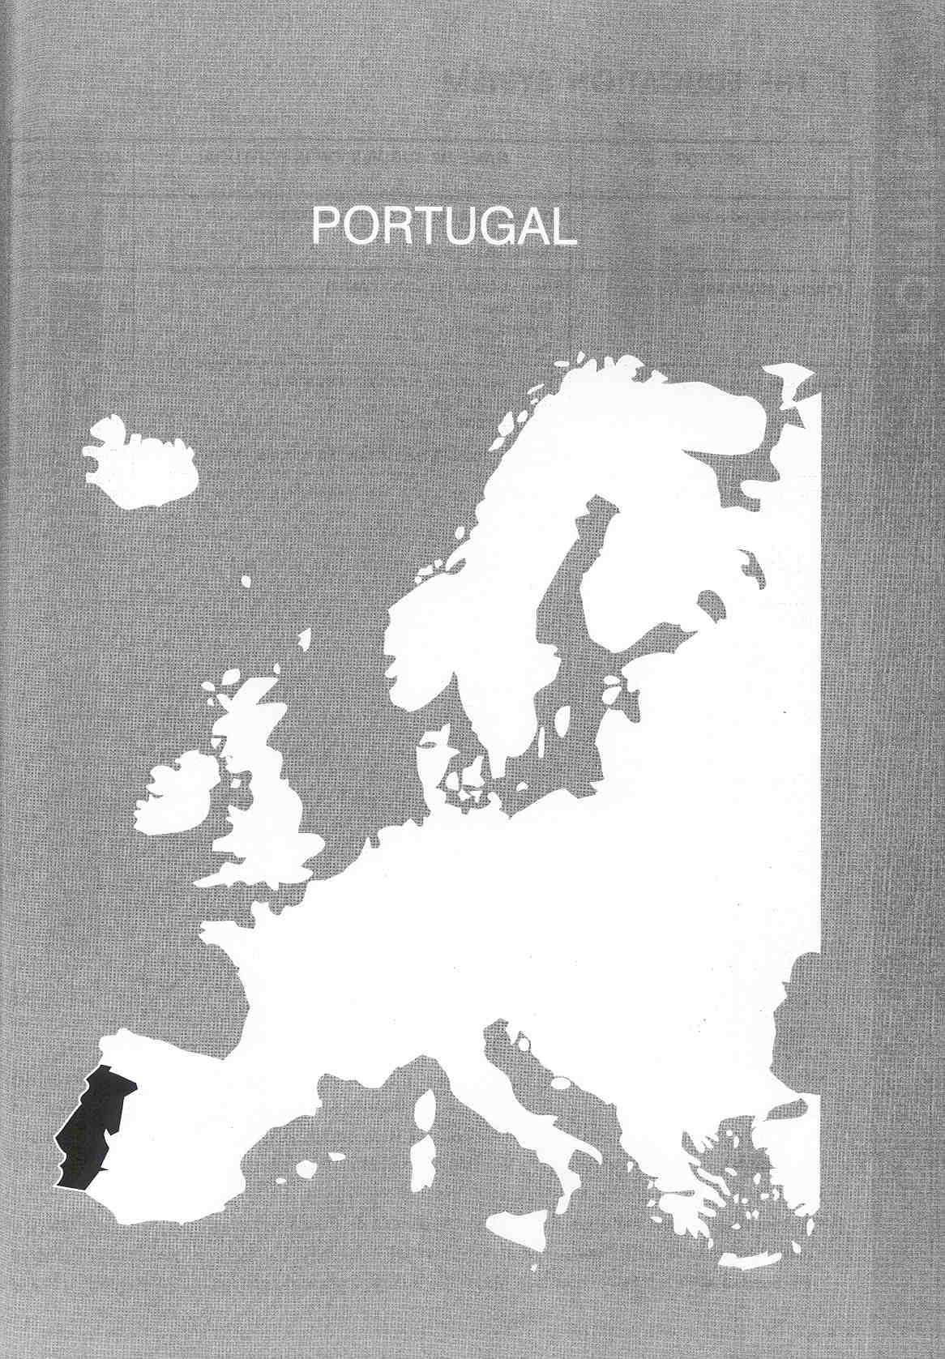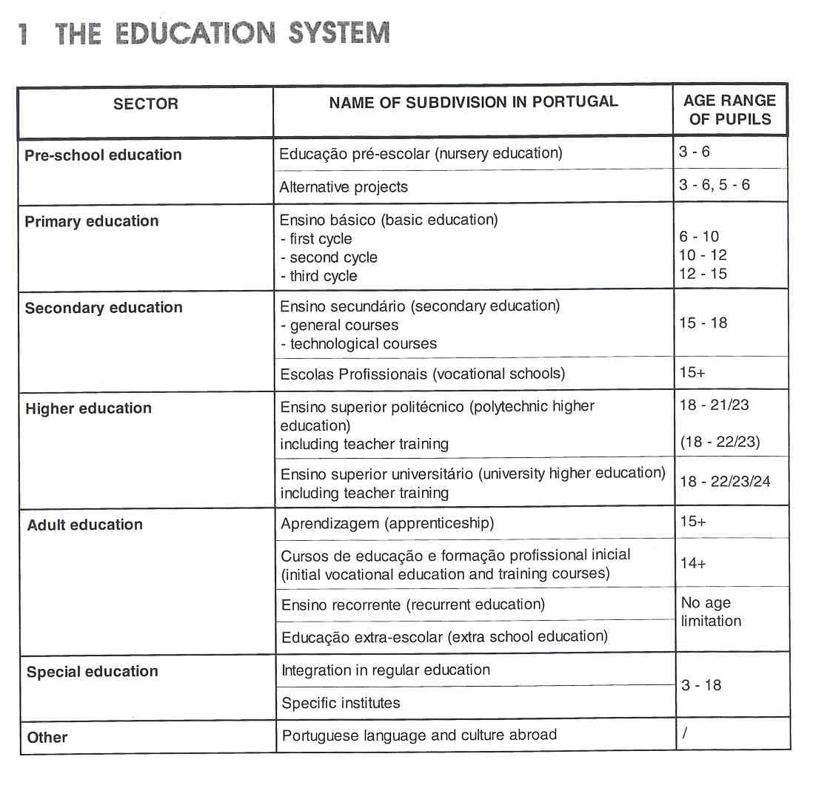
Νίκος Ηλιάδης, Πολ/κός Μηχ/κός Ε.Μ.Π., M.Sc.,
Ph.D. Industrial Education, Organization and Management,
Σύμβουλος του Παιδαγωγικού Ινστιτούτου

THE ADMINISTRATION OFTHE EDUCATION SYSTEM

In Portugal education is administrated at national, regional and local level as well as at the level of the education establishment.

- The Ministry of Education is responsible for defining the national educational policy. The administrative structure of the Ministry of Education comprises central and regional services and schools at the various levels of education. The task of the central services is essentially to assist the Ministry in the definition of the educational policy and to plan, co-ordinate, control and evaluate the formulated policy, whereas the executive duties are the responsibility of the regional services.
- At the regional level there are 5 "Direc95es Regionais de Educag5o" (DRE), regional services with administrative autonomy These decentralised services carry out a number of tasks, such as: financing the building of new schools, providing guidelines, co-ordination and pedagogical support to non-higher
- 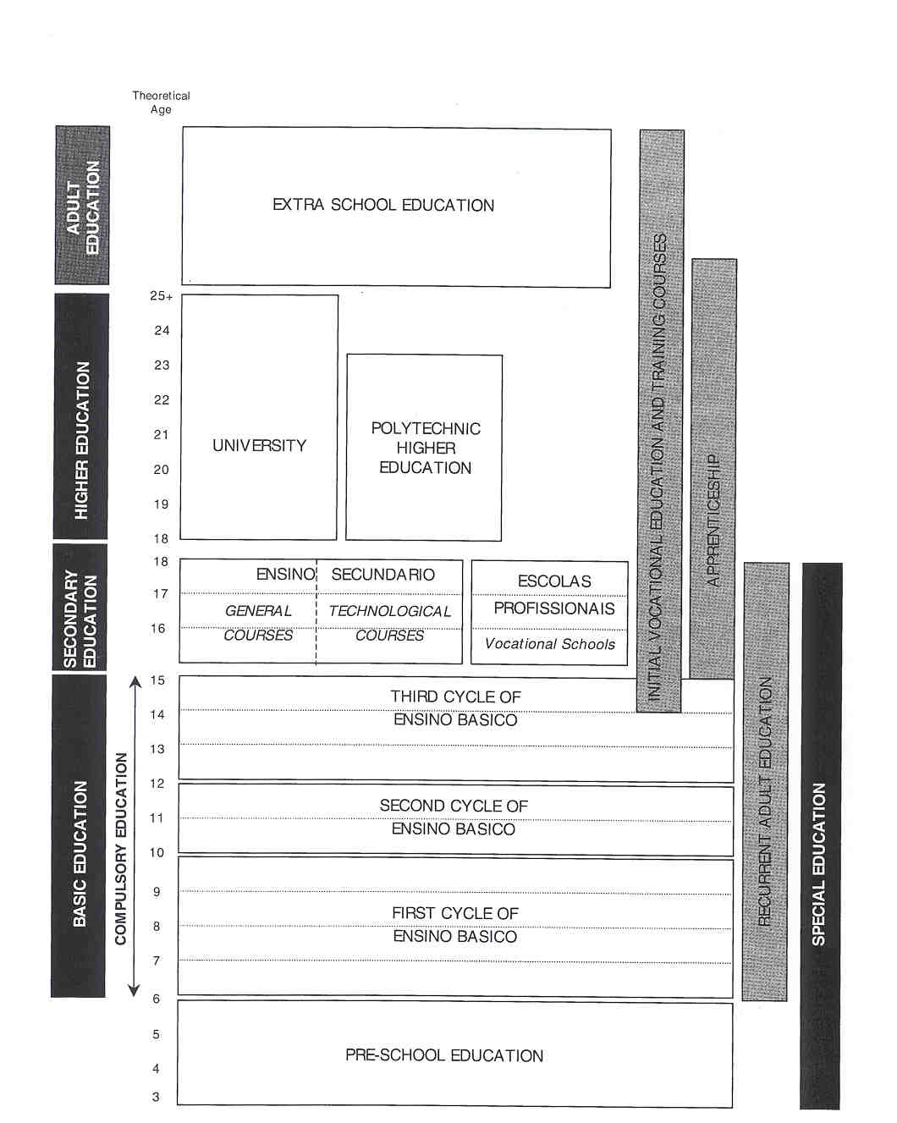

education schools, managing human, material and financial resources, providing school social support, supervising interschool sport activities.
- In the autonomous regions of Azores and Madeira, the administration of education is the responsibility of the Regional Secretary of Education, which is a regional governmental department with specific competencies allowing t .he adoption of some national legislation to the local characteristics and needs.
- Within each DRE, there are - at municipal or inter-municipal level - local education centres responsible for co-ordinating, orientating and assisting the activities of non-higher education establishments.
- Since 1989 there is a legislative framework laying down the statutory basis for autonomy. After an experimental period, in 1998, a new statutory basis for the pedagogical and cultural autonomy, administration and management of schools was approved and will be gradually implemented until the end of the school year 1999-2000. This legislation enhances the role of the educational establishments by giving them organizational resources and pedagogical responsibilities that will reduce direct intervention of the Ministry of Education.
The legislation gives full pedagogical, administrative and financial autonomy to universities and polytechnics.

The Portuguese Constitution acknowledges the freedom to learn and teach, including parents' right to choose and guide their children's education. There are two main types of schools: public schools, which are non denominational, established by and operating under the central and local public administration; and private and co-operative education schools, established and managed by private persons acting individually or collectively. Additionally, the Education System Act stipulates that "the establishments of private and co- operative education which fall under the general principles, aims, structures and objectives of the education system are deemed to be an integral part of the school networw'.

The State is the main contributor to the financing of education in Portugal. The Ministry of Education finances public education and central and regional services by means of the allocation of funds, while private and co-operative education are mostly financed through pupils' fees.

The general and specific objectives of each education sector are defined at national level. The curricular plans and programmes for preschool education, basic and secondary education are also defined by the Ministry of Education. The national curricula in basic and secondary education not only include the different subjects, time allocation and sequence, but also a detailed content of each subject, with objectives, topics, sequence and suggested teaching methodologies. It is possible, however, to adjust the organisation of curricula to the school's infrastructure and resources, in accordance with proposals submitted to the "DirecgAo Regional de Educa95o" under the school's statute of autonomy.
The organisation of the curricular plans in higher education is the responsibility of the individual establishments and has to be approved by the Minister of Education before being published.

The assessment of pupils/students in each education sector, except in higher education, is regulated by law. Assessment should focus on the achievement of the objectives of each sector and the specific objectives of each subject or subject area. Two kinds of examinations are organised centrally at national level:

- At the end of secondary education, national summative examinations are organised by the National Council for Secondary Education Examinations.
- The Ministry of Education, through a specific Education Evaluation Unit, also measures to what extent the curricular objectives are met at national level in order to monitor the quality of education by means of an "avaliagc@io aferida". This is a method of comparative assessment used for basic and secondary education levels, which consists of applying standardised tests for certain subjects at any time of the school year.

COMPULSORY EDUCATION

The Education System Act stipulates that there are 9 years of compulsory education. Compulsory education begins at the age of 6 with the lst year of basic education. Obligatory school attendance ends at the age of 15, i.e. at the end of basic education. The purpose of free compulsory schooling is to ensure that all children have access to education and academic success.

EDUCATIONAL.SECTORS AND SUBDIVISIONS

Pre-school Education (Educacao pre-escolar)

Pre-school education, provided for children between the ages of 3 and 6, is optional and is seen as an integral part of the education system. Nursery schools can be autonomous or associated to a school providing basic education.
There are 2 types of pre-school networks: a public and a private one. Shortly, both networks should be merged into a national network which will ensure universal preschool education.

The national preschool education objectives have to be achieved in accordance with appropriate contents, methods, and techniques which must take the child's home environment into account. A set of pedagogical guidelines and recommendations to achieve these objectives for preschool education have been laid down in legislation.
The pre-school teacher works 5 hours a day with the children, which corresponds to the educational component period. Beyond these hours, during the family support component, social and educational recreational activities are carried out. The Ministry of Work and Solidarity may support family expenses.

The access criterion in the public network is the children's age, priority being given to the eldest children. In the public nursery schools, attendance of the educational component is free of charge. Access criteria in private nursery schools are of a social nature and based on the needs of the families (parents share the costs according to the family income).

There are several alternative projects aiming at compensating the lack of resources of the preschool national network, e.g. itinerant education and child and community work. Itinerant education allows attending children to receive education within their family and community environment, and is meant for children who live in small and isolated areas. Child and community work is intended for children who will be attending the first year of basic education in the following year and who come from disadvantaged urban or suburban areas where there are no nursery schools.

Basic Education (Ensino baslco)

The 1986 Education System Act defines the organisation and the objectives governing basic education. It also establishes a general framework concerning school administration and management, curricular organisation and assessment.

Basic education is compulsory and free of charge. It aims at guaranteeing general education for all children, allowing the pupils to continue thei r studies or to join courses oriented towards active professional life. Basic education consists o f 3 consecutive cycles: the first lasts 4 years, the second 2 years and the third 3 years. Pupils enter the first cycle of basic education when they have reached the age of 6 before Septernber 15th, or Decernber 31st if there are free places at the school.

- Teaching in the first cycle is of a general nature, focused on the integrated development of studies and school activities. A single teacher teaches a class but other teachers may assist, when possible, in specific areas. The curriculum covers the following subjects: Portuguese language, mathematics, environmental studies, expression and education (physical, musical, drama and plastic), personal and social development or moral and religious education, ",&rea-escoia" and extra-curricular activities (which are optional and mainly of a recreational, formative and cultural nature). ",Area escoia" is a non- academic compulsory curricular area given at every year of basic and secondary education, through activities and multi-disciplinary projects in order to stimulate the social and personal development and autonomy of pupils and the acquisition of knowledge about the school or regional environment. Schools may also introduce the teaching of a foreign language (English or French) on a non-curricular and very elementary basis.
- In the second cycle a multi-teacher system is applied, with 1 teacher for each subject or combination of subjects. The curriculum, compulsory for all pupils, is organised in multidisciplinary areas: language (Portuguese, English/French) and social studies, mathematics and natural sciences, artistic and technological education, physical education, personal and social education, "@irea escola", and extra- curricular activities.
- The third cycle is also organised by subjects or groups of subjects, and teachers tend to be specialists in one or two cognate subjects. The curriculum plan for this cycle embraces a variety of subjects and multi-disciplinary subject areas covering individual subjects, allowing for pupils to make choices.

In "ensino basico", there are several forms of assessment. Formative assessment, the main assessment method, provides information on pupils' learning progress and on the achievement of the curriculum objectives. Ordinary summative assessment, at the end of each cycle (and at the end of each term in the second and third cycle) cheeks the overall development of the pupils against the national curriculum objectives and against the objectives set by the school. The result of this assessment is a "Pass" or a "Fail", which determines whether the pupil is going to pass on to the next cycle or not. Pupils who seem to have difficulties or a deficiency may have to take an extra-ordinary summative assessment in order to allow the school to decide whether a pupil has to repeat a year or not. They will have to follow an individual working programme.

Pupils in public education and in educationally equivalent private and co-operative schools who pass the final summative assessment are awarded a basic education certificate or "Diploma de Ensino Bdsico". Other pupils (e.g. pupils receiving education at home, or pupils in educationally non-equivalent private schools) have to pass an examination carried out at national level. Pupils who have reached the age limit for compulsory education (15) and have attended school with diligence are entitled to the Certificate of Completion of Compulsory Education, whether or not they have obtained a "Pass" in the final sumrnative evaluation.
Pupils with special educational needs who followed an alternative programme are awarded a certificate in order to be able to follow vocational training and employment, describing the skills and cornpetencies acquired.

Secondary Education (Ensino secundario)

The 1986 Education System Act established the objectives and the organisation of the "ensino secundario", defining it as a single post-compulsory education cycle with a duration of 3 years. Pupils can only enter these courses when they have successfully completed basic education or when they have obtained an equivalent qualification. Access to Specialised Art Schools (within the "ensino secund,-irio" system), however, requires previous training.

Secondary education is organised in two models. The model providing general courses is essentially aiming at the continuation of studies after secondary education. The other model provides technological courses, which are oriented to working life (but pupils still have the possibility to pursue their studies at a higher education level). Pupils can transfer between these models. Each secondary school has to provide the 2 models, although one of them may predominate.
In general courses as well as in technological courses, there are 4 broad groups of courses (branches of study): the scientific branch, the arts branch, the economic and social branch and the humanities branch. The curricular plans of each branch consist of general, specific and technicallartistic components, and of extra-curricular activities and "Area escoia". The general component, which is compulsory for all pupils, includes Portuguese, foreign language, introduction to philosophy, physical education, personal and social development or moral and religious education. The specific component differs according to the branch of study, but it must at least include the 2 or 3 core subjects which are common to general and technological courses of that branch. Finally, pupils have to choose a number of subjects from the technicallartistic component.

Specific for this education sector are the 2 kinds of summative assessment: internal summative assessment and external summative assessment. Internal summative assessment is a form of continuous assessment planned and carried out by the school itself. The external form, which is the final examination in "ensino secund6.rio", is an examination at national level. These final examinations on the subjects of the general and the specific components, are the responsibility of the Ministry of Education. They are intended to help ensure the homogeneity of grades. The final grade for each subject is calculated as a weighted average of the internal and the external final summative assessment. Pupils who complete the "ensino secundcario" are awarded a "Diploma de Estudos Secundarios" (diploma of secondary education) indicating the course taken and the final grade obtained. Pupils who complete an Arts course or a technological course also receive a "Diploma de QualificagAo Profissional de nfvel 111" (diploma of level Ill professional qualification).

Vocational Schools (Escolas Profissionale)

This relatively new type of school is an alternative to the regular "ensino secundario" system. These (mostly private) schools aim at providing vocational training alternatives through a network of schools set up under local initiative and using public or private funds. Pupils in these schools graduate as intermediate technicians.

Vocational schools are open. to applicants (adolescents or adults) having successfully completed basic education or obtained an equivalent qualification. Some of these schools also offer professionalising courses for applicants over the age of 15 who have completed the second cycle of basic education and subsequently dropped out of school.

Vocational schools offer a wide variety of 3-year vocational courses, which may be grouped under 17 training areas. 'The vocational courses consist of social and cultural, scientific, technical, artistic, practical and technological training components. They are usually organised in a modular structure. Vocational courses also include an obligatory period of training in a working environment during a probationary period. Pupils who succesfully complete vocational courses, are awarded a "Diploma de Estudos Secundarios" and a "Diploma de Qualificapdo Profissional de nivel 111" (diploma of level Ill professional qualification).

Vocational schools can also organise other courses, education or training activities:

- art courses for pupils who have concluded the second cycle of "ensino basico";
- second chance education;
- training courses, provided after working hours;
- specific vocational programmes for young people who dropped out of "ensino bdsico" or "secunddrio";
- specialised technological training courses, wich is a supplementary vocational training for students with a level Ill professional qualification or pupils who only reached the l lth year of secondary education (or equivalent). These courses comprise training at school and training in a working environment. They provide students with a professional qualification giving access to level IV vocational training and - under certain conditions - a secondary education diploma;
- other vocational training activities.

Higher Education

Higher education consists of both university education ("ensino superior universitdrio") and polytechnic education ("ensino superior polit6cnico"). University education is more theory-oriented, while polytechnics offer specialised education of a more practical and profession-oriented nature. These two subsystems within the higher education system are interconnected and it is possible to transfer from one to the other. Admission to higher education establishments is subject to the restrictions resulting from the maximum number of places available ("numerus clausus"). Applicants have to comply with a number of conditions, a.o. having obtained an application grade, which is equal to, or above the minimum established limit. These application grades are based on the grades obtained at the national final summative examination in "ensino secundario". Each higher education establishment is responsible for its own curricular plans. Assessment procedures depend on the higher education establishment but usually take the form of examinations.

In university education, courses are provided in all study areas. Universities may be organised into different faculties, institutes, departments or other units. At university level the following academic degrees can be obtained:

- “Bacharel": this degree reflects a scientific, technical and cultural education suitable for performing certain professional activities; these are usually 3-year courses.
- "Licenciado" (licentiate): this degree reflects a more profound academic, technical and cultural education, and aims at specialisation in a specific area and a high professional performance; these are usually 415- year courses.
- "Mestre" (master): this degree reflects profound knowledge in a scientific area, as well as the ability to carry out research. Normally it takes 2 years to become "Mestre" (1 curricular year plus 1 year to prepare a thesis).
- “Doutor” (doctor): this degree reflects the highest scientific and cultural level and the ability to carry out research in a specific area of knowledge. It normally takes 5 years to become a "Douto@' (4 years of research plus 1 year to prepare a thesis).

The polytechnic higher education is taught at Polytechnic Higher Institutes, specialised in the fields of technology, arts and education. This type of education has a 3 years' duration, awarding a bachelor's degree, or 4 years awarding a "licenciado" degree. High Schools of Education only offer 4 years' teacher training courses awarding a "licenciado" degree.

Teacher Training

Initial teacher training is provided by universities and polytechnic higher education establishments specialised in the area of education ("Escolas Superiores de Educa95o"). They also provide supplementary training or post-graduation specialisation courses preparing a teacher to carry out duties of a pedagogical or administrative nature, e.g. pedagogical guidance, school inspection, and school administrationlrnanagement.

"Escolas superiores de educag5o" and universities provide the initial training of nursery teachers ("educadores de inf;Ancia") and of teachers of "ensino b@tsico". The training of teachers for "ensino secund;Ario" takes place in universities only. The initial training courses include initial training in the area of special education. The professional qualification of "ensino bdsico" and "ensino secund6rio" teachers is also acquired through "licenciatura" courses (awarding a licentiate degree) that ensure academic training in the respective area of teaching (e.g. mathematics), supplemented by appropriate pedagogical training.

In 1998, the "escolas superiores de educagao" started to organise 2-cycle courses for teachers to become licentiate ("licenciado"), because an amendment in the Education System Act stipulated that all teachers at every level of education must hold such a degree. These courses are organised in 2 cycles, the first cycle (3 years) conferring the right to a bachelor degree and the second (1 or 2 years) to a licentiate degree.

Teachers in pre-school education, basic or secondary education, who have working experience in regular or special education, become qualified to work as special education teachers when they have successfully completed specific courses in higher education establishments.
A licentiate with a "douto@' or "rnestre" degree who has passed examinations testing pedagogical aptitudes and scientific competency or individuals with equivalent qualifications may teach in higher education establishments. There is no professional training for teachers of this education sector. '

Portugal also has a system of in-service professional training for teachers of the second and third cycles of "ensino bc@sico" or of "ensino secunddrio" who have an academic degree but do not have the necessary qualifications to teach. Higher education establishments provide these 2-year training courses.

Adult Education

In Portugal adult education is organised into the following main areas:

Apprenticeship (Aprendelzagem)

Apprenticeship is the initial vocational training process, integrated in the educational system and aimed at developing young people's capacities and acquisition of the necessary skills to pursue a qualified profession. It is a rotating system for young people who are over the compulsory schooling age limit and are preferably under 25. It comprises multi-purpose training integrated in the labour market and preparing the pupils for specific professional opportunities. It confers a professional qualification and the possibility of school progress and certification. Apprenticeship lasts 1 to 4 years. The courses differ according to the target group they are designed for:

- people who did not complete basic education;
- people who completed the 9 years of compulsory education but have no professional qualification;
- young people holding a level Ill professional qualification who want to attend post-secondary training, technological specialisation or advanced technological qualification courses.

Initial Vocational Education and Training Courses (cursos de educacao e formacao profissional inicial)

These courses, organised in basic and secondary schools in co-ordination with other local entities, aim at providing young people with a qualifying professional training before they integrate in working life. These courses are meant for young people, lacking any professional qualification, who completed or attended the gth year of schooling and who wish to start a working life. These courses - in addition to the apprenticeship system - are developed under the responsibility of State departments and public organisations. They aim at promoting vocational training and helping young people to obtain vocational and employment qualifications and at providing employers with skilled workers. The courses have a flexible duration and include training at school and training in a working environment. They confer a level ii professional qualification certificate and/ or a diploma certifying completion of the gth year of schooling.

Recurrent Education (ensino recorrente)

This is the adult education area that follows organised structures and syllabuses allowing to obtain a degree and awarding diplomas or certificates which are equivalent to those provided by regular education. This special education modality, aiming at ensuring second chance schooling, includes two levels of education: basic education and secondary education. The specific organisation of recurrent education is characterised by the fact that it seeks to adapt itself to the age of people for whom it is intended, taking into account their life experience and knowledge level.

Extra-school Educatfon (educacao extra – escolar)

Extra-school education is a set of systematic cultural and educational activities, which are organised outside the school system and carried out through multiple public or private initiatives. It may be co-ordinated with recurrent education and school education. It is considered as being part of permanent education and aims at achieving an overall and continuous education. The courses may be of the following types: literacy courses, upgrading courses, social-educational courses and social-vocational courses. It allows individuals to complement their school education or to make up for the lack of it.

Special Education

Special education is organised according to diversified models of integration in regular schools. Special education initiatives may fall under central, regional or local.authority Other collective entities, namely parents and local associations, civic, religious, professional union organisations and welfare institutions may equally develop special education and teaching initiatives. Special education is delivered in specific institutions whenever the type and level of the pupil's special educational needs truly requires it. The attendance of a specific institution is su'pplementary to the application of the principles of school integration, and is acceptable whenever there is no educational alternative in regular schools. These specific institutions are meant for pupils, within school age, who have special needs resulting from serious communication handicaps (e.g. sight and hearing impairments, language handicaps), serious difficulties in understanding the normal curriculum (e.g. mental handicaps), or serious emotional and behaviour problems.

The Ministry of Education also has local support structures for special education, which cover the entire non- higher education system. These structures include special support teachers and special educational support co-ordination teams. Support teachers are responsible for developing the direct assistance of children and young people with special educational needs, for promoting the active participation of teachers (from regular education) and parents in the implementation and evaluation of individual programmes. The educational support co-ordination teams (consisting of teachers with a specialised training) are responsible for co-ordinating, monitoring and stimulating the local provision of educational support in their area.

There is no specific curriculum for special education in Portugal. Each school or teacher may adjust the normal curricula to meet the special needs. The curricular adjustments may consist in partial reduction of the curriculum or exemption from some activities. As a consequence, a pupil with special educational needs may follow:

- the curriculum organised by the school which, though in line with the national curriculum, is adjusted to the level and type of disability;
- alternative curricula designed to establish a differentiated education, e.g. through flexibility in the curricula for specific groups of pupils who are confronted with learning difficulties, repeated school failures, or difficulties of integration in the school community.

Portuguese Language and Culture Abroad

This is a special modality of school education aiming at promoting the diffusion and the formal study of the Portuguese language and culture, namely through

- the integration of courses on the Portuguese language and culture in the national curriculum of other countries. In most cases these courses are taught by Portuguese teachers at the expenses of the Portuguese government;
- the establishment of Portuguese schools in the countries where Portuguese is the official language;
- the provision of courses and activities in a system that is complementary to the education systems of countries with large Portuguese communities (e.g. in France, Germany, Luxembourg, Spain, Switzerland, USA).

The main goals are:

- the preservation and development of the Portuguese language and culture;
- the protection of the rights of Portuguese citizens and their children aiming at a full integration in the education systems of the countries where they live in;
- the maintenance of the linguistic and cultural links to Portugal;
- eventually, their (re)-integration in the Portuguese education system and in the homeland.

2 THE ORGANISATION OF THE INSPECTORATE

The "Inspeccaoo-Geral da Educacao" (IGE), the General Inspectorate of Education, is a central service of the Ministry of Education. The IGE is responsible for the educational and technical supervision and monitoring of the education system. It exercises its authority at every level of the State and private education system: pre- school education, basic education, secondary education and higher education, including adult education and special education. As far as higher education is concerned, the Inspectorate's work is confined to administrative and financial matters.

The Portuguese Inspectorate is basically structured in three kinds of services, which all come under the General Inspector, who is assisted by two Deputy General Inspectors.

- Those whose responsibility is strategic. They form part of the central services. Their main duties are the definition of types and methodologies of intervention, the study and the production of instruments and the analysis of the results. Four Unit Chiefs head these services with strategic responsibility.
- Those whose responsibility is operational. the 5 Regional Delegations. At regional level, the competencies of the General Inspectorate of Education are carried out by these delegations, whose territorial scope generally coincides with the National Planning and Development Co-ordination Sectors in which the country is divided and the Regional Services of Education (DRE). These regional delegations of the Inspectorate are responsible for the technical, educational, administrative, financial, and assets supervision of the education system in their respective regional areas. They perform their duty in the field and, due to their experience and knowledge, also collaborate with the services of strategic responsibility in the study and definition of inspection methodologies and in the production of instruments and reports. These services with operational responsibility are headed by 5 Regional Delegates (Regional Chief Inspectors).
Each Regional Delegation has two services: a technical unit (GATI) of which the main tasks are to give support to the Regional Chief Inspector in the co-ordination of the inspection activities and to the inspectors, to prepare reports related to the inspection interventions, to collaborate in the preparation of the Annual Activity Plan; to organise the documentation centre and to distribute all information to the inspectors. The second service is the administrative office which deals with human, budgetary and material matters. The technical unit (GATI) which is headed by a Unit Chief, can be divided into 1 to 4 subunits. A number of inspectors (not fixed) and technicians are attached to these units.
- Those whose responsibility is structural and supporting. They are part of the central services. They supply the activities of the IGE with general support in areas such as legislation (GAJ-unit), human resources, general administration and budget (GAG-unit), planning, documentation and in-service training (GPDF-unit), new information technologies (Gi-unit). These 4 services with structural and supporting responsibility, which are headed by 4 Unit Chiefs, are directly co-ordinated by the General Inspector or by one of the Deputy General Inspectors.

In addition to these services, an advising and assisting service for the General Inspector was set up (REI). This was necessary because of the specificity of certain external and international matters, such as the European Schools, Portuguese language and culture in the African countries where Portuguese is the official language, and international affairs. This service, which is supervised by 2 inspectors of the highest rank (inspector superior principal), is directly co-ordinated by the General Inspector.

The IGE is a service of national dimension and regards the entire education system, while its Regional Delegations provide the essential support for the operationalisation of its work. '

The senior management of the Inspectorate consists of 1 General Inspector, 2 Deputy General Inspectors, 5 Regional Delegates (Regional Chief Inspectors) and 9 Unit Chiefs.
The IGE human resources involve:

- Inspection staff with 4 career categories: Inspector, Inspector Principal, Inspector Superior, Inspector Superior Principal;
- Technical staff ("T6enico Superio@'): civil servants with a higher education degree in specific areas, e.g. law, new information technologies, finance, documentation/ librarianship;
- Administrative staff.. civil servants with professional qualifications, e.g. as archivists, typists, administration and human resources officers;
- Auxiliary staff., civil servants with no specific professional qualifications who do very simple tasks, e.g. assuring the distribution of mail, internal orders, information, photocopies.

As the number of inspectors is not yet completed (the total formation for inspectors is 430, but at present only 234 places are fulfilled), a certain number of teachers is seconded to work in the central and regional services, where they develop inspection tasks. At present there are 127 of these teachers ("professores requisitados").

The Government, through the Ministry of Education, is responsible for funding the Inspectorate. The Inspectorate has an annual budget included in the budget of the Ministry of Education, which is approved by Parliament. The General inspector is entirely responsible for the functioning of the Inspectorate, within the autonomy the law allows and under financial rules.
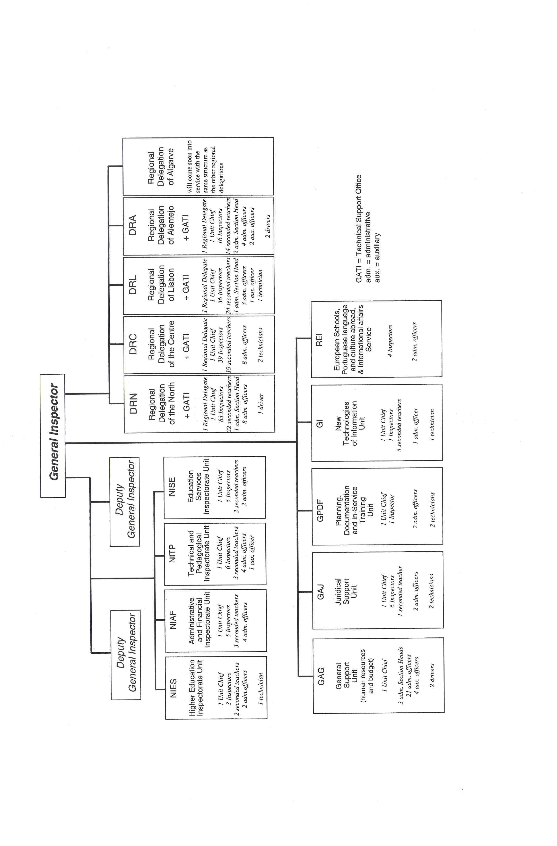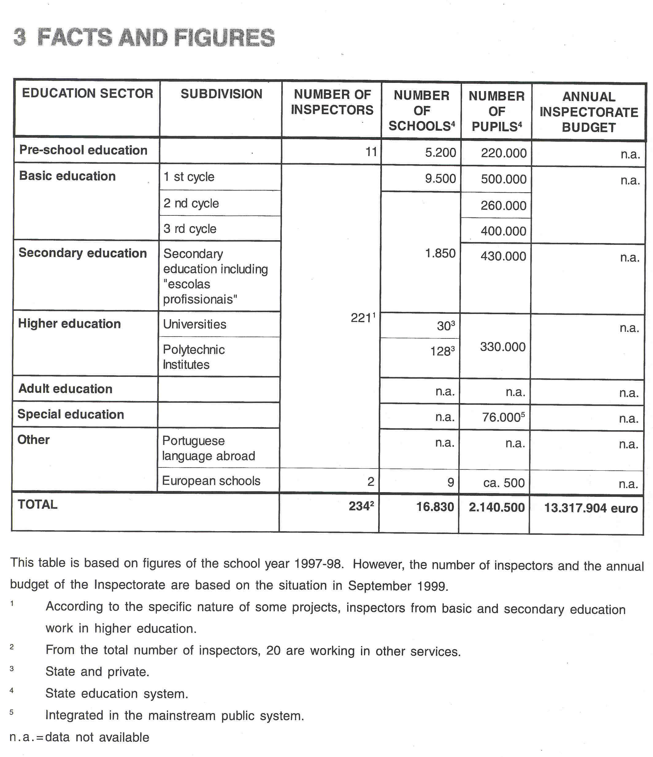

4 THE RECRUITMENT OF THE INSPECTORATE

Candidates to the IGE are required to have a higher education diploma ("licenciatura") and pedagogical qualification plus experience in teaching or in the civil service. At least 5 years of experience as a qualified teacher or, in certain circumstances, as an up-graded civil servant are required. Some supplementary aspects, which are taken into consideration for the recruitment procedures are, e.g. frequency of in-service training, teacher training monitoring, post-graduation in the education area, management or co-ordination functions in the administration of the education system or in one or more schools.

Applicants take part in a national competition and are appointed on the base of an analysis of their curriculum vitae, the results of a written selection test and an interview. The selection test, which includes different topics, is organised under the responsibility of the Inspectorate (e.g. on education, pedagogy, state organisation and administration, education system, school management, budget management, legislation and others). Both the evaluation of the "curriculum vitae" and the tests are aimed at selection.

When the new inspectors have finished their probation period (1 year), consisting of a theoretical part organised by a university and a practical part under the direct supervision of the Inspectorate, they are evaluated and may or may not get a permanent position.

5 THE WORKING CONDITIONS OF THE INSPECTORATE

The function of inspector has always been a full-time job. In general, inspectors hold a permanent position. They are appointed to the Central Services or to one of the Regional Delegations. When they are appointed to a Regional Delegation, inspectors are spread in the geographical area of that Delegation.

6 AREAS OF INSPECTORATE RESPONSIBILITY

Legally, the IGE has the following specific duties:

- to assess and monitor the educational and technical quality of preschool, school and extra-school establishments, services and activities;
- to provide educational and administrative support to the directorate and management bodies of the non- higher education establishments;
- to assess and monitor the administrative, financial and management efficiency of all establishments and services within the education system;
- to assist with technical support in the preparation of measures aimed at improving the education system;
- to assure the organisation of inspections of the teaching of the Portuguese language and culture abroad;
- to represent the Ministry of Education in the European Schools' Inspectorate;
- to make inquiries into and to take disciplinary action against teaching and non-teaching staff.

The main aim of the Inspectorate is above all the evaluation and control of the education system, thus acting as an audit and inspection service of the way the education system works. The IGE is responsible for the educational and technical supervision and monitoring of all education establishments. With regard to public higher education, the Inspectorate is mainly responsible for verifying compliance with the legal pedagogical and financial provisions, governing tuition fees and social support for students.

Consequently, the Inspectorate is also a service of technical support to the Ministry of Education. Its activities comprise technical, pedagogical, administrative, financial and disciplinary aspects both in non- higher and higher education, both State and private education.

Each year an Annual Activity Plan is set up by the General Inspector, which establishes the following ultimate objectives:

- to ensure the control of the way the education system works;
- to guarantee the quality of education;
- to protect the rights and legal interests of the pupils and their families.

This Activity Plan contains a number of specific projects,. which are included in several main programmes. However, in this Plan the regular and systematic work of the IGE, for example, disciplinary activities or the human and budgetary resources management, is not included.
The Annual Activity Plan for 1 999 contains 8 main programmes, each of them with a certain number of projects:

- Pre-school Education: 2 projects
- Basic/Compulsory Education: 4 projects
- Secondary Education: 4 projects
- Higher Education and In-service Teacher Training: 6 projects
- Portuguese Language and Culture Abroad: 3 projects
- IGE Administrative Modernisation: 5 projects
- International Affairs. 3 projects
- The Situation of Education: 1 project

In general, the key functions of the Portuguese Inspectorate are: evaluating, auditing, advising, monitoring and reporting.

6.1 EVALUATING

Evaluation of Schools/Ilntitutions

- In the past, the inspection activities were focused on checking compliance with norms and regulations. As a consequence, school inspectors spent a great deal of their time on disciplinary actions against school staff and institutions. The emphasis in the work of the Inspectorate was to control the schools' compliance with rules. The main concern of the Inspectorate was to guarantee the normative conformity of schools to the rules and regulations at organisational, pedagogical, and administrative level. Moreover, the Inspectorate was also the key disciplinary agency that acted with regard to teachers and other staff. The Inspectorate performed a role as the guardian of normative conformity by controlling schools' strict compliance with rules. As a consequence of the fact that educational policy changed in the direction of deregulation and school autonomy, compliance with regulations is no longer the central concern of the work of inspectors. The Inspectorate goes on performing its duty of checking the observance of the law but more and more it assumes the role of evaluator of the quality of schools' performance through external evaluation of schools and other education services, and promotes the self-evaluation of these institutions/services. Summarised, the evaluation of schools' compliance with regulations is still important but it is turning into only one of the different aspects of the integral evaluation of the school as a whole.
- Evaluation of the quality of the education provided by each school is a main aim of the Inspectorate. Normally this is done in the form of integral school evaluation inspections. Through these inspections the Inspectorate wants to support the school management by informing them about the strong and weak points detected and to.prornote school self-evaluation. Recently, the Inspectorate has explicitly been calling attention of schools to the importance and the need for a self-evaluation process, which is not yet a obligatory task but should take place in a regular and systematic way. Such seif-evaluation must act as a view of the strong and weak points in relation to the school's education project. School's self-evaluation can be very helpful for the elaboration of proposals the Inspectorate considers necessary for the general improvement of the education system.

These integral school inspections are carried out for the first time in 1999, on the basis of experimental activities performed during the past few years. These school audits constitute a very important and powerful working method. They are focused on the school as a whole and not on specific evaluation of the individual actors in the school. The following elements are characteristic of the Portuguese school audits:

- audits are simultaneously process and product oriented;
- the aspects specially focused on are: educational planning, general organisation, curricular management, pupiis'assessment, school ethos, budget management, school's compliance with statutory regulations, pastoral and social support;
- schools have some administrative and financial autonomy and are responsible for their own budget and financial management. So, strong emphasis is put on the evaluation of managerial-adrninistrative tasks such as school pupils' social support, organisation of staff timetables, organisation of pupils' files and class timetables;
- schools are requested to report on their performance and specific context in a self-evaluative way;
- inspectors use quantitative and qualitative data during the inspection and in reporting;
- inspectors identify the key strengths and the main points for action, discuss them with the school and produce a report;
- until now auditing services have involved inspectors, headteachers and administrative staff, but in the near future a broader audience for these reports will be considered involving the staff of the school inspected, parents and the regional educational authorities.

- The development of public and private higher education in this decade impelled the Inspectorate to develop regular general audits of the pedagogical, administrative and financial organisation and functioning of universities and polytechnic institutes. This systematic approach enables the preparation of reports with recommendations and, whenever the situation demands it, the presentation of proposals to change the existing conditions. The production of instruments to support this kind of activities implies permanent improvement with the participation of other institutions and, in particular, of external experts.
- The lnspectorates both of the Ministry of Education and the Ministry of Social Security and Solidarity are now running a joint project of pedagogical audits in the private network of nursery schools that are under the supervision of the Ministry of Labour and Solidarity to evaluate their overall quality. These pedagogical audits focus mainly on the teaching process and resources.

Evaluation of Subject Areas

Evaluation of selected subject areas in public schools has recently been included in the Activity Plan of the Inspectorate. The aim is to judge how schools guarantee the quality of the teaching-learning process. The evaluation includes the appreciation of how area/subject co-ordinators and pedagogical councils work. An example of areas/subjects evaluated in a separate inspection project is: Portuguese, mathematics, philosophy and sciences, in secondary education, 12th year.

Evaluation of Branches of Study

Besides emphasis on evaluation of subject areas, emphasis is also put on evaluation of branches of study, depending, however, on priorities. In the school year 1998, for example, the secondary final year (12th year) was specially focused on through study case methodology. This kind of evaluation was a separate inspection project but it is now going to be part of the integral school evaluation.

Aspect Evaluations at a National Level

The project concerning the start of the school year (organisation of classes and courses, pupils' and teachers' timetables, organisation of teaching support to pupils with special needs) in basic and secondary schools is an example of this kind of evaluation. It is meant for the Minister and national and regional authorities.

Control of the Organisation of National Examinations In Schools

The control of national examinations (final examination of secondary education) deserves special attention of the IGE due to their national interest. The Inspectorate has the responsibility to control the way schools organise the national examinations. Every year this evaluation takes place before, during and after the examinations at the national level.

Evaluation of Other Educational Establishments and Services

According to the law, the Inspectorate has to assess the efficiency of all establishments and services within the education system. As a consequence, it also fails within the duties of the IGE:

- to ensure the realisation of audits of the Central and Regional services of the Ministry of Education, by decision of the Minister himself.
- to ensure audits of every education structure involved in the management of projects or activities financed by national or E.U. authorities, e.g. in-service teacher training projects, acquisition of equipment and education infrastructures.

Evaluation of Teachers, School Staff, and Other Individuals under the Responsibility of the Ministry of Education

- The Inspectorate is not concerned with the evaluation of individual teachers. Each school is responsible, according to specific legislation, for the evaluation of its teachers. However, principals tend to leave their disciplinary responsibilities to the Inspectorate. Moreover, according to the law, the Inspectorate is also responsible for the organisation, development and registration of disciplinary actions (simple investigations, inquiries and disciplinary procedures) against individuals or institutions directly under the responsibility of the Min istry of Education. The Inspectorate has to make disciplinary investigations into situations of irregular behaviour of the different members of the school staff and into situations of non- compliance with legal norms and regulations. In case of disagreement or complaints about a teacher the Inspectorate is part of an appeal commission.

- The IGE is also responsible for the supervision of courses and teachers of the Portuguese language and culture abroad. Yearly some inspection visits are made to countries where these courses take place in order to supervise them and to inform the Minister about the quality of these courses.

Evaluation of the Portuguese Education System

In order to have a general insight into the education system, the Inspectorate is responsible for the evaluation of the school system as a whole (at the different education levels). The Inspectorate has to try to make an evaluation of the actual practice to get a picture of how school life is and of things happening in schools., By evaluating schools as individual organisations and by evaluating the school system as a whole, the Inspectorate wants to build up a permanent observation system of the education system and school performance. These activities ought to produce the necessary information to report to the Government on the existing situation. The contribution of IGE to the evaluation of the education system as a whole will be based on the information gathered during the inspection activities. The way in which IGE will make this contribution is still being prepared.

6.2 ADVISING

- The Inspectorate provides advice to the regional and central education authorities and to the Minister. The activities of the Inspectorate are a fundamental element of support for political decisions, especially by providing carefully worked out information resulting from regular, systematic, integrated and planned work carried out by teams of inspectors in schools.
- The Inspectorate can also provide guidance and advice to the school management. This support is seen as an inherent part of the evaluation activities and not as a particular goal. The Inspectorate informs the school on what has to be improved but does not say how it has to be done.

6.3 MONITORING

- The information collected during school inspections and other evaluations is used for the implementation of a permanent obervation system of the schools and of the education system as a whole. Therefore, a database of all the information coming from schools is now being set up.
- The Portuguese Inspectorate co-operates and participates in the administrative management, the pedagogical and financial guidance, and the co-ordination of European schools.

6.4 REPORTING

- The Inspectorate produces reports on its evaluation of schools and other educational establishments and services, of subject areas, of branches of study, of aspect evaluations at national level, of the organisation of national examinations in schools, of teachers, school staff, and other individuals under the responsibility of the Ministry of Education, and on the evaluation of the Portuguese school system as a whole.
- The reports resulting from advisory tasks are addressed to the Minister, governing bodies and headteachers, teachers and school officials. They include the Inspectorate's views on the issues under observation or treatment.

7 THE ROLE OF THE INSPECTORATE IN EDUCATIONAL POLICY

As the General Inspector is a permanent member of the "Board of Directors General of the Ministry of Education", an advisory body the Minister regularly meets, the Inspectorate participates in preparing the educational policy mainly through the results of the evaluation activities. The Inspectorate also participates, though indirectly, by,rneans of the reports and recommendations it sends to the Ministry.

Because the Inspectorate predominantly works in schools, it is a pre-eminent service the Ministry of Education has at its disposal to control the development and implementation of the education policy in schools. This is an important function which the Inspectorate permanently carries out.

In general the Inspectorate is on the front line whenever the effectiveness of the policy is evaluated. Its contribution is valuable since, differently from other institutions, the Inspectorate works in the field in direct contact with schools, governing bodies, teachers, pupils and parents.

8 WHO IS IN CHARGE?

The General Inspector, assisted by the other members of the senior management, decides upon the Inspectorate orientation. The senior management suggests a number of projects for the following year. For each project the co-ordination responsibility, the external partners (departments of the Ministry of Education), the general and specific objectives, the guidelines, the methodology and time schedule, the co-ordination team, the duration and costs are defined.
Once the General Inspector has approved the different projects, they are included in the Annual Activity Plan of the Inspectorate. This plan is submitted to the Minister for approval. He has the final say. Once the Annual Activity Plan is approved by the Minister, the responsibility for the further development and implementation lies with the General Inspector.
The Inspectorate senior management and particularly the Heads of the Regional Delegations have the competence to administer their local resources and to organise the service distribution within the framework of the General Inspector and the time distributions included in the Activity Plan.
Finally, it is the individual inspector or a team of inspectors who organise the work according to the tasks and the time available. The programme of activities is approved and controlled by their immediate chiefs.

In addition to approving the Annual Activity Plan, the Minister may also decide at any time on any activity not included in the Plan for a certain period. In general these activities correspond to a very specific or urgent situation, for example an activity regarding the immediate results of new rules on the organisation of timetables of teachers.

9 THE POSITION OF THE INSPECTORATE

As the Inspectorate is a part of the structure of the Ministry of Education, it depends directly on the Minister and his Secretaries of State. Its mission is to aid, sustain and technically support the processes of evaluation and follow-up of the educational policy, which is issued at governmental level.

The Inspectorate is apartner as well as an evaluator of the education administration services. As a partner, the Inspectorate informs the administration about the concrete performance of each school or organisation within the education system or about the educational system as a whole. On the other hand, the Inspectorate can also evaluate the performance of the administration as part of the education system.

The Inspectorate has a complementary position regarding the institutions for national assessment, such as the Department of Evaluation, Planning and Prospective, the Department of Financial Management and the Institute of Innovation in Education. All of them in their own way participate in the assessment of the educational system using different methods and tools. Every perspective and view can be useful for creating a better picture of the real, concrete situation.

The position of the Inspectorate regarding institutions for curriculum development is more distant. There is only an indirect relation: on the one hand through the analysis these institutions can make of the inspection reports, and on the other hand through the participation of the Inspectorate in interdepartmental specific work groups dealing with curriculum issues.

10 THE INSPECTION PROCESS

Inspection work is developed according to broad programmes, which include several projects. Methodology, timing, type of reports are indicated for each project. E.g. for the project "integral school evaluation", the following phases were defined:

PREPARATION PHASE

Schools to be inspected are selected. The formats for the reports are prepared to facilitate the organisation of the regional and national reports. The inspection learns that are involved in the project are composed and prepared.
The school is informed about the inspection that is going to take place. The inspector or the co-ordinator of the inspection team contacts the school to give information about the day or days the visit will take place. If necessary, he asks the school to send pre-inspection information or documentation.

SCHOOL PHASE

The tearn carries out the inspection, which, on average, takes one week.

REPORTING PHASE

Immediately after the inspection the team informs the school on what has been observed, on the strong and weak points. Subsequently the report is prepared, including conclusions and recommendations to be integrated in the strategic development of the school and is then sent to the IGE regional department to be analysed. Finally it is formally presented to the school.

FOLLOW-UP PHASE

In the sequence of inspection a follow-up activity can often take place to evaluate the results of the previous inspection. But there is no systematic follow-up procedure yet.

11 INSTRUMENTS AND METHODS

THE COLLECTION OF INFORMATION

Inspection work is developed according to projects included in programmes. Each project has its own methodology and may be developed by a tearn of inspectors or by a single inspector.

a. Questionnaires

Questionnaires are used to collect specific information from schoolheads or parents, for instance, when the performance of the school as a whole is being evaluated.
For evaluation projects of national scope, questionnaires can be used (e.g. in case of an aspect evaluation about a specific topic).

b. Interviews

Individual and group interviews are procedures frequently used to collect information.

c. Observations

Current procedures used by inspectors are direct observations of lessons, activities or meetings. Observations and interviews can be considered as the most important techniques and the strongest tools the Portuguese inspectors have at their disposal.

d. Tests/examinations

Inspectors do not test pupils. Only in the case of very specific complaints, tests or written examinations of pupils are used by the Inspectorate but they are treated as mere documents. (See e.)

e. The Collection of Documents

The collection of documents is another frequently used procedure of the Inspectorate and it is considered to be an indispensable source of information.

f. The use of National Data

Inspectors also use "national data", as in data on the number of schools, type of schools, number of pupils and teachers, qualification of teachers, funding, etc.

APPROACHES

a. Instruments

The Inspectorate performs its role mainly by means of evaluation inspections and audits. For that purpose inspectors use specific and as far as possible common methodologies, guidelines and procedures. The work is developed through projects, mainly aimed at the evaluation of the performance of the school as a whole or of some particular aspects of school life (subject departments, pupil assessment, curriculum, school management, budget control .... ),

In general, for each projectlactivity a specific guide is prepared and used by the team of inspectors involved. Certain projects, such as the general evaluation of entire schools make use of uniform instruments. A specific guide for each education level is produced by a team of inspectors with the support of external experts and the participation of the Departments of Basic and Secondary Education for the identification of possible or particular priorities. Both the guides and support documentation are analysed and discussed by representatives of the IGE Regional Delegations and Education Regional Services (DRE).
Only schools subjected to an inspection know the contents of these instruments, which are, in general, periodically updated in accordance with the experiences and the suggestions of inspectors based on their work in schools, the suggestions of external experts, DRE, Basic and Secondary Education Departments, school direction boards and other partners (teachers' Unions, Parents' Associations).

b. Teamwork - Individual Work

Inspectors can work individually or in teams according to the methodology indicated for the projects. Teams can also be mixed: basic and secondary inspectors, pedagogical and financial inspectors.

12 JUDGEMENT AND ITS CONSEQUENCES

After an inspection of a school, the strong and weak points as well as recommendations for a better performance are pointed out to the school. If the school is not acting in compliance with statutory regulations it has to rdrnedy its procedures as quickly as possible. In case of evident or serious disrespect of legal procedures a decision to hold an inquiry or a disciplinary action can be taken by the General Inspector.

For the moment, there are no data to calculate a reliable ratio on the judgements based on the inspections. It can, however, be said that most schools have more strong than weak points.

A negative recommendation does not necessarily reflect on the teacher's appointments or on the annual school budget unless a particular project for which the school receives extra money, does not meet its objectives. A negative recommendation mainly implies that the school has to be carefully followed.

A positive recommendation recognises how well the school is working, appreciates its social merit and value. This recommendation is a stimulus for the school to go on.

The school report is sent to the regional education authorities - Regional Director of Education - who have the opportunity to support, for example, positive initiatives or to create conditions to improve the school's performance, including material resources.

13 OUTCOMES

The Inspectorate draws up the following reports.

REPORTS ON TEACHERS OR OTHER INDIVIDUALS UNDER THE RESPONSIBILITY OF THE MINISTRY OF EDUCATION

Reports on evaluation of teachers or other individuals are only prepared in case of very specific issues, e.g. as a result of disciplinary action. These reports are confidential and only meant for the school, the teacher, the

Minister and other education authorities, if requested.

REPORTS ON SCHOOLS /INSTITUTIONS

Reports on Schoois'Compliance with Statutory Regulations

These reports mainly deal with compliance with statutory regulations in the financial and administration areas. They are based on separate inspections and are addressed to the schools involved. They can also be addressed to regional education authorities. (DRE), if this is decided by the Inspector General.

Reports on School Evaluations

This report describes the strong and weak points of the school. A number of recommendations are made in the report which is meant for the school, the regional education authorities, the parents' association and in some circumstances the local administration authorities.

Reports on the Evaluation of State and Private Higher Education lnatitutes/Universities

The State and private higher education comes also under the authority of the Inspectorate regarding the management of State or E.U. funds as well as pedagogical and administrative aspects and their compliance with statutory regulations. The Inspectorate develops a regular activity in this area, the reports of which are sent to the Minister and the central Higher Education Department.

REPORTS ON THE EVALUATION OF SUBJECT AREAS

These reports are the result of an experimental project (mathematics and Portuguese, philosophy andlor sciences, 12th year) that took place in a very small sample of secondary schools, that volunteered to take part in it. This kind of evaluations might be inserted in the project concerning the integral evaluation of schools. The final general report will be presented to the schools at a specific seminar.

REPORTS ON ASPECT EVALUATIONS AT NATIONAL LEVEL

These reports, for example, on the start of the school year, are meant for the Minister and central and regional education authorities.

REPORTS ON OTHER EDUCATIONAL ESTABLISHMENTS AND SERVICES

The work of the Inspectorate also extends to central and regional services. The Inspectorate has to control and evaluate their efficiency The decision to carry out such an evaluation has to be taken by the Minister.

REPORTS ON THE ORGANISATION OF NATIONAL EXAMINATIONS IN SCHOOLS

The inspectorate yearly controls the overall organisation and development of examinations in the secondary schools at national level (it does not analyse pupils' results). The reports are specially meant for the Minister and the national board that is responsible for the implementation of the examinations.

REPORTS ON THE PORTUGUESE EDUCATION SYSTEM

The organisation of a report on the state of Portuguese education is not the responsibility of any specific institution. The different education services produce their own reports according to their competencies and analysis of the system. The Inspectorate is now studying, on the basis of a more systematic integral evaluation of schools, the best way to organise its report and its contribution to the evaluation of the education system.

Reports are not published or distributed but in some circumstances they are obtainable by request. Depending on the contents, any of the reports mentioned above, except those of a disciplinary nature, can also be addressed to other education authorities or institutions.

- Reports written only for the Minister are confidential.
- Reports addressed to the schools are not confidential, but must be used strictly by the school and by the regional or central education authorities.
- Reports for both the Minister and the schools are not confidential but they are not public either. Besides the Minister and the school, central and regional education authorities have access to them.
- In general, there are no reports addressed to individual teachers unless they are of a disciplinary nature. In this case they are confidential.

14 FOLLOW-UP PROCEDURES

There is no systematic follow-up procedure yet. But in the sequence of a school evaluation a follow-up activity can often take place to evaluate the results of the previous inspection. Each inspector or team takes into account previous inspection reports, compares data and situations and takes all that into consideration to prepare judgements, comments or recommendations.

15 INSPECTORS AS ARBITRATORS

The Inspectorate has been assigned a specific task, namely the "ombudsman servicd', designed to receive, organise and provide adequate answers to complaints and grievances about teachers and schools sent in by students, parents or users of the education system or to provide solutions to problems with the education services. If necessary, inspectors can be sent to analyse and investigate the situation and report about it. The treatment of this kind of issues is regarded as a significant part of the work of the Inspectorate.
Teachers have the opportunity to complain about headteachers and central or regional governing bodies. They have to apply to the Inspectorate and not to individual inspectors.
These complaints activities are seen as very important because when they are well performed, potential conflicts and disciplinary action may be avoided.

16 THE INSPECTORATE AS AN ACTOR IN PUBLIC DEBATE

In general, the Inspectorate does not have a significant role in public debate on education and educational policy. As any civil servant, inspectors-are, however, allowed to participate in debates on education or to write articles in newspapers if and when they are invited. When an inspector acts in public, he has to observe professional secrecy and impartiality
It may also happen that the General Inspector is interviewed by newspapers or TV stations on specific matters related to the inspection work and the education system.

17 THE EVALUATION OFTHE INSPECTORATE

EXTERNAL EVALUATION

The Inspectorate as such is not formally evaluated. According to the prevailing legislation it has to prepare an annual report which is mainly the result of a serious reflection on the work developed in relation to the Activity Plan and an evaluation of what has been achieved or not and why. This report is written for the Minister.

INTERNAL EVALUATION

The senior management meets periodically which allows a continuous self-evaluation of the work (projects and activities that have been carried out) of the Inspectorate.
Two persons evaluate individual inspectors every year: their direct chief and the Regional Delegate in the Regional Delegations, the Unit Chiefs and the Deputy General Inspectors or the General Inspector in the Central Department. The team of evaluators fills out an evaluation document, which is discussed with the inspector in an interview.

ADAPTATIONS AS A RESULT OF EVALUATION AND AS A RESULT OF EDUCATIONAL POLICY

Methods, tasks and functions of the Inspectorate are adjusted as a result of these evaluation activities. The strategical options of the Inspectorate are partly defined on the basis of the results of self-evaluation and partly on the basis of educational policy The present mission of the Inspectorate is seen as a significant re- orientation of its traditional institutional role. In fact, this re-orientation is the result not only from considerable transformations of the education system over the last few years, but also from the context of a new educational policy. From a technical support service, the Inspectorate has now become a service of organisational evaluation, of which the main task is to evaluate the quality of the educational work carried out by each school, structure or department coming under the Ministry of Education.

18 THE INSPECTORATE'S INITIAL TRAINING AND IN- SERVICE TRAINING

TRAINING OF NEW INSPECTORS

Training of new inspectors is included in their probationary year of service. An experienced inspector monitors each new inspector. In addition to this guidance, the candidates are given a preparation for their function, which includes technical, theoretical and practical aspects. There are two training components:
- a general component, corresponding to 150 hours and organised by higher education institutions;
- a specific component (comprising theory and practice) about the inspection activities with a final individual report on the practical work.

PROFESSIONAL DEVELOPMENT

A coherent and structured in-service project is being prepared, taking into account the new roles of the Inspectorate and the need to prepare the inspectors for more and more demanding actions. The training will perhaps consist of modules covering a broad field of subjects and will probably last for a period of 2 to 3 years. The formal participation of universities, among other external experts, will be considered.

19 RECENT OR FUTURE ISSUES AND DEVELOPMENTS

RECENT

Significant reformulation of the definition of educational policy and administration strategies is taking place. The definition of those policies and procedures that take into consideration negotiation, decentralisation, contractualisation, differentiation and evaluation contrast with a former central technocracy and bureaucracy. This implies important transformations in the different departments of the Ministry of Education, namely of their missions, structures, management methods and the way they relate with schools. In this context the redefinition of the mission of the Inspectorate as a service in charge of the evaluation and control of the realisation of education in schools is now being analysed and discussed. The current concern of the Inspectorate is to consolidate its role as an evaluation service firmly prepared to evaluate the quality of the education provided by schools, structures or services which come under the Ministry.
The new educational policy is directed at the decentralisation of the administration of the education system and at a clear deregulation, in contrast to a long lasting over-regulation. Wider, more general and flexible normative frames are being defined so that they can adapt to the diversity and the evolution of the school organisations. School autonomy plays an important role in the definition of this policy for schools must know how to find its best way to provide the education service for which it is responsible, taking into account its human and financial resources and the population it houses. This scenery implies a new approach to the compliance with statutory regulations as far as that compliance, although a very important issue, no longer tends to be the central concern of the Inspectorate's work. Emphasis is now being laid on evaluation of the school as a whole and not on schools' compliance with statutory regulations. The regulations are now submitted to analysis but integrated in the evaluation process of each concrete education organisation, the same way as resources, procedures and results are.

Another aspect has to do with the completion of the inspection staff and the development of inspectors' in- service training. This means that the present number of inspectors is far from sufficient and taking out time for their professional development is difficult. A strategy, however, is in course to remedy this problem.

FUTURE

According to what has been said above, the reformulation of the mission of the Inspectorate is taking place, both at the formal level of its structures and at the level of the definition of its programmes and projects. This way, the Inspectorate must be able to perform consistent inspection activities in accordance to the new political education options.
It has to be prepared to be an efficient and credible organisation of evaluation of the quality of the education service, that is, an organisation prepared to evaluate the performance of the institutions aiming to provide education: first of all the schools, but also all the other services of the Ministry of Education and any other structures, programmes and projects developed under the authority of the Ministry of Education.

20 LITERATURE

EURYDICE, The education system in Portugal (1998). Eurydice Eurybase, 1999, http:llwww.eurydice.org/ Eurybase/Files/PTEN/PTEN.htm

HOOGE, E.H., Het onderwijs in Portugal (Onderwijs in de Europese Unie: eenheid in verscheidenheid.) Leuven- Apeldoorn, Garant, 1995, 80 pp.

INSPECCAO-GERAL DA EDUCACAO (IGE), Website of the Portuguese Inspectorate. Lisboa, s.d., http:ll www.min-edu.ptligelindex2.htmi

NEVES, Maria Julia, FERNANDES, Olinda, & LEAL, Amadeu, Portugal. - In: C. HOPES (Ed.), School inspectorates in the member states of the European Community. Frankfurt am Main, Deutsches lnstitut fur fnternationale Pddagogische Forschung, Abteilung Recht und Verwaltung, 1991, 96 pp.

AFONSO, N., The Portuguese General Inspectorate of Education and the changes in the educational system. - In: THE STANDING INTERNATIONAL CONFERENCE OF CENTRAL AND GENERAL INSPECTORATES OF EDUCATION (SICI) (Ed.), National conference of the Portuguese Inspectorate: View on three other inspectorates. The Netherlands, SICI, 1998, 1-12
