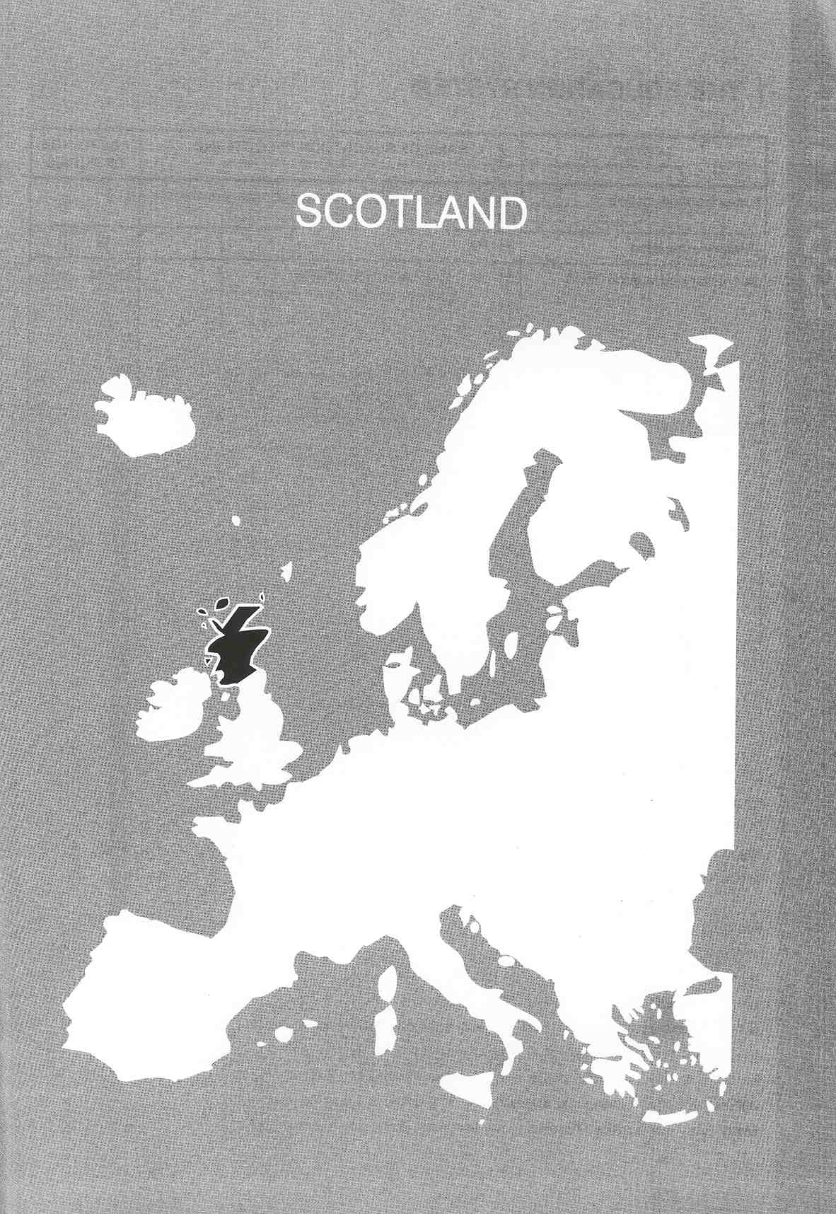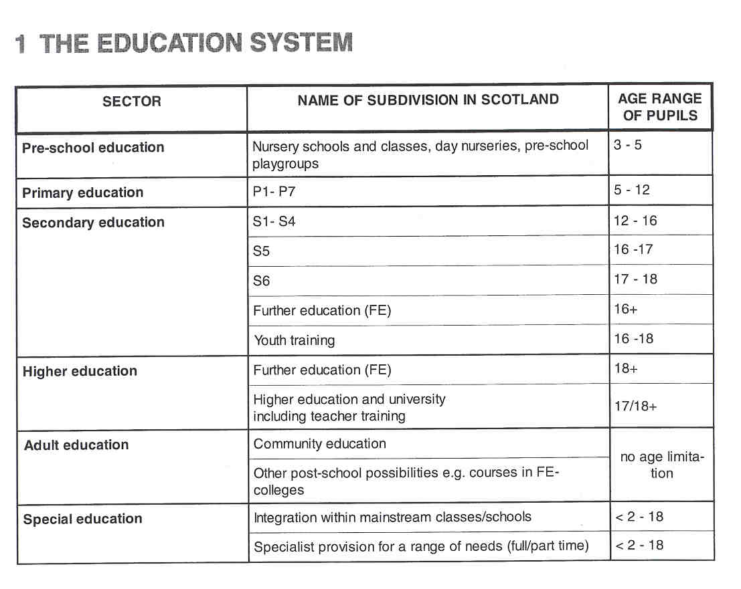
Νίκος Ηλιάδης, Πολ/κός Μηχ/κός Ε.Μ.Π., M.Sc.,
Ph.D. Industrial Education, Organization and Management,
Σύμβουλος του Παιδαγωγικού Ινστιτούτου

THE ADMINISTRATION OF THE EDUCATION SYSTEM

Scottish education is a partnership between government and other organisations. By devolving powers and increasing choice, successive Education Acts have encouraged partnership between central and local government, parents and the business community.
The Scottish Office Education and Industry Department (SOEID) is responsible for the administrative and legislative aspects of education, the funding of education, the monitoring of educational quality and the production of statistics.

Although central government plays an important part in the administration of Scottish education, many of the executive powers are, for preschool and compulsory school education, delegated to the 32 local Education Authorities (EAs) and in some cases to the schools themselves. There is, however, a close working relationship between SOEID and the local EAs. Local Education Authorities as part of local government provision work within a statutory framework. Each EA has a duty to provide adequate and efficient compulsory education in its area, to assess the special educational needs of children and provide special help. They are also obligated to provide school pupils with adequate facilities for physical education and training and for social, cultural and other recreational activities, and to provide voluntary courses of instruction for persons over age. Many Eas have a policy of providing pre-school provision and ou – of - school care. The Education Authority is
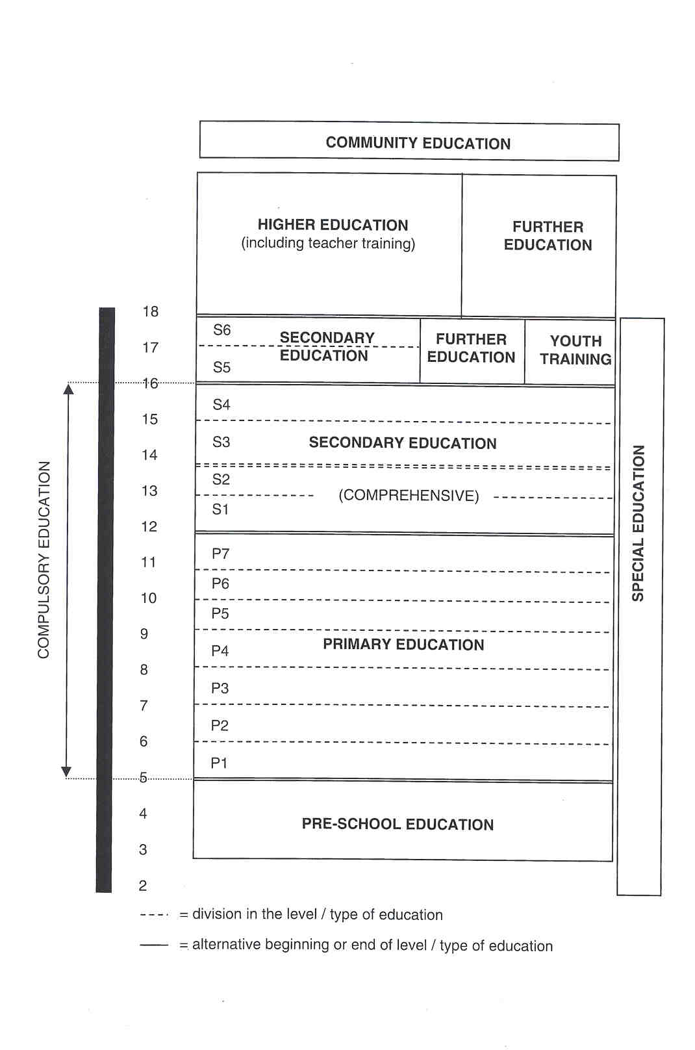

responsible for the employment of teachers and other staff. It is also free to decide how schools will be staffed subject to the national contractual agreements with teachers' unions and others. Most EAs have an Education Committee and Director of Education or equivalent. The Director of Education will usually head a number of officers with special responsibilities.

Public accountability requires schools to produce a development plan every two years, and submit it to the School Board and, at national level, the SOEID's Audit Unit collects, analyses and publishes evidence of the performance of schools.

In Post-school education (further and higher education) the institutions themselves are responsible for most of their own administration. The further education colleges are funded directly by the government. The SOEID administers these grants and maintains an oversight over the colleges. Although Central Government provides the finance for the system of higher education, the Scottish Higher Education Funding Council (SHEFC) is responsible for the allocation of funds to the higher education institutions. SOEID administers government policy for the development of community education (adult education) and youth work. The Department administers the grant scheme to support national voluntary organisations in the community education sector and funds the Scottish Community Education Council, which is responsible for the promotion and development of community education in both the statutory and voluntary sectors.

Rigorous standards for schools, colleges and universities are set, maintained and advanced by independent professional bodies working with SOEID.

Parents are encouraged to take an active part in education from pre-school onwards. School Boards give parents opportunity to influence the running of primary and secondary schools.

Business plays an increasingly important role in education. Contact with local businesses gives children practical experience of working life. In return, businesses gain contact with potential customers or employees and contribute to the development of skills and motivation of the future work force.

COMPULSORY EDUCATION

Most children attend schools which are comprehensive, coeducational, and provided free of charge by local authorities. School provision is also available through the independent schools which offer both day an boarding places at a charge. Compulsory education begins at 5 with entry to primary education and continues to age 16. After the age of 16 pupils may stay one or two additional years in secondary education before proceeding to post-school education in further education colleges or higher education institutions. Pupils may leave at 16 to take up employment.

EDUCATIONAL SECTORS AND SUBDIVISIONS

Pre-school Education

There are three forms of provision for children in the year before they are due to start primary school: nursery schools and classes, day nurseries and preschool play-groups. Pre-school education may be provided in public, private and voluntary centres. A curriculum framework for the preschool stage is published and helps the centres to provide a sound basis for.planning an effective programme. About 74% of the 3 and 4 year olds has a half-day place in preschool provision.

Primary Education

All children are admitted to secondary education after completing seven years of primary education (P1-P7). The curriculum up to age 14 is not determined by statute or regulation, but by National Guidelines from the SOEID, monitored by Her Majesty's Inspectors. The Government's main advisory body in this area is the Scottish Consultative Council on the Curriculum (SCCC). These guidelines for the progress and performance of children at different stages of primary and early secondary school allow for different levels of development in each stage (even for pupils with special needs). The basis of the primary school curriculum is a number of broad curricular areas: language, mathematics, environmental studies, expressive arts, and religious, moral and social education. There is no streaming of pupils by ability.

In P4 and P7, pupils have to undergo a national examination for language and mathematics. These tests are compulsory but have only a diagnostic function. Teachers can decide when they want to subject their pupils to the national tests.

Secondary Education

Secondary education consists of six years (S1-S6) and can be divided into lower secondary education (12-16 years) and upper secondary education (16-18 years). Each secondary school creates its own curriculum with advice from the SOEID, local authority education departments (LEAS) and specialist agencies.

- Lower secondary education consists of two stages of two years each. In Stage 1 (Sl and S2) all pupils undertake a common course with a wide range of subjects, based on the 5-14 Curriculum but with some new subjects. Schools vary in the number of courses or subjects they offer in Sl/S2. Near the end of S2 pupils have to choose their courses for years S3 and S4. Pupils choose courses from the menu of the school which is usually a "core" of subjects and an optional element, where free choice exists. An emphasis is placed on preparation for more specialised study and training, and for later life, but all pupils must continue to the age of 16 with the study of English, mathematics, a science and a modern foreign language.

At the end of four years of lower secondary education pupils are eligible to receive the Scottish Certificate of Education (Standard Grade) awarded by the Scottish Qualifications Authority (SOA). This certificate, inte nded to be attainable by all pupils, is gained by external examination with an element of assessment within the school itself. Pupils in S3 and S4 can also take modules from the catalogue of the SOA. When they complete them successfully, they receive credit towards the National Certificate which is a "non-advanced" vocational qualification.
- Some pupils leave at 16 and others start upper secondary education. The aim of this stage is to equip pupils to profit from vocational training and higher education. All 16 year olds must be given two weeks of work experience in local firms as part of their general pre-vocational training. Many pupils continue to study the same subjects studied in previous years but the level of study is higher. The broad choice of subjects remains, with freedom of choice being greater than in previous years. The Higher Grade of the Scottish Certificate of Education, taken in the fifth year of secondary education at about age 17, is the target for many school pupils who aim to enter professions or to go into higher education. The number of subjects studied for the Higher Grade of the Scottish Certificate of Education is likely to be more than five.

The Certificate of Sixth Year Studies is available for pupils who obtain a pass at Higher Grade in their fifth year and wish to continue their studies for another year.

Some schools offer a wide range of short, modular vocational courses as an alternative to those leading to the Higher Grade and Certificate of Sixth Year Studies. Some schools have pupils studying combinations of courses (Higher Grade and vocational courses).

A new broadly based qualification, the General Scottish Vocational Qualification (GSVQ) has been developed. It is aimed at the 16-19 age range in schools and further education, providing core skills, broad training and progression to higher education.

From 1999, the upper secondary school examination system changes. Higher Grade and Sixth Year Studies is replaced by Higher and Advanced Higher in August 1999. These qualifications are to be pursued in the 5th and 6th year, using both external and internal assessment. These changes aim to increase opportunities and raise expectations for all students preparing for work, college or university. The new, unified "Higher Still" courses and qualifications enable students to gain core skills for a continually changing job market, to combine academic and vocational courses and to learn at a pace which suits them.

Further Education

Further education (FE) offers courses in academic and vocational subjects from craft to degree level. The FE colleges provide both full-tirne and part-time day and evening courses, distance and open learning, and intensive short courses. They vary in the range of courses which they offer. Some colleges are specialist institutions covering areas such as agriculture, food technology and maritime studies. Colleges have a high degree of freedom to structure programmes of study to meet the needs of students and employers. The 46 further education colleges are open to an enormous range of students from the age of 16 and for the rest of their lives. There are students who have just left school with or without formal certification and, perhaps, some who are still at school, taking vocational and general courses at further or higher education levels, aiming for a specific job, learning a craft, or working towards higher level qualifications. These same opportunities are also increasingly taken by older students, overseas students, people with or without jobs and people with disabilities and special needs. The FE colleges provide each student with a high level of support through guidance, counselling, and learning support services.

Most of the courses are assessed, accredited and awarded by SOA. Awards include Scottish Vocational Qualifications (SVQs), designed to national standards by industry and involving assessment in the workplace, National Certificates, Higher National Certificates, the Higher National Diploma; General Scottish Vocational Qualifications (GSVQS) for students aged 16-19 and adults returning to education.
The new unified qualification system (in 1999) applies to FE colleges as well as to secondary schools. "Higher Still" will be open to all FE students beyond Standard Grade.

Youth Training

Youth Training is an initiative of the government. It consists of vocational training for pupils under 18. It lasts two years and is organised in "units of competence". Vocational training takes place in a firm while more general education-courses can be taken at a FE college.

Higher Education

Higher education is the term generally used to refer to courses in higher education leading to a degree, diploma or postgraduate qualification. It is usually undertaken by students over 18 years of age. Entry is usually by way of a group of passes in national examinations, but greater provision for adult students has lead to a development of special access courses with guaranteed places for successful participants.

Courses in higher education are available at universities, colleges and institutions of higher education (HEls), colleges of education and schools of art. Normally students advance through a choice of general subjects to more specialised studies, although some institutions move away from this approach. Generally students take three years to gain an Ordinary degree and four years to attain Honours standard.

Teacher Training

There are three routes to a Teaching Qualification:

- a four-year course leading to the Bachelor of Education degree (BEd) Primary, or for secondary education a four-year course leading to a BEd Technology, Physical Education or Music;
- a combined degree course for secondary subjects only, which includes subject-specific study, the study of education, and school experience;
- a one-year Postgraduate Teacher Certificate in Education (PGCE) in Primary or Secondary, following an appropriate degree course.

It is not enough for students to pass examinations. The award of teaching qualification, which has the status of a degree, is based on a combination of assessment, external examination and project work. The six teacher training institutions also offer a large number of in-service courses for teachers and others in the education profession.

All teachers have to be registered. New teachers can only be fully registered when they have completed two years of probation.

Adult Education (Community Education)

People not only learn in schools but also through day-to-day involvement in their local community. Community education is the term for community-based education provided by local authorities and non-governmental organisations. It is an informal type of education, determined by the educational needs of the users. Community education tackles social exclusion and promotes lifelong learning and community development. The Scottish Community Education Council (SCEC) is responsible for the development and improvement of community education.

Special Education

Education authorities are obliged to provide appropriate education for children with special educational needs (SEN). They determine the kind of special needs provision they wish to make for their pupils. They normally have the responsibility of preparing a Record of Needs. This record identifies a child's special educational needs following a full assessment by an appropriate range of specialists. EAs have a duty to open Records of Needs for children between the age of 2 and 6 years with pronounced, specific or complex special educational needs. In practice, EAs support children with special needs from under 2 years through to 18 years.

There is a special preschool provision for children with special educational needs. This includes home visits by teachers and placing children in mainstream nurseries and in specialist nurseries. This provision is available to parents and children, but is not compulsory at the preschool stage. Parents do not have to utilise this provision.

During primary and secondary education the trend is for children with quite pronounced impairments to be educated in mainstream schools or classes. For most pupils with special needs the provision comprises a special learning support teacher. For pupils with more significant learning difficulties, there is a variety of provision across Scotland, including day or residential special schools or units and special classes. The existence of special schools (for approximately 1.7% of the school population) does not mean that the pupils there are segregated, for there are many strategies for integrating them with the community or with neighbouring schools.

There is no specific curriculum for SEN pupils. The curriculum offered takes into account the nature and severity of the needs. The guidance of pupils with special needs is largely in the hands of educational psychologists, medical staff when appropriate, class teachers and teachers specifically designated for guidance, particularly in secondary schools.

2 THE ORGANISATION OF THE INSPECTORATE

The Inspectorate has its headquarters in Edinburgh and several regional offices. Her Majesty's Senior Chief Inspector (HMSCI) is the head of the Inspectorate. The HMSCI is assisted by one (and in the near future by two) Her Majesty's Deputy Senior Chief lnspector(s) (HMDSCI). The Inspectorate is divided into several units. Each unit (with the exception of the Central Management Unit and the Information Technology Services) consists of one Her Majesty's Chief Inspector (HMCI), a number of Her Majesty's Inspectors (HM1s) and administrative staff. Some units also include professional, research and statistical staff.

HM Inspectorate is governed by the Senior Management Group consisting of the HM Senior Chief Inspector, the HM Deputy Senior Chief lnspector(s), all HM Chief Inspectors and three persons of the administrative staff.

The Inspectorate is authorised to evaluate the quality of schools and educational institutions offering pre- school education, primary education, secondary education, further education, higher education (including teacher training) and community education. The Inspectorate is also responsible for the inspection of independent schools and for inspecting the welfare of residential pupils.

In some types of inspection HMis are assisted by associate assessors and lay members:

- Associate assessors are experienced teachers from another school, who provide an additional professional view during the inspection process.
- Inspection teams may include one inspector without personal experience. in the management or the provision of education in any school. These are known as Lay Members, and may be drawn from industry and commerce or from the wider community. Lay inspectors are expected to contribute a common-sense view of a school.

Though HM Inspectorate is independent of The Scottish Office Education and Industry Department (SOEID), the Government is responsible for funding the Inspectorate.
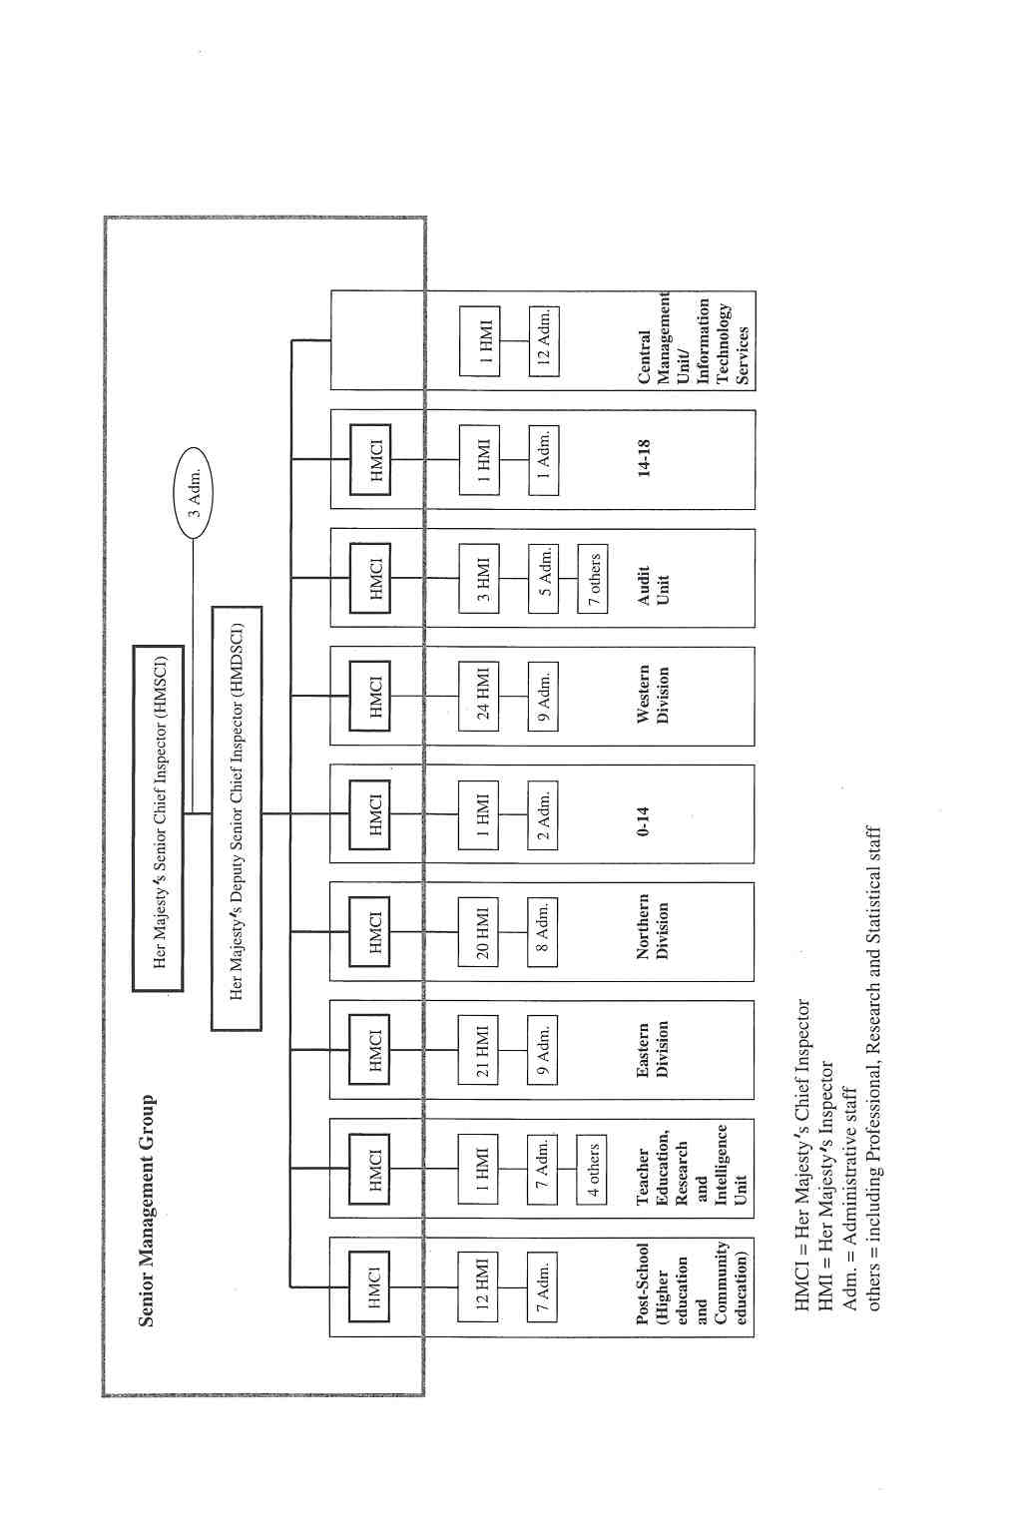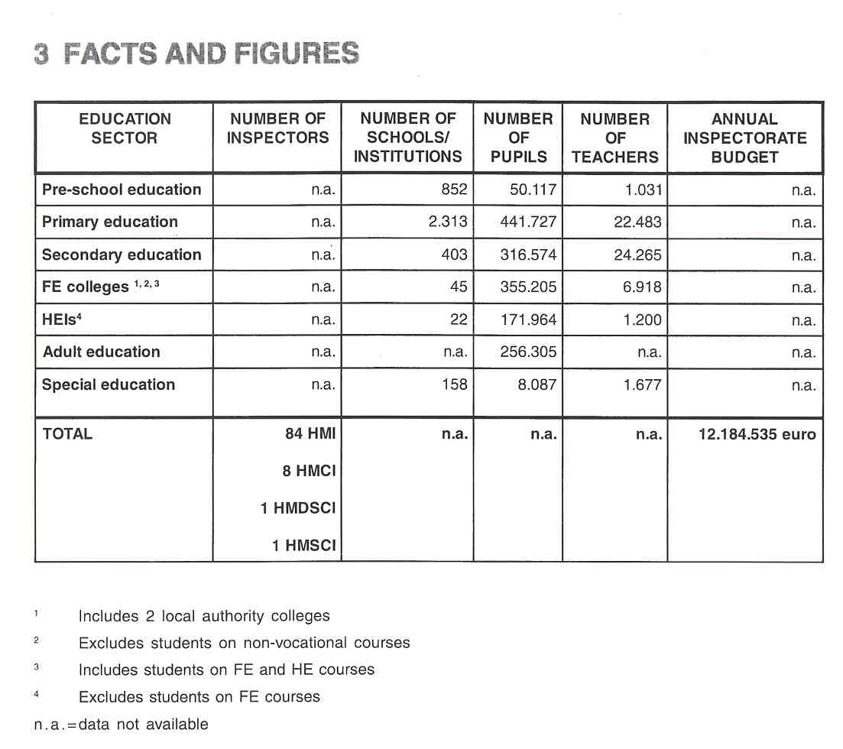

4 THE RECRUITMENT OF THE INSPECTORATE

To be eligible for the position of HM Inspector the candidates have to fulfil some requirements. They need an Honours degree and a Teaching Qualification. In addition, they have to prove they kept their knowledge of education up-to-date by substantial in-service staff development.

Not only is a Teaching Qualification required, but substantial teaching experience is also a necessity. Besides teaching experience candidates, must have experience in a (senior) promoted post in a school or an Education Authority.

On the basis of an interview and a presentation, HMI-candidates are appointed by the Queen in Council on the Secretary of State's recommendation.

Associate assessors are usually nominated by Education Authorities. Only a small percentage is picked by HMI. These assessors are specially trained to undertake inspections.

5 THE WORKING CONDITIONS OF THE INSPECTORATE

The function of HM Inspector is a full-time job. However, Inspectors may work part-time but are not usually permitted to engage in other paid employment.

After a probationary period, HM Inspectors become established civil servants. As a consequence, civil service conditions apply and the function of HM Inspector is a permanent position.

This ruling does not apply to associate assessors and lay members, who only function temporarily as a member of an inspection team. They keep their original position in the world of education as a teacher or senior member of staff in a school (associate assessors) or outside the field of education, e.g. in industry, commerce or the wider community (lay members).

6 AREAS OF INSPECTORATE RESPONSIBILITY

HM Inspectorate has responsibility for promoting quality assurance within the education system as a whole. The role of the Inspectorate is described in the policy statement of 1992 written by the Secretary of State for Scotland: "The role of HM Inspectors of Schools in Scotland: Policy Statement". This document describes the key functions of the Inspectorate: evaluating, advising, monitoring and reporting.

6.1 EVALUATING

HM Inspectorate has to carry out a programme of full inspections of a sample of schools and other educational institutions (a) and has to undertake a number of inspections and visits to evaluate certain aspects of education (b).

a. Full Inspections

HM Inspectorate is primarily responsible for the independent and objective evaluation of the standards and the quality of individual schools and of the education system. HMis provide an audit of the overall quality of education, standards of attainment, the effectiveness of individual institutions, the arrangements for assuring quality and value for money Each year the Inspectorate carries out a programme of general inspections of a sample of schools (about 150 inspections yearly) and other educational institutions (e.g. FE colleges) as part of the national evaluation of the education system. The emphasis is on full inspection of entire schools, covering all aspects of schools' work. There are different types of inspection. The main inspection models are:

- Pre-schoof Registration Inspection
- Primary Standard Inspection
- Primary Extended Inspection
- Secondary Standard Inspection
- Secondary Extended Inspection
- Secondary Departmental Inspection
- Inspection of Welfare of Residential Pupils

Models for the inspection of higher education institutions and community education are currently being developed.

Pre-school registration inspections are for those preschool institutions which are independent or in partnership with Education Authorities but which are applying centrally for funding. HMI inspections act to maintain standards across the sector.

In primary and secondary education there are two types of inspection: the standard inspection and the extended inspection. Although the used inspection methods and the framework for performance indicators are the same, the extended inspection is more thorough and covers a larger part of the curriculum in comparison with the standard-type. All inspections cover a comprehensive range of aspects, but extended inspections range across more aspects.

Recently, a new type of inspection has been introduced: the "departmental inspection' in secondary education. The subject departments to be inspected are chosen as part of a national sample of subjects taught in secondary schools.

Standard and extended inspections focus on generic issues, while departmental inspections focus on subject areas.

An "inspection of welfare of residential pupils” evaluates the quality of provision made for the welfare and pastoral care of residential pupils in all schools which have boarding arrangements for pupils.

HM Inspectorate has developed a framework for reliable and consistent school evaluation: "How Good is Our School?' (HMI, 1996). This framework consists of seven key areas relating to the main functional aspects of a school's work. Full inspection covers all these key areas:

1. Curriculum
2. Attainment (e.g. national examinations)
3. Learning and teaching (e.g. quality of teaching) 4. Support for pupils 5. Ethos
6. Resources (budget-financial management)
7. Management, leadership and quality assurance (school management and administrative decisions)

Each key area contains a number of performance indicators (PI) and each indicator has one or more themes.

HM Inspectors interpret the extent to which national guidelines and advice, published both by Scottish Office Education and Industry Department (SOEID) and the Scottish Consultative Council on the Curriculum (SCCO), are met by the institutions and whether the quality of provision is in line with this advice.

School self-evaluation is considered the heart of the Scottish approach to quality assurance. Schools are expected to use the national set of performance indicators, developed by HM Inspectorate, as part of school development planning to self-evaluate present provision and as the basis for future action. These performance indicators are the basis for school self-evaluation as well as being the basis for HMI judgement in external inspections. External inspection in primary, secondary and special education is based on the same set of indicators. The evaluation of school's self-evaluation is an important aspect of all general school inspections.
Individual teachers are not evaluated per se, although the quality of the lessons taught is evaluated. The effectiveness of leadership of teachers occupying promoted posts is evaluated. The work of teachers is evaluated in myriad ways.

b. Aspect Evaluations

Inspectors annually undertake a number of inspections and visits as a basis for reports on certain aspects of education. These thematic inspections are used to pursue particular areas of interest: e.g. effective learning and teaching in modern languages, religious observance in primary and secondary schools. These aspect evaluations may form the starting point for a further, fuller investigation.

6.2 ADVISING

A key function for HM Inspectors is to provide, through the Senior Chief Inspector, full and objective advice to the Secretary of State for Scotland and the Scottish Office Education and Industry Department on all aspects of Scottish education. The Secretary of State expects Inspectorate advice on how Government might best achieve its objectives for education in a sound, coherent and practical manner. The advice has to be provided independent of the SOEID.

The Inspectorate maintains close contact with Directors of Education (of the EAs) and members of their staffs. This work is crucial for the effective operation of the partnership between central and local government. It places considerable importance on the position of District Inspectors who, together with those of their colleagues responsible nationally for particular subjects or stages of education, are seen as the linchpins of the system.

The Inspectorate establishes links with external bodies such as the SOA, the SCCC and a wide range of other organisations directly concerned with education and its products, including industry, commerce and the public at large. HM Inspectors play a lead role in national developments, such as developments in the curriculum and the national examination system, in collaboration with education authorities and practitioners. They also contribute to the development of national advicelguidelines, either as participants in working groups or as assessors to groups. Moreover, recommendations concerning the curriculum are made for individual schools inspected. On the other hand, developing educational materials is not a key part of HM Inspectors' work.

The Inspectorate also has to lead and contribute to initiatives designed to improve standards and quality in Scottish education. For example, the Inspectorate has played a lead role in developing and implementing

Government policy on "Raising Standards: Setting Targets in Scottish Schools", targets for improvement are set for all schools (from 1998-1999). Other examples of these initiatives are promoting school self-evaluation and development planning, and particular curricular developments, such as those in modern languages and preschool education.

6.3 MONITORING

The monitoring of the education system by developing and managing a data base is a key part of the HM Inspectors' work, but as a support for reporting and advising, not as an end in itself.
The Audit Unit of the Inspectorate is responsible for gathering and analysing a wide range of factual information on the education system. It has the function to monitor the performance of all schools and colleges through the data gathered during scrutiny of school and college development plans, examination results, attendance and truancy figures, the destination of leavers, costs and the findings of the inspections. Evaluations per performance indicator are stored in a data base which is interrogated for various reports, including a triennial "Standards and Quality" report on the education system. HM Inspectorate has to identify elements requiring attention and improvement in individual institutions and in the system as a whole.

6.4 REPORTING

Public reports are written on full inspections of institutions or departments. At fixed intervals a report is published on the state of affairs in the entire education system, based on the inspection of individual schools. Annually reports on aspect-evaluations are published.

Public examination results for each school are examined and published by HM Inspectorate for use in schools as part of self-evaluation. Standard tables on national examinations are produced annually for each school on its own results, comparisons being made with national averages and between departments in the school. These tables are intended only for the school.
Furthermore, there is an annual publication providing a summary of results in national public examinations for ail schools. This publication reflects the results of each school.

7 THE ROLE OF THE INSPECTORATE IN EDUCATIONAL POLICY

The Inspectorate plays an important role in preparing policy and in decision-making. HM Inspectors work within the Scottish Office and implement national legislation. They are, however, expected to give advice to the Secretary of State for Scotland. This advice is independent and is not constrained by existing legislation, but informed by a concern for the curriculum.

HM Inspectorate plays a central role in stimulating the implementation of the policy and in evaluating the effectiveness of national policy by evaluating and monitoring the work of individual institutions and by identifying the elements requiring attention and improvement in individual institutions and in the system as a whole.

8 WHO IS IN CHARGE?

The Secretary of State for Scotland sets the broad agenda for policy and development. Based on this policy, Her Majesty's Senior Chief Inspector (HMSCI) undertakes to run a programme of inspection/policy work in line with the Departmental Plan for The Scottish Office Education and Industry Department (SOEiD).

HMSCI decides on the Inspectorate's policy emphasis and its programme of activities. In this role there is consultation with the Inspectorate's senior management (consisting of Her Majesty's Deputy Senior Chief Inspector and Her Majesty's Chief Inspectors) and members of the administrative divisions.

The individual inspector works within an annual plan, and has a small amount of self-managed time.

Public sector education in Scotland is a partnership between central and local government (e.g. the educational authorities and the schools). At each level of the Scottish education policy there is close collaboration with the different people that are involved in education. As a consequence, when deciding on the Inspectorate's policy and programme of activities there is a responsiveness to the views expressed by schools/teachers.
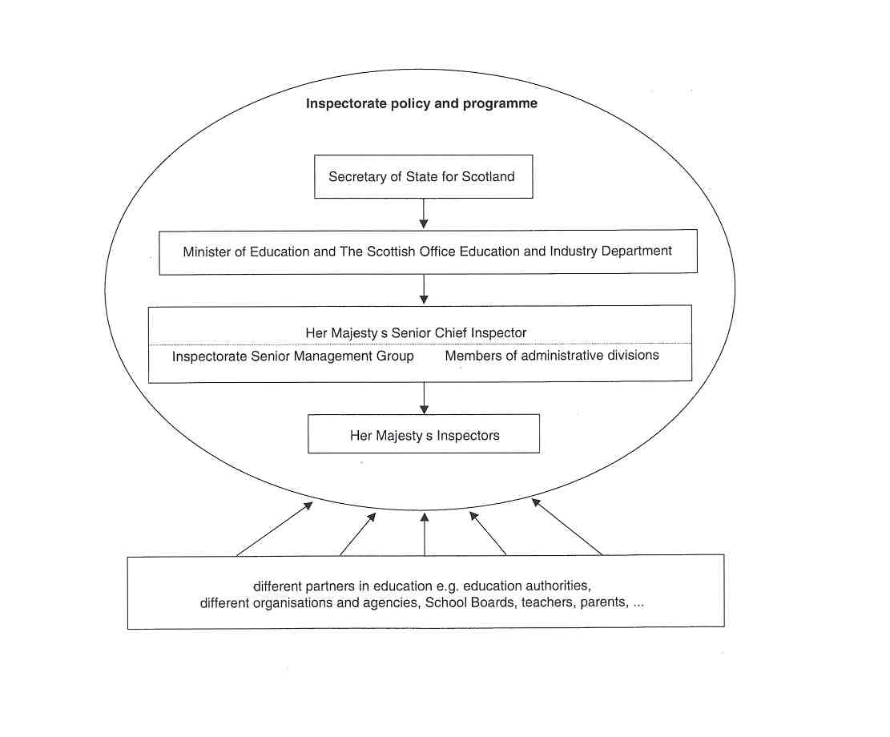

9 THE POSITION OF THE INSPECTORATE

The Secretary of State for Scotland is responsible to Parliament for the overall supervision and development of education. He delegates direct day-to-day responsibility to the Minister of Education, and exercises his functions through the Scottish Office Education and Industry Department (SOEID). Her Majesty's Senior Chief Inspector is senior professional adviser to the Secretary of State for Scotland on all aspects of education. The Inspectorate provides advice and information about the performance and needs of the Scottish education system as a whole and about specific bottlenecks in the system. HM Inspectors also provide advice and information via administrative divisions in response to questions by Members of Parliament (MPs).

HM Inspectorate has an independent position towards schools, EAs and specialist organisations. To guarantee the independent and impartial evaluations of the quality of the education system, HM Inspectors are appointed by the Queen and give direct account to the Minister of Education.

In Scotland there is a network of specialist organisations and agencies which support, maintain and enhance the education system. These agencies work independently within the policy framework of the Scottish Office Education and Industry Department. The Inspectorate has developed close and effective relationships with these organisations. For instance, the Scottish Consultative Council on the Curriculum (SCCC) and the Scottish Qualifications Authority (SQA) work closely with the Inspectorate.

- The SCCC is the principal advisory body to the Government on the curriculum for 3-18 year olds. SCCC keeps the curriculum under review and produces guidance and support materials for schools.
- The SOA is the certificating body for qualifications in the national education and training system in Scotland. It is responsible for most qualifications taken at school, college or workplace, for all secondary school external examinations, for quality assurance of internal assessment and for 5-14 assessment in schools.

HM Inspectors serve as assessors to many of the SCCC groups and SOA groups.

10 THE INSPECTION PROCESS

The Inspectorate initiates the inspection and adopts the following inspection process:

Phase 1 (Preparation)

Weeks 1 to 8 in standard inspection / weeks 1 to 9 in extended inspection

- The school Education Authority, School Board and parents are informed of the inspection, normally six working weeks in advance.
- Pre-inspection profile'information is gathered, including school development plan and a survey of parents' views conducted, and analysed.
- Inspector visits the school to meet and brief the staff on the form of the inspection.
- Key findings of this phase are recorded and a number of specific questions to be addressed in the next phase are identified.

Phase 2 (Inspection of provision)

Week 9 in standard inspection 1 weeks 1 0- 11 in extended inspection

This phase of the inspection evaluates pupil attainment and learning and teaching in a sample of curriculum areas and departments. It normally lasts no longer than two weeks.
- Brief feedback is given to teachers of each lesson observed.
- Key findings to support the evaluations are recorded using a standard set of proformae.
- Oral feedback is provided to the school's senior management at the end of phase 2 or in phase 3, depending on the type of inspection.

Phase 3 (Reporting)

Weeks 10-1 3 in standard inspection / weeks 12-17 in extended inspection

- The inspection team meets to consider the findings of phase 2 and draft the final report.
- The reporting officer discusses the draft report with the headteacher, Chair of School Board and EA.
- A final report is published highlighting the positive features and recommendations where further action is required.

Phase 4 (Follow- up)

(1-2 years later)

- A follow up inspection is held within 1-2 years of publication of the report, us.ing the published recommendations as its agenda.

11 INSTRUMENTS AND METHODS

To assist them in their task of evaluating the work of educational institutions, the Inspectorate has devised a range of inspection methods and instruments.

THE COLLECTION OF INFORMATION

HM Inspectors use a range of methods to collect the necessary information, which include questionnaires, interviews, observations, testslexaminations of pupils, the collection of documents and the use of national data.

- Ouestionnaires

- School Profile Pro forrna:
sent to headteacher (HT) requesting information on organisation and management of the school; offers opportunity for schools to identify any other issues they consider relevant.

- Secondary Profiles:
in addition to the above, information is also gathered for secondary schools on departments, guidance and learning support.

- Parents' Questionnaire:
sent to parents for their views.

- Headteacher Questionnaire:
sent to the headteacher following an inspection to gather information about his/her view on the inspection process.

- Teachers Questionnaire:
sent to teachers following an inspection to gather information about their views on the inspection.

- Reporting Officer Questionnaire:
completed by reporting officer at the end of the inspection.

b. Interviews

- Headteacher and other members of the Senior Management Team (SMT) are interviewed initially to discuss information in the profile documentation.
- The Chairperson of the School Board is interviewed to establish parents' views.
- In addition, further targeted interviews will be conducted with the SMT, representative groups of middle management (including those responsible for pupil support), unpromoted staff and pupils.

c. Observations

Classroom visits and observations of classroom activity are undertaken to establish the quality of:

- the teaching process (lessons are evaluated, not the individual teachers); *pupils' learning;
- meeting pupils' needs;
- assessment as part of teaching.

The quality of accommodation, equipment and special aids is checked.

d. Tests/examinations

In primary schools, inspectors measure pupils level of attainment against national levels, mainly to verify teachers' own assessments. In secondary schools HM Inspectors conduct similar exercises at SI-S2, but rely on results in national examinations from S3-S6.

e. The Collection of Documents

- Statistical information on pupils' attainment in public examinations in S4-S6.
- School development plans.
- Staff lists.
- School Profile material covering: role, location and history, accommodation, resources, staffing, curriculum structure and tirne-tabling, ethos, the school in its community, aims, policies and quality assurance, drug education.
- Range of documentation available in the school.

f. The Use of National Data

In full inspections HM Inspectors make use of national data regarding public examination results and of the data base of the Inspectorate.

Whenever HMis inspect a school, a questionnaire is sent to a sample of parents (10% of the parents or 100 parents, whichever is greater) to gather their views about the school. Information from these questionnaires is analysed on a national basis to establish responses for a "typical school" as a benchmark for future evaluations by HMI (benchmarking guidance).

APPROACHES

The full inspections are characterised by an independent, responsive and open approach by the inspection team based on a uniform evaluation instrument, with performance indicators and guidelines for the various inspection types.

a. Instruments

The Inspectorate uses a uniform set of guidelines for different types of inspection, which cover reporting on accommodation, staffing and resources; the quality of courses; the effectiveness of management and arrangements for quality assurance; ethos; parents views., the curriculum in the school; the quality of learning and teaching. The guidelines are updated at least annually.

Inspectors reach their evaluation based on evidence gathered during the inspection process. They use their professional judgement to weigh up strengths and weaknesses. The inspectorate has developed an evaluation instrument, the framework of which is described in "How Good is Our School?' HMI (1996) and which can be used in different contexts and for different purposes. This instrument can be used for self-evaluation by the school, as well as for external evaluation by HMis. It is also applicable to the primary, secondary, and special education sectors and to all groups within these sectors.

During full inspections Inspectors focus on seven areas for special attention, the key areas (See section 6: "Areas of Inspectorate Responsibility"). Each key area contains a number of performanice indicators, for example:

Key Area 1 . Curriculum
Performance Indicator 1.1: Structure of the curriculum
Performance Indicator 1.2: Quality of courses or programmes
Performance Indicator 1.3: Quality of teachers' planning

Performance indicators (Pis) help the Inspectors and other team members to reach their evaluations. Pis describe benchmarks of quality and provide a framework for reliable and consistent evaluation. And each PI has one or more themes, for example:

Key Area 1: Curriculum
PI 1.1: Structure of the curriculum
Themes: - breadth and balance across elements of the curriculum;
- integration, permeation;
- effectiveness of lime tabling and arrangements for pupil choice.

The quality of what is observed within each theme has to be judged against four levels of performance:

Level 4 very good: major strengths
Level 3 good: strengths outweigh weaknesses
Level 2 fair: some important weaknesses
Level 1 unsatisfactory: major weaknesses

During full inspections of individual schoolslinstitutions, all themes of the performance indicators are evaluated using this 4-point scale. To make these evaluations easier, each theme is illustrated at two levels (Level 4 very good, and Level 2 fair) indicating the specific features to look for. This is illustrated for the themes of the PI structure of the curriculum (Key Area l):

Level 4 illustration
- The curriculum has breadth and balance across its various elements. It is fully in keeping with the school's aims and with national and local guidance.
- There is full integration of knowledge, skills, understanding, and personal and social qualities and key aspects permeate the curriculum.
- Timetables are designed successfully to enable the curriculum to be offered efficiently, giving appropriate times and emphasis to each curriculum area, subject or mode. There are appropriate opportunities for pupil choice.

Level 2 illustration
- The curriculum does not have breadth and balance across its various elements. It does not fully reflect the school's aims. It is not closely aligned with national and local advice.
- There is limited integration of knowledge, skills, understanding, and personal and social qualities. Key aspects permeate the curriculum in only a limited way.
- The design of timetables is not fully successful in enabling the curriculum to be delivered efficiently. Time allocations and emphases to curriculum areas, subjects or modes are inappropriate. There are limited or inappropriate opportunities for pupil choice.

b. Independent, Responsive and Open Approach

HMis do not govern or manage schools or appoint staff. Inspectors take account of parents' views, the schools' development plan and the school's aims and circumstances. Inspection procedures are clearly described and known by all parties involved. HMis use published criteria, indicators and national targets. Reports are published and available to all.

c. Teamwork

In inspections, inspectors work in teams. There is a reporting officer in each team. The reporting officer is the HMI who manages and leads the inspection. He is the main point of contact with the school and drafts the report.

The number of inspectors per team varies from 2 to 6 depending on the type of inspection, the size of the school and the education sector.

Depending on the inspection type, teams may include an experienced teacher from another establishment to provide an additional professional view. These "associate assessors" are senior members of staff in another school and are specially trained to undertake inspections. Some inspection teams (again depending on the type of inspection) have a lay member whose experience and direct involvement is not in education (but e.g. in industry or commerce). Lay members bring in an outside view and take an interest in how the school and its pupils interact with parents and the local community. They help HMis to ensure that parents' views are taken fully into account during the inspection. They are not involved in evaluating the curriculum, the quality of learning and teaching, or pupil aftainrnent.

12 JUDGEMENT AND ITS CONSEQUENCES

Schools are evaluated, not with the objective of accreditation, but as a means of benchmarking quality and supporting schools' self-evaluation. The HMI report highlights the school's key strengths and identifies main points for action. Recommendations are made for improvement and these are rigorously followed up.

Schools are funded by the Education Authorities. EAs are expected to address the recommendations and to respond appropriately to reports by HM Inspectors on the schools they manage. EAs are jointly responsible with "their" schools for following up points of action in HMI reports.

The points for action are followed up by HM Inspectors at 1-2 year intervals until they have been addressed satisfactorily.

Reports on progress are published and sent to all parents of children in the school, as well as being available, on request, to the general public.

13 OUTCOMES

Each year HMis inspect and report on a wide range of educational establishments including pre-5 centres, primary, secondary and special schools, further education colleges and community education. Inspection is also involved in assessing the quality of teacher education.

Inspections are designed to inform:

- parents about the quality of the school of their children and the standards being achieved in that school;
- teachers about the effectiveness of their work;
- headteachers about how well their schools are performing;
- Education Authorities, School £3oards and school governors about the overall quality of their schools;
- the Secretary of State for Scotland about the performance and the needs of the Scottish education system as a whole.

The Inspectorate publishes different kinds of reports. It publishes reports on individual schools, on aspect evaluations, on the education system, and on public examination results.

All reports (with the exception of reports on public examinations, which are meant for self-evaluation) are published for public consumption and are, free of charge, available to Ministers, Education Authorities, schools, teachers, parents and the public in general. The Inspectorate can only charge for reports older than 3 years. Arrangements are in hand to make all the reports available on the lnternet.

REPORTS ON SCHOOLS/INSTITUTIONS

In the course of a year up to 150 institutional reports, that relate to full inspections, are published.

The published reports on individual schools are written with the parents as prime audience. The content of the reports on school evaluations differ according to the model of inspection, but they all have the following features:

- The report indicates parents' views, the ethos (of the school, department, boarding house or hostel) and its links with the community, accommodation, staffing and resources, the curriculum in the school and the quality of management and leadership.
- It also indicates the quality of learning and teaching, and the effectiveness of arrangements for supporting pupils, and how well pupils are performing.
- Finally, the report highlights the key strengths and the main points for action of the school, the departments) or the residential provision.

There are different kinds of reports on schoolslinstitutions corresponding to the different inspection models. Some of these reports are described briefly.

a. Report of a Standard Inspection

In a primary school, the inspection includes any provision made for nursery education. The report provides information on the progress of children in the nursery class and on how well pupils in the primary class are performing in English language, mathematics and in one other curriculum area.

The report on a secondary school contains information about how well pupils are performing in English, mathematics and class-work and evaluates the overall quality of results in external examinations.

b. Report of an Extended Inspection

In a primary school, the inspection includes any provision made for nursery education. The report provides information on the progress of children in the nursery class and the quality of work in all five areas of the primary curriculum.

The report on a secondary school evaluates the overall work of a sample of eight departments, pupils' performance in coursework and the overall quality of results in external examinations.

c. Report of a Departmental Inspection

In a departmental inspection in secondary schools, the findings relate solely to the departments inspected. They do not apply to other departments in the school, nor to the school as a whole.

The report includes information arrangements for quality assurance, how well pupils are performing in coursework and on the overall quality of results in external examinations.

d. Report of a Special School Inspection

The Inspectorate looks at provision for the educational and pastoral needs of pupils attending the school. It takes account of the specialised aids to learning and teaching and the involvement of parents and professio- nal carers in the community.

For a primary school, the report gives information on the quality of work in all five areas of the curriculum.

The report on a secondary school evaluates the work of a sample of departments, pupils' performance in coursework and, if appropriate, the overall quality of results in external examinations.

e. Report of Inspection of Welfare of Residential Pupils (WRP)

A WRP inspection evaluates the quality of provision made for the welfare and pastoral care of residential pupils. The report indicates the overall quality of care and the effectiveness of the school in catering for the development of individual pupils, the health and safety of pupils and pupils' rights and responsibilities.

REPORTS ON ASPECT EVALUA'n0NS

In the course of a year some 600 establishments are visited for selective inspection purposes resulting in the publication annually of a number of national thematic reports on aspect evaluations, i.e. evaluations of the quality of particular aspects of educational provision, such as the use of computers, the teaching of mathematics or the management of secondary schools. The Inspectorate identifies strengths and weaknesses and makes recommendations for improvement.

REPORTS ON THE EDUCATION SYSTEM

HM Inspectorate produces every three years a national report on Standards and Quality. These reports summarise the findings derived from the evidence that is accumulated through the inspection of individual schools.

REPORTS ON PUBLIC EXAMINATION RESULTS

Public examination results are published by the Inspectorate for use in schools as part of self-evaluation. Standard tables on national examinations are produced annually for each school on its own results, and comparisons are made with national averages and between departments in the school. These results are intended only for the school concerned.

There is also an annual publication of a summary of results in national public examinations for all schools.

14 FOLLOW-UP PROCEDURES

After an inspection, the school and Education Authority or school Governing Body publish an action plan within four months of the publication of the inspection report, showing how they will act on the report's main points for action.

HM Inspectors revisit the school 1-2 years after the report has been published to assess pr ogress. There are about 150 follow-up inspections yearly. HMis' conclusions are published in the same way as the original report. The follow-up report indicates that the inspection is now complete or that a further follow-up inspection is required. The Inspectorate finds that over 80% of recommendations are satisfactorily addressed at follow-up.

If HM]s are not satisfied with the progress made, further action is required of the school and the Education Authority.

15 INSPECTORS AS ARBITRATORS

Occasionally, parents or other concerned parties contact HM Inspectors, usually through politicians, to raise specific issues of concern (e.g. complaints about schools or teachers). This does not happen frequently because parents'first line of contact is normally the local Education Authority with responsibility for providing education.

In the course of inspection students or parents are invited to give their views on a range of aspects of provision.

Teachers and other members of staff have the opportunity to approach inspectors with complaints about headteachers or Governing Bodies. During an inspection teachers may raise such issues with HMis. However, such complaints are usually raised with the Local Education Authority.

Reports by HM Inspectorate may be commissioned by the Secretary of State in response to concerns raised about issues, nationally or locally. The independent report may be referred to by parties in a dispute but is not, normally, an established part of an arbitration process.

16 THE INSPECTORATE AS AN ACTOR IN PUBLIC DEBATE

HM Inspectors publish and follow up reports on a wide range of educational and curricular issues. These reports are supported through lectures, talks, seminars to education authority and schools' personnel.
When thematic reports are issued, they are accompanied by a press release and there is often a press briefing which may include TV/radio interviews.

17 THE EVALUATION OF THE INSPECTORATE

Internal evaluation (self-evaluation) plays a significant role. HM Inspectors gather the views of schools/ parents following the inspection of a school. The Audit Unit monitors standards in inspections and reporting officers, headteachers, teachers and parents are consulted. In 1998-9 HM Inspectorate intends to formalise and develop the work of the Inspectorate in self-evaluation.
Furthermore, the Senior Management Group monitors the work of individual HMis. Individual inspectors are appraised annually.
Results of follow-up to reports are tracked. However, this process is being reviewed at present.

The process of inspection is being continuously adjusted and refined in response to evaluations. Within the inspectorate there is a standing committee which monitors the effectiveness of the guidelines.

A key part of the annual appraisal of individual inspectors is the extent to which they meet clearly specified targets. As a result of this process, methods, tasks and functions can be adapted.

The balance of the Inspectorate's work is agreed annually. In response to the perceived needs of the system and to developments in educational policy, adjustments are made to the

- inspection process,
- roles of inspectors,
- policy priorities.

18 THE INSPECTORATE'S INITIAL TRAINING AND IN- SERVICE TRAINING

All new inspectors serve a one-year probationary period. During that time they have extensive staff development. Subsequently, at twice-yearly meetings with line managers their needs are discussed and performance reviewed.

All members of the Inspectorate receive an annual appraisal review. Their professional development needs are identified and provision is made to meet them.

19 RECENT OR FUTURE ISSUES AND DEVELOPMENTS

Recently, the Inspectorate has played a lead role in developing and implementing Government policy on "Raising Standards: Setting Targets in Scottish Schools". The targets initiative is aimed at raising levels of attainment through the setting of targets for individual schools and taking account of local social and economic factors. The Inspectorate's involvement will continue beyond the implementation phase as the Inspectorate continues to monitor and report on schools' performance against these targets.

In the future, the establishment of a Scottish Parliament with devolved powers from the UK Parliament will have a direct impact on the work of the Department. Education will undoubtedly feature as a key issue. It is difficult to be precise at this stage, but it seems likely that there will be increased activity for the Inspectorate as a result of.

- the appointment of a minister with responsibility only for education, as currently the minister covers education and industry;
- greater opportunity for a Scottish Parliament to scrutinise the Departments work;
- more legislative opportunities;
- an increased profile for Scotland, and within that an increased profile for education in Scotland in a European context.

20 LITERATURE

EURYDICE, The education system in the United Kingdom (Scotland-1997). Eurydice Eurybase, 1998, http:l lwww.eurydice.org/Eurybase/Files/SCVOISCVO.htrn

STANDAERT, R., & LETSCHERT, J., Het onderwijs in Schotland. (Onderwijs in de Europese Unie: eenheid in verscheidenheid.) Leuven-Apeldoorn, Garant, 1997, 71 pp.

THE AUDIT UNIT, How Good is Our School? Self-evaluation using Performance Indicators. Edinburgh, HM Inspectors of Schools, The Scottish Office Education and Industry Department, 1996, IX -85 pp.

THE BRITISH COUNCIL SCOTLAND &THE SCO-MSH OFFICE EDUCATION AND INDUSTRY DEPARTMENT, A World of Opportunity. Education & training in Scotland. Edinburgh, The British Council Scotland & The Scottish Office Education & Industry Department, 1998, 42 pp.

THE BRITISH COUNCIL SCOTLAND, &THE SCOTTISCH OFFICE EDUCATION AND INDUSTRY DEPARTMENT, Education and Training in Scotland. The British Council Scotland and The Scottish Office Education and Industry Department, 1998,
http:llwww.hmis.scotoff.gov.uk/GETS/

THE BRITISH COUNCIL SCOTLAND, &THE SCOTTISCH OFFICE EDUCATION AND INDUSTRY DEPARTMENT, HM Inspectors of Schools (Scotland). The British Council Scotland and The Scottish Office Education and Industry Department, 1998, http:llwww.hmis.scotolf.gov.uklhmil

WOOLTHUIS, T, De werkwijze van de Schotse inspectie. Aikrnaar, lnspectie van het Onderwijs, 1997, 23 pp + attachments

Leaflets providing advice for parents on the different types of inspection undertaken by the Inspectorate:

- Notes for parents on Standard Inspections
- Notes for parents on Extended Inspections
- Notes for parents on Departmental Inspections
- Notes for parents on Special School Inspections
- Notes for parents on Welfare of Residential Pupils Inspections

