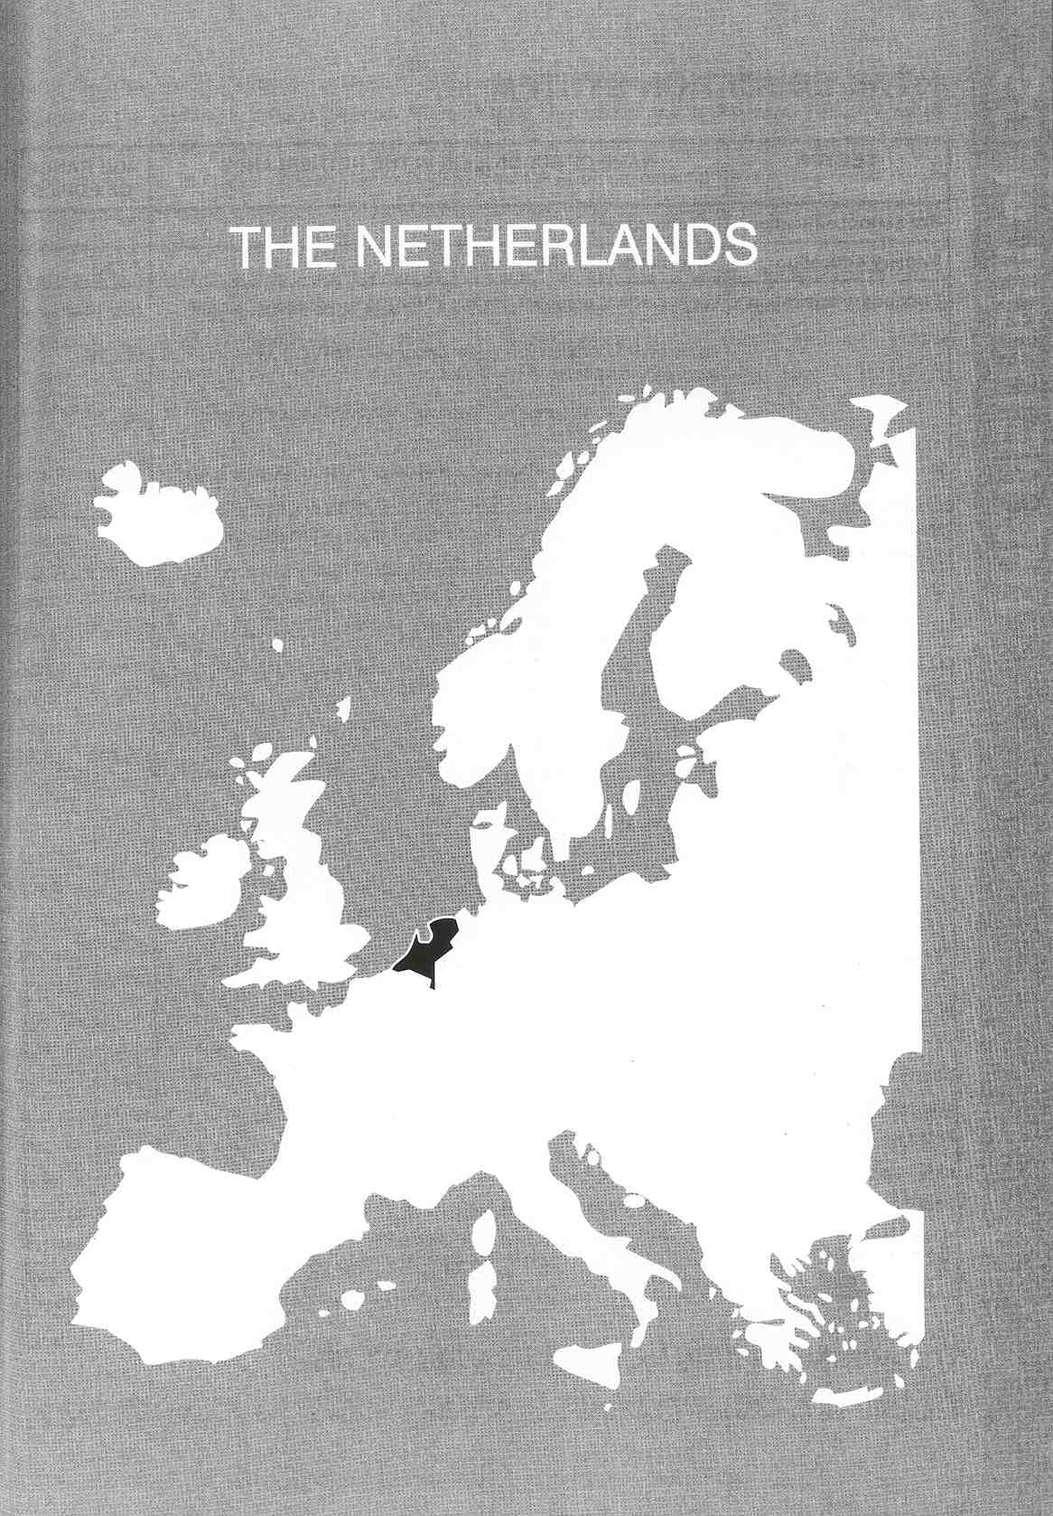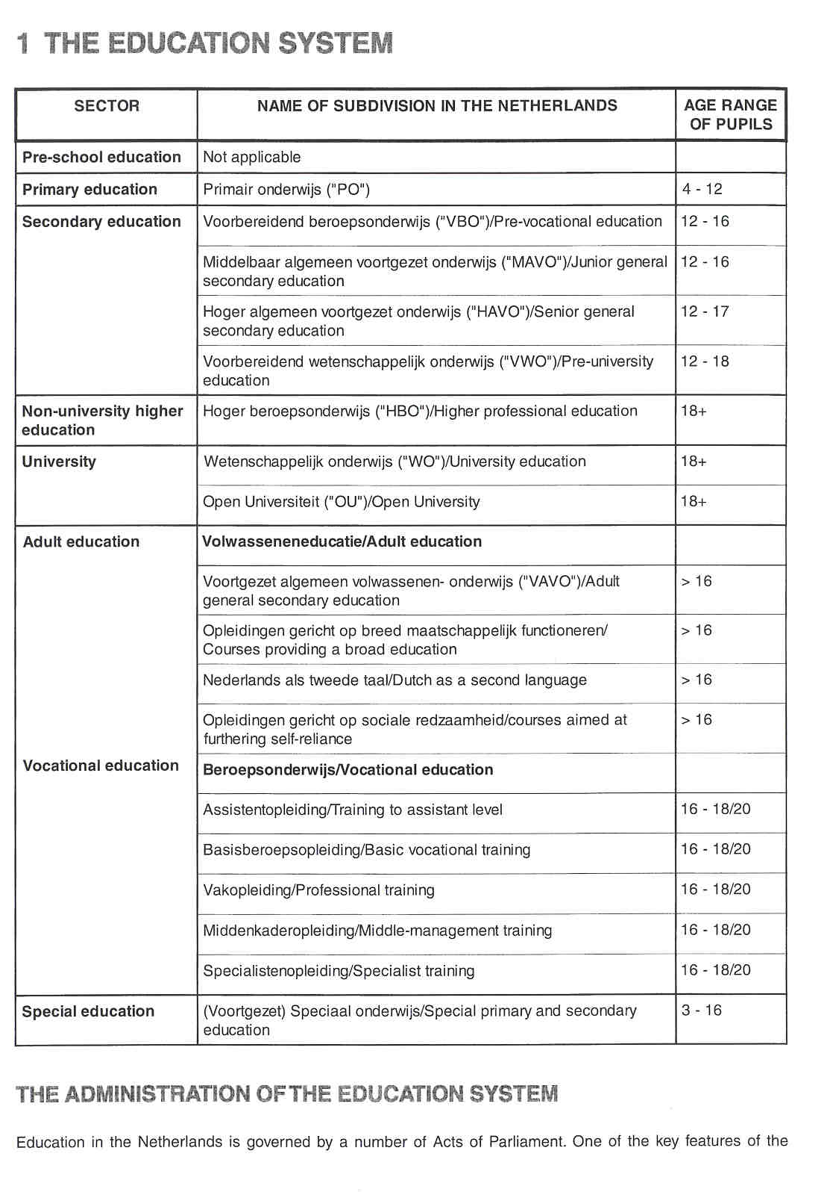

Dutch education system, is freedom of education, i.e. the freedom to found schools (freedom of establishment), to organise the teaching in schools (freedom of organisation of teaching) and to determine the principles on which they are based (freedom of conviction). This means that different groups in society have the right to found schools on the basis of their own religious, ideological or educational beliefs. The result of this constitutional right is that schools in the Netherlands differ from each other in terms of their denomination or ideological outlook.

There are two main categories: publicly run and privately run schools. Publicly run schools are non- denominational; in other words, they are open to all children regardless of religion or outlook. Private schools can be subdivided into two main groups: denominational and non-denominational schools. The former include Roman Catholic and Protestant schools and schools founded by other religious groups. Approximately, 65% of all pupils attend privately run schools.

The freedom to organise teaching means that private schools are free to determine what is taught and how. This freedom is however limited by the qualitative criteria set by the Ministry of Education, Culture and Science in educational legislation. These criteria, which apply to both public and private education, prescribe the subjects to be studied, the attainment targets or examination syllabuses and the content of national examinations, the number of teaching periods per year, the qualifications which teachers are required to have, giving parents and pupils a say in school matters, planning and reporting obligations, and so on. The Constitution places public and private schools on an equal financial footing. This means that government expenditure on public education must be matched by spending on private education. The conditions which private schools must satisfy in order to quality for funding are laid down by law.
A distinctive feature of the Dutch education system is that it combines a centralised education policy with the decentralised administration and management of schools.

Most aspects of the administration of the Dutch education system are centralised in the Ministry of Education, Culture and Science. The Ministry is headed by the Minister of Education, Culture and Science. There are currently two State Secretaries (junior Ministers), each with specific areas of responsibility (education and culture) within the general policy lines laid down by the Minister. The Minister and junior Ministers formulate policy-decisions for their sectors and responsibilities.
The Ministry comprises a number of administrative departments plus the Central Funding of Institutions Agency and the Education Inspectorate. There are three types of department: field departments, cross- sectoral departments and support departments. Specific educational policies and science policy are developed and evaluated in the six field departments. Each of these is responsible for a particular field of education and maintains contact with the institutions in that field. The cross-sectoral departments have the task of developing policy in a specific area of expertise touching upon virtually all the field departments. The chief civil servants together form the Executive Board, which bears management responsibility for the realisation of the political decisions. The support departments are responsible for developing policy for the Executive Board andlor provide a specialist service of some kind for all the units within the Ministry.

Central government sets the general regulations for schools and is directly responsible for negotiating with the unions of schoolboards and the teacher-unions. Central government controls education by means of legislation and regulations with due regard for the provisions of the Constitution. Control is exercised in this way.

Νίκος Ηλιάδης, Πολ/κός Μηχ/κός Ε.Μ.Π., M.Sc.,
Ph.D. Industrial Education, Organization and Management,
Σύμβουλος του Παιδαγωγικού Ινστιτούτου

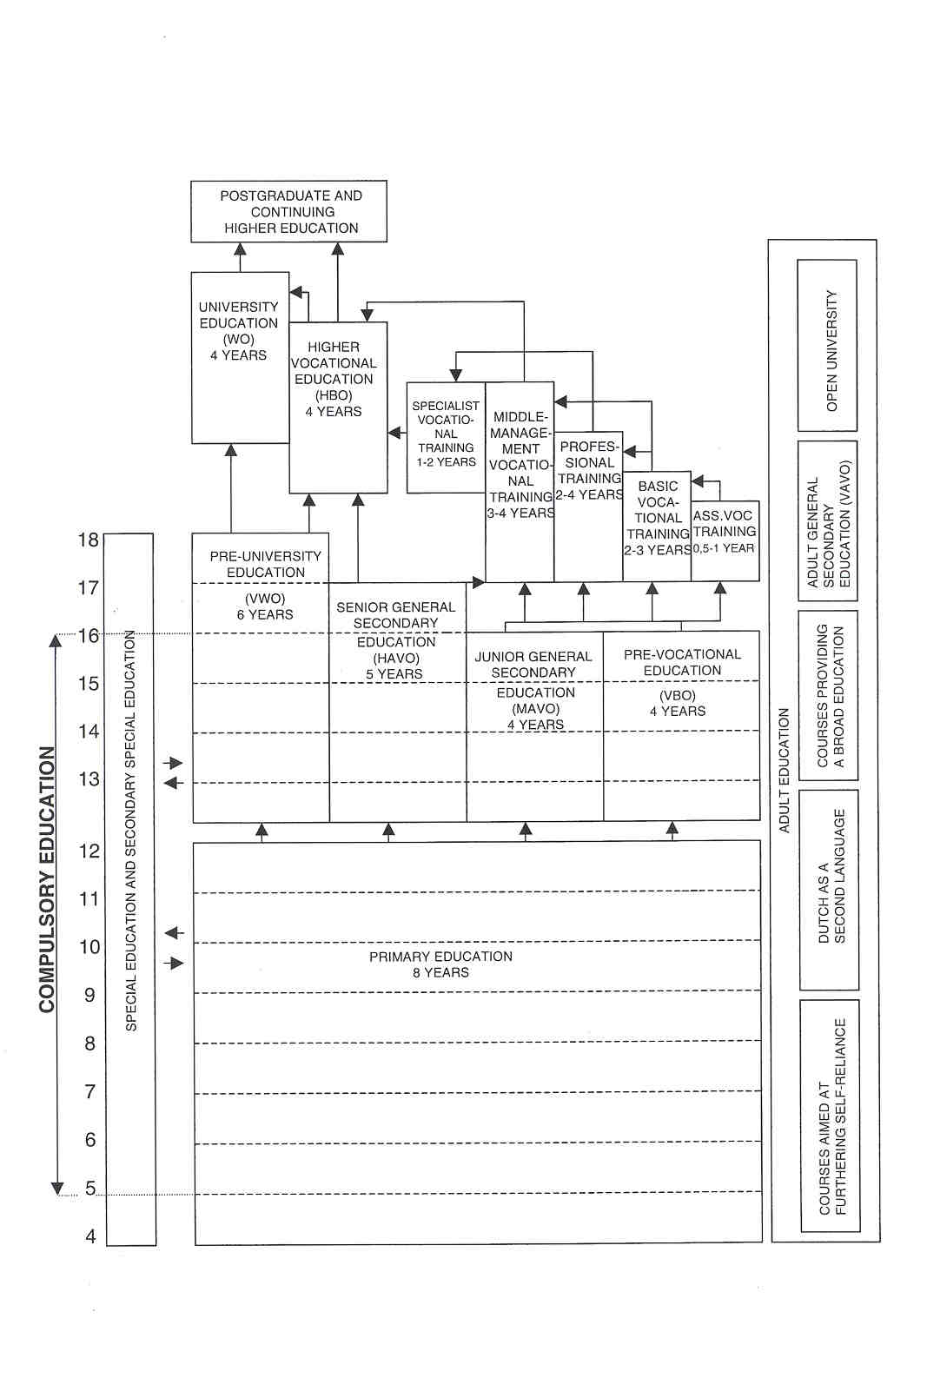

The involvement of the provincial authorities mainly takes the form of statutory supervisory and judicial duties.

As the local authority for all schools in the area, the municipal authorities have certain statutory powers and responsibilities. All schools are governed by a legally recognised competent authority, also referred to as the school board. The competent authorities are the bodies responsible for implementing legislation and regulations in schools. The municipal authorities have a dual role as the local authority for all schools in the area and as the competent authority for public school,%. The competent authority of a private school is the board of the association, foundation or church body that has established the school.

COMPULSORY EDUCATION

The obligation to attend school is laid down in the Compulsory Education Act of 1969. Every child must attend school full time from the first school day of the month following its fifth birthday; in fact, however, nearly all children attend school from the age of four. Full-time education is compulsory until the end of the school year in which the pupil reaches the age of 16 or has completed at least 12 full years of schooling. In the latter case young people are then required to attend an institution providing courses for this purpose for two days a week for another year. Linked to this is a partial education obligation until the age of eighteen. Those who have a practical training contract in a particular sector of employment attend classes one day a week on a day release basis and work the rest of the week.

The Compulsory education Act is implemented by the municipal authorities. At local level, the Municipal Executive Council checks whether pupils subject to compulsory education have been admitted to schools in their municipalities.

EDUCATIONAL SECTORS AND SUBDIVISIONS

Primary Education

Primary education lasts 8 years and is for children from the age of 4 to 12. Children may not remain at primary school beyond the end of the school year in which they reach the age of 14.
Primary education is free of charge. Parents are free to send their child to either a public-authority or a private school.

The subjects in the curriculum are compulsory, but schools are free to decide how much time they devote to each subject. The content of teaching is not prescribed. Instead, attainment targets have been formulated which indicate in general terms the basic minimum that schools are expected to teach their pupils. Since 1 August 1998 revised attainment targets apply

Schools may also have additional specialist teachers, e.g. for physical education. Since 1997 teachers may be assisted in the classroom by a teaching assistant.
The government does not prescribe methods for assessing the progress of primary school pupils. Methods of assessment and reporting are recorded by each individual school in its school plan.

At the end of their 8 years of primary schooling pupils do not receive a certificate or diploma, but a school report describing their level of attainment and potential. As an aid in assessing the educational potential of their pupils, almost 70% of all Dutch schools use the tests for primary school leavers developed by the National Institute for Educational Measurement ("CITO" tests).

Since 1999 primary schools have to use 2 new quality control instruments: the school plan and the school guide, and next to that a right of complaint. The school plan, which must be updated every 4 years, outlines the school's policy on educational matters, staffing and quality, and provides specific information about the school. Through this document the school accounts to the Inspectorate for its policies. The school guide is an annual document containing more detailed information for parents and pupils about what goes on in the school, its objectives and the results achieved. The complaints procedure supplements the opportunities for participation in decision-making and the management of the school. The school board is obliged by law to set up a complaints committee.

There are special measures to help the educationally disadvantaged and children with mental andlor physical handicaps, e.g.:

- educational priority policy: extra resources for schools in areas where 75% or more for schools with pupils with disadvantaged home backgrounds, e.g. from ethnic minorities;
- integration of children with special educational needs into mainstream primary schools;
- personal budget: a new funding system to be introduced in stages from 1 999 onwards at both primary and secondary level. After assessment by an independent committee, children who require special facilities because of their handicap will be awarded a personal budget (a voucher), which parents may spend at either a special or a mainstream school. The budget will be allocated to the school.

Secondary Educffiion

Secondary education comprises:

- Pre-vocational education ("VBO") lasts four years and covers the first stage of secondary education. Both general and vocational subjects are taught. Pro-vocational education is for pupils between the ages of 12 and 16. It provides a basis for further vocational training.
- Junior general secondary education ("MAVO") lasts four years and is for pupils aged 12 to 16 years. It prepares pupils for entry to senior secondary vocational education ("MBO"), apprenticeship training or the last two years of senior general secondary education ("HAVO").
- Senior general secondary education ("HAVO") lasts five years and is for pupils aged 12 to 17 years. It prepares pupils mainly for entry to higher professional education ("HBO").
- Pre-university education ("VWO") lasts six years and is for pupils aged 12 to 18 years. It prepares pupils mainly for admission to university.

Most secondary teaching takes place within combined schools offering a number of different types of secondary education. All lessons are given by specialist subject teachers.

The First Stage of Secondary Educatlon

The first stage encompasses the 4-year "VBO" and "MAVO" courses and the first 3 years of "HAVO" and “VWO". "VBO", "MAVO", "HAVO" and "VWO" all begin with a period of basic secondary education, lasting no more than 3 years. It provides a broad-based general education for pupils between 12 and 15 with no strict dividing line between general and technical subjects. Pupils are taught a compulsory core curriculum of 15 subjects (3.000 hours over 3 years). The remaining 20% of teaching time (840 hours) may be used by schools for lessons and other educational activities at their own discretion. National attainment targets have been set for the subjects in the core curriculum. These targets indicate the level of attainment in terms of knowledge, understanding and skills. They are compulsory minimum criteria which schools are expected to achieve by the end of the period of basic.secondary education.
There are no detailed regulations with regard to the curriculum (content, teaching methods, materials). The school plan must describe the subject matter covered and the teaching methods used. The leaving examination regulations provide guidance as to the content of the various curricula.
Under the aegis of the Minister of Education, Culture and Science, tests are set for each subject in the core curriculum, with the exception of physical education. These tests are based on the attainment targets. The method of testing is recorded in the school plan.
Pupils who have completed the period of basic secondary education receive a certificate on leaving secondary school. At the end of the school year the school board will advise pupils as to which option of further schooling they should choose.
At the end of "VBO" and "MAVO" there are school-leaving examinations. These comprise two parts: internal school examinations and national examinations.
In order to improve the transition from "MAVO" and "VBO" to other types of education, three learning pathways will be introduced: a theoretical programme, a vocational programme, and a combined theoretical and vocational programme.

The Second Stage of Secondary Education

This stage encompasses the 4th and 5th years of "HAVO" and the 4th to 6th years of "VWO".
There are 3 types of "VWO" school: the atheneum (no Greek and Latin), the gymnasium (Greek and Latin are compulsory) and the lyceum (Greek and Latin are optional).
"HAVO" pupils choose their (6) examination subjects at the end of the 3rd year, "VWO" pupils choose their (7) examination subjects at the end of the 4th year. Since August 1998 onwards this system are replaced by 4 set subject groups combinations for which pupils have to opt:

- culture and society;
- economics and society;
- science and health care;
- science and technology.

Schools have to develop into 'places of study', where pupils are given increasing responsibility for planning their own work, work more on their own or in groups, carry out assignments, etc.
The leaving examinations for "HAVO" and "VWO" comprise 2 parts: internal school examinations and national examinations. The "VWO" examination includes 7 subjects, the "HAVO" examination 6. It is possible to sit the examination in more subjects. Since August 1998 there is a new examination syllabus for every subject, that ties in with the four subject combinations.

Higher Education

Higher Professional Education

Higher professional education provides theoretical and practical training for occupations which require a higher vocational qualification. It is provided at "hogescholen" (polytechnics) and is for students around 18 and over. There are 51 "hogescholen" in the Netherlands. The institutions generally offer courses in several different fields of education. The institutions vary in size: from 400 up to 25.000 students. There are both full-time and part-time "HBO" courses.
Students wishing to enrol for a course must possess a "HAVO" certificate, or a "VWO" certificate, or an "MBO" certificate.
The study load of each course is 168 credits (4 years). One credit is equivalent to one week of study (40 hours), made up of lectures, laboratory work (where applicable) and independent study. Each academic year lasts 42 weeks. After four years the final examinations are held.
The first part of the study is called the propaedeutic part and consists of 42 credits. This part of the course concludes with an examination.

University Education

Degree courses, for students aged around 18 and over, are provided at 13 universities.
University courses lead to a masters ('doctoraai') examination and have a study load of 168 credits, in theory equivalent to four years of study. One credit is equivalent to one week's work (see under "HBO"). Where the study load for the whole course is 168 credits, the course will last four years. There are also longer first degree courses with a heavier study load, varying between 210 credits (five years) and 252 credits (six years).

Open University

The Open University (OU) is a state establishment of higher education offering distance learning courses for people aged 18 and over. Besides the headquarters in Heerien, there are 18 study centres spread through the country, providing information, guidance and advice.
The OU courses are organised in the form of separate modules, each of which is deemed to require 100 hours of study. Students may combine various courses to compile their own programme of study. It is also possible to complete a full "HBO" or university programme.

Teacher Training

Initial teacher training courses for the various types of school are part of higher education, some being provided at colleges of higher professional education and some at universities.

Primary school teacher training is a form of higher professional education. Both full and part-time courses leading to a qualification to teach at primary school level have a study load of 168 credits (equivalent to four years). The duration of the part-time courses varies in practice depending on a range of factors, including the student's previous educational qualifications. Course graduates are fully qualified to teach all subjects and all age groups (4 to 12 years) at primary level and to teach in special education and adult basic education. Candidates for admission to an "HBO" primary teacher training course must possess an "HAVO" or "MBO" certificate. There are no restrictions on the number of places (numerus clausus).

A teacher training course for special education can be taken after completing primary school teacher training. This is a two-year, part-time "HBO" course to which only those with a primary school teaching qualification are admitted. Students can specialise in a particular field of work (e.g. teaching maladjusted children) and are awarded a special education teaching qualification with the relevant endorsement.

There are two ways of qualifying as a secondary school teacher via:

- "HEO" teacher training courses: There are as many teacher training courses as there are subjects in the secondary curriculum. Students may obtain a grade two qualification in a specific subject (languages, mathematics, physics, chemistry, history, etc.), a grade one or two qualification in arts and crafts (drawing, visual arts, textile crafts, handicrafts, etc.) or a grade one qualification in physical education.
- Postgraduate teacher training course: University graduates can take a postgraduate teacher training course leading to a grade one qualification. Courses are available in all subjects in the secondary curriculum, both compulsory and optional.

Teachers with a grade two qualification are qualified to teach the first three years of "VWO" and "HAVO" and ail age groups in "MAVO", "VBO" and "MBO", while those with a grade one qualification are qualified to teach at all levels of secondary education.
There are no specific training courses for those wishing to teach in higher education. Lecturers at colleges of higher professional education ("HBO") must hold a higher education qualification plus a certificate of competence to teach. This does not apply to staff at teacher training institutions who must have a grade one teaching qualification in the relevant subject. For university lecturers, there are no specific requirements regarding teaching competence.

Vocational and Adult Education

Since 1 January 1996 the Adult and Vocational Education Act ("WEB") has been in force. The Act was introduced to give more unity to the various forms of educational provision within the vocational and adult education sector, bringing together institutions from all the different fields of vocational and adult education. The main reason for the creation of these centres is to be able to tailor training to students' needs.

Vocational Education

Since 1 August 1997 there are four levels of training based on the European "SEDOC"-system2:
- training to assistant level (level 1; 6 to 12 months). For those who are not able to obtain a basic qualification (level 2) but can thus obtain a certificate nonetheless. Students are trained to perform simple executive tasks;
- basic vocational training (level 2., 2 to 3 years). Prepares students to perform executive tasks at a slightly higher level. The diploma is equivalent to a basic qualification, which is the minimum qualification that everyone should have;
- professional training (level 3; 2 to 4 years). Holders of this level are able to carry out tasks completely independently. They must also be able to account for their actions to colleagues and monitor and supervise the application of standard procedures by others;
- middle-management training (level 4, 3 to 4 years). Prepares students to carry out tasks completely independently, combined with the ability to perform a broad range of tasks or specialisation in a particular field. Students must also demonstrate that they possess non-job-specific skills, such as tactical and strategic thinking, and can expect to take up posts in which they have hierarchical, formal or organisational responsibilities;
- specialist training (level 4, 1 to 2 years). See middle-management training.

At each level there is one course, with the exception of the 4th level, for which there are two courses. For each course there are in principle two pathways: vocational training where practical training takes up between 20% and 60% of the course, and block or day release where practical training takes up more then 60% of the course.
The competent branche authority draws up teaching and examination regulations for each course offered by the institution. Each course includes practical training in the occupation concerned. This will be provided on the basis of a contract between the institution, the student and the company or organisation providing the placement.
At the heart of the qualification structure lie the exit qualifications. These describe the qualities in terms of knowledge, understanding, skills and, where applicable, professional attitude which those completing a course should possess. The exit qualifications are divided up into a number of partial qualifications. The national vocational education bodies formulate the exit qualifications for each sector of employment,. groups of sectors or occupational group, which are then finalised by the Minister of Education, Culture and Science. External validation is carried out by or on behalf of examining bodies and has built-in guarantees to ensure that the content and level of the examinations match the exit qualifications.

Adult Education

In adult education the following courses are offered:

- adult general secondary education ("VAVO"). For adults who wish to obtain "MAVO", "HAVO" or "VWO" qualifications in one or more subjects;
- courses providing a broad education include courses with a finishing level equivalent to completion of the first stage of secondary education. They are not intended as terminal education but provide a basis for further education, such as "VAVO", basic vocational training, professional training or middle- management training;
- Dutch as a second language. To bring the language skills of non-native speakers up to an acceptable level;
- courses aimed at fostering self-reliance are of a general introductory nature. They aim to give students the minimum of language, numeracy and social skills necessary to get by.

The competent authority draws up teaching and examination regulations for each course offered by the institution. These regulations include the examinational syllabus, except for "VAVO" and Dutch as a second language.

Special Education

Special primary schools cater for children aged from 3 or 4 through to around 12 years, while special secondary schools are for children aged 12 and over. The maximum age is 20. Special education is provided in separate schools catering for either the' primary or the secondary age group. Special education for pre- school children with developmental difficulties is provided in units attached to special primary schools. Each special school is geared to the particular learning difficulties that children may encounter in the course of their schooling.
Education policy in the Netherlands aims at giving primary responsibility for all children, with or without special needs, to ordinary primary schools. This is meant to reduce the number of referrals to special schools. The relevant legislation came into force in 1994 and contains provisions governing peripatetic supervision, regional referral committees and admission of pupils with learning difficulties to schools for children with learning and behavioural difficulties and vice versa. Schools are required to establish consortia of special schools and mainstream primary and secondary schools.
Since 1 August 1998 schools for children with learning difficulties, children with learning and behavioural difficulties and preschool children with developmental difficulties are known officially as special schools for primary education. Funds are allocated to wherever pupils with special needs are being catered for, i.e. as far as possible in ordinary schools and, where there is no other option, in special schools. Consortia of ordinary and special schools must encompass at least 2.000 pupils. Each consortium must set up a permanent special needs committee to assess whether placement at a special primary school is necessary.

In special secondary education three pathways are to be introduced, all of which will allow pupils to obtain a diploma giving them access to the second stage of secondary education. Pupils who are able to obtain a diploma in this way provided they receive extra help will be given the extra support they need to do so. It will be left to the consortia to decide how this support will be provided. Each consortium will appoint a special needs committee to assess whether pupils require extra help.
An ernployment-oriented programme is to be introduced for pupils who are unlikely, because of their handicap, to obtain a regular diploma and thus go on to other kinds of education. Each school is responsible for the content of the programme, which must include a work placement.

2 THE ORGANISATION OF THE INSPECTORATE

Central government, in the person of the Minister of Education, Culture and Science, controls education by means of regulations and legislation, taking due account of the provisions of the Constitution. As well as internal evaluation by schools and institutions themselves, the quality of education is evaluated at national level, by the education Inspectorate among other bodies. The government is also completely responsible for funding the Inspectorate and its services.

The Inspectorate is a serni-independent agency and is directly governed by the Senior Chief Inspector. Together with 4 Chief Inspectors he manages the Inspectorate. Each Chief Inspector is responsible for a different sector: primary education, secondary education, vocational training and adult education and higher education. There is a Central Staff Office with 6 staff inspectors and divisions for services (public relations, finances, personnel, ICT, etc.).

Each sector has a number of Co-ordinating Inspectors. They co-ordinate the work of a group of some 3 until 15 inspectors in a region; they manage Inspectorate projects, are responsible for the editing of reports. These Co-ordinating Inspectors supervise a smaller number of schools, but have to maintain their links with education in day-to-day practice, links which are considered essential to their duties as co-ordinators.
Each sector consists of a number of inspectors and a support staff. The sector higher education also includes a scientific staff.

The Inspectorate has its headquarters in Utrecht. The inspectors who are housed in an Inspectorate office, help ensure cohesion within the office by collaborating on projects and by exchanging information with colleagues (e.g. in connection with the assessment of school work plans or co-ordinated visits to establishments). There are 12 regional offices distributed throughout the country for primary and secondary education and 3 offices for higher education and for vocational and adult education, including the office of the Chief Inspector and his or her advisory staff.

Responsibility for the inspection of agricultural education rests with the Minister of Agriculture, Nature Management and Fisheries. There are six regional offices for agricultural education.

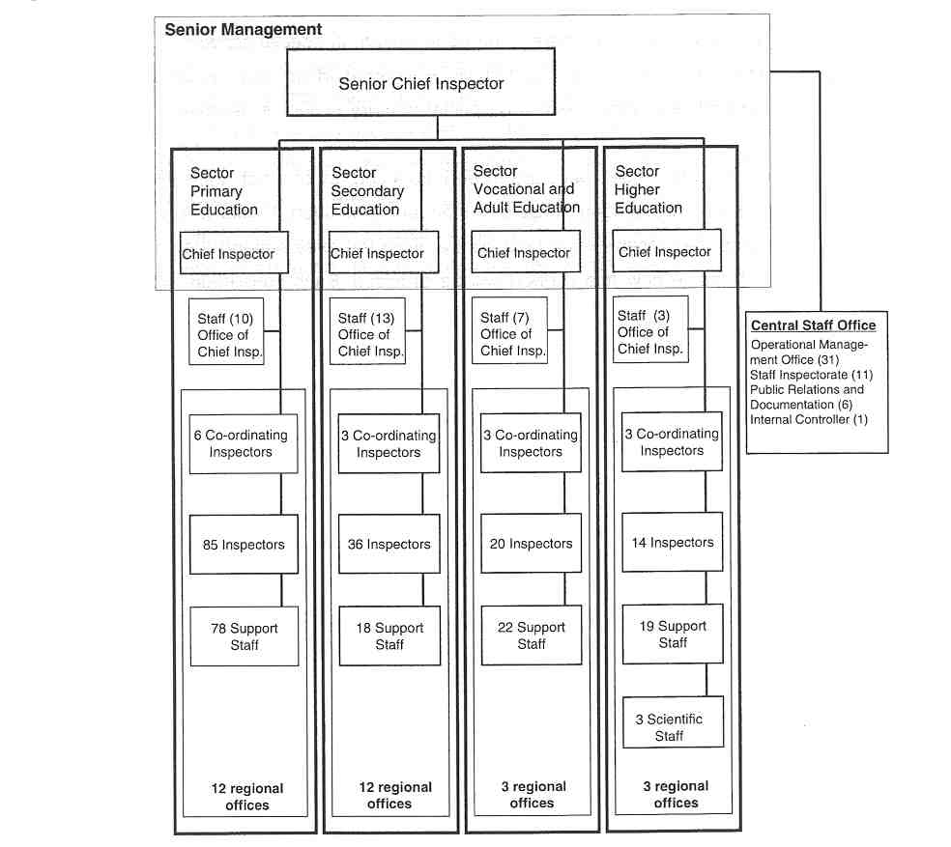
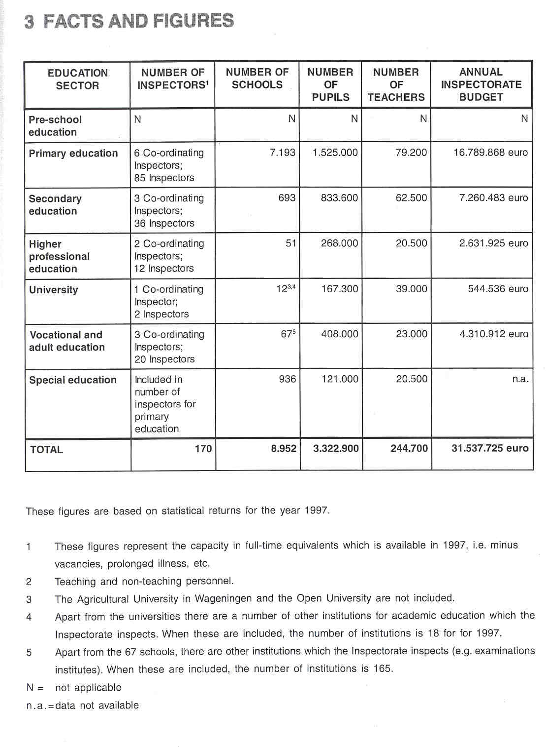

4 THE RECRUITMENT OF THE INSPECTORATE

Candidates for the post of inspector have to fulfil some requirements. They need a university degree in e.g. educational sciences or public administration and a reasonable (5 to 10 years) practical experience in the field of education.

An analytical intellect and a broad social orientation is an obligatory recruitment condition for applicants. Having at one's disposal an unimpeachable conduct is also a necessity The candidates must be capable of setting up and maintaining a social network.

The candidates must bring something extra, apart from education and experience; e.g. experience as projectmanager in innovation, co-ordinating experience in e.g. teacher in-service-training, an active participation in a professional association. They have to show that they have a network of contacts in the educational field.

For some vacancies experience in specified aspects of education is identified as desirable e.g. special education, information technology, further education or a background in a particular school-subject.

A vacancy is announced in the newspapers. A commission consisting of the Chief Inspector, 2 inspectors and a personnel-staff, selects letters and has interviews with potential candidates (8 to 20). A second commission, consisting of the senior Chief Inspector, a Chief Inspector, 3 other inspectors and a personnel staff member, interviews the selected 3 to 5 candidates. In some cases there is an assessment, done by an external bureau. In all cases the second commission consults earlier employers or colleagues of the candidates.
All newly appointed inspectors enter into an induction period and a probationary period of one year with two assessments. If everything is very well, tenure is given after that year.

5 THE WORKING CONDITIONS OF THE INSPECTORATE

Formally, inspectors are appointed by the Queen on the request of the Minister. But in fact, inspectors are appointed by the Senior Chief Inspector. For the Chief Inspectors and the Senior Chief Inspector the Minister is personally involved.

At present, the function of inspector is preferably a full-time job. However, considering the prevailing conditions of employment, exceptions are possible. Inspectors with a full-time job (40 hours a week) are forbidden to have another additional paid job. Voluntary work in leisure time is allowed, but the inspectors have to inform their Chief Inspector in,order to enable him to judge if there could be incompatibility. Most additional jobs concern positions on boards in the fields of education and politics.

In general, the function of an inspector is a permanent position for the very reason that it guarantees continuity. For most inspectors, the Inspectorate is a life-long career until retiren@ent age.

Within the Dutch Inspectorate there is no real "progression in caree@'. However, when there are vacancies, inspectors can opt for a management function as a co-ordinator or a Chief Inspector.

6 AREAS OF INSPECTORATE RESPONSIBILITY

The duties of the Inspectorate, as laid down in educational legislation, are:

- to ensure compliance with statutory regulations (control).,
- to keep up to date with the state of education (evaluation);
- to promote the development of education through consultation with the competent authorities and staff of schools and with the regional and local authorities (promotion);
- to report to and advise the Minister, both at his request and on its own initiative (advising/reporting).

6.1 ENSURING SCHOOLS'COMPLIANCE WITH STATUTORY REGULATIONS (CONTROL)

Contemporary legislation is characterised by greater freedorns of insight and interpretation on the part of the schools. Despite more say on the part of the schools in the education they offer, the Government is held responsible for ensuring education is differentiated and of high quality, serving the needs of all its citizens. Under the authority of the Minister the Inspectorate supervises the schools.

The inspection of schools' compliance with statutory regulations is being increasingly integrated in integral school supervision and other forms of full inspection that are being developed. It is a key element in the work of the Inspectorate. The inspection of schools' compliance with statutory regulations is mainly concerned with the attainment targets, etc. The inspection puts also a strong emphasis on schools' compliance with regulations concerning e.g. support system for pupils with learning difficulties, timetables, agreements with special schools, etc.
Yearly each sector decides on which aspects the inspection will primarily focus.

Control by the Inspectorate does not concern financial or administrative management of schools. Schools have a wide administrative and financial autonomy and are responsible for their own administration and budget and financial management. Schools are obliged to send a report of an external accountant to the accountancy department in the Ministry. This accountancy department cheeks the reports and samples. The Inspectorate has also no role concerning the appointment of staff.

6.2 EVALUATING

In the period 1985-1995 the Inspectorate focused on control (see b) and the evaluation of certain aspects of the quality of education, for instance:

- The quality of mathematics teaching in primary schools;
- The quality of counseling in secondary schools;
- The reliability of examinations in vocational schools.

In a sample of schools (60 a 300) lessons were observed, meetings held, questionnaires filled out, etc. The result was reported in a report for Parliament and public; summarized in the Annual Report about the state of education. Although this type of evaluation is continued (See below.), now the method of full inspection is being developed. In the Nederian ds, evaluation of entire schools is becoming increasingly important.

Full Inspection

To make objective methods of working possible, the Inspectorate is at the moment designing two types of school inspection. In order to gain a first impression of the state of affairs in a school, a short but general inspection is carried out. If there is no evidence of exceptional situations, further inspection of the school will be unnecessary at that time. The result of the overall approach may also be that particular aspects will be scrutinised in more depth.

The quality of school management is evaluated in so far it affects the quality of learning and teaching. The Dutch Inspectorate has no tasks regarding the evaluation of teachers with the purpose to assess them. However after classroom visits feedback is given to the teacher and in the case of serious problem the head teacher is confidentially informed.

Primary Education

Full inspection has already been developed and tried out for primary education and is since 1997 being put into practice in this sector. Integral school supervision (ISS) in primary education makes it possible to view and assess the various aspects of education simultaneously and in their interrelationship. ISS focuses on the teaching-learning process; the results; school conditions (are these sufficiently conducive to the quality of the teaching-learning process and to the achievement of sufficient results?). Regular School Supervision (developed in 1998) is a shorter version of ISS. ISS is carried out if RSS shows doubts about the quality; and in a sample of 400 schools per year in order to be able to report about the state of primary education.

Secondary Education

For secondary education the method of full inspection is being developed. The RSS-system will be implemented in 1999. Much experience has been gathered in the evaluation of the introduction of basic secondary education which was introduced in 1993. The object of the evaluation is assessing and describing the quality of a number of important characteristics of the teaching in the school years in which basic secondary education is realised. The evaluation focuses on school organisational aspects, the teaching- learning proces and pupils' performances. The final report appeared in September 1999. The aim of the evaluation has to create possibilities for a social and political discussion on the desired further introduction and development of basic secondary education in the first stage of secondary education.

Since 1998 primary and secondary schools are obliged to develop self-evaluation and to report about it in a schoolguide for parents and the community. In the inspection-systems for RSS and ISS the evaluation of the self-evaluation will become more important in coming years.

Higher Education

The Higher Education Act gives universities and institutions for higher professional education a great deal of freedom, but with the responsibility to organise their own system of quality assurance. The Inspectorate for higher education does not evaluate branches of study itself. In higher education 'full inspections' of courses or faculties are carried out by external Review Committees.
The primary task of the Inspectorate for higher education is to evaluate the quality of this quality assurance by carrying out a meta-evaluation of the national review reports, compiled by Review Committees. The Inspectorate carries out its own evaluation at those institutions where the reports of the Review Committees express concern about the quality of education. This may result in a recommendation to the Minister to warn or even close the course in question. The Inspectorate also evaluates the actions the institutions take on the basis of the review reports.

The quality of the school management is not evaluated in higher education.

Vocational and adult education

For vocational and adult education the method of full inspection was developed in 1998 and is implemented in 1999.
Since the introduction of the Adult and Vocational Education Act (WEB, 1996), the institutions are required to develop a good system of internal quality assurance and thereby have to involve outside experts to evaluate aspects of the education provided and its results. The Inspectorate evaluates the reports the institutions provide on this quality assurance and its results. The Inspectorate does not limit itself to the evaluation of the quality assurance, but also checks whether the reports are consistent with reality. This evaluation of the self- assessment is incorporated into full inspection.

Aspect Evaluations

A range of specific topics is evaluated in the various sectors.

In primary education the evaluation of specific topics is as much as possible included in the integral school supervision; for the first phase of secondary education they form part of the evaluation of basic secondary education.

For both primary and secondary education whole-school issues are also taken as the focus of evaluation. These evaluations of selected subject areas are included in the annual work plan of the lnspectorates.

For vocational and adult education the focus is mainly on whole-school issues, such as ICT, quality assurance. The same holds for higher education. There are also topics which are evaluated in all sectors in the same year(s), e.g. in-service training and discrimination at schools.

In the Netherlands, the Inspectorate is not involved in drawing up examinations. For the sectors secondary education and vocational and adult education, the Inspectorate supervises and evaluates the way in which examinations proceed (organisation, etc.), Yearly particular aspects of the examinations are evaluated as well, e.g. the school examinations for Latin or for Mathematics. The Inspectorate evaluates whether these examinations meet reasonable criteria regarding content, length, construction, level, and standardisation.

6.3 ADVISING

An important task of the Inspectorate is advising the Minister and the Ministry on all aspects of the Dutch education. They give full and objective advice either on request or on the Inspectorate's own initiative.

The Inspectorate is not responsible for writing the curriculum and plays also no role in advising concerning national development, such as curriculum developments and developments in the national examination system, but checks and evaluates the way in which the curriculum is being taught at the schools. Inspectors have to promote the development of education through consultation with the competent authorities and staff of schools and with the regional and local authorities.

Advising schools (teachers, head teachers) has become less important in the last few years. This role is left to the educational support structure, to which inspectors can refer schools. Of course, some advice will be given during school visits where necessary.

6.4 MONITORING

In general the Inspectorate monitors the system as a whole by analysing the results of school inspections, aspect-evaluations and investigations of universities about developments in education.

linked to the development of new inspection systems (cf. RSS, ISS) databases about schools are being set up since 1997. These are connected with the databases of the Ministry regarding numbers of schools, staff, students, mobility.

The Inspectorate deals with complaints about and by schools. The Inspectorate employs six "confidential inspectors", who - beside their "normal" tasks - deal with complaints about undesirable behaviour and sexual intimidation.

6.5 REPORTING

The inpectorate has to report to the Minister and to Parliament about the "state of education". This is done in some 15 reports a year about matters of interest and in the Annual Report about the State of Education. All kinds of topics are dealt with, for example:

- The results of full inspections;
- The quality of management in schools;
- The position of ethnic minorities;
- The implementation of new regulations.

The Inspectorate also reports about the Regular School Supervision and the Integral School Supervision. (See below.)

7 THE ROLE OF THE INSPECTORATE IN EDUCATIONAL POLICY

The Inspectorate has no official role in preparing educational policy, but the Inspectorate's evaluation reports on particular aspects or topics are used in the policy-making process, by the Ministry and by Parliament. The Inspectorate has an advising, recommending and consulting role in decision-making of the education policy, but it is not involved in decision-making itself.

The Inspectorate stimulates the implementation of the policy. This is done through inspection and dissemination of inspection findings. The results of the Inspectorate's evaluations at individual schools will mostly be the starting point for stimulating the further development of the school in question, also where the implementation of a particular policy development is concerned.

The Inspectorate does not evaluate the effectiveness of the policy, but the way in which schools implement that policy. By comparisons and contrasts drawn between situations and developments at schools and in education generally, the Inspectorate is able to inform those responsible for policy regarding the state of education and also attend to changes in policy at an early stage. The Inspectorate's reports on the state of education are used in the debate about the policy's effectiveness.

In assessing education in combination with particular policy developments, the Inspectorate takes into account how much time must reasonably be taken in order to achieve the objectives of the policy development in question. For instance, a policy development designed to have an effect on the process of primary education will require a lead in time of five to ten years. In cases of this nature, the Inspectorate assesses whether schools are 'on track' or not, whether they are making sufficient effort to make the new policy development possible.

8 WHO IS IN CHARGE?

Under various education acts, the Minister of Education, Culture and Science is charged with the inspection of education, which is carried out under his authority by the Education Inspectorate.

After consultation with the Chief Inspectors, the Senior Chief Inspector decides on the programme of activities and on the evaluation emphasis. The Minister has the right to ask for certain evaluations and checks to be carried out in a particular period, but negotiations are possible; he can do so in the stage of the programme being compiled as well as while the programme is being carried out. The annual programme of activities has to be submitted to the Minister for approval.

The Minister inforrns Parliament about the programme. Parliament does not decide on the programme but it may ask the Minister to request the Inspectorate to evaluate a particular topic or aspect. If there is a national priority interest the Inspectorate will try to include it in its work programme anyway.

The work programme for the individual inspector is for the greater part centrally (i.e. per sector) programmed or scheduled. This is particularly the case in primary education (centrally programmed integral school supervisions) and in secondary education (centrally programmed evaluation of basic secondary education). The individual inspector has significant autonomy in managing his own work within the demands of the wider programme of activity decided upon and allocated by the Chief Inspector.

- THE POSITION OF THE INSPECTORATE

The Minister of Education, Culture and Science bears the final responsibility for the supervision of education. The Inspectorate formally is a staff department of the Ministry but in order to express the independent position the Inspectorate is placed outside the Ministry. Supervision is done under the authority of the Minister, but with a large degree of independence.
In May 1 999 the Minister sent a policy paper on the Inspectorate to Parliament. Two points are very important:
a.The Inspectorate will have the task and the duty to publish an assessment of the quality of each school once in a certain period. So, the systems of full inspection will have a legal base.
b.The independence of the Inspectorate will be strengthened.

In the Netherlands there is a network of specialist organisations and agencies which support, maintain and enhance the education system. These organisations work independently within the policy framework of the Dutch education system. The Inspectorate sometimes Co-operates in particular projects with these agencies like the SLO (institute for Curriculum Development) and Cito (National Institute for Educational Measurement), but it does not take part in curriculum or examination development.

When developing evaluation criteria for the evaluation of particular topics or subjects the Inspectorate consults national councils of teachers, school boards, universities, individual researchers, etc.

The Dutch Inspectorate also has close contacts and links with international organisations (e.g. lnspectorates in other European countries/regions, CIDREE, etc.).

10 THE INSPECTION PROCESS

For all sectors holds that the Inspectorate initiates an inspection. During recent years, the Inspectorate has developed a method of operation that makes it possible to examine and evaluate various aspects of the education provided in their relationship.

PRIMARY AND SECONDARY EDUCATION

In primary and secondary education two types of school visit can be distinguished, namely 'Regular School Supervision' (RSS) and 'Integral School Supervision' (ISS).

In the case of Regular School Supervision (RSS), the Inspectorate examines the school's results and the core of several important quality aspects of the teaching-learning process (the teaching content, the learning time, the teachers' teaching strategies and the pupil monitoring system). Moreover, during their visit, the inspectors examine the school plan and the school prospectus. A RSS visit usually lasts one day.

Depending on the results of the RSS school visit, it may be desirable to carry out an ISS visit to a school within a period of time. In addition, ISS is carried out annually on a representative group of schools in order to collect information on the state of education and to report on this subject in the Education Report.

The method of operation that the Inspectorate employs in the case of Integral School Supervision (ISS) in primary education and secondary education corresponds to the new administrative relationship, whereby the school is primarily responsible for the quality of education provided.

In the case of ISS, the Inspectorate explicitly chooses to enter into a dialogue with the school and all interested parties: the school has to present itself in its self-evaluation. The Inspectorate cheeks the validity, adds its own investigations, and evaluates the school's quality.

The visit to a school in the context of the integral school supervision will usually be carried out by the school's regular inspector. At larger schools and in the secondary schools the visit will be done by a team of inspectors. An ISS school visit lasts an average of two and a half days. Different arrangements may be made in some cases. It depends on the size of the school, the number of locations and the timetable.

Preparation Phase

A few weeks beforehand the Inspectorate informs the school and its competent authority of its intention to carry out an RSS or ISS visit to the school. Generally by support staff setting a date in contact with the school. The school management team receives a brochure about RSS or ISS.
During an information meeting, the Inspectorate informs those present of the content and the procedure of the visit. This meeting is also used to make concrete agreements about the school visit: the data of the visit, the preparations the school needs to make and any bottlenecks that may occur.
Following the information meeting, the school receives notification of the visit. This notification is sent to the school together with a questionnaire for the school management team, the pupil monitoring co-ordinator and the class teachers.
During the preparatory stage the inspector and his assistant will analyse all the documents available at the office of the Inspectorate.
A timetable will be made for the school visit, in consulting with the school management team.
The inspector concludes the preparatory stage by processing the details obtained from the questionnaires for the school management team, the pupil monitoring co-ordinator and the teachers, as well as data from the documents analysed.

Implementation Phase

The implementation phase consists of a quality judgement of the teaching at both group and school level. During a start meeting the school management team will have the opportunity to present the school and to provide further information. The inspector will also use this meeting to interview the school management team on matters featuring on the school management team questionnaire that still need to be supplemented or clarified. The school has the opportunity to present its pupil monitoring system.
The inspector discusses the documents that have been submitted by the school management team and the pupil monitoring co-ordinator. The inspector checks the school's administrative system and school procedures. In order for the inspector to obtain a clear and comprehensive picture of the quality of the teaching-learning process the inspector wishes to observe full lessons. In all cases it concerns complete lessons. If teachers wish to discuss the lessons visited briefly with the inspectors in order to get some feedback, the school can include short meetings in the ISS visit schedule. Similarly, the inspectors may wish to hold short discussions with some teachers about some specific themes.
During the school visit the inspector has also a discussion with a limited. group of pupils and with a limited group of parents.

Reporting Phase

The Inspectorate will conclude the evaluation at the school with both an oral and a written report. At the end of the school visit, the inspector/team leader meets to consider the preliminary findings and conclusions with the school management team. They also highlight the strong and weak points of the education at the school. This is used as a basis for discussions with the school regarding possibilities and plans for further development. A few weeks after the final day of the school visit, the school will receive the written report.
The Inspectorate has the objective to visit each school every two or three years.

HIGHER EDUCATION

In higher education, the Review Committees visit the faculties in more or less the same structure, but - for reasons of time - do not observe many lessons/courses. Inspectors visiting certain faculties where Review Committees reported doubts or concerns, may spend one day, discussing with students, teachers and management their reports, which have been requested by the Inspectorate. But they observe lessons only rarely

VOCATIONAL AND ADULT EDUCATION

In vocational and adult education the ISS-system, developed for this sector in 1998, has the same structure. Because the institutions are very large (up to 20.000 students) and complicated (up to 300 programmes of study) the team consists of 5 through 9 inspectors and 2 to 3 support staff. They visit the institutions during 5 up to 15 days. Some 30 to 60 lessons, training sessions or laboratory-exercises are observed.

11 INSTRUMENTS AND METHODS

THE COLLECTION OF INFORMATION

a. Questionnaires

In Integral School Supervision (ISS) in primary, in secondary and in vocational and adult education a standardised questionnaire is sent to the school management tearn, the pupil monitoring co-ordinator and the class teachers as well as a letter for the parents whom the Inspectorate is to involve in the ISS visit a few weeks before the inspection.
The questionnaires are intended to provide the Inspectorate with information such as details of the school's content, the curriculum, pupil monitoring, a number of school conditions and the results. The Inspectorate uses the information acquired to form an initial picture of the school's qualities prior to the visit proper.

b. Interviews

In primary, in secondary and in vocational and adult education the school management team is interviewed to get information about the school's content, the curriculum, the learning time, professional development, internal communication, external contacts, the contacts with parents and the use of staff and material resources. The inspector will also use the meeting to interview the school management team on matters featuring on the school management team questionnaire that still need to be supplemented or clarified.
The inspectors collect information by interviewing a delegation of teachers on the curriculum, the level of subject matter, the results, etc. The objective of the interview is to question teachers on matters that were dealt with during the lessons and which require clarification. The discussion will also focus on themes as the teaching content, the internal communication, the contacts with parents and the staff development.
In primary and secondary education a limited group of parents are also interviewed to discuss the school prospectus; the discussion will also focus on the manner in which the school maintains contacts with them.

In addition further targeted interviews will be conducted with a limited group of pupils. The discussion will focus on issues such as pupil monitoring, education in the various years and the school climate.

In higher education individual and group interviews are held as well. The issues and the interviewees depend on the evaluation object.

c. Observations

Direct observations of lessons, activities and meetings in order to gain as good and as broad a picture as possible of the quality of the teaching-learning process are current procedures, albeit more in primary and secondary education than in vocational and adult education and higher education.

d. Tests/examinations

The Inspectorate measures pupils level of attainment mainly to verify teachers' own assessments. The Inspectorate does not use its own tests during inspections, but analyses testslexaminations developed by the school or the National Institute for Educational Measurement.

e. The Collection of Documents

The Inspectorate analyses a number of relevant documents, such as the school (work) plan, a number of intervention plans, reports on previous visits, guide, survey of test results, curricula, textbooks, plans for change, plans on the subject of in-service training and supervision, amendment clauselamendment plan, school prospectus or information booklet, minutes of team andlor subteam meetings, some educational reports and the group records of the teachers to be visited, notices to parents, policy plans if they exist, merger plans and the like, and other documents that the school regards as important for getting a good idea of the type of school to be visited.

The Inspectorate increasingly uses schools' documents on self-evaluation, and schools' internal reports on self-evaluation.
In order to check the administrative system and the school procedures a lot of items must be available at all times at the school. During the year visits, the inspector will have access to a number of documents, namely a lot of registers, class records, school handbooks, summaries of pupils' progress and written work from pupils. The school is requested to have these documents at all times ready for the inspector.

f. The use of National Data

For secondary education statistical information on pupils' results in national examinations as well as data on pupil input, throughput and output are gathered and analysed beforehand. Charts are compiled presenting the school's performance in absolute terms, in comparison with schools in comparable circumstances, and in comparison with the national results. These charts are discussed during the inspection.
For other education sectors the Inspectorate can not use this kind of data, because it is not available.
APPROACHES

a. Instruments and/or Evaluation Criteria

Instruments and Evaluation Criteria for Aspect Evaluations

In an evaluation-project on a certain aspect or topic (e.g. the quality of mathematics teaching in primary schools) the Inspectorate uses uniform instruments. Evaluation criteria are developed in consultation and these criteria are translated into items for questionnaires and observation forms. Training in using them and in scoring is provided.

Instruments and Evaluation Criteria for Full Inspections

To determine what the quality characteristics of a school are, the Inspectorate has developed an instrument for each education sector. Legislation is the main source from which the Inspectorate derives these characteristics. The Inspectorate cheeks whether the education provided in practice in schools corresponds to the objectives and provisions laid down in the law and is as intended by the legislator.

A frame of reference has been developed. In all sectors the instruments generally consist of questions, criteria and, for each criterium, indicators, and statements of norms.
Based on the definition of a good school the Inspectorate has formulated a number of questions as point of departure for the evaluation. The major question for the evaluation is: How is the quality of education in this school?
To answer these questions the Inspectorate has developed criteria. Setting criteria includes decision rules and qualifications for judging the extent to which a certain criterium has been met. Each criterium is therefore concretised in a restricted number of overall indicators. The extent to which these indicators apply determines the criterium level judgement. All inspectors apply these indicators to their observations, they give a score to each indicator and are required to make a summary evaluation per criterium. That is how a school quality profile orginates that brings the strong and weak points to the fore. This quality profile also answers the central questions and the subquestions postulated for each sector. This forms the basis for the final written report and is also used as a basis for discussions with the school regarding possibilities and plans for further development.

The set of criteria in the evaluation framework constitutes the point of departure for the development of instruments. The set of instruments consists of forms for observations, discussions and oral and written surveys.

In primary education the Inspectorate has formulated evaluation questions regarding the teaching-learning process, pupil performances and school organisational aspects. In order to answer these questions, the Inspectorate developed 13 criteria concerning:
- Teaching-Learning Process
TLP 1. Curriculum
TLP 2. Learning time
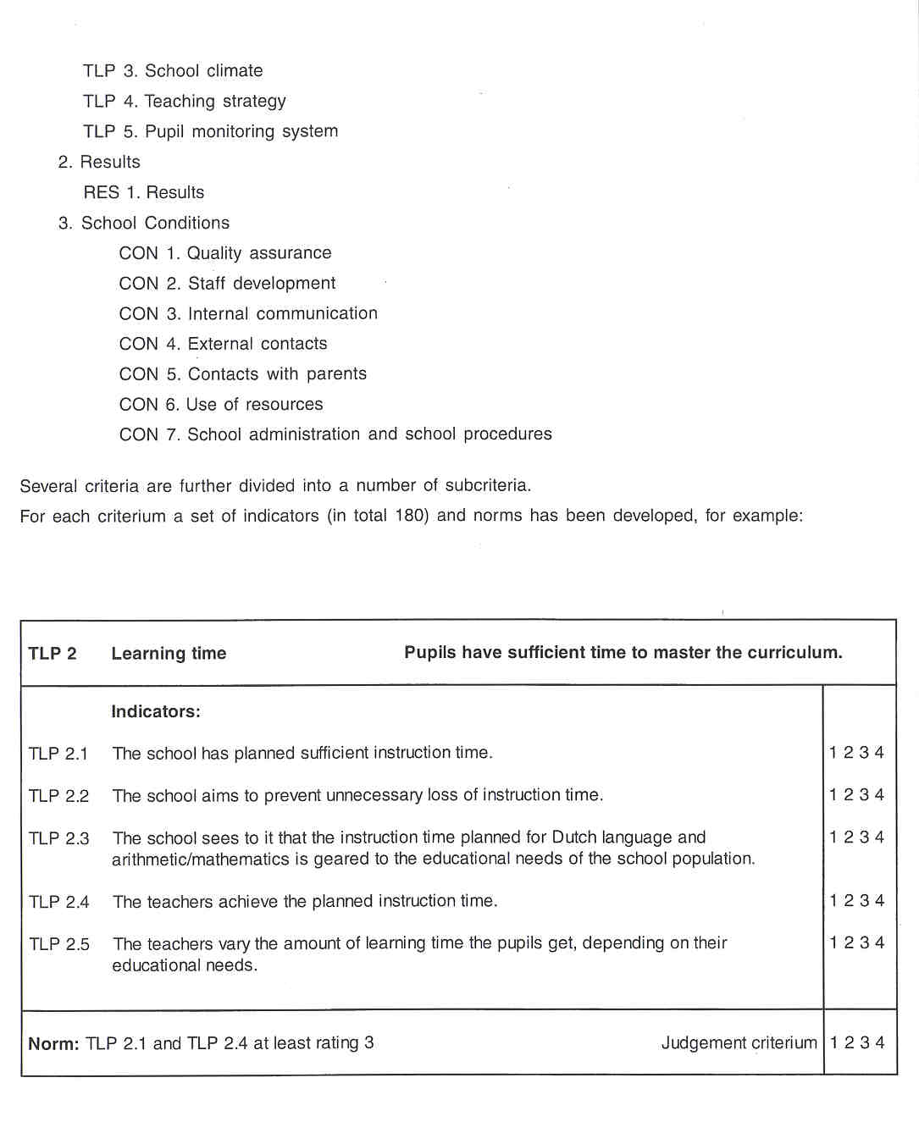

In primary education, criteria form the relevant features education in a school is assessed by. The indicators are the aspects the criteria are operationalised in. The indicators are used when collecting data and judging the criterium involved. Criteria specify the decision rules and qualifications for the extent to which the criterium has been met. A specific norm is developed for each criterium.
Standardisation is expressed on a scale of 4 points: mainly weak, more weak than strong, more strong than weak or mainly strong. For qualifications linked up with the scale points in the indicators, the division above was opted for a 4-point scale, from "applicable to a very small extent or not at all" up to "applicable to a high extent".

For secondary education, the evaluation of basic secondary education may be seen as the predecessor of the systems of RSS/ISS that are now being implemented. The plan for evaluation, drawn up by the Inspectorate, consists of evaluation questions regarding school organisation aspects, the teaching-learning process and pupil performances. It starts from 8 questions which deal with the teaching-learning process, school climate, individual guidance, study and career choice, results, school organisation and alignment with primary education and with the higher forms of secondary education.
The frame of reference in basic secondary education describes what the Inspectorate regards to be important quality features (criteria), on the basis of which aspects of this quality can be observed in the practical situation (indicators) as can the type of decisive rules that must be observed in order to arrive at the judgement that a criterium has been realised to a sufficient extent (norms). For secondary education, only the frame of reference for the teaching-learning process and for the school policy are developed up to the indicator level. The school policy questions include 5 criteria and 31 indicators. The teaching-learning process questions were operationalised in 14 criteria and more than 217 indicators (for criterium 1 and 2 there are no indicators mentioned). This big amount of indicators has to be with the 144 subject specific indicators under criterium 3. For each subject 5 to 10 indicators concerning the teaching methodology strategy is summed up. For example:
Question 1:
Is the basic secondary education teaching content consistent with the subject-specific attainment
targets and the general skill objectives?

Criterium 1. The actual subject matter covers the subject-specific attainment targets. Criterium 2. The actual subject matter covers the general skill objectives.

Question 2:
Does the strategy of teachers in basic secondary education support the realisation of the subject- specific attainment targets and the general skill objectives?

Criterium 3. The teaching methodology strategy used by the teacher is in agreement with the general objective of the subject and with the other demands placed on the subject.
Criteriurn 4. The instructional behavier of the teacher contributes to a good teaching-learning process.
Indicator 4.1. The teacher shows respect for the students in the way s/he behaves and speaks.
Indicator 4.2. The teacher takes into account the every-day lives of the students.
Indicator 4.3. The teacher gives positive feedback to questions, comments and answers from the students.

A norm was formulated for each criterium regarding the evaluation of the teaching-learning process which applies to school evaluations. The system evaluation norm will be determined at a later stage. The level at which judgement is given is indicated together with the school evaluation norm. In the statement of the norm, the school qualifies for one of the categories listed below: mainly poor, poor rather than strong, strong rather than poor, mainly strong. The qualification required for 'strong rather than poor' is mentioned in each of the individual criteria. In the case of school policy evaluation, the 'sufficient' norm is indicated for each criterium. It refers to a number and nature of indicators required to be positive.
The criteria have been formulated in such a way that they can be assessed both for school evaluations and for the system evaluation.

The evaluation framework for primary education is also used for the evaluation of special education. Special schools are intended for children for whom it has been determined that a predominantly orthopedagogic and orthodidactic approach is required such that they need to be taught, at least for a certain period of time, at these schools. In the context of ISS, the point of departure is that there is, in principle, only a difference of degree between both education forms. The education provided at these schools is regarded as more intensive, specific and planned.

In vocational and adult education the Inspectorate has developed and uses a set of criteria for evaluating the schools' quality assurance. These are related to criteria such as:
- Does the quality assurance cover all relevant aspects of teaching and learning?
- Is there a. systematic gathering of facts about the performance of students, teachers, managers?

In the recently developed system for full inspection in vocational and adult education the approach is the same as for primary and secondary education, but with specific criteria for e.g. the relations with factories and firms for the practical component of the curriculum, or for accessability of vocational programmes for everybody (which is one of the aims of the Act).

In higher education the Inspectorate has developed and uses a frame of reference (set of criteria) for the evaluation of the work of the external Review Committees and for the response of the institutions to the reports.

b. Individual Work and Teamwork

In the integral school supervision of primary schools inspectors work mostly individually. In some cases, e.g. the supervision of a very large school, the help of a colleague may be called in.

In the evaluation of basic secondary education the inspectors work in teams. These teams consist of 6 to 10 inspectors per school.

In higher education, discussions with institutions where the review reports express cause for concern about the quality of education, are mostly conducted by 2 inspectors.

In vocational and adult education the evaluation of schools' quality assurance is generally carried out by 2 or 3 inspectors.

The ratio individual versus teamwork is in:

- primary education: 9011 0;
- secondary education: 30170;
- vocational and adult education: 50150;
- higher education: 50150.

What has been said above only concerns the work of inspectors actually carried out at the schools. For all sectors holds that development, consultation, preparation, analysis of findings, reporting, quality control, etc. are matters of teamwork.

12 JUDGEMENT AND ITS CONSEQUENCES

JUDGEMENTS

In primary and secondary education, the Inspectorate will award a quality judgement for each criterium. The judgements on the criteria are explained in the draft report and justified on the basis of the indicators that have been formulated for each criteriurn. An indication is given per indicator as to the extent to which it is applicable to the school. This judgement will be expressed as one of the following four phrases: predominantly weak, weak points outweigh strong points, strong points outweigh weak points and predominantly strong. This forms the basis for the draft report. In addition, the draft report contains a quality profile and conclusions are formulated on the basis analysis of all the data, including the context factors. Context is not a part of the supervision object. No criteria were formulated either. In primary as well as in secondary education is mentioned that the collected data have to be set against the positive and negative influencing context factors. Context elements may indeed play a role in school supervision: on the one hand, the context includes elements a school can do a little about at short notice, but the school can affect them in the long run (involvement, parents, features of pupils and teachers). On the other hand, the context contains matters the school is unable to do much about in the long run as well (legislation, official policy, social developments). Integral School Supervision provides data on the context possibility to consider the education state discovered in a broader perspective and to explain it. A school that operates in favourable context circumstances shall generally have to make less efforts to achieve good education than a school with a less favourable context. It is interesting that the Inspectorate also includes the findings of earlier assessments and supervisions in context. This way, the findings can be considered against the background of the developn@ents going on at school and the aims it laid down.
The school is invited'to respond to the draft report in writing and in this way submit any points for discussion for the concluding team meeting. This provides an opportunity for the school to correct possible factual errors and to query the emphasis and interpretations in the draft report.
As Integral School Supervision has started only recently, figures relating to the average ratio of the judgements
are not yet available systematically.

The judgements given in higher education are very diverse, depending of Review Committees.
Approximately 10% of the cases is judged to give cause for serious concern. In the second opinion evaluation by the Inspectorate some 2 to 3% give serious concern.

The judgements concern the schools' quality assurance given in vocational and adult education are: sufficient, weak and insufficient. In 1997, 60% of the judgements were: weaklinsufficient. In 1999 it was not much better.

Consequences

In primary and secondary education the judgements of the Inspectorate (made on the basis of inspection), have no consequences in the sense of schools being closed by the Minister, etc. The Inspectorate makes recommendations for improvement, but schools are not legally obliged to take action on the basis of these recommendations. When the school appears not to comply with statutory regulations, the school is obliged to take action to improve the situation. However, as legislation is not very detailed or specific, the fact that a school does not adequately comply with statutory regulations will not lead to disciplinary actions by the Minister. The evaluation has no consequences for the school's budget. This may change in the future. In the policy paper of May 1999, the Minister proposes 2 important measures:

- All inspection reports about schools will be made public and this may have consequences for the intake of new pupils (in the Netherlands the choice of schools is free).
- If a repeated ISS results in a negative judgement, this will be published and reported to the Minister. Revised laws for primary and secondary education will make sanctions possible.

The situation is different in higher education. If the assessment of a certain faculty or course, made by an outside Review Committee, expresses concern about the quality of the education provided, the Inspectorate investigates this faculty or course again.

The Inspectorate advises the Minister, who can give a warning to the faculty or course. After one or two years the Inspectorate itself inspects the faculty or course. If the assessment is negative again, the Minister can take action, e.g. holding of funding or closure.

In vocational and adult education various forms of sanctions are possible: a cutback in funding, putting the institution in receivership, or closure.

13 OUTCOMES

REPORTS ON INDIVIDUAL SCHOOLS/INSTITUTIONS

Reports on integral school evaluations (RSS or ISS) in primary and secondary education contain the Inspectorate's evaluations with regard to the criteria and indicators. The Inspectorate will award a quality judgement for each criterium. The Inspectorate has to comply with the Government Information (public access) Act. This means that the public can access Inspectorate records and reports. The Inspectorate does not actively publish the RSS or ISS reports itself. By sending the report to the competent authority, the school and the school's participation council, the Inspectorate assumes that any active publication is the competent authority's prerogative, given that the latter is responsible for the quality of the education provided by the school in question. These reports are not published by the Inspectorate, but the school is free to do so.

In secondary education the Inspectorate has developed a 'quality card' with data per school. This card presents (in a standardised way) information on relevant aspects of the curriculum, pastoral care, school organisation, results in the first and second stages of secondary education, and characteristics of pupil intake. The quality cards are meant to provide a broad insight into what schools have to offer. Publication of the cards facilitates comparisons between schools. In due course all reports on schools will be published by the Inspectorate on the lnternet.

For vocational and adult education the reports of the Inspectorate on quality assurance are published reports. This is also the case with the new (since 1999) ISS-reports on vocational and adult schools.

For higher education the reports of the Review Committees are published reports, as are the meta-evaluations by the Inspectorate. Reports on institutions are only for the institution and the Minister. But this will also change.

A school's compliance with statutory regulations may be described in the report on an inspection or school visit which is sent only to the school. The Inspectorate draws up public reports on schools' compliance with statutory regulations in which individual schools are not discernible. Evaluation activities of the Inspectorate may also comprise a part directed at checking schools' compliance with statutory regulations. The outcomes of this part of the activity will also form part of the report. In this kind of report individual schools are not discernible. But also this will change: everything will be made public.

The Inspectorate does not write reports on individual teachers or individual lessons. Spoken feedback is given to teachers after lessons have been observed.

REPORTS ON THE EDUCATION SYSTEM

Reports on Criteria and Quality

The state of education in the various sectors is described in the annual report. In the annual report the Inspectorate gives a general description of and comments on the state of education in the year concerned as well as on specific information about a number of selected topics. The report describes the state of education per sector rather than the state of the entire system. This report is based on the evaluation of schools, aspects of education, or education sectors, and also on the knowledge and information of others (e.g. researchers).

Reports on the evaluation of education sectors (e.g. the evaluation of primary education, the evaluation of basic secondary education) are published from time to time. The evaluation questions are answered in the form of description and assessments, also from an international perspective. In the report on basic secondary education (September 1999) the Inspectorate gives a description of the various factors which may have had a positive or a negative effect on the secondary school years in which basic secondary education is provided.

Reports on the evaluation of schools' quality assurance in the sector vocational and adult education are published biannually.

Reports on quality assurance in higher education are published annually There are separate reports on quality assurance for higher professional education and for universities.

Reports on the evaluation of the way in which institutions for higher education take consequences on the basis of the conclusions and recommendations of Review Committees are published annually.

No reports are made on advisory work.

Reports on Subject Inspections

The Inspectorate draws up reports on the evaluation of subject areas. These are published reports.
In higher education branches of study are evaluated by external Review Committees. The reports of the Review Committees are public. The Inspectorate evaluates these review reports (meta-evaluation). The meta- evaluations of the Inspectorate are published reports. The reports of the Inspectorate on individual courses or faculties giving cause for serious concern about the quality of education, are not yet published.

Reports on Aspect Evaluations at National Level

Reports on aspect evaluations at national level are published reports. Examples are: the pedagogical climate in secondary schools, transition from primary to secondary schools, the position of women in the management of institutions for higher education.

REPORTS ON EXAMINATION RESULTS

Annual reports on (the proceedings of) the examinations in secondary education and vocational and adult education are published reports.

DESTINATION OF THE REPORTS

The reports are addressed to the Minister, Parliament, the schools and the broader public. There are no reports addressed to individual teachers and to parents specifically.
Apart from reports on individual schools, all reports are published, disseminated and obtainable by request. As most of the reports are published, everybody can obtain them if they want to. Reports on individual schools are for the schools only. The possibility of publishing reports on individual schools is a much discussed issue at the moment. However, schools are free to publish them if they wish to do so. Reports on inspections relating to concern about an institution's quality of education (in higher education) are meant for the Minister and the institution.
But, as reported earlier, in the very near future all these reports will be published.

- FOLLOW-UP PROCEDURES

In primary education the integral supervision of schools leads to an inspection report. This report has no officialllegal consequences. The school is not obliged to take measures in order to redress the weaknesses pointed out in the report. The Inspectorate invites schools to draw up an action plan in that respect and discusses this plan with the schools.

However, there is no legal basis for action by the Inspectorate, unless the school does not comply with statutory regulations. This will change, according to the proposals of the Minister of May 1999.

In secondary education the evaluation of basic secondary education as it is provided by schools is mainly directed at macro-evaluation. This evaluation was carried out in a sample of 120 schools in 1997 and 1998. There is no follow-up and there are no consequences.

The system of RSS/ISS in secondary schools is implemented in 1999. The legal situation is similar to what has been written about primary education.

In higher education there is a completely different type of follow-up. Here the Inspectorate evaluates the quality of the quality assurance of institutions for higher education. The institutions are obliged to involve external experts (Review Committees) and to develop plans for action. The Inspectorate evaluates:

- the quality of the work of the Review Committees;
- the quality of the institutions' plans for action;
- the effects of the action after two years.

If the assessment of a faculty or course, made by a review committee, expresses concern about the quality of education provided by one or more institutions, the Inspectorate investigates the matter. If the Inspectorate is also concerned about the quality of the education provided, it advises the Minister, who will issue a warning. After one or two years the Inspectorate itself inspects the course or faculty. If the assessment is again negative, the Minister can take actions (e.g. closure).

In vocational and adult education the Act (introduced in 1996) obliges the institutions to develop a quality assurance system in which external judgements are involved. The institutions are also obliged to publish every two years a report on the operations of the system of quality assurance and on the results of the institution in terms of realised quality of important aspects. The Inspectorate evaluates:

- whether the report meets the demands of legislation with respect to the criteria for quality assurance;
- whether the report reflects reality (inspectors carry out inspections in samples of institutions regarding samples of aspects);
- if the quality cycle in an institution operates satisfactorily.

In 1997 the Inspectorate published the first report on quality assurance in vocational and adult education. Agreements were made with the schools about what they should improve before May 1999. Follow-up inspections were carried out in 1998. These have had no consequences before 1999, as the development of the institutions' systems of quality assurance has only started recently.

15 INSPECTORS AS ARBITRATORS

Students and parents have the opportunity to approach inspectors with complaints about teachers, headteachers, schools or governing bodies. However, parents' and students' first line of contact should normally be with the principal or the complaints committee. By law schools are obliged to have a complaints committee with independent members, and to have procedures for dealing with complaints. These obligations hold since 199711998. Nevertheless many students and parents address the Inspectorate. In 1997 the nurnber of complaints about and by schools for all the sectors was 3.432.

The Inspectorate employs six "confidential inspectors", who deal - beside their normal duties - with complaints about undesirable behaviour and sexual intimidation. In 1997 they dealt with 181 complaints. Most complaints were related to school staff.

The Inspectorate refers to the cornplaint-cornmittees. If that does not help, the Inspectorate tries to intermediate. The Inspectorate has no power to give a binding judgement.

16 THE INSPECTORATE AS AN ACTOR IN PUBLIC DEBATE

The Senior Chief Inspector, the Chief Inspectors and some inspectors give lectures and interviews, but not very often. Articles in newspapers or journals are written, though not frequently. The Inspectorate is reluctant to be a partner in the public debate. Its tasks are inspection and evaluation rather than arguining for or against education policies. However, this policy of the Inspectorate is currently under discussion.

17 THE EVALUATION OF THE INSPECTORATE

Inspectors are periodically evaluated as to their performance by Co-ordinating Inspectors. The performance of Co-ordinating Inspectors is evaluated by the Chief Inspectors, and the Chief Inspectors are evaluated by the Senior Chief Inspector.

In 1986 the Inspectorate was assessed by the Audit Office, the office which evaluates public sector organisations; the report of the Audit Office was presented to Parliament in May 1987. The methods used were mainly interviews and analysis of documents.

After 1986 no real external evaluation of the Inspectorate has been carried out. However, the Inspectorate holds discussions on its strategies for the coming years; outsiders are invited to participate in these discussions. Previous strategy discussions led to policy documents in 1990 and 1993 respectively. In 1997 the Inspectorate, with active participation by outsiders, has taken stock of its strategies over the next five years, as well as the structures, systems and people it will need to carry these through. In 1998 the strategy discussions are followed by policy developments, consultations with those involved, instrumentation and introduction of a number of major issues. All this led to discussions with the Minister and to his decision to send new proposals about the position and tasks of the Inspectorate to Parliament (May 1999).

The evaluation of the performance of individuals (e.g. inspectors) may result in a change in function. For example: promotion, transfer to another team or sector, obligation to take a certain course, in exceptional cases: dismissal.

18 THE INSPECTORATE'S INITIAL TRAINING AND IN- SERVICE TRAINING

THE INSPECTORATE'S INITIALTRAINING

There is an extensive induction programme for new inspectors, which lasts six months. In this programme the new inspector gets acquainted with internal procedures, criteria, and methods of operation. The induction procedure contains the following elements:

- A comrnunal induction course (ca. 20 days) for all new inspectors, spread over the first three months of service, followed by a two-day course around three months after the end of the twenty-day course. This course was developed under the aegis of, and according to guidelines provided by the Inspectorate management, by a project manager working together with inspectors, Ministery policy officials and external experts.
- Intensive individual on-the-job training during the remaining days of the first three months after appointment. This training takes place under the aegis of an inspector (termed a tutor) assigned by the relevant Chief Inspector.
- A period of individual supervision by the tutor, beginning after the first three months, lasting a further five months and gradually decreasing in intensity. During this period the new inspector is already in full operation as an inspector and bears full responsibility for his/her own actions.

THE INSPECTORATE'S IN-SERVICETRAINING

Each sector of the Inspectorate (primary education, secondary education, vocational and adult education, and higher education) has a sector-specific training programme which is decided on and carried out every year. It concerns training with respect to subjects as ICT, new methods of operation, the implementation of new criteria for inspection etc.
The Inspectorate also works at its professional development through co-operation with education lnspectorates in other countries. Co-operation takes place within the structure of SIC] (multilateral co-operation), and bilaterally with the lnspectorates of neighbouring countries, such as Flanders, Northrhine-Westfalia, Lower Saxony, England and Scotland.

19 RECENT OR FUTURE ISSUES AND [)EVELOPMENTS

RECENT

- Developments in vocational and adult education (described earlier).
- Since 1998 primary and secondary schools are obliged to develop self-evaluation and to report about it in a schoolguide for parents and the community.
- The schools have become more independent and legislation has become less detailed. Schools themselves give shape to legally imposed developmental directives in diverse ways. This has consequences for the work of the Inspectorate. In close dialogue with the relevant parties, it is the task of the Inspectorate to work towards the setting up of a bandwidth for reasonable criteria, while at the same time clearly indicating what is to be expected from a school. This dialogue entailed in 1997198:
- a development towards full inspection (in primary, secondary, and vocational and adult education). • the Inspectorate as central supplier of information on the quality of vital aspects of schools and on the quality of vital aspects of the national state of education; this concerns information gathered through inspection but also information from Review Committees, universities, individual researchers, the national testing institute, etc.
- consequences of inspection:

- inspection reports on individual schools to be published;
- the Inspectorate making judgements on schools;
- sanctions for schools that are below standard.

FUTURE

- The further development of a data base will be take place.
- The possibility of publishing reports on individual schools is a much discussed issue at the moment. But, as reported earlier, in the very near future all the reports will be public.
- The still uncertain political decisions regarding the consequences of judgements by the Inspectorate (sanctions for schools, etc.).
- In the inspection-systems for RSS and ISS the evaluation of the self-evaluation will become more important in coming years.
- The question whether a school should have a regular school inspector. In principle all schools have a regular school inspector, although in vocational and adult education and in higher education this principle is no longer maintained strictly. Now that the Inspectorate makes full inspection a major method of operation, the principle of schools having their own regular inspector will change. Many people within and outside the Inspectorate would applaud schools keeping regular inspectors. The issue is how this can be realised.
- An issue that has recently become important and will become increasingly important in the near future is the question who has the right to have information on schools and the quality of education: parents? the Inspectorate? the public? And if various groups have a right to obtain that information, will the Inspectorate function as a supplier of information?
Recently the Dutch Inspectorate was involved in court procedures, because a national newspaper wanted the Inspectorate to supply information on individual schools. The newspaper won the case. Another newspaper wanted to publish the names of the institutions for higher education where according to the Inspectorate the quality of education caused serious concern. The result was that. the Ministry had to supply the names of the institutions, but not the reports of the Inspectorate. The Inspectorate is currently developing standpoints and procedures for an active policy concerning publication of inspection information.

20 LITERATURE

NETHERLANDS MINISTRY OF EDUCATION, CULTURE AND SCIENCE, Diversity and guarantee. Proposals for the development of the supervision of education, The Hague, Sdu, 1999, 56 pp.

DEKETELAERE, Ann, Indicators for good schools: Comparative analysis of the instruments for full inspection of primary and secondary schools in England, Flanders, the Nederiands and Scotland. Standing International Conference of Central and General lnspectorates of Education (SICI), 1999, 86 pp.

EURYDICE, The education system in The Netherlands. Eurydice Eurybase, 1999, http:/lwww.eurydice.org/ Eurybaselfiles/

HOPES, C., Assessing, evaluating and assuring quality in schools in the European Union. Frankfurt, DIPF, 1997, 211 pp.

INSPECTIE VAN HET ONDERWIJS, Handboek Integraal Schooltoezicht Primair Onderwijs. 1997, (Manual for integral school supervision in primary education).

INSPECTIE VAN HET ONDERWIJS, Schoolbeleid voor de basisvorming. Zwolle, 1997, 25 pp.

INSPECTORATE OF EDUCATION, Integral school supervision 1999. Information brochure for schools, Utrecht, 1999, 70 pp.

INSPECTORATE OF EDUCATION, Information for foreign observers for the evaluation of the teaching-leaming process in basic secondary education. Utrecht, 1997, 40 pp.

INSPECTORATE OF EDUCATION, School policy for basic training: appendix 1: test framework for assessing the school policy in basic training. Zwolle, 1996, 33 pp.

VAN BRUGGEN, J.C., The Netherlands Inspectorate of Education: old but young. - In: SICI, National Conference of the Portuguese Inspectorate. SICI-secretariat, The Netherlands Inspectorate, 1 999, 1 1 pp.
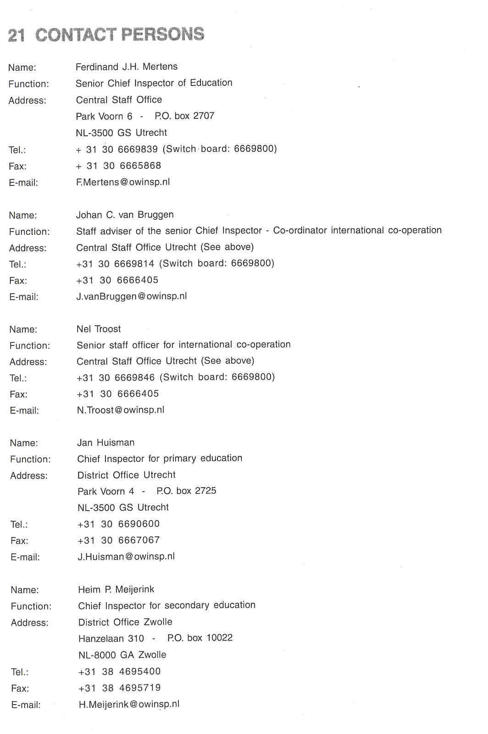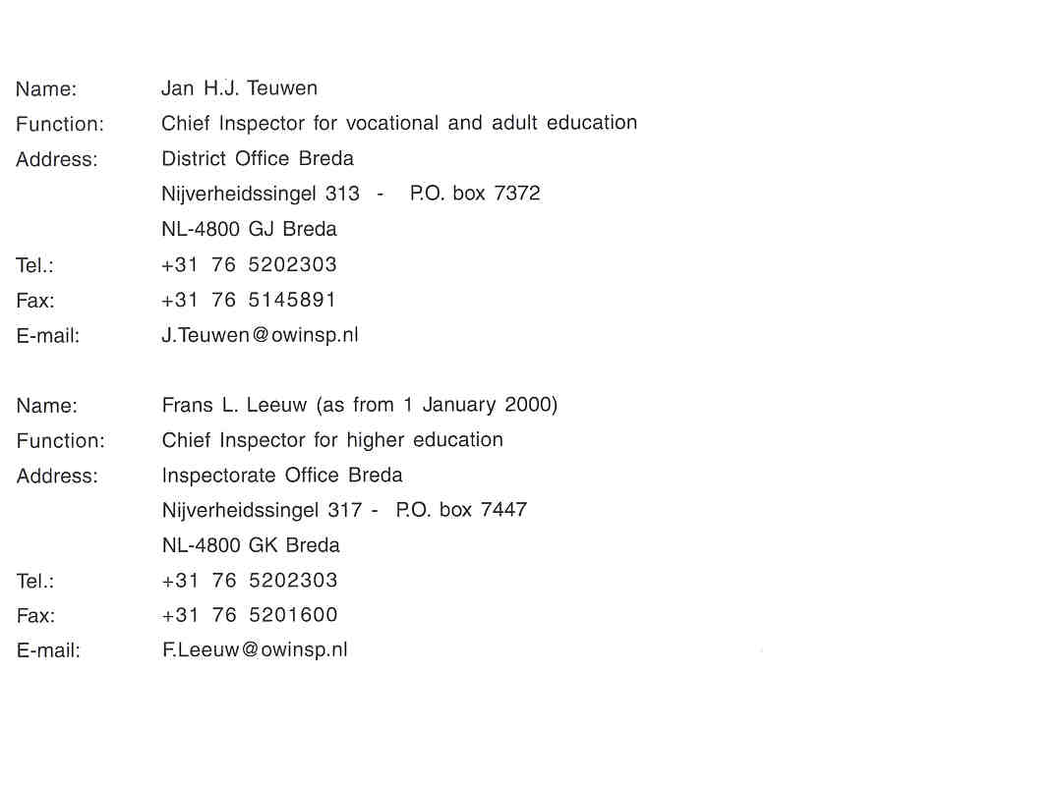

Since the introduction of the Adult and Vocational Education Act k'1996) vocational and adult education is regarded as one education sector. In the structure of the education system one component of the sector, vocational education, preceeds,higher education.
2 "Systeme Furopeen de Diffusion des Offres et des dernandes d'empioi enregistrdees en Compensation internationale.

